Perceptions of BREEAM in the Construction Industry

Amoah-Korsah, A.; Ayinla, K.; Madanayake, U.; Keates, R.; Seidu, R.; and Young, B.
Institution: London South Bank University

Abstract

Since the effects of climate change are being felt on a worldwide scale with negative influence on the environment, industries are adopting sustainable practices to lessen the damage. However, due to various perceptions, including the notion that green practices adversely impact profitability, the implementation of a mitigating model like the Building Research Establishment's Environmental Assessment Method (BREEAM) seems to have been met with apathy within the UK construction industry. This study seeks to dispel current perceptions associated with BREEAM relating to the increase in costs due to implementation of the scheme. The study employed a case study methodology to gather qualitative primary data using semi-structured interview. Participants were chosen using a purposive sample strategy. The study identified that though cost was a key component in the BREEAM assessment process, being it in the design or construction stage, its impact on overall project cost is insignificant in comparison to its high impact and numerous benefits. By way of contribution, this paper will positively shape understanding and attitudes about BREEAM across the UK construction industry to encourage industry players to embrace it.

Keywords: Sustainability, Buildings, Cost, Construction, BREEAM

Introduction
The reality of climate change and its damaging impact on the environment are being felt globally. The impact of this has led many industries to begin implementing sustainable procedures to minimize the effect. However, the implementation of a mitigating model like Building Research Establishment’s Environmental Assessment Method (hereafter, BREEAM) seems to have been met with an attitude of apathy within the UK Construction Industry. A major contributor is as a result of the perceptions that green practices adversely impact profitability Alwan, Jones and Holgate (2017). Yang,Vladimirova and Evans (2017) discovered that companies felt sustainability practices would be an economic burden for them due to the initial set-up fee required for their implementations. On the other hand, some firms believe green practices would enhance their shareholder value or enhance their reputations among the public (Adams,Thornton, and Sepehri, 2012; Soulti and Leonard, 2016). In corroboration with this, Esty & Winston (2009) reported that sustainability practices are no longer to be considered an economic threat to a company. By implementing business models that drive sustainability and green practices, UK construction companies would have the power to drastically transform the sector by changing the way a company delivers, creates and seizes value (Bocken et al., 2014).
Therefore, this paper aims to explore the BREEAM assessment in its entirety, dispelling typical perceptions and myths associated with BREEAM and encourage the use of BREEAM across the UK construction industry, where viable. Overall, this study encapsulates the contributory factors for employing BREEAM, its setbacks and sustainable benefits associated with it.

Literature Review
BREEAM was conceptualised and ultimately commenced assessment in 1990 whereby it was originally utilised for assessing the environmental impact, solely for contemporary offices (Taylor and Pineo, 2015). BREEAM assesses sustainability practices under a total of ten categories as of Building Research Environment (2018), with a further eleventh category providing a 10% boost in score from innovation. The primary ten categories are: waste, water, pollution, transport, management, energy, materials, health & wellbeing, land use and ecology. Each of these subcategories provides a percentage weighting to the overall building score (out of 100%), with the most heavily weighted category understandably being energy, which accounts for 16% of the total classification score, as illustrated is Figure 1 (Building Research Environment, 2018).

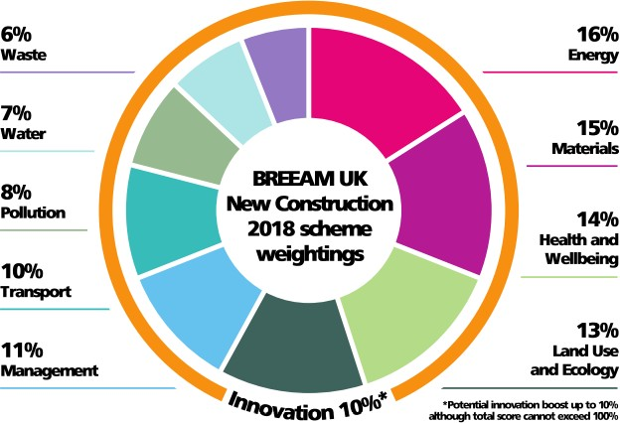

Figure 1. Shows BREEAM’s categories and their contribution to the final assessment grading (BRE, 2018)
BREEAM is generally well received, so much that a BSRIA report by Parker (2012) found that 88% of respondents found it a good practice, 96% would use it again. In the same study, a further 88% of respondents confirmed they would recommend the process to others. This data testifies to the popularity of BREEAM.
- Drivers of BREEAM
Many of the forces behind BREEAM are driven by the Government and Local Authorities (LA) (BREEAM, 2014). As part of their sustainability strategy and goal, many local authorities now require BREEAM certification for contemporary project under their purview (Griffiths, 2013). The UK’s Central Government and its buying standards require all Government Estate buildings to achieve a minimum rating of Excellent and Very Good, for new builds and refurbishments respectively; with exception of the Ministry of Defence whose buildings require a more specialised assessment process (Ministry of Justice, 2021).
A survey undertaken by Wessing, Spada and BPF (2010) found that a total of 64% of their seven thousand respondents considered BREEAM an essential tool. As such, it is highly regarded amongst many sectors, as illustrated in Figure 2 below. Likewise, a number of reasons for utilising BREEAM have been purported and could be further narrowed into the following: increasing chances of sale/let, organisational policy, planning requirement or potentially making the building more profitable long term, as seen in Figure 3.

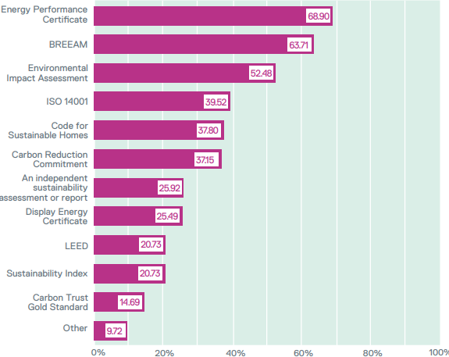

Figure 2. The results to the Wessing, Spada & BPF survey (2010). Participants were asked to indicate which items listed were essential in the decision-making process to business dealings.

It is obvious from Figure 3, that there are several reasons why an organisation may choose to implement BREEAM. However, these issues vary among different personnel, with typical organisational policy and planning requirements prevailing as the most frequent reasons for implementation of BREEAM. Therefore, those contractors, developers and the like may not have a choice in the matter, in regards to public procured buildings.

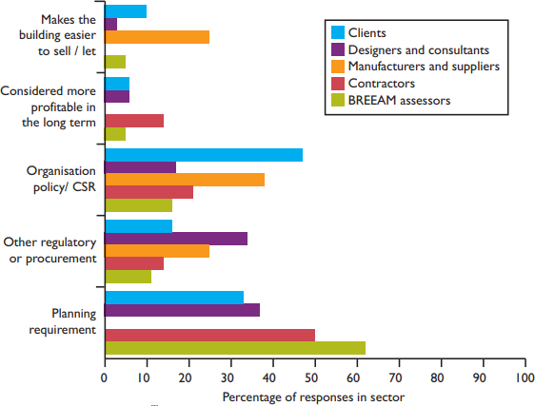

Figure 3. Reasons for utilising BREEAM (Parker, 2012)

Figure 3 shows the professionals’ reasons for using BREEAM. In contrast to this, Figure 4 illustrates the clients’ reasons for applying BREEAM assessments (Parker, 2012). There are some notable similarities showing that organisational policy and planning requirements again ranked highly as the reasons for implementing BREEAM.

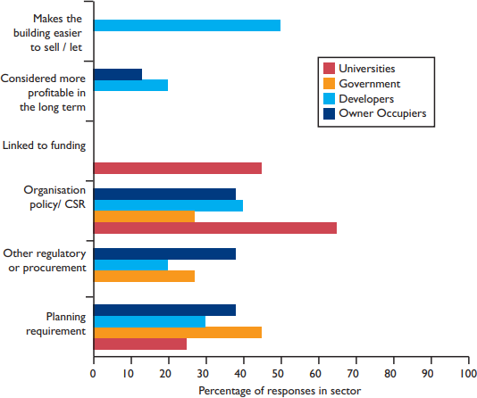

Figure 4. The client’s responses as to why they utilise BREEAM (Parker, 2012)

With the aforementioned drivers for implementing BREAAM comes further drivers for attaining specific ratings within the BREEAM system. As mentioned earlier in the review, there are various ratings achieved from Pass, Good, Very Good and Excellent through to Outstanding. However, the factors that facilitate such ratings have not been documented thoroughly.
The drivers of BREEAM go beyond the desire to determine a building’s sustainability to include economic, environmental and social benefits to the people associated with the life-span of that building (Stone Cycling, 2021). Contemporary tenants and people who use buildings have preference for associated benefits just as mentioned above, making BREEAM an apparent tool for reaching such feat. Bailey (2021) reports that a Savills survey in August 2020 uncovered that 49% of prospective property buyers showed more interest in buildings with green credentials and affirmed that such have become more important than ever. Bergeron, (2021) noted that tenants’ attention has turned on buildings’ sustainability with increasing desire to see many new projects and landlords adapting to green practices. An additional drive for using BREEAM is its health and wellbeing benefit. Taylor and Pineo (2015) report that the application of BREEAM assessment facilitates mitigation of risks associated with flood management, water pollution, light pollution, poor indoor ventilation and inadequate daylight, all of which have adverse potential effect on human health and wellbeing.

- Drawback of BREEAM
It is generally accepted that implementing the BREEAM assessment will cause an increase in construction cost, ranging from the initial design stages through to the construction itself. According to Isaksson and Linderoth (2018) companies felt sustainability practices would bring economic burden for them. Contrary to this conventional thought process, Plebankiewics, Juszczyk and Kpzik (2019) discovered that BREEAM certified buildings are the solution to high energy consumption when compared to non-certified builds.
When dissecting the make-up of construction costs, it is apparent that BREEAM certified buildings require greater preliminary, design, finishes and fitting expenses. This is due to the requirement of specifically demanded items and materials to meet such regulations. Notably, significant increases in design costs are expected. A study by Kats (2009) uncovered that it costs about 2% higher in cost in constructing sustainable buildings than traditional buildings. This significant information has equally been confirmed by Gatley (2021) who noted that there is a marginal increase of 2% in green building projects than conventional buildings.

- Benefits of Sustainable Buildings – (Via BREEAM)

Due to BREEAM’s nature and its ability to be used in various ways across a number of professions, developers, clients, design teams and building managers (BREEAM, 2020), it poses a number of benefits. For example, BREEAM helps to achieve sustainable buildings with little impact to the environment when compared to their non-BREEAM assessed counterparts (Serrance-Baena et al., 2020; Soulti and leonard, 2016; BREEAM, 2020; Dwaikat & Ali, 2018). According to Goode and Xiao (2012), some of the stated benefits of BREEAM include: less trash transported to landfills, lower operational costs, increased market value and marketability of green buildings, improved animal habitats, lower waste costs, and encourages efficient energy and material usage. Furthermore, Cabrita and Alvarez (2010) have noted a number of indirect benefits through the implementation of BREEAM; these include greater continuity and communication between departments during the building process. This may prove incredibly valuable, particularly in an industry that has been described as volatile and confrontational (Al-Bizri and Gray., 2010; Naoum and Egbu., 2015).
Kats et al., (2003) note stark benefits due to a reduction in energy and water consumption and lower maintenance costs. Amongst these benefits include social factors like the improvement of health and productivity which have been quantified as 10 times higher than the additional costs required in order to implement these green elements in the construction process (Kats et al., 2003). Furthermore, the energy savings had been quoted at a 30%, which is clearly a significant saving for any business. These economic savings in energy are echoed by Yudelson (2008), who stated savings can be anywhere between 30 and 50% for both energy and water when compared to conventional buildings. Likewise, Madew (2006) reported a 60% decrease in energy and water consumption in green buildings. All these asserted reductions in energy and water consumption clearly imply significant reductions in annual operating costs for the building in the future. Similarly, Torcellini and Pless (2006) found a fairly vast reduction in energy costs from 25 to 75% within code compliant buildings within the United States. Equally, Ries et al., (2006) again, like the aforementioned researchers, found a 30% decrease in energy consumption, as well as, a 25% increase in productivity, albeit a LEED assessed building as opposed to BREEAM.

In conclusion, it appears as though for BREEAM to be considered a success at project level, there needs to be consistent planning as well as the need for sustainability to be of key significance to the client.

Research Methodology

In line with the purpose of the study, a qualitative research strategy was employed. The study utilized the case study method to collect qualitative primary data through semi-structured interviews. As stated in the introduction, the aim of this research study is to dispel the barriers and factors inhibiting BREEAM usage, so semi-structured interviews were used to allow for flexible discussions on the topic, thereby getting data based on first-hand experience, understanding and opinions about the assessment system (Daniel, 2010.; Fairlamb, 2021).

A single case study approach was used with data collected from the design team at St Nicholas SEN school, the case study for this research. Small number of participants were selected purposively for the study, per purposive sampling (Denscombe, 2017). For the purposive sampling to be effective, 3 participants were chosen for primary data collection. Their knowledge and experiences throughout the design and construction phases of the case study helped to form the basis of the study, consequently facilitating the semi-structured interview process, ultimately meaning their intimacy with the case study would provide great insight. Thus, proving to be extremely important in ascertaining highly valid and reliable data (Gurbium et al., 2012). One potential issue is that with such a small sample size, their opinions and subjectivity towards the project may be deduced as biased, therefore not giving a true representation of industry beliefs and realisations. That is why it was of upmost importance to compare the findings with contemporary literature.
An evaluation of the findings and comparisons to current literature was engaged to increase the validity further. This method of verifying validity via the comparisons with current literature is highly recommended (Armstrong, 2022). As with any research it is imperative that validity and reliability are upheld – this will help achieve a significantly more efficacious study (Hall and Roussel, 2020). It was of great importance to conduct the interviews and collect the data to the greatest standard possible This is due to the amount of influential reliability placed upon the primary researchers. The preceding semi-structured pilot interviews allowed the questions and interview process to be amended in order to achieve greater levels of validity and reliability and, as such, enhance the final stage interviews.

Data Analysis and Results
Due to the qualitative element of the study, typical data analysis software and statistical packages cannot be used. For this reason, a two-fold variation of Qualitative Data Analysis (QDA) was chosen for analyzing the data obtained from the interviews. QDA “is based on ability to examine and interpret the meaningfulness and symbolism of the content of qualitative data” (Nigatu 2009). Comparisons are made between the literature and the results at hand, as well as appropriate scrutinization and limitations noted. The interview data is presented in the form of a Thematic Analysis (TA). The highlighted themes and categories are reflective of the initial research objectives set out in the introduction. Within the categories themselves there are further sub-categories listed below, utilised to address topics and ulterior themes further:
- BREEAM and its perceived effect on cost & time during the design process.
- BREEAM and its perceived effect on cost & time during the construction process.
- The effect of the implementation of BEEAM on energy.

Table 1 contains the roles and general working background of each interview participant within the design team, and appropriately aligned with the research question and case study as per Roberts, (2020). Following this, the results is displayed in the form of thematic table and subsequent thematic map. These findings then lead into a full discussion, analysis and comprehensively compared to contemporary literature.

BACKGROUND QUESTIONS
Participant Number | 1 | 2 | 3
Current Role | Design Manager | Architect | Structural Manager
Amount of Experience | 10 years | 12 years | 15 years
Experience with BREEAM before | Yes | Yes | Yes

Table 1 – Depicts the general working background of the interview participants

Results

Thematic Table
All of these themes in table 4 relate back to the literature review where the interview questions were ascertained. The themes and subsequent subthemes are depicted with the representation of a capital Y as to whether they revealed themselves in the relating interview.

THEME | Sub-themes | 1 | 2 | 3
INDUSTRY STANDARD |  | Y | Y | Y
INCREASE OF COST | Design Cost | Y | Y | Y
 | Construction Cost |  | Y | Y
“EASY WINS” WITH BREEAMS | Disproportional Credit Scheme | Y |  | Y
 | Design Credits easy to achieve | Y |  | Y
ENERGY COSTS | Life Cycle | Y | Y | Y
DOES BREEAM ACHIEVE WHAT IT SETS OUT TO DO?
COMMUNICATION |  | Y | Y
OPINION OF BREEAM UTILISATION |  | Y | Y | Y
Table 2. Shows the visual representation of the reoccurring themes and sub-themes within each participant interview.

Thematic Map
Figure 6 illustrates the thematic map developed from the interview responses. The rectangles represent the key themes, whereas the oval shapes represent the sub-themes and finally, reoccurring themes are linked by blue lines. The specific graphical representation of shapes and colours were chosen in order to facilitate the data representation process. Further to the thematic table 2, it is possible to see a whole host of connections and themes appearing with the thematic map itself. There were five key themes observed within the thematic analysis, each of these is explored in the following section of this paper.

Figure 6. Thematic Map

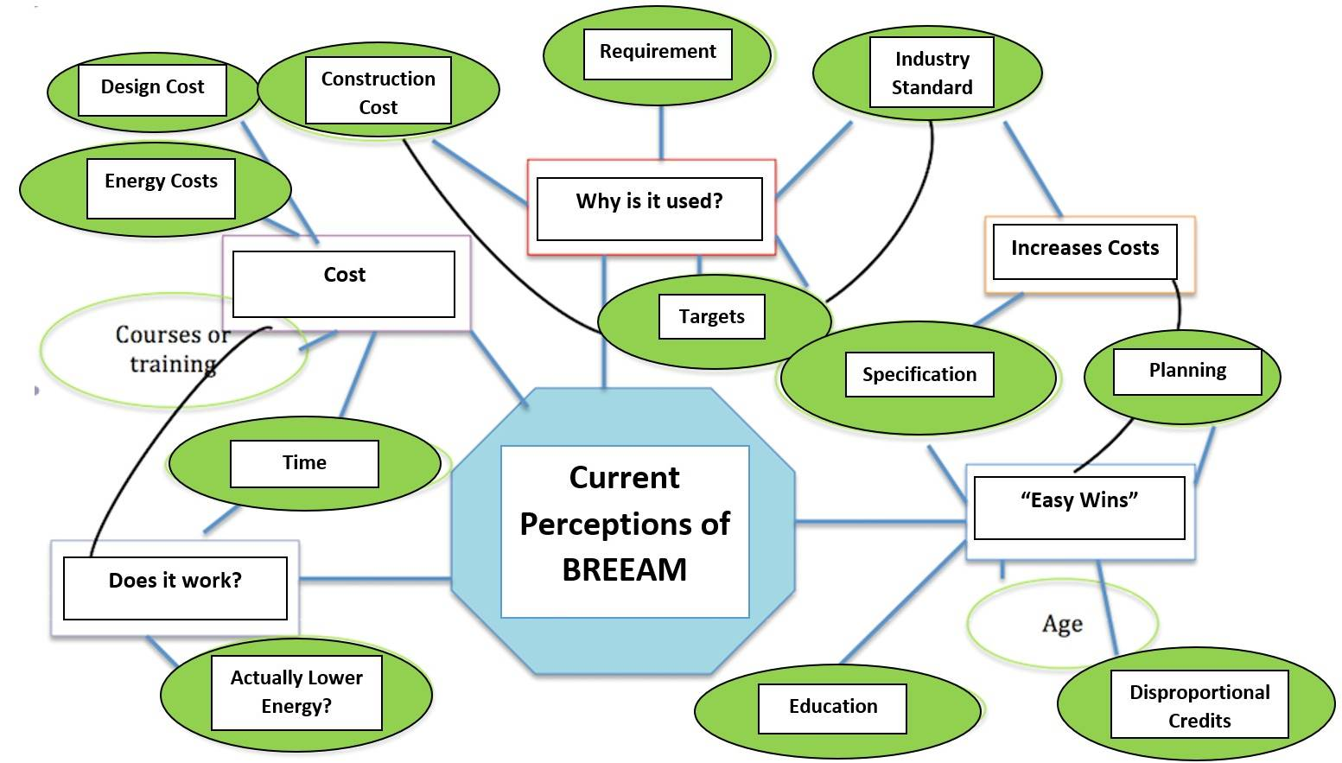

Interview Responses & Coding

Cost of Implementation at Design & Construction Stages
It was apparent that cost was a key component in the BREEAM assessment process. All interviewees in one way or another highlighted the effect BREEAM had on cost in the construction phase, with two out of the three interviewed highlighting BREEAMs effect of increased costs in the design phases. These identifications of BREEAM’s effect were either positive or negative. These instances were clearly identifiable, not only directly, but also indirectly with the identification of associated sub-themes such as product selection, and implementation of building services e.g., water, electricity, etc.
Design Stage
“We were lucky in the fact that initially the project was due to be an extension of an existing building. This then turned into 12 extra classes, from the initial 6 we designed. This again increased further into a total of 28 new classrooms… The early notification meant we could implement changes earlier, the earlier you implement these changes the less the associated costs”. I1 – T1
Here the initial interviewee (Design Manager) highlights the importance of early implementation in the mitigation of increased design costs. The view here was that with greater planning, there would be no real need for costs to rise, even as the project unfolds.
“… it is inevitable some design costs are going to be incurred, from the greater specification of windows, to allow appropriate light, thermal comfort etc.” I2-T1
The above citation is of the view of the architect, their view is that costs will always be incurred simply due to the materials being selected being of better quality and specification when compared to their non-BREEAM certified counterparts.
“No real design costs incurred that I knew of structurally, however, I do know there was an issue with council planning and the urban drainage strategy. Although these are not driven by BREEAM” I3-T1
The structural Engineer was unaware of any cost increases from a structural standpoint in regard to BREEAM. Structurally, buildings of this nature should be very similar in regards to weight bearing and from a civil engineering standpoint.
Construction Stage:

“I don’t feel as though it (BREEAM) effected costs during the construction. If a project is costed appropriately against the proposal, then there simply shouldn’t be an issue” I1-T1
Again, the design manager states the importance of planning with regards to the project and cost management. If a project is poorly planned and costed poorly against the proposal only then should you see an increase in construction costs. This may be because of failing to see issues, as such, changing materials, sizes, specification etc. All things that can affect cost and time.
“… bare ceilings allow for greater thermal comfort during the summer and is obviously inexpensive to implement, so I feel this is a common misconception with BREEAM” I2-T1
The above citation is a great example of how BREEAM does not have to cost more to implement. It shows how something as simple as the provision of a bare, “unfinished” ceiling can have a great effect on cooling and the thermal comfort of a classroom. Yet, this citation is of opposition to the architect’s previous statement, therefore potentially highlighting confusion, misconceptions and lack of understanding around the scheme.
“I’m not aware of anything that brought up the construction costs specifically, but I do imagine it (BREEAM) would have had an increased cost… maybe not by a whole lot though”
Here, the structural engineer cannot provide any specific incurred costs, however, it is their perception that BREEAM does have to cost more. This is an interesting point that shows itself amongst the literature numerous times, this will be examined further throughout the discussion chapter, it is important to find out where these perceptions may have come from and understand why individuals have this thought process.

“Easy wins” – Credit Scheme:

The previous theme about the general costs of BREEAM at the design and construction phases leads us into this next theme about the credit scheme itself. With two out of the three interviewees specifically mentioning the credit scheme and how some credits offer a vastly unbalanced number of credits despite their relative costs and or method of implementation.
“…design stage assessment is based on what you say you are going to do (in regards to construction), not what actually happened… make sure you are in a position to do what you said you will” I1-T2/T3
The above statement from the design manager (DM) highlights an interesting point. They essentially say design assessment credits are based upon what is outlined within the design, so if one was to design the perfect BREEAM certified building they could receive a vast number of credits during the design assessment. Whether on decides to build to said specification is another factor. The DM also links this back to planning appropriately “make sure you are in a position to do what you say you will”, this shows the clear importance of proper planning within the credit distribution, and again, costs of the project. If one is not in a position to do what they set out to do, credits could easily be lost and money added onto the construction phase.
“I have heard there are easy wins with things such as bicycle racks. The implementation of bicycle racks provides a disproportionately favourable credits here, despite relative low realisation costs”
Here the participant clearly outlines how implementing a relatively inexpensive product can provide one with a greater proportion of credits. Whether this true or not remains to be seen, however, a total of two credits can be awarded for such implementation – the percentage weighting of these credits though is harder to determine. With this being said, it still demonstrates how one’s perception of BREEAM is influenced by their peers. This can be compared to the industry as a collective, as discussed in preceding sections, and ultimately how perceptions are or can be influenced by an outdated narrative.

Energy Costs – Life Cycle:

With all three participants mentioning life cycle costs and how they think BREEAM will influence energy demands, it is clear to see the importance of this theme. It is also one of the main drivers for utilisation, as such is vastly important to the uptake and use of BREEAM itself. However, by a further two participants, the question was poised whether BREEAM actually measures what it says it does. For example, just because a project achieves an “Excellent” rating, does this actually mean life cycle energy costs should be significantly lower. Despite this, neither participant could actually confirm this as a definite.
“It was designed to BREEAM Excellent, it should run far better than buildings that haven’t... However, the school went from 2 forms of entry to 4 forms of entry – so building vastly increased in size, meaning operational costs are going to be higher” I1-T3
“According to the models it works, however, (the) climate is changing and you cannot value how it works until you do a post-occupancy test” I1-T3/T4
Both citations, from the same participant, are evidence to the fact that one essentially does not know if BREEAM has a positive effect of occupancy energy usage. Again, pointing to the perceptions towards BREEAM and how, in theory, it is meant to decrease energy usage through occupancy and how no one actually knows for certain this is the case, despite the modelling, this would in fact require permanent supervision and measurement In spite of these statements, and potential questioning of whether BREEAM achieves what it sets out to, the same interviewee concludes the interview by stating “… (it) may cost more to implement initially but it does contribute to the building running efficiently, reduced emissions etc.”. Thus, showing potential convolution and conflicting thoughts over the certification scheme, maybe this participant is siding with the general narrative over BREEAM, despite their reservations.
During interviews three similar notions were uncovered – “I would like to think it (BREEAM) would lower occupational costs, although there is no real way of knowing… I would assume mostly from energy costs”. This statement again highlights how this individual is unsure BREEAM does reduce energy costs, although if it did reduce such costs, these reductions would be mostly from lowered emissions and energy usage. From these last two citations it can be said that in general people do believe BREEAM has a positive effect on energy costs, although, they do seem sceptical about such statements.

Discussion
These key findings are highlighted and appraised against the literature review to inform a conclusive discussion.
BREAAM and Design & Construction Costs

Despite building sustainable developments being a key requirement for government funded buildings, it is not the major cost driver on the vast array of projects, as such, it is typically a considered a challenge for the design team to deliver a green building within a traditional budget (World Green Building Council, 2013). However, because of the perceived increases in design and construction of green buildings of between 10 & 20% (some as high as 29%), this task becomes infinitely more difficult (Kehl, 2020).
In a range of reports between 2000 and 2012, between various countries and a number of different certification schemes, it had been reported that perceived increases in design and construction costs for green buildings were between 0.9 and 29%. In comparison, the actual design and construction costs were between -0.4 and 12.5% (BRE Trust, 2005; Target Zero, 2010 and 2011; Kats, 2003, 2006 and 2009). This is a fairly significant difference in the perception gap, thus, highlighting a need for changing attitudes towards the cost increases of green buildings (World Green Building Council, 2013).
A 2008 study by Gomez compared these perceptions of greater cost variability with professionals within the construction industry who have experience with the design and construction of green buildings and professionals who had little or no experience. It was found that those individuals who had previous experience generally believed the cost premiums would be in the region of 13%, in line with the uppermost figures found within the research above. However, those who had little experience with the construction of green buildings perceived the costs to be upwards of 18%. Thus, indicating even those with relevant experiences tend to perceive costs to be at the very least as expensive as the greatest values found above, when in fact they can be decidedly lower. With the reports outlined above, it is easy to see how real design and construction costs can in fact be well within budget, even below budget as seen with the negative value within the Building Research Environment’s 2007 report. With this in mind, it must be sought out to find where these perceptions come from, as such, to educate the industry in the fact that sustainable developments do not have to be more expensive than a typical code compliant build.

BREEAM & Energy Performance
Many buildings, once in operation, are not quite as comfortable or as efficient from an energy performance standpoint as they were initially predicted (Wall, 2006). According to the literature, reasons may include the industry’s general nature, that is lack of integration from the buildings occupants, “over the wall” nature (Kalay, 2006), its general organisation and its “one-off” products and “temporary” design teams, to issues with modelling and interoperability (Dainty, Moore and Murray (2006). Although some of these issues did not highlight themselves specifically within the results, these could quite easily be linked to themes that made themselves apparent. For example, the reoccurring theme of whether BREEAM actually measures what it sets out to achieve – two interviewees specifically mentioned this and how despite modelling, one never does actually know if the building is going to perform the way it should. This too, is in corroboration with Aspinal et al., (2012) who found that all of their interviewees focussed largely on sustainability as it relates to the impact of buildings on the environment, as opposed to the social facets of sustainability. This is extremely important, as in the same Aspinal et al., (2012) study they put this down to the fact that BREEAM was originally produced to assess the environmental impact of buildings on the environment.

Conclusion and Future Recommendations
Notwithstanding some of the parallels found with the literature and the researchers’ efforts to link with further studies, a larger scale study could see a comparison of a number of case studies or a larger scale case study, getting the point of view of Construction Managers, Quantity Surveyors and the like in order to achieve a more well-rounded view of the perceptions and experiences with BREEAM. Thus, facilitating further recommendations and advances in the narrative of BREEAM.
It is imperative that further research be conducted to firmly ascertain the impact of sustainable developments on finance and compare this to perceptions of the matter within the UK construction industry and the BREEAM certification scheme.

References

Adams, M., Thornton, B., and Sepehri, M. (2012) The Impact of the pursuit of sustainability on the financial performance of the firm, Journal of Sustainability and Green Business, 1(1), pp.1-14.
Aspinall, S., Setyesilisik, B., Sourani, A., and Tunstall, A. (2012), How Accurately Does Breeam Measure Sustainability? Creative Education, Vol, 3, pp. 1-8
Al-Bizri, S. and Gray, C. (2010), ‘Management framework for technology clusters implementation’, Construction Management and Economics, Vol. 28 No. 7, pp. 771-782.
Alwan, Z., Jones, P., and Holgate, P. (2017), ‘Strategic sustainable development in the UK construction industry, through the framework for strategic sustainable development, using Building Information Modelling’, Journal of Cleaner Production, Vol. 140(1), pp. 349-358.
Armstrong, Argyro A., (2022), First-Generation Women College Student Starving to Matter: REVEALING THE LIVED EXPERIENCE OF A STUDENT POPULATION IN CRISIS. London: Lexington Books
Bailey, C., (2021) ‘Property and Carbon’ Conference of the Parties (COP26), Glasgow, November.
Bergeron, P., (2021) Environmentally-Conscious Space Has Become a Key Demand by Tenants [Online]. Available at: https://www.globest.com/2021/12/02/environmentally-conscious-space-has-become-a-key-demand-by-tenants-environmentally-conscious-space-has-become-a-key-demand-by-tenants/?slreturn=20220825110729 (Accessed: June 12, 2022).
Bocken, N.M., Short, S.W., Rana, P. and Evans, S., 2014. ‘A literature and practice review to develop sustainable business model archetypes’, Journal of cleaner production, 65, pp.42-56.
Gattley, N. (2021), How much does sustainable building construction cost? British Assessment Bureau, 18 August [Blog]. Available at: https://www.british-assessment.co.uk/insights/how-much-does-sustainable-building-construction-cost/#:~:text=Do%20sustainable%20buildings%20cost%20more,a%20green%20or%20sustainable%20way (Accessed: June 12, 2022)
Building Research Environment (BRE) (2007) “Costing Sustainability: How much does it cost to achieve BREEAM and Eco Homes ratings?” Information Paper.
Building Research Environment (BRE) (2005) Putting a Price on Sustainability. Watford: Building Research Environment
Building Research Environment (BRE) (2018). BREEAM UK New Construction: Non-domestic Buildings (United Kingdom). Watford: Building Research Environment
Building Research Establishment's Environmental Assessment Method (BREEAM) (2020). Why BREEAM? The world’s leading science-based suite of validation and certification systems for a sustainable built environment. [online]. Available at: https://bregroup.com/products/breeam/why-breeam/ (Accessed: June 12, 2022)
Building Research Establishment's Environmental Assessment Method (BREEAM) (2014). The case for BREEAM Communities [online]. Available at: https://tools.breeam.com/filelibrary/BREEAM%20Communities/The_Case_for_BREEAM_Communities_-_Fact_Sheet_-_January_2014.pdf (Accessed: June 20, 2022]
Cabrita, A. L. and Alvarez, J. R (2010) BREEAM Communities in Spain, in Brebbia, C. A.(ed), The Sustainable World, Wessex: WIT Press, pp 86-100.
Daniel, B. K., (2010), Handbook of Research on Methods and Techniques for Studying Virtual Communities: Paradigms and Phenomena. New York: Information Science Reference

Dainty, A., Moore, D. and Murray, M. (2006), Communication in Construction, London: Taylor & Francis

Denscombe, M., (2017) The Good Research Guide: For small-scale social research projects, 6th edn. London: Open University Press
Dwaikat, L.N. and Ali, K.N., (2018) The economic benefits of a green building–Evidence from Malaysia. Journal of Building engineering, 18, pp.448-453.
Esty, D. C., & Winston, A. S. (2009). Green to gold: How smart companies use environmental strategy to innovate, create value, and build competitive advantage: John Wiley & Sons Inc.
Fairlamb, S., (2021). Understanding Quantitative and Qualitative Research in Psychology: A Practical Guide to Methods, Statistics, and Analysis. London: OXFORD UNIVERSITY PRESS
Griffiths, R. (2013). Just how important is a BREEAM rating? [Online]Available at: http://www.propnews.co.uk/issues/2013/04/articles/94/just-how-important-is-a-breeam-rating-/ (Accessed: June 10, 2022)
Gomez, S. (2008). ‘Is the Client Willing to Pay to Occupy a Greener Building? Improving Energy Efficiency in Commercial Buildings Conference.’’ Building Performance Congress, Frankfort, German
Goode, R., and Xiao, H. (2012) ‘Is BREEAM suitable for small and medium refurbishment/ Maintenance projects?’. 48th ASC Annual International Conference Proceedings, Birmingham, 11-14 April.
Gubrium, J. F., Holstein, J. A., Marvasti, A. B., and Mckinney, K. D. eds (2012), The SAGE handbook of interview research: The complexity of the craft. London: Sage Publications.
Hall, Heather R. and Roussel, Linda A. (2022). EVIDENCE-BASED PRACTICE: An Integrative Approach to Research, Administration, and Practice 3rd Edn. Burlington: Jones & Bartlett Learning.

Isaksson, A. and Linderoth, H. (2118) ‘Environmental considerations in swedish building and construction industry: The role of costs, institutional setting, and information’, journal of Housing and Built Environment, 33 (4), pp. 615-632. DOI: 10.1007/s10901-017-9588-8
Kalay, Y. (2006), ‘The impact of information technology on design methods, products and practices’, Design Studies, Vol. 27 No. 3, pp. 357-80.
Kats, G. Alevantis, L. Berman, A. Mills, E. and Perlman, J., (2003). The Costs and Financial Benefits of Green Buildings: A Report to California’s Sustainable Building Task Force. New York: Green Building Council
Kats, G. (2006) Greening America’s Schools: Costs and Benefits. Massachusetts: Capital E. Analytics
Kats, G. (2003), The Costs and Benefits of Green, Report to California’s Sustainable Building Task Force, California: Capital E. Analytics
Kats, G. (2009) Greening Buildings and Communities: Costs and Benefits. Massachusetts: Capital E. Analytics
Kats, G. (2009) Greening Our Built World: Costs, Benefits and Strategies. Washington D.C.: Island Press.
Kehl, L. M., (2020). The myth of increased costs in sustainable building. [Online] Available at: https://www.construction21.org/deutschland/articles/h/the-myth-of-increased-costs-in-sustainable-building.html (Accessed: Mar 10, 2022)

Madew, R. (2006) The Dollars and Sense of Green Buildings: A report for the Green Building Council of Australia, Green Building Council of Australia.
Ministry of Justice. (2021) Property Directorate: Sustainable Construction: BREEAM Policy. [online]. Available at: https://assets.publishing.service.gov.uk/government/uploads/system/uploads/attachment_data /file/790826/sustainable-construction-breeam-policy.pdf [Accessed: Jun. 10, 2022]
Naoum, S. and Egbu, C. (2015), ‘Critical review of procurement method research in construction journals’, Procedia Economics and Finance, Vol. 21, pp. 6-13. DOI: 10.1016/S2212-5671 (15) 00144-6
Nigatu, T. (2009) Qualititive Data Analysis [Powerpoint slides]. Slide Share. [Online] Available at: http://www.slideshare.net/tilahunigatu/qualitative-data-analysis-11895136 [Accessed: April 24, 2022]
Parker, J., (2012). The Value of BREEAM: Bracknell: BSRIA Ltd. [Online] Available at: https://tools.breeam.com/filelibrary/BREEAM%20and%20Value/The_Value_of_BREEAM.pdf (Accessed: April 24, 2022)
Plebankiewicz, E., Juszcyk, M., and Kozik, R. (2019) ‘Trend, Costs, and Benefits of Green Certification of Office Buildings: A Polish Perspective’, Sustainability, Vol 11, pp.2359.
Ries, R., Bilec, M.M., Gokhan, N.M. and Needy, K.L. (2006) The Economic Benefits of Green Buildings: A Comprehensive Case Study in Engineering. Economist, Vol. 51 259–295. Available at;https://www.researchgate.net/publication/238317394_The_Economic_Benefits_of_Green_Buildings_A_Comprehensive_Case_Study [Accessed: September 18, 2022]
Roberts, R. E., (2020). Qualitative Interview Questions: Guidance for Novice Researchers. The Qualitative Report, vol. 25(9), 3185-3203. https://doi.org/10.46743/2160-3715/2020.4640
Serrance-Baena, M. M., Triviño-Tarradas, P., Ruiz-Diaz, C., and Hidalgo Fernández, R. E. (2020) ‘Implications of BREEAM sustainability assessment on the desigm of hotels’, Sustainability, 12(16). Pp.65599. DOI: https://doi.org/10.3390/su12166550
Soulti, E., and Leonard, D., (2016) The Value of BREEAM: A review of latest thinking in the commercial building sector [Online]. Available at: https://tools.breeam.com/filelibrary/Briefing%20Papers/BREEAM-Briefing-Paper----The-Value-of-BREEAM--November-2016----123864.pdf (Accessed: March 10, 2022)
Stone Cycling, (2021 BREEAM Benefits: 8 Ways Certification Can Increase the Value of Your Construction Project, STONE CYCLING, 20TH July [Blog]. Available at: https://www.stonecycling.com/news/breeam-benefits/#:~:text=By%20providing%20baseline%20targets%2C%20with,and%20waste%20transfer%20is%20minimised. (Accessed: March 10, 2022)
Taylor, T., and Pineo, H., (2015) Health and Wellbeing in BREEAM. [Online] Available at: https://files.bregroup.com/breeam/briefingpapers/99427-BREEAM-Health---Wellbeing-Briefing.pdf (Accessed: March 10, 2022)
Target zero. (2010) Guidance on the Design and Construction of Sustainable, Low Carbon School Buildings. V1.0, London. Available at: www.targetzero.info
Target zero. (2011) Guidance on the Design and Construction of Sustainable, Low Carbon Warehouse Buildings. V2.0, London. Available at: www.targetzero.info

Torcellini, P. and Pless, S. (2006) ‘Net-Zero Energy Buildings: A Classification System Based on Renewable Energy Supply Options.’ Technical Report. Colorado: National Renewable Energy Laboratory.

Wall, M. (2006), “Energy-efficient terrace houses in Sweden: simulations and measurements”, Energy and Buildings, Vol. 38 No. 6, pp. 627-34.
Wessing, T., Spada, & BPF (2010). Hitting the …. and beyond: How is the UK development industry building sustainable foundations? [Online] Available at: www.taylorwessing.com/sustainability/doc/HittingTheGreenWall.pdf (Accessed: Aug 10, 2022)
World Green Building Council (2013). The Business Case for Green Building: A Review of the Costs and Benefits for Developers, Investors & Occupants. [online] Available at: https://group.skanska.com/4af531/siteassets/sustainability/reporting-publications/reports- on-green-building/business_case_for_green_building_report_web_2013-03-13.pdf [Accessed: June 18, 2021].
Yang, M., Vladimirova, D., and Evans, S., (2017), ‘Creating and Capturing Value Through Sustainability’ in Research-Technology Management, Vol 60 (3), pp. 30-39. DOI: https://doi.org/10.1080/08956308.2017.1301001
Yudelson, J. (2008) The Green Building Revolution. Washington D. C- Island Press

