Impact that Acoustic Design has on Higher Education for Non-English Speaking Students
Rodrigo Sanchez-Pizani
London South Bank University, School of the Built Environment, London, UK
email: rgosp@yahoo.co.uk
Stephen Dance
London South Bank University, School of the Built Environment, London, UK,
Speech is one of the main forms of communication, and in teaching environments is fundamental to transmit the message effectively. Significant amounts of the research that has been undertaken concentrating on measuring and studying the impact of intelligibility on native populations, particularly children. There is also evidence that the acoustic design of a room has impact on the overall student experience. This investigation therefore focuses in the analysis of the possible effects that acoustic design and characteristics of heritage buildings has in higher education environments; with a particular interest in those students whose English is not their first language. Rooms and people with similar characteristics from King's College London; were used as sample for the environmental and subjective evaluation respectively. The speech transmission index was assessed in accordance to BS IEC 60268-16:2011, while reverberation time was calculated in accordance with the recommendations for precision measurements in accordance to ISO 3382-2:2008 and ISO 18233:2006. The study compares the student experience subjective acoustic evaluation, their test marks with the measured Speech Transmission Index, as well as the result of a phonetically balanced word test. Results will be presented together with analysis as to if intelligibility correlates to student experience.

Introduction
One of the central aims of the thesis is to provide an internal acoustic assessment for teaching facilities in a higher education institution, and to compare these measurements with current standards and guidance.
The study of the relationship between acoustic parameters and student satisfaction then becomes the main focus, concentrating efforts in those individuals whose English is not their first language; and it is around these people and their results that the acoustic parameters for reverberation, noise and intelligibility are compared and analysed both objectively and subjectively.
Techniques and theory is mainly dictated by the BS EN 60268-16:2011, BS 7445-1:2003, BS EN ISO 3382-2:2008, and BS EN ISO 18233:2006

Background
Anecdotal observations seem to indicate that there is dissatisfaction from students and the general public with the overall acoustics of the college rooms, particularly those in heritage buildings at King’s College on the Strand campus.Therefore, these rooms were a good place to start to investigate the extent and impact of acoustics on student satisfaction.
Previous research has shown advantages and disadvantages to acoustic treatments in university classrooms (1).In particular, the fact that excessive absorption can have an impact on the sound-to-noise ratio, and henceimpactunaided speech. In addition, studies have shown that students found it easier to concentrate in spaces with acoustic treatment (2); another study concludes that ‘during listening tasks a substandard classroom built environment can have a measurable negative effect on adult student learning and performance’ (3). It is therefore easy to theorise that acoustic design of teaching rooms will have an impact on students’ results and experience, and that these results are valid for higher education environments.
For this investigation there is particular interest in students whose first language is not English and are at tertiary level.
In the research of Escobar and Morillas indicated a relationship between the STI and the actual intelligibility results for university classrooms in results tested for Spanish language (4) ; therefore, it seems the initial hypothesis for the project is reasonable.

Overview
Four rooms, all with flat floors and mostly of a shoebox type were measured.The main construction comprising of concrete walls, tiled carpet, high ceilings and medium upholstery seating

Table 1: Room Characteristics
Floor | Room | Capacity | Volume  (m³) | Objective  Test | Subjective
Ground Floor | STD/K0.16 | 49 | 526.8 | STIPA/RT | Survey
Ground Floor | STD/K0.18 | 43 | 537.0 | STIPA/RT/PB | Survey/Exam
Ground Floor | STD/K0.20 | 48 | 575.7 | STIPA/RT/PB | Survey/Exam
4th | STD/K4U.12 | 150 | 774.2 | STIPA/RT/PB | Survey/Exam

From experience and first-hand conversations with several lecturers, three main forms of teaching have been identified:
1. Classic lecture: the teacher speaks without any electroacoustic amplification or support (e.g. microphones, amplifiers, speakers, etc.) from the front of the room.
2. Classic assisted lecture: the teacher speaks using electroacoustic aids normally, from a fixed position, usually a lectern.
3. Play back: this is a method in which the student listens to some pre-recorded material through the installed PA system.
As the present study focuses on listed buildings and given that noise control will, in most cases, require modification to the fabric of the building (changing windows, or adding mass to walls or replacing doors, etc.), this type of work is less likely to be approved by Historic England and therefore it will be excluded from the scope of this study.
Currently there is no regulation or British Standard for the acoustic design of teaching rooms in higher education institutions in England; however, BB93 can be used as an initial recommendation (5); therefore, this is to be used as the benchmark to measure the acoustic of the heritage rooms in the report. i.e. To ensure repeatability accepted and approve British Standards are used for measurement of values for reverberation and STI.
Table 2: Standard used for Measurement
Method/Measurement | Standard used |  | Benchmark |  | Descriptor
STIPA |  | BS EN 60268-16:2011 |  | 0.8-1 s | T_{mf}
RT (Using Sweep) |  | BS EN 18233:2006 |  | 0.6 | STI

Additionally, it is expected that as described by Yang, Becerik-Gerber and Mino,poor acoustics to be one of the main contributors to student dissatisfaction (6). Their study, however, only examines the general influence of the acoustic environment and not the individual elements. It is therefore the intention of this research to investigate the possible impact of some of the individual factors, i.e. reverberation time, STI.
To this purpose the results from a survey, a phonetically balanced test and a language test results are compared with those of individual rooms given in Table 1

Room Measurement
At least 12 source-microphone combinations with a minimum of 6 different receiver locations and 2 sources positions used to measure reverberation time. STI was measured using a mouth simulator, this was to comply with recommendations from current standards.
Three different scenarios were studied in each room
- Natural acoustics:a Yamaha MS101 II Studio Monitor Speakerwas used to reproduce a STIPA signal from a CD playerwithout any other audio aid. NorsonicNor 140 used.
- Program Audio or PA acoustics:the STIPA signal was fed to the sound system directly and used the main front program audio speaker system. Norsonic Nor140 used.
  - three of the rooms also included a distributed sound system and in these cases STIPA was measured using a tie mic (only for K0.20) and/or the lectern microphone (for all rooms) using the distributed sound system. This type of measurement is referred during the report as 100V System; the intention was to see if the STI changed when different system configurations were used.
- Reverberation Time:WinMLS using sweep technique through a hemi-dodecwas used
.
As a comparison two solution scenarios were also tested. In K0.20 was testedbefore and after acoustic treatment was introduced in the form of 18 panels, see Figure 1.

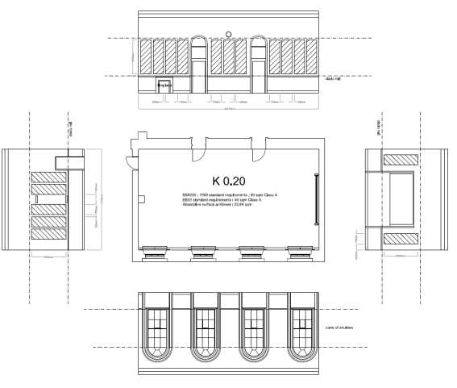
Figure 1:Installation of Acoustic Panels in Room K0.20, used with permission from King’s College London
For K4u.12 STIPA measurements were taken before and after the introduction of electronic active equalisation.The results of the different measurements for all the rooms are shown in Table 3. Showing a clear change between the values obtained before and after the installation of the panels.As for K4u.12,STIPA results before and after equalisation are shown inFigure 2with STIPA presented as a function of distance.
From Figure 2 it is evident that after equalisation the STIPA measurements are improved, correlation of 0.82. However, as shown by Table 3, once one standard deviation is deductedcomparable results were found and hence the result is inconclusive particularly for measurement in the reverberant field.

Figure 2: STIPA in K4u.12, Equalised and not Equalised,as a Function of Distance
Figure 3seem to be consistent with the findings by Hodgson about classroom design that these tend to favour control of reverberation having a detrimental impact on speech levels (1)
Hodgson’s conclusion seems to be perfectly consistent with this research, as shown the decay in level of approximately 3dB per position when comparing level of natural acoustic in a treated and untreated room for all positions.

Figure 3: Comparison of Natural Acoustics Levels between an Untreated and Treated Room
Background noise and reverberation time were higher than the levels recommended by BB93, while STI showed values lower than 0.6. for all rooms, except for the treated K0.20 room.

Table 3:Summary of Results of Measured Rooms (U) And (T) Indicate Treated and Untreated Conditions and Results for Program Audio in K4u.12 Are Shown with and Without Equalisation
Parameter/Room | K0.20 (U) | K0.16 | K0.20 (T) | K0.18 | K4u.12 | K4u.12 (eq)
STI Program Audio | 0.51 ± 0.01 | 0.49 ± 0.01 | 0.60 ± 0.01 | 0.47 ± 0.01 | 0.56 ± 0.01 | 0.57 ±0.01
STI Distributed Sound | 0.41 ± 0.01 | 0.46 ± 0.01 | 0.48 ± 0.01 | 0.45 ± 0.01 | n/a | n/a
STI Natural Acoustics | 0.47 ± 0.01 | 0.47 ± 0.01 | 0.53 ± 0.02 | 0.50 ± 0.01 | 0.52 ± 0.01 | n/a
RT_{mf} (seconds) | 1.69 ± 0.01 | 1.65 ±0.01 | 0.96 ± 0.01 | 1.73 ± 0.01 | 1.19 ± 0.01 | n/a
Noise Levels LAeq (dBA) | 39 | 45 | 37 | 39 | 43 | 43
STI value without signal | < 0.2 | < 0.2 | < 0.2 | < 0.2 | < 0.2 | < 0.2
Average Temperature (C) | 24 | 27 | 24 | 26 | 27 | 27
Relative Humidity (%) | 39 | 43 | 42 | 56 | 52 | 52

As the STIPA results are directly related to different style of teaching it seems important to understand if there is any evident correlation amongst them, as shown in Table 4, interestingly the correlation appears to improve when equalisation was added. And it becomes close to perfect for natural acoustics and distributed sound after treatment was applied. i.e. non-treated rooms have a weaker correlation between the natural acoustics of the room and scenarios where audio visual aids are used.
Table 4:Room by Room Correlation of STIPA Measurements
 | Totals |  |  |  | K0.18 |  |  |  |  | K0.16
 | STI  (Natural) |  | STI  (PA) | STI  (100v) | STI  (Natural) | STI  (PA) |  | STI  (100v) | STI  (Natural) |  | STI  (PA) |  | STI  (100v)
STI  (Natural) | 1.00 |  |  |  | 1.00 |  |  |  | 1.00
STI  (PA) | 0.35 |  | 1.00 |  | -0.11 | 1.00 |  |  | 0.64 |  | 1.00
STI  (100v) | 0.84 |  | 0.39 | 1.00 | 0.59 | -0.23 |  | 1.00 | 0.71 |  | 0.35 |  | 1.00
 | K0.20 (T) |  |  |  | K0.20  (U) |  |  |  | K4U.12
 | STI  (Natural) |  | STI  (PA) | STI  (100v) | STI  (Natural) | STI  (PA) |  | STI  (100v) | STI  (Natural) |  | PA  (No Eq) |  | PA  (Eq)
STI  (Natural) | 1.00 |  |  |  | 1 |  |  |  | 1.00
STI  (PA) | -0.06 |  | 1.00 |  | 0.27 | 1.00 |  |  | 0.27 |  | 1.00
STI  (100v) | 1.00 |  | -0.06 | 1.00 | 0.18 | 0.23 |  | 1 | 0.43 |  | 0.82 |  | 1.00

Parameters Comparison
As with Escobar’s research, it is noticeable that the background noise had an impact on the design but it does not seem to be the main contributor (4). For example, in room K0.20, in the circled area in Figure 4 where it is evident that after the treatment of the room there is a substantial improvement in the STI value despite the background noise level remaining relatively unchanged.

Figure 4: Comparison of Total Average STI Values per Room as a Function of Background Noise in dB(A)

The relationship between reverberation and STIPA was investigated in the four rooms and the results showed a significant relationship in all cases.However, in two of the rooms the early decay time proved to have a better relationship than T20 for the mid frequency (averaged500 Hz- 2kHz).
Table 5: STI Compared as Function of T_{20,mf} and EDT_{mf}
Room | F | R² | p | Sig. | Parameter
K0.20 (U) | 13.97 | 0.66 | p<0.001 | ** | T20
 | 26.08 | 0.78 | p<0.001 | ** | EDT
K0.20 (T) | 6.45 | 0.53 | p<0.001 | ** | T20
 | 4.31 | 0.43 | p<0.02 | * | EDT
K4u.12 | 15.74 | 0.68 | p<0.001 | ** | T20
 | 8.27 | 0.53 | p<0.001 | ** | EDT
K0.16 | 0.08 | 0.01 | p<0.97 | no | T20
 | 3.21 | 0.29 | p<0.05 | * | EDT
K0.18 | 1.96 | 0.23 | p<0.2 | no | T20
 | 4.80 | 0.42 | p<0.011 | * | EDT

Intelligibility Results
Table 6: Proposed Unified STI Matrix for Native and Non-Native Speakers, Based on BS EN 60268-16:2011
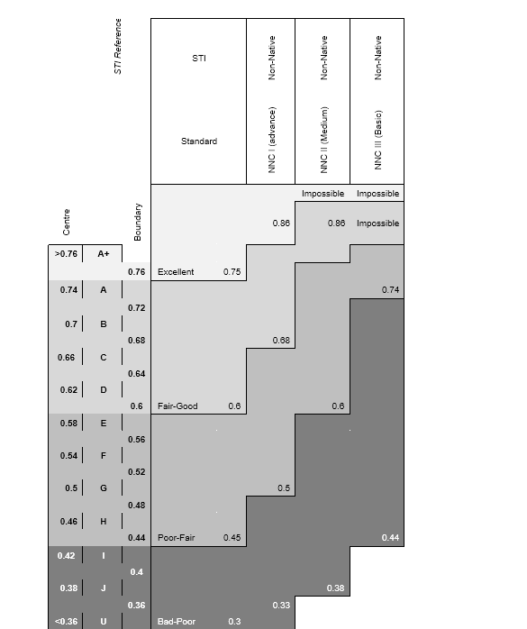

As a way to measure the impact of the intelligibility on students results; an exam administered by the English Language Centre to a diverse population of students (28 different nationalities) whose English is not their first language was compared with the measured STI at each seat position.
It is important to highlight at this time that students who undertook the ELC exam did so in accordance with the regular procedures as set out by the exam board and timetable. As such, at no point were the students, knowingly nor intentionally, were put in a disadvantageous position due to the research, and all conditions were made asfair as possible for the students – a real life scenario.
All AV equipment in the rooms had identical exam files with computers with the same software build and similar characteristics. The signal was adjusted to an average of 63±1 dB(A), as measured at the same designated seating position in each room before and after the examination.
This group of students studied were at a similar level of English i.e. taken training and were at category NNCII as described in Table 6. As such, a random selection of the sample ELC exam score can be analysed, see Figure 5.

Figure 5: Exam Marks as Function of STI

Figure 5 shows that if the exam results are compared as a 1-1 relationship with the STI measurement and centring the study in the middle values then a relationship between the exam results and the measured STIPA seem to exist, R=0.68 based on a third polynomial fit.This accounts for approximately 46% of the total variance of the results, i.e. The overall regression model was significant, F (3,16) = 4.54. p<0.02, R²=0.46.
Morales’s research (7 p. 58), found a third degree polynomial relationship between PB and STI for native English speaking population as result it was decided to study the relationship between STI and PB for non-native volunteers.

Figure 6: Analysis of the Correct Answers as Function of the STI (Program Audio) for Non-Native Speakers
The results seen in Figure 6, indicate that if the model is taken as a polynomial function the STIPAaccounts for approximately 70% of the total variance of the results of the measured STI in the Room.The overall regression model was significant, F(3,32) = 24.41. p<<.001, R²=0.70.
Taken as a linear function the STIPAaccounts for approximately 68% of the total variance of the results of the measured STI in the Room.The overall regression model is significant, F(1,34) = 73.12. p<<.001, R²=0.68.

Subjective results
The final part of research focusses on studying the subjective evaluation of some acoustic parameters.For this 77 students from the English Language Centre and Summer Schools where surveyed in the previously analysed rooms and were asked if the quality of the sound and intelligibility was important for their learning. The survey was given to the tutor of the students who encouraged them to fill in this at the end of the class.

Table 7: Relative Importance of Intelligibility on Student Experience
Importance | Total | %
Not Important (5,8) | 7 | 9.86%
Somewhat Important (9, 11) | 12 | 16.90%
Very Important (12, 14) | 32 | 45.07%
Extremely Important (15) | 20 | 28.17%
Total interviews | 71 | 100.00%

Students were also asked about their view on reverberation and noise in the room and in general, it can be observed that what seems to have a larger influence on the subjective evaluation of the student experience is the noise levels, followed by the reverberation.
For either or both, the reverberation and noise, the higher their subjective value, the more difficult it was to understand the speech, therefore the lower student experience and this trend seemed to be independent of their mother tongue.
The subjective results can be compared per room with their measured counterparts, see Figure 7.

Figure 7 Subjective and Measured Values Relationship per Room for Noise, Reverberance and Speech
From Figure 7, it is possible to see some relationship between the actual or measured values (Noise(dBA), RT(mf) and STI) and their relative subjective values (Noise, Reverberance, Speech).

Table 8: Correlation of Measured Values and Subjective Results. Subjective Headers in Bold
 | Noise | RT | Speech | STI | RT(mf) | Noise dB(A)
Noise | 1.0
RT | -0.5 | 1.0
Speech | 0.8 | -0.6 | 1.0
STI | -0.7 | 0.4 | -1.0 | 1.0
RT(mf) | 0.8 | -0.1 | 0.8 | -0.9 | 1.0
Noise dB(A) | 0.2 | 0.5 | 0.1 | -0.2 | 0.5 | 1.0

Table 8 shows the correlation between subjective values (bold) and measured values (italic), with the shadowed area indicating the subjective-measured correlation of the acoustics factors.
Interestingly, although the correlation between the measured noise and reverberation time with their subjective counterparts is not entirely obvious, in the case of Intelligibility, this is essentially perfect. In the survey the higher the value, the more difficult it was to understand or lower the intelligibility, so a correlation value of -1 seems shows exactly that.

Conclusions and recommendations
In terms of intelligibility, non-native students, as expected, had a lower score than predicted by current standards and studies with native population and therefore this shows the relevance of good acoustics design in rooms to be used by students whose English is not their first language.
To summarise there is an evident difference between native and non-native listeners we would encourage non-native students to sit at the front of the room or closer to the source.

References
1. Case-study evaluations of the acoustical designs of renovated university classrooms. Hodgson, Murray. Vancouver : s.n., 25 July 2003, Applied Acoustics 65 (2004) 69–89, p. 89.
2. An investigation of acoustic treatment for children in a classroom of an elementary school. Peng, Jianxin, et al. 89, 2014, Applied Acoustics, pp. 42-45.
3. The impact of the classroom built environment on student perceptions and learning. Marchand, Gwen C., et al. 40, 2014, Journal of Environmental Psychology, pp. 187-197.
4. Analysis of intelligibility and reverberation time recommendations in educational rooms. Escobar, V. Gómez and Morillas, J.M. Barrigón. 96, 2015, Applied Acoustics, pp. 1-10.
5. DfES.Building Bulletin 93 Acoustic Design of Schools. London : DfES, 1993.
6. A study on student perceptions of higher education classrooms: Impact of classroom attributes on student satisfaction and performance. Yang, Zheng, Becerik-Gerber, Burcin and Mino, Laura. 70, 2013, Building and Environment, pp. 171-188.
7. IEC 60268-16: 2011 .Sound system equipment - Part 16: Objective rating of speech intelligibility by speech transmission index
8. Morales, Lorenzo.Validation and optimization of the Speech Transmission Index for the English Language. London : LSBU, 2014.

Tests before and after acoustic treatment
Tested with and without EQ

