**An evaluation of the effect of incorporating metal salts into 1,8 diazafluoren-9-one (DFO) formulations for fingermark enhancement**

**Abstract**

A study into the modification of 1,8-diazafluoren-9-one (DFO) formulations by the additions of metal salts into the working solution is reported. Similar additions have been found to increase the fluorescence of marks developed using other amino acid reagents including 1,2-indandione and the ninhydrin analogue 5-methylthioninhydrin. It was found that adding zinc chloride to give a 1:1 ratio of zinc ions:DFO molecules gave optimum fluorescence, and improvements in performance over the standard DFO formulation were achieved. Attempts to produce equivalent formulations with iron, nickel and palladium chlorides were unsuccessful. In a comparative trial with a 1,2-indandione-zinc formulation on brown paper and cardboard substrates, 1,2-indandione-zinc gave superior results and it was decided to focus further research on this reagent instead of DFO-zinc.

**Keywords:** Fingermark; DFO; zinc toning; metal complex; 1,2 indandione

**Introduction**

Since the introduction of ninhydrin as a fingermark enhancement reagent in the 1950s, amino acid reagents have become widely used and recognised as the most effective processes for recovering fingermarks from porous surfaces that have not been wetted. The processes most widely used in this application are ninhydrin, 1,8-diazafluoren-9-one (DFO) and 1,2-indandione, and there has been almost continual research into methods for improving the fingermark recovery rates from these reagents.

One method that has been considered is the use of metal salts, both as a post treatment and as an addition into the working solution of the reagent. This was first observed by Morris [1], who noted that post treatment of the purple marks developed by ninhydrin with different metal salts resulted in the formation of different coloured complexes with blue, red, pink and orange marks being obtained in this way. Zinc, cadmium and lead salts were found to be most effective in this application.

It was later found that several of these coloured complexes were also fluorescent when illuminated by an appropriate light source [2,3] and that cooling below ambient temperature increased the intensity of fluorescence observed. Fluorescence intensity increased as temperature decreased, and use of liquid nitrogen cooling to achieve very low temperatures was found to be an effective means of obtaining and viewing fluorescent marks. Subsequent studies into a wider range of metal salts found the products obtained with zinc and cadmium were the most fluorescent [4,5], and that results were improved by first processing articles treated with metal salts at elevated temperature in a humid environment to form the metal complexes, then cooling them below ambient temperature to obtain the optimum fluorescence [6,7].

Research into analogues of ninhydrin in the mid-1980s [8,9,10] also considered post treatment of developed marks with metal salts. Of the analogues studied benzo[f]ninhydrin and 5-methoxyninhydrin showed particular promise, giving reaction products with more intense fluorescence than ninhydrin that could be readily observed at room temperature. Fluorescence was also found to occur at longer wavelengths than that of the product formed with ninhydrin, thus reducing problems associated with background fluorescence from paper.

Research in this area mostly ceased once DFO, and later 1,2-indandione, entered operational use because these reagents produced highly fluorescent marks without the need for a post-treatment or cooling of the substrate. However, the introduction of more effective 1,2-indandione formulations incorporating zinc in the working solution instead of as a post treatment has prompted similar studies into the toning of ninhydrin analogues [11]. Formulations of 5-methoxyninhydrin (5-MN) and 5-methylthioninhydrin (5-MTN) incorporating zinc salts were proposed as ‘dual action’ reagents that produced both an intense colorimetric reaction and fluorescent marks.

It had already been recognised in early studies of 1,2-indandione that metal salt toning could enhance fluorescence if used as a post-treatment, as observed for ninhydrin and some of its analogues [12]. As mentioned above, more recent work has shown that the addition of zinc salts to the working solution improves the fluorescence of the mark and the resultant formulation is considerably more resilient to local fluctuations in humidity and environment [13,14]. Nearly all formulations of 1,2-indandione used operationally now incorporate zinc salts.

In contrast, attempts to improve the performance of DFO formulations using metal toning have been less reported and apparently less successful. Conn *et al.* [15] investigated metal salt post treatment of DFO but concluded that, in contrast to ninhydrin and 1,2 indandione, metal salts had little effect on the fluorescent product.

However, the studies reported above where zinc salts were incorporated directly into formulations of ninhydrin, ninhydrin analogues and 1,2 indandione prompted a re-evaluation of the toning of DFO with metal salts. This paper describes studies to develop an optimised formulation of DFO-zinc, which was then incorporated into comparative trials against DFO and 1,2 indandione incorporating zinc. The primary focus of the work was on brown paper and cardboard substrates, as this was the type of substrate where comparative studies at the time [16] had indicated that 1,2-indandione was beginning to provide potential operational benefits over DFO.

**Experimental design**

The primary experiment was conducted in three stages:

1. Initial comparison of DFO with a non-optimised DFO-zinc formulation
2. Optimisation of the DFO-zinc formulation
3. Larger-scale comparison of the optimised DFO-zinc formulation against DFO and 1,2 indandione-zinc formulations

In addition, a secondary experiment was conducted to establish whether metal salts other than zinc could be used to further enhance the performance of DFO formulations.

The work reported here is considered a Phase 1 (pilot) study under the methodology published by Home Office CAST and the International Fingerprint Research Group for research into fingermark enhancement processes [18, 19], and as such it should be noted that the experiments reported are restricted to relatively small numbers of fingermarks.

**Materials and Methods**

***Chemicals***

The chemicals used to produce the DFO and DFO-zinc formulations were as follows:

1,8-diazafluoren-9-one >99% (LumiChem, Belfast, UK), acetic acid, analytical grade ≥ 99.7%, methanol, analytical grade, ≥99.7%, zinc chloride, reagent grade, ≥98% (Sigma Aldrich, Gillingham, UK), HFE7100, HFE71DE (3M Novec, St Paul, USA).

Chemicals used in the studies into toning DFO with alternative metal salts were:

Iron(III) chloride, reagent grade, 97%, nickel(II) chloride, 98%, palladium(II) chloride, 99% (Sigma Aldrich, Gillingham, UK)

The additional chemicals used to produce the 1,2 indandione formulation used in comparative studies were as follows:

1,2-indandione, >99% (BVDA, Haarlem, Netherlands), ethyl acetate, analytical grade, ≥99.7% (Sigma Aldrich, Gillingham, UK)

The filter paper used for the ‘quartered fingerprint’ experiments was Whatman 541 grade (GE Healthcare, Little Chalfont, UK)

***DFO-zinc formulations***

A preliminary experiment was conducted to establish whether incorporating zinc salts into the DFO working solution provided any benefits over the DFO formulation used in the UK at the time of the study and still in use to the present day [17]. The proportion of zinc chloride to DFO was chosen to mimic that in the 1,2-indandione-zinc formulations published around the time of the study reported here [13,14]. It is recognised that 1,2 indandione formulations have since been further refined. The formulations used are given in Table 1.

|  |  |  |
| --- | --- | --- |
| **Chemical** | **DFO** | **DFO-zinc** |
| DFO | 0.25g | 0.25g |
| Acetic acid | 20 mL | 20 mL |
| Methanol | 30 mL | 30 mL |
| HFE7100 | 725 mL | 725 mL |
| HFE71DE | 275 mL | 275 mL |
| Zinc chloride stock solution* | - | 0.5 mL |

* zinc chloride stock solution consists of 0.2g zinc chloride in 5 mL methanol

*Table 1. DFO and DFO-zinc formulations used in initial comparisons*

For the initial comparison, a 110gsm brown Kraft paper and a brown Kraft envelope were used. A total of 30 male and female donors who had not washed their hands for over 30 minutes deposited single fingermarks on each of the two substrates. Hands were rubbed together to evenly distribute deposits prior to deposition. The fingermarks were stored at room temperature for 4 days before the substrates were cut into strips, dividing the deposited fingermarks in half and producing 6 strips, each containing 10 half fingermarks.

Half of these strips were dipped through the standard DFO formulation, the corresponding halves were dipped through the DFO-zinc formulation. All strips were allowed to dry, then heated for 20 minutes in a Heraeus D-6450 oven that had been allowed to stabilise at 100˚C, the standard UK processing conditions for DFO [17].

The developed fingermarks were graded under fluorescence examination, using both a Coherent TracER Compact 532 nm green and a 577 nm yellow laser. It has been previously observed that DFO has a broad emission spectrum and illuminating at longer wavelengths can reduce background fluorescence for some types of brown paper.

Grading was conducted according to the scheme described in Table 2. This scheme was used to establish if there were any large differences between the quality and clarity of marks developed by the two different processes.

|  |  |
| --- | --- |
| **Grade** | **Description of level of detail present** |
| 0 | No evidence of fingermark |
| 1 | evidence of contact but no ridge detail observed |
| 2 | less than ⅓ clear ridge detail present across original contact area |
| 3 | ⅓ to ⅔ clear ridge detail present across original contact area |
| 4 | over ⅔ clear ridge detail present across original contact area |

*Table 2: The numerical grading scheme used to grade the level of detail in any chemically enhanced friction ridge [17,18]*

The number of additional high quality marks detected by the yellow laser after initial examination using the green laser was recorded. At the same time, the average luminance of the fingermarks was recorded under illumination by the green and then the yellow laser, using the equipment set-up shown in Figure 1. Luminance measurements were conducted to distinguish between marks of nominally equivalent quality and clarity.

Following comparative trials of the DFO-zinc formulation against 1,2-indandione which showed the DFO-zinc product to be less fluorescent, further experiments were conducted to establish whether altering the ratio of zinc to DFO in the formulation would have any effect on performance.

Four different DFO-zinc formulations were compared using quartered fingermarks deposited on Whatman hardened ashless filter paper. The filter paper is not necessarily representative of an operational substrate but was instead chosen because it has a low level of background fluorescence, making developed fluorescent marks easier to distinguish. The formulations differ from that used in the initial study, containing more methanol to aid the solubility of DFO and the zinc salt, and a reduction in the acetic acid content. The formulations used are summarised in Table 3.

|  |  |  |  |  |
| --- | --- | --- | --- | --- |
|  | **DFO** | **DFOZ 0.5** | **DFOZ 1** | **DFOZ 2** |
| DFO/g | 0.05 | 0.05 | 0.05 | 0.05 |
| Methanol/mL | 10 | 10 | 10 | 10 |
| Acetic acid/mL | 6 | 6 | 6 | 6 |
| HFE 71DE/mL | 55 | 55 | 55 | 55 |
| HFE 7100/mL | 145 | 145 | 145 | 145 |
|  |  |  |  |  |
| ZnCl2 stock solution*/mL | 0 | 0.1 | 0.2 | 0.4 |
|  |  |  |  |  |
| Zn:DFO ratio/mol | 0 | 0.5 | 1 | 2 |

*ZnCl2 stock solution is as follows: 0.4g zinc chloride in 5 mL methanol.

*Table 3. DFO and DFO-zinc formulations used to refine the DFO-zinc formulation*

The DFO solution above was produced as a single batch and was then measured into 4 separate beakers each containing 216 mL. To each of the beakers the corresponding amount of the zinc chloride solution was added to produce the four zinc:DFO ratios for the experiment.

10 donors were asked to donate 5 ‘natural’ fingermarks (as described above) on each of two filter papers in a ‘quartered fingermark’ arrangement [18]. A thumb mark was collected on the cross in the centre of the filter paper and marks from four fingers deposited across the lines extending out from the cross. The filter papers were stored at room temperature for 4 days prior to being processed and cut into the 4 quarters on the morning of treatment. Since only one ageing condition was used, for this part of the study, 4 days was selected to give a reasonable compromise between ‘fresh’ marks and those that have lost most of their water content. The quarters were processed with the DFO-zinc formulations and then heated for 20 minutes in a Heraeus D-6450 oven that had been allowed to stabilise at 100˚C.

The developed fingermarks were not graded because it was evident that there was little difference in the quality and clarity of the fingermarks developed by different formulations. Experiments therefore concentrated on differences in luminance of the developed marks. A sample from a donor representative of the general trend seen across all the filter papers was chosen and the luminance of all the quarter and half fingermarks were recorded using the arrangement shown in Figure 1, with the luminance meter 44 cm from the sample being measured. Although the exact geometry of the arrangement is not critical, it was important to keep it constant throughout the series of measurements to reduce potential variability in results. Both light source and luminance meter were therefore clamped in position once set up.



*Figure 1. Set up of the luminance meter and light source for measurements of fluorescent fingermarks*

The fluorescence of the developed marks was measured over a wide range of wavelengths to ensure the optimum fluorescence of the product was being obtained. A Quaser 101 filtered high intensity white light source was used together with the following excitation filters:

violet/blue (385-469nm)

broadband blue (385-519nm)

green (473-548nm)

green/yellow (503-591nm).

Background readings were also recorded from the paper and subtracted from the luminance reading of the fingermark to give a value more representative of the contrast observed between mark and background.

***Formulations of DFO with other metal salts***

#### The aim of this experiment was to examine whether any metal salts other than zinc could be added to DFO to increase the level of fluorescence and the observable ridge detail for a mark.

#### It was thought that the smaller metal salts would form complexes with DFO more easily, due to the smaller metal having less steric hindrance for the formation of the conjugated electron system, and therefore two metal salts with lower atomic numbers than zinc (iron(III) chloride and nickel(II) chloride) were selected, together with a salt of a higher atomic number metal, palladium(II) chloride, for comparison.

#### In order for the presence of the metal salt to have the greatest effect, it was thought that the amount of metal should equate to the same quantity of DFO, i.e. a 1:1 ratio, so that as close to all of the DFO present in the formulation can form a complex with the metal. Therefore the mass of the metal salt was weighed out to establish a 1:1 molar ratio with DFO and added to the DFO working solution. Additional 5 mL quantities of methanol were added and the solution stirred until all of the metal salt had dissolved.

#### In the case of iron(III) chloride, 10 mL of methanol was required to dissolve the salt, whereas for nickel(II) chloride 25 mL was required. Due to the observed low solubility of the palladium(II) chloride in methanol, it was not possible to prepare a palladium-DFO formulation for comparison. This research therefore compared only the iron-DFO formulation and the nickel-DFO formulation with the standard CAST DFO formulation.

#### Two surface types were investigated; white A4 printer paper (80gsm) and white A4 envelope (90 gsm).

#### Fingermarks were collected from 9 donors varying in age from 23 to 53 and with a mix of genders. Marks were deposited in a 6 print split depletion series using the same finger along a drawn line on the surface. The marks deposited on the two surfaces were left to age for 1 week. The surface was then cut along the centre line, with one half enhanced using the standard DFO formulation as a standard and the other with one of the metal salt-DFO formulations. The two halves were then recombined for analysis and comparison, using both grading of marks and measurements of luminance conducted using the equipment shown in Figure 1 but with a Coherent TracER Compact 532 nm green laser as the light source.

***Comparison of DFO-zinc with 1,2-indandione zinc***

With the primary aim of the study being to identify the most effective processes for the recovery of fingermarks on brown papers and cardboard, a more detailed comparison was conducted between the best performing DFO-zinc formulation and the best performing 1,2-indandione-zinc formulation available at the time (note this formulation was subsequently refined as a consequence of further work [20] and it is believed that the refined 1,2 indandione-zinc formulation would have given superior results to that used here). The formulations used in the comparison are given in Table 4.

|  |  |
| --- | --- |
| **DFO-zinc** | **1,2-indandione-zinc** |
| 0.25g DFO  50 mL methanol  30 mL acetic acid  725 mL HFE7100  275 mL HFE71DE  1 mL zinc chloride stock | 0.25g 1,2-indandione  90 mL ethyl acetate  10 mL acetic acid  1L HFE 7100  0.5 mL zinc chloride stock |
| Zinc chloride stock solution:  0.4g zinc chloride  5 mL methanol | Zinc chloride stock solution:  0.2g zinc chloride  4 mL ethyl acetate  1 mL acetic acid |

*Table 4. Formulations of DFO-zinc and 1,2 indandione-zinc used in comparative studies*

The substrates used are described in Table 5:

|  |  |  |  |
| --- | --- | --- | --- |
| **Substrate type** | **Description** | **Colour** | **Weight (gsm)** |
| Kraft envelope | Envelope produced from standard Kraft paper | Brown | Not given |
| Kraft paper | Standard Kraft paper | Brown | 110 |
| T2 | ‘Test’ paper produced by the Kraft process but using recycled scrap production material | Brown | 120 |
| T3 | ‘Test’ paper produced by the Kraft process but consisting of recycled consumer waste | Brown | 115 |
| WTK | ‘White Top Kraft’, Kraft paper with pigments used as top surface for cardboard boxes | White | 115 |
| WTT | ‘White Top Test’, Kraft paper with pigments used as top surface for cardboard boxes | White | 125 |
| Brown folder | Brown card document wallet | Brown | Not given |
| Printer paper | Standard white A4 printer paper | White | 80 |

*Table 5. Substrates used in comparative studies between DFO-zinc and 1,2 indandione-zinc*

10 donors were asked to provide five natural fingermarks per substrate as shown in Figure 2.

I1 and I2 = 1,2-indandione

D1 = DFO

D2 = DFOZ

I1

D2

I2

D1

*Figure 2. The quartered fingermark arrangement used for comparative studies between DFO, DFO-zinc and 1,2 indandione-zinc*

The paper substrates were stored in the dark at room temperature for 4 days prior to being processed and cut into the 4 quarters on the morning of treatment. All quarters were heated for 20 minutes in a Heraeus D-6450 oven that had been allowed to stabilise at 100˚C (note that subsequent work [20] indicates that 1,2 indandione-zinc only requires 10 minutes at 100°C to achieve optimum performance and that heating for longer periods may reduce fluorescence).

The developed fingermarks were then examined using the blue (385-509nm), green (475-548nm) and green/yellow (503-591nm) excitation bands of the Quaser 101 and scored three times according to their perceived brightness relative to the corresponding half mark in the neighbouring quarter, as illustrated in Figure 3. The central mark was used as a reference, enabling a rapid assessment of which (if any) of the four quarters was brightest. It was not included in the scoring process.

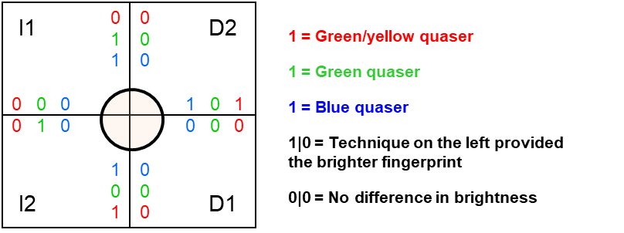

*Figure 3. An example of the scoring system applied to the relative brightness of fluorescent, quartered fingermarks in comparative studies between DFO, DFO-zinc and 1,2 indandione-zinc*

This enabled four 2-way comparisons to be carried out, 1,2-indandione-zinc to DFO, 1,2-indandione-zinc to DFO-zinc, DFO to DFO-zinc and 1,2-indandione-zinc to itself, giving a measure of how consistent the results are for a single, selected reagent. In such a two-way comparison, a process scoring 10 overall will be consistently brighter than the process it is being compared with for all of the donors used in the study.

Quantitative values of luminance were also recorded using the broadband blue (385-509nm), green (475-548nm) and green/yellow filter (503-591nm) excitation bands of the Quaser 101.

The quality and clarity of the marks were also considered in this experiment, but as for previous experiments marks were not graded because there were negligible differences in quality between marks developed using different processes and the major variability was observed in intensity of fluorescence.

**Results and Discussion**

***DFO-zinc formulations***

The results of the initial comparison between DFO and the preliminary DFO-zinc formulation can be seen in Figure 4 (fingermark grade) and Figure 5 (fingermark luminance).



*Figure 4. The number of marks graded 3 and 4 developed using DFO and DFO-zinc in the preliminary study, showing the number of marks found by the green laser, and the additional marks found by the yellow laser.*



*Figure 5. The net average luminance (measured value minus background luminance level) of fingermarks developed using DFO and DFO-zinc in the preliminary study, comparing the levels measured when marks were illuminated using the green and yellow lasers.*

The number of fingermarks graded 3 and 4 that are developed by each process is similar on both the paper types, with slightly more marks detected using DFO-zinc on the brown Kraft paper. The yellow laser did detect additional fingermarks, and it was also observed that the number of fingermarks developed on the brown Kraft paper was significantly lower than on the brown envelope. This may be due to differences in porosity or the additives used in manufacture but was not investigated further in this study and illustrates the value of including multiple substrates in large scale studies to obtain data representative of range of nominally similar materials.

The luminance of the marks developed with DFO-zinc developed fingerprints was more than double the luminance of those developed using DFO on both the brown Kraft paper and the brown envelope. This is a significant difference in the brightness of the fluorescent product. The luminance values of the developed fingermarks were higher on the brown envelope than on the brown Kraft paper, following the same trend as was seen in the grading of the same fingermarks.

In this preliminary experiment, it was observed that the addition of zinc chloride does little to develop additional ridge detail or affect clarity of developed marks but does significantly improve their fluorescence. It was determined that there was potential merit in refining the DFO-zinc formulation further, as described below. Subsequent experiments therefore primarily looked at luminance rather than grading of marks.

The results comparing the fluorescence of fingermarks treated with different DFO-zinc formulations at a range of excitation wavelengths are shown in Figure 6.



*Figure 6. Luminance values for different DFO-zinc formulations illuminated with different excitation wavebands*

The brightest fluorescence for any of the formulations was obtained using illumination in the green region of the spectrum for DFOZ 1, which is consistent with the excitation conditions currently used for DFO. However, the fingermarks produced some degree of fluorescence over the full range of the spectrum, particularly using broadband blue illumination, which could be beneficial when trying to identify imaging conditions that reduce background fluorescence of certain paper types. All DFO-zinc formulations produced marks that were more highly fluorescent than unmodified DFO, but overall it was evident that the DFOZ 1 formulation (with 1:1 Zn:DFO mole ratio) developed marks with the brightest fluorescence and was selected as the formulation to be used in comparative experiments with 1,2-indandione-zinc.

However, it was observed that this solution could turn cloudy during storage within a chemical cupboard at ambient temperature, sometimes within days, with a large amount of yellow precipitate formed. This precipitate was found to be insoluble after shaking and DFO-zinc solutions where this had occurred were deemed unusable. The onset of precipitation was found to be related to ambient temperature, and it was therefore recommended that DFO-zinc solutions be stored and used above 19°C. This is in contrast to standard DFO formulations that can be stored in a fridge prior to use (although allowed to reach ambient temperature before use), and have been shown to have shelf lives of several months.

***Formulations of DFO with other metal salts***

The results from the reformulation work using zinc chloride reported above indicated that the 1:1 ratio of metal ion:DFO molecules was a sensible starting point for formulations using other metal salts, however the results obtained showed that both DFO-iron and DFO-nickel formulations were less effective than standard DFO. This can be seen in the appearance of the marks developed during split depletion studies and shown in Figures 7 and 8, both of which show the first mark in the depletion series.

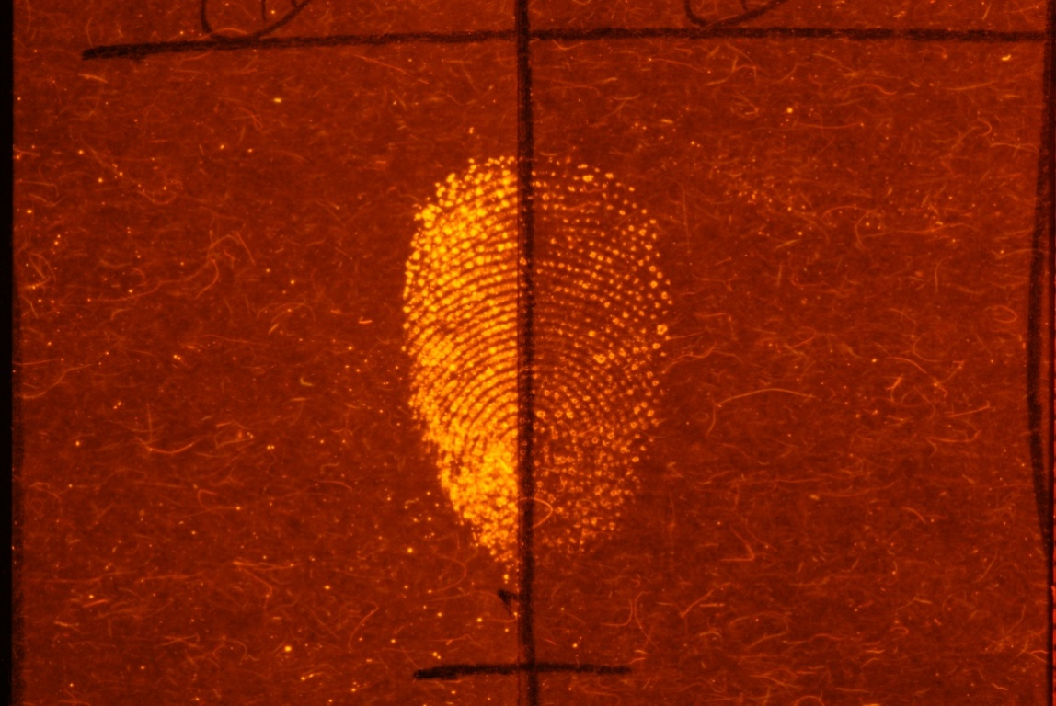 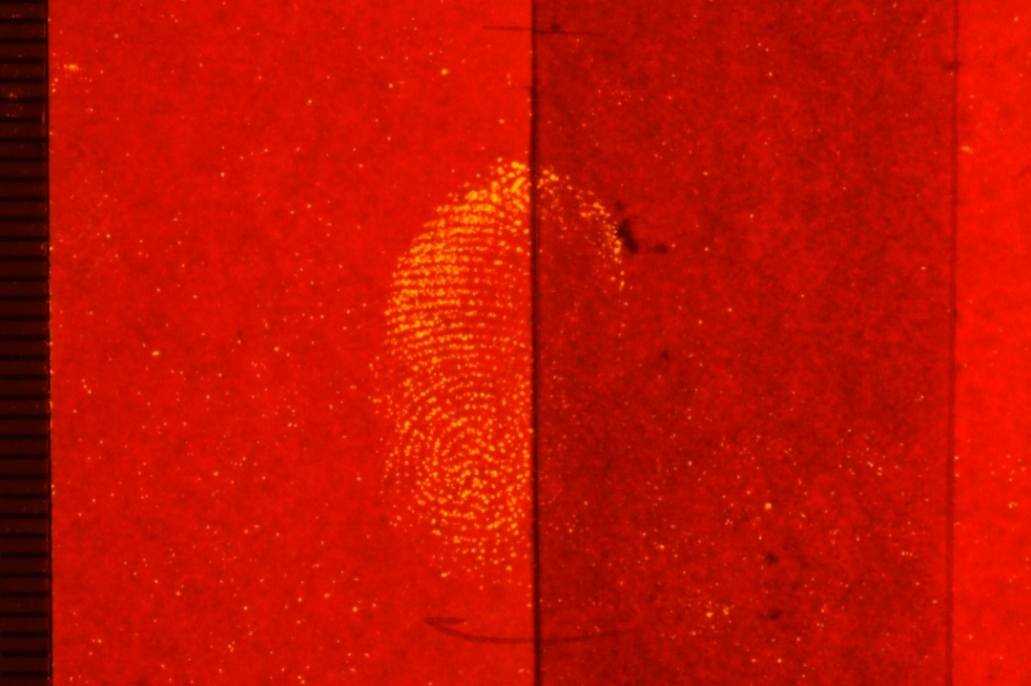

a) b)

*Figure 7. Fingermarks developed using DFO (left hand side) and DFO-iron (right hand side) formulations on a) printer paper, and b) a white envelope*

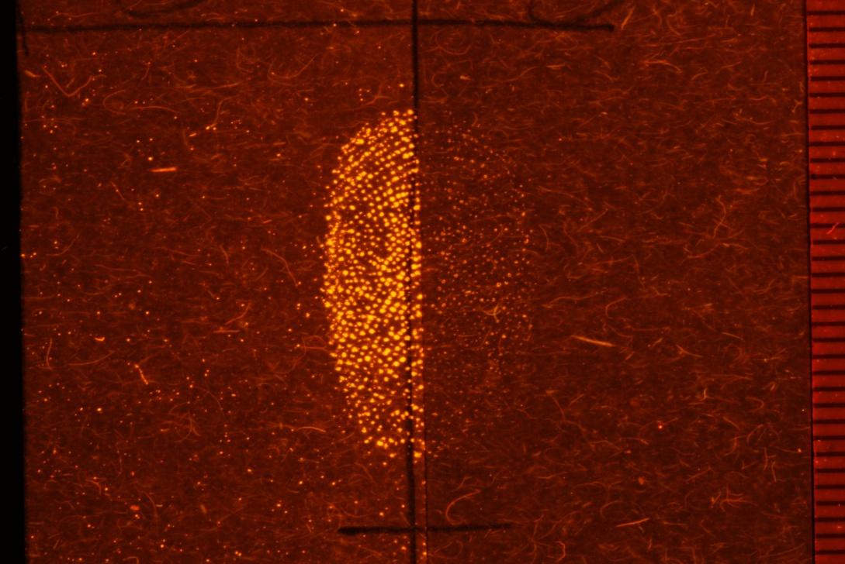 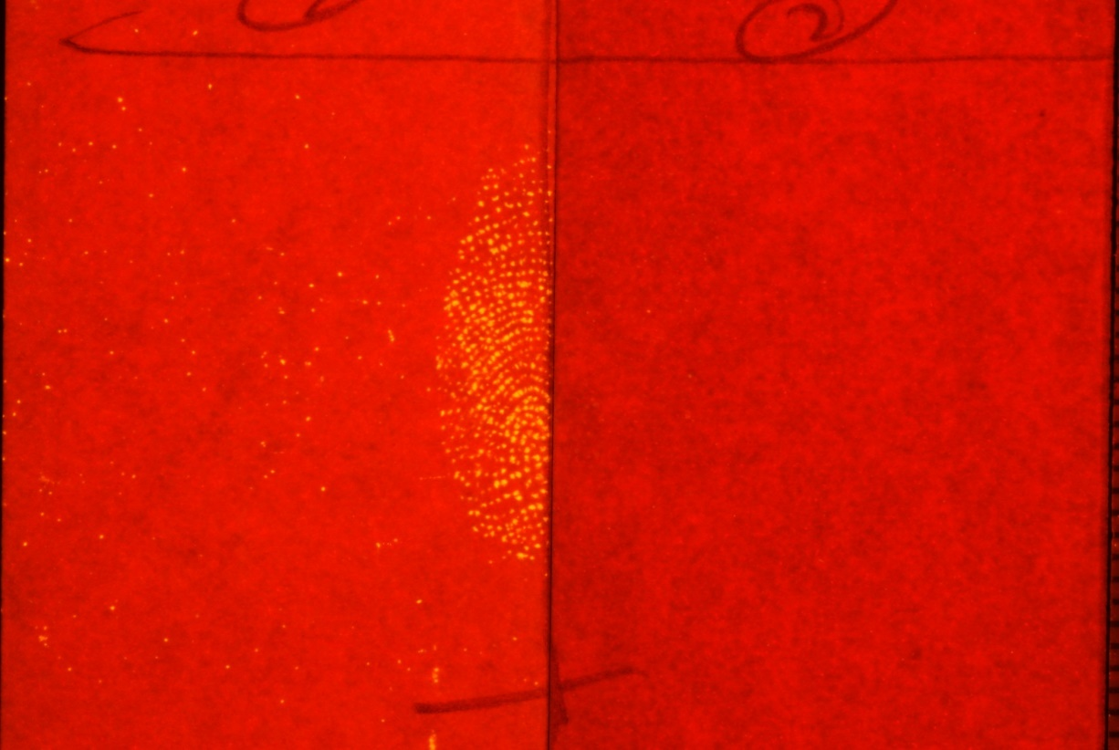

a) b)

*Figure 8. Fingermarks developed using DFO (left hand side) and DFO-nickel (right hand side) formulations on a) printer paper, and b) a white envelope*

The results of grading and luminance measurements are summarised in Table 6.

|  |  |  |  |  |
| --- | --- | --- | --- | --- |
| **Formulation** | **Printer paper** | | **White envelope** | |
|  | Number of marks graded 3 or 4 | Average luminance (cd/m2) | Number of marks graded 3 or 4 | Average luminance (cd/m2) |
| DFO | 26 | 10.0 | 22 | 42.6 |
| DFO-iron | 10 | 5.1 | 2 | 17.4 |
| DFO | 27 | 10.6 | 29 | 46.4 |
| DFO-nickel | 2 | 3.3 | 1 | 11.7 |

*Table 6. Results of grading and luminance measurements conducted on split fingermarks treated with DFO and DFO with additions of other metal salts*

It should be noted that grading and measurements of luminance were conducted at an illumination wavelength optimised for unmodified DFO, making the assumption that DFO toned with metal salts will fluoresce at a similar wavelength (as is observed for 1,2 indandione with zinc salt additions and for DFO-zinc in this study). However, excitation and emission spectra were not collected for DFO-iron and DFO-nickel complexes and it is conceivable that the excitation and emission peaks may have been shifted by the addition of different metals. This was not pursued because of the poor results of the initial measurement conditions and the superior performance of DFO-zinc.

This investigation has demonstrated that the addition of iron and nickel salts to the DFO formulation negatively affected the degree of ridge detail and the level of fluorescence obtained, with the results indicating that overall the standard DFO formulation is preferential for DFO enhancement. No further work was conducted into alternative metals for toning of DFO.

***Comparison of DFO and DFO-zinc with 1,2-indandione zinc***

The results of each of the two-way comparisons based on relative brightness of the fluorescent marks in each pair are summarised in Figures 9-12.

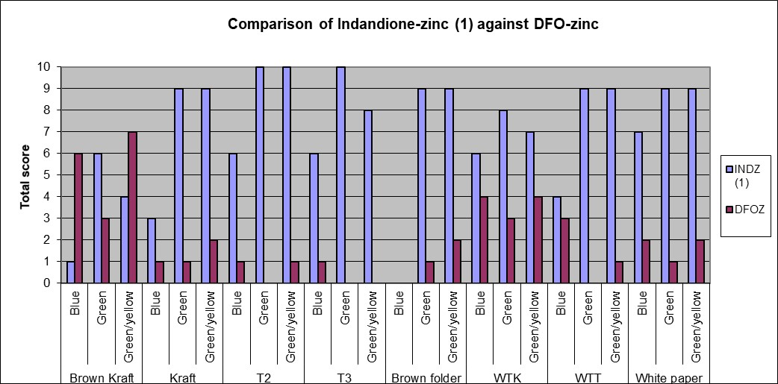

*Figure 9. Results of the two-way comparison of the brightness of developed marks between 1,2-indandione zinc and DFO-zinc*

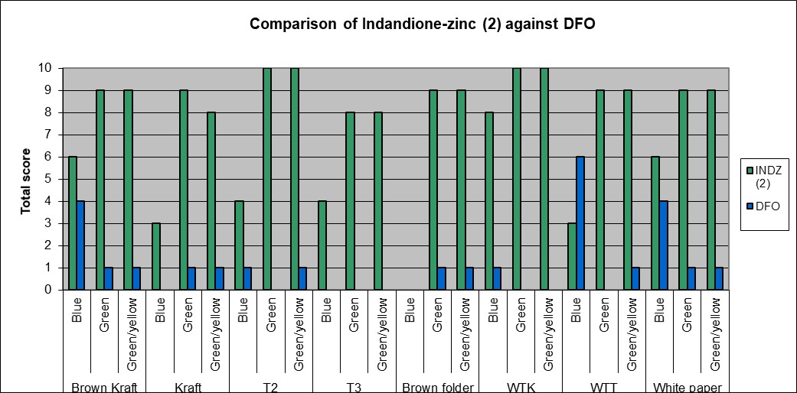

*Figure 10. Results of the two-way comparison of the brightness of developed marks between 1,2-indandione-zinc and DFO*

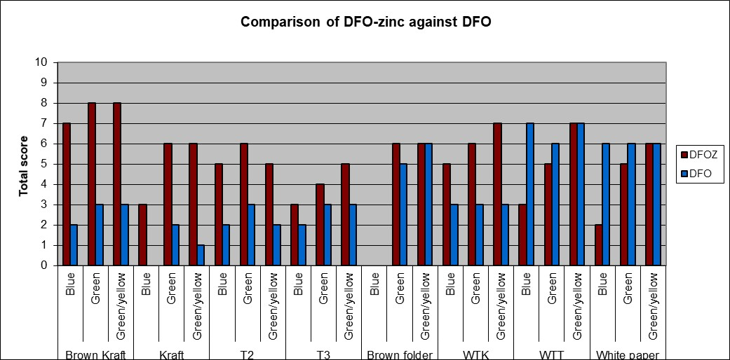

*Figure 11. Results of the two-way comparison of the brightness of developed marks between DFO-zinc and DFO*

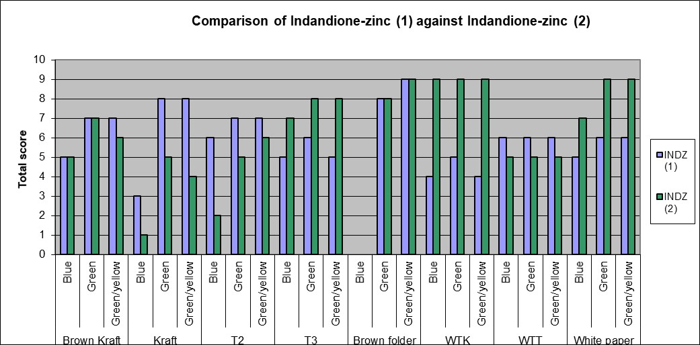

*Figure 12. Results of the two-way comparison of the brightness of developed marks between the two quarters treated with 1,2-indandione-zinc*

It is apparent that the marks developed 1,2-indandione-zinc formulation are consistently brighter than those developed using either DFO or DFO-zinc across almost all of the substrates and all of the illumination conditions studied. The exception to this was the brown Kraft envelope, where DFO-zinc gave brighter marks when illuminated in both the blue and the green/yellow region of the spectrum.

The results of the DFO-zinc to DFO comparison support the results of the earlier formulation work and confirm that DFO-zinc generally produces more highly fluorescent marks on the brown papers. However, DFO occasionally performed better on the white surfaces.

Examples of the results of the quartered fingermark experiment and the fluorescence seen from the different formulations at different wavelengths are shown in Figures 13 and 14, which illustrate a scenario where 1,2-indandione-zinc exhibited more intense fluorescence, and another where DFO-zinc appeared better.

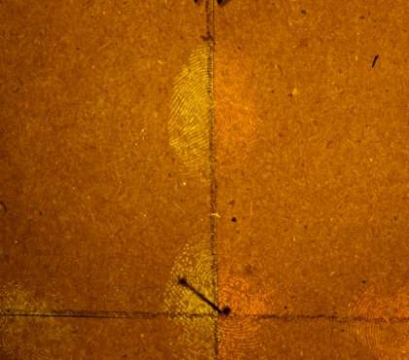 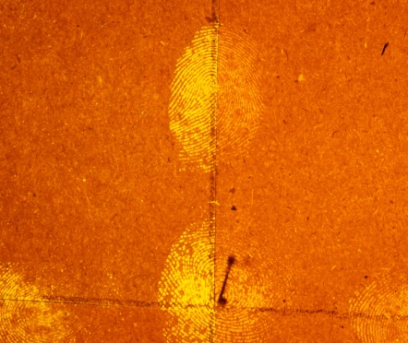 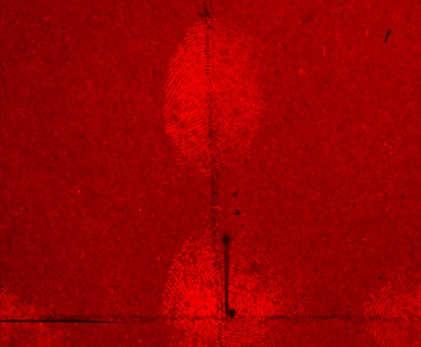

a) b) c)

*Figure 13. Results obtained from illuminating quarters of T2 brown paper with a) broadband blue, b) green and c) green/yellow light, comparing 1,2-indandione-zinc (left hand side) with DFO-zinc (right hand side)*

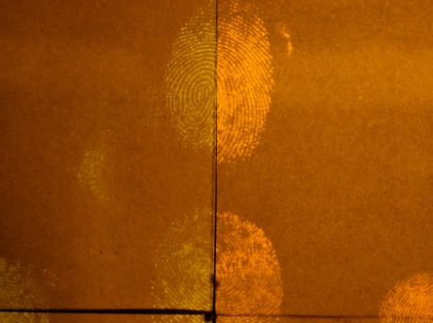 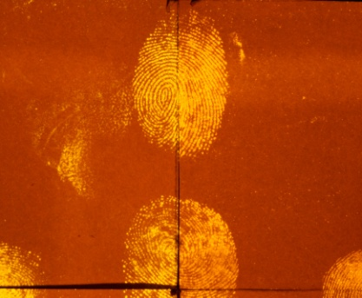 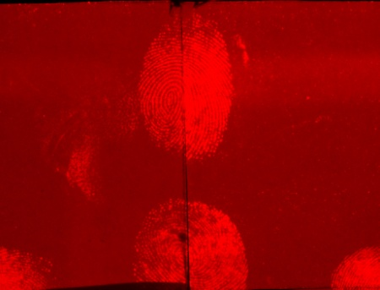

a) b) c)

*Figure 14. Results obtained from illuminating quarters of a brown envelope with a) broadband blue, b) green and c) green/yellow light, comparing 1,2-indandione-zinc (left hand side) with DFO-zinc (right hand side)*

The two halves of the fingermark processed with 1,2-indandione-zinc were processed with the same batch of solution at the same time. It was therefore expected that the scores between the two quarters would be the same. Although in practice the scores were similar, there were inconsistencies that could be attributable to a number of factors including the quarters being processed in different areas of the oven, variation in deposition pressure across the fingertip, variations in illumination conditions (although this was controlled as much as possible) or a slightly different time in the dipping solution. An example of the minor differences in brightness that were seen is shown in Figure 15.

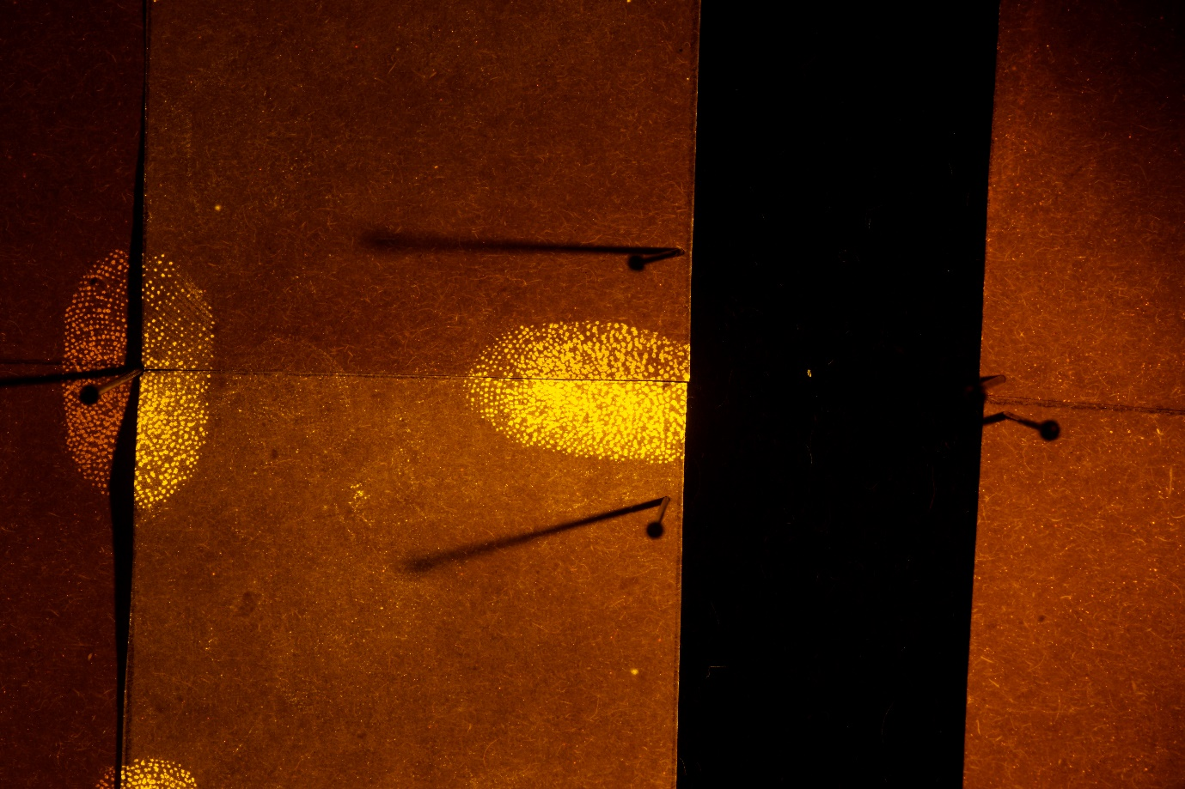

*Figure 15. Results obtained from illuminating quarters of White Test Top paper with green light, comparing the brightness of the two quarters (upper right and lower right) processed with 1,2-indandione-zinc*

The observations above were reinforced by the quantitative readings of luminance taken from the developed marks. Luminance readings taken across four representative substrates (brown Kraft envelope, T2, WTK and WTT papers) were combined to produce an overall average luminance reading for each of the reagents in the three wavelength regions. The two-way comparisons of these readings are given in Figure 16.

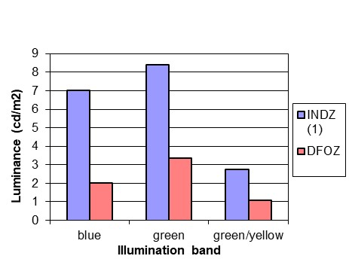 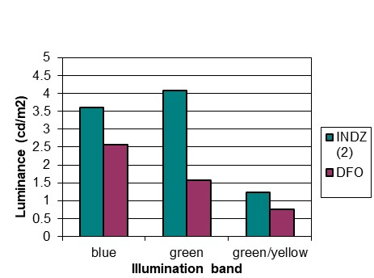

a) b)

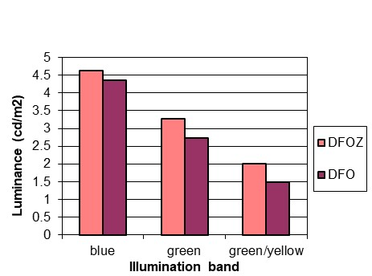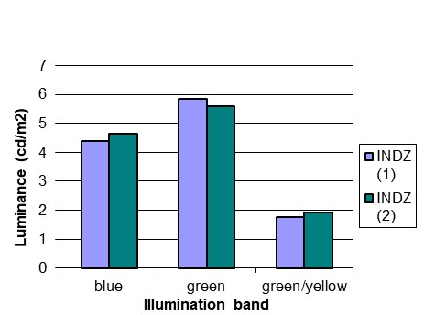

c) d)

*Figure 16. Two-way comparisons of average luminance for each illumination condition studied, a) 1,2-indandione-zinc against DFO-zinc, b) 1,2-indandione-zinc against DFO, c) DFO-zinc against DFO, and d) inter-comparison of 1,2-indandione-zinc*

1,2-indandione-zinc developed brighter fingerprints than both DFO-zinc and DFO across all three of the wavelengths studied. The difference in luminance between DFO-zinc and DFO was only marginal at all three wavelengths, with DFO-zinc producing slightly brighter fingerprints than DFO. There is a higher degree of consistency between the luminance values measured for the different quarters treated using 1,2-indandione-zinc. In general, the green illumination wavelengths produced most fluorescence from the developed marks for both DFO-zinc and 1,2-inadndione-zinc, as expected.

**Conclusions**

It has been demonstrated that the addition of zinc salts to the DFO formulation does have a beneficial effect on the fluorescence of the developed marks, and it is thought that this may be due to the formation of complexes with the zinc ions in a similar way to that seen for other amino acid reagents. This does not appear to be accompanied by an obvious colour change, as is the case for ninhydrin, but the colour of the DFO reaction product is generally very faint red/pink and in most cases not discernible by eye so the lack of an obvious colour change is not surprising.

The DFO-zinc formulation with a 1:1 ratio of zinc ions to DFO molecules developed fingermarks with the highest levels of fluorescence. However, results obtained using formulations of other metal ions including iron, nickel and palladium in equivalent ratios were disappointing and DFO-zinc remains the most effective formulation studied to date.

The DFO-zinc solution was observed to irreversibly form precipitates at low temperatures, and storage and use of the solution at above 19°C is recommended.

In comparative studies between DFO-zinc and 1,2-indandione-zinc, 1,2-indandione-zinc developed a greater number of fingermarks with brighter fluorescence across the range of substrates and excitation wavelengths studied. It can therefore be concluded that for brown papers and cardboard 1,2-indandione-zinc appears to be the most effective fingermark enhancement technique.

Although DFO-zinc showed advantages over the standard DFO formulation, it is concluded that it does not represent a significant enough improvement in performance to justify research ahead of other, better-performing amino acid reagents such as 1,2-indandione-zinc. It develops marks that are less intensely fluorescent than 1,2 indandione, and requires longer treatment times to develop fluorescent marks. The storage of DFO-zinc was also found to be a limiting factor, with solution shelf lives in the region of days and precipitation of the zinc from solution being observed. Taking these factors into account, the work on DFO-zinc was not progressed to a Phase 2 [19] study because of the greater potential of the 1,2 indandione-zinc formulation used in the comparison, which were reinforced by the subsequent refinements to it [20].

**References**

1. Morris, J. R.(1978) *Extensions to the NFN (Ninhydrin) Reagent for the Development of Latent Fingerprints*, SSCD Memorandum, CRP Work Item 41A, February. Aldermaston: Atomic Weapons Research Establishment.
2. Herod, D. W. and Menzel, E. R.‘Laser Detection of Latent Fingerprints: Ninhydrin Followed by Zinc Chloride’, *J. Forens. Sci*, vol. 27 (3), 1982, p513–518.
3. Kobus, H. J., Stoilovic, M. and Warrener, R. N. ‘A Simple Luminescent Post-Ninhydrin Treatment for the Improved Visualisation of Fingerprints on Documents in Cases Where Ninhydrin Alone Gives Poor Results’, *Forens. Sci. Int*., vol. 22, 1983, p161–170.
4. Stoilovic, M., Kobus, H. J., Margot, P. A. J. - L. and Warrener, R. N. ‘Improved Enhancement of Ninhydrin Developed Fingerprints by Cadmium Complexation Using Low Temperature Photoluminescence Techniques’, *J. Forens. Sci*, vol. 31 (2), 1986, p432–445.
5. Menzel, E. R., Bartsch, R. A. and Hallman, J. L. ‘Fluorescent Metal-Ruhemann’s Purple Coordination Compounds: Applications to Latent Fingerprint Detection’, *J. Forens. Sci.* vol. 35 (1), 1990, p25–34.
6. Everse, K. E. and Menzel, E. R. ‘Sensitivity Enhancement of Ninhydrin-Treated Latent Fingerprints by Enzymes and Metal Salts’, *J. Forens. Sci*, vol. 31 (2), 1986, p446–454.
7. Lennard, C. J., Margot, P. A., Sterns, M. and Warrener, R. N. ‘Photoluminescent Enhancement of Ninhydrin Developed Fingerprints by Metal Complexation: Structural Studies of Complexes Formed Between Ruhemann’s Purple and Group IIb Metal Salts’, *J. Forens. Sci*., vol. 32 (3), 1987, p597–605.
8. Menzel, E. R. and Almog, J. ‘Latent Fingerprint Development by Frequency Doubled Neodymium: Yttrium Aluminium Garnet (Nd:YAG) Laser: Benzo[f]ninhydrin’, *J. Forens. Sci*, vol. 30 (2), 1985, p371–382.
9. Lennard, C. J., Margot, P. A., Stoilovic, M. and Warrener, R. N. ‘Synthesis of Ninhydrin Analogues and Their Application to Fingerprint Development: Preliminary Results’, *J. Forens. Sci. Soc*., vol. 26, 1986, p323–328.
10. Lennard, C. J., Margot, P. A., Stoilovic, M. and Warrener, R. N. ‘Synthesis and Evaluation of Ninhydrin Analogues as Reagents for the Development of Latent Fingerprints on Paper Surfaces’, *J. Forens. Sci. Soc*., vol. 28, 1988, p3–23.
11. Almog, J., Klein, A., Davidi, I., Cohen, Y., Azoury, M. and Levin-Elad, M. ‘Dual Fingerprint Reagents with Enhanced Sensitivity: 5-Methoxy- and 5-Methylthioninhydrin’, *J. Forens. Sci*, vol. 53 (2), 2008, p364–367.
12. Roux, C., Jones, N., Lennard, C. and Stoilovic, M.‘Evaluation of 1,2-Indanedione and 5,6-Dimethoxy-1,2-Indanedione for the detection of latent fingerprints on porous surfaces’, *J. Forens. Sci.*, vol. 45 (4), 2002, p761–769.
13. Wallace-Kunkel, C., Lennard, C., Stoilovic, M. and Roux, C. ‘Optimisation and Evaluation of 1,2-Indanedione for use as a Fingerprint Reagent and its Application to Real Samples’, *Forens. Sci. Int*., vol. 168 (1), 2007, p14–26.
14. Stoilovic, M., Lennard, C., Wallace-Kunkel, C. and Roux, C. ‘Evaluation of a 1,2-indanedione Formulation Containing Zinc Chloride for Improved Fingermark Detection on Paper’, *J. Forens. Ident*., vol. 57 (1), 2007, p4–18
15. Conn, C., Ramsey, G., Roux, C. and Lennard, C. ‘The Effect of Metal Salt Treatment on the Photoluminescence of DFO-treated fingerprints’, *Forens. Sci. Int.,* vol. 116, 2001, p117–123
16. Sears, V., Batham, R. and Bleay, S. ‘The Effectiveness of 1,2-Indandione–Zinc Formulations and Comparison with HFE-Based 1,8-diazafluoren-9-one for Fingerprint Development’, J. Forens. Ident., vol. 59 (6), 2009, p654–678
17. Bandey H., ‘Fingermark Visualisation Manual 1st edition’, Home Office. 2014
18. Sears, V.G., Bleay, S.M., Bandey, H.L. and Bowman, V.J. ‘A methodology for finger mark research’, Science & Justice, vol. 52(3), 2012, p145–160
19. IFRG, ‘Guidelines for the Assessment of Fingermark Detection Techniques’, J. Forens. Ident., vol. 64 (2), 2014, p174-200
20. Nicolasora N, Downham R, Hussey L, Luscombe A, Mayse K, Sears V, ‘A validation stady of the 1,2-indandione reagent for operational use in the UK: Part 1 – Formulation Optimization’, *Forens. Sci. Int.,* vol. 292, 2018, p242-253