Development and Validation of the Metacognitions about Sex Scale: Exploring its Role as a Mediator between Negative Affect, Emotion Dysregulation Strategies, and Compulsive Sexual Behavior Disorder

Yaniv Efrati^{a*}, and Marcantonio M. Spada^{b}

ª Bar-Ilan University, Faculty of Education, Ramat Gan, Israel.
^{b} Division of Psychology, School of Applied Sciences, London South Bank University, London, UK.

Declarations
Compliance with Ethical Standards: The Institutional Review Board (IRB) determined this study was exempt from requiring IRB approval.
Consent to Participate: All information was recorded anonymously, and respondents were assured that personal information would be kept confidential.
Conflicts of Interest/Competing Interests: The author has no conflicts of interest to declare that are relevant to the contents of this article.

_____________________________________________________________________
Corresponding author: Bar Ilan University, Faculty of Education, Ramat Gan, Israel.
Email: yaniv.efrati@biu.ac.il Phone: +972-545-800094, ORCID https://orcid.org/0000-0003-3176-3708

Abstract
Metacognitions about sex are theorized to shape cognitive appraisal, coping mechanisms, and regulation or dysregulation before, during, and/or after exposure to sexual triggers. In our study, we examined the construct structure and validity of the Metacognitions about Sex Scale (MSS) by using Exploratory Graph Analysis (EGA) and Confirmatory Factor Analysis (CFA) among a sample of adolescents. We estimated the convergent validity of the MSS by factors: negative affect, dysregulated thoughts, and impulsivity, and compulsive sexual behavior (CSB). We also ran a structural equation model in which we examined the possibility that metacognitions about sex would mediate the association between negative affect, dysregulated thoughts, and impulsivity on the one hand, and CSB on the other. The study population included 662 adolescents (252 boys and 410 girls, M = 16.70, SD = 1.32) between 13–18 years of age. The analyses indicated that the factorial structure of the MSS comprised the two expected factors. We also found that positive and negative metacognitions about sex significantly mediated the effect of negative affect, dysregulated thoughts, and impulsivity on CSB. The findings provide evidence that MSS among Israeli adolescents are psychometrically appropriate for use by researchers and practitioners in the prevention and treatment of CSB.

Keywords: Compulsive sexual behavior; Metacognitions; Negative affect; Dysregulated thoughts; Impulsivity.

Development and Validation of the Metacognition about Sex Scale: Exploring its Role as a Mediator between Negative Affect, Emotion Dysregulation Strategies, and Compulsive Sexual Behavior Disorder

For more than two decades, experts in both scientific and clinical fields have grappled with defining problematic sexual behaviors, employing a range of terms from compulsive sexual behaviors (Gola et al., 2022; Mechelmans et al., 2014; Voon et al., 2014) to sexual addiction (Gold & Heffner, 1998; Goodman, 1998) and hypersexuality (Bostwick et al., 2009; Klos et al., 2005). While there is no consensus on a single theoretical framework, it is widely accepted that these behaviors stem from a mix of obsessions, compulsions, impulsivity, or addiction. In a landmark move, the World Health Organization officially included Compulsive Sexual Behavior Disorder (CSBD) in the 2019 ICD-11, classifying it as an impulse control disorder (World Health Organization, 2019). This disorder is defined by a chronic inability to control intense, repetitive sexual impulses, leading to considerable distress or dysfunction in various aspects of life (Kraus et al., 2018). CSBD is estimated to affect between 3-10% of adults (Briken et al., 2022; Grubbs et al., 2023; Bőthe et al., 2023) and 12-18% of adolescents (Efrati & Dannon, 2018), amounting to more than 13 million adults and 11 million adolescents in the United States alone (U.S. Census Bureau, 2022). Recent scholarly work has identified metacognitions as a significant predictor of various forms of psychopathology, particularly those featuring compulsive thoughts and behaviors (Casale et al., 2021). The term ‘metacognition’ was first coined by Flavell (1978, 1979) and later expanded upon by Wells and Matthews in their Self-Regulatory Executive Function (S-REF) model of psychopathology in 1994. This model suggests that metacognitions, or one’s beliefs about their own cognitive and emotional processes, are instrumental in initiating and maintaining maladaptive coping strategies like rumination and worry. Empirical evidence has not only validated the cross-diagnostic applicability of generic metacognitions but has also shown that these cognitive processes can differ among various disorders (Casale et al., 2021). To date, existing studies have highlighted the role of generic metacognitions in understanding different aspects of sexual dysfunctions, such as dysregulated sexuality (Thomas et al., 2020), problematic pornography use (Allen, Kannis-Dymand & Katsikitis, 2017; 2021), and sexual distress (Zarbo et al., 2019). However, given the accumulating data suggesting that metacognitions can be disorder-specific (Casale et al., 2021), the current research aims to develop an assessment tool focused on metacognitions that are particularly relevant to sexual behavior.
What are metacognitions?
Metacognitions are crucial in shaping behaviors and emotional states (Casale et al., 2021). Five core dimensions of generic metacognitions have been identified, contributing to the maintenance of maladaptive coping mechanisms (Cartwright-Hatton & Wells, 1997; Wells & Cartwright-Hatton, 2004). These dimensions include positive beliefs about worry, suggesting that worrying can be a useful problem-solving tool; negative beliefs concerning the uncontrollability and danger of thoughts, which often lead to heightened stress and anxiety; cognitive confidence, or the lack thereof, affecting one’s trust in their own mental faculties; the perceived need to control thoughts, which can become an obsessive endeavor; and cognitive self-consciousness, or the extent to which individuals focus on their own thought processes. Each of these dimensions serves as a lens through which individuals interpret and react to their internal and external experiences, often perpetuating cycles of maladaptive behavior and emotional distress.
In the realm of addictive behaviors, metacognitions are typically conceptualized across three temporal phases: pre-engagement, engagement, and post-engagement (Spada et al., 2013; Spada & Wells, 2009). These metacognitions can be categorized into positive and negative types. For example, a positive metacognition might be the belief that “drinking alcohol will help me relax and enjoy the party,” which motivates individuals to engage in potentially addictive behaviors. Conversely, negative metacognition could be something like “once I start drinking, I won’t be able to stop,” focusing on the uncontrollability and potential dangers of one’s thoughts and behaviors. These negative metacognitions are activated during and after the engagement in the addictive behavior, often perpetuating the cycle of addiction as they induce emotional states that the individual then tries to regulate through further engagement in the addictive behavior (Caselli et al., 2018; Spada, Caselli, et al., 2015).
Recent systematic reviews have delved deeply into the complex interplay between metacognitions and addictive behaviors, offering valuable insights into how our thoughts about thinking can drive maladaptive patterns (Hamonniere & Varescon, 2018; Casale et al., 2021). Particularly noteworthy is the emphasis on the dimension of metacognition that centers on the belief about the need to control one’s thoughts. This dimension is most closely linked with addictive behaviors. For example, a study found that individuals with substance abuse issues often held strong beliefs about the necessity of controlling their thoughts, which in turn, contributed to their engagement in addictive behaviors (Carlisle-Frank, 1991). These beliefs can manifest as thoughts like “I need to control my urge to drink to prove I am strong,” which paradoxically may lead to more drinking as a way to test or challenge their self-control.
The mediation role of metacognitions in the relationship between negative emotional states and addictive behaviors has also been highlighted in these reviews. For instance, research by Marino and colleagues (2020) showed that metacognitions could act as a bridge between anxiety and technological addictions. In this context, someone with high anxiety levels might hold the metacognition that “playing video games will distract me from my worries,” leading them to engage in excessive gaming. However, it is crucial to note that metacognitions are not just by-products of negative emotional states like anxiety or depression. They have their own standalone influence on addictive behaviors. A systematic review by Casale and colleagues (2020) concluded that metacognitions were still significant predictors of Internet Gaming Disorder even when accounting for negative emotional states. This underscores the unique and pivotal role that metacognitions play in both the onset and perpetuation of addictive behaviors. Accordingly, the current study aims to (i) develop a metacognition questionnaire specifically tailored to sexual behavior (i.e., Metacognition about Sex Scale; MSS) and (ii) examine whether these metacognitions about sex serve as a bridge between negative affect, dysfunctional emotion regulation strategies, and dysfunctional sexual behavior in the form of CSBD.
The possible metacognitions about sex
In the pre-engagement phase, triggers such as urges, fantasies, or memories activate the Self-Regulatory Executive Function and associated metacognitive beliefs. These beliefs guide one’s appraisal and coping mechanisms. Positive metacognitive beliefs like “Fantasizing about sexual encounters will ease my stress” and negative beliefs such as “I can’t control my sexual thoughts” may lead to persistent processing of these intrusions and attempts to suppress them. This could result in heightened negative emotions and increased sexual cravings, making the individual more likely to engage in sexual behavior as a way to regulate these feelings and bridge the gap between their current and desired states.
It is worth noting that if the sexual behavior becomes habitual, the pre-engagement phase might be skipped. This is more likely to occur in a new contextual environment, when the habitual behavior is externally interrupted, or through deliberate attempts to abstain. This helps explain why individuals with severe addictions may not report extended pre-engagement thinking, as seen in studies like those by Caselli and Spada, 2011.
During the engagement phase, positive metacognitive beliefs about the act, such as “Engaging in this sexual behavior will help me control my thoughts,” coincide with shifts in metacognitive monitoring – the ability to gauge internal states to achieve desired outcomes. These factors contribute to a diminished capacity for self-regulation. Specifically, this reduced metacognitive monitoring may stem from behaviors that divert attention away from self-awareness and goal-progress monitoring or from the physiological effects of the sexual behavior, which can impair higher cognitive functions and negatively impact metacognitive monitoring.
As the addictive behavior intensifies over time, negative metacognitive beliefs about its uncontrollability start to surface, perpetuating the cycle. These include beliefs like “Thinking about sexual encounters can make me engage in them” and “Once I start, I find it hard to stop.”
In the post-engagement phase, intrusive thoughts such as guilt or regret trigger positive metacognitive beliefs about post-engagement reflection. For example, “If I dissect why I feel this way, I’ll understand my sexual behavior better.” This activates coping styles like rumination and thought suppression, which worsen negative emotions and increase the likelihood of re-engagement as a means of self-regulation.
Accordingly, we intend to develop items corresponding with positive and negative metacognitions relating to all phases. Specifically, positive metacognitions about sex would concern the usefulness of sexual behavior in controlling cognition, like “sexual behavior stops my worry,” and in controlling emotion, such as “sexual behavior reduces my anxious feelings.” Negative metacognition items about sex would focus on the uncontrollability of sex, for example, “I cannot control my sexual behavior,” and the dangers of sexual behavior, such as “thoughts about sex interfere with my functioning.”
Metacognitions about sex as the possible bridge between negative affect, dysfunctional emotion regulation strategies, and CSBD
The role of metacognitions as a mediator between negative affect, emotion dysregulation, and addictive behaviors, such as Internet Gaming Disorder, has been substantiated in recent studies (Marino et al., 2020). Although positive metacognitions were found to have a weaker indirect effect, they may be activated by emotional distress and serve as a cognitive-affective self-regulation tool (Billieux et al., 2020; Marino & Spada, 2017). In contrast, negative metacognitions often have a more significant indirect impact and stem from underlying beliefs of inadequacy and powerlessness, compelling individuals to engage in addictive behaviors as a form of coping (King & Delfabbro, 2014; Spada & Caselli, 2017). These negative metacognitions exacerbate negative emotional states, making individuals feel compelled to continue their addictive behaviors (Spada & Caselli, 2017; Perales et al., 2020).
Given that CSBD was found to be closely link to various negative affect states such as shame (Dhuffar & Griffiths, 2014; Efrati, 2018; Reid et al., 2009; Sassover et al., 2021) and anxiety (Grant Weinandy et al., 2023), and emotion (dys)regulation strategies such as sexual suppression (Efrati, 2019; Efrati et al., 2021), moral disapproval (Grubbs et al. 2018; 2019), and impulsivity (Bőthe, Koós, & Demetrovics, 2022), we predicted that negative and positive metacognitions about sex could mediate these links. Specifically, shame, a complex emotion deeply rooted in self-perception and moral behavior, can significantly influence both positive and negative metacognitions about sex. For instance, an individual grappling with shame might develop the positive metacognition that “engaging in sexual behavior will alleviate my feelings of inadequacy.” This belief can serve as a temporary escape from the emotional burden of shame, thereby increasing the likelihood of engaging in compulsive sexual behavior (CSB) as a coping mechanism. On the other hand, the same individual may also cultivate negative metacognitions such as “I can’t control my sexual thoughts,” which reinforces the shame they already feel. This negative metacognition can create a vicious cycle, making the individual more susceptible to CSB as a way to manage these overwhelming emotions.
Anxiety, particularly regarding emotional regulation, can also be a potent catalyst for positive and negative metacognitions about sex. Individuals with high anxiety levels may adopt the positive metacognition that “sexual activity will distract me from my worries,” viewing it as a form of cognitive-affective self-regulation. This belief can then act as a justification for CSB, offering a temporary but ultimately harmful relief from anxiety. Conversely, the same individual might develop the negative metacognition that “I can’t control my urge to engage in sexual activity when I’m anxious,” thereby exacerbating their anxiety levels and making them more likely to resort to CSB as a coping strategy.
Emotion dysregulation strategies such as sexual suppression, moral disapproval, and impulsivity can also foster positive and negative metacognitions about sex. For example, someone who suppresses sexual thoughts might think, “If I engage in sexual activity, I can finally stop suppressing these thoughts,” serving as a positive metacognition that encourages CSB. Conversely, moral disapproval could lead to negative metacognitions like “I can’t control my sexual behavior, and it’s morally wrong,” which can further entrench the individual in a cycle of CSB as they struggle with their conflicting emotions and beliefs. Impulsivity, often linked to emotional dysregulation, can also contribute to this cycle by reinforcing the belief that one’s sexual behavior is uncontrollable, thereby perpetuating CSB. Accordingly, we predict that emotional states like shame and anxiety and emotion dysregulation strategies can influence metacognitions in a way that perpetuates and possibly exacerbates CSB, making metacognitions about sex a pivotal mediator of these processes.
2. Method
2.1. Participants
The study population comprised 662 Jewish Israeli adolescents from the general community (252 male adolescents and 410 female adolescents), aged 13–18 (M = 16.70, SD = 1.32), all enrolled in the ninth (n= 78; 12%), tenth (n = 101; 16%), eleventh (n = 150; 24%), and twelfth (n = 308; 48%) grades, and unknown (n=25). The age range of 13-18 years was selected as it is a period typified by extensive transformations (Crone, & Dahl, 2012) and the onset of various psychopathologies, including addictive behaviors (Holmbeck et al., 2006). Most (96%) were native Israelis, and 92% had Hebrew as their native language. Socioeconomically, 0.5% of participants described their level as being “very bad,” 2.9% “bad,” 63% “good,” and 33% “very good.” In terms of religious affiliation, the sample consisted of 123 (19%) self-reported religious individuals, of whom 201 (31%) were traditional, 314 (48%) secular, and 20 (3%) ultra-Orthodox.
2.2. Measures
Sociodemographic variables. Adolescents reported their age (13–18), sex assigned at birth (male, female), religiosity (secular, traditional, religious, ultra-Orthodox), immigration status (Israeli or immigrant), and socioeconomic status (SES). For SES we used a four-point scale: “very good,” “good,” “bad,” and “very bad.” Given that the number of individuals who marked the “bad” and “very bad” categories was low, we merged them into a single category and divided the categories into three: 1) “very good,” 2) “good,” and 3) “bad” and “very bad.”
Metacognitions about Sex Scale (MSS)
The translation from English into Hebrew followed the guidelines for translating measurement tools (Wild et al., 2005). Initially, the 12-item original version of the Metacognitions about Online Gaming Scale (MOGS; Spada & Caselli 2017) was translated into Hebrew by a speaker proficient in both languages. It was then back-translated by the first author. Using the MOGS as a foundation, we developed the Metacognition about Sex Scale (MSS), as was previously done successfully in other adaptations of the scale to various disorders (e.g., Spada & Caselli, 2017). Cognitive interviews were conducted to detect problems respondents have in understanding survey instructions and items, and in formulating answers. These interviews employed a combination of verbal probing and think-aloud techniques. During the verbal probing phase, professionals were asked to articulate their understanding of each item, paraphrase them, and comment on their wording. This helped identify any ambiguously worded or unclear questions. For example, terms like “Thoughts about sex” and “Engaging in sex” were scrutinized for their clarity and cultural relevance, especially from adolescents' perspectives. In the think-aloud phase, professionals were encouraged to verbalize their thought processes as they responded to each item, providing invaluable insights into the information they retrieved from memory when deciding how to respond to a particular item. This also helped the team understand how each item was interpreted in the context of Israeli culture and the specific field of behavioral addiction and sex research. Several modifications were made to the MSS based on the data collected from these cognitive interviews. The research team carefully discussed and refined the wording, content, and cultural adaptations. Three additional items were added to improve the scale’s comprehensiveness. The definitions of key terms were also fine-tuned to ensure they were culturally and contextually appropriate. The MSS comprises two factors, each assessed using several items: (i) “positive metacognitions about sex,” referring to the usefulness of sex as a cognitive-affective self-regulatory strategy (e.g., “Engaging in sex will help me to control my negative thoughts”), and (ii) “negative metacognitions about sex,” referring to the uncontrollability and dangers of sex and sex-related thoughts (e.g., “I have no control over my thoughts about sex”). Participants were asked to rate their agreement with each item on a 4-point scale, ranging from (1) “do not agree” to (4) “agree very much.” Items were summed to obtain scores for both positive and negative metacognitions, with higher scores representing higher levels of metacognitions. The Cronbach’s alphas in the current study were .89 for positive metacognitions and .84 for negative metacognitions.
Shame. This variable was assessed using the External and Internal Shame Scale (EISS; Ferreira et al., 2020), an 8-item self-report instrument aimed at assessing two factors, each of which is measured by four items: 1) “external shame” strategy (e.g., “People around me see me as not being up to their standards”); and 2) “internal shame” strategy (e.g., “I am unworthy as a person”). The back-translation method was used to translate the items for this study (from English into Hebrew and then back again). Participants are asked to rate each item using a 5-point scale from 0 (never) to 4 (always), with higher scores representing higher levels of shame. The Cronbach’s alphas in the current study were .72 for external shame and .79 for internal shame.
Sexual suppression. This variable was assessed using the Suppression Scale (Efrati, 2019) based on the White Bear Inventory (Wegner et al., 1987) and the expressive suppression scale from The Emotion Regulation Questionnaire for Children and Adolescents (ERQ–CA), developed by Gullone and Taffe (2012). The Hebrew version of this scale had already been used to examine the structural validity of the measure, and a confirmatory factor analysis (CFA) had been conducted by Efrati (2019). Participants were asked to rate, on a 5-point Likert scale from 1 (not at all) to 5 (very much) the degree to which each statement characterized their feelings (e.g., Item 1: “Very often I find myself trying to suppress my sexual thoughts”; Item 11: “Sometimes I try to get involved with work or studies just to avoid all sorts of sexual thoughts”). The Cronbach’s alpha in the current study was .84.
Moral disapproval. To assess level of moral or ethical objections to sexual thoughts, we used a scale developed by Grubbs et al. (2018). The scale consists of four statements, and respondents rated their level of agreement with each statement using a 7-point Likert scale. The back-translation method was used to translate the items in this study (from English into Hebrew and then back again). We adapted this scale by replacing the words “viewing pornography” with variations of the expression “sexual thoughts.” For example, “I believe that thoughts about sex are morally wrong.” The Cronbach’s alpha in the current study was .90.
Anxiety symptoms. Anxiety symptoms were assessed via the Hospital Anxiety and Depression Scale (HADS) (Zigmond and Snaith, 1983), which enquires about symptoms in the past week. It measures anxiety symptoms (seven items; e.g., “I feel tense or wound up”) and depressive symptoms (seven items; e.g., “I still enjoy the things I used to enjoy”) using 4-point Likert scales. Higher scores indicate higher levels of symptoms. The Hebrew translation of the HADS has been extensively used (e.g., Buria et al., 2015) and is valid and reliable. In the current study we used only the anxiety scale, which had a Cronbach’s alpha of .79.
Impulsivity. This variable was assessed using the Short UPPS-P Impulsivity Scale (Cyders et al., 2014). The Short UPPS-P is a 20-item self-report measure assessing positive urgency (i.e., rash action in a positive mood state; Cronbach’s alpha = .78), negative urgency (i.e., rash action in a negative mood state; Cronbach’s alpha = .75), lack of perseverance (i.e., lack of focus; Cronbach’s alpha = .73), lack of premeditation (i.e., lack of planning; Cronbach’s alpha = .73), and sensation seeking (thrill-seeking, adventurousness; Cronbach’s alpha = .74). The back translation method was used to translate the items for this study (from English into Hebrew and then back again). All responses were measured on a 4-point Likert scale from 1 (agree strongly) to 4 (disagree strongly) and were reverse-scored so that higher values indicated higher impulsivity.
CSB. This variable was assessed using the Individual-Based Compulsive Sexual Behavior Scale (I-CSB; Efrati & Mikulincer, 2018). The I-CSB was developed to assess distinct aspects of CSB, such as sexual fantasies, obsessive sexual thoughts, and amount of time spent watching pornography. The I-CSB is a self-report measure with 24 items measuring the following factors: unwanted consequences (e.g., “I feel that my sexual fantasies hurt those around me”); lack of control (e.g., “I waste lots of time on my sexual fantasies”); negative affect (e.g., “I feel bad when I’m unable to control my sexual urges”); and affect regulation (e.g., “I turn to sexual fantasies as a way to cope with my problems”). Using a 7-point Likert scale, participants were asked to rate the degree to which each statement accurately described their feelings from 1 (not at all) to 7 (very much). The measure has been used in previous research among non-clinical populations of adolescents (Efrati, 2023a; 2023b; 2023c). We computed a total I-CSB score by averaging the 24 I-CSB items (Cronbach’s alpha for the current study was .93). Using the reported cut-off point of 4.1, we found that 5.9% of the current sample had clinical levels of CSBD. CSB scores ranged between 1 and 6.96, with an average of 2.27 and a standard deviation of 1.02.
Procedure
The study was presented to participants as a research project on sexual behavior in Jewish adolescents from various regions of Israel (boys and girls, secular and religious, from the eastern, central, southern, or northern parts of Israel). The participants constituted a convenience sample recruited from various sources (postings on bulletin boards and online forums: Instagram and Facebook groups). The measures were uploaded onto Qualtrics, an online survey platform, and distributed by research assistants. Parents of adolescents who agreed to participate in the study were contacted via email or phone. They were asked to review the study and sign an informed parental consent form that was sent back to the research assistants by email. Upon agreement, the research assistants sent a link to the online study; participants were assured of anonymity. To ensure such anonymity, responses were automatically collected into a single database that did not enable the tracing of an individual source. Participants were then asked to complete the study alone in a quiet homeroom. After receiving an informed consent form, signed by the adolescents themselves, measures were presented in random order. All measures were in Hebrew, the native language of most Israelis. Lastly, there was an online debriefing, and participants were thanked for participating. The procedure was approved by the Institutional Review Board (IRB).
2.4. Data analysis
In the first part of the results, we examined the construct structure and validity of the MSS. To do so, we employed Exploratory Graph Analysis (EGA; Golino et al., 2020) using EGAnet R package – a novel network psychometrics method that uses undirected network models for the assessment of psychometric properties of measures. EGA was used to appraise the number of factors using graphical lasso (Friedman et al., 2008) and the items that are associated with each factor. Network loadings, which are roughly equivalent to factor loadings, are reported using net.loads, which suggest general effect size guidelines for network loadings of 0.15 for small, 0.25 for moderate, and 0.35 for large (Christensen & Golino, 2021). Number of factors was corroborated with other traditional methods – parallel analysis (PA), Velicer’s minimum average partial (MAP) test, and the comparison data approach (Ruscio & Roche, 2012). After establishing the number of factors, we dropped items with a network loading < .15, and/or loading > .15 on more than one factor. Next, to examine the structure stability of the final version of the measure, we followed the analysis with Bootstrap Exploratory Graph Analysis with 5,000 resampling cycles and with the itemStability function to detect unstable items (i.e., items that switch factors in different bootstrap analyses). To end the first part of the results, we estimated the quality of the construct structure by a CFA using the CFA function in EGAnet R package and the maximum likelihood estimation with robust standard errors and a mean- and variance-adjusted test statistic (MLMVS). Goodness of fit was appraised by Comparative Fit Index (CFI), Tucker Lewis Index (TLI), and Root Mean Square Error of Approximation (RMSEA), with values > .95 in CFI and TLI, and upper bout of RMSEA’s confidence interval < .08 would indicate excellent fit.
In the second part of the results, we estimated the convergence validity of the MSS by associating its factors with the following measures: external and internal shame, anxiety, suppression of sexual thoughts, moral disapproval of sexual thoughts, impulsivity scales (i.e., negative urgency, positive urgency, sensation seeking, and lack of premeditation and perseverance) and CSB. Associations were based on Spearman Rho correlations. We also examined differences in metacognitions about sex between genders (boys, girls), and religiosity status (secular, religious) because of the documented differences between these groups in other sex-related factors. To do so, we conducted Welch’s independent samples t-test alongside Hedges’ g effect sizes.
In the third and final part of the results, we ran a structural equation model in which we examined the possibility that metacognitions about sex would mediate the association between negative affect (external and internal shame, anxiety), dysregulated thoughts (suppression of sexual thoughts, moral disapproval of sexual thoughts), and impulsivity on the one hand (negative and positive urgency, sensation seeking and lack of premeditation), and CSB on the other hand. To do so, we estimated the suggested model using the lavaan R package. In the model, negative affect, dysregulated thoughts, and impulsivity were latent factors that served as predictors, metacognitions about sex were exogenous factors that served as mediators, and CSB was the exogenous factor that served as the outcome measure. Anxiety was loaded on the negative affect latent factor based on a CFA. Lack of perseverance was not included in the impulsivity factor because it created compiling issues within the model. Significance of all effects (direct and indirect) were estimated using bias-corrected and accelerated bootstrap analysis with 1,000 resampling cycles; missing data pattern was assessed with the finalfit R package (specifically the missing_pattern and missing_compare functions) and handled by full information maximum likelihood (FIML). Goodness of fit was appraised by CFI, TLI, and RMSEA.
Results
Part I: Construct structure and validity of the MSS
The Exploratory Graph Analysis (EGA) suggested a factor solution of two factors, which was corroborated by parallel analysis (Eigenvalues of 5.42 and 1.69 for the first two factors, respectively); Velicer’s minimum average partial (MAP) test (smallest average squared correlation is 0.023, and smallest average 4th power correlation is 0.0018 for 2 factors); and the comparison data approach (best solution as compared with 1 to 7 possible factors). Network loadings are presented in Table 1. The two factors were negative metacognitions about sex (Items 1-8) and positive metacognitions about sex (Items 9-13). We also found, however, that Item 1, “I continue to think about sex despite thinking it would be better to stop,” had an inadequate loading, and that Item 9, “Engaging in sex will make my worries more bearable,” had a high loading on both negative and positive metacognitions about sex. Accordingly, these items were dropped.
To appraise the stability of the structure, we conducted a Bootstrap Exploratory Graph Analysis, which showed excellent stability (SE = 0.02, 95% confidence interval [CI] for the number of dimensions: 1.96, 2.04) such that 99.996% of the 5,000 models produced a 2-factor solution (0.0004% produced a 3-factor solution). In keeping with these results, all items had 100% stability – i.e. none switch factors in all 5,000 models. Finally, the CFA corroborated the results and had adequate fit to the observed data, χ²_{(27.84)} = 81.34, p < .05, CFI = .95, TLI = .95, RMSEA = .06, 95% CI .05, .07.
3.2. Part II: Convergent validity of the MSS
Spearman Rho correlations are presented in Figure 1; these indicated adequate convergent validity for the MSS, such that both positive and negative metacognitions about sex were strongly correlated with CSB symptom severity, and moderately with external and internal shame, anxiety, negative and positive urgency, and lack of premeditation. In addition, negative but not positive metacognitions about sex were correlated with suppression of sexual thoughts and moral disapproval of sexual thoughts; positive but not negative metacognitions about sex were correlated with sensation seeking.
Regarding differences between genders and religiosity status (secular, religious), the analyses, Welch’s independent samples t-test indicated that boys had higher positive and negative metacognitions about sex than did girls, and religious people had higher negative metacognitions about sex than did secular people (see Figure 2).
3.3. Part III: Do metacognitions about sex mediate the associations between negative affect, dysregulated thoughts, and impulsivity, and CSB? The model is presented in Figure 3 and summarized in Table 2. The model had adequate fit to the observed data, χ²₍₄₂₎ = 193.28, p < .05, CFI = .95, TLI = .93, RMSEA = .07, 95% CI .06, .08. We found four significant mediated paths via metacognitions about sex: (i) negative affect were associated with more positive metacognitions about sex, which were, in turn, linked with greater CSB symptom severity; (ii) dysregulated thoughts were associated with more negative metacognitions about sex, which were, in turn, linked with greater CSB symptom severity; and (iii, vi) impulsivity was associated with more positive and negative metacognitions about sex, which were, in turn, linked with greater CSB symptom severity. In sum, metacognitions about sex might be potent factors in predicting sex- and sexual-related constructs.
4. Discussion
The current study highlights metacognitions about sex as a critical factor associated with CSB among adolescents. In the current study, we focused on critical factors that might support the existence of the MSS, including its factor structure, reliability, and predictive validity. To do so, we conducted a study involving 662 Israeli-Jewish adolescents from the general population. We examined the contribution of metacognitions about sex as a mediator of the effects of negative affect, dysregulated thoughts, and impulsivity on CSB.
Overall, we corroborated the results of the EGA with a CFA on metacognitions about sex, suggesting that the MSS can optimally measure a two-factor latent construct: “negative metacognitions” and “positive metacognitions.” This raises the following question: Are the two positive and negative metacognitions factors merely expressions of the same latent constructs that all addictive behaviors share, or do sex-related metacognitions represent a distinct semantic/conceptual category? In line with Casale and colleagues (2020), who suggested that different metacognitions would emerge in various addictive behaviors, our two-factor solution aligns with several addictive behaviors, such as Internet Gaming Disorder (Spada & Caselli, 2017; Efrati & Spada, 2023). However, it does not align with others, such as smartphone use (MSUQ; Casale et al., 2020). The latter was found to have a three-factor structure, identifying two types of positive metacognitions: one related to emotional and cognitive regulation (e.g., “Using the smartphone helps me relax when I am agitated”) and another related to social advantages (e.g., “Using my smartphone makes me more sociable when I feel alone”). Future studies are therefore needed to examine the specific metacognitions at play in different addictive behaviors, as relying solely on generic metacognitions may not provide a complete picture. Additionally, we found that Item 1 and Item 9 had high loadings on negative and positive metacognitions, respectively. This finding could be attributed to a technical issue: both items contained positive and negative wording, leading to inconsistent adolescent responses.
In keeping with convergent validity predictions, the positive and negative metacognitions about sex reported by adolescents were strongly linked with CSB symptom severity and moderately with external and internal shame, anxiety, negative and positive urgency, and lack of premeditation. The strong associations between metacognitions about sex and CSB keep with research highlighting metacognitions’ central role in various addictive behaviors (Casale et al., 2020). For instance, negative metacognitions like “Thoughts about sex are becoming an obsession” and “Once I start thinking of sex, I cannot stop” may indicate that sexual thoughts are consuming an individual’s mental space to the point of obsession, making it difficult to focus on other aspects of life and potentially leading to risky sexual behaviors. On the other hand, positive metacognitions such as “Engaging in sex distracts my mind from problems” and “Engaging in sex reduces my anxious feelings” can also be problematic. These beliefs may encourage the individual to use sex as a coping mechanism for emotional or psychological issues, thereby reinforcing the cycle of compulsive sexual behavior. In both cases, the metacognitions serve to perpetuate the compulsive behavior, either by making it difficult to control one’s thoughts and actions or by providing a seemingly beneficial but ultimately harmful coping strategy.
This argument is also consistent with research on CSBD. For example, Paunovic and Hallberg (2014) suggested that CSB may be associated with a collection of negative and distorted beliefs and interpretations about one’s sexual fantasies, urges, and behaviors. These beliefs can lead adolescents with CSB to think, “I can’t control my sexual behavior,” and consequently, “I am a bad person." Maladaptive sexual cognitions concerning one’s ability to regulate sexual activity and the inability to alter sexual conduct are also known to be prevalent among those with CSB (Kraus et al., 2015; Pachankis et al., 2014; Reid, Temko, Moghaddam, & Fong, 2014). To date, distorted cognitions related to CSB have been explored in only a few studies (Efrati, Shukron, & Epstein, 2021), particularly in the context of metacognition, a topic we examined in the current study.
Consistent with previous research (Casale et al., 2016; Casale et al., 2021; Marino et al., 2019), our study found that metacognitions about sex mediated the relationship between potential risk factors and Compulsive Sexual Behavior (CSB). Specifically, positive metacognitions like “Engaging in sex reduces my anxious feelings” mediated the link between sexual suppression (“Very often I find myself trying to suppress my sexual thoughts”) and moral disapproval (“I believe that thoughts about sex are morally wrong”) and CSB. This suggests that individuals who suppress sexual thoughts or morally disapprove of them might use positive metacognitions to justify engaging in CSB as a coping mechanism. On the other hand, negative metacognitions such as “Thoughts about sex are becoming an obsession” could mediate the relationship between negative affect (like shame and anxiety) and CSB. This implies that individuals experiencing negative emotions might develop obsessive thoughts about sex, which could lead to CSB. These findings align with prior research suggesting that engagement in CSB may temporarily alleviate distress and challenging emotional states (Gola et al., 2022; Lew-Starowicz et al., 2020; Sassover et al., 2021). We speculate that adolescents may resort to CSB to manage their negative emotional states by activating positive metacognitions about sex, thereby perpetuating a vicious cycle, as CSB is not an effective long-term coping strategy. Additionally, we found that impulsivity was associated with positive and negative metacognitions about sex, which were, in turn, linked with greater CSB symptom severity. This supports existing views that impulsivity is a key factor in CSB, both among adults (Antons & Brand, 2018; Miner et al., 2009; Voon et al., 2014; Walton et al., 2017) and adolescents (Efrati et al., 2020; 2021).
Overall, our mediation model offers some support for the possibility that adolescents in Western societies may be navigating a complex landscape of academic and social pressures, which could be associated with increased distress—such as shame, anxiety, suppression of sexual thoughts, moral disapproval of sexual thoughts, and impulsivity. This distress could, in turn, potentially lead them to engage in CSB as a coping mechanism. It is important to note that this suggestion was not directly tested in our model, and future studies should explore this relationship further.
Aside from the mediation role of metacognitions about sex, we also observed differences related to gender and religiosity. For example, boys reported higher levels of positive metacognitions, such as “Engaging in sex reduces my anxious feelings,” compared to girls. This may align with societal norms that often encourage boys to be more sexually assertive, making it more socially acceptable for them to use sex as a coping mechanism (Efrati & Amichai-Hamburger, 2021). Boys also reported higher levels of negative metacognitions, such as “Thoughts about sex are becoming an obsession,” consistent with existing research suggesting that boys generally exhibit higher levels of metacognitions (Dang et al., 2022) as well as studies showing earlier and greater engagement in sexual activities for boys than girls (e.g., Meekers & Calvès, 1999).
Similarly, religious adolescents displayed higher levels of negative metacognitions, such as “I have no control over my sexual behavior,” compared to their secular counterparts. This could be attributed to the strict moral and ethical codes often associated with religious teachings, which may induce a sense of guilt or lack of control when thinking about or engaging in sexual activities. On the other hand, religious adolescents were less likely to endorse positive metacognitions, such as “Engaging in sex will help me to control my negative thoughts,” possibly reflecting religious prohibitions against using sex for purposes other than procreation or within the confines of a sanctioned relationship.
Although our main premises received support, it's important to acknowledge the significant limitations of the current study. First, the study employed a cross-sectional design to examine mediation processes. While the role of metacognitions as mediators is strongly rooted in both theory and research, this model should be reaffirmed in future longitudinal studies to better understand the associations' direction. Second, the study was correlational in nature, which limits our ability to draw inferences about causative processes. As such, caution is advised when applying these findings in treatment settings. Lastly, the research population was restricted to Israeli Jewish adolescents. Future research should explore different ethnic and cultural teenage populations to determine whether these findings can be replicated and generalized.
Despite the study’s limitations, our findings offer valuable insights into the associations between metacognitions about sex and CSB in adolescents. These insights have the potential to inform more targeted therapeutic interventions, emphasizing the need for therapists to recognize the significant role that metacognitions about sex can play in treating CSB symptoms. Specifically, our results point to the potential utility of Metacognitive Therapy (Wells et al., 2009) for treating CSB. This therapy focuses on restructuring unhelpful metacognitions and interrupting maladaptive self-regulatory behaviors like worry, rumination, and desire thinking. Given the proven efficacy of Metacognitive Therapy in treating other addictive behaviors, such as Alcohol Use Disorder (Caselli et al., 2018), we recommend its consideration in the context of CSB. By deepening therapists' understanding of the role of metacognitions about sex, we can pave the way for more effective, individualized treatment strategies for adolescents who are predisposed to CSB. Ultimately, this study contributes to the growing body of research on metacognitions, offering insights that could advance our understanding of CSB and a wide range of addictive behaviors.

Table 1: Network loadings for the MSS.

 | Negative metacognitions | Positive metacognitions
5. Thoughts about sex interfere with my functioning | 0.40
6. Thoughts about sex are becoming an obsession | 0.34
4. Sexual thoughts make me lose control | 0.32
3. Once I start thinking of sex, I cannot stop | 0.31
8. I have no control over my sexual behavior | 0.28
7. Having thoughts about sex means I will act on them | 0.19
2. I have no control over my thoughts about sex | 0.17
1. I continue to think about sex despite thinking it would be better to stop | 0.12
12. Engaging in sex distracts my mind from problems |  | 0.42
13. Engaging in sex reduces my feelings of tension |  | 0.40
11. Engaging in sex reduces my anxious feelings |  | 0.40
10. Engaging in sex will help me to control my negative thoughts |  | 0.34
9. Engaging in sex will make my worries more bearable | 0.15 | 0.20
Note. Network loadings of 0.15 are small, 0.25 are moderate, and 0.35 are large (Christensen & Golino, 2021). Items 1 and 9 (in red) were dropped because of low and dual loading, respectively.

Table 2: Significance of model’s path by 95% bias-corrected and accelerated bootstrap analysis and standardized coefficients.

Effect |  |  | 95% LL | 95% UB | β
Negative affect | ⇒ | CSB | 0.07 | 0.40 | 0.15
Impulsivity | ⇒ | CSB | 0.05 | 0.39 | 0.12
Dysregulated thoughts | ⇒ | CSB | 0.78 | 1.34 | 0.42
Negative affect | ⇒ | Negative metacognitions | -0.00 | 0.19 | 0.12
Impulsivity | ⇒ | Negative metacognitions | 0.25 | 0.43 | 0.36
Dysregulated thoughts | ⇒ | Negative metacognitions | 0.21 | 0.44 | 0.26
Negative affect | ⇒ | Positive metacognitions | 0.14 | 0.42 | 0.24
Impulsivity | ⇒ | Positive metacognitions | 0.17 | 0.47 | 0.22
Dysregulated thoughts | ⇒ | Positive metacognitions | -0.18 | 0.20 | 0.00
Negative metacognitions | ⇒ | CSB | 0.17 | 0.58 | 0.19
Positive metacognitions | ⇒ | CSB | 0.22 | 0.22 | 0.22
Negative affect ⇒ Negative metacognitions | ⇒ | CSB | 0.00 | 0.09 | 0.02
Impulsivity ⇒ Negative metacognitions | ⇒ | CSB | 0.06 | 0.22 | 0.07
Dysregulated thoughts ⇒ Negative metacognitions | ⇒ | CSB | 0.06 | 0.21 | 0.05
Negative affect ⇒ Positive metacognitions | ⇒ | CSB | 0.04 | 0.15 | 0.06
Impulsivity ⇒ Positive metacognitions | ⇒ | CSB | 0.05 | 0.17 | 0.05
Dysregulated thoughts ⇒ Positive metacognitions | ⇒ | CSB | -0.06 | -0.06 | -0.06
Note. Paths with a 95% confidence interval that do not include 0 are significant; 95% LL = lower bound of confidence interval, UB = upper bound of confidence interval. β = standardized coefficient.

Figure 1: Convergent validity between metacognitions about sex and related measures. For simplicity, nonsignificant correlations were omitted.

Figure 1 Alt Text: Spearman Rho correlations are presented in Figure 1; these indicated adequate convergent validity for the MSS, such that both positive and negative metacognitions about sex were strongly correlated with CSB symptom severity, and moderately with external and internal shame, anxiety, negative and positive urgency, and lack of premeditation. In addition, negative but not positive metacognitions about sex were correlated with suppression of sexual thoughts and moral disapproval of sexual thoughts; positive but not negative metacognitions about sex were correlated with sensation seeking.

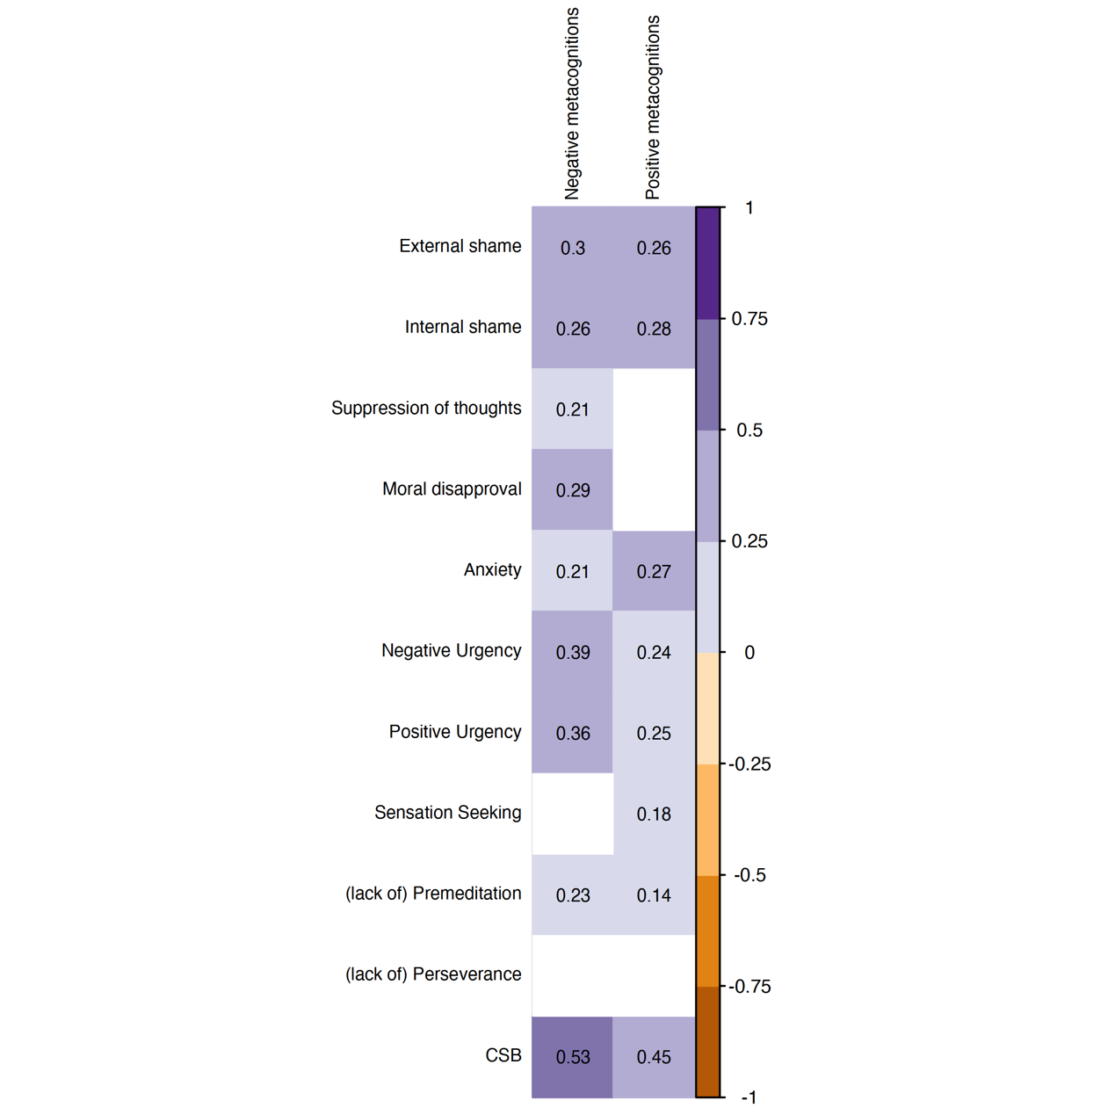
Figure 2: Differences in negative and positive metacognitions about sex between genders (left column) and religiosity status (right column).

Figure 2 Alt Text: Regarding differences between genders and religiosity status (secular, religious), the analyses, Welch’s independent samples t-test indicated that boys had higher positive and negative metacognitions about sex than did girls, and religious people had higher negative metacognitions about sex than did secular people.

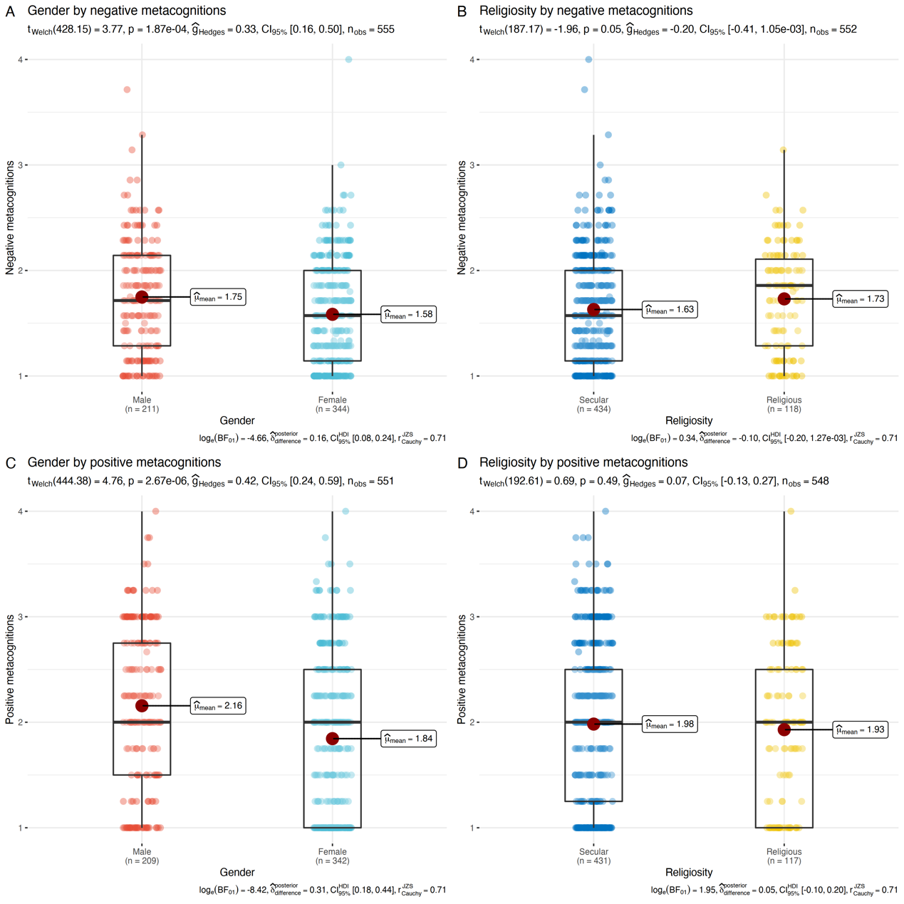

Figure 3: Possible model associating CSB with negative affect, dysregulation thoughts and impulsivity via metacognitions about sex. Solid black lines represent significant paths (p < .05 or better). Grey dashed lines are nonsignificant.

Figure 3 Alt Text: Four significant mediated paths via metacognitions about sex: (i) negative affect were associated with more positive metacognitions about sex, which were, in turn, linked with greater CSB symptom severity; (ii) dysregulated thoughts were associated with more negative metacognitions about sex, which were, in turn, linked with greater CSB symptom severity; and (iii, vi) impulsivity was associated with more positive and negative metacognitions about sex, which were, in turn, linked with greater CSB symptom severity.
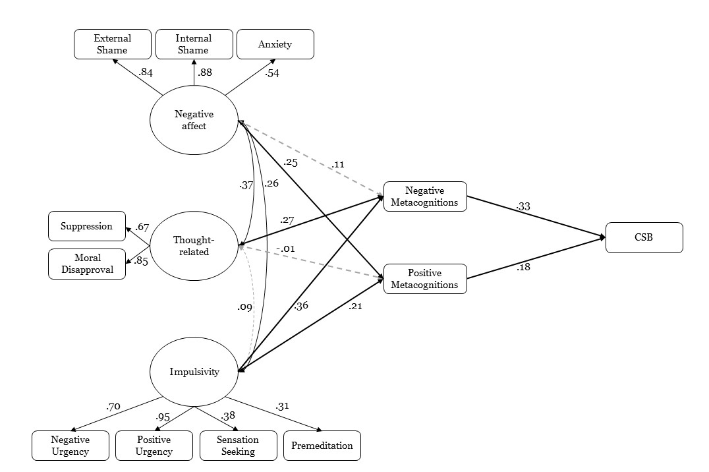

Appendix A
Metacognitions about Sex Scale (MSS) – Structured version (Final version)
Factor | Item
Negative metacognitions | 1. I have no control over my thoughts about sex | 1 | 2 | 3 | 4
 | 2. Once I start thinking of sex, I cannot stop | 1 | 2 | 3 | 4
 | 3. Sexual thoughts make me lose control | 1 | 2 | 3 | 4
 | 4. Thoughts about sex interfere with my functioning | 1 | 2 | 3 | 4
 | 5. Thoughts about sex are becoming an obsession | 1 | 2 | 3 | 4
 | 6. Having thoughts about sex means I will act on them | 1 | 2 | 3 | 4
 | 7. I have no control over my sexual behavior | 1 | 2 | 3 | 4
 | 8. I have no control over my thoughts about sex | 1 | 2 | 3 | 4
Positive metacognitions | 9. Engaging in sex will help me to control my negative thoughts | 1 | 2 | 3 | 4
 | 10. Engaging in sex reduces my anxious feelings | 1 | 2 | 3 | 4
 | 11. Engaging in sex distracts my mind from problems | 1 | 2 | 3 | 4
 | 12. Engaging in sex reduces my feelings of tension | 1 | 2 | 3 | 4

References
Allen, A., Kannis-Dymand, L., & Katsikitis, M. (2017). Problematic internet pornography use: The role of craving, desire thinking, and metacognition. Addictive behaviors, 70, 65-71.‏
Allen, A., Kannis-Dymand, L., & Katsikitis, M. (2021). Investigating anger in a metacognitive model of problematic pornography use: Preliminary findings. Sexual and Relationship Therapy, 1-14.‏
Antons, S., & Brand, M. (2021). Diagnostic and classification considerations related to compulsive sexual behavior disorder and problematic pornography use. Current Addiction Reports, 8(3), 452-457.‏
Billieux, J., Potenza, M. N., Maurage, P., Brevers, D., Brand, M., & King, D. L. (2020). Cognitive factors associated with gaming disorder. In Cognition and addiction (pp. 221–230). Academic Press.
Bőthe, B., Koós, M., & Demetrovics, Z. (2022). Contradicting classification, nomenclature, and diagnostic criteria of Compulsive Sexual Behavior Disorder (CSBD) and future directions•: Commentary to the debate: “Behavioral addictions in the ICD-11”. Journal of Behavioral Addictions, 11(2), 204-209.‏
Bőthe, B., Koós, M., Nagy, L., Kraus, S. W., Demetrovics, Z., Potenza, M. N., ... & Vaillancourt-Morel, M. P. (2023). Compulsive sexual behavior disorder in 42 countries: Insights from the International Sex Survey and introduction of standardized assessment tools. Journal of Behavioral Addictions.‏
Bostwick, J. M., Hecksel, K. A., Stevens, S. R., Bower, J. H., & Ahlskog, J. E. (2009, April). Frequency of new-onset pathologic compulsive gambling or hypersexuality after drug treatment of idiopathic Parkinson disease. In Mayo Clinic Proceedings (Vol. 84, No. 4, pp. 310-316). Elsevier.‏
Briken, P., Wiessner, C., Štulhofer, A., Klein, V., Fuss, J., Reed, G. M., & Dekker, A. (2022). Who feels affected by “out of control” sexual behavior? Prevalence and correlates of indicators for ICD-11 compulsive sexual behavior disorder in the German health and sexuality survey (GeSiD). Journal of Behavioral Addictions, 11(3), 900–911.
Buria, L., Drori, Y., Geulayov, G., Schwammenthal, E., Kobaliov, A., & Dankner, R. (2015). The psychometric properties of the Hebrew version of the Hospital Anxiety and Depression Scale (HADS) in cardiac patients. Gerontol Geriatr, 42, 41-58.‏
Cartwright-Hatton, S., & Wells, A. (1997). Beliefs about worry and intrusions: The Meta-Cognitions Questionnaire and its correlates. Journal of anxiety disorders, 11(3), 279-296.‏
Carlisle-Frank, P. (1991). Examining personal control beliefs as a mediating variable in the health-damaging behavior of substance use: An alternative approach. The Journal of psychology, 125(4), 381-397.‏
Casale, S., Caplan, S. E., & Fioravanti, G. (2016). Positive metacognitions about Internet use: The mediating role in the relationship between emotional dysregulation and problematic use. Addictive Behaviors, 59, 84-88.‏
Casale, S., Caponi, L., & Fioravanti, G. (2020). Metacognitions about problematic Smartphone use: Development of a self-report measure. Addictive Behaviors, 109, 106484.‏
Casale, S., Musicò, A., & Spada, M. M. (2021). A systematic review of metacognitions in Internet Gaming Disorder and problematic Internet, smartphone and social networking sites use. Clinical Psychology & Psychotherapy, 28(6), 1494-1508.‏
Caselli, G., & Spada, M. M. (2011). The desire thinking questionnaire: Development and psychometric properties. Addictive Behaviors, 36(11), 1061-1067.‏
Caselli, G., Martino, F., Spada, M. M., & Wells, A. (2018). Metacognitive therapy for alcohol use disorder: A systematic case series. Frontiers in psychology, 9, 2619.‏
Christensen, A. P., & Golino, H. (2021). On the equivalency of factor and network loadings. Behavior Research Methods, 53(4), 1563-1580.
Crone, E. A., & Dahl, R. E. (2012). Understanding adolescence as a period of social–affective engagement and goal flexibility. Nature reviews neuroscience, 13(9), 636-650.‏
Cyders, M. A., Littlefield, A. K., Coffey, S., & Karyadi, K. A. (2014). Examination of a short English version of the UPPS-P Impulsive Behavior Scale. Addictive Behaviors, 39(9), 1372-1376.‏
Dang, L., Chen, J. H., Zhou, H., Spada, M. M., & Wu, A. M. (2022). Validation of the metacognitions about online gaming scale (MOGS) among Chinese gamers. Addictive Behaviors, 129, 107255.‏
Dhuffar, M., & Griffiths, M. (2014). Understanding the role of shame and its consequences in female hypersexual behaviours: A pilot study. Journal of Behavioral Addictions, 3(4), 231-237.‏
Efrati, Y. (2018). Adolescents with a disposition toward compulsive sexual behavior: The role of shame in willingness to seek help and treatment. Sexual Addiction & Compulsivity, 25(1), 28-45.‏
Efrati, Y., & Dannon, P. (2018). Normative and clinical self-perceptions of sexuality and their links to psychopathology among adolescents. Psychopathology, 51 :380–389.

Efrati, Y., & Mikulincer, M. (2018). Individual-based compulsive sexual behavior scale: Its development and importance in examining compulsive sexual behavior. Journal of Sex & Marital Therapy, 44, 249-259.
Efrati, Y. (2019). God, I can’t stop thinking about sex! The rebound effect in unsuccessful suppression of sexual thoughts among religious adolescents. The Journal of Sex Research, 56(2), 146-155.‏
Efrati, Y., Kolubinski, C.D, Caselli, G., & Spada, M.M. (2020). Desire thinking as a predictor of compulsive sexual behaviour in adolescents: Evidence from a cross-cultural validation of the Hebrew version of the Desire Thinking Questionnaire. Journal of Behavioral Addictions, 9, 797–807.
Efrati, Y., Kolubinski, C.D, Marino, C., & Spada, M.M. (2021). Modelling the contribution of metacognitions, impulsiveness, and thought suppression to behavioural addictions in adolescents. International Journal of Environmental Research and Public Health, 18, 3820.
Efrati, Y., Shukron, O., & Epstein, R. (2021). Early maladaptive schemas are highly indicative of compulsive sexual behavior. Evaluation & the Health Professions, 44(2), 142-151.‏
Efrati, Y., & Amichai-Hamburger, Y. (2021). Adolescents who solely engage in online sexual experiences are at higher risk for compulsive sexual behavior. Addictive Behaviors. Volume 118, 106874.
Efrati, Y., & Spada, M. M. (2023). “I have no control over how much time I play” the metacognitions about online gaming scale: Evidence from a cross-cultural validation among Israeli adolescents. Addictive Behaviors, 141, 107638.‏
Efrati, Y. (2023a). Compulsive sexual behavior in adolescents: the roles of personality, attachment orientations, cognitive mechanisms, and psychopathology. Cognitive Therapy and Research, 1-14.‏
Efrati, Y. (2023b). Parental practices as predictors of adolescents’ compulsive sexual behavior: a 6-month prospective study. European Child & Adolescent Psychiatry, 1-13.‏
Efrati, Y. (2023c). Risk and protective factor profiles predict addictive behavior among adolescents. Comprehensive Psychiatry, 123, 152387.‏
Ferreira, C., Moura-Ramos, M., Matos, M., & Galhardo, A. (2020). A new measure to assess external and internal shame: Development, factor structure and psychometric properties of the external and internal shame scale. Current Psychology, 1-10.‏
Flavell, J. H. (1978). Metacognitive development. Structural/process theories of complex human behavior, 213-245.‏
Flavell, J. H. (1979). Metacognition and cognitive monitoring: A new area of cognitive–developmental inquiry. American psychologist, 34(10), 906.‏
Friedman, J., Hastie, T., & Tibshirani, R. (2008). Sparse inverse covariance estimation with the graphical lasso. Biostatistics, 9(3), 432-441.
Gola, M., Lewczuk, K. , Potenza, M. N. , Kingston, D. A. , Grubbs, J. B. , Stark, R. , & Reid, R. C. (2022). What should be included in the criteria for compulsive sexual behavior disorder? Journal of Behavioral Addictions, 11, 160–165. https://doi.org/10.1556/2006.2020.00090.
Gold, S. N., & Heffner, C. L. (1998). Sexual addiction: Many conceptions, minimal data. Clinical Psychology Review, 18, 367-381.‏
Golino, H., Shi, D., Christensen, A. P., Garrido, L. E., Nieto, M. D., Sadana, R., Thiyagarajan, J. A., & Martinez-Molina, A. (2020). Investigating the performance of exploratory graph analysis and traditional techniques to identify the number of latent factors: A simulation and tutorial. Psychological Methods, 25(3), 292.
Goodman, A. (1998). Sexual addiction: An integrated approach. International Universities Press, Inc.‏
Grant Weinandy, J. T., Lee, B., Hoagland, K. C., Grubbs, J. B., & Bőthe, B. (2023). Anxiety and compulsive sexual behavior disorder: A systematic review. The Journal of Sex Research, 60(4), 545-557.‏
Grubbs, J. B., Wilt, J. A., Exline, J. J., Pargament, K. I., & Kraus, S. W. (2018). Moral disapproval and perceived addiction to internet pornography: A longitudinal examination. Addiction, 113(3), 496-506.‏
Grubbs, J. B., Perry, S. L., Wilt, J. A., & Reid, R. C. (2019). Pornography problems due to moral incongruence: An integrative model with a systematic review and meta-analysis. Archives of Sexual Behavior, 48(2), 397-415.‏
Grubbs, J. B., Reid, R. C., Bőthe, B., Demetrovics, Z., Coleman, E., Gleason, N., … Kraus, S. W. (2023). Assessing compulsive sexual behavior disorder: The development and international validation of the compulsive sexual behavior disorder-diagnostic inventory (CSBD-DI). Journal of Behavioral Addictions, 12(1), 242–260
Gullone, E., & Taffe, J. (2012). The emotion regulation questionnaire for children and adolescents (ERQ–CA): a psychometric evaluation. Psychological assessment, 24(2), 409.‏
Hamonniere, T., & Varescon, I. (2018). Metacognitive beliefs in addictive behaviours: A systematic review. Addictive Behaviors, 85, 51-63.‏‏
Holmbeck, G. N., Friedman, D., Abad, M., & Jandasek, B. (2006). Development and Psychopathology in Adolescence. In D. A. Wolfe & E. J. Mash (Eds.), Behavioral and emotional disorders in adolescents: Nature, assessment, and treatment (pp. 21–55). Guilford Publications.
King, D. L., & Delfabbro, P. H. (2014). The cognitive psychology of Internet gaming disorder. Clinical psychology review, 34(4), 298-308.‏
Klos, K. J., Bower, J. H., Josephs, K. A., Matsumoto, J. Y., & Ahlskog, J. E. (2005). Pathological hypersexuality predominantly linked to adjuvant dopamine agonist therapy in Parkinson's disease and multiple system atrophy. Parkinsonism & related disorders, 11(6), 381-386.‏
Kraus, S. W., Rosenberg, H., & Tompsett, C. J. (2015). Assessment of self efficacy to employ self-initiated pornography usereduction strategies. Addictive Behaviors, 40, 115–118. doi:10.1016/j.addbeh.2014.09.012
Kraus, S. W., Krueger, R. B., Briken, P., First, M. B., Stein, D. J., Kaplan, M. S., ... & Reed, G. M. (2018). Compulsive sexual behaviour disorder in the ICD‐11. World Psychiatry, 17(1), 109.‏
Lew-Starowicz, M., Lewczuk, K., Nowakowska, I., Kraus, S., & Gola, M. (2020). Compulsive sexual behavior and dysregulation of emotion. Sexual medicine reviews, 8(2), 191-205.‏
Marino, C., & Spada, M. M. (2017). Dysfunctional cognitions in online gaming and internet gaming disorder: A narrative review and new classification. Current Addiction Reports, 4, 308-316.‏
Marino, C., Marci, T., Ferrante, L., Altoè, G., Vieno, A., Simonelli, A., ... & Spada, M. M. (2019). Attachment and problematic Facebook use in adolescents: The mediating role of metacognitions. Journal of Behavioral Addictions, 8(1), 63-78.‏
Marino, C., Canale, N., Vieno, A., Caselli, G., Scacchi, L., & Spada, M. M. (2020). Social anxiety and Internet gaming disorder: The role of motives and metacognitions. Journal of Behavioral Addictions, 9(3), 617-628.‏
Mechelmans, D. J., Irvine, M., Banca, P., Porter, L., Mitchell, S., Mole, T. B., ... & Voon, V. (2014). Enhanced attentional bias towards sexually explicit cues in individuals with and without compulsive sexual behaviours. PloS one, 9(8), e105476.‏
Meekers, D., & Calves, A. E. (1999). Gender differentials in adolescent sexual activity and reproductive health risks in Cameroon. African Journal of Reproductive Health, 3(2), 51-67.‏
Miner, M. H., Raymond, N., Mueller, B. A., Lloyd, M., & Lim, K. O. (2009). Preliminary investigation of the impulsive and neuroanatomical characteristics of compulsive sexual behavior. Psychiatry Research: Neuroimaging, 174(2), 146-151.‏
Pachankis, J. E., Rendina, H. J., Ventuneac, A., Grov, C., & Parsons, J. T. (2014). The role of maladaptive cognitions in hypersexuality among highly sexually active gay and bisexual men. Archives of Sexual Behavior, 43, 669-683.‏
Paunovic, N., & Hallberg, J. (2014). Conceptualization of hypersexual disorder with the behavioral-cognitive inhibition theory. Psychology, 5, 151–159. doi:10.4236/psych.2014.52024
Perales, J. C., King, D. L., Navas, J. F., Schimmenti, A., Sescousse, G., Starcevic, V., ... & Billieux, J. (2020). Learning to lose control: A process-based account of behavioral addiction. Neuroscience & Biobehavioral Reviews, 108, 771-780.‏
Reid, R. C., Harper, J. M., & Anderson, E. H. (2009). Coping strategies used by hypersexual patients to defend against the painful effects of shame. Clinical Psychology & Psychotherapy: An International Journal of Theory & Practice, 16(2), 125-138.‏
Reid, R. C., Temko, J., Moghaddam, J. F., & Fong, T. W. (2014). Shame, rumination, and self-compassion in men assessed for hypersexual disorder. Journal of Psychiatric Practice®, 20(4), 260-268.‏
Ruscio, J., & Roche, B. (2012). Determining the number of factors to retain in an exploratory factor analysis using comparison data of known factorial structure. Psychological Assessment, 24(2), 282.
Sassover, E., Abrahamovitch, Z., Amsel, Y., Halle, D., Mishan, Y., Efrati, Y., & Weinstein, A. (2021). A study on the relationship between shame, guilt, self-criticism and compulsive sexual behaviour disorder. Current Psychology, 1-9.‏
Spada, M. M., & Wells, A. (2009). A metacognitive model of problem drinking. Clinical Psychology & Psychotherapy: An International Journal of Theory & Practice, 16(5), 383-393.‏
Spada, M. M., Caselli, G., & Wells, A. (2013). A triphasic metacognitive formulation of problem drinking. Clinical psychology & psychotherapy, 20(6), 494-500.‏
Spada, M. M., Caselli, G., Nikčević, A. V., & Wells, A. (2015). Metacognition in addictive behaviors. Addictive behaviors, 44, 9-15.‏
Spada, M. M., & Caselli, G. (2017). The metacognitions about online gaming scale: Development and psychometric properties. Addictive Behaviors, 64, 281-286.‏
Thomas, J., Katsikitis, M., Allen, A., & Kannis-Dymand, L. (2020). Desire Thinking and Metacognition Associated with Dysregulated Sexuality. Sexual Addiction & Compulsivity, 27(1-2), 119-134.‏
U.S. Census Bureau. (2022). American Community Survey Data. Retrieved August 27, 2023, from https://www.census.gov/data.html
Voon, V., Mole, T. B., Banca, P., Porter, L., Morris, L., Mitchell, S., ... & Irvine, M. (2014). Neural correlates of sexual cue reactivity in individuals with and without compulsive sexual behaviours. PloS one, 9(7), e102419.‏
Walton, M. T., Cantor, J. M., Bhullar, N., & Lykins, A. D. (2017). Hypersexuality: A critical review and introduction to the “sexhavior cycle”. Archives of Sexual Behavior, 46(8), 2231-2251.‏
Wegner, D. M., Schneider, D. J., Carter, S. R., & White, T. L. (1987). Paradoxical effects of thought suppression. Journal of personality and social psychology, 53(1), 5.‏
Wells, A., & Matthews, G. (1994). Self-consciousness and cognitive failures as predictors of coping in stressful episodes. Cognition & Emotion, 8(3), 279-295.‏
Wells, A., & Cartwright-Hatton, S. (2004). A short form of the metacognitions questionnaire: properties of the MCQ-30. Behaviour research and therapy, 42(4), 385-396.‏
Wells, A., Fisher, P., Myers, S., Wheatley, J., Patel, T., & Brewin, C. R. (2009). Metacognitive therapy in recurrent and persistent depression: A multiple-baseline study of a new treatment. Cognitive therapy and research, 33, 291-300.‏
Wild, D., Grove, A., Martin, M., Eremenco, S., McElroy, S., Verjee-Lorenz, A., & Erikson, P. (2005). Principles of good practice for the translation and cultural adaptation process for patient-reported outcomes (PRO) measures: report of the ISPOR task force for translation and cultural adaptation. Value in health, 8(2), 94-104.‏
World Health Organization (WHO). ICD-11. version 04/2019. Compulsive sexual behavior disorder. Geneva: WHO; 2019. Available from: https://icd.who.int/browse11/l-m/en#/http%3a%2f%2fid.who.int%2ficd%2fentity%2f1630268048 . Accessed March 25, 2023.
Zarbo, C., Brugnera, A., Compare, A., Secomandi, R., Candeloro, I., Malandrino, C., ... & Frigerio, L. (2019). Negative metacognitive beliefs predict sexual distress over and above pain in women with endometriosis. Archives of Women's Mental Health, 22, 575-582.‏
Zigmond, A. S., & Snaith, R. P. (1983). The hospital anxiety and depression scale. Acta psychiatrica scandinavica, 67(6), 361-370.‏

