Infrastructure Model Development to Enhance Resilience against future changes using InfraWorks & GIS
U.A.Khan¹, Y. Chen¹, R. Jin¹, R. Seidu¹, Hoc Tran Duc^{2,3,*}
¹Centre for Integrated Delivery of the Built Environment (IDoBE), School of Built Environment and Architecture, London South Bank University, 103 Borough Road, London, UK. SE1 0AA.
²Faculty of Civil Engineering, Ho Chi Minh City University of Technology (HCMUT), 268 Ly Thuong Kiet Street, District 10, Ho Chi Minh City, Vietnam.
³Vietnam National University Ho Chi Minh City, Linh Trung Ward, Thu Duc District, Ho Chi Minh City, Vietnam.
*tdhoc@hcmut.edu.vn
Abstract. The Smart City idea is becoming more popular because cities are getting too crowded. This study looks at how BIM and Geographical Information Systems (GIS) work together. The study focused on infrastructure and figuring out how long a building would last, as early stages of infrastructure development would help the public organization to better plan and design. The GIS mapping shows which areas are more likely to become cities or towns. The AEC industry stakeholders can benefit from mapping to achieve Sustainable Development Goals (SGDs). The AEC industry has also been constantly moving towards Building Information Modelling (BIM). In this study, the city of London was considered, and Land Cover predictions from 2000 to 2025 were made. The predicted Map of 2025 would help developers and planning authorities on decision making on housing development. Based on the current study, more research could be extended on how BIM and GIS could work together for urban development.
Keywords: Smart City, GIS, BIM, Infrastructure management
- Introduction
The study focuses on a developed area of London in the United Kingdom to see how development changed over time of the Geographic Information System (GIS). Also, Building Information Modelling (BIM) tools are used to develop, model, and build a more sustainable solution based on GIS analyses. The tremendous increase of urban areas is a contemporary global trend, and migration and population growth are the real drivers of this growth. Urban growth affects how cities are organized and the economy and society function, but these effects cut across territorial boundaries and have a significant impact. Urbanization results from the current globalization, with social and economic development due to which people migrate to the cities (Kühn, 2018). It is argued that this process is the center of progress that provide people with various possibilities. Emphasis on the urbanization process increases strain on the environment, its ecosystems, and its resources (Ahmed et al., 2020).
Designers employ infrastructure modelling at the urban community level to comprehend development and create and administer sustainable design plans (Umair et al., 2022). Urban planners can then analyze city development that can boost effective mobility in urban areas by reviewing the prices and duration of the currently built environment. Unfortunately, collecting and keeping up-to-date building data from a neighborhood with many structures is challenging. Urban design development may suffer due to several uncertainties and mistakes. Since most current urban modelling systems use lower-level or abstract building data, planners may have to infer unknown building data to account for future uncertainty.
The abovementioned issues highlight the need for new strategies and tools that use current infrastructure design data to strengthen future development. Another issue is the distinction between design processes at urban level and infrastructure scale. The many design processes are interconnected and should not be considered separate from one another. This research examines the urban design development viability of employing ontologies to create semantic integration between GIS and InfraWork data. GIS, InfraWork, and urban design are the three fields this research covers. This study incorporates GIS and InfraWorks to analyze urban expansion and infrastructural model development utilizing Revit and Infraworks, both of which are a component of BIM (Umair et al., 2022). These two technologies can support applications in larger-scale areas, such as urban planning, where buildings, a road network, or underground utilities are connected and used for analysis.
The current study would support creating a decision support system for policymakers to facilitate the efficient planning and design of urban development projects through cutting-edge information and technology. Utilizing a variety of software packages would lower the probability of mistakes for sustainable development in metropolitan areas. A more comprehensive strategy was attempted for efficient planning and development. Research objectives outlined in the current study included: 1) analyzing how future urban infrastructure can improve with time; 2) analysis of City's Expansion; and 3) 3D Modelled Infrastructure for achieving Sustainability using BIM.
- Literature Review
A GIS is a system that can represent and analyze the items and connections in the actual world (Wright, 2015). The traditional GIS can represent geographical data on scales ranging from the globe to the building level (Weibel and Dutton, 1999). Research findings also demonstrated that GIS was an effective tool for managing and analyzing diverse spatial data throughout the decision-making process (Wright, 2015). Geo database, Shapefile, and TIGER are some examples of prominent data formats. Each of these data formats was built for a distinct GIS platform, resulting in a great deal of complexity and difficulty regarding data interchange (Arctur and Zeiler, 2004).
One of the most popular pieces of software for planning and designing infrastructure projects in a BIM environment is InfraWorks (Barazzetti and Banfi, 2017). Model-based planning and design of civil infrastructure in the context of the actual environment is made possible by the BIM platform named InfraWorks (Avramovic and Johnsson, 2017). InfraWorks improves interoperability, enabling teams to communicate while also allowing designers to work in the richer, more genuine context of the project's actual environment (El-Labany, 2021). Additionally, even though there is little literature and study on the combined usage of Revit and InfraWorks, they are a component of BIM and can help to improve the effectiveness and efficiency of the construction processes (Eleftheriadis et al., 2017).
The integration of the GIS-BIM is the most current data mining application to acquire data for decision support systems. Recently, the use of BIM and GIS in the building industry transitioned from research to practice (Ma and Ren, 2017). The incorporation of BIM-GIS had been limited due to the various data formats and modelling methodologies used in these respective disciplines (Song et al., 2017). Many individuals believe that Geo-BIM, also known as the integration of GIS and BIM data, will aid in resolving the transdisciplinary challenges of the built environment (Johansson et al., 2017). Municipal administration must employ smart cities to address the problems brought on by the growing urbanization. Systems for intelligent and environmentally friendly mobility are a component of ICT, the backbone of the smart city. For planning and observing traffic, geospatial technologies might be helpful (Homainejad, 2015). The integration of BIM and GIS analytics during the design and preconstruction stages will considerably help the planning process (Karan and Irizarry, 2015). Therefore, in this era of smart cities, when aspirations for a better future are strong, this combination of BIM and Geospatial technologies could no longer be ignored (Kumar et al., 2014).
Building safer and more intelligent transportation systems and structures is made possible by integrating geospatial services into infrastructure design and construction (Richter et al., 2020). Technologies rely exclusively on reliable data and software systems and their integration (Mubarak and Petraite, 2020). More issues arise because engineers, designers, and planners must sometimes manually retrieve such data (Dawson, 2020). In designing an urban infrastructure system, it is desirable to integrate data from many sources and LODs (Kim et al., 2012). Designers may access information from macro and micro level-built environment data to integrate GIS and Infrawork. It also makes it possible to use the advantages of these two technologies (Ma and Ren, 2017). While Infrawork focuses on the micro-level of infrastructure components, GIS focuses on the macro level, providing descriptions and precise geographic coordinates of an item, such as cities, land, and building landscape. Since both BIM and GIS are based on the graphic depiction of specific objects connected to a database, they may be used for various purposes (Irizarry et al., 2013). To obtain a more integrated approach, current research on integrated BIM/GIS systems aims to leverage a variety of formats, such as Industrial Foundation Class (IFC) and City Geography Markup Language (Wu and Zhang, 2016).
This study evaluates the methodology used in Autodesk Revit and InfraWorks (Ma and Ren, 2017). The major goal was to use the program to build a BIM-GIS for the city of London, starting with the features already included in the package. The idea presented in this study outlines the key benefits of working with InfraWorks and the accessible cartographic data. However, the method described in this research needed additional software tools to overcome various issues discovered during data processing.
- Methodology
This study suggested a method for urban mining that is based on the process of classifying data from different dimensions. A case study building was constructed using Autodesk Revit 2019 as the BIM authoring tool to establish the model shown in Fig.1.
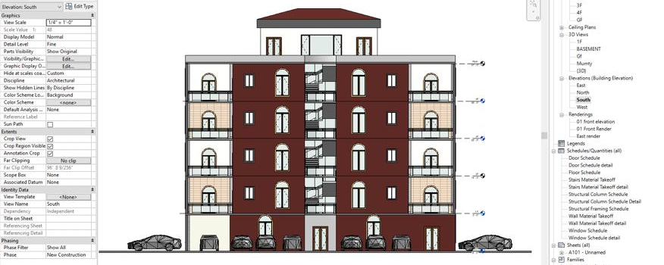
Fig. 1 Developed Model on Revit with exterior Finishing
The researchers recognized the integration of BIM and GIS to improve planning and implement sustainable strategies in London, as partly shown in Fig.2. The model was then imported into InfraWorks for improved visibility and structural viability on the ground. InfraWorks allows the setup of GIS data or files inside of it. The urban area of London was seen as all the parts of a scene with a spectrum similar to the areas that were chosen. The order of processing was spectral analysis followed by spatialization, which was performed using the Google Earth Engine (GEE) cloud computing environment. Processing and deployment in the cloud made it possible to scale computing efforts in a consistent way across large geographic areas. The process consists of the following steps, namely: 1) pre-processing and selection of a set of Landsat scenes, including the geographic area and time period of interest; 2) computing index normalized difference spectral vectors (NDSVs), which are a set of spectral indices that were good inputs for classifying urban areas; 3) spatial post-processing; 4) accuracy assessment; and 5) prediction of land cover.
Fig. 2 Partly screenshot map of the London city and its position with vegetation, buildings, and water.
Autodesk InfraWorks is a straightforward drawing tool that landscape architects and infrastructure designers may use. With Autodesk InfraWorks, high-level visual models could be made without the need for any other visualization tools than what is included in the package. A highly accurate model may be constructed by efficiently gaining access to data from various sources and combining that data. It is possible to confidently envision a project's full potential and establish a competitive distinction by utilizing cloud technology and vertical position capabilities, in conjunction with a computer-controlled and robust capability for the creation of 3D models. When InfraWorks was used for the first time, a model of the existing conditions was created by combining data from CAD, GIS, raster, and BIM files. This model represents the current state of the infrastructure. In this research, an InfraWorks 360 model was constructed, and an InfraWorks environment with ESRI data sources was used to acquire a 200 km² region in London. InfraWorks was connected to a 3D GIS making it possible for customers to obtain real-time mapping directly from InfraWorks. ArcGIS allowed users to manage imagery and other remotely sensed data and obtain information from such datasets. InfraWorks made it possible to include a wide variety of data sources into the model so that it could be analyzed. Following the construction and acquisition of the model, the Revit Architectural model was customized with the help of data sources. The defined Co-ordinate system was chosen, and the model was then positioned in a free-form environment as shown in Fig. 3. The structure's location on the designated terrain was located using the coordinates 51.5072° N and 0.1276°. Following the model's placement, the designated region was analyzed in a real-time 3D environment to provide urban planners with useful information. The coordinates could be seen on Google Street Maps. With the help of the InfraWorks conceptual design software, professionals in architecture, technology, and construction could model, evaluate, and visualize connectivity design concepts in the context of the built and natural environment. This helps them make better decisions and speed up project approval. In addition, the Conceptual Design Model allows users to construct various projects, including highways and roads, site designs and layouts, railway routes, water systems, and bridge designs, among others.
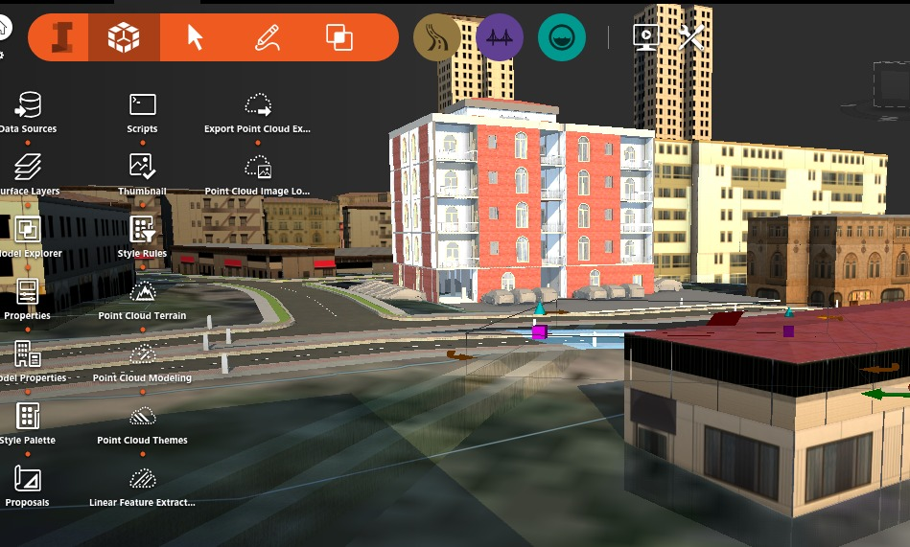
Fig. 3 Three-Dimensional Revit Model inclusion in InfraWork Environment
- Results and Discussion
In this study, BIM and GIS were used to assist in the planning stage of building projects to manage urbanization. GIS was used to forecast land cover and land use, and then six images were derived at intervals of five years. A comprehensive architectural model was generated via Autodesk Revit. InfraWorks 360 was adopted to analyze this building once it was constructed. Real-time visualization was made easier with InfraWork, which in turn enabled planners to organize projects more effectively.
When it comes to the process of building design, the primary advantages of using BIM are parametric modelling and interoperability, specifically by compiling data from a wide variety of fields into a single file and providing designers with a model that responds to certain geometry-related criteria. In its most basic form, BIM is a digital representation of the structural and functional properties of a structure. BIM allows the creation of smart cities that are both more environmentally friendly and more stringent in their requirements. In addition to this, it has the potential to correct the planning error in any development project. The case study model that was constructed in Revit 2019 was fetched and configured in InfraWork based on the coordinates. If there are several building structures in an area designed by BIM and GIS, it may be much simpler for the council to acquire the census data and achieve sustainability in a specified area. BIM could be adopted in the urban development and design processes that take place during the pre-construction phase. When combined with GIS, BIM could provide a graphical database that could improve the visual tracking and collection of information about landscapes, grids, buildings, and cities. Because BIM and GIS are able to provide 3D models of buildings and sites, an early assessment of the construction site could be carried out applying this technology. Integration of BIM and GIS has the potential to enhance planning and design phases, particularly in the areas of site selection, planning for sites and safety, adaptation to climate change, operations during the pre-construction stage, and planning and design of the deconstruction process.
This research also adopted GIS in order to improve urban planning and management by more sophisticated design methodologies within BIM and GIS. Both Revit and InfraWorks were part of BIM platform, and each contributed to the lifespan study of a building structure, which in turn contributed to sustainability. The vast majority of design companies have been using Revit because to the sophisticated capabilities it offers for architectural, structural, MEP, multi-discipline collaboration, design and documentation, and conflict analysis. In contrast, InfraWorks allows professionals in the fields of architecture, engineering, and construction to model, analyse, and visualize proposals for infrastructure design within the context of both the built and natural environments. The combination of BIM and GIS is helpful in the following areas:
• A centralized data repository and an ongoing, fluid exchange of information between the two systems, with no data being lost in the process
• A perspective on the project, the urban setting, and the environment that is far more specific and all-encompassing
• offering users the ability to make strategic choices throughout the design, construction, and operating phases of the life cycle of a construction project.
- Conclusion
The Smart City idea has become more popular because cities are getting more crowded. There has been growing needs of smart urbanization for citizens’ wellbeing and sustainable community. The study focused on how BIM and (Geographical Information Systems) GIS work together in addressing urbanization. The study has been mostly about infrastructure and figuring out how long a building could last. All possible uses for the recommended case study model at all stages of smart cities were laid out. The early stages of infrastructure development would help the public organization to better plan and design. All project stakeholders could visualize it, obtain geographic and environmental data, and make their recommendations about infrastructure development. The GIS mapping showed which areas were more likely to become cities or towns. The AEC industry stakeholders could benefit from mapping to achieve Sustainable Development Goals (SGDs). The city of London was considered, and Land Cover predictions from 2000 to 2025 were made. The predicted Map of 2025 would help stakeholders find suitable areas for urbanization. Overall, the developed methods in this research could help the government and the planning department on decision making. These digital technologies, including GIS and BIM, could be utilized to develop intelligent, safer, well-planned cities. With more availability of digital tools to stakeholders such as planning and construction professionals, more practices of integrating GIS and BIM can be implemented in the future.

Acknowledgement
We acknowledge Ho Chi Minh City University of Technology (HCMUT), VNU-HCM for supporting this study.

References

Ahmed, Z. et al. (2020) ‘Moving towards a sustainable environment: the dynamic linkage between natural resources, human capital, urbanization, economic growth, and ecological footprint in China’, Resources Policy, 67, p. 101677.

Arctur, D. and Zeiler, M. (2004) Designing Geodatabases: case studies in GIS data modeling. ESRI, Inc.

Avramovic, S. and JOHNSSON, E. (2017) ‘Evaluation of Autodesk InfraWorks 360 and PTV Vissim-A comparative study of two traffic simulation software products’

Barazzetti, L. and Banfi, F. (2017) ‘BIM and GIS: When parametric modeling meets geospatial data’, in ISPRS Workshop on Geospatial Solutions for Structural Design, Construction and Maintenance in Training Civil Engineers and Architects, Geospace 2017, pp. 1–8.

Dawson, K. (2020) Facilities & Design, the Call Center Handbook. Crc Press. doi: 10.1201/9781482295658-8.

El-Labany, S. (2021) ‘InfraWorks models to assist with construction sequencing and planning’, in High Speed Two (HS2): Infrastructure Design and Construction (Volume 2). ICE Publishing, pp. 43–59.

Eleftheriadis, S., Mumovic, D. and Greening, P. (2017) ‘Life cycle energy efficiency in building structures: A review of current developments and future outlooks based on BIM capabilities’, Renewable and Sustainable Energy Reviews, 67, pp. 811–825. doi: 10.1016/j.rser.2016.09.028.

Homainejad, A. S. (2015) ‘With geospatial in path of smart city’, The International Archives of Photogrammetry, Remote Sensing and Spatial Information Sciences, 40(7), p. 1381.

Irizarry, J., Karan, E. P. and Jalaei, F. (2013) ‘Integrating BIM and GIS to improve the visual monitoring of construction supply chain management’, Automation in construction, 31, pp. 241–254.

Johansson, T., Olofsson, T. and Mangold, M. (2017) ‘Development of an energy atlas for renovation of the multifamily building stock in Sweden’, Applied Energy, 203, pp. 723–736.

Karan, E. P. and Irizarry, J. (2015) ‘Extending BIM interoperability to preconstruction operations using geospatial analyses and semantic web services’, Automation in Construction, 53, pp. 1–12. doi: 10.1016/j.autcon.2015.02.012.

Kim, S. A. et al. (2012) ‘Integrated energy monitoring and visualization system for Smart Green City development: Designing a spatial information integrated energy monitoring model in the context of massive data management on a web based platform’, Automation in Construction, 22, pp. 51–59.

Kühn, M. (2018) ‘Immigration strategies of cities: local growth policies and urban planning in Germany’, European Planning Studies, 26(9), pp. 1747–1762.

Kumar, P. et al. (2014) ‘Capacity building through geospatial education in planning and school curricula’, The International Archives of Photogrammetry, Remote Sensing and Spatial Information Sciences, 40(8), p. 1253.

Ma, Z. and Ren, Y. (2017) ‘Integrated application of BIM and GIS: an overview’, Procedia Engineering, 196, pp. 1072–1079.

Mubarak, M. F. and Petraite, M. (2020) ‘Industry 4.0 technologies, digital trust and technological orientation: What matters in open innovation?’, Technological Forecasting and Social Change, 161, p. 120332.

Richter, A. et al. (2020) ‘Towards an integrated urban development considering novel intelligent transportation systems: Urban Development Considering Novel Transport’, Technological Forecasting and Social Change, 155, p. 119970.

Song, Y. et al. (2017) ‘Trends and opportunities of BIM-GIS integration in the architecture, engineering and construction industry: A review from a spatio-temporal statistical perspective’, ISPRS International Journal of Geo-Information, 6(12), p. 397. doi: 10.3390/ijgi6120397

Umair, M. et al. (2022) ‘Impact of Virtual Reality-Based Design Review System on User’s Performance and Cognitive Behavior for Building Design Review Tasks’, Applied Sciences, 12(14), p. 7249.

Weibel, R. and Dutton, G. (1999) ‘Generalising spatial data and dealing with multiple representations’, Geographical information systems, 1, pp. 125–156.

Wright, J. (2015) ‘Geographic information systems and spatial analysis’, Routledge Handbook of Water and Health, 93(3), pp. 608–615. doi: 10.4324/9781315693606.

Wu, B. and Zhang, S. (2016) ‘Integration of GIS And BIM for indoor geovisual analytics’, International Archives of the Photogrammetry, Remote Sensing and Spatial Information Sciences - ISPRS Archives, 41, pp. 455–458.

