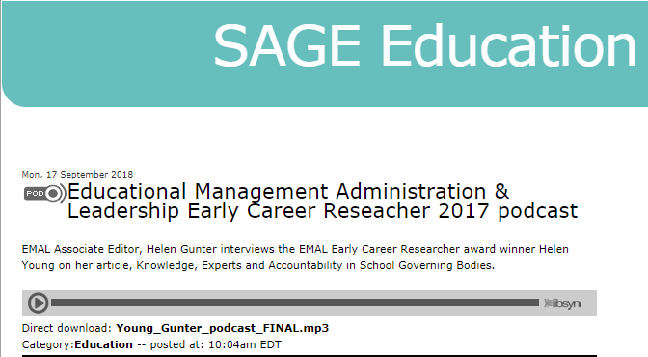
Podcast with Prof Helen Gunter: http://sageeducation.sage-publications.libsynpro.com/educational-management-administration-leadership-early-career-reseacher-2017-podcast

