Radiofrequency magnetic resonance coils and communication antennas: Simulation and design strategies
Giulio Giovannetti ^{a,b,}⁎, Gianluigi Tiberi ^{c,d}
ª Institute of Clinical Physiology, National Council of Research, Pisa, Italy
^{b} Fondazione G. Monasterio CNR - Regione Toscana, Pisa, Italy
^{c} Laboratory of Medical Physics and Biotechnologies for Magnetic Resonance, IRCCS Stella Maris Foundation, Pisa, Italy
^{d} Imago7 Foundation, Pisa, Italy

a b s t r a c t

Coils simulation and design is a fundamental task to maximize Signal-to-Noise Ratio in Magnetic Resonance appli- cations. In the meantime, in the last years the issue of accurate communication antennas analysis has grown. Coil design techniques take advantage of computer simulations in dependence on the magnetic field wavelength and coil sizes. In particular, since at high frequencies coils start to behave as antennas, modern Magnetic Resonance coil development exploits numerical methods typically employed for antennas simulation.
This paper reviews coil and antenna performance parameters and focuses on the different simulation approaches in dependence on the near/far field zones and operating frequency.

- Introduction

Magnetic Resonance Imaging (MRI) is a non-invasive diagnostic technique based on the phenomenon of Nuclear Magnetic Resonance (NMR), which employs the signal from protons for producing anatomic images. The basic physical principle is related to the behaviour of atomic nuclei with a magnetic moment, which when placed in a static magnetic field (B₀) precess about its direction at a specific frequency, named Larmor frequency. For examining the tissue characteristics, the nuclei in the static field are irradiated by a radiofrequency (RF) magnetic field (B₁) whose direction is perpendicular to B₀ field direction and whose fre- quency is equal to the Larmor frequency. The nuclear magnetization will make an excursion from the static field direction and induce a voltage in the receive coil as it returns to align with the static field. Tissue character- istics information is achieved by studying the atoms magnetic moment dynamics. In MR systems, the irradiated RF field and the transverse RF field are generated and picked up by transmit and receive coils, respec- tively [1]. The transmit coil has to produce a highly homogeneous alter- nating field in a wide field of view (FOV), since the extension of the region under investigation is not known a priori. For achieving this, transmit coils are usually large for optimizing the field homogeneity and including a significant tissue volume. The receive coil has to maxi- mize signal detection while minimizing the noise, and for this purpose

its dimensions have to be minimized [2]. For achieving an optimal signal reception over a large region, phased array coils have been introduced [3]. In such configuration, each coil element within the array picks up the signal from a specific tissue region while minimizing the interactions with the other coil elements. Finally, both transmit and receive coils must be adapted to the specific goal and to the sample sizes.
For optimizing RF coil performance for a given application, an accu- rate simulation and design process has to be performed. Current design techniques take advantage of computer simulations for preliminary test- ing different coil geometries.
Some coil characteristic, as magnetic field homogeneity, can be esti- mated by electromagnetic theory as Biot-Savart as long as the nearly static field assumption holds, but with the increase of static field intensi- ty in modern scanners, this condition is rarely satisfied [4]. Moreover, when the coil is loaded with a sample, the distribution of Signal-to- Noise Ratio (SNR) is strongly affected by sample electromagnetic proper- ties. For these reasons, modern MR coil development exploits numerical methods which permit to simulate the behaviour of the coil in presence of realistic loads and to investigate the coil efficiency at high frequency, when the coils start to behave as antennas. This review brieﬂy describes coil and antenna performance parameters and their estimation methods.

- Characterization of RF coils for MR

RF coils are designed as resonant structures and can be schematized by an equivalent RLC circuit whose current which ﬂows on it is

maximized at the Larmor frequency (Fig. 1). As according to the reciproc- ity theorem [5], V can be the voltage source (transmit coil) or the sample- induced voltage (receive coil). L is the system inductance which takes into account for the energy that can be stored in the magnetic field and it is related to the conductors size and geometry. C is the system capaci- tance and is mainly resulting from the contribution of discrete capacitors. Energy exchange between magnetic (B) and electric (E) field might alternate in time with maximum efficiency at the resonant frequency. By applying Kirchhoff law, the circuit resonant frequency can be calculat-
ed as:
- Characterization of antennas for communication

An antenna, being a device for radiating or receiving radiowaves, needs currents and voltages on its structures to generate the required B- and E-fields that constitute an electromagnetic wave. The perfor- mance of an antenna are described by various parameters [10].
The power and the energy of the electromagnetic waves can be as- sociated with the electromagnetic fields through the definition of the Poynting vector, which will be defined later.
The radiation pattern is a graphical representation of the spatial distribution of radiated energy in dependence on space coordinates. In

1
f
₀ ¼ 2πpﬃLﬃﬃCﬃﬃ
ð1Þ
particular, antenna performance are described in terms of its E-plane and B-plane patterns, which are usually referred to as “radiation lobes”. The radiation intensity in a given direction describes the power ra-

The resistance R is the sum of all the resistances that can be associated to loss mechanism within the conductors and within the sample [6]. In particular:
R ¼ Rcoil þ Rsample ð2Þ
R_{coil} takes into account for the losses within the coil conductors, de- pending on the conductor geometry, and includes radiative and tuning capacitors losses. R_{sample} are the sample losses caused by RF currents, in- duced by the ﬂuctuating magnetic field, and by electric fields in the sam- ple, mainly generated by the coil capacitors due to their dielectric media generating displacement currents [7].
The definition of the coil quality factor, expressed in terms of circuit parameters, provides a quantitative measure of circuit quality, as [1]:
diated from an antenna per unit solid angle and can be obtained by mul- tiplying the radiation density (antenna power density associated with the electromagnetic fields) by the square of the distance.
The directivity indicates the radiation intensity in the direction of its
strongest emission versus the radiation intensity emitted by an ideal isotropic radiator radiating the same total power.
The gain of an antenna is usually defined as the ratio between the ra-
diation intensity in a given direction and the radiation intensity that would be obtained if the power accepted by the antenna were radiated isotropically.
The efﬁciency of an antenna is the ratio of the power delivered to the
antenna relative to the power radiated from the antenna. This parameter takes into account the losses at the input terminals and within the anten- na structure: a high efficiency antenna will have most of the power pres-
ent at the antenna input radiated away, while a low efficiency antenna

Q ¼ 2πf 0 L ¼ 1 rﬃLﬃﬃ

ð3Þ
will have most of the power absorbed as losses within the antenna, or

R R C

A common parameter of coil performance evaluation is the ratio r between the quality factor of empty resonator (Q_{empty}) and resonator with the sample (Q_{sample}) [8]:
reﬂected away due to impedance mismatch.
In a plane which contains the direction of the beam maximum, the half-power beamwidth (HPBW) indicates the angle between the two directions in which the radiation intensity is one-half (−3 dB) the max- imum beam value. It describes the antenna resolution capabilities for distinguishing between two adjacent radiating sources.

r ¼ Q empty ¼ 1 þ Rsample
ð4Þ
The polarization of an antenna in a given direction describes the po-

Qsample
Rcoil
larization of the wave radiated by the antenna (transmit antenna) or in- cident at the terminals (receive antenna), in terms of electric field

An optimal coil design is a necessary constraint for minimizing the coil noise with respect to the sample noise and for providing maximum
qﬃﬃﬃﬃﬃﬃﬃﬃﬃﬃ
SNR, since SNRα 1− 1 [9].
r
The coil sensitivity is another important parameter that character- izes the RF coils performance. It is defined as the ratio between the mag- netic field (B₁) induced by the RF coil at a given point and the total power delivered to the coil P (P = 0.5*R*i², where i is unit current), as follows [10]:
orientation. Polarization can be classified as linear, circular or elliptical, in dependence on E-field components in terms of direction and magnitude.
Finally, for receive antenna an equivalent length or an equivalent
area can be defined in dependence on antenna geometry, with the pur- pose to describe the antenna receiving characteristics in terms of capabil- ity to capture electromagnetic waves and to extract power from them.

- Near ﬁeld and far ﬁeld

B
η 1
¼ pﬃPﬃﬃ
ð5Þ

While an antenna has to emit an electromagnetic wave, the name “coil” derives from the working principle of RF coils in classic MR imag- ing, because it is based on the principle that currents will generate a B₁

The reciprocity theorem [5] allows to use Eq. (5) to characterize both the transmit and receive performance of a coil. It is important to note that maximizing the coil sensitivity will maximize also the SNR.
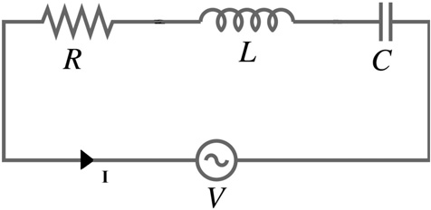

Fig. 1. RLC equivalent circuit of a radiofrequency coil.
field. And thanks to the reciprocity principle, elements that are designed to receive signals are also called coils. However, at high frequencies, coils begin to act as antennas [11].
High intensity B₁ field is present in a region close to the coil, the so- called “reactive field” region, that is associated with the classical desired coil resonance operation. In this region, the B-field generated by the cur- rents in the coil is much greater than the E-fields that are generated in concomitance and only a small fraction of the B-field can be associated to the propagating wave. The major part of this B-field is associated to the reactive field, which causes a trapped energy near the coil without emissions to the surroundings. Being the coil a resonant structure, these fields are the coil resonant fields, which increase with increasing coil quality factor, which will be described later. This region is called the “near field” zone.

When the depths become larger inside the tissue (i.e. the distance from the coil increases), the reactive fields vanish and the so-called “ra- diative fields” become more dominant. In these regions both E-fields and B-fields decrease and the radiative part of the electromagnetic wave becomes dominant with respect to the reactive part. Such regions far away from the coil are characterized by pure propagating wave be- haviour and the RF field distribution has become an electromagnetic wave which propagates away from the coil, with a precise relationship between E-fields and B-fields and with the power ﬂow direction toward the target region, as described by the Poynting vector [11]. This region is called the “far field” zone. The estimation of the extent of the near field and the start of the far field can be performed by using a rule of thumb as
[12] r = λ/2π. This is a “crossover point” which permits to discriminate near field and far field in dependence on the wavelength.

- Similarities and differences between RF coils and communication antennas

RF coils are designed to work at the Larmor frequency with maxi- mum efficiency. In particular, as described in the previous section, the current generated in the coil must be maximal at the Larmor frequency. If this condition is verified, the coil is said to be tuned at the Larmor fre- quency, that thus corresponds to the coil resonant frequency. Since the magnetic field produced by the coil is directly proportional to the magni- tude of the current, a coil operating at the resonant frequency produces the desired magnetic field strength with a relatively low input voltage [1]. However, the resistance R limits the current in the coil and, thus, the quality factor (Eq. (3)). In order to maximize its performance, a RF coil should be designed as a resonant structure with a high quality factor
Q. A practical way to measure the Q is based on the following definition:
transmission line (which is usually real). Therefore, efficient matching networks must be designed for providing the desired frequency charac- teristics [10].
The use of phased-array RF coils permits to provide a large region of sensitivity, similarly to that obtained with volume coils, and a high SNR, usually associated with surface coils. The simplest design of such RF coils is an array of circular or rectangular loops of conducting material. Each array element is connected to an independent receiver channel and the outputs from these channels are combined in an optimal man- ner with a phase correction dependent on the point in space from which the signal is originated. The most common challenge in designing array coils is the mutual coupling between the elements. This phenomenon, giving rise to a change in the coil inductance, modifies the resonant fre- quency of each coil and thus leading to a worsening of the SNR. More- over, each array element would be sensitive to a region that should be sensed by another element thus leading to an incorrect spatial encoding. Generally, the adjacent coils are overlapped to yield zero mutual induc- tance, while for reducing the interference between the overlapped cou- ple and the other coils in the array, each coil can be connected to a low input impedance preamplifier [14].
Similarly, when is necessary to design antennas with very directive
characteristics for long distance communications, an array of radiating elements fixed in a precise geometrical configuration has to be designed. However, the presence of an antenna element near to another can alter the current distribution and the radiated field, since antenna perfor- mance depends on also the current of neighbouring elements. Such cou- pling between two or more antenna elements is a function of the position of one element respect to the others and mutual effect have to be discussed for the different arrangements. In order to maximize anten- na performance, the fields from the array elements have to interfere con- structively in the desired directions and interfere destructively in the

Q f 0
¼
B_{w}
ð6Þ
remaining space. The array antenna overall pattern depends on the ele- ments geometrical configuration, the relative displacement between el- ements, the excitation amplitude and phase of the single elements and

where B_{w} is the −3 dB coil bandwidth. Accordingly to the previous con-
siderations, B_{w} should be minimized. As described in Eq. (4), the term r is employed to verify that there are no significant coil losses, which ensures large reactive fields in the near-field region [11].
Similarly, the quality factor is a figure-of-merit which is representa- tive of antenna losses, constituted by radiation, conduction, dielectric and surface wave losses [10]. The same Eq. (6) characterizes the Q of the antenna, where f_{o} is the center frequency and B_{W} the bandwidth of the antenna (which defines the frequency range in which the antenna characteristics are not very different with respect those at the center frequency).
In an antenna, the resulting B- and E-fields generate a Poynting vector which is oriented toward the direction of propagation. The electromag- netic wave is characterized by the ratio between electromagnetics wave components E and B, namely “wave impedance”. In far field region, for a wave traveling in a medium, wave impedance is equal to equilibri-
um wave impedance η_{medium}:
the radiation pattern of the single elements [10].

- Simulation of RF coils for MR

Magnetostatic theory implies a nearly static field assumption that holds only when the coil dimensions are much lower than the wave- length. It has been demonstrated useful for the design of low frequency coils constituted by linear and circular conductor segments [15], where the calculation of the magnetic field generated by the currents along the coil conductors can be performed by subdividing the coil path in seg- ments, in order to separately study their total magnetic field contribution.
The static magnetic field produced by a steady electric current I ﬂowing in an arbitrary closed contour C can be calculated by using Biot-Savart law [1]:

ηmedium ¼
rμﬃﬃﬃ

ε

ð7Þ
B r μ0I
4π
Zð Þ ¼
C
dl∧R R3
ð8Þ

where μ and ε are, respectively, medium permeability and permittivity. In an antenna, impedance should be as close as possible to the equi- librium wave impedance and, as a consequence, antennas will have a
low Q factor [11].
RF coil has to have low impedance for minimizing the electric field component and consequently the sample dielectric losses. Such coil im- pedance has to be matched to the (purely resistive) standard imped- ance of 50 Ω by using a non-dissipative network minimizing the losses. A good review of matching circuit configuration can be found in [13]. Even antennas, whose input impedance is generally a function of frequency, has to be matched to the characteristic impedance of the

where μ₀ = 4π ∗ 10⁻⁷ Henry per meter (H/m) is the free space perme- ability, dl is the infinitesimal vector tangential to C and R is the distance between the conductor path and the observation point.
Biot-Savart equation can be used for the simulation of the three- dimensional B₁ field distributions of the coils. The conductor sizes can be neglected respect to the wavelength, and the magnetic field generated by the currents can be evaluated considering conductors as very thin wires. Being derived from Maxwell's fourth law by neglecting the term ∂ E/∂t (where E is the electric field strength), Biot-Savart law can be employed for B magnetic field calculation only for Direct Current (DC) and low frequencies. Fig. 2 shows an

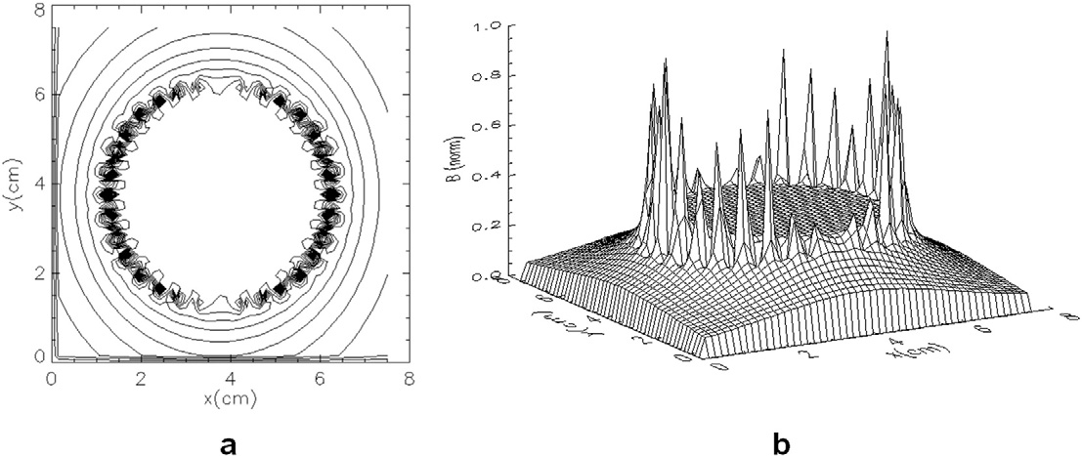

Fig. 2. Contour plot (a) and 3-dimensional representation (b) of a birdcage coil B₁ magnetic field pattern.

example of a 32 legs highpass birdcage coil B₁ field pattern calculated with the software simulator described in [16].
At high frequencies, electric fields will be induced in the tissues due to Faraday's law:

conditions. Powerful personal computers (PC) or other dedicated com- puting platforms have to be used for implementing these methods.

  - Transmit coils

♙ E ∂B
× ¼
∂t
ð9Þ

When an RF coil is used in transmission, it has to generate a homo- geneous B₁ field in the volume of interest, in order to excite the nuclei

and the term ∂E/∂t cannot longer be neglected. At high frequencies, the joint presence of the E-fields and B-fields will generate an electromag- netic wave that will be emitted from the coil, starting to behave as anten- nas, as previously stated.
The E-field and B-field which constitute the electromagnetic wave have got a periodicity in time and in space and are orthogonal to each other and to the propagating direction.
Let's now define the H magnetizing field strength which is related to B as according to:
B ¼ μ₀μr H ð10Þ
where μ₀ and μ_{r} are, respectively, the permeability of free space and the relative permeability of the medium.
The quantity which takes into account the energy associated to the electromagnetic wave is the Poynting vector S:
S ¼ E × H ð11Þ
which is expressed in watts per meter square and whose direction indi- cates the energy ﬂow direction [11].
At high frequencies, SNR distribution is affected by sample electro- magnetic properties leading to a difficult analytical solution. For these reasons, modern MR coil development exploits numerical methods (Method of Moments [17], Finite Element Method [18] and Finite-Differ- ence Time-Domain method [19]), which can be classified according to whether the computation is made in the time or frequency domain, and if the method is based on differential or integral equations. Numeri- cal methods allow to simulate the behaviour of the coil in presence of re- alistic loads and to investigate the coil efficiency at high magnetic fields. Numerical approach could easily also take into account the currents in- duced in the coil conductors by the changing magnetic field, i.e. the eddy currents. Finally, the use of numerical methods joined with ad- vanced optimization algorithms, as genetic algorithms [20], may allow to design coils with a complex shape.
Numerical methods are used to estimate the magnetic field pattern of
RF coil in loaded condition (with part of exposed body) and to provide a numerical solution of Maxwell's equations with specific boundary
uniformly. Therefore, magnetic field homogeneity is an important pa- rameter in the design, because the FOV depends on it. Magnetic field pattern can be evaluated with magnetostatic theory or by using numer- ical methods as according to wavelength size, as previously described.
New-generation MRI systems are designed to work with higher B₀ fields, which leads to a higher exciting B₁ field and hence to a RF power deposition. When the B₁ field wavelength approaches the sam- ple sizes, significant interaction between the field and the sample may occur [21]. This causes safety concerns because it generates a much stronger electric field and eddy currents in the sample, resulting in in- creased power deposition.
Specific Absorption Rate (SAR) is the dosimetric parameter employed for monitoring and quantifying the subject power deposition. SAR can be calculated using a geometrical model of the transmit coil and the human subject. The power deposition on the subject can be calculated by analyt- ical equations [22], or by the numerical resolution of Maxwell's equa- tions to estimate the electric field on the human subject [23].
Literature reported data on SAR estimation in a high-resolution body model [24] and in an accurate human head model, segmenting the image of a male cadaver and calculating the local SAR [25], in which both sim- ulations were performed using the FDTD method.
An example of a transmit-receive shielded 16 elements ¹H high-pass birdcage head coil manufactured by Nova Medical (Wilmington, MA, USA), operating in quadrature at 298 MHz, is given in Fig. 3. The coil was simulated using Finite Integration Technique (FIT) in the CST MW Suite, and it was loaded with of an anatomical human head [26]. Fig. 4a shows the B₁₊ magnitude map and Fig. 4b the local SAR on the sagittal slice using a total input power of 4 W.
SAR evaluation is especially important with the use of transmit phased array coil systems, recently proposed to provide a highly uniform tissue excitation [27]. This makes SAR evaluation a challenging problem due to the infinite number of possible field distributions in the sample [28].

  - Receive coils

As described early, when an RF coil is employed in reception, must provide a high SNR. since this parameter affects the reconstructed image quality [29].

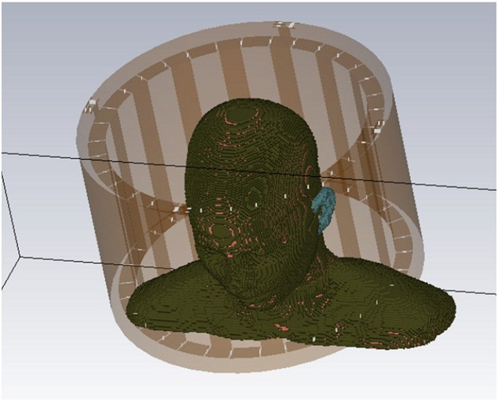
local SNR obtained with parallel imaging (SNR_{PI}) can be evaluated as [33]:

SNR_{PI}
SNRfull
13Þ

¼ pR g ð
ﬃﬃﬃ
where SNR_{full} is the SNR which would be obtained with full gradient encoding by using the same coil array and the same sequence, R is the ac- celeration factor taking into account of k-space density reduction and g is the geometry factor. Being g dependent on number and geometrical con- figuration of the array elements, SNR_{PI} can be improved by an accurate de- sign of array geometry [34].

- Simulation of antennas for communication

Fig. 3. Quadrature birdcage coil loaded with human head.

SNR can be expressed as the ratio between the induced MR-signal and the rms of the thermal noise voltage measured at the coil terminals [30]:

2πfMVB1P
In the last years the problem of efficient and accurate analysis of an- tennas for communications have largely grown. Antennas are usually assumed to radiate in free-space, and they can be mounted or not on structure. Typical examples of antennas mounted on structures include slotted array antennas mounted on platforms, or on a ship or aircraft surface. Hybrid approaches are often used to address this task [35].
Specifically, the antenna array itself may be analyzed with a state-of- the-art numerical method such as FEM or FDTD technique [36]. Howev- er, the much larger platform on which the antenna is mounted remains beyond the capability of numerical methods without the use of very large-scale computer resources.
Recently, the Characteristic Basis Function Method of Moment (CBFM) [37] and its analytical version, namely the High-Frequency Inte-

SNR_{P} ¼ q4ﬃﬃﬃkﬃﬃﬃTﬃﬃΔﬃﬃﬃﬃfﬃﬃﬃ ﬃﬃRﬃﬃﬃﬃﬃﬃﬃﬃﬃﬃﬃﬃﬃﬃRﬃﬃﬃﬃﬃﬃﬃﬃﬃﬃﬃﬃﬃﬃ ﬃﬃ
coil þ sample
ð12Þ
gral Equation (HFIE) method [38], have been introduced for efficient analysis of electromagnetic scattering and radiation problems involving complex targets. The CBFM is based on utilizing Characteristic Basic Functions (CBFs), special functions defined on macro domains (blocks),

where f is the Larmor frequency, M is the magnetization, V is the voxel
volume, B_{1P} is the receive coil magnetic field per unit current at the obser- vation point P, k is the Boltzmann constant, T is the resistance absolute temperature and Δf is the receiver bandwidth.
An estimation of coil SNR can be achieved by computing the coil mag- netic field B_{1P}, the coil resistance R_{coil} and the sample induced resistance Rsample.
Magnetic field pattern can be evaluated as for transmit coils, thanks to the reciprocity theorem [5].
The sample induced resistance can be calculated using a numerical method which implements the FDTD algorithm, by using resonant cir- cuits theory [31], while a recent work [32] employed FEM for predicting the losses within the coil.
High SNR and large FOV can be obtained with array coils, which also allow the implementation of parallel imaging, a technique that exploits array coils for spatial encoding, providing a substantial reduction of the ac- quisition time. For the parallel sensitivity encoding (SENSE) technique, the
which include a relatively large number of conventional sub-domains discretized by using triangular or rectangular patches. Use of these basis functions leads to a significant reduction in the number of un- knowns, and results in a substantial size-reduction of the MoM matrix. This, in turn, enables us to handle the reduced matrix by using a direct solver, without the need of the iteration process. An example of antenna on large platform is given in Fig. 5a (the operating frequency is 9 GHz), while Fig. 5b depicts an array of 4 slot antennas mounted on a missile. For the last example, Fig. 6 shows the co-polar components of the electric far field, in the three planes, when the operating frequency is 3 GHz [39].

- Conclusions

RF coils are key components in Magnetic Resonance systems. For obtaining high quality images, coils should be able to support FOV with high magnetic field homogeneity in transmission and achieve high SNR in reception.

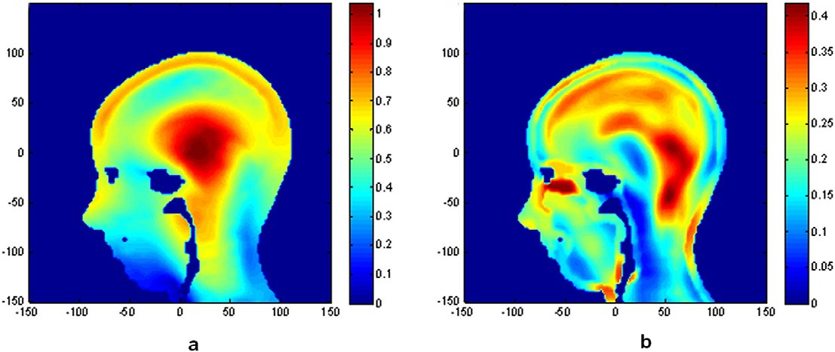

Fig. 4. B₁₊ magnitude map (a) and local SAR on the sagittal slice (b). The central focusing effect (typical for the birdcage) is clearly visible in B₁₊ maps. B₁₊ is in μT, SAR in W/kg.

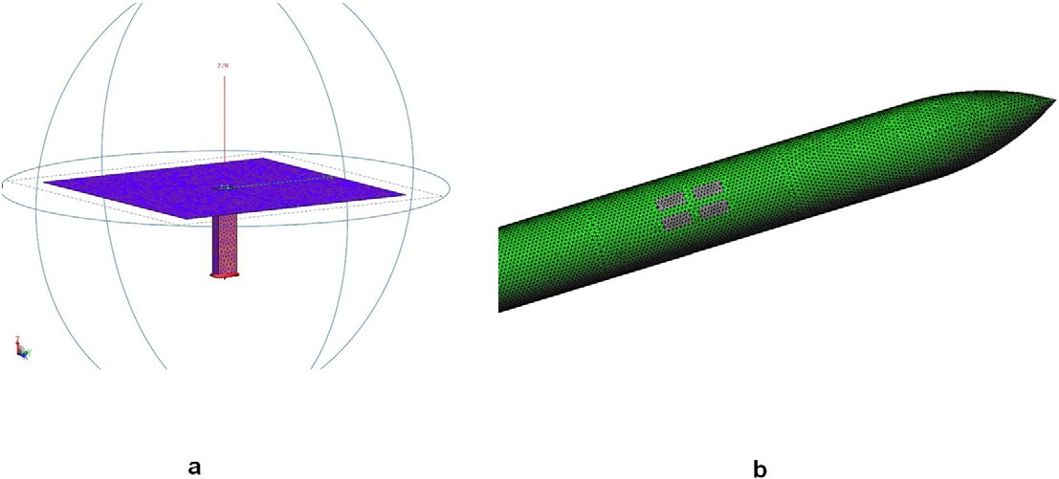

Fig. 5. 9 GHz antenna on a large platform (a) and 4 slot antennas array on a missile (b).

Starting from the RF coils theory, this paper describes coil and antenna performance parameters and their simulation and design methods.
We believe the paper could be interesting for graduate students and researchers working in the fields of magnetic resonance coil and com- munication antenna design and development.

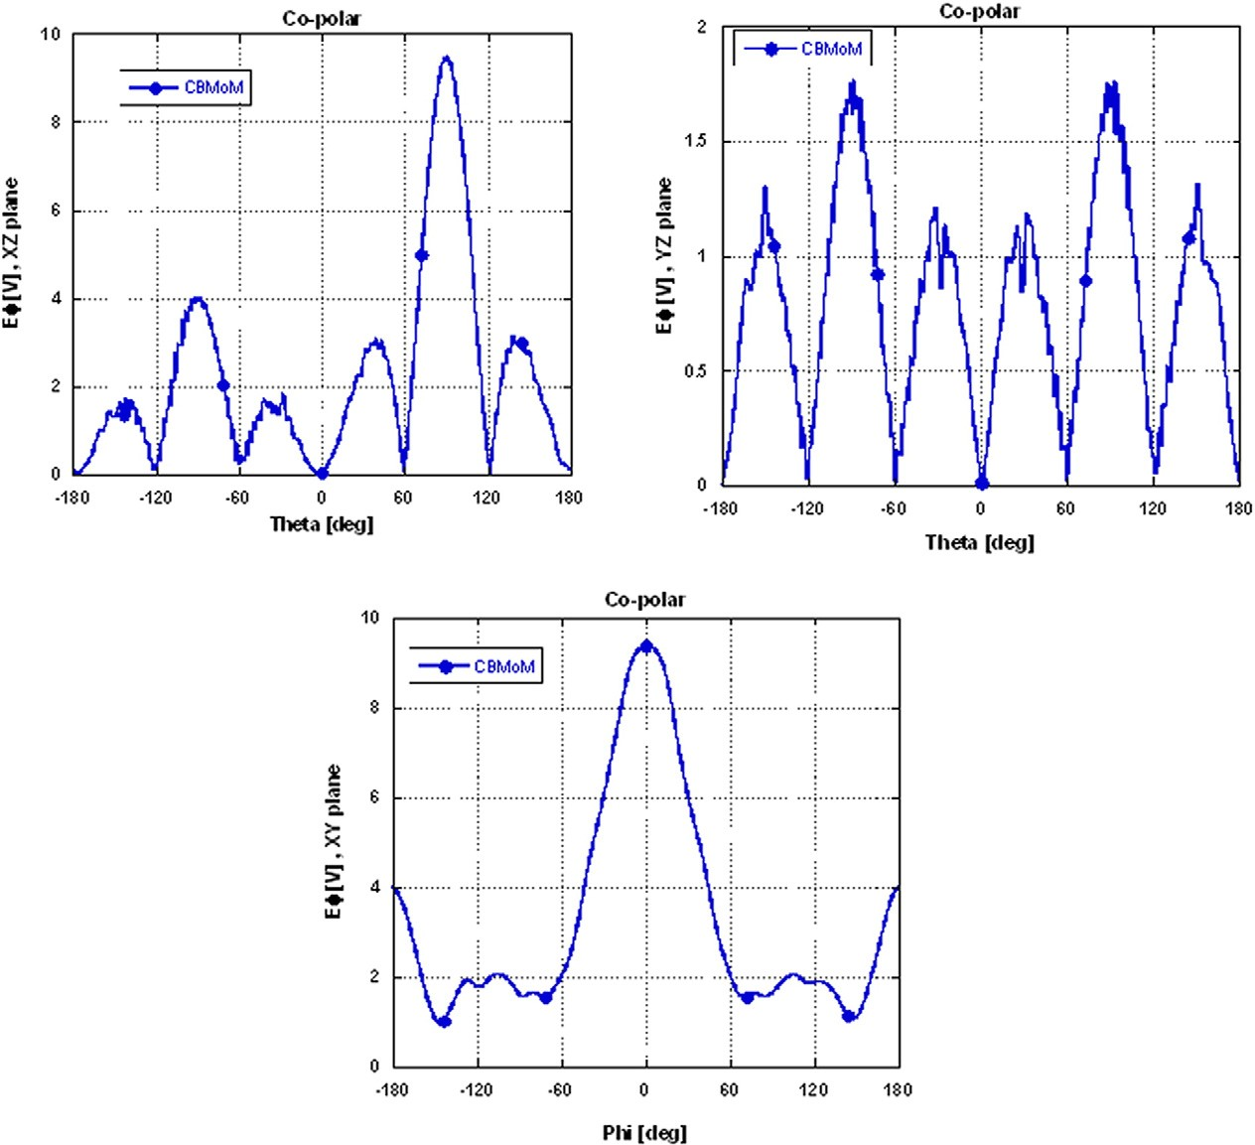

Fig. 6. Ф-component of the E far field calculated on the three planes.

References
  - Jin JM. Electromagnetic analysis and design in magnetic resonance imaging. Boca Raton, FL: CRC Press; 1999.
  - Hoult DI, Richards RE. The signal-to-noise ratio of the nuclear magnetic resonance experiment. J Magn Reson 1976;24:71–85.
  - Roemer PB, Edelstein WA, Hayes CE, Souza SP, Mueller OM. The NMR phased array. Magn Reson Med 1990;16:192–225.
  - Giovannetti G, Hartwig V, Positano V, Vanello N. Radiofrequency coils for magnetic resonance applications: theory, design, and evaluation. Crit Rev Biomed Eng 2014; 42(2):109–35.
  - Hoult DI. The principle of reciprocity in signal strength calculations? A mathematical guide. Concepts Magn Reson 2000;12:173–87.
  - Giovannetti G, Hartwig V, Landini L, Santarelli MF. Low field MR coils: comparison between strip and wire conductors. Appl Magn Reson 2010;39:391–9.
  - Haase A, Odoj F, Von Kienlin M, Warnking J, Fidler F, Weisser A, et al. NMR probeheads for in vivo applications. Concepts Magn Reson 2000;12:361–88.
  - Hayes CE, Edelstein WA, Schenck JF, Mueller OM, Eash M. An efficient, highly homo- geneous radiofrequency coil for whole-body NMR imaging at 1.5 T. J Magn Reson 1985;63(3):622–8.
  - Edelstein WA, Glover GH, Hardy CJ, Redington RW. The intrinsic signal-to-noise ratio in NMR imaging. Magn Reson Med 1986;3:604–18.
  - Balanis CA. Antenna theory-analysis and design. John Wiley & Sons, Inc: U.S.A; 1997.
  - Raaijmakers AJE, van den Berg CAT. Antennas as surface array elements for body im- aging at ultrahigh field strengths. Encyclopedia of magnetic resonance. Hoboken (NJ): John Wiley & Sons, Ltd; 2012.
  - Capps C. Near field or far field? EDN magazine. http://www.edn.com/design/ communications-networking/4340588/Near-field-or-far-field-. (Accessed December 2016).
  - Mispelter J, Lupu M, Briguet A. NMR probeheads for biophysical and biomedical ex- periments. Theoretical principles and practical guidelines. London: Imperial College Press; 2006.
  - Wright SM, Wald LL. Theory and application of array coils in MR spectroscopy. NMR Biomed 1997;10:394–410.
  - Giovannetti G, Viti V, Positano V, Santarelli MF, Landini L, Benassi A. Magnetostatic simulation for accurate design of low field MRI phased-array coils. Concepts Magn Reson B 2007;31B(3):140–6.
  - Giovannetti G, Landini L, Santarelli MF, Positano V. A fast and accurate simulator for the design of birdcage coils in MRI. Magn Reson Mater Phys Biol Med 2002;15: 36–44.
  - Hand JW, Lau RW, Eagendijk JJW, Ling J, Burr M, Young IR. Electromagnetic and ther- mal modeling of SAR and temperature fields in tissue due to a RF decoupling coil. Magn Reson Med 1999;42:183–92.
  - Simunic D, Wach P, Renhart W, Stollbergcr R. Spatial distribution of high-frequency electromagnetic energy in human head during MRI: numerical results and measure- ments. IEEE Trans Biomed Eng 1996;43(I):88–94.
  - Collins CM, Li S, Smith MB. SAR and B₁ field distributions in a heterogeneous human head model within a birdcage coil. Magn Reson Med 1998;40:847–56.
  - Cantú-Paz E. Efficient and accurate parallel genetic algorithms. Dordrecht: Kluwer Academic Publishers; 2001.
  - Hoult DI, Phil D. Sensitivity and power deposition in a high-field imaging experi- ment. J Magn Reson Imaging 2000;12:46–67.
  - Bottomley PA, Redington RW, Edelstein WA, Schenck JF. Estimating radiofrequency power deposition in body NMR imaging. Magn Reson Med 1985;2(4):336–49.
  - Liu W, Collins CM, Smith MB. Calculations of B 1 distribution, specific energy absorp- tion rate, and intrinsic signal-to-noise ratio for a body-size birdcage coil loaded with different human subjects at 64 and 128 MHz. Appl Magn Reson 2005;29:5–18.
  - Yee KS. Numerical solution of initial boundary value problems involving Maxwell's equations in isotropic media. IEEE Trans Antennas Propag 1966;AP-14:302.
  - Collins CM, Smith MB. Signal-to-noise ratio and absorbed power as functions of main magnetic field strength, and definition of “90 degrees” RF pulse for the head in the birdcage coil. Magn Reson Med 2001;45(4):684–91.
  - Tiberi G, Costagli M, Biagi L, De Ciantis A, Fontana N, Stara R, et al. SAR prediction in adults and children by combining measured B1+ maps and simulations at 7.0T. J Magn Reson Imaging 2016;44:1048–55.
  - Katscher U, Bornert P, Leussler C, Van den Brink JS. Transmit SENSE. Magn Reson Med 2003;49:144–50.
  - Mao W, Wang Z, Smith MB, Collins CM. Calculation of SAR for transmit coil arrays. Concepts Magn Reson B 2007;31B(2):127–31.
  - Hoult DI, Richards RE. The signal-to-noise ratio of the nuclear magnetic resonance experiment. J Magn Reson 1976;24:71–85.
  - Hoult, Lauterbur PC. The sensitivity of the zeugmatographic experiment involving human sample. J Magn Reson 1979;34:415–33.
  - Giovannetti G, Viti V, Liu Y, Yu W, Mittra R, Landini L, et al. An accurate simulator for MR coil sensitivity estimation. Concepts Magn Reson B 2008;33B(4):209–15.
  - Giovannetti G, Tiberi G, Tosetti M. Finite element method-based approach for radio- frequency magnetic resonance coil losses estimation. Concepts Magn Reson B 2016; 46B(4):186–90.
  - Pruessmann KP, Weiger M, Scheidegger MB, Boesiger P. SENSE: sensitivity encoding for fast MRI. Magn Reson Med 1999;42:952–62.
  - Wiesinger F, Boesiger P, Pruessmann KP. Electrodynamics and ultimate SNR in par- allel MR imaging. Magn Reson Med 2004;52:376–90.
  - Burkholder RJ, Pathak PH, Sertel K, Marhefka J, Volakis JL. A hybrid framework for antenna/platform analysis. Appl Comput Electromagn Soc J 2006;21(3):177–95.
  - Peterson AF, Ray SL, Mittra R. Computational methods for electromagnetics. U.S.:Wiley-IEEE Press; 1998.
  - Prakash VVS, Mittra R. Characteristic basis function method: a new technique for ef- ficient solution of method of moments matrix equation. Microw Opt Technol Lett 2003;36(2):95–100.
  - Tiberi G, Rosace S, Monorchio A, Manara G, Mittra R. Electromagnetic scattering from large faceted conducting bodies by using analytically-derived characteristic basis functions. IEEE Antennas Wirel Propag Lett 2003;2(20):290–3.
  - De Gregorio M, Tiberi G, Bianchi D, Monorchio A. Radiation of apertures arrays mounted on large conducting structures through a Characteristic Basis Function (CBF) approach. Int Conf Electromagn Adv Appl (ICEAA) 2012:1180–3.

