Alloy selections in high-temperature metal hydride heat pump systems for industrial waste heat recovery

Y.T. Ge*, P.Y. Lang

School of the Built Environment and Architecture
London South Bank University, 103 Borough Road, London, SE1 0AA, UK

ABSTRACT
In an energy intensive industrial site such as a steel plant, there are plenty of medium and low temperature waste heat which could be recovered for heating purposes with advanced and feasible technologies for example metal hydride (MH) heat pumps. Compared to other heat pump systems such as those with compression and absorption cycles, the MH heat pump has some distinctive advantages including low carbon system in terms of less electricity input and environmentally friendly working mediums, compactness, and most importantly achievable heat output with relatively high temperature. However, the applicable alloys for the high-temperature MH heat pump systems are critical and need to be purposely selected. Accordingly, in this paper, a comprehensive procedure to select alloys for the high-temperature MH heat pump systems is explained based on the operating temperatures, system efficiencies and thermodynamic equilibriums. From the database of literatures, totally 82 alloys are potentially used for this special application of which 1560 alloy pairs are formed and each pair consists of one high-temperature alloy and another low-temperature alloy. Subsequently, a number of applicable alloys are selected for each designed temperature of heat pump output and one pair is ultimately finalised. The alloy can be further examined considering of its thermophysical properties, heat transfer behaviours, costs and safety issues.
Keywords: waste heat recovery, high-temperature metal hydride (MH) heat pumps, alloy selections, system efficiencies.

* Corresponding author.
E-mail address: yunting.ge@lsbu.ac.uk (Y.T. Ge)

Nomenclature
C_{v} specific heat at constant volume (J/mol alloy.K) Subscripts
C_{p} specific heat at constant pressure (J/kg.K) c Carnot
COA coefficient of amplification h high
∆H standard enthalpy (kJ/mol H₂) l low
HT high temperature m,MH metal hydride
LT low temperature R reactor
n molar number t transfer
P pressure (atm) 1 reactor one
Q heat capacity (W or kW) 2 reactor 2
R universal gas constant
∆S standard enthalpy and entropy (J/mol H₂.K)
T Temperature (K)
W Weight (kg)
WM molar weight (g/mol)
ψ exergy efficiency

Introduction

Industrial waste heat recovery for decarbonised heating and cooling is an attractive concept that could simultaneously reduce fossil fuel consumption and CO₂ emissions. In the UK, based on a recent report, of the total industrial waste heat sources, about 28 TWh/yr could be potentially used in district heat networks [1]. The waste heat sources from different industrial sectors can have different temperature grades and various applications. For the low grade heat sources with temperature below 230°C, Organic Rankine Cycles (ORCs) might be applied for potential power generations. However, the thermal (electric) efficiency of an ORC with the low grade heat source is quite low (about 10% or below) which might not be a good investment from the economic point of view [2]. In addition, a typical energy intensive industrial site such as steel plant also has plenty of waste heat with extra low grade around 40°C which is conventionally exhaust to ambient directly[3]. These low grade waste heat sources can be combined with some advanced energy conversion systems such as heat pump to produce average low grade heat sources at temperature around 130°C which are more applicable for district heating at remote areas. Correspondingly, the conventional absorption or adsorption heat pump systems might be applied but they are hard to obtain heat output with temperature as high as 130 °C. Alternatively, a hydrogen related technology namely metal hydride (MH) heat pump can be a feasible option to achieve a high temperature heat output. Its working mechanism is quite similar to that of absorption or adsorption heat pump. However, for a MH heat pump, high and low temperature metal hydride alloys and hydrogen working fluid are applied to absorb heat from high and low temperature heat resources and produce heat at medium temperature. Meanwhile, the hydrogen desorption and absorption processes are conducted respectively during the heat input and output operations. Comparing to absorption or adsorption heat pump, the MH heat pump has similar operation efficiency but is more compact and can achieve higher temperature heat output. The MH heat pump has been investigated mostly in conventional heat pump systems [4,5], but has not been applied in district heating systems with industrial waste heat due to relatively high temperature heat input and output. To facilitate this, one of the critical points is to select appropriate alloy pairs for the MH heat pump at the applicable operating conditions and acceptable system performance efficiency.
Conventionally, the applicable alloys for the MH heat pump (MHHP) systems are categorised as intermetallics with conventions of AB, AB₂, A₂B and AB₅, where ‘A’ is usually a lanthanide element (Atomic numbers 57-71), such as La, or mischmetal (rare earth metal mixture), and ‘B’ is Ni, Co, Al, Mn, Fe, Sn, Cu, Ti etc.[6]. In addition, element ‘A’ refers to rare earth and alkaline elements, presenting a high affinity for hydrogen to form stable hydride, while element ‘B’ is generally a transition metal and it usually presents a poor affinity for hydrogen and thus forming unstable hydrides [7]. The A_{x}B_{y} alloys can be modified by changing the alloy composition of x or y such that metal hydride with suitable properties can be formed[8,9]. Therefore, plenty of such alloys have been synthesized, characterized and are recommended for use in MHHPs. In addition, these intermetallic materials can be used as either low or high temperature alloys in their associated heat pump systems based on their corresponding operating temperatures and pressures. Satheesh et al. [10] investigated a single-stage metal hydride heat pump working with five different alloy pairs of AB₅, AB₂, AB types of alloys. These included MmNi_{4.6}Al_{0.4}/ MmNi_{4.6}Fe_{0.4}, LaNi_{4.61}Mn_{0.26}Al_{0.13}/La_{0.6}Y_{0.4}Ni_{4.8}Mn_{0.2}, LmNi_{4.91}Sn_{0.15}/Ti_{0.99}Zr_{0.01}V_{0.43}Fe_{0.09}Cr_{0.05}Mn_{1.5}, LaNi_{4.6}Al_{0.4}/MmNi_{4.15}Fe_{0.85} and Zr_{0.9}Ti_{0.1}Cr_{0.9}Fe_{1.1}/Zr_{0.9}Ti_{0.1}Cr_{0.6}Fe_{1.4}. The high (T_{H}), medium (T_{M}) and low (T_{L}) MH temperatures in the system were in the ranges of 110~170°C, 25~35°C and -30~20°C respectively, while the high and low operating pressures were in the ranges of 30~40 bar and 0.1~2 bar each. Based on the calculated system COP with each alloy pair, the optimum operating temperature ranges of each pair were suggested. At a heat source temperature of 130 °C and a refrigeration temperature of 20°C, a single-stage MHHP working with LmNi_{4.91}Sn_{0.15}/ Ti_{0.99}Zr_{0.01}V_{0.43}Fe_{0.09}Cr_{0.05}Mn_{1.5} was investigated numerically and experimentally[11]. The COP was calculated as 0.25 which was relatively low. A MHHP with MmNi_{4.5}Al_{0.5}/MmNi_{4.2}Al_{0.1}Fe_{0.7} MH alloy pair was studied theoretically by Mellouli et al. [12]. For the operating temperature ranges of 52~167°C /0~20°C /-23~-8 °C (TH/TM/TL), the COP was calculated as 0.45~0.5. There are also some other research investigations from literatures on MHHPs [13-15]. The heat source temperature can be as high as 200 °C but the heat output temperatures are mostly below 50°C. If a MHHP is applied for space heating purpose, a higher heat output temperature up to 100°C is required. In addition, for the applications of industrial processes, the heat output temperature from the heat pump up to 150 °C is expected [16]. However, such a high temperature is hard to be achieved with conventional compression and absorption heat pumps. Potentially, the MHHPs can obtain the heat output with such a high temperature but the applied MH alloys should be purposely selected, which haven’t been done yet from literatures.
Subsequently, in this paper, a comprehensive procedure to select alloys for the high-temperature MH heat pump systems is explained based on the operating temperatures, system efficiencies and thermodynamic equilibriums. From the database of literatures, totally 82 alloys are potentially used for this special application of which 1560 alloy pairs are formed and each pair consists of one high-temperature alloy and another low-temperature alloy. Subsequently, a number of applicable alloys are selected for each designed temperature of heat pump heat output. An applicable MH alloy pair is thus finalised based on its operating pressures and performance efficiencies.

System description

The schematic diagram of the MHHP system and its operating cycle on a Van’t Hoff plot is shown in Fig. 1. As depicted, the system consists of two MH reactor pairs, MH1a and MH2a, and MH1b and MH2b. Each pair has one high temperature MH reactor (MH1a or MH1b) and one low temperature MH reactor (MH2a or MH2b). For each MH reactor pair, a hydrogen connection pipe with a control valve is connected in-between to facilitate hydrogen to flow between two reactors. In the system, there are one heat input (Q_{h}) with high temperature (T_{h}), one heat input (Q_{l}) with low temperature (T_{l}), and two heat outputs (Q_{m1} and Q_{m2}) with medium temperature (T_{m}). The system operation consists of two half cycles. For the first half cycle (solid line in the system layout), the high temperature heat Q_{h} is input to MH1a such that hydrogen (H2) is desorbed from MH1a and passes through the H2 connection pipe and is absorbed by MH2a. The reaction heat Q_{m2} at temperature T_{m} during the absorption process is therefore released from MH2a. Meanwhile, the low temperature heat Q_{l} is added to MH2b to desorb H2 from the reactor. The H2 released from MH2b then passes through the H2 connection pipe and is absorbed by MH1b such that the heat Q_{m1} at temperature T_{m} is released. For the second half cycle (dot line in the system layout), the directions of heat inputs to and outputs from the reactors are swapped. In that case, Q_{h} and Q_{l} are inputs to MH1b and MH2a respectively while Q_{m1} and Q_{m2} are outputs from MH1a and MH2b each. In addition, the H2 flows in those two connection pipes flow in opposite directions to those in the first half cycle. The operating cycle can thus ensure continuous operation of the system. It should be noted that the temperatures of heat source (T_{h} and T_{l}) and heat sink (T_{m}) are assumed the same as those of their corresponding reactors.

MH alloy selection

3.1 Thermodynamic analysis

For the application of industrial waste heat recovery using the MHHP system described in section 2, the designed temperature ranges of high temperature (T_{h}), medium temperature (T_{m}) and low temperature (T_{l}) heat sources are specified as 180~240°C, 120~140°C and 25~45 °C respectively. For the hydrogen absorption or desorption process of a MH reactor in the system, the MH alloy (M) reacts reversibly with hydrogen (H₂) as follows:
$M+{(\frac{x}{2})H}_{2}\begin{matrix}absorption \\ ⇄ \\ desorption\end{matrix}{MH}_{x}+Q$ (1)
where x is the hydrogen atom number in the metal hydride, Q is heat release during hydrogen absorption (exothermic) process or heat input during hydrogen desorption (endothermic) process. For each reaction process, the van’t Hoff’s law applies with following form:
$\ln{P_{H_{2}}=-\frac{∆H×1000}{RT}+\frac{∆S}{R}}$ (2)
where $P_{H_{2}}$(atm) is hydrogen pressure, ΔH (kJ/mol H₂) and ΔS (J/mol H₂.K) are the standard enthalpy and entropy of hydride formation respectively, R is the gas constant (8.134 J/mol.K) and T is the hydrogen temperature (K). This equation is schematically represented in Fig. 1 for both MH1 and MH2 with two reaction processes including desorption and absorption. For a particular MH , the ΔH and ΔS are fixed such that the hydrogen absorption or desorption pressure is a function of reactor or hydrogen temperature only. For this MHHP system, since the designed temperatures of T_{h} , T_{m} and T_{l} are specified, the corresponding hydrogen pressure P_{h}, P_{m1}, P_{m2} and P_{l} can be calculated with equation (2). P_{m1} and P_{m2} represent hydrogen pressures in MH1 and MH2 respectively at the same medium temperature T_{m}. As seen from Fig. 1, the system operates at two different pressure levels, high and low. At the high pressure level, the hydrogen with temperature T_{h} and pressure P_{h} is desorbed at MH1 and flows to MH2 at temperature T_{m} and pressure P_{m2} and is absorbed there. At the low pressure level, the hydrogen with temperature T_{l} and pressure P_{l} is desorbed at MH2 and flows to MH1 at temperature T_{m} and pressure P_{m1} and is absorbed there. Practically, to enable the hydrogen to flow from one reactor to another, the pressure P_{h} and P_{l} should be slightly higher than P_{m2} and P_{m1} respectively. However, to facilitate the MH alloy selection, P_{h} and P_{l} are assumed the same as P_{m2} and P_{m1} correspondingly. In that case, the following formulas will follow:
$-\frac{{∆H}_{1}×1000}{T_{h}}+{∆S}_{1}=-\frac{{∆H}_{2}×1000}{T_{m}}+{∆S}_{2}$ (3)
$-\frac{{∆H}_{1}×1000}{T_{m}}+{∆S}_{1}=-\frac{{∆H}_{2}×1000}{T_{l}}+{∆S}_{2}$ (4)
where, the subscripts 1 and 2 indicate the MH reactor 1 (MH1) and 2 (MH2) respectively. To simply, two parameters of η and ξ are defined as below:
$η=\frac{{∆S}_{1}-{∆S}_{2}}{{∆H}_{2}}$ (5)
$ξ=\frac{{∆H}_{1}}{{∆H}_{2}}$ (6)
Accordingly, the following equations are obtained:
$η=(\frac{ξ}{T_{h}}-\frac{1}{T_{m}})×1000$ (7)
$η=(\frac{ξ}{T_{m}}-\frac{1}{T_{l}})×1000$ (8)
From Equations (5) and (6), the parameters η and ξ are the functions of thermophysical properties of the MH alloy pair applied particularly the values of their ΔH and ΔS. Based on Equations (7) and (8), the parameters η and ξ are also constrained by the operating temperatures of T_{h} , T_{m} and T_{l}. Therefore, at specified temperature ranges of T_{h} , T_{m} and T_{l}, the potential MH alloy pairs used in the MHHP system can be identified. From literature review, as listed in Table 1, totally 82 MH alloys are chosen from which the potential MH alloy pairs for the MHHP system will be selected[10],[17-26]. As listed in the table, the important parameters of ΔH and ΔS for each MH alloy are listed. In addition, for this particular MHHP, it is known that the lowest average MH reactor temperature T_{l} is 35°C. Correspondingly, the hydrogen pressure P_{l} is calculated for each MH reactor. In the proposed system, it consists of two identical high temperature (HT) MH alloys and two identical low temperature (LT) MH alloys. Therefore, two types of MH alloys, HT and LT, need to be identified in the system. To classify, if the calculated P_{l} is less than 1 bar, the MH alloy is HT one otherwise it is LT one. Subsequently, of the total 82 MH alloys, 30 are classified as HT types and 52 are belonged to LT alloys. For each HT MH alloy, it can be paired with any of the LT MH alloys such that totally 1560 MH pairs can be formed.
Based on the equations (5) and (6), the coordinate points (ξ,η) of all the available MH alloy pairs (1560 in total) can be demonstrated in a ξ-η diagram, as shown in Fig. 2. From this statistical diagram, it can see roughly a linear relation between η and ξ although further verification is needed. In addition, according to equations (7) and (8), at a constant T_{h} and T_{m} or constant T_{l} and T_{m}, a straight line of function η(ξ) can be drawn. From the system design, the maximum and minimum values of T_{h} are set to 220°C and 180°C respectively, while the maximum and minimum values of T_{l} are set to 25°C and 45°C each. Therefore, at a constant T_{m}, four straight lines at the maximum and minimum values of T_{h} and T_{l} can be shown in the same diagram. Correspondingly, when temperatures of T_{m} are set to 120°C, 130°C and 140°C，coordinate points (𝛏 , 𝛈 ) for the available MH alloys and four straight lines at maximum and minimum temperatures of T_{h} and T_{l} are shown in Figs 3,4 and 5 respectively. At a constant T_{m}, the system should operate with the temperatures of T_{h} and T_{l} at their respective temperature ranges. As such, the coordinate points (𝛏 , 𝛈 ) representing the applicable MH alloy pairs (solid circles in the diagram) should be enclosed with those four straight lines. Subsequently, there are 109, 35 and 12 applicable MH alloy pairs for T_{m} temperatures at 120°C, 130°C and 140°C respectively. It can be seen that the higher the heat pump output temperature is the less the applicable MH alloy pairs would be. However, the applicable MH alloys need to be further evaluated and identified based on the system performance when these alloy pairs are applied.
It should be noted that due to the inherent hysteresis in a MH alloy, at a constant temperature the MH absorption pressure is higher than that of desorption pressure. However, to simplify the selection procedure, the effect of the hysteresis on the MH alloy selection is neglected. In a practical application, once the MH alloys are identified, the heat source and sink temperatures can always be adjusted slightly to meet the pressure difference requirement of hydrogen transfer between two reactors.

3.2 Operation analysis

To analyse the system performance at the specified operating condition and MH alloy pairs, the energy input or output from each MH reactor in the system shown in Fig. 1 needs to be identified and calculated. To achieve that, it is necessary to fully understand the system operating cycle and the role of each MH reactor. For the HT MH reactors MH1a and MH1b, one reactor receives heat Q_{h} and another releases heat Q_{m1} for the first half cycle while for the second half cycle, the roles of these two reactors are changed over. Similarly, for the LT MH reactors MH2a and MH2b, one reactor receives heat Q_{l} and another releases heat Q_{m2} for the first half cycle while for the second half cycle, the roles of these two reactors are swapped. In addition, the directions of hydrogen transports from one reactor to another also changed over between two half cycles. Subsequently, the Q_{h}, Q_{m1}, Q_{m2} and Q_{l} can be calculated by equations (9) to (12) respectively.
$Q_{h}=n_{t1}{∆H}_{1}+(n_{1}{Cv}_{1}+W_{1R}{Cp}_{1R})(T_{h}-T_{m})$ (9)
$Q_{m1}=n_{t2}{∆H}_{1}+(n_{1}{Cv}_{1}+W_{1R}{Cp}_{1R})\left(T_{h}-T_{m}\right)$ (10)
$Q_{m2}=n_{t1}{∆H}_{2}-(n_{2}{Cv}_{2}+W_{2R}{Cp}_{2R})\left(T_{m}-T_{l}\right)$ (11)
$Q_{l}=n_{t2}{∆H}_{2}-(n_{2}{Cv}_{2}+W_{2R}{Cp}_{2R})(T_{m}-T_{l})$ (12)
In these equations, n_{t1} and n_{t2} are the total amount of hydrogen (mol) transferred from reactor MH1 and MH2 respectively, which should be the same at steady state. The n_{t1} or n_{t2} can be calculated based on the weight and gravimetric hydrogen storage capacity of respective metal hydride alloy charged in the reactor. The n₁ and n₂ are the number of moles of MH alloys for MH1 and MH2 respectively, which are dependent on the weight and type of MH alloy charged in each reactor. The W_{1R} and W_{2R} are the metal weight of reactor MH1 and MH2 respectively. The Cp_{1R} and Cp_{2R} are the specific heat capacity of metal reactor MH1 and MH2 respectively. It is noted that at the stage of MH alloy selection, the heat capacity rate of each reactor is not included in the energy calculation. However, these heat capacity rates should be included and considered in the system energy calculation once the MH alloys are determined. The Cv₁ and Cv₂ are the specific heat capacity of MH alloys at constant volume for reactors MH1 and MH2 respectively. These MH alloy properties are important to calculate the energy inputs and outputs in the system but mostly are not available such that some modes of calculation correlations are necessarily generated. Henceforward, based on available data from literature, it is found that the specific heat capacity Cv is closely related to the molar mass of the MH alloy applied, as shown in Fig. 6. A linear correlation is therefore obtained to calculate the C_{v} with the function of molar mass of the MH alloy, if the data is not available:

$C_{v}=0.3995{WM}_{MH}+33.287$ (13)

For this MHHP, the system efficiency is defined as coefficient of amplification (COA) and calculated as below:
$COA=\frac{Q_{m1}+Q_{m2}}{Q_{h}}$ (14)
Compared to conventional COP, the coefficient COA is of practical important for the specified application of hydride chemical heat pump [27]. It should be noted that the LT heat source heat input Q_{l} is not taken into account in the calculation of COA since it is conventionally exhausted into ambient. Supposing all the system processes are reversible, the total entropy production during the system operation will be zero such that the Carnot coefficient of amplification COA_{c} can be derived and calculated as:
${COA}_{c}=\frac{T_{m}(T_{h}-T_{m})}{T_{h}(T_{m}-T_{l})}$ (15)
The system exergy efficiency ψ can therefore be calculated as the ratio of COA and COA_{c}:
$ψ=\frac{COA}{{COA}_{C}}$ (16)
Based on the analysis results above, the applicable MH alloy pairs at heat output temperatures (T_{m}) 130 ℃ and 140 ℃ are listed in Tables 2 and 3 respectively. In addition, some important parameters including COA, COA_{c}, 𝝍, W₁, W₂, P_{h}, P_{l}, T_{h} and T_{l} are calculated and listed in each table, in which W₁ and W₂ are the weights of MH alloys charged in reactors MH1(MH1a or MH1b) and MH2 (MH2a or MH2b) respectively.
To evaluate and compare the system performance when different MH alloy pairs are applied, the variations of COA, COA_{c} and 𝝍 with various MH alloy pairs at T_{m} temperatures of 130 ℃ and 140 ℃ are shown in Figs 7 and 8 respectively. In addition, the variations of hydrogen high and low pressures with various MH alloy pairs at T_{m} temperatures of 130 ℃ and 140 ℃ are shown in Figs 9 and 10 respectively. For the heat pump application, the system is applicable only if its system efficiency COA is higher than one. In that case, for the temperatures T_{m} at 130 ℃ and 140 ℃, respectively 24 and 8 MH alloy pairs can be applied. For the high and low hydrogen pressures, the low hydrogen pressures are acceptable since almost all the low pressures are below 30 bar. However, some of the high pressures are quite high with the values up to 150 bar which need to be considered in the manufacturer’s ability , cost and operating safety. As seen from Tables 2 and 3 and Figs 7-10, only two MH alloy pairs can be applicable for both temperatures of T_{m} and acceptable COA values which are LaNi_{4.25}Al_{0.75}/ Zr_{0.9}Ti_{0.1}Cr_{0.6}Fe_{1.4} (HT/LT) ( pair number 6 in Table 2 and pair number 5 in Table 3) and LaNi_{4.8}Al_{0.2}/ CeNi₃Cr₂ (HT/LT) ( pair number 23 in Table 2 and pair number 9 in Table 3). However, the high hydrogen pressure with LaNi_{4.8}Al_{0.2}/ CeNi₃Cr₂ (HT/LT) is about 126 bar while the high hydrogen pressure with LaNi_{4.25}Al_{0.75}/ Zr_{0.9}Ti_{0.1}Cr_{0.6}Fe_{1.4} is below 30 bar. Therefore, from the system performance point of view, the MH alloy pair of LaNi_{4.25}Al_{0.75}/ Zr_{0.9}Ti_{0.1}Cr_{0.6}Fe_{1.4} is preferred.

3.3 System performance prediction

Based on the thermodynamic and operation analyses, the MH alloy pair LaNi_{4.25}Al_{0.75}/ Zr_{0.9}Ti_{0.1}Cr_{0.6}Fe_{1.4} (HT/LT) is determined for the proposed MHHP system. The system performance at different design and operating conditions can therefore be predicted. To simply the process, the effect of hysteresis on the MH absorption and desorption pressures at the same temperature is neglected. In addition, it is assumed that there is no temperature difference between heat source or sink temperature with its corresponding MH temperature. Nevertheless, effects of MH reactor heat capacity and hydrogen pressure difference for hydrogen transport through each MH rector pair are considered in the performance prediction. The metal material for each MH reactor is assumed as stainless steel and the meal reactor weight is assumed as 50% of its corresponding MH alloy charged. Since the weights of MH alloys in reactors MH1 and MH2 are 1.96 kg and 1 kg respectively, the corresponding reactor metal weights are 0.98 kg and 0.5 kg each. The hydrogen pressure difference between hydrogen transport through each MH rector pair on either high or low pressure side is assumed as 2 bar to facilitate the hydrogen transport. Accordingly, the variations of high and low temperature heat source temperatures T_{h} and T_{l} with heat output temperature T_{m} are calculated and shown in Fig. 11. It is seen from the prediction, the T_{h} and T_{l} both increase linearly with higher heat output temperature T_{m}. This indicates that to obtain a higher heat output temperature, both heat source temperatures of T_{h} and T_{l} need to be increased. Correspondingly, the variations of hydrogen pressures at those four reactors P_{h}, P_{m2}, P_{m1} and P_{l} with heat output temperature T_{m} are calculated and shown in Fig. 12. Similarly, the high and low side hydrogen pressures both increase with higher heat output temperature although the increase rates of the high side hydrogen pressures (P_{h} and P_{m2}) are relatively higher. This implies that the maximum MH reactor pressure should be considered at design stage based on the applicable maximum heat output temperature in the system. On the other hand, the system efficiencies in terms of COA_{c}, COA and 𝝍 can be calculated at varied heat output temperatures as shown in Fig. 13. As depicted, the COA_{c} decreases with increased heat output temperature while the COA decreases slightly with higher heat output temperature. Subsequently the exergy efficiency 𝝍 increases somewhat with the amplified heat output temperatures.
At constant heat output temperature T_{m} at 140°C, the variations of low temperature heat input Q_{l}, heat output Q_{m} and system cycle time with high temperature heat input Q_{h} are calculated and demonstrated in Fig. 14. As depicted, both low temperature heat input Q_{l} and heat output Q_{m} increase with higher high temperature heat input Q_{h}. Meanwhile, the system cycle time decreases rapidly at the beginning and slows down a bit with the increased high temperature heat input. This indicates that at a designed heat output temperature, the heat output capacity, system cycle time and low temperature heat input can be controlled by the high temperature heat input.

Conclusions

There are plenty of low grade waste heat from industries which can be recovered and converted to useful heat for district heating network with the technology of metal hydride (MH) heat pump (MHHP). The MHHP has several advantages compared with other heat pump technologies. However, one of the important tasks to utilise this technology in the industrial waste heat recovery is to find out the appropriate MH alloys for the system. Therefore, in this paper, a detailed MH alloy selection procedures are explained for the proposed high temperature MHHP system. Of the total available MH alloys, an efficient method is proposed to classify the applicable high and low temperature MH alloys based on the lowest hydrogen operation temperature and its corresponding pressure. A number of MH alloy pairs can therefore be formed, and each MH pair consists of one high temperature alloy and one low temperature alloy. For these MH alloy pairs, thermodynamic analysis is conducted based on thermodynamic equilibrium in the system and specified operating conditions. The applicable MH pairs are therefore figured out for each designed heat output temperature. It is found that the higher the designed heat output temperature, the less the applicable MH pairs. Thereafter, operation analysis is carried out to evaluate and compare the system energy and exergy efficiencies and operating pressures at specified heat output temperatures. Meanwhile, a correlation to calculate alloy specific heat capacity at constant volume based on its molar mass is obtained which is quite useful for the operation analysis. The MH alloy pair for the proposed MHHP system is thus identified and finalised. The system performance is then predicted at various heat output temperatures and high temperature heat inputs. The predicted results can be applied for the optimal system designs and operation controls.

Acknowledgement

The authors would like to acknowledge the support received from Research Councils UK (RCUK, EP/T022760/1) for this research project.

References

[1] Element Energy- The potential for recovering and using surplus heat from industry. Final Report for DECC (2014).
[2] L. Li L, Y.T. Ge, X. Luo, S.A. Tassou, Experimental investigations into power generation with low grade waste heat and R245fa Organic Rankine cycles (ORCs). Applied Thermal Engineering 115 (2017) 815-824.
[3] A. Patsos, Port Talbot Exergy Mapping and waste heat recovery opportunities. Project report 150552. Corus Research, Development & Technology (2010).
[4] M. Gamnini, Performance of metal hydride heat pumps operation under dynamic conditions. Int J Hydrogen Energy 14 (1989) 821-830.
[5] H. Bjurstrom, S. Suda, The metal hydride heat pump: dynamics of hydrogen transfer. Int J Hydrogen Energy 14 (1989)19-28.
[6] D. Chandra D, J.J. Reilly,R. Chellappa , Metal hydrides for vehicular applications: The state of the art. JOM 58 (2006)26–32.
[7] J. Payá Herrero, Modelling and analysis of a metal hydride cooling system, PhD thesis, Valencia, September (2010).
[8] H. Nakamura, Y. Nakamura, S. Fujitani, I. Yonezu, A method for designing a hydrogen absorbing LaNi5-x-yMnxAly alloy for a chemical refrigeration system. Journal of Alloys and Compounds 252 (1997) 83–87.
[9] P. Muthukumar, M. Groll, Metal hydride based heating and cooling systems: A review. Int J Hydrogen Energy 35 (2010)3817–3831.
[10] A. Satheesh, P. Muthukumar, Performance investigations of a single-stage metal hydride heat pump. Int J Hydrogen Energy 35 (2010) 6950-6958.
[11] M. Linder, E. Laurien, Thermally driven sorption machine for fast hydrogen exchange. In: Proceedings of hydrogen and hydrogen storage – methods and materials (H3-2009). Bangalore, India: Indian Institute of Science; Jan. 3–6 (2009).
[12] S. Mellouli, F. Askri, H. Dhaou, A. Jemni, S.B. Nasrallah, Parametric studies on a metal hydride cooling system. Int J Hydrogen Energy 34 (2009)3945-3952.
[13] F. Qin, J. Chen, M. Lu, Z. Chen, Y. Zhou, K. Yang, Development of a metal hydride refrigeration system as an exhaust gas-driven automobile air conditioner. Int J Hydrogen Energy 32 (2007) 2034–52.
[14] J. Ni, H. Liu, Experimental research on refrigeration characteristics of a metal hydride heat pump in auto air-conditioning. Int J Hydrogen Energy 32 (2007) 2567–72.
[15] S.G. Lee, Y.K. Kim, J.Y. Lee, Operating characteristics of metal hydride heat pump using Zr-based laves phases. Int J Hydrogen Energy 20(1995)77–85.
[16] K. George, A. Cordin, N. Panagiotis,B. Stefan, Techno-economic analysis of high-temperature heat pumps with low-global warming potential refrigerants for upgrading waste heat up to 150 ◦C. Energy Conversion and Management 226(2020)113488.
[17] P. Dantzer, E. Orgaz, Thermodynamics of hydride chemical heat pump-II. How to select a pair of alloys. Int J Hydrogen Energy 11 (1986)797-806.
[18] E.L. Huston, Engineering properties of metal hydrides. Journal of the Less-Common Metals 74(1980) 435 -443.
[19] K.J. Kim, K.T. Feldman Jr, G. Lloydt, A. Razanit, Compressor-driven metal-hydride heat pumps. Applied Thermal Engineering 17 (1997)551-560.
[20] N. Yasuda, T. Tsuchiya, N. Okinaka, T. Akiyama, Application of metal hydride sheet to thermally driven cooling system. Int J Hydrogen Energy 38 (2013)7469-7476.
[21] M.V. Lototskyy, I. Tolj, M. Davids,V. Yevgeniy,A. Parsons,D. Swanepoel, R. REhlers , G. Louw, B. van der Westhuizen, F. Smith, B. Pollet, C. Sita, V. Linkov. Metal hydride hydrogen storage and supply systems for electric forklift with low-temperature proton exchange membrane fuel cell power module. Int J Hydrogen Energy 2016; 41:13831-13842.
[22] F. Qin, J. Chen, M. Lu, Z. Chen, Y. Zhou, K. Yang, Development of a metal hydride refrigeration system as an exhaust gas-driven automobile air conditioner. Renewable Energy 32 (2007) 2034–2052.
[23] V.M. Skripnyuk, M. Ron, Evaluation of kinetics by utilizing the normalized pressure dependence method for the alloy Ti_{0.95}Zr_{0.05}Mn_{1.48}V_{0.43}Fe_{0.08}Al_{0.01}. Journal of Alloys and Compounds 293–295 (1999) 385–390.
[24] M. Linder, R. Kulenovic, An energy-efficient air-conditioning system for hydrogen driven cars. Int J Hydrogen Energy 36 (2011)3215-3221.
[25] N. Rusman, M. Dahari, A review on the current progress of metal hydrides material for solid-state hydrogen storage applications. Int J Hydrogen Energy 41 (2016) 12108-12126.
[26] C. Weckerle, I. Bu ̈rger, M. Linder, Numerical optimization of a plate reactor for a metal hydride open cooling system. Int J Hydrogen Energy 44(2019)16862-16876.
[27] F. Grandjean, G. J. Long, K. H. J. Buschow. Interstitial Intermetallic Alloys.
Springer Netherlands. 1995 (728 Pgs).

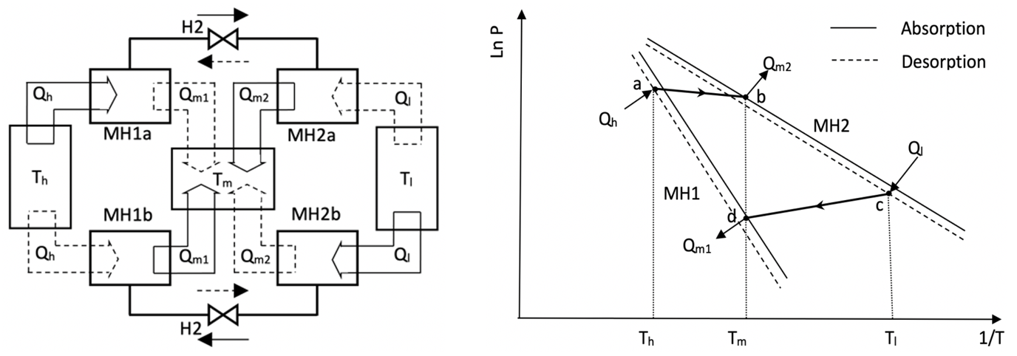

Fig. 1. Schematic diagram of a single stage metal hydride heat pump and its operating cycle on a Van’t Hoff plot . (Q_{h} =heat input at high temperature heat source T_{h}; Q_{m1},Q_{m2}=heat outputs at output temperature T_{m}; Q_{l}=Heat absorption at low temperature heat source T_{l})

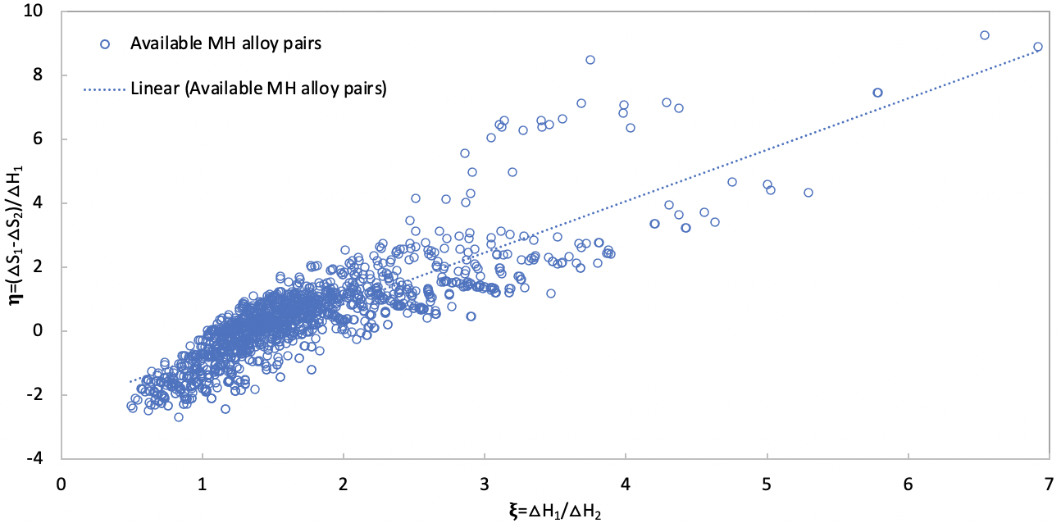
Fig. 2. Coordinate points (𝛏 , 𝛈 ) for all the available MH alloy pairs.

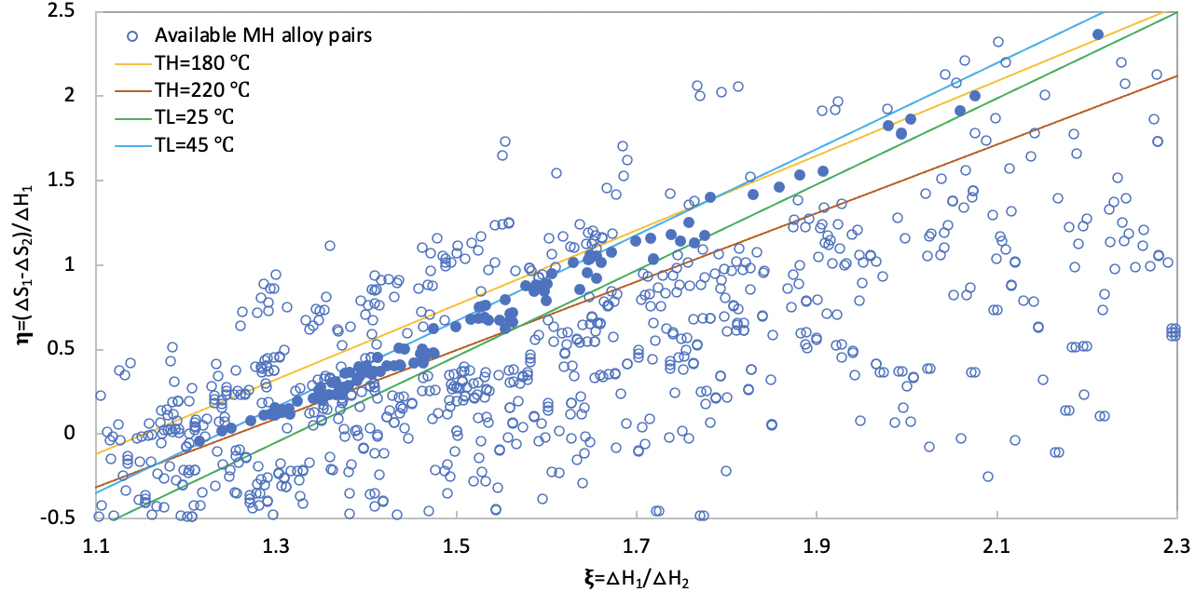
Applicable MH alloy pairs
Fig. 3. Coordinate points (𝛏 , 𝛈 ) for the applicable MH alloys and four straight lines at maximum and minimum temperatures of T_{h} and T_{l}, and constant temperature T_{m}(=120°C).

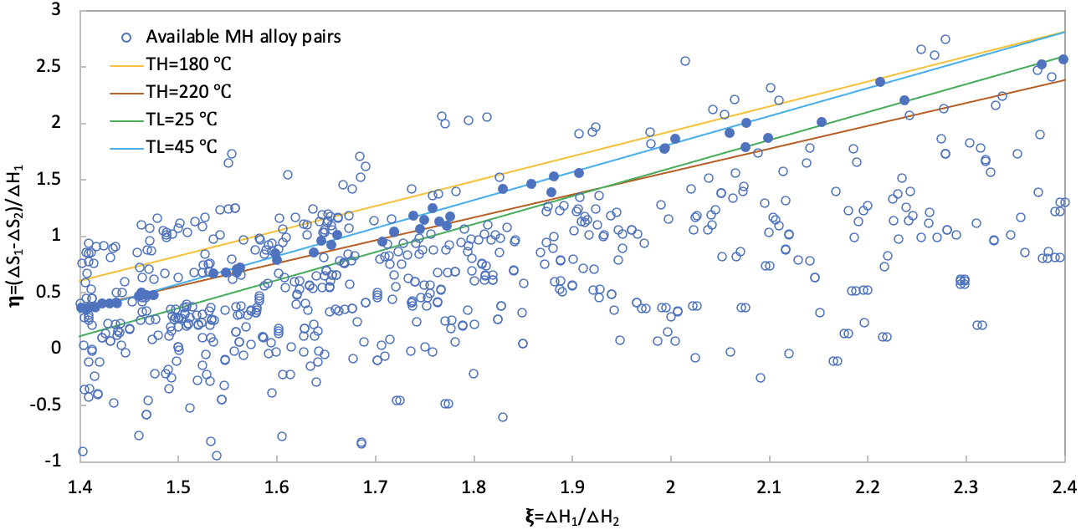
Applicable MH alloy pairs
Fig. 4. Coordinate points (𝛏 , 𝛈 ) for the applicable MH alloys and four straight lines at maximum and minimum temperatures of T_{h} and T_{l}, and constant temperature T_{m}(=130°C).

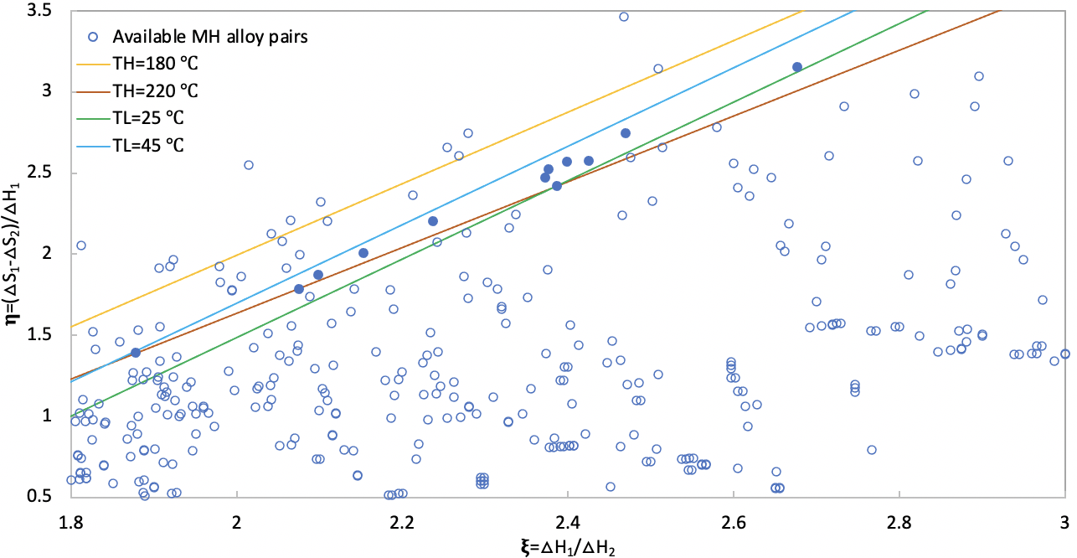
Applicable MH alloy pairs
Fig. 5. Coordinate points (𝛏 , 𝛈 ) for the applicable MH alloys and four straight lines at maximum and minimum temperatures of T_{h} and T_{l}, and constant temperature T_{m}(=140°C).

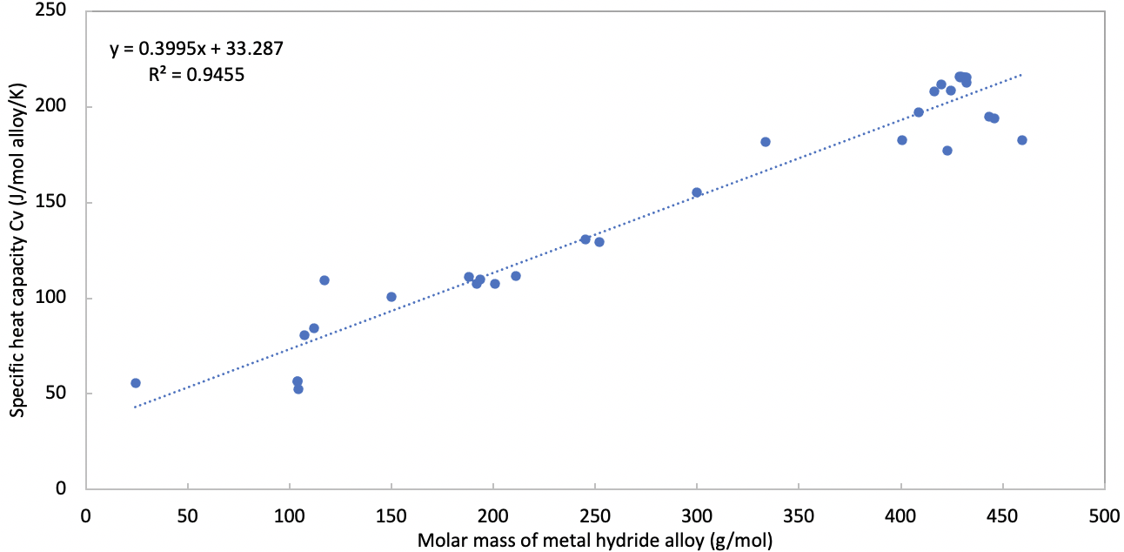
Fig. 6. Correlation of specific heat capacity at constant volume with molar mass for metal
hydride alloys

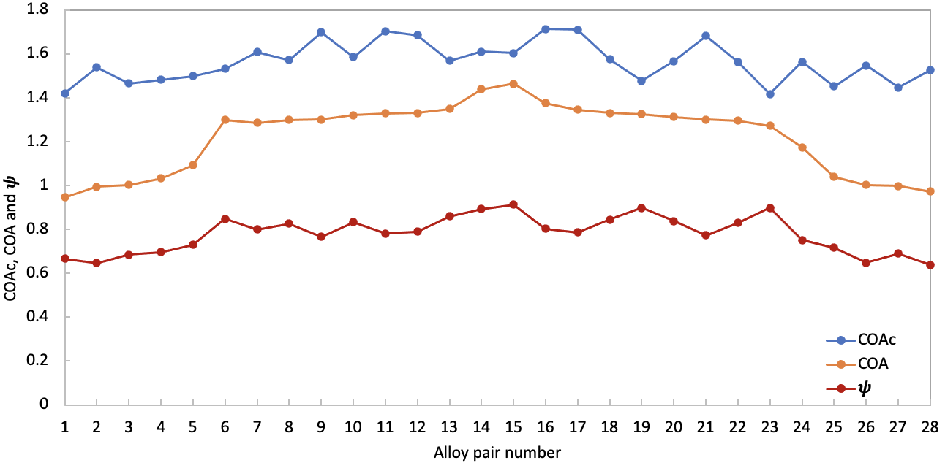
Fig. 7. Variation of COA, COA_{c} and 𝝍 with different alloy pair numbers for T_{m}=130 ℃

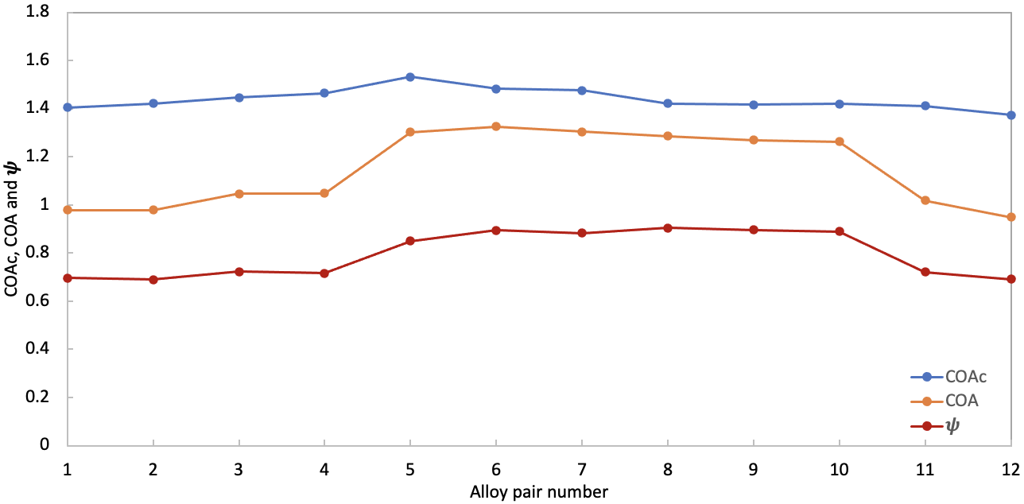
Fig. 8. Variation of COA, COA_{c} and 𝝍 with different alloy pair numbers for T_{m}=140 ℃

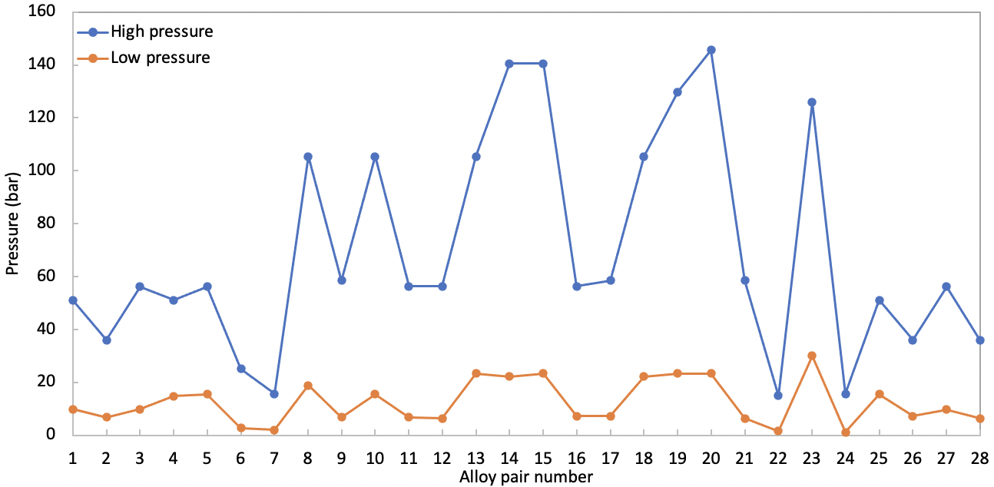
Fig. 9. Variation of high and low hydrogen pressures with different alloy pair numbers for T_{m}=130 ℃

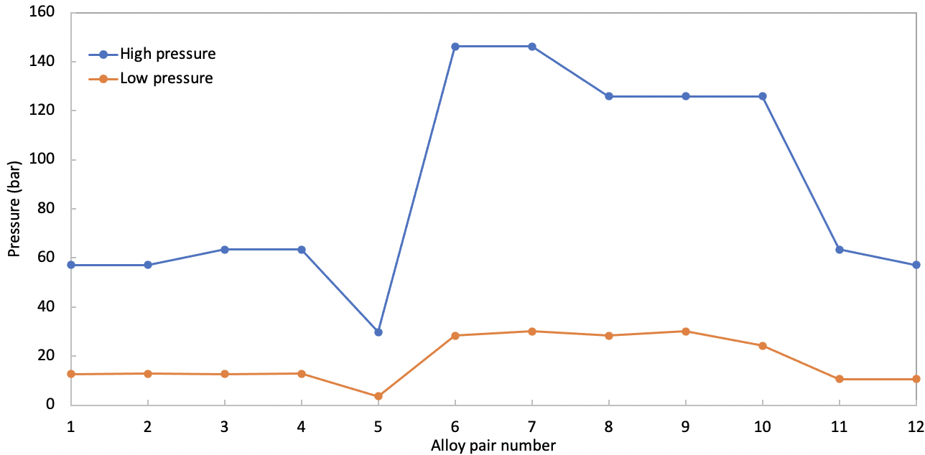
Fig. 10. Variation of high and low hydrogen pressures with different alloy pair numbers for T_{m}=140 ℃

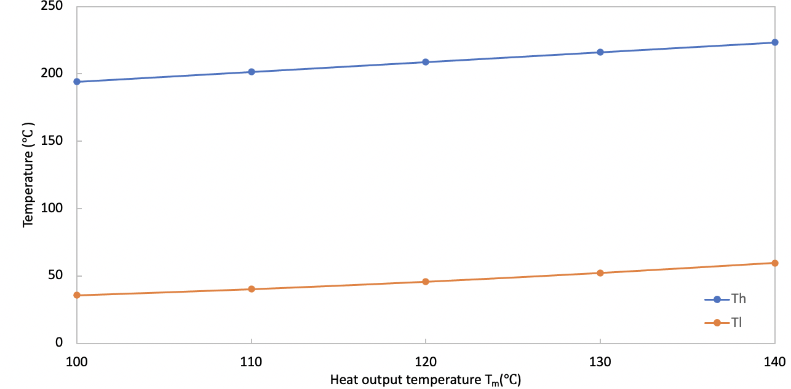
Fig. 11. Variation of high and low heat source temperatures (T_{h} and T_{l}) with heat output temperature T_{m}

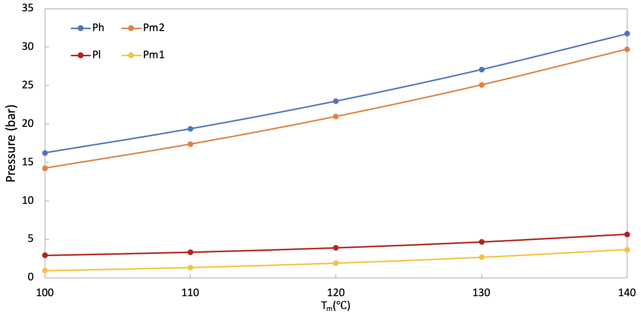
Fig. 12. Variation of high and low heat source temperatures (T_{h} and T_{l}) with heat output temperature T_{m}

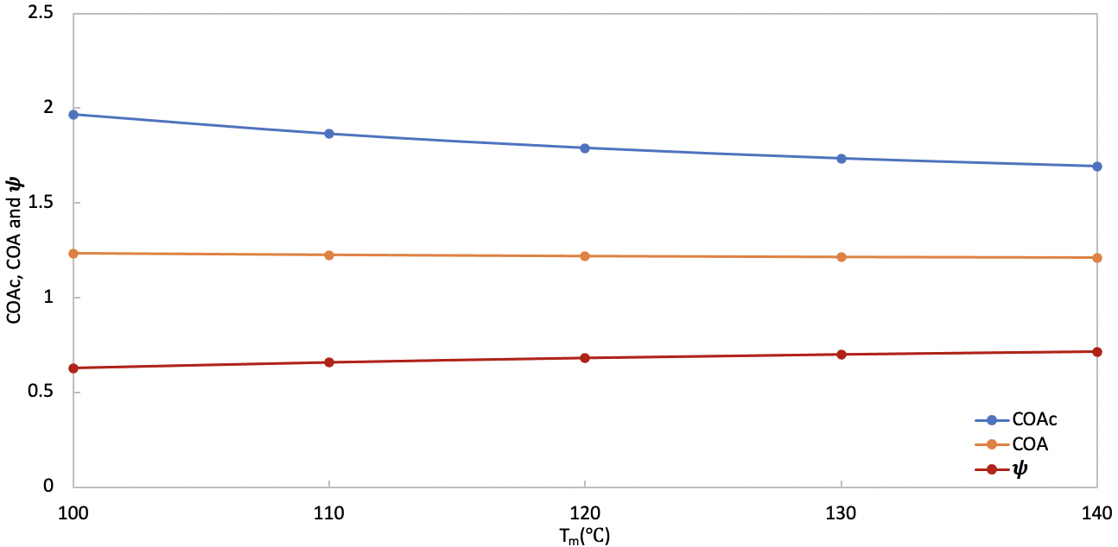
Fig. 13. Variation of COAc, COA, and ψ with heat output temperature T_{m}

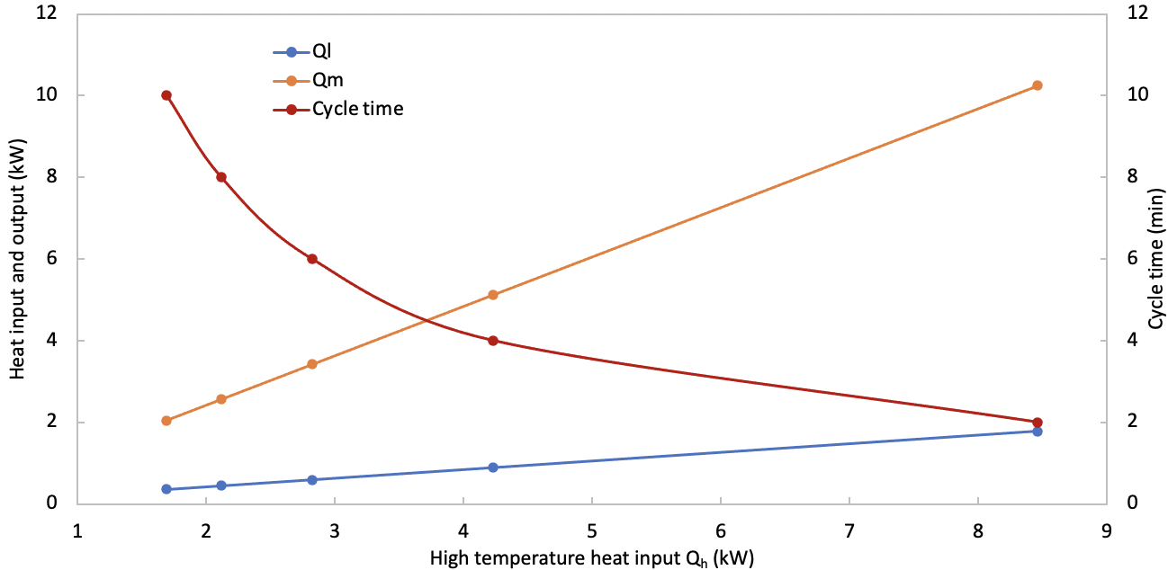
Fig. 14. Variation of low temperature heat input Q_{l} , heat output Q_{m} and cycle time with high temperature heat input Q_{h}

Table 1 MH alloys to be selected
No | Alloy | △H | △S | T_{l} | P_{l} | LT or HT | Ref
 |  | kJ/mol H2 | J/K/mol H2 | ℃ | bar
1 | Mg(LaNis)20% | 76.99 | 138.32 | 35 | 1.517E-06 | HT | [17]
2 | Mg₂Cu | 72.80 | 142.34 | 35 | 1.258E-05 | HT | [18]
3 | Mg₂Ni | 64.43 | 122.30 | 35 | 2.962E-05 | HT | [18]
4 | Mg_{2.4}Ni | 64.31 | 122.30 | 35 | 3.111E-05 | HT | [17]
5 | LaNi_{4.06}Mn_{0.94} | 48.70 | 116.90 | 35 | 7.186E-03 | HT | [17]
6 | LaNi₄Al | 47.70 | 118.83 | 35 | 0.013 | HT | [17]
7 | Z r_{0.8}Ce_{0.2}Mn₂ | 44.89 | 110.00 | 35 | 0.014 | HT | [17]
8 | LaNi_{4.30}Mn_{0.70} | 44.27 | 115.14 | 35 | 0.033 | HT | [17]
9 | NiZr | 30.42 | 71.63 | 35 | 0.039 | HT | [17]
10 | ZrMn₂Cu_{0.8} | 25.82 | 57.74 | 35 | 0.044 | HT | [19]
11 | LaNi_{4.25}Al_{0.75} | 44.35 | 117.99 | 35 | 0.045 | HT | [17]
12 | ZrMn₂Cu_{0.8} | 25.82 | 57.91 | 35 | 0.045 | HT | [17]
13 | TiFe_{0.9}Ni_{0.1} | 35.60 | 94.65 | 35 | 0.082 | HT | [20]
14 | Zr_{0.7}Ti_{0.3}Mn₂ | 32.30 | 87.36 | 35 | 0.124 | HT | [17]
15 | LaNi_{4.56}Mn_{0.44} | 39.50 | 113.22 | 35 | 0.168 | HT | [17]
16 | Fe_{0.8}Ni_{0.2}Ti | 41.00 | 118.81 | 35 | 0.182 | HT | [18]
17 | LaNi_{4.5}Al_{0.5} | 38.49 | 111.29 | 35 | 0.197 | HT | [17]
18 | LaNi_{4.61}Mn_{0.26}Al_{0.13} | 37.90 | 110.35 | 35 | 0.221 | HT | [10]
19 | LaNi_{4.61}Mn_{0.26}Al_{0.13} | 32.38 | 94.69 | 35 | 0.291 | HT | [10]
20 | LaNi_{4.65}Mn_{0.35} | 37.82 | 112.55 | 35 | 0.297 | HT | [17]
21 | LaNi_{4.6}Al_{0.4} | 36.40 | 109.20 | 35 | 0.346 | HT | [17]
22 | ZrMn_{2.8} | 18.41 | 52.30 | 35 | 0.414 | HT | [17]
23 | Zr_{0.9}Ti_{0.1}Cr_{0.9}Fe_{1.1} | 27.97 | 85.60 | 35 | 0.544 | HT | [10]
24 | LaNi_{4.7}Al_{0.3} | 33.89 | 106.75 | 35 | 0.687 | HT | [18]
25 | ZrMn_{3.8} | 19.71 | 61.50 | 35 | 0.755 | HT | [17]
26 | LaNi_{4.75}Al_{0.25} | 34.73 | 110.46 | 35 | 0.774 | HT | [17]
27 | CaNi₅ | 31.80 | 101.18 | 35 | 0.796 | HT | [18]
28 | V_{0.9}Cr_{0.1} | 41.71 | 133.89 | 35 | 0.848 | HT | [19]
29 | LaNi_{4.83}Mn_{0.17} | 34.52 | 111.25 | 35 | 0.924 | HT | [17]
30 | LaNi_{4.8}Al_{0.2} | 34.90 | 112.65 | 35 | 0.942 | HT | [21]
31 | LaNi_{4.6}Al_{0.4} | 30.68 | 99.73 | 35 | 1.034 | LT | [10]
32 | La_{0.6}Y_{0.4}Ni_{4.9}Al_{0.1} | 26.85 | 87.35 | 35 | 1.040 | LT | [22]
33 | ZrCr_{0.6}Fe_{1.4} | 26.90 | 89.50 | 35 | 1.319 | LT | [17]
34 | Zr_{0.8}Ti_{0.2}MnFe | 11.13 | 39.25 | 35 | 1.476 | LT | [17]
35 | LaNi_{4.9}Al_{0.1} | 32.64 | 110.46 | 35 | 1.752 | LT | [17]
36 | LaNi_{4.95}Mn_{0.05} | 32.30 | 110.37 | 35 | 1.976 | LT | [17]
37 | LaNi₅ | 31.80 | 110.04 | 35 | 2.309 | LT | [17]
38 | Zr_{0.9}Ti_{0.1}Cr_{0.6}Fe_{1.4} | 23.61 | 85.23 | 35 | 2.860 | LT | [10]
39 | LmNi_{4.91}Sn_{0.15} | 25.90 | 93.82 | 35 | 3.282 | LT | [10]
40 | MNi_{4.5}Al_{0.46}Fe_{0.05} | 31.05 | 110.88 | 35 | 3.426 | LT | [19]
41 | Zr(Fe_{0.75}Cr_{0.25})₂ | 24.77 | 91.63 | 35 | 3.920 | LT | [19]
42 | La_{0.6}Y_{0.4}Ni_{4.8}Mn_{0.2} | 23.25 | 86.78 | 35 | 3.961 | LT | [10]
43 | Fe_{0.85}Mn_{0.15}Ti | 29.46 | 107.11 | 35 | 4.052 | LT | [19]
44 | Ce_{0.5}La_{0.5}Ni_{2.5}Cu_{2.5} | 23.01 | 86.61 | 35 | 4.255 | LT | [19]
45 | Fe_{0.9}Mn_{0.1}Ti | 29.29 | 107.00 | 35 | 4.269 | LT | [18]
46 | La_{0.6}Y_{0.4}Ni_{4.8}Mn_{0.2} | 27.05 | 100.50 | 35 | 4.678 | LT | [10]
47 | Z r_{0.8}Ti_{0.2}Cr_{0.6}Fe_{1.4} | 26.90 | 100.46 | 35 | 4.929 | LT | [17]
48 | Ca_{0.7}M_{0.3}Ni₅ | 26.78 | 100.42 | 35 | 5.151 | LT | [19]
49 | Ca_{0.7}M_{0.3}Ni₅ | 26.78 | 100.43 | 35 | 5.161 | LT | [18]
50 | MmNi_{4.6}Al_{0.4} | 24.68 | 93.82 | 35 | 5.278 | LT | [10]
51 | Ce_{1.1}Ni_{2.5}Cu_{2.5} | 20.71 | 81.04 | 35 | 5.350 | LT | [17]
52 | MNi_{4.5}Al_{0.5} | 28.03 | 104.84 | 35 | 5.372 | LT | [18]
53 | MNi_{4.5}Al_{0.05} | 28.03 | 105.44 | 35 | 5.772 | LT | [19]
54 | FeTi | 28.03 | 106.09 | 35 | 6.242 | LT | [18]
55 | V_{0.95}Cr_{0.05} | 37.36 | 139.33 | 35 | 8.913 | LT | [19]
56 | Ca_{0.5}M_{0.5}Ni₅ | 25.77 | 103.76 | 35 | 11.400 | LT | [19]
57 | CeNi_{2.5}Cu_{2.5} | 16.90 | 75.31 | 35 | 11.867 | LT | [17]
58 | MmNi_{4.6}Fe_{0.4} | 21.68 | 91.22 | 35 | 12.432 | LT | [10]
59 | CeNi₃Cu₂ | 15.31 | 70.58 | 35 | 12.500 | LT | [17]
60 | CeNi_{4.5}Al_{0.5} | 21.88 | 92.05 | 35 | 12.722 | LT | [19]
61 | Ti_{0.95}Zr_{0.05}Mn_{1.48}V_{0.43}Fe_{0.08}Al_{0.01} | 25.35 | 103.65 | 35 | 13.267 | LT | [23]
62 | Ti_{0.95}Zr_{0.05}Mn_{1.46}V_{0.45}Fe_{0.09} | 25.26 | 103.55 | 35 | 13.578 | LT | [24]
63 | MmNi_{4.15}Fe_{0.85} | 21.73 | 92.13 | 35 | 13.641 | LT | [10]
64 | V_{0.925}Cr_{0.075} | 36.32 | 139.75 | 35 | 14.099 | LT | [19]
65 | CeNi₃Zr₂ | 29.55 | 118.25 | 35 | 14.897 | LT | [25]
66 | MNi_{4.15}Fe_{0.85} | 25.10 | 104.60 | 35 | 16.372 | LT | [19]
67 | MNi_{4.15}Fe_{0.85} | 25.10 | 104.76 | 35 | 16.683 | LT | [18]
68 | Ca_{0.4}M_{0.6}Ni₅ | 25.27 | 105.44 | 35 | 16.961 | LT | [19]
69 | Ti_{0.98}Zr_{0.02}V_{0.41}Fe_{0.09}Cr_{0.05}Mn_{1.46} | 19.85 | 87.85 | 35 | 16.974 | LT | [26]
70 | CeNi₄Zr | 21.08 | 93.30 | 35 | 20.220 | LT | [25]
71 | PrNi₅ | 29.04 | 119.24 | 35 | 20.529 | LT | [19]
72 | NdNi₅ | 27.82 | 116.32 | 35 | 23.177 | LT | [19]
73 | Ti_{0.99}Zr_{0.01}V_{0.43}Fe_{0.09}Cr_{0.05}Mn_{1.5} | 19.77 | 90.35 | 35 | 23.620 | LT | [24]
74 | CeNi₄Cr | 16.63 | 81.59 | 35 | 28.095 | LT | [25]
75 | CeNi₃Cr₂ | 14.55 | 75.31 | 35 | 29.729 | LT | [25]
76 | MNi₅ | 20.92 | 96.65 | 35 | 32.219 | LT | [19]
77 | MNi₅ | 20.92 | 96.77 | 35 | 32.705 | LT | [18]
78 | V_{0.85}Cr_{0.15} | 29.71 | 125.52 | 35 | 33.629 | LT | [19]
79 | Ti_{0.99}Zr_{0.01}V_{0.43}Fe_{0.09}Cr_{0.05}Mn_{1.5} | 20.25 | 95.15 | 35 | 34.939 | LT | [26]
80 | Ca_{0.2}M_{0.8}Ni₅ | 24.27 | 108.75 | 35 | 37.376 | LT | [18]
81 | Ca_{0.2}M_{0.8}Ni₅ | 24.27 | 108.78 | 35 | 37.542 | LT | [19]
82 | CeNi₅ | 22.18 | 111.71 | 35 | 120.821 | LT | [19]

Table 2 Applicable MH alloy pairs for T_{m}=130 ℃
Pair No | MH alloy pair |  | COA | COAc | 𝝍 | W₁ | W₂ | P_{h} | P_{l} | T_{h} | T_{l}
 | HT MH alloy | LT MH alloy | - | - | - | kg | kg | bar | bar | ℃ | ℃
1 | LaNi_{4.6}Al_{0.4} | CeNi₃Cu₂ | 0.969 | 1.421 | 0.682 | 0.59 | 1 | 51.122 | 9.853 | 202.04 | 23.20
2 | LaNi_{4.5}Al_{0.5} | Ce_{1.1}Ni_{2.5}Cu_{2.5} | 1.005 | 1.538 | 0.653 | 0.395 | 1 | 35.947 | 6.789 | 198.44 | 44.36
3 | LaNi_{4.6}Al_{0.4} | CeNi_{2.5}Cu_{2.5} | 1.019 | 1.464 | 0.696 | 0.589 | 1 | 56.178 | 9.853 | 206.95 | 26.55
4 | CaNi₅ | CeNi₃Cu₂ | 1.052 | 1.482 | 0.710 | 0.525 | 1 | 51.122 | 14.823 | 190.51 | 44.05
5 | LaNi_{4.7}Al_{0.3} | CeNi_{2.5}Cu_{2.5} | 1.110 | 1.499 | 0.741 | 0.441 | 1 | 56.178 | 15.518 | 188.77 | 48.06
6 | LaNi_{4.25}Al_{0.75} | Zr_{0.9}Ti_{0.1}Cr_{0.6}Fe_{1.4} | 1.258 | 1.532 | 0.821 | 1.96 | 1 | 25.079 | 2.646 | 212.56 | 32.42
7 | LaNi_{4.30}Mn_{0.70} | ZrCr_{0.6}Fe_{1.4} | 1.289 | 1.608 | 0.802 | 0.714 | 1 | 15.660 | 1.926 | 206.03 | 46.54
8 | LaNi_{4.75}Al_{0.25} | Ti_{0.98}Zr_{0.02}V_{0.41}Fe_{0.09}Cr_{0.05}Mn_{1.46} | 1.306 | 1.572 | 0.831 | 2.13 | 1 | 105.369 | 18.880 | 210.21 | 39.29
9 | LaNi_{4.5}Al_{0.5} | Z r_{0.8}Ti_{0.2}Cr_{0.6}Fe_{1.4} | 1.296 | 1.699 | 0.763 | 0.93 | 1 | 58.536 | 6.789 | 223.09 | 44.69
10 | LaNi_{4.7}Al_{0.3} | Ti_{0.98}Zr_{0.02}V_{0.41}Fe_{0.09}Cr_{0.05}Mn_{1.46} | 1.324 | 1.586 | 0.835 | 1.38 | 1 | 105.369 | 15.518 | 224.22 | 31.47
11 | LaNi_{4.5}Al_{0.5} | La_{0.6}Y_{0.4}Ni_{4.8}Mn_{0.2} | 1.325 | 1.703 | 0.778 | 0.867 | 1 | 56.311 | 6.789 | 221.04 | 46.27
12 | LaNi_{4.56}Mn_{0.44} | La_{0.6}Y_{0.4}Ni_{4.8}Mn_{0.2} | 1.326 | 1.685 | 0.787 | 0.698 | 1 | 56.311 | 6.342 | 221.70 | 44.15
13 | LaNi_{4.8}Al_{0.2} | Ti_{0.98}Zr_{0.02}V_{0.41}Fe_{0.09}Cr_{0.05}Mn_{1.46} | 1.357 | 1.569 | 0.865 | 1.25 | 1 | 105.369 | 23.342 | 198.23 | 48.21
14 | LaNi_{4.83}Mn_{0.17} | CeNi₄Zr | 1.441 | 1.611 | 0.894 | 3.85 | 1 | 140.580 | 22.112 | 218.26 | 38.39
15 | LaNi_{4.8}Al_{0.2} | CeNi₄Zr | 1.467 | 1.604 | 0.915 | 2.87 | 1 | 140.580 | 23.342 | 214.01 | 40.47
16 | LaNi_{4.61}Mn_{0.26}Al_{0.13} | La_{0.6}Y_{0.4}Ni_{4.8}Mn_{0.2} | 1.370 | 1.714 | 0.799 | 0.52 | 1 | 56.311 | 7.232 | 219.40 | 48.26
17 | LaNi_{4.61}Mn_{0.26}Al_{0.13} | Z r_{0.8}Ti_{0.2}Cr_{0.6}Fe_{1.4} | 1.340 | 1.710 | 0.784 | 0.56 | 1 | 58.536 | 7.232 | 221.47 | 46.68
18 | LaNi_{4.83}Mn_{0.17} | Ti_{0.98}Zr_{0.02}V_{0.41}Fe_{0.09}Cr_{0.05}Mn_{1.46} | 1.338 | 1.575 | 0.849 | 1.68 | 1 | 105.369 | 22.112 | 202.04 | 45.89
19 | LaNi_{4.8}Al_{0.2} | CeNi₄Cr | 1.342 | 1.477 | 0.909 | 2.50 | 1 | 129.697 | 23.342 | 209.49 | 26.44
20 | LaNi_{4.8}Al_{0.2} | Ti_{0.99}Zr_{0.01}V_{0.43}Fe_{0.09}Cr_{0.05}Mn_{1.5} | 1.318 | 1.567 | 0.842 | 1.22 | 1 | 145.585 | 23.342 | 215.99 | 34.53
21 | LaNi_{4.56}Mn_{0.44} | Z r_{0.8}Ti_{0.2}Cr_{0.6}Fe_{1.4} | 1.297 | 1.681 | 0.771 | 0.748 | 1 | 58.536 | 6.342 | 223.71 | 42.58
22 | LaNi₄Al | La_{0.6}Y_{0.4}Ni_{4.9}Al_{0.1} | 1.302 | 1.563 | 0.833 | 3.7 | 1 | 14.921 | 1.521 | 221.31 | 46.60
23 | LaNi_{4.8}Al_{0.2} | CeNi₃Cr₂ | 1.301 | 1.417 | 0.919 | 2.713 | 1 | 125.899 | 30.032 | 207.85 | 35.55
24 | LaNi₄Al | ZrCr_{0.6}Fe_{1.4} | 1.177 | 1.564 | 0.752 | 2 | 1 | 15.660 | 1.078 | 223.38 | 29.19
25 | LaNi_{4.7}Al_{0.3} | CeNi₃Cu₂ | 1.062 | 1.452 | 0.731 | 0.444 | 1 | 51.122 | 15.518 | 183.89 | 46.57
26 | LaNi_{4.61}Mn_{0.26}Al_{0.13} | Ce_{1.1}Ni_{2.5}Cu_{2.5} | 1.014 | 1.546 | 0.655 | 0.234 | 1 | 35.947 | 7.232 | 196.62 | 46.94
27 | LaNi_{4.65}Mn_{0.35} | CeNi_{2.5}Cu_{2.5} | 1.016 | 1.447 | 0.702 | 0.538 | 1 | 56.178 | 9.641 | 204.62 | 25.59
28 | LaNi_{4.56}Mn_{0.44} | Ce_{1.1}Ni_{2.5}Cu_{2.5} | 0.984 | 1.524 | 0.645 | 0.313 | 1 | 35.947 | 6.342 | 199.60 | 41.62

Table 3 Applicable MH alloy pairs for T_{m}=140 ℃
Pair No | MH alloy pair |  | COA | COAc | 𝝍 | W₁ | W₂ | P_{h} | P_{l} | T_{h} | T_{l}
 | HT MH alloy | LT MH alloy | - | - | - | kg | kg | bar | bar | ℃ | ℃
1 | LaNi_{4.65}Mn_{0.35} | CeNi₃Cu₂ | 0.954 | 1.405 | 0.679 | 0.54 | 1 | 57.100 | 12.669 | 205.44 | 35.69
2 | LaNi_{4.6}Al_{0.4} | CeNi₃Cu₂ | 0.956 | 1.421 | 0.673 | 0.59 | 1 | 57.100 | 12.816 | 207.81 | 36.29
3 | LaNi_{4.65}Mn_{0.35} | CeNi_{2.5}Cu_{2.5} | 1.026 | 1.447 | 0.709 | 0.538 | 1 | 63.472 | 12.669 | 210.83 | 38.08
4 | LaNi_{4.6}Al_{0.4} | CeNi_{2.5}Cu_{2.5} | 1.030 | 1.464 | 0.703 | 0.589 | 1 | 63.472 | 12.816 | 213.47 | 38.63
5 | LaNi_{4.25}Al_{0.75} | Zr_{0.9}Ti_{0.1}Cr_{0.6}Fe_{1.4} | 1.139 | 1.532 | 0.743 | 1.96 | 1 | 29.740 | 3.644 | 220.22 | 43.32
6 | LaNi_{4.83}Mn_{0.17} | CeNi₄Cr | 1.310 | 1.482 | 0.884 | 3.35 | 1 | 146.246 | 28.372 | 220.57 | 35.47
7 | LaNi_{4.8}Al_{0.2} | CeNi₄Cr | 1.288 | 1.477 | 0.873 | 4.95 | 1 | 146.246 | 30.032 | 216.25 | 38.20
8 | LaNi_{4.83}Mn_{0.17} | CeNi₃Cr₂ | 1.260 | 1.422 | 0.887 | 3.65 | 1 | 125.899 | 28.372 | 211.93 | 32.49
9 | LaNi_{4.8}Al_{0.2} | CeNi₃Cr₂ | 1.245 | 1.417 | 0.879 | 5.41 | 1 | 125.899 | 30.032 | 207.85 | 35.55
10 | LaNi_{4.75}Al_{0.25} | CeNi₃Cr₂ | 1.240 | 1.419 | 0.874 | 4.62 | 1 | 125.899 | 24.261 | 220.38 | 24.35
11 | Fe_{0.8}Ni_{0.2}Ti | CeNi_{2.5}Cu_{2.5} | 0.996 | 1.412 | 0.705 | 0.464 | 1 | 63.472 | 10.655 | 212.62 | 30.05
12 | Fe_{0.8}Ni_{0.2}Ti | CeNi₃Cu₂ | 0.922 | 1.373 | 0.672 | 0.465 | 1 | 57.100 | 10.655 | 207.61 | 26.98

