Treatment with folic acid ameliorated the histopathological alterations caused by propylthiouracil-induced hypothyroid rat testes

Ehab Tousson¹, Ehab MM Ali², Wafaa Ibrahim³, and Mohammed A Mansour²

Abstract

Hypothyroidism is an underactive thyroid gland that cannot make enough thyroid hormone to keep the body running normally. Here we studied the histopathological, immunohistochemical, and ultrastructural changes in the hypothyroid rat testes at the postpubertal stage, in addition to the ameliorating role of folic acid in enhancing spermatogenesis, boosting sperm concentration and building up the antioxidant status against the oxidants. A total of 50 male albino rats were equally divided into 5 groups; the first and second groups comprised the control and folic acid groups, respectively; while the third group comprised the hypothyroid group in which rats received 6-n-propyl-2-thiouracil in drinking water for 6 weeks to induce hypothyroidism. The fourth and fifth groups comprised hypothyroid rats treated with folic acid for 4 weeks and dissected after 6 and 10 weeks, respectively. Testes in the hypothyroid rats showed marked morphological and histological changes in the seminiferous tubules with a reduction in sperm count. Our results indicate that hypothyroidism adversely affects spermatogenesis, suggesting that thyroid hormone might play an important role not only in controlling normal testicular development but also in maintaining normal testicular function and spermatogen-esis. Further, we suggested an ameliorating role of folic acid in the relief of testicular tissue from changes due to hypothyroidism. However, we found that the best results were found in cases where folic acid was used as an adjuvant therapy for returning to the euthyroid state.

Keywords

Hypothyroidism, PTU, testes, spermatogenesis, TEM

Introduction

Hypothyroidism is an underactive thyroid gland that cannot make enough thyroid hormone to keep the body running normally. Appropriate level of thyroid hormone is essential for normal development and metabolism in most vertebrate tissues and altered thyroid status has adverse impacts on them (Toshi-hiro, 2009). People are hypothyroid if they have too little thyroid hormone in the blood. Common causes are autoimmune disease, surgical removal of the thyr-oid, and radiation treatment. It is now established that triiodothyronine (T₃) regulates the maturation and growth of testis, in rats and other mammal species, by inhibiting the proliferation of immature Sertoli cells and stimulating their functional differentiation (Gereben et al., 2008; Jansen et al., 2007; Tarulli

et al., 2006; Toshihiro, 2009; Van Haaster et al., 1993). Also, thyroid hormone has been shown to play a critical role in the onset of Leydig cell differentiation and stimulation of steroidogenesis in postnatal rat testis (Lin et al., 2009; Mendis-Handagama and Ariyaratne,

¹Department of Zoology, Faculty of Science, Tanta University, Tanta, Egypt

²Department of Medical Biochemistry, Faculty of Medicine, Tanta University, Tanta, Egypt

³Biochemistry Section, Department of Chemistry, Faculty of Science, Tanta University, Tanta, Egypt

Corresponding author:

Ehab Tousson, Department of Zoology, Faculty of Science, Tanta

University, Tanta 002040, Egypt

Email: toussonehab@yahoo.com

2005). Altered thyroid status, experimentally induced or occurring in adult life, is frequently associated with some kind of sexual dysfunction and/or morphological testicular degeneration (Krassas et al., 2008a,b). Most experimental studies to date have focused on thyroid hormone effects on the developing testes, only limited data are available on its role in prepubertal rat testis function especially spermatogenesis.

Spermatogenesis is influenced by a combination of endocrine, genetic, and environmental factors, includ-ing nutrition and lifestyle (Kuroki et al., 1999; Wong et al., 2000). Evidence is increasing that nutritional factors are important in reproduction and thus in spermatogenesis as well. Of main interest are the B vitamins folate, cobalamin, and pyridoxine, which are involved in homocysteine metabolism. Folic acid (vitamin B9 or folacin) is essential for numerous bod-ily functions ranging from nucleotide biosynthesis to the remethylation of homocysteine. The human body needs folate to synthesize DNA, repair DNA, and methylate DNA as well as to act as a cofactor in bio-logical reactions involving folate. It is especially important during the periods of rapid cell division and growth (Lucock, 2000). The efficiency of spermato-genesis depends on the proliferative activity of sper-matogonia and the loss of germ cells during meiosis and spermatogenesis (Toshihiro, 2009).

Folic acid has been reported to have an antioxidant power against reactive oxygen species (ROS) and an alleviating role in hyperhomocysteinemia and the associated endothelial dysfunction. Also, progressive folate deficiency was suggested to develop with hypothyroidism (Diekman et al., 2001). This defi-ciency may be responsible for reduced sperm concen-tration (Wallock et al., 2001). Supporting this assumption, a high-affinity folate-binding protein has been identified in human semen and prostate gland (Holm et al., 1991). This finding supports the connec-tion between folate status and male reproductive func-tion. This further illustrates the need for an intact folate cycle to maintain normal spermatogenesis and the positive effect of folic acid on sperm parameters (Forges et al., 2007).

The reversible goitrogen (6-n-propyl-2-thiouracil [PTU]) is known to inhibit thyroid hormone biosynth-esis and decrease the conversion of peripheral thyroxine (T₄) into T₃ and thereby reduces serum T₃ concentra-tion. Folic acid was suggested to enhance spermatogen-esis, boost sperm concentration, and build up the antioxidant status against the oxidants in our study. So, we investigated these changes with folic acid

treatment as a co- and posttreatment with hypothyroid state and as an adjuvant therapy after returning to the euthyroid state. This depended on the fact that PTU is a reversible goitrogen and that if it is withdrawn after the dose period the animal will return to the euthyroid state directly and serum T₃ concentration will return to its normal range (Tousson et al., 2011).

Materials and methods

The experiments were performed on 50 male albino rats (Rattus norvigicus) weighing 120 + 10 g and of 6–7 weeks of age. They were obtained from our laboratory farms, Zoology Department, Faculty of Science, Tanta University, Egypt. The rats were kept in the laboratory for 1 week before the experimental work and maintained on a standard rodent diet (20% casein, 15% corn oil, 55% corn starch, 5% salt mix-ture, and 5% vitaminized starch; Egyptian Company of Oils and Soap Kafr-Elzayat, Egypt) and water available ad libitum. The temperature in the animal room was maintained at 23 + 2 C with a relative humidity of 55 + 5%, with a 12-h light–dark cycle. The experimental protocol was approved by Local Ethics Committee and Animals Research. The rats were randomly and equally divided into 5 groups (10 animals each).

Group I (G₁): control group in which the animals never received any treatment.

Group II (G₂): folic acid group in which the animals received folic acid (orally by stomach tube; El Nasr Pharmaceutical Chemicals Co.; 0.011 mmol/g of body weight) daily for 4 weeks (from 2nd week to 6th week).

Group III (G₃): hypothyroid group in which the rats received 0.05% PTU in drinking water daily for 6 weeks (Sahoo et al., 2008) to cover a complete spermatogenic cycle in rats (de Kretser, 1982).

Group IV (G₄): Cotreatment group in which the animals received 0.05% PTU daily in drinking water and folic acid simultaneously, according to Lalonde et al. (1993) and Matte et al. (2007). The dose period of PTU was 6 weeks as in hypothyroid group. However, folic acid was administered orally for 4 weeks from the 2nd to 6th week after evidence of hypothyroidism had been established at the end of the 2nd week.

Group V (G₅): Posttreatment group in which the rats received 0.05% PTU daily in drinking water for 6 weeks as in hypothyroid group.

Additionally, folic acid was administered for another 4 weeks (from 7th week to 10th week), while PTU was withdrawn after the 6th week to return to the euthyroid state.

At the end of the experimental period, five rats from each group were euthanized using sodium pentobarbi-tal intravenously and subjected to a complete necropsy. Blood samples were individually collected from the inferior vena cava of each rat in nonhepari-nized glass tubes to estimate the blood parameters. Blood serum was separated by centrifugation at 3000 rpm for 15 min. The collected serum was stored at 18 C until analysis. Blood serum was analyzed to determine the T₃ and thyroid-stimulating hormone (TSH) levels. Serum T₃ was assayed using commer-cial test supplied by the Diagnostic systems Labora-tories (DSL), TX, USA. Serum TSH was assayed using commercial kit supplied by Coat-A-Count TSH IRMA, Los Angeles, USA.

Histological investigation

The other five rats from each group were anaesthe-tized with thiopental. The thorax was opened with surgical incision on the sternum and the perfusion was done from left ventricle and right atrium. A rinsing solution was perfused before the fixation solution (Bouin’s fluid). Due to the narrow testicular artery branches from the abdominal aorta near the renal artery, it is probably constricted and occluded during the perfusion process. Perfusion with rinsing solution helped overcome this problem. To prepare rinsing solution 9.0 g sodium chloride (NaCl), 25 g polyvinyl pyrrolidone, 0.25 g heparin, and 5.0 g procain-hydrochloric acid (HCl) were dissolved in 1 L of water by thorough stirring. The pH was adjusted to 7.35 with 1 N NaOH and filtered twice through Milli-pore filters of 3.0 mm or less pore size. The perfusion of both solutions was performed using a scalp vein attached to a 50-cc syringe. Testes were immediately removed, taking care to handle the specimens gently to minimize trauma to the delicate seminiferous tubules prior to placement of each testis into the fixa-tive solution. The tunica albuginea was shallowly pierced at each pole 5 times with a 21-gauge needle to aid in the penetration of the fixative solution. Fixa-tion time was limited to 24 hours and tissues were transferred to 70% ethyl alcohol. Alcohol was chan-ged 3 times daily for 2 days before transferring the specimens to a saturated solution of 70% ethyl alcohol

and lithium carbonate to neutralize the picric acid in Bouin’s fluid. The ethyl alcohol–lithium carbonate solution was changed three or more times until the yellow colour of Bouin’s fluid was almost com-pletely depleted from the tissue. Testes were stored in 70% ethyl alcohol until they were processed. The fixed testis were dehydrated through a graded series of ethanol and embedded in paraffin according to the standard procedures. Paraffin sections (5-mm thick) were mounted on gelatin chromalum-coated glass slides and stored at room temperature until further processing. Some paraffin sections were used for haematoxylin and eosin stains as a routine method, according to Bancroft and Stevens (1990).

Transmission electron microscopic studies

Small pieces (1 mm) of control and treated tissues were freshly cut and fixed in 3% glutaraldehyde (pH 7.4) in phosphate buffer and postfixed in 2% osmium tetroxide in phosphate buffer. Following fixation, the tissues were dehydrated at increasing concentrations of ethanol. They were then embedded in araldite resin. Ultrathin sections were cut using an ultratome and stained by uranyl acetate saturated in 70% ethanol and lead citrate. Ultrathin sections of rat testes were performed in the faculty of medicine, Tanta Univer-sity using a JEOL transmission electron microscope (TEM) JEM-1200, Ex, Japan.

Statistical and image analyses

Data were expressed as mean values + SD, and statistical analysis was performed using one-way analysis of variance (ANOVA) to assess significant differences among treatment groups. The criterion for statistical significance was set at p < 0.05. All statis-tical analyses were performed using SPSS statistical version 16 software package (SPSS¹ Inc., USA). All stained slides were viewed using Olympus micro-scope and images were captured by a digital camera (Cannon 620). Brightness and contrast were adjusted using Adobe Photoshop software (version 4.0.1; Adobe Systems, Mountain View, CA, USA) and the analysis of the images was adjusted using PAX-it image analysis software.

Results

Table 1 shows that the serum T₃ levels were signifi-cantly (p < 0.05) lower in hypothyroid rats compared with the control, folic acid, and posttreatment groups

Table 1. Serum T₃, TSH levels, and sperm count in different groups under studyª
 |  |  |  |  | Mean sperm count (sperm/g
Groups | T₃ (ng/dl) |  | TSH (mIU/ml) |  | epididymis wt) 10⁶ + SD
G₁ | 147 | + 22.37 | 0.014 | + 0.003 | 250.36 | + 25.94
^{G}2 | 148 | + 23.52 | 0.152 | + 0.124 | 233.60 | + 25.85
G₃ | 57.7 | + 6.89^{b} | 3.900 | + 0.513^{b} | 134.18 | + 28.78^{b}
G₄ | 40 | + 6.89^{b} | 5.367 | + 0.462^{b} | 192.10 | + 28.46^{b}
G₅ | 142.7 | + 22.11 | 0.060 | + 0.026 | 229.93 | + 14.44

G₁: control group, G₂: folic acid group, G₃: hypothyroid rats group, G₄: cotreatment group, G₅: posttreatment group, T₃: triiodothyr-
onine, TSH: thyroid-stimulating hormone.
ªValue are mean + SD for 10 rats.
^{b}Significantly different from control at p < 0.05.

and significantly higher than those found in the cotreated folic acid group. On the other hand, serum TSH levels in hypothyroid rats were significantly higher than those found in the control, folic acid, and posttreated folic acid groups and significantly lower than those found in the cotreated folic acid group.

Light microscopic examination

Histopathological study showed the cycle of sperma-togenesis was regular in all male rats in the control group and folic acid group that were orally treated with folic acid (Figure 1A–C). The structural compo-nents of the testis are the seminiferous tubules and interstitial tissues (Leydig cells). Two types of cells are identified in rat seminiferous tubules, the Sertoli cells and the spermatogenic cells (spermatogonia, primary spermatocytes, secondary spermatocytes, spermatids, and sperms). The Sertoli cells rest on the thin basal lamina (basement membrane), while the spermatogenic cells are arranged in many layers, namely, the spermatogonia, primary and secondary spermatocytes; spermatoids and finally mature sper-matozoa (Figure 1B and C).

However, the light microscopic examination of the testis of the rats receiving PTU for 6 weeks resulted in a significant decrease in the number of spermatogenic cells in the seminiferous tubules (Figure 1D and E). The seminiferous tubules had been thickened in basement membrane together with focal areas of vacuolar degenerative changes appeared in the cytoplasm of the spermatogenic epithelium and in the Sertoli cells (Figure 1D and E). Further, abnormal distribution of spermatozoa was seen in the lumina of the seminiferous tubules and a number of little Leydig cells were also found (Figure 1D). Intertubular space and vein congestion

increased in the hypothyroid rat group as compared with those seen in the control and folic acid groups. Marked morphological changes such as degeneration of germinal epithelium and sloughing of germ cells into the tubular lumen were also seen in the hypothyroid rat group (Figure 1E). A significant decrease in primary spermatogonia and round sper-matid number was recorded by histological analysis of testis of hypothyroid rat group without significant change in number of spermatocytes. On the other hand, seminiferous lumen diameter was increased in hypothyroid rat group and decreased in co- and posttreatment groups in comparison to the control group (Figure 1). Treating the hypothyroid rats with folic acid during or after receiving PTU for 4 weeks showed more exaggerated features of focal areas of spermatogenesis, arrest at the spermatid level, in the form of degenerative changes in the germinal cells together with few fragmented sperms in the lumen and acquired a thick, irregular basement membrane (Figure 1E–H). Histological study showed that the accumulation of spermatogenic and Leydig cells increased in hypothyroid rats treated with folic acid (co- and posttreatment groups) when compared with the hypothyroid rat group (Figure 1C–H). Also the lumen of the seminiferous tubules was fully packed with sperms (Figure 1C–H).

Sperm count and morphology

Administration of PTU orally for 42 consecutive days significantly reduced the sperm count in experimental group as compared with the control group (p < 0.05; Table 1). Moreover, sperm viability was significantly declined in the hypothyroid group when compared to the control group (p < 0.05; data not shown). Treat-ment of hypothyroid rats with folic acid as in co- and

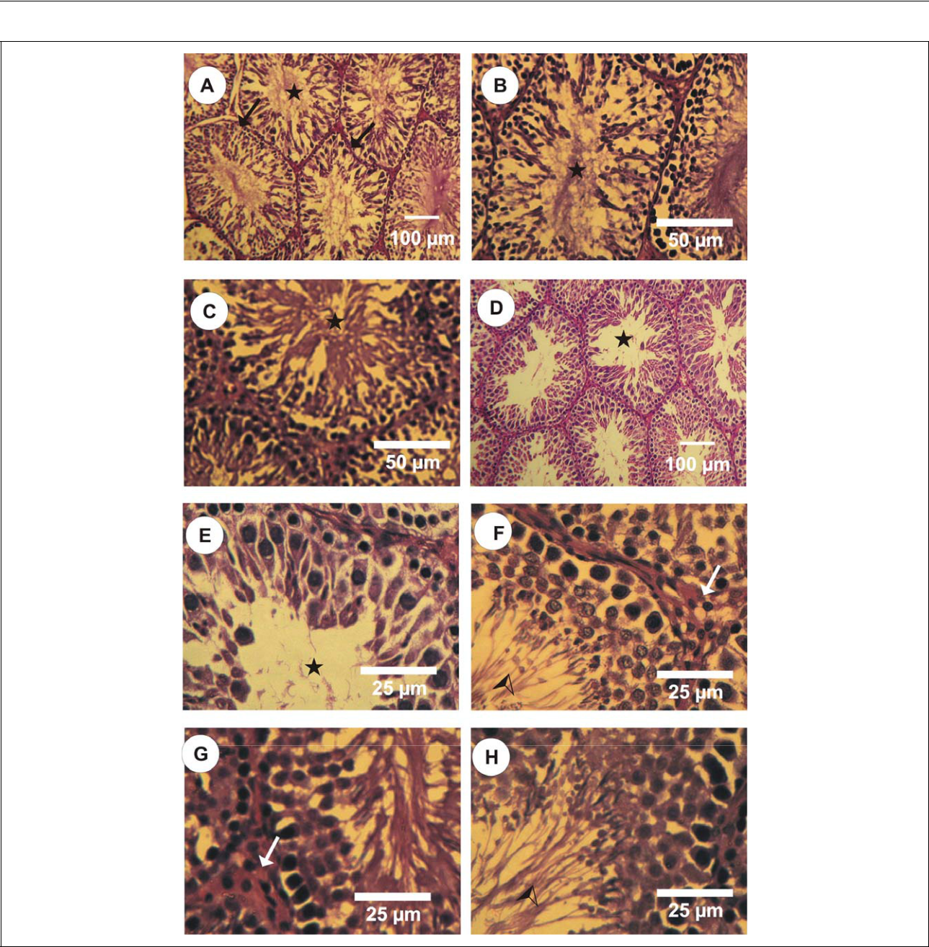

Figure 1. Photomicrographs of rat testes stained by haematoxylin–eosin (HE). (A and B) Photomicrographs of control rat testes showing normal seminiferous tubules (arrows). The cycle of spermatogenesis was regular and the lumen of semi-niferous tubules was fully packed with sperms (stars). (C) Photomicrograph of rat testes in folic acid group showing nor-mal seminiferous tubules and their lumen was fully packed with sperms (stars). (D and E) Photomicrographs of hypothyroid rat testes showed marked morphological changes as degeneration of germinal epithelium and sloughing of germ cells into the tubular lumen. The lumen of the seminiferous tubules was increased and showing lack of sperms (stars).

- Photomicrograph of hypothyroid rat testes cotreated with folic acid showing normal distribution of the spermatogenic cells and an increase of sperms (arrows head) and decrease in the seminiferous tubules lumen, in addition to increased number of Leydig cells (arrows). (H and G) Photomicrographs of hypothyroid rat testes posttreated with folic acid stained with HE showing normal count of Leydig cells (arrows) and normal structure of seminiferous tubules with regular cycle of spermatogenesis and their lumen was fully packed with sperms (arrows head).

posttreatment groups significantly increased sperm count as compared with the hypothyroid rats (Table 1). Four different abnormalities in sperm morphology

were found with a high percentage in hypothyroid rats, these abnormalities were bent and coiled tail, bent neck, and double-head sperms (Figure 2A–E).

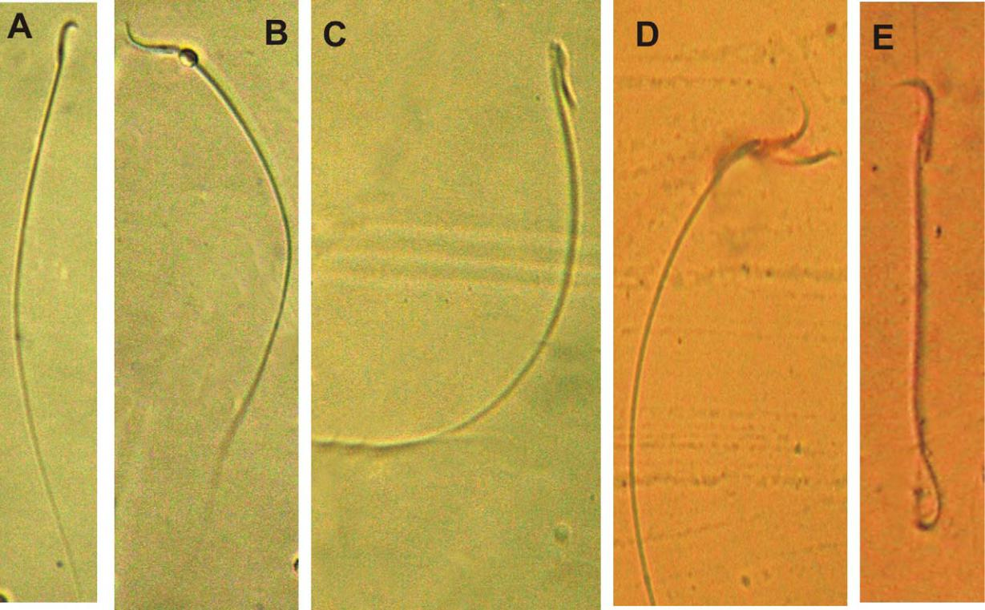

Figures 2. Normal and abnormal sperm morphology. (A) Normal form, (B and C) bent neck, (D) double head, and (E) coiled and bent tail.

Electron microscopic examination

The electron micrographs of control rat testis showed normal structure completely enveloped by a thick capsule, tunica albuginea, which is composed mainly of dense collagenous fibrous connective tissue. The structural components of the testis are the semi-niferous tubules and interstitial tissues. The parench-yma is made up of seminiferous tubules. Among the tubules are located the interstitial cells of Leydig in contact with few thin-walled capillaries. The semini-ferous tubules of control rats showed all stages of spermatogenic cells and the lumen of seminiferous tubules are full of mature spermatozoa (Figure 3A– D). Two types of cells are identified in the rat seminiferous tubules, the Sertoli cells (Figure 3A) and the spermatogenic cells (spermatogonia, primary spermatocytes, secondary spermatocytes, sperma-tids, and sperms).

The Sertoli cells rest on the thin basal lamina (base-ment membrane), while the spermatogenic cells are formed of many layers, namely, the spermatogonia, primary and secondary spermatocytes, spermatoids, and finally mature spermatozoa. The spermatogonia

are large diploid cells which lie against the boundary tissue of the seminiferous tubules and divide mitoti-cally. Two types of spermatocytes (primary and sec-ondary spermatocytes) are identified in the testes of control rats (Figure 3B and C). The primary sperma-tocytes are characterized by the presence of intercel-lular bridges between these cells, spherical nuclei with finely granular nucleoplasm and chromatin accu-mulation, while the secondary spermatocytes are smaller in size than the late primary spermatocytes and are rarely seen among the germinal cells of rat, their lifespan is short and enter into the second meio-tic division producing the spermatids; also the lumen of the seminiferous tubules was fully packed with sperms. The electron micrographs of the seminiferous tubules in hypothyroid rat testis as in hypothyroid rat group showed cellular alteration of cells than those in the control group (Figures 3E, F and 4A, B). The seminiferous tubules of rats showed moderate dam-aged tubules displaying advanced stage of injury in cells and a thick, irregular tubular basement mem-brane (Figure 3E). Spermatogonia are less affected, while the primary and secondary spermatocytes were clearly affected; the cells are compact and are reduced

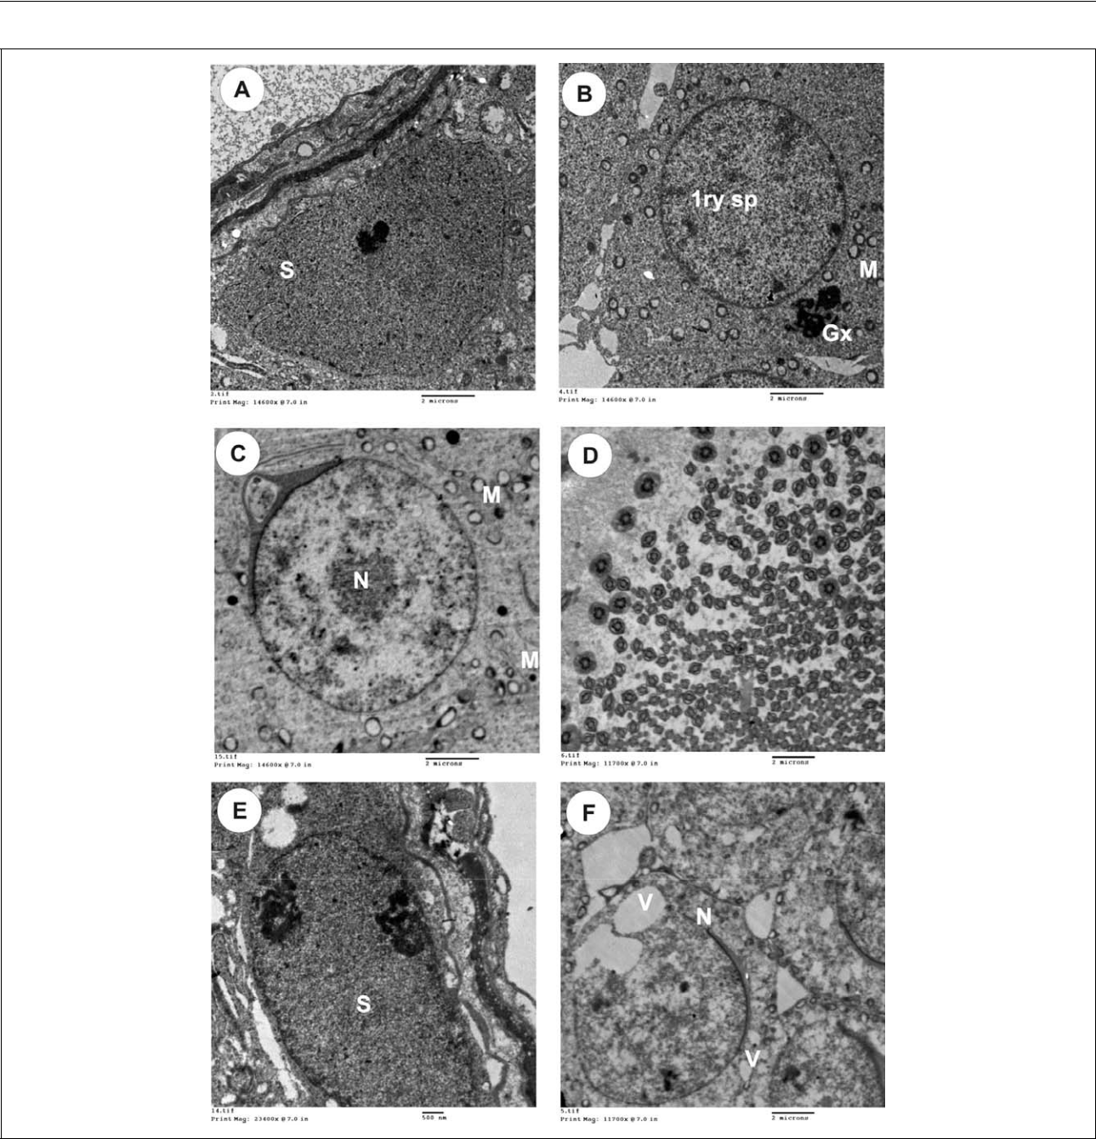

Figure 3. Photoelectron micrographs (transmission electron microscopy [TEM]) of the rat testis. (A) TEM of control rat testis showing the basement tubular membrane of the seminiferous tubules and Sertoli cell (S). (B) TEM of control rat testis showing normal primary spermatocytes (1ry sp), Golgi complex (Gx) and large number of mitochondria (M). (C) TEM of control rat testis showing secondary spermatocytes nucleus (N) and mitochondria (M). (D) TEM of rat testis in folic acid group showing large number of spermatozoa in the lumen of the seminiferous tubule. (E) TEM of hypothyroid rat testis showing a thick, irregular tubular basement membrane and damaged Sertoli cells (S). (F) TEM of hypothyroid rat testis showing more damaged spermatocytes with cytoplasmic vacuolation, degenerative mitochondria, dilation endoplas-mic reticulum, and lipid droplets. Also, primary spermatocytes with irregular, damaged nuclear membrane (N), cytoplas-mic vacuoles (V), and damaged mitochondria (M).

in sizes in comparison to the control group, with flat-tened nucleus and cytoplasm (Figures 3F and 4A). The basement membranes of the seminiferous tubules were more thickened and irregular with fibrous

connective tissue than that of the control group (Figure 3E). The smooth endoplasmic reticulum and Golgi apparatus are dilated, the mitochondria are con-densed and appeared darkly outlined and the nucleus

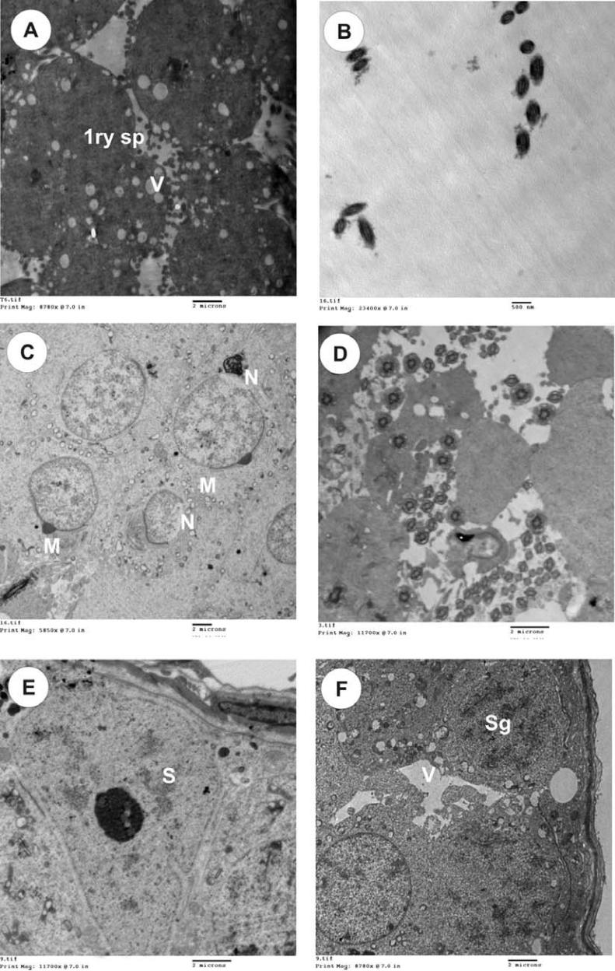

Figure 4. Transmission electron microscopy (TEM) of the rat testis. (A) TEM of hypothyroid rat testis co-treated with folic acid showing moderate damage in the spermatocytes with minimal cytoplasmic vacuolation. (B) TEM of hypothyroid rat testis showing little number of spermatozoa in the lumen of seminiferous tubule. (C and D) TEM of hypothyroid rat testis cotreated with folic acid showing an increase in sperm count and decrease in the lumen of seminiferous tubule. M: mitochondria, N: spermatocytes nucleus. (E) TEM of hypothyroid rat testis posttreated with folic acid showing normal structure of basement membrane and Sertoli cells. (F) TEM of hypothyroid rat testis posttreated with folic acid showing normal structure of spermatogenic cells (spermatogonia and spermatocytes) with minimal cytoplasmic vacuolation. S: Sertoli cells.

is less damaged and has chromatin condensation at periphery of the nuclear membrane which is irregular in some area. The Sertoli cells showed more damage as the spermatocytes in cytoplasmic vacuolation, degenerative mitochondria, dilation endoplasmic

reticulum, and lipid droplets (Figure 3E). The lumen of the seminiferous tubules in hypothyroid rat group had lack of sperms (Figure 4B). The spermatocytes in the hypothyroid rats showed clear degeneration in all cytoplasm, and the mitochondria are darkly

outlined and condensed, the cytoplasmic organelles are vacuolated, the nucleus has irregular nuclear membrane and clamped chromatin. The Golgi appara-tus and the endoplasmic reticulum are dilated and fragmented (Figure 4B).

The electron micrographs of the seminiferous tubules in hypothyroid rat testis treated with folic acid during hypothyroidism showed minimal damaged tubules displaying advanced stage of injury in cells where the basement membrane of the seminiferous tubules were more thickened with fibrous connective tissue than in control groups. The Sertoli cells were less affected (Figure 4C and D). The electron micro-graphs of the seminiferous tubules in hypothyroid rat testis treated with folic acid after hypothyroidism as in posttreatment group showed normal distribution of spermatogenic cells and normal structure of sper-matocytes only the Sertoli cells were less affected and the lumen of the seminiferous tubules was fully packed with sperms (Figure 4E and F).

Discussion

hypothyroid rats treated with folic acid when com-pared with the control. The seminiferous lumen dia-meter was increased in hypothyroid group and decreased in folic acid-treated group. This finding confirmed the statements of Cooke and Meisami (1991), Van Haaster et al. (1993), Tarulli et al.

(2006), Jansen et al. (2007), and Lin et al. (2009) about the role of thyroid hormone in regulating the maturation and growth of testis in rats and other mam-mals, by inhibiting the proliferation of immature Ser-toli cell and stimulating their functional differentiation. Moreover, the histoarchitectural dis-turbances leading to the accumulation of germ cells and debris in the lumen might cause a disturbance in the normal sperm release from the Sertoli cell and thereby a dip in the sperm counts in experimental groups.

Also, several reports emphasize the regulatory effect of thyroid hormone on early testis development by affecting T₃ receptors particularly in Sertoli cells, which play a critical role in spermatogenesis (Palmero et al., 1989; Rao et al., 2003). Simorangkir et al. (1997) showed an impairment in spermatogenesis in

The thyroid hormone is essential for the development | hypothyroid rats. They reported absence of round
and maintenance of the testes. The thyroid hormone | spermatids in the 30-day hypothyroid testis and the
has few serious effects on the testes except during the | inability of the spermatogenic cells to complete meio-
neonatal stage when the thyroid hormone receptor is | sis. Decrease in seminiferous lumen diameter is con-
mainly present. Any deficiency of thyroid hormone | sistent with the increase in Sertoli cell and germ cell
during early developmental stage affects testicular | numbers in the testes after treatment with folic acid.
maturation and reproduction later in life. Induction | Treatment of hypothyroid rats with folic acid signifi-
of hypothyroidism in the PTU-treated group was con- | cantly increased the sperm count as compared with
firmed by the reduction of serum T₃ concentration in | hypothyroid rats. However, significant decrease in the
the present study. The effect of PTU on T₃ seems to be | percentage of live sperms in both transient and persis-
reversed in adult rats when the treatment was with- | tent hypothyroid rats indicate the damaging effect of
drawn after 30 days as the levels of the T₃ and TSH | PTU on normal spermatogenesis, which is further con-
tend to be nearing the normal levels. Our results indi- | firmed by the accompanying low serum testosterone
cate that hypothyroidism adversely affects spermato- | levels in the hypothyroid group.
genesis, suggesting that thyroid hormone might play | During normal spermatogenesis controlled cell
an important role not only in controlling normal testi- | proliferation is of fundamental importance, assuming
cular development but also in maintaining normal tes- | highly coordinated mechanisms between the mito-
ticular function and spermatogenesis. Also, | tically inactive Sertoli cells and the germ cells
hypothyroidism in rat testes showed marked morpho- | undergoing mitosis and meiosis. Efficiency of sper-
logical changes in the seminiferous tubules such as | matogenesis depends on the proliferative activity of
thickened in basement membrane together with focal | spermatogonia and the loss of germ cells during meio-
areas of vacuolar degenerative changes appeared in | sis and spermatogenesis. Van Haaster et al. (1992)
the cytoplasm of the spermatogenic epithelium and | and Holsberger and Cooke (2005) reported that neo-
in the Sertoli cells, degeneration of germinal epithe- | natal hypothyroidism might increase adult Sertoli cell
lium with abnormal distribution of spermatozoa and | populations by extending Sertoli cell proliferation.
sloughing of germ cells into the tubular lumen were | Moreover, hypothyroidism is reported to be associated
also seen. Accumulation of spermatogenic cells and | with delayed structural and functional maturity of
Leydig cells in seminiferous tubules increased in | Sertoli cells in rat testis and may be directly resulting

from the action of thyroxine whose receptor mRNAs are identified in Sertoli cells (Bunick et al., 1994). Therefore, regulation of interstitial fluid volume by Sertoli cells warrants attention, especially as neonatal hypothyroidism prolongs Sertoli cell proliferation (Sharpe and Cooper, 1983; Sharpe et al., 1991). According to these combined results, we showed that PTU-induced hypothyroidism at the postpubertal stage had made a number of histoarchitectural changes in the testes as compared to the controls. Further, we sug-gested an ameliorating role for folic acid in the relief of testicular tissue changes developed due to hypothyr-oidism. However, we found that the best results were found in case of using the folic acid as an adjuvant ther-apy after returning to the euthyroid state.

Funding

This research received no specific grant from any funding agency in the public, commercial, or not-for-profit sectors.

References

Bancroft JD, Stevens GA (1990) Theory and Practice of Histological Techniques 2nd Ed. London: Churchill Livingstone.

Bunick D, Kirby J, Hess RA, and Cooke PS (1994) Development expression of testis messenger ribonucleic acids in the rat following propylthiouracil-induced neonatal hypothyroidism. Biology of Reproduction 51(4): 706-713.

Cooke PS, Meisami E (1991) Early hypothyroidism in rat causes increased adult testis and reproductive organ size but does not change testosterone levels. Endocrinology 129(1): 237-243.

de Kretser DM (1982) Sertoli cell–Leydig cell interaction in the regulation of testicular function. International Journal of Andrology 5: 11-17.

Diekman MJ, van der Put NM, Blom HJ, Tijssen JP, and Wiersinga WM (2001) Determinants of changes in plasma homocysteine in hyperthyroidism and hypothyr-oidism. Clinical Endocrinology 54(2): 197-204.

Forges T, Monnier-Barbarino P, Alberto JM, Gue´ant-Rodriguez RM, Daval JL, and Gue´ant JL (2007) Impact of folate and homocysteine metabolism on human repro-ductive health. Human Reproduction Update 13(3): 225-238.

Gereben B, Zavacki AM, Ribich S, Kim BW, Huang SA, Simonides WS, et al. (2008) Cellular and molecular basis of deiodinase-regulated thyroid hormone signal-ing. Endocrine Reviews 29(7): 898-938.

Holm J, Hansen SI, and Hoier-Madsen M (1991) A high-affinity folate binding protein in human semen. Bioscience Reports 11(5): 237-242.

Holsberger DR, Cooke PS (2005) Understanding the role of thyroid hormone in Sertoli cell development: a mechan-istic hypothesis. Cell and Tissue Research 322(1): 133-140.

Jansen HT, Kirby J, Cooke PS, Arambepola N, and Iwa-moto G (2007) Impact of neonatal hypothyroidism on reproduction in the male hamster, Mesocricetus auratus. Physiology & Behavior 90(5): 771-781.

Krassas GE, Papadopoulou F, Tziomalos K, Zeginiadou T, and Pontikides N (2008a) Hypothyroidism has an adverse effect on human spermatogenesis: a prospec-tive, controlled study. Thyroid 18(12): 1255-1259.

Krassas GE, Papadopoulou F, Tziomalos K, Zeginiadou T, and Pontikides N (2008b) Erectile dysfunction in patients with hyper- and hypothyroidism: how common and should we treat? The Journal of Clinical Endocri-nology and Metabolism 93(5): 1815-1819.

Kuroki Y, Iwamoto T, Lee W, Yoshiike M, Nozawa S, Nishida T, et al. (1999) Spermatogenic ability is differ-ent among males in different Y chromosome lineage. Journal of Human Genetics 44(5): 289-292.

Lalonde R, Joyal CC, and Botez MI (1993) Effects of folic acid and folinic acid on cognitive and motor behaviors in 20-month-old rats. Pharmacology, Biochemistry, and Behavior 44(5): 703-707.

Lin H, Hu G, Dong L, Dong Q, Mukai M, Chen B, et al. (2009) Increased proliferation but decreased steroido-genic capacity in Leydig cells from mice lacking cyclin-dependent kinase inhibitor 1B1. Biology of Reproduction 80(6): 1232-1238.

Lucock M (2000) Folic acid: nutritional biochemistry, molecular biology, and role in disease processes. Mole-cular Genetics and Metabolism 71(1-2): 121-138.

Matte C, Scherer EB, Stefanello FM, Barschak AG, Vargas CR, Netto CA, et al. (2007) Concurrent folate treatment prevents Naþ, Kþ- ATPase activity inhibition and memory impairments caused by chronic hyperhomocys-teinemia during rat development. International Journal of Developmental Neuroscience 25(8): 545-552.

Mendis-Handagama SM, Siril Ariyaratne HB (2005) Leydig cells, thyroid hormones and steroidogenesis. Indian Jour-nal of Experimental Biology 43(11): 939-962.

Palmero S, de Marchis M, Gallo G, and Fugassa E (1989) Thyroid hormone affects the development of Sertoli cell function in the rat. Journal of Endocrinology 123(1): 105-111.

Rao JN, Liang JY, Chakraborti P, and Feng P (2003) Effect of thyroid hormone on the development and gene expression

of hormone receptors in rat testis in vivo. Journal of Endocrinological Investigation 26(5): 435-443.

Sahoo D, Roy A, Bhanja S, and Chainy G (2008) Hypothyr-oidism impairs antioxidant defence system and testicular physiology during development and maturation. General and Comparative Endocrinology 156(1): 63-70.

Sharpe RM, Bartlett JM, and Allenby G (1991) Evidence for the control of testicular interstitial fluid volume in the rat by specific germ cell types. Journal of Endocri-nology 128(3): 359-367.

Sharpe RM, Cooper I (1983) Testicular interstitial fluid as a monitor for changes in the intratesticular environment in the rat. Journal of Reproduction and Fertility 69(1): 125-135.

Simorangkir DR, Wreford NG, and De Kretser DM (1997) Impaired germ cell development in the testes of imma-ture rats with neonatal hypothyroidism. Journal of Andrology 18(2): 186-193.

Tarulli G, Stanton P, Lerchl A, and Meachem S (2006) Adult Sertoli cells are not terminally differentiated in the djungarian hamster. Effect of FSH on proliferation and junction protein organization. Biology of Reproduc-tion 74(5): 798-806.

Toshihiro I (2009) Thyroid hormone and atherosclerosis.

Vascular Pharmacology. doi:10.1016/j.vph.2009.09.004.

Tousson E, Ibrahim W, Arafa N, and Akela MA (2011) Monoamine concentrations changes in the PTU induced hypothyroid rat brain and the ameliorating role of folic acid. Human & Experimental Toxicology. Published online on 8 April 2011. doi:10.1177/0960327111405 863.

Van Haaster LH, de Jong FH, Docter R, and De Rooij DG (1992) The effect of hypothyroidism on Sertoli cell pro-liferation and differentiation and hormone levels during testicular development in the rat. Endocrinology 131(3): 1574-1576.

Van Haaster LH, de Jong FH, Docter R, and de Rooij DG (1993) High neonatal triiodothyronine levels reduce the period of Sertoli cell proliferation and accelerate tubular lumen formation in the rat testis and increase serum inhibin levels. Endocrinology 133(2): 755-760.

Wallock LM, Tamura T, Mayr CA, Johnston KE, Ames BN, and Jacob RA (2001) Low seminal plasma folate concentrations are associated with low sperm density and count in male smokers and nonsmokers. Fertility and Sterility 75(2): 252-259.

Wong WY, Thomas CM, Merkus JM, Zielhuis GA, and Steegers-Theunissen RP (2000) Male factor subfertility: possible causes and the impact of nutritional factors. Fertility and Sterility 73(3): 435-442.

