A comparative study of different biocementation implementation methods for embankment foundation soil
M.U. Safdar¹, M. Mavroulidou^{1*}, M.J. Gunn¹, D. Purchase², I. Payne³, J. Garelick³
¹London South Bank University, UK,
mavroum@lsbu.ac.uk (corresponding author)

²School of Natural Sciences, Faculty of Science and Technology, Middlesex University, UK
³Network Rail, UK

ABSTRACT: In the context of sustainable ground engineering practices, biocementation has recently attracted the vivid interest of researchers worldwide. The technique utilises the natural biological process of biomineralisation (the biological production of minerals through the metabolic processes of different types of microorganisms/ plants) as a soil stabilisation method. The technique has the potential to be environmentally superior to other common chemical soil stabilisers. This study uses indigenous ureolytic micro-organisms to biocement an organic soil from the UK railway network. The paper focuses on the comparative investigation of different methods of implementation of biocementation treatments. Namely, mixing of all treatments, pressure injection and electrokinetic injection. The success of the techniques is discussed in terms of a) Unconfined compressive strength (UCS); b) calcium carbonate precipitation and c) compressibility and consolidation characteristics. It is shown that electrokinetic treatment is overall more successful as it led to higher strengths and CaCO₃ contents, as well as higher stiffness of the treated soil. It also shows promise for a successful implementation of the treatments under existing infrastructure.
Keywords: biocementation, mixing, electrokinetics, pressure injection

Introduction
Due to the growing urbanisation and the scarcity of urban space, new infrastructure works in urbanised areas will be increasingly constructed on inferior ground i.e., weak natural or man-made geomaterials (e.g. in waste disposal sites) with increased hazards and impacts of catastrophic failures. Existing infrastructure facilities will also need to be upgraded to meet future needs and changing environmental loads due to climate change. These include ageing transport earthworks in many European countries suffering from serviceability problems and requiring costly maintenance/remediation. Current policies require infrastructure to be provided in an economical and environmentally responsible manner (reducing material use, embedded carbon and other impacts on the natural environment and ecosystems). Improving rather than replacing and landfilling inferior ground or geomaterials (including wastes) for civil infrastructure uses, will thus become critically important in future engineering practice towards low-carbon, sustainable solutions. In line with this, an emerging ground improvement technique, which has recently attracted the interest of researchers worldwide, is soil biocementation. It utilises the natural biological process of biomineralisation (the biological production of minerals through the metabolic processes of different types of microorganisms/ plants) as a soil stabilisation method. The technique was claimed to be environmentally superior to conventional grouts or other common soil stabilisers e.g., cement or lime (linked to high CO₂ emissions) and potentially more sustainable overall, since the non-pathogenic micro-organisms used are natural, readily available and renewable (DeJong et al, 2013). A major challenge however is finding suitable ways to implement treatments under existing infrastructure, as pressure injection can often lead to non-uniform mineral precipitation.
Recent work funded by Network Rail, proved biocementation of a problematic organic foundation soil of UK railway embankments (causing severe settlements), using non-pathogenic, indigenous ureolytic bacteria extracted from the in situ soil (Mavroulidou et al, 2019; Safdar et al, 2020a,b). This paper focuses on the effect of different treatment implementation techniques in successfully biocementing the soil. The success of the techniques is discussed in terms of a) Unconfined compressive strength (UCS); b) CaCO₃ precipitation and c) compressibility characteristics.

Materials and methods
  - Soil type and treatments
The soil used in this study came from two boreholes at an East Anglian railway site in the UK. It was dark grayish brown, had a 50.8% organic matter content, 55.5% natural water content (consistent with a humified/decomposed organic soil), a quasi-neutral pH (7.15) and Liquid Limit and Plastic Limit of 101% and 63% respectively. The soil was identified as amorphous peat. Details on the physico-chemical soil characteristics can be found in Safdar et al, (2000a). Following a microbiological study described in detail in Safdar et al. (2020a,b) four ureolytic indigenous strains were identified as possible candidates for biocementation of the soil (through microbially induced CaCO₃ precipitation). These were Bacillus licheniformis, Rhodococcus erythropolis, Micrococcus luteus, and Lysinibacillus fusiformis, all of biosafety level (BSL) 1 i.e., not known to consistently cause disease in healthy adults, and of minimal potential hazard to laboratory workers and the environment (U.S. Department of Health and Human Services (CDC/NIH, 2007)). For the hydromechanical property testing, all the test strains were cultivated at pH 7 under aerobic batch conditions in a sterile culture medium of Nutrient Broth (Oxoid, UK) consisting of 5 g/l peptone, 5 g/l sodium chloride, 2 g/l yeast extract and 1 g/l beef extract. Incubation was performed in a shaking incubator at 200 rpm and 37 °C. The strains were grown to an early stationary phase i.e., Optical Density (OD): OD600 ranging from 0.5-0.7 (measured using a Pharmacia LKB Novaspec II spectrophotometer of 325-900 nm Wavelength Range). They were then harvested by centrifuging at 8000g for 10 minutes to achieve the final concentration of approximately 1x10⁸ cfu/mL (optical density 3.3).

The cementing reagents used in this study were equimolar (1M) concentrations of urea and calcium chloride mixed together in one solution. Different equimolar concentrations were also considered in a parametric study described in Mavroulidou et al, (2019) and Safdar et al (2020a). Cementation reagent solutions (or in the case of control samples, nutrient solution+bacteria without cementing reagents) 15 % by weight of the dry soil mass were then added into the soil for all implementation techniques. Samples were then compacted statically to the original field dry density of 0.919 g/cm³, at a rate of 1mm/min. The samples were wrapped in cling film and were tested after constant moisture curing.

  - Implementation methods
Five different treatment implementation methods were used, i.e., biostimulation (with nutrients to stimulate native micro-organism growth and cementing reagent added into the soil) and four bioaugmentation methods (i.e. supplying precultured microorganisms into the soil to enhance favourable microorganism populations). These were (a) mixing with the soil both the nutrients+bacteria solution and the cementing agent solution (urea and calcium chloride); (b) implementation of cementing solution through a flow column under light pressure (nutrients+bacteria were premixed in the soil); (c) Electrokinetic (EK) injection of cementing agents with nutrients+bacteria premixed in the soil; (d) full treatment injected by EK (i.e., nutrients+bacteria and cementing agents). Bacteria were initially premixed to prove biocementation for this soil, circumventing bacteria delivery complications and ensuring better uniformity of treatments. Mixing is however unfeasible under existing embankments unless deep mixing is used with especially designed augers to fit within the rails.

    - Mixing Method
During implementation by mixing, the soil was mixed with each culture medium containing the urease-producing bacteria, having a concentration of 1 x 10⁸ cfu/mL. After thorough mixing with bacteria, the samples were kept in air-tight containers for 24 hours to attain homogeneity of the microorganisms throughout the specimen. Cementation reagent solutions 15 % by weight of the soil sample (made with equimolar concentrations of urea and calcium chloride prepared in Nutrient Broth) were then added into the soil. The cementation reagent was added and mixed thoroughly in three equal portions i.e., each 24 hours, and the samples were again kept in an air-tight container for treatment for 7 days (starting from the mixing of microorganisms); then standard UCS specimens (of 50 mm diameter and 100 mm height) were prepared; before testing, they were wrapped in cling film and left to cure at constant moisture in a humidity and temperature-controlled cabinet for 2 days.

Pressure flow
The apparatus used consisted of a Plexiglas cylindrical mould (50 mm in diameter and 170 mm in length), a hydraulic pump, a compression frame and an effluent collector (see Safdar et al, 2020a). Aqueous solution of Nutrient Broth with bacteria of a total of 15 % by mass of soil was then supplied for all soil samples. The soil was covered in air-tight seal and left for 48-72 hours to attain homogeneity. Then statically compacted UCS specimens were made and transferred into the Plexiglas mould, where they were sandwiched between the two layers of perforated disks and filter papers (to avoid turbulent inflow and clogging at the inlet and outlet) and were mounted tightly onto the compression frame. The mould inlet was connected to the outlet of the pump. The cementing reagent solution was supplied into the specimen at a constant flow pressure of 150 kPa (the selection of the pressure is explained in Safdar et al, 2020a) and at room temperature (22-27ºC) during 3 days; this was followed by 7 days of curing.

Electrokinetic Implementation
For the EK method, a tank of 10 mm thick nonconductive acrylic ‘Perpex’ sheet with internal dimensions 210 mm length x 160 mm width x 140 mm depth was used. A purpose-built sample extractor internal layer was incorporated to prevent sample disturbance during extraction at the end of the test. The description of the EK cell can be found in Safdar et al. (2020a). The dimensions of the cell allowed for extraction of duplicate UCS specimens (50 mm diameter and 100 mm height cylinders) from three different locations in the soil sample: namely from the areas next to the two electrolyte chambers and from the middle of the sample. The soil sample was statically compacted in the EK tank in five equal layers to its in situ dry density of 0.919 g/cm³ using a hydraulic compression frame. Bacteria were implemented either (a) by EK injection together with the cementation solutions or (b) were pre-mixed thoroughly with the soil; then the soil-bacteria mix was covered with air-tight seal and left for 48-72 hours to attain homogeneity of treatments throughout the sample and the cementing reagents were then injected by EK. Premixing was mainly used to assess the feasibility of the technique, circumventing complications linked to the bacteria transport and uniformity of bacteria distribution in the sample. However, a more realistic field implementation scenario would use EK injection for all treatments. Bacteria were cultivated directly in the Nutrient Broth solution to the required 1 x 10⁸ cfu/mL concentration. A voltage gradient of 0.4 V/cm was maintained throughout the tests as recommended in the literature to prevent potential harm to the bacteria (Mizuno & Hori, 1988; Hassan et al., 2016). Periodic polarity reversal was applied every 24 h, which is recommended for a better uniformity of the treatment but also prevents high pH gradients that could be harmful to the bacteria (Mena et al. 2016). The nutrient broth solution and the cementing reagents were supplied all in one single solution (divided equally in the two electrolyte compartments i.e. 7.5% per dry soil mass per compartment). The EK treatment lasted for two weeks, (i.e. 7 days per electrode polarity), followed by one additional day of curing, which is a typical field treatment length (Mena et al. 2016). At the end of the tests, specimens for unconfined compressive strength (UCS) and oedometer tests were cut from the respective samples.

Results
Figure 1 (a) and (b) shows comparative results of the first set of studies (average values of triplicate specimens), using mixing and pressure flow injection of the treatments for the four monocultures, supplied at a concentration of 1x10⁸ cfu/mL. It can be seen that, based on the strengths achieved and the CaCO₃ contents, mixing did not achieve biocementation, although a slight increase in the CaCO₃ content compared to the native soil was observed; on the other hand, similar CaCO₃ contents were observed in the control specimens (nutrients+ bacteria cells) and for this reason, the possibility that late compaction could have broken biocementation bonds seems unlikely. Almajed (2017) observed the same for long curing periods and samples treated by enzymatically induced calcite precipitation, and attributed this to a loss of enzymatic activity due to ammonia by-product. The lack of success of mixing was surprising, as it was expected that it would enable more uniform treatments. A change in protocol and shorter mellowing periods could be tried; on the other hand, mixing would not be useful for existing infrastructure and for this reason its study was temporarily suspended, to focus on more successful treatments. Unlike mixing, pressure flow column was successful in increasing the strength and CaCO₃ contents of the soil for all monocultures compared to their respective control specimens (nutrients+monoculture). It is interesting that the nutrient+L.fusiformis control specimens had strengths as high as biocemented specimens; on the other hand, their CaCO₃ content was low and does not concur with biocmentation (which would not have been expected due to the lack of cementing reagents). Conversely, all specimens with full treatments (incl. cementing reagents) do show an increase in the CaCO₃ content pointing at biocementation, with the least well performing strain being R. erythropolis. The other monocultures showed similar results for the 1M concentration of cementing agent. However, using equimolar concentrations of lower molarity B. licheniformis was found to give better results (see e.g. Fig. 4), with the second best strengths (in our parametric study) achieved by L. fusiformis. Both B. licheniformis and L. fusiformis, have elongated cells making it more difficult to flush out during pressure or EK injection, therefore were initially selected as more preferred compared to M. luteus. Figure 2 (a) and (b) shows respectively indicative SEM-EDS results from pressure flow column tests with B. licheniformis, L. fusiformis; well distributed precipitation products have formed on the particles; indicative EDS spectra from sites on the samples show clear Ca and C peaks, concurring to CaCO₃ precipitation.

Due to a lack of sufficient sample from the same location one strain was used for further studies. Bacillus licheniformis was chosen because: (a) it is widespread in nature and is found in abundance in natural soils; (b) it is motile (using its flagellum) and relatively small (of about 1 μm diameter) which facilitates its motility through smaller pore throats; (c) it is reported to be facultative anaerobic (e.g. Clements et al, 2002) so it can survive in environmental conditions of reduced oxygen supply; (d) it is a spore generating bacterium, therefore potentially appropriate for self-healing of the treatments.

Figure 3 shows indicative UCS results of of 1x10⁸ cfu/mL B. licheniformis specimens with 85% degree of saturation treated with equimolar (1M) reagent solution and different methods. It can be seen that EK injection (with polarity reversal) was the most successful implementation method, superior to the pressure injection; the EK method was studied for degrees of saturation S_{r}=75-95% with the latter giving the best results (not shown here for brevity). Implementation in wetter periods of the year would therefore be recommended for better success of the treatment. Consistently, the highest CaCO₃ contents in the soil (not shown here) were detected for the EK method. Pressure flow led to strength improvement (and increased CaCO₃ contents) but to a lesser extent than EK, whilst biostimulation by pressure injection and implementation of full treatments by mixing were not successful. There was obviously a combined effect of biocementation and EK (which is an improvement method per se) as EK control samples (not shown here for brevity) had higher strengths than the respective pressure flow ones; however, CaCO₃ contents and increased strengths (compared to EK control) when bacteria were used in the EK tests, concur with the conclusion that the strength increase was due to biocementation. Whilst treatment non-uniformity (when bacteria were injected rather than premixed) still needs to be addressed, there is promise that EK could be a viable technique for treating soil under existing infrastructure. The comparatively higher success of the EK method in biocementing the sample can also be testified by the indicative stress-strain behaviour plots in Fig. 4. Even with the best performing pressure flow column treatment concentration (0.75M reagent solution), against 1M reagent solution for the EK (which had a rather modest performance for the B.licheniformis pressure flow column treatment, as shown in Fig. 1 and 3) the EK curves show a more brittle response -and a slight increase in stiffness-, which is consistent with the higher degree of cementation of the EK sample. This is also consistent (with one exception) with the indicative oedometer results in Table 1 showing coefficient of volume compressibility m_{v} values; both EK and pressure flow led to a reduction in the compressibility of the treated specimens compared to the untreated specimen.
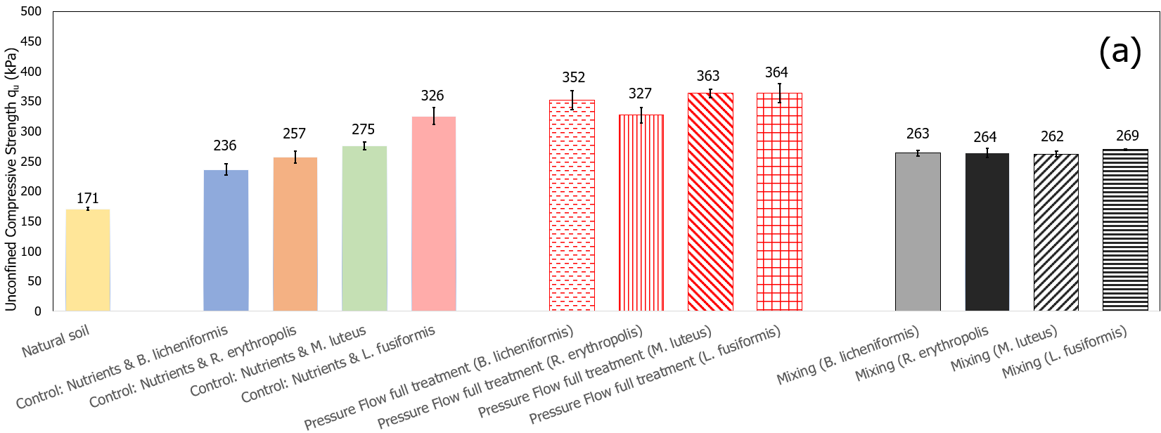
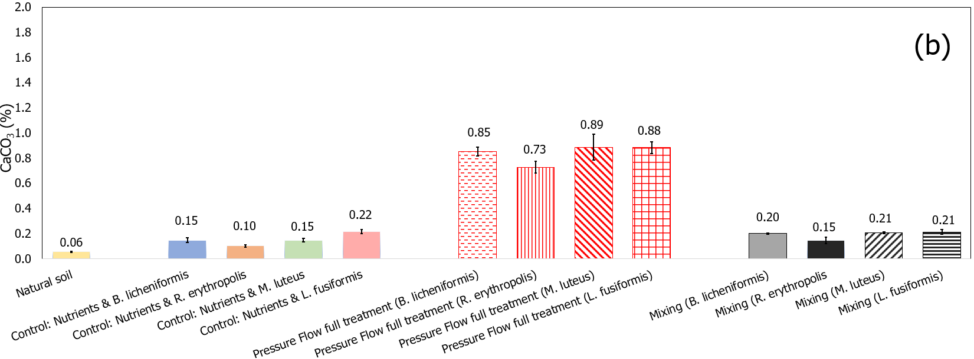
Figure 1. Preliminary testing results with four monocultures: (a) UCS results; (b) CaCO₃ measurements
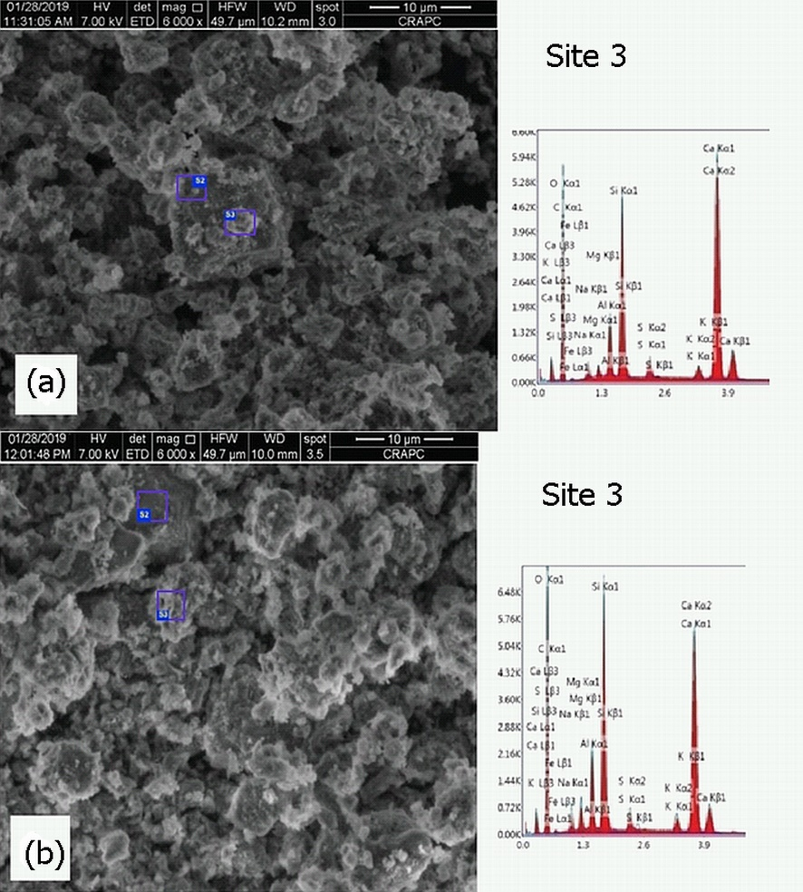
Figure 2. Indicative SEM-EDS results for two monocultures: (a) B. licheniformis;(b) L.fusiformis
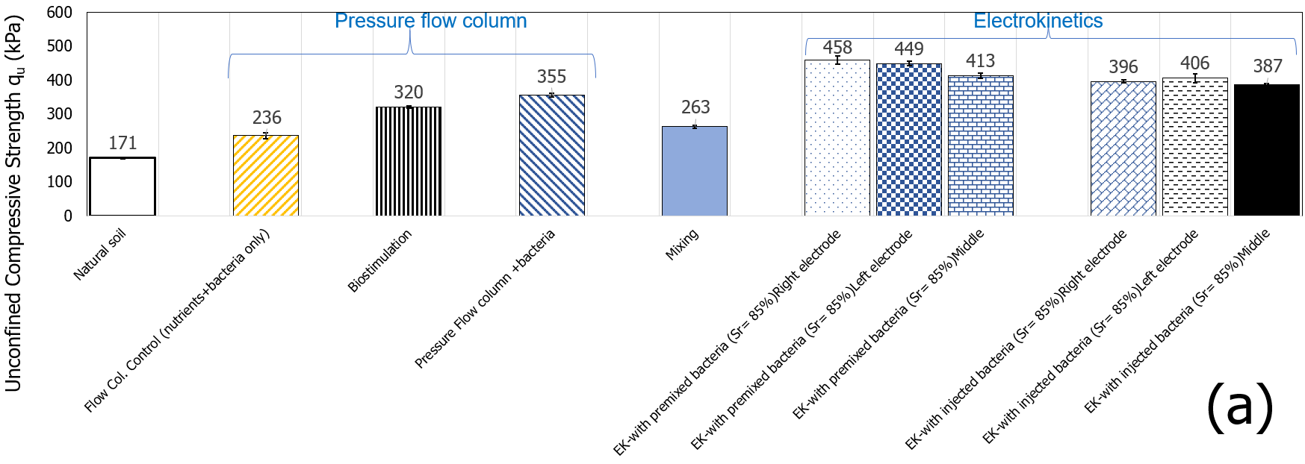
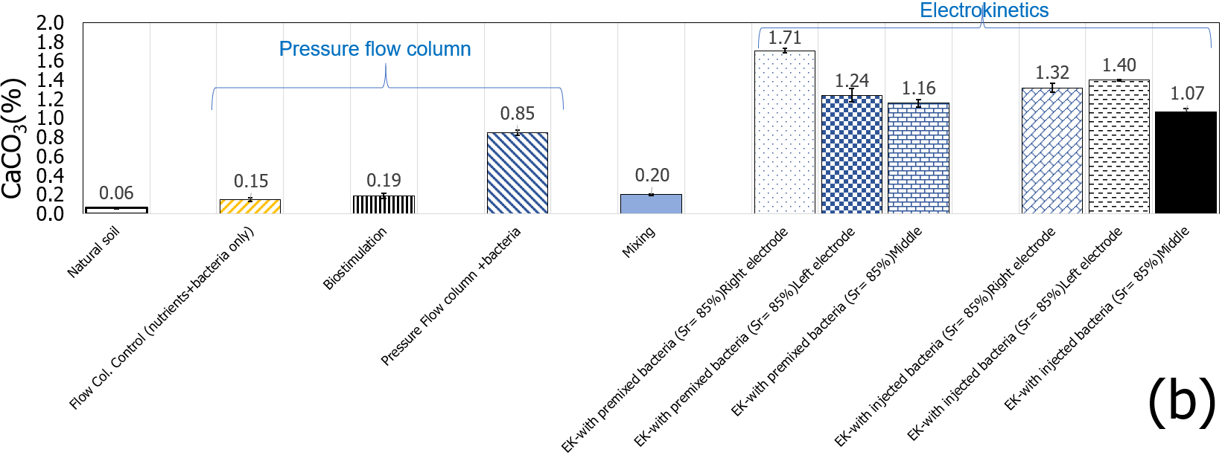
Figure 3. Comparative results for all methods using the selected monoculture (B. licheniformis): (a) UCS results; (b) CaCO₃ measurements
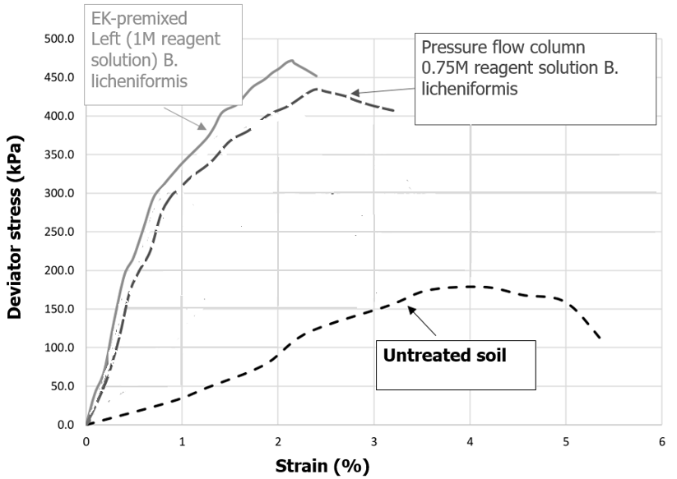
Figure 4. Comparative stress-strain behaviour for the selected monoculture (B. licheniformis)

Table 1. Indicative comparative results of coefficient of volume compressibility, m_{v}
Effective stress range (kPa) | Untreated  (m²/kN) | Pressure injection  (m²/kN) | EK  (m²/kN)
0-25 | 0.0009 | 0.0006 | 0.0005
25-50 | 0.0005 | 0.0002 | 0.0003
50-100 | 0.0004 | 0.0003 | 0.0003
100-200 | 0.0003 | 0.0002 | 0.0002
200-400 | 0.0003 | 0.0002 | 0.0001

Conclusions
The paper considered comparatively five different implementation methods to realise biocementation of an organic soil; namely, four bio-augmentation implementation methods and biostimulation. Of these, electrokinetics performed the best producing the highest strengths, CaCO₃ contents and higher soil stiffness. There was obviously a combined effect of biocementation and electrokinetics; however, CaCO₃ contents and increased strengths compared to EK control when bacteria were used in the EK tests, support the conclusion that the strength increase was due to biocementation. Pressure flow did lead to strength improvement and increased CaCO₃ contents but to a lesser extent than EK, whilst mixing of the treatments and biostimulation by pressure injection were not successful in this instance. The latter two techniques will be revisited changing the procedure and treatment protocol; in particular, biostimulation is an interesting technique and will be studied further. Whilst treatment non-uniformity (when bacteria were injected rather than premixed) still needs to be addressed, there is promise that EK could be a viable technique for treating foundation soil under existing infrastructure, which is a major challenge for engineers.

Acknowledgements
The authors would like to acknowledge the financial contribution of Network Rail Ltd for this project under research contracts NR-ANG-00164 and ecm_18210_ANG.
References
Almajed, A.A. (2017). Enzyme Induced Carbonate Precipitation (EICP) for Soil Improvement. Ph.D. Thesis, Arizona State University, Tempe, AZ, USA.
CDC/NIH (U.S. Department of Health and Human Services, Centers for Disease Control and Prevention, & National Institutes of Health) (2007). Biosafety in microbiological and biomedical laboratories, 5th edn (eds L. C. Chosewood and D. E. Wilson). Washington, DC, USA: U.S. Government Printing Office. See www.cdc.gov/od/ohs/biosfty/bmbl5/bmbl5toc.htm (accessed 08/04/2020).
Clements, L.D., Miller B.S., Streipsa, U.N.(2002). Comparative Growth Analysis of the Facultative Anaerobes Bacillus subtilis, Bacillus licheniformis, and Escherichia coli. Systematic & Applied Microbiology, 25(2), pp. 284-286
DeJong J. T., Soga K., Kavazanjian E. et al (2013). Biogeochemical processes and geotechnical applications: progress, opportunities and challenges. Géotechnique, 63(4), pp. 287–301.
Hassan, I., Mohamedelhassan, E., Yanful, E.K., Yuan, Z.-C. (2016). A Review Article: Electrokinetic Bioremediation Current Knowledge and New Prospects. Advances in Microbiology, 6, pp. 57-72.
Mavroulidou, M., Safdar, M.U., Gunn, M.J., Payne, I., Garelick, J., Purchase, D. (2019). Innovative methods of ground improvement for problematic transport earthwork materials, 16th Int. Conference on Environmental Science and Technology CEST2019, Rhodes 4-7 September 2019
Mena E, Villaseñor J, Cañizares P and Rodrigo MA (2016) Effect of electric field on the performance of soil electro-bioremediation with a periodic polarity reversal strategy. Chemosphere, 146, pp. 300-307
Mizuno, A., Hori, Y. (1988). Destruction of Living Cells by Pulsed High-Voltage Application. IEEE Transactions on Industry Applications, 24, pp. 387-394. http://dx.doi.org/10.1109/28.2886
Safdar, M.U., Mavroulidou, M., Gunn, M.J., Garelick, J., Payne, I., Purchase, D. (2020a). Innovative methods of ground improvement for railway embankment Peat Fens foundation soil. Géotechnique. https://doi.org/10.1680/jgeot.19.SiP.030.
Safdar, M., Mavroulidou, M., Gunn, M.J., Garelick, J., Payne, I., Purchase, D. (2020b). Biocementation of an organic soil using indigenous ureolytic bacteria, Proceedings of the 6th International Symposium on Green Chemistry, Sustainable Development and Circular Economy (Greenchem6), Thessaloniki, 20-23 September 2020, ISBN:978-618-5494-13-1

