Finite Element Analysis of Shear-off Failure of Keyed Dry Joints in Precast Concrete Segmental Bridges
Rabee Shamass¹; Xiangming Zhou, Ph.D., M.ASCE²; Giulio Alfano³
¹PhD Student in Civil Engineering, School of Engineering and Design, Brunel University, Kingston Lane, Uxbridge, Middlesex UB8 3PH,United Kingdom Email: Rabee.Shamass@brunel.ac.uk
²Senior Lecturer in Civil Engineering Design, School of Engineering and Design, Brunel University, Kingston Lane, Uxbridge, Middlesex UB8 3PH, United Kingdom, Tel: +44 1895 266 670, Fax: +44 1895 256 392, Email: Xiangming.Zhou@brunel.ac.uk
³Senior Lecturer in Computational Mechanics, School of Engineering and Design, Brunel University, Kingston Lane, Uxbridge, Middlesex UB8 3PH, United Kingdom, Email: Giulio.Alfano@brunel.ac.uk

Abstract: The structural behaviour of precast concrete segmental bridges is largely dependent on the behaviour of the joints between segments. The current practice is to use small keys that are usually unreinforced, distributed over the height of the web and the flange of concrete segments and these keys are normally dry. In this study, a numerical analysis model was established based on ABAQUS finite element code to investigate structural behaviour of keyed dry joints under direct shear. The concrete damage plasticity model along with the pseudo-damping scheme were incorporated to analyse the system for microcracks and to stabilize the solution, respectively. The numerical model is calibrated by full-scale experimental results published elsewhere. It was found that the predicted ultimate load, cracking evolution history, and final crack pattern agree reasonably well with experiment results. The validated numerical model was then employed for parametric study on factors affecting shear behaviour of keyed dry joints, in this case confining pressure. It has been found that shear capacity predicted by AASHTO diverges from that predicted by numerical analysis at high confining pressure because the contribution of friction in the total shear capacity reduces with the increase in confining pressure. Hence, it is recommended to reduce the friction coefficient used in AASHTO code when high confining pressure is applied. Moreover, the propagation of inclined crack is arrested at high confining pressure due to the fact that the fracture propagation direction is governed by the criterion of the maximum energy release rate.
CE Database subject headings: Concrete bridges; Failure modes; Finite element method; Girder bridge; Joints; Precast concrete; Shear; Shear failures; Shear strength
Author Keywords: Concrete damage plasticity; Direct shear; Dry joint; Keyed joints; Precast concrete segmental bridges; Shear-off

Introduction
Precast concrete segmental box girder bridges externally prestressed have become more and more popular in construction resulted from the demand of an economical and safe design, fast, versatile and practical construction, and excellent serviceability of concrete bridges (Poston and Wouter 1998). The overall behaviour of precast concrete segmental bridges largely depends on the joints between segments which represent locations of discontinuity along a bridge span (Issa and Abdalla 2007). Compression and shear forces across bridge sections are transmitted through these joints (Zhou et al. 2005). Individual precast segments connected by such keyed joints are then externally prestressed forming the bridge superstructure. The current practice is to use multiple castellated small keys that are usually unreinforced in the key zone, distributed over the height of the web and flanges, to provide an improved interlocking performance.
The joints can be constructed and erected either using an epoxy layer between segments or in a dry condition. It has been concluded based on experimental results that the most significant parameters that affect the shear behaviour of the keyed joints are the prestress value, thickness of epoxy, shape of the key, surface preparation, concrete strength, contact area of the joint and friction coefficient between concrete to concrete surfaces (Buyukozturk et al. 1990). Epoxied joints are regarded to be able to perform better in terms of durability and ultimate shear capacity (Koseki 1981). However, it has been found that epoxied joints fail in a brittle manner which is not desirable in structural design. Besides, epoxy has to be put in construction site and the weather condition could become a dominant factor making its quality difficult to be controlled. It also takes time for epoxy to harden thus increases the construction period. Turmo et al. (2006b) pointed out that, when possible, the use of epoxied joints should be avoided since it redounds in time savings. Therefore in modern precast concrete segmental bridge construction, dry joints are more frequently used.
Though concrete segmental bridges with dry joints may be susceptible to suffer durability problem, it seems to be more and more popular due to its simplicity in construction. However, the behaviour of dry joints has not been understood well. Experimental results from various studies all indicated that the failure model of the shear keys was fracture of concrete along the joint with shearing off the keys (Buyukozturk et al. 1988; Zhou et al. 2005; Turmo et al. 2006b). Shear strength and stiffness of keyed dry joints increased with confining stress, i.e. prestress applied on the joint holding the male and female parts together. Most researchers accept that the shear strength of keyed dry joints is contributed by two different mechanisms (Turmo et al. 2006a). The first mechanism depends on the friction resistance between the flat surfaces which attempts to slide against the other. This resistance is proportional to the actuating compression load, i.e. the confining pressure. The second mechanism represents the support effect of the castellated shear-keys which behave like small plain concrete corbels when they are in contact. If compression stresses exist, the keys turn out to be small prestressed concrete corbels and the ultimate shear capacity of keyed joint increases as compression stresses increase. Though the shear flow mechanisms across dry joints are qualitatively well known, there is no consensus regarding their quantification.
Kaneko et al. (1993a) developed a simple mechanical model for the analysis and design of plain or fibre-reinforced concrete shear key joints. Their analysis employs a single discrete crack model under wedging force and a smeared crack model under remote shear force. Their proposed formulation identifies two main fracture mechanisms for shear-off failure of key joints: single curvilinear cracking and development of multiple diagonal cracks. Kaneko et al. (1993a) also proposed a simple design formula as a first step in developing design aids for the shear strength of shear keys and subsequently validated their fracture mechanics model (Kaneko et al. 1993b). On the other hand, Kaneko and Mihashi (1999) presented an analytical damage model which is able to predict the nonlinear strain localization along the shear key base at the cracking transition for keyed dry joint, The model is able to describe the transition phenomenon between a large single curvilinear crack (S-crack) and diagonal multiple cracks (M-crack) observed during the shear-off failure sequence of concrete shear key joints. Though analytical models proposed by Kaneko et al. (1993a) and Kaneko and Mihashi(1999) are scientifically sound, they are not easy to be directly adopted by structural engineers in daily work for designing keyed dry joints. Neither are they easy to be incorporated into a full finite element model for analysing structural behaviour of precast concrete segmental bridges with keyed joints. More recently, Li et al. (2013) conducted an experimental study mainly on the behaviour of keyed joints in precast concrete segmental beams under shear, bending and combined shear and bending. They deduced formulas to evaluate the ultimate strength of keyed joints under combined shear and bending. But it should be noted that their formulae are proposed for keyed joints subjected to combined shear and bending which is not necessarily applicable to keyed joints under direct shear even assuming bending moment equal to zero in their formulas.
On the other hand, from practical point of view, there are several formulae proposed for ultimate shear strength of unreinforced keyed dry joints among which some are based on experimental results and some on theoretical or numerical analyses. These formulae are all conceptually very similar conforming to the shear stress transfer mechanism aforementioned. Foure et al. (1993) tested assemblies of three precast segments under external prestressing. A formula was proposed but needs to be more largely checked by comparison with other test results and then simplified, to make for practical use. Roberts and Breen (1993) theoretically deduced a formulation to evaluate the shear strength of keyed dry joints which later on was adopted by American Association of State Highway and Transportation Officials (AASHTO) by applying a safety factor, φ_{j} = 0.75. The AASHTO PP34-99 formulation for shear strength of keyed joints is quoted as following:
$$V=A_{k}\sqrt{6.792×{10}^{-3}f_{cm}}(12+2.466σ_{n})+ µ.A_{sm}.σ_{n}$$ | (1)
$f_{cm}$: Characteristic compressive strength of concrete in MPa.
$σ_{n}$: Average compressive stress in concrete across the key base area in MPa.
$A_{k}$: Area of the base of all keys in the failure plane.
$A_{sm}$: Area of contact between flat surfaces on the failure plane.
$µ$: The friction coefficient between concrete to concrete surfaces which AASHTO suggests as 0.6. It is obvious that this formula separates the shear load-bearing capacity that the joint is capable of transmitting by the keys A_{k} and the flat area, A_{sm}, between the keys. On the other hand, based on nonlinear finite element analysis results, Rombach (1997) proposed another formula to calculate the shear capacity of keyed dry joints between bridge segments:
$$V=0.14f_{cm}A_{k}+ µ.A_{sm}.σ_{n}$$ | (2)
Where $f_{cm}$, $A_{k}$, $µ$, A_{sm} and σ_{n} in Eq. 2 refer to their counterpart, respectively, in Equation (1). It can be seen that Rombach’s formula is similar to the AASHTO one but it does not take into consideration the internal friction of a keyed joint. However, it has been found that the application of the above formulations leads to very different values of the ultimate shear capacity of the keyed dry joints from experiment (with some results that can vary by 100%) (Zhou et al 2005; Turmo et al. 2006b).
Though there are various experimental studies on shear keys reported (notably Koseki, 1981; Buyukozturk et al. 1988; Zhou et al. 2005; Turmo et al. 2006b; Li et al. 2013), there are limited numerical analyses on shear behavior of keyed joints published. As aforementioned, Rombach (1997) conducted numerical studies on keyed dry joints using ANSYS finite element code and summarized their work by a shear design formula shown in Equation (2). Turmo et al. (2006a) conducted FEM study on the structural behavior of simply supported segmental concrete bridges with post-tension and dry joints in which castellated keyed joints were analysed using a flat joint model to avoid very fine mesh needed for keys in a full finite element model therefore to save computing cost. The joint was modelled with interface elements with different constitutive laws depending on the geometry. It should be also noted the flat joint model proposed by Turmo et al. (2006a) was a macro model for keyed joints aiming at mainly reducing computation cost for analyzing concrete segmental bridges with keyed joints between segments. It is not possible to predict the stress, strain and crack evolution in keys in the joint by this model as the keys are not geometrically modelled. The model was proposed purely for the sake of structural analysis of precast segmental concrete bridge not for the keyed joints themselves. From this point of view, it cannot be counted as a numerical model for keyed dry joints. For this purpose, a micro finite element model is needed which falls in the scope of this research. Kim et al. (2007) presented a numerical study on the flat joints between precast post-tensioned concrete segments in which they employed very similar modelling techniques to that adopted by Turmo et al. (2006a). Turmo et al. (2012) presented a joint model for studying shear transfer between match-cast keyed dry joints between concrete segments. In their model, interface elements are used to reproduce the nonlinear behaviour of the joint and parameters deduced from various tests are used to define constitutive law of those interface elements for the joint. Alcalde et al. (2013) developed a finite element model of four different types of joints, with a number of keys varying between one and seven, to analyze the fracture behavior of keyed dry joints under shear, focusing on the influence of the number of keys on the joint capacity and its average shear stress. The results show that the average shear stress transferred across joints decreases with the number of keys which is consistent with the findings of Zhou et al. (2005) from experiment. It can be seen that there are very limited numerical studies published on structural behaviour of keyed joints between concrete segments. In line with this, a numerical study was conducted in this paper based on ABAQUS finite element code to simulate the behaviour of male-female matching single-keyed dry joints under direct shear till failure. Ultimate load capacity in shear and evolution of deformation, stress and crack in keyed dry joints were obtained through numerical analyses and calibrated by full-scale experimental results presented elsewhere (Buyukozturk et al. 1988; Zhou et al. 2005). The numerical model was then employed for parametric studies on structural behaviour of keyed dry joints. Some interesting findings were presented including the recommendation of modification of AASHTO’s formula (i.e. Eq. 1) for shear capacity of keyed dry joints.
Numerical
Concrete damage plasticity model
ABAQUS code provides tools for simulating damage in concrete using one of the crack models for reinforced concrete, namely, smeared crack concrete model, concrete damage plasticity (CDP) model and brittle crack model. The CDP model has been chosen in the present study for simulating concrete. It allows the definition of inelastic behaviour of concrete in compression and tension stiffening in tension including damage characteristics in both tension and compression. The CDP model can be used in applications in which concrete is subject to static and cyclic loading.
Initial parameters
The general CDP model parameters are chosen as follows (Kmiecik and Kaminski 2011): dilation angle, flow potential eccentricity and viscosity parameter are assigned equal to${36}^{o}$,$0.1$ and$0$, respectively; the ratio of the strength in the biaxial state to the strength in the uniaxial state, $\frac{σ_{b0}}{σ_{c0}}$=1.16; and the ratio of the second stress invariant on the tensile meridian,$K_{c}=0.666$
Stress-strain curve of concrete under uniaxial compression
As aforementioned, CDP model is used for simulating concrete cracking and crack propagation. To employ this approach, stress-strain relationships for concrete in compression and post-failure stress-strain relationship in tension are required. In this study, the complete $σ_{c}$-$ε_{c}$ curve proposed by Eurocode 2 (BSI 2004) is adopted for concrete under compression which suggests the expression:
$$σ_{c}=\left(\frac{k η-η^{2}}{1+(k-2)η}\right)f_{cm}$$ | (3)
Where:
$η=\frac{ε_{c}}{ε_{c1}}$. | (4)
$$k=1.05{ E}_{cm}\frac{ε_{c1}}{f_{cm}}$$ | (5)
$$ε_{c1}(‰)=0.7{\left(f_{cm}\right)}^{0.31}≤2.8$$ | (6)
$$E_{cm}=22{\left(0.1 f_{cm}\right)}^{0.3}$$ | (7)
$E_{cm}$ is the elastic modulus [in GPa] of concrete; ${ f}_{cm}$ is the ultimate compressive strength of concrete. Fig. 1 shows the complete compressive stress-strain curve of concrete with the ultimate compressive stress${ f}_{cm}$ [MPa], strain at peak stress $ε_{c1}$ and ultimate strain ${ ε}_{cu1}$ which is taken as 0.0035 by Eurocode 2. A linear stress-strain relationship which obeys Hooke’s law was assumed up to 40% of ultimate compressive strength ($f_{cm}$) in the ascending branch.
Inelastic strains $\tilde{ε_{c}^{in}}$ corresponds to compressive stresses $σ_{c}$ are used in the CDP model. To obtain them, one has to substitute the total strain from elastic strain $ε_{oc}^{el}$ which corresponds to undamaged material as following:
$$\tilde{ε_{c}^{in}}=ε_{c}-ε_{oc}^{el}$$ | (8)
$$ε_{oc}^{el}=\frac{σ_{co}}{E_{cm}}$$ | (9)
Additionally, the compressive damage parameter $dc$ needs to be defined at each inelastic strain level. It ranges from zero for an undamaged material to one when the material totally lost its load-bearing capacity. The value $dc$ is obtained only for the descending branch of the stress-strain curve of concrete in compression as following (See Fig. 2):
$$d_{c}=0 ε_{c}<ε_{c1}$$  $$d_{c}=\frac{f_{cm}-σ_{c}}{f_{cm}}{ ε}_{c}≥ε_{c1}$$ | (10)
Therefore, the plastic strains calculated using Eq. 11 must be always positive:
$$\tilde{ε_{c}^{pl}}=\tilde{ε_{c}^{in}}- \frac{d_{c}}{\left(1-d_{c}\right)}\frac{σ_{co}}{E_{cm}}$$ | (11)
Post-failure stress-strain relationship in tension (Tension stiffening)
Tensile strength of concrete was taken as 10% of its compressive strength. Tension stiffening refers to the phenomenon that concrete can carry tension even after cracking though tensile strength gradually decreasing with increasing tensile strain. In this study, a linear stress-strain relation (see Fig. 3) was adopted for concrete in tension. It assumes that the strain softening after failure point reduces the stress linearly to zero at a total strain of about 10 times the strain at tensile cracking ${ ε}_{cr}$ (Simulia 2011). Cracking strains $\tilde{ε_{t}^{ck}}$ correspond to tension stresses $σ_{t}$ are used in CDP (see Fig. 4). To obtain them, one has to substitute the total tensile strain $ε_{t}$ from the elastic strain $ε_{ot}^{el}$ as following:
$$\tilde{ε_{t}^{ck}}=ε_{t}-ε_{ot}^{el}$$ | (12)
$$ε_{ot}^{el}=\frac{σ_{t}}{E_{cm}}$$ | (13)
Similarly to the case of compression, the tensile damage parameter $dt$ needs to be defined at each cracking strain. The $dt$ value is valid only at the descending branch of the stress-strain curve of concrete in tension as following (See Fig. 4):
$$d_{t}=0 ε_{t}<ε_{cr}$$  $$d_{t}=\frac{f_{t}-σ_{t}}{f_{t}} ε_{t}≥ε_{cr}$$  Where: $ε_{cr}=\frac{f_{t}}{E_{cm}}$ | (14)
The plastic strain is defined from the following equation:
$$\tilde{ε_{t}^{pl}}=\tilde{ε_{t}^{ck}}- \frac{d_{t}}{\left(1-d_{t}\right)}\frac{σ_{t}}{E_{cm}}$$ | (15)
Crack detection in numerical analysis
The CDP model does not support the concept of cracks developing at the material integration point. However, in this study it is assumed that cracking occur at point when the maximum principal total strain exceeds the value of the strain${ ε}_{o}=10ε_{cr}$ (see Fig. 3). Under such high strain, a concrete element totally losses its resistance to tension.
Material properties for reinforcement bar
Though it has been found that the stress in the reinforcement bar was far lower than its yielding strength throughout the loading till the shear-off failure of concrete keys, without losing generality, in this study a linear elastic and fully plastic bilinear stress-strain material model was employed for reinforcement bar in tension and compression. The yield strength$f_{y}$, elastic modulus $E_{s}$ and Poisson’s ratio $ν$ of reinforcement bar was taken as 400 MPa, and 210 GPa and 0.33, respectively.
Numerical Simulation
In this study, the single-keyed dry joints tested elsewhere by Zhou et al. (2005) and by Buyukozturk et al. (1990) were analysed using FE code ABAQUS, version 6.11-1, based on the model parameters discussed above. In Zhou’s specimens, the overall dimensions of the single-keyed dry-joints were 500×620×250 mm³ with 250 mm the thickness of the joint including a male part and a female part (see Fig. 5). The castellated joint had a 100×250 mm² base area and a 50×250 mm² top area with a 50 mm depth. The most critical area in which cracking happens is the castellated keyed area where a finer mesh with nominal element size about 5 mm was used compared with a coarser mesh with the nominal element size about 15 mm adopted for the rest of the model as shown in Fig. 6. 4-node bilinear plane stress quadrilateral elements (CPS4) were used for modelling the key assembly. The plane stress thickness was taken 250 mm. There are in total 2255 elements for a typical single keyed dry joint assembly. A full integration algorithm was used in numerical analyses. For those keyed joints tested by Zhou et al. (2005), the specimen identifier is represented as Mi-D-Km-n, where M represents monotonic loading, and the numeral following M in this case i indicates the confining stress in MPa. D is identified as dry joint while K indicates keyed joint and m is the key number. The last numeral n represents the test number under the same testing condition.
In the experiment reported by Buyukozturk et al. (1990), the overall dimensions of the single-keyed dry-joints were 21×10×3 inches³ (533.4×251×76.2 mm³) with 3 inch (76.2 mm) the thickness of the joint including a male part and a female part. The castellated joint had a 3×3.875 inches² (76.2×98.425 mm²) base area and a 3×2.625 inches² (76.2×66.675 mm²) top area with a 1.25 inch (31.75 mm) depth (Fig. 7). Again, the most critical area is the castellated keyed area where a finer mesh with nominal element size about 3.5 mm was used compared with a coarser with the nominal element size about 7-12 mm adopted for the rest of the model as shown in Fig. 6. Similarly, 4-node bilinear plane stress quadrilateral elements (CPS4) with full integration algorithm were used and the plane stress thickness was taken 76.2 mm. There are in total 3965 elements for a typical single keyed dry joint assembly. In all cases, first-order truss elements were used for modelling the reinforcement bars embedded in the keyed joints.

Contact Relationship
The Node-to-surface contact discretization provided in ABAQUS was adopted to formulate the contact simulation for both models of Zhou et al. (2005) and Buyukozturk et al. (1990). In terms of tracking approach for simulating the relative motion of two interacting surfaces in mechanical contact simulations, the small sliding analysis procedure is used in the analysis (Simulia 2011). Normally, in Node-to-surface contact pair, the contact surface associated to the key part which sits on the ground, i.e., lower part, was taken as the master surface and the other surface of the contact associated with upper key part was taken as a slave surface. The friction coefficient for the contacting concrete surfaces in the keyed joints was derived from experimental results of flat joint tests conducted by Zhou et al. (2005) and by Buyukozturk et al. (1990). Based on their results, a value of 0.72 and 0.67 were taken for the case of Zhou’s and Buyukozturk’s experiments, respectively.
Simulation of reinforcement bars embedded in concrete
In this study, a technique was used to set embedded nodes at desire location with the constraints on translational degree of freedom on the embedded element by the host element. The reinforcement bars was modelled as embedded region in concrete using constraints in interaction model and making concrete as the host region. By doing so, the rebar elements can only have translational degree of freedom equal to those of the host elements surrounding them (Garg and Abolmaali 2009). The bar size used to model the reinforcements in Zhou’s and Buyukozturk’s specimens were $2Ф12mm$ and $2Ф10mm$, respectively, while their position in the specimens is shown in Fig. 5 and Fig. 7, respectively.
Specification of support and assignment of applied load
In numerical analysis, the bottom surface, which contacted the ground, of the keyed joint specimen was restrained against all translational degrees of freedom. On the other hand, in all experiments conducted by Zhou et al. (2005) and Buyukozturk et al. (1990), displacement controlled loading was applied on the top of the joint. Numerically, this was simulated by creating boundary condition moving vertically downward with a prescribed displacement rate as adopted in the experiment done by Zhou et al. (2005) and Buyukozturk et al. (1990), respectively, and assigning it to General-Static step with damping factor used for automatic stabilization. For the case of Zhou et al. (2005) specimens, the confining stress is simulated by applying constant uniform pressure on both sides of the model covering keyed area of 200×250 mm² and assigned to general-static step. The confining stress value is 1, 2, 3, 4, and 4.5 MPa, respectively, as per Zhou et al. (2005). Similarly, for the case of Buyukozturk et al. (1990) specimens, the confining pressure was applied covering keyed area of 254×76.2 mm² and assigned to general-static step. The confining pressure value is 0.69, 2.07 and 3.45 MPa, respectively, as per Buyukozturk et al.(1990).
FEA results
Load-displacement relationship
The analytical values of the ultimate loads/shear strength of nine single-keyed dry joint are summarized in Table 1 along with the corresponding experimental values reported by Zhou et al. (2005) and Buyukozturk et al. (1990). It can be seen that predicted ultimate shear strength for joints are all in good agreement with the corresponding experimental results. The average deviation is about 9%. It appears that the model used in the analysis is reliable and it is generally conservative in predicting the ultimate shear strength of single-keyed dry joint. Fig. 8-Fig. 9 show numerical results of the applied load versus the deflection at the top surface of the joint. It can be seen that there is an obvious drop in loading at ultimate strength in all the load-displacement curves obtained from numerical simulation which is associated with shear-off failure of the key, i.e., the corbel-like key is totally sheared off the base of the male part of the joint which represent ultimate failure of joint. In general, the ultimate shear strength of the joint increases as confining pressure increases. It also depends on concrete strength, a higher concrete strength leading to higher ultimate shear strength of the joint. After shear-off failure of the keys, residual strength is kept which is due to friction between cracked concrete surfaces under confinement. The residual strength of a joint is largely dependent on the confining pressure as can be seen from Fig. 8. As confining pressure increases from 1 to 4.5 MPa, the residual strength generally increases. But it also depends on concrete strength. M3-D-K1-1 demonstrated the highest residual strength due to the highest concrete strength with the value of 80.1 MPa of the 9 single-keyed dry joints tested by Zhou et al. (2005). It can also be seen from Fig. 8 that the initial stiffness increases with the increase of confining pressure and the vertical deformation of the joint at peak load increases as confining pressure increases. For those single-keyed dry joints tested by Buyukozturk et al. (1990), these findings are more obvious as the concrete for making the three keyed joints was the same grade of concrete. It can be seen that both ultimate shear strength and residual strength of keyed dry joint increases as confining pressure increases (see Fig. 9). Again, initial stiffness and vertical deformation of the joint at peak load increase as confining pressure increases.
Crack pattern
Fig. 10a and Fig. 10b show the crack patterns for the specimen M1-D-K1-2 associated with tension strains of $ε_{o}$ (Fig. 3) or higher and concrete crushing associated with compression strain 0.0035 or higher (Fig. 1) at the applied loads of 161, 165, 219, 211 and 166 KN, which corresponds to the applied displacement of 0.157, 0.167, 0.28, 0.281 and 0.282 mm, respectively. Additionally, Fig. 11a and Fig. 11b present the crack patterns and crush evolution of the specimen M3-D-K1-1 at the applied loads of 328, 344, 429 and 383 KN, which corresponds to the applied displacement of 0.266, 0.289, 0.415 and 0.416 mm, respectively. Moreover, Fig. 12a and Fig. 12b show the crack patterns and crush evolution of the specimen “Keyed dry-2.07 Mpa” at the applied loads of 63, 68, 78 and 65 KN, which corresponds to the applied displacement of 0.251, 0.284, 0.358 and 0.360 mm, respectively.
From all these predicted crack evolution history, it can be seen that basically crack initiates at the bottom corner of a key and propagates sideway upward at about 45 degrees to the horizontal. Then this crack ceases to grow. Later on vertical crack, which is a new crack, initiates from the bottom of the key and propagates upward vertically in the loading plane. It is this crack initiated later causing ultimate shear-off failure of the key from its base when it propagates to the top corner of the key. By comparing crack evolution obtained from numerical analysis to those from experiment (see Fig. 13-Fig. 14), it can be seen that they are highly similar further indicating that the microscopic FE model developed in this study for keyed dry joint is reliable.
A number of points on the FE predicted load - displacement curve in Fig. 10a for the specimen M1-D-K1-2, Fig. 11a for the specimen M3-D-K1-1 and Fig. 12a for the specimen “Keyed dry-2.07” were chosen to interpret crack initiation and propagation process. All these figures obtained from numerical analyses from various specimens indicate similar crack evolution and ultimate shear-off failure. The crack pattern obtained numerically reveals that crack which is called (S) crack first forms at the bottom corner of the key of the male part of a joint at approximately 72%-80% of the ultimate shear strength and propagates sideways upward from the base key at almost 45 degree which is coincidence with observation obtained from experiment (see Fig. 13 - Fig. 14). As the load increases until the ultimate load, a complete S crack happens and short diagonal cracks start to appear along the root of the key once the load drops beyond the ultimate load and form a compression strut. After that, the distribution of diagonal cracks along the root key increase and form multiple cracks. That indicates all the concrete fibres at the base key are cracked and the compression struts between multiple diagonal cracks expose to crushing (See Fig. 10b, Fig. 11b, Fig. 12b) which coincides well with experimental observation that there was concrete in the surface of keyed area spalling as reported by Zhou et al. (2005). On the other hand, the experiments reveal the formulation of the diagonal multiple cracks along the root of the key which eventually separate the key from the male part resulting in the so-called shear-off failure. The reason why numerical results show a sudden decrease in the Load-Deflection curve could be that all the concrete fibres along the root of the key are cracked and crushed simultaneously due to the same material properties being assumed for the whole concrete volume. However, experimental observations do not show a sudden drop in load because direct failure plane formed along the joint surface, and the load was then carried mainly through friction by aggregate interlock between cracked concrete surfaces which is not able to be simulated by the FE model developed in this study.
Parametric study: Effect of the confining pressure
Load – displacement relationship
The ultimate shear strength and structural behaviour of a joint is affected by concrete strength and confining pressure. Parametric study was carried out on the specimens M2-D-K1-1, M3-D-K1-1 and M3-D-K1-2 which have the concrete compressive strength equal to 56.2, 80.8 and 48.8 MPa, respectively, and are assigned different values of confining pressure ranged between 1 to 9 MPa. Restricting the attention to the numerical results obtained for specimen M2-D-K1-1, applied load versus the deflection at the top surface of the specimen of the joint is shown in Fig. 15. It can be seen that the initial stiffness, vertical displacement at the peak load and ultimate shear strength of the joint increase as confining pressure increases similar to the behaviour of other prestressed concrete elements and structures. It is the confining pressure enforced by prestressing or post-tensioning tendons that make the individual concrete segments form the super bridge structure and maintain integrity of the bridge.
Crack propagation
Fig. 16 shows the final crack pattern of the M2-D-K1-1 single-keyed dry joint under different values of confining pressure. It can be noticed that as the confining pressure increase, the length of the crack forming at the bottom key of the male part of the joint (called S crack) decrease and therefore most of the load is transferred through the bearing of the lower surface of the key. It is interestingly noticed that when the confining pressure increases to 6 MPa, this single crack disappears. The S crack can be explained by the fact that this crack propagates sideway into a low stress zone in the material and therefore release energy (Bazant et al.1985). Therefore, increasing confining pressure leads to high compression stress zone at the entire key area which arrests the inclined crack and induces other cracks running vertically to remain in high stressed zone, and can, therefore, cause large release of strain energy enforced by the applied shear loading on the joint specimen.
Comparison with AASHTO formula
Comparing shear capacity of the keyed dry joint obtained from numerical analysis conducted on M2-D-K1-1, M3-D-K1-1 and M3-D-K1-2 in this study with their counterpart estimated by AASHTO formula (i.e., Equation 1), under different values of confining pressure, is illustrated in Fig. 17, Fig. 18 and Fig. 19. It can be seen that they are almost identical under low values of confining stress. However, the numerical analysis results and AASHTO results start to diverge under high value of confining pressure. For instant, the numerical results for M2-D-K1-1 and M3-D-K1-2 diverge from AASHTO predictions after confining pressure becomes greater than 4 MPa, as shown in Fig. 17 and Fig. 19.
In order to explain the differences between the shear capacity of a single- keyed dry joint predicted by the numerical analysis established in this paper and AASHTO formulation, the numerical model was run for frictionless contact in the male-female joint while zero friction coefficient was assigned into AASHTO formula. The resulting shear capacities of various joint specimens under different values of confining pressure are presented in Table 2 and Table 3. It can be seen that numerical results indicate decreasing in friction contribution in the overall shear capacity of a keyed dry joint with increasing the confining pressure. However, AASHTO formulation demonstrates different trend. It shows increasing in friction contribution with increasing confining pressure. As it is well known, friction between two solid objects largely depends on roughness of the contacting surfaces. With the increasing confining pressure, the debris on the contacting surfaces of the male and female parts of a keyed dry joint turns to be crushed into powder which reduces roughness of the contacting surfaces and in turn friction coefficient. Therefore, it is reasonable to accept that shear capacity due to surface friction of a keyed dry joint decreases with the increase in confining pressure. Thus it can be reasonably concluded that the friction should have a decreasing contribution to the overall shear capacity of a keyed dry joint with increasing confining pressure as the numerical analyse discover. Therefore the results based on the numerical model established in this paper are more reliable than AASHTO predictions for keyed dry joints under high confining pressure. It therefore suggests here that a reduced friction coefficient μ should be assigned in AASHTO’s formula, i.e. Equation (1), under high confining pressure.

Crack width
The calculated crack width for M2-D-K1-1 is presented at ultimate shear strength under various values of confining pressure in Table 4. The crack width is identified at the bottom corner of the key of the male part of the joint as shown in Fig. 20. The crack width was not directly measured in experiment but it deserves a comparison of such a parameter under different values of confining stress. In numerical analyses of this research, crack width is calculated by multiplying the crack opening strain, which is equal to the strain normal to the crack direction after the complete stress release with the characteristic element length or crack band width (Kaneko 1992). The Characteristic element length in ABAQUS is a typical length of a line across an element for a first-order element (Kaneko 1992; Simulia 2011). It can be seen from Table 4 that the crack width decreases as the confining pressure increase and become negligible under high value of confining stress which is consistent with crack evolution observed from experiment. As presented above, the S crack disappears under high value of confining pressure, indicating that crack width may decrease to zero under certain high value of confining pressure.
Conclusion
This research aims to better understand behaviour of single-keyed dry joints in precast concrete segmental bridges by establishing and validating a finite element model for keyed dry joints under direct shear. The numerical approach used to simulate the non-linear behaviour of concrete in this paper was ABAQUS concrete Damage Plasticity model (CDP). The numerical results were produced in the form of ultimate shear strength of keyed joint, load-deflection curves, crack evolution and concrete crushing evolution in keyed zone for various joints. The validated numerical model was then employed for parametric studies on behaviour of keyed dry joints which are not physically tested. By comparing numerical results with experimental results published elsewhere, the following conclusion can be drawn:
- Good agreement between experimental and numerical results was obtained for all twelve dry-keyed joints tested elsewhere. Crack propagation obtained from numerical simulation accords very well with that from experiment for all the specimens. The maximum deviation in the prediction of ultimate shear strength has been found to be 9% and the results validated the finite-element model established in this study. The FE model can be conveniently used to simulate shear behaviour of multiple-keyed dry joints.
- The ultimate failure of the dry keyed joints was fracture of concrete along the root of the key with shearing off. Crack initiates at the bottom corner of a key and propagates sideway upward at about 45 degree. Then this crack ceases to grow. Later on vertical crack, which is a new crack, initiates from the bottom of the key and propagates upward vertically along the loading plane. It is this crack initiated later causing ultimate shear-off failure of the key from its base when it propagates to its top corner.
- The initial stiffness, vertical displacement at the peak load and ultimate shear strength of a keyed dry joint increase as the confining pressure increase. On the other hand, the length the crack forming at the bottom key of the male part of the joint (called S crack) decreases as the confining pressure increases and therefore most of the load is transferred through the bearing of the lower surface of the key. At high confining stress, the S crack disappears. This phenomenon can be explained that the entire key area experiences high stress zone under high confining pressure and therefore arrests the inclined crack and instead induces another cracking mechanism which is exposed under higher stress zone and cause a larger release of strain energy. Moreover, the S crack width decreases as the confining pressure increase and become negligible under high value of confining stress.
- AASHTO formula well predicts the ultimate shear strength of keyed dry joints under low values of confining stress when comparing with numerical results. However, it over predicts the ultimate shear strength of keyed dry joints under high confining stress. It is suggested that a reduced friction coefficient should be assigned to AASHTO’s formula for estimating shear capacity of keyed dry joints under high confining pressure.
Acknowledgements
The financial support from the UK Engineering and Physical Sciences Research Council (EPSRC) under the grant of EP/I031952/1 is gratefully acknowledged.
Reference
AASHTO (1999).Guide specification for the design and construction of segmental concrete bridges,2nd Ed., AASHTO, Washington, DC, 3-118.
Alcalde M., Cifuentes H., and Medina F., (2013). “Influence of the number of keys on the shear strength of post-tensioned dry joints,” Materiales de construction, 63(310), 297-307.
Bazant, Z. P. and Pfeiffer, P. A., (1986). “Shear fracture tests of concrete.” Mater. Struct., 19(110), 111-121.
Buyukozturk, O., Bakhoum, M. M. and Beattie, S. M. (1990). “Shear behaviour of joints in precast concrete segmental bridges.” J. Struct. Eng., 116(12), 3380-3401.
British Standards Institution (2004). BS EN 1992-1-1:2004: Eurocode 2: Design of concrete structures. Part 1-1: general rules and rules for buildings, London, UK.
Foure, B. et al. (1993). “Shear Test on Keyed Joints between Precast Segments,” Proceedings of the Workshop AFPC External Prestressing in Structures. Saint-Rémy-lès-Chevreuse, 297-319.
Garg, A. K., and Abolmaali, A. (2009).“Finite-Element modelling and analysis of reinforced concrete box culverts.” J. Transp. Eng.-ASCE, 135(3),121-128.
Issa, M. and Abdalla, H. (2007).“Structural behaviour of single key joints in precast concrete segmental bridges.”J. Bridge Eng., ASCE, 12(3),315-324.
Kaneko,Y.(1992).“Modelling of shear-off failure of concrete: fracture mechanics approach.”Ph.D. thesis, Massachusetts Institute of Technology, Cambridge, MA.
Kaneko, Y., Mihashi, H. (1999). “Analytical study on the cracking transition of concrete shear key.” Mater. Struct., 32(3), 196-202.
Kaneko, Y., Connor, J.J., Triantafillou T.C., Leung, C.K. (1993a). “Fracture mechanics approach for failure of concrete shear key. I: Theory.” J. Eng. Mech-ASCE, 119(4), 681-700.
Kaneko, Y., Connor, J.J., Triantafillou T.C., Leung, C.K. (1993b), “Fracture mechanics approach for failure of concrete shear key.II: Verification.” J. Eng. Mech-ASCE, 119(4), 681-700.
Kim, T., Kim, Y., Jin, B. and Shin, H. (2007).“Numerical study on the joints between precast post-tensioned segments.” Int. J. Concr. Struct. Mater., 19(1E), 3-9.
Kmiecik, P. and Kaminski, M. (2011).“Modelling of reinforced concrete structures and composite structures with concrete strength degradation taken into consideration.” Arch. Civ. Mech. Eng., 11(3) ,623-636.
Li, G., Yang, D., and Lei, Y. (2013).“Combined shear and bending behavior of joints in precast concrete segmental beams with external tendons.” J. Bridge Eng., 18(10), 1042–1052.
Poston, R. W., and Wouter, J. P. (1998), “Durability of Precast Segmental Bridges.” http://apps.trb.org/cmsfeed/TRBNetProjectDisplay.asp?ProjectID=1434 NCHRP Web Document 15, National Cooperative Highway Research Program.
Rombach, G. (1997). “Segmental box girder bridges with external prestressing.”Conference. Actual Problems in Civil Engineering, St. Petersburg.
Simulia (2011). ABAQUS Theory Manual. Version 6.11-1.Dassault Systems.
Turmo, J., Ramos, G., and Aparicio, A.C. (2006a). “Shear strength of dry joints of concrete panels with and without steel fibres: Application to precast segmental bridges.” Eng. Struct.,28(1),23-33.
Turmo, J., Ramos, G., and Aparicio, A.C. (2006b). “Strength of match cast dry joints of precast concrete segmental bridges: proposal for Eurocode 2.” Mater. Construc., 56(282), 45-52.
Turmo, J., Ramos, G., and Aparicio, A.C. (2012). “Towards a model of dry shear keyed joints: modelling of panel tests,” Comput. Concr., 10(5), 469-487.
Zhou, X., Mickleborough, N., and Li Z. (2005).“Shear strength of joints in precast concrete segmental bridges.”ACI Struct. J., 102(1), 3-11.

Appendix I Tables

Table 1. Ultimate shear strength of single-keyed dry joints: experimental vs. numerical
Test name | f_{cm} (MPa) | Experimental Ultimate Strength (KN) | Numerical Ultimate Strength (KN) | $$\frac{V_{u(Numerical)}}{V_{u(Experimental)}}$$
M1-D-K1-1 | 38.7 | 193 | 180.8 | 0.94
M1-D-K1-2 | 50.0 | 211 | 219.1 | 1.04
M2-D-K1-1 | 56.2 | 335 | 294 | 0.88
M2-D-K1-2 | 59.6 | 337 | 314 | 0.93
M3-D-K1-1 | 80.1 | 448 | 429 | 0.96
M3-D-K1-2 | 48.8 | 360 | 324 | 0.90
M4-D-K1-1 | 37.1 | 354 | 312 | 0.88
M4-D-K1-2 | 36.7 | 392 | 309 | 0.79
M4.5-D-K1-1 | 37.7 | 375 | 332 | 0.89
Keyed dry-0.69 Mpa | 48.4 | 66 | 59 | 0.9
Keyed dry-2.07 Mpa | 47.6 | 84 | 78 | 0.93
Keyed dry-3.45 Mpa | 49.44 | 111 | 99 | 0.89
Average |  |  |  | 0.91

Table 2. Friction contribution from numerical analysis and AASHTO code (specimen M3-D-K1-1)
Confining pressure  (MPa) | Numerical Analysis (kN) |  |  | AASHTO formulation (kN)
 | With friction contact | Friction-less contact | Friction effect  (%) | With friction contact | Friction-less contact | Friction effect  (%)
1 | 335 | 196 | 41.39 | 281 | 266 | 5.35
2 | 378 | 296 | 21.50 | 341 | 311 | 8.80
3 | 429 | 396 | 7.77 | 401 | 356 | 11.2
4 | 489 | 473 | 3.18 | 461 | 401 | 13.01
5 | 538 | 479 | 10.99 | 522 | 447 | 14.4
6 | 581 | 531 | 8.68 | 582 | 492 | 15.5
7 | 608 | 569 | 6.28 | 642 | 537 | 16.35
8 | 622 | 602 | 3.29 | 702 | 582 | 17.09
9 | 660 | 642 | 2.59 | 763 | 628 | 17.70

Table 3. Friction contribution from numerical analysis and AASHTO code (specimen M3-D-K1-2)
Confining pressure  (MPa) | Numerical Analysis (kN) |  |  | AASHTO formulation (kN)
 | With friction contact | Friction-less contact | Friction effect  (%) | With friction contact | Friction-less contact | Friction effect  (%)
1 | 219 | 196 | 10.63 | 222 | 207 | 6.75
2.5 | 299 | 279 | 6.80 | 298 | 260 | 12.60
3 | 324 | 301 | 7.26 | 323 | 278 | 13.94
4 | 367 | 338 | 7.93 | 373 | 313 | 16.08
5 | 387 | 370 | 4.34 | 424 | 349 | 17.71
5.5 | 404 | 390 | 3.49 | 449 | 366 | 18.39
6 | 421 | 409 | 3.04 | 474 | 384 | 18.99

Table 4.Crack width at the ultimate shear strength of keyed dry joints from numerical analysis (specimen M2-D-K1-1)
Confining pressure (MPa) | At the peak load
 | Ultimate Load (KN) | Crack width (mm)
1 | 247 | 0.320
2 | 294 | 0.206
3 | 344 | 0.178
4 | 397 | 0.128
5 | 412 | 0.033
5.5 | 434 | 0.031
6 | 452 | 0.035

Appendix II Figures
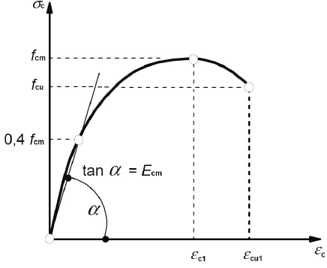
Fig.1. Stress-strain diagram of concrete in compression according to Eurocode 2

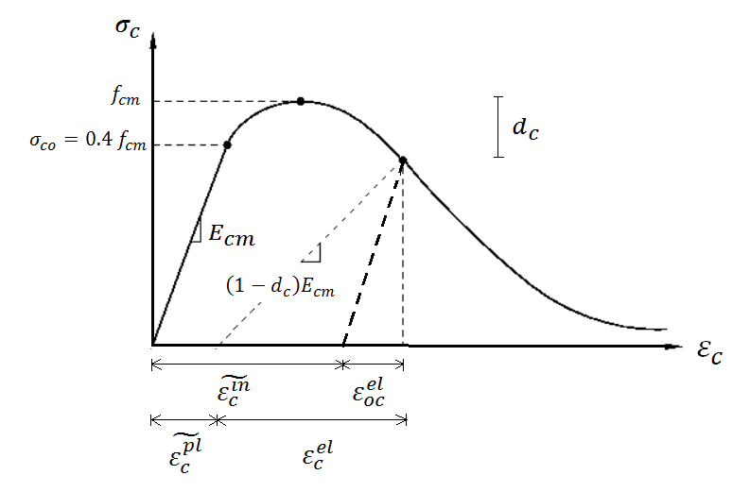
Fig.2. CDP model in compression

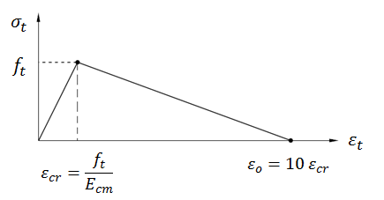
Fig.3. Tensile σ-ε curve for concrete: linear representation

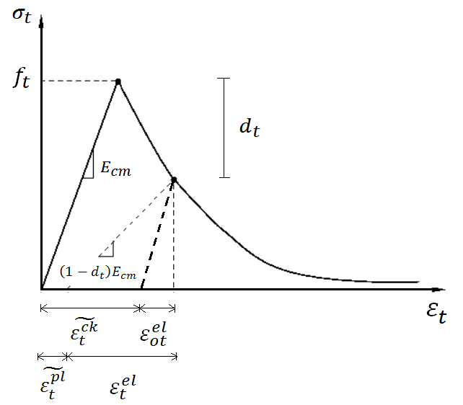
Fig.4. CDP model in tension

Prescribed displacement
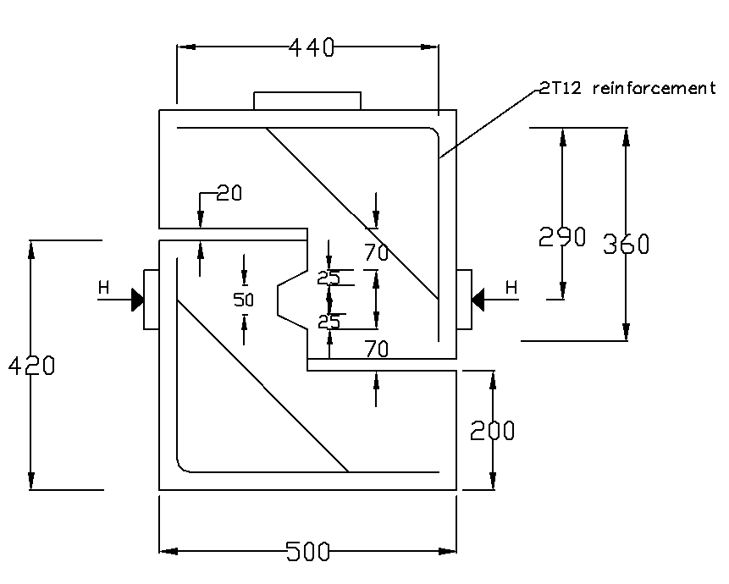
Confining pressure
Confining pressure
Fig.5. Dimensions of the single-keyed joints tested by Zhou et al. (2005)

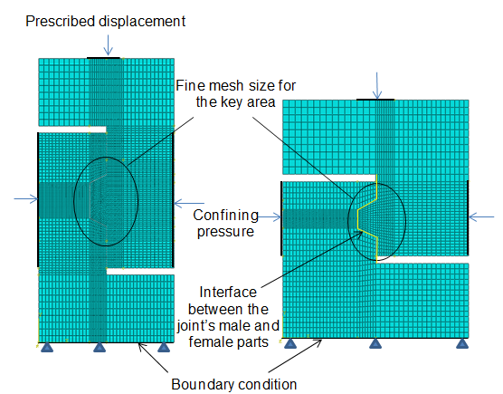
(a) (b)
Fig.6. Finite element mesh, boundary conditions, loadings and contact relationship for: (a) Buyukozturk’s specimens (b) Zhou’s specimens

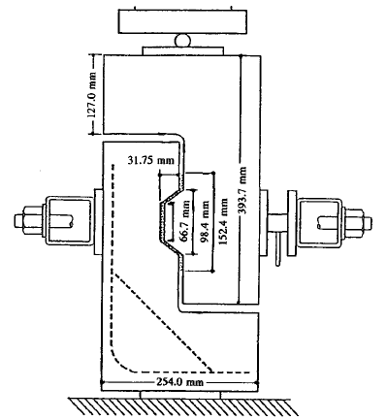
Confining pressure
Confining pressure
Prescribed displacement
Fig.7. Dimensions of the singled-keyed joints tested by Buyukozturk et al. (1990) (adapted from)

Fig.8. Load – displacement curves from numerical analysis for keyed dry joints of Zhou et al. (2005)

Fig.9. Load – displacement curves from numerical analysis for keyed dry joints of Buyukozturk et al. (1990)

(a)

(b)
Fig.10.(a) Crack patterns of specimen M1-D-K1-2; (b) Concrete crushing evolution on the root of the key specimen M1-D-K1-2

(a)

(b)
Fig.11. (a) Crack patterns of specimen M3-D-K1-1; (b) Concrete crushing evolution on the root of the key specimen M3-D-K1-1

(a)

(b)
Fig.12. (a) Crack patterns of specimen “Keyed dry-2.07 Mpa”; (b) Concrete crushing evolution on the root of the key specimen “Keyed dry-2.07 MPa”

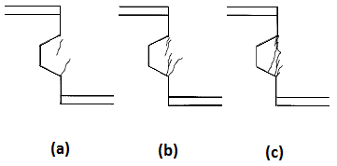
Fig.13. Crack pattern obtained from experiment reported by Zhou et al. (2005) (with permission)

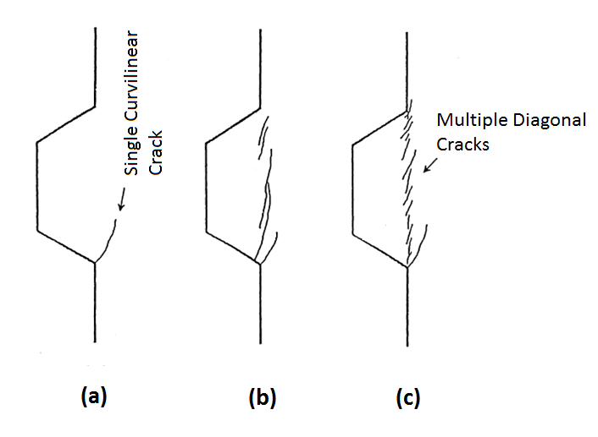
Fig.14. Crack pattern obtained from experiment reported by Buyukozturk et al. (1990) (with permission)

Fig.15. Load – displacement curves for specimen M2-D-K1-1 under various values of confining pressure

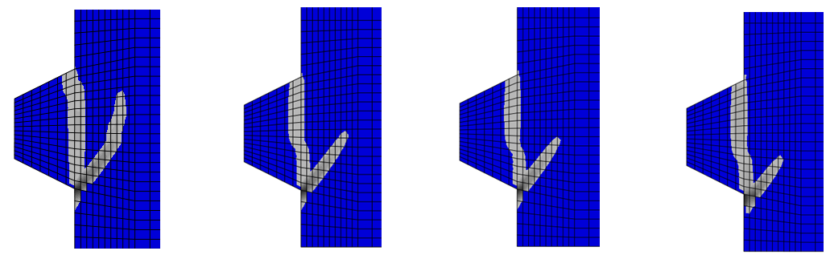
1MPa 2Mpa 3Mpa 4Mpa
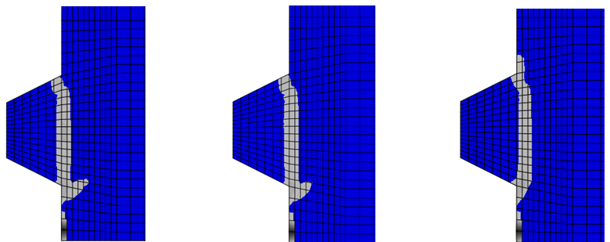
5Mpa 5.5Mpa 6Mpa
Fig.16. Final crack pattern of specimen M2-D-K1-1 under various values of confining pressure

Fig.17.Ultimate shear strength of specimen M2-D-K1-1 from numerical analysis and AASHTO formula under various values of confining pressure

Fig.18.Ultimate shear strength of specimen M3-D-K1-1 from numerical analysis and AASHTO formula under various values of confining pressure

Fig.19. Ultimate shear strength of specimen M3-D-K1-2 from numerical analysis and AASHTO formula under various values of confining pressure

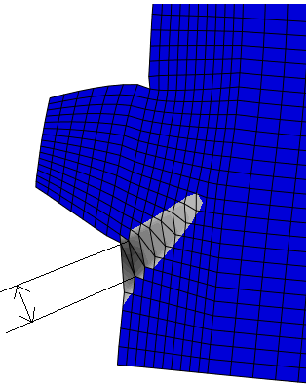
Crack width
Fig.20. Location where crack width is taken in numerical analysis

