Skin Effect Estimation in Radiofrequency Coils for Nuclear Magnetic Resonance Applications

Giulio Giovannetti^{1,2} • Gianluigi Tiberi^{3,4}

Abstract The design and development of dedicated radiofrequency (RF) coils is a fundamental task to maximize the signal-to-noise ratio (SNR) in nuclear magnetic resonance (NMR) applications. Coil resistance reduces the SNR and should be minimized by employing conductors of appropriate shape and cross section. At RF, the conductor resistance is increased due to the skin effect, which distributes the current primarily on the surface of the conductor instead of uniformly over the cross section. In particular, in rectangular shape conductors the current density is con- centrated in the high-curvature area and increases the conductor resistance, while rounded conductors present lower resistance and demonstrate improvements in performance especially in low-frequency tuned coils. This paper summarizes the different methods for estimating conductor losses in RF coils for NMR applications, whose performance strongly affect quality data. Because the impact to coil loss from conductors with different cross-sectional area is not something generally recognized and nor addressed in many other coil design works, we believe the review could be interesting for researchers working in the field of NMR coil design and development.

& Giulio Giovannetti giovannetti@ifc.cnr.it

¹ Institute of Clinical Physiology, National Council of Research, Via Moruzzi 1, 56124 S. Cataldo, Pisa, Italy
² Fondazione G. Monasterio CNR, Regione Toscana, Pisa, Italy
³ Laboratory of Medical Physics and Biotechnologies for Magnetic Resonance, IRCCS Stella Maris Foundation, Pisa, Italy
⁴ Imago7 Foundation, Pisa, Italy

Introduction

Radiofrequency (RF) coils are the key components in nuclear magnetic resonance (NMR) systems since the use of coils which fit around parts of the body to be imaged is necessary for obtaining high-quality images [1]. The signal-to-noise ratio (SNR) is an accepted standard for quality index in NMR and it is dependent on the hardware, particularly the main field strength and radiofrequency coils, upon the acquisition sequence parameters and the tissue relaxation properties [2]. In particular, SNR depends on the thermal noise voltage measured at the coil terminals which, in turn, depends on the coil resistance and the biological sample- induces resistance [3]. At low frequencies the SNR is strongly dependent on the coil losses [4] and an optimal coil design is a necessary constraint for minimizing the coil noise with respect to the sample noise.
In dependence on their cross-sectional shape, conductors used for coils building can be categorized into two groups: cylindrical rod shapes (hereafter referred to as ‘‘wires’’) and rectangular shapes (hereafter referred to as ‘‘strips’’). While conducting wires size is defined by their radius, conducting strips are characterized by width and thickness (see Fig. 1).
In this review, we summarize the different methods for estimating losses in wire and strip conductors. In particular, an analysis of the few works investigating the conductor geometry effects was presented, with a focus on the approaches that can be successfully employed for the design of RF coils for NMR applications.

Coil Performance Characterization

RF coil can be schematized by an equivalent RLC circuit whose current which flows on it is maximized at the f₀ Larmor frequency [5] (Fig. 2). As according to the reciprocity theorem [6], V can be the voltage source (transmit coil) or the sample- induced voltage (receive coil). L is the system inductance which takes into account for the energy that can be stored in the magnetic field, and it is related to the conductors size and geometry. C is the system capacitance and is mainly resulting from the contribution of discrete capacitors. Energy exchange between magnetic and electric field might alternate in time with maximum efficiency at the resonant frequency.

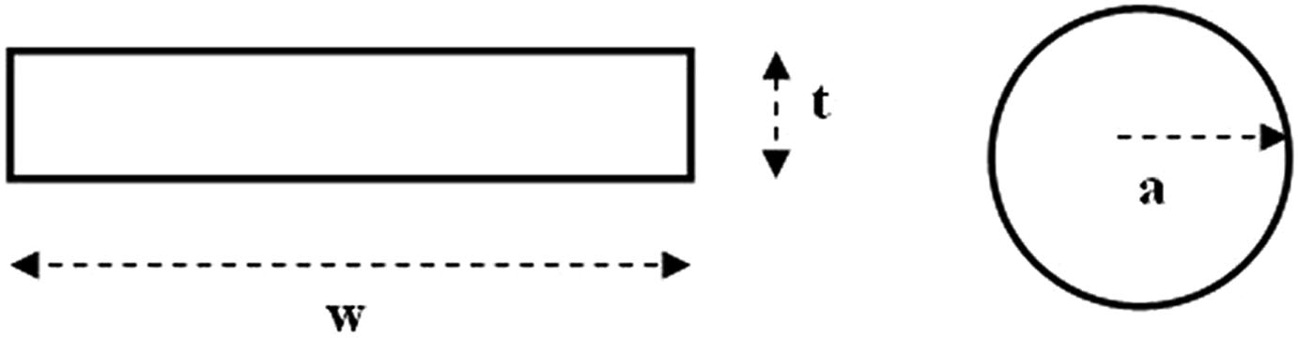

Fig. 1 Strip (left) and wire (right) conductors

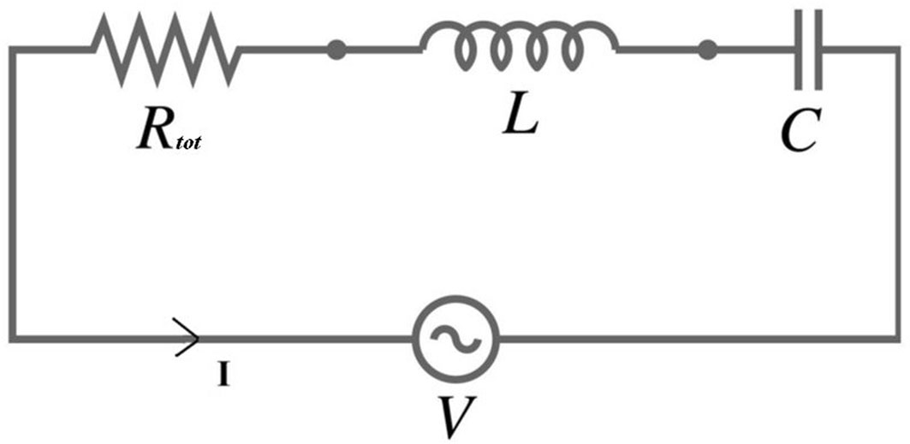

Fig. 2 RLC equivalent circuit of a radiofrequency coil

The resistance R_{tot} is the sum of all the resistances that can be associated to loss mechanism within the conductors and within the sample [7]. In particular:
Rtot ¼ Rcoil þ Rsample þ Rextra ð1Þ R_{coil} takes into account for the losses within the coil conductors and R_{sample} are the sample losses caused by RF currents, induced by the fluctuating magnetic field,
and by electric fields in the sample, mainly generated by the coil capacitors. R_{extra}
include radiative and tuning capacitors losses, which can be neglected in many applications
The definition of the coil quality factor, expressed in terms of circuit parameters, provides a quantitative measure of circuit quality, as [1]:

Q ¼ 2pf₀ L ¼ 1 rﬃLﬃﬃﬃ
Rtot
Rtot
C
ð2Þ

A common parameter of coil performance evaluation is the ratio r between the quality factor of empty resonator (Q_{empty}) and resonator with the sample (Q_{sample}) [8]:

r ¼ Qempty ¼ Rcoil þ Rsample
ð3Þ

Qsample Rcoil
An optimal coil design is a necessary constraint for minimizing the coil noise with respect to the sample noise and for providing maximum SNR, since
qﬃﬃﬃﬃﬃﬃﬃﬃﬃﬃSNRa 1 — [9].
1

r
Another important parameter which characterizes RF coil performance is the sensitivity, defined as the B₁ magnetic field induced by the RF coil at a given point per unit of supplied power P as follows [7]:

B
g 1
¼ pﬃPﬃﬃ
ð4Þ

The reciprocity theorem [6] allows the use of the same quantity defined in Eq. (4) to characterize both the transmit and the receive performance of an RF probe. It is important to note that maximizing the coil sensitivity will maximize also the SNR.

Different Approaches for Conductor Resistance Estimation

The conductors resistance for unit length can be estimated using the classic formula R = q/S which takes into account for the conducting pathway geometry, q is the conductor resistivity (1.68 9 10⁻⁸ m X for copper) and S is the cross-sectional area [10]. In particular, when a direct current (DC) flows through a conductor, the resistance per unit length (R_{DC}) can be calculated using S = pa² and S = wt for, respectively, wire and strip conductors.
Differently, an alternating current (AC) flowing in a conductor is not uniformly distributed across its section, but its density decreases exponentially with the distance from the boundary surface. For AC resistance calculation, the current is considered confined in a region near the surface whose thickness (penetration depth) d is given by [11]:

d ¼ rﬃﬃﬃﬃqﬃﬃﬃﬃﬃﬃ
pf l0
ð5Þ

where f is the coil tuning frequency and l₀ is the free space permeability (4p 9 10⁻⁷ Henry per meter). The conductor volume crossed by the RF current is limited by penetration depth value given the so called ‘‘classical skin effect’’ [12].
For a wire conductor, if the wire radius a is much greater than d, the conductor losses for unit length can be calculated as follows:

Rclas—wireðf q
Þ¼ 2pad
ð6Þ

where the dependence on frequency is due to the penetration depth, as in Eq. (5).
For strip conductors of w width, when the strip thickness t is greater than two times the penetration depth size, the conductor resistance can be evaluated as:

Rclas—stripðf q
Þ¼ 2wd
ð7Þ

otherwise, the current flows in the total conductor cross-sectional area and the resistance value has to be calculated as:

Rclas—stripðf Þ¼ q
twd
ð8Þ

In real cases, the tendency of the current density to concentrate towards the surface is more marked at the points where the curvature is greatest. For instance, in an elliptic cross-section conductor, the current density is enhanced at the ends of the major axes with respect to the ends of the minor axes. Now, assuming the strip conductor as the limiting case of a very thin elliptic cylinder, the current concentration is expected to be enhanced at conductor edges. This phenomenon is called the ‘‘lateral skin effect’’ [13] and ensures that the current distribution in the strip is less uniform than in the wire.
The current distribution in an infinitely long flat strip was solved using Maxwell’s equations with boundary conditions [14]. By assuming that the surface current flows in the z direction and that current density function J is independent on y (thin strip

approximation) and on z (long wavelength assumption) axes, the surface current can be evaluated as (Fig. 3):
I 1

JðxÞ¼ 2p q ﬃﬃﬃﬃﬃ ﬃﬃ₂ﬃﬃﬃﬃﬃﬃﬃﬃﬃﬃ
w
2
—x2
ð9Þ

where I represents the total current magnitude and -w/2 \ x \ w/2.
The plot related to Eq. (9) shows an increase in the current distribution near the flat strip edge and tends to a uniform pattern near the centre (Fig. 4).
In [15] an equation for finding the d_{w} equivalent diameter of a wire conductor with the same resistance of a strip conductor is proposed:
w
dw ¼ 1 þ 1:13 log ðw=tÞ ð10Þ
10
which provides that the resistance of a strip is equal to that of a wire conductor with a diameter of about 1/4 of the strip width. The expression is valid when w is much smaller than a wavelength and t is much thicker than a skin depth. When the skin depth is of the same order as the thickness, the equation doesn’t work reliably. Moreover, since proximity effect between conductors can significantly influence current distribution around the strip, the conductor has to be located far enough from other conductors.
In [16] Terman proposed an equation for calculating the high-frequency resistance per unit length for a strip conductor (in X/cm) as:
ﬃﬃ¼

r K 261pf
2ðw þ tÞ
×10^{—9} ð11Þ

where w and t are expressed in cm, f in Hz and K is a constant depending on w/t ratio as according to a plot showed in [16] for the range 1 \ w/s \ 100. The results provided by the equation were described as accurate only when t is much greater than twice skin depth.
Gerling [17] investigated the skin effect in strip conductors employed for the development of hybrid and pure electric drives in the automotive industry. The

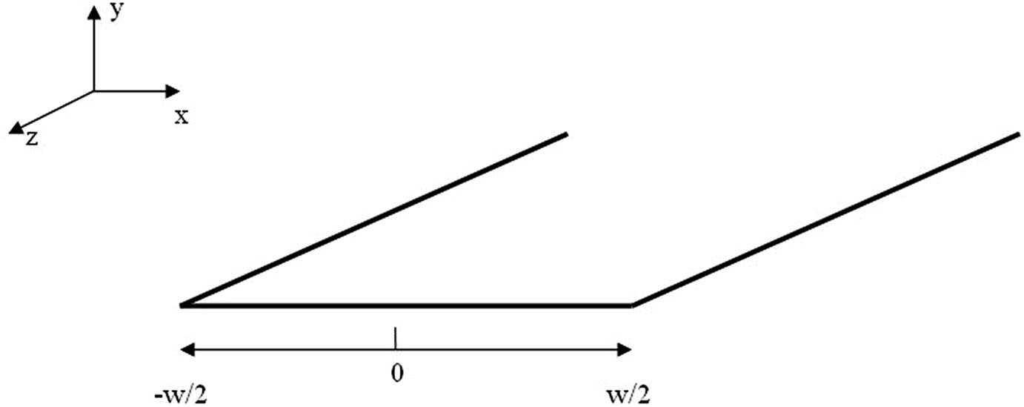

Fig. 3 Infinitely long flat strip

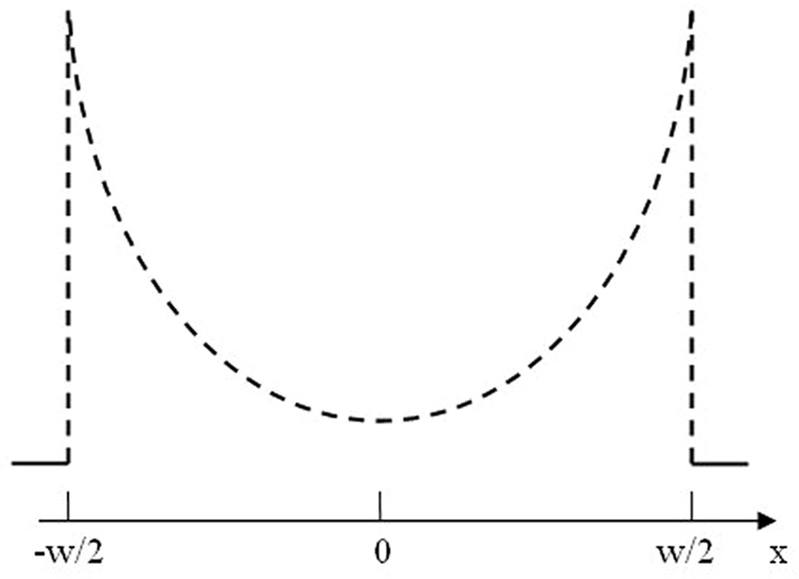

Fig. 4 Current distribution over the flat strip surface

analytical calculation was performed by applying Maxwell’s equations and a certain edge condition which takes into account for the special behavior of the electromagnetic field at the edges of the strip. An exact solution of the current density distribution in dependence on temperature and material were presented only for arbitrary strip geometry and low frequency (under 1 kHz) or for the symmetric geometry (w = t) and arbitrary frequency. For arbitrary geometry and frequency (but limited to 20 kHz) the presented solution was only an approximation but results showed that with increasing frequency the current was displaced more and more to the corners of the strip.
Guo [18] described the distribution of the current inside a strip using a numerical solution provided by surface integral equation (SIE) formulation. In the exterior region the strip was modelled as an electric surface current that radiates in the free space, while in the interior region the strip was replaced by an electric surface current radiates in a homogeneous space with the strip conductivity. After enforcing the continuity of the electric (E) and magnetic (H) fields at the strip surface, the AC resistance was computed from the power dissipated inside the strip evaluated by the Poynting vector flux over the strip surface as:
H¼

RAC
Re SðE × HÞdS jIj
ð12Þ

where the total current I was calculated by evaluating the line integral of the magnetic field around the perimeter of the strip. The redistribution of current over the conductor cross-sectional area causes an increase of the ratio R_{AC}/R_{DC} due to the skin effect since portions of the conductor are not fully effective in carrying current. The same paper presented a diagram which computed the ratio R_{AC}/R_{DC} for strip and wire conductors with the same cross-sectional area (wt = pa²) as a function of
2

the square root of the frequency for different ratios w/t between 1 and 32. The results confirmed the experimental one described in [16] and were employed for the skin effect analysis of digital circuits, operating at rates of hundreds of megahertz [19].
Extrapolating data from the cited Terman’s diagram [16], Mispelter [20] proposed an approximated equation for the strip resistance calculation for unit length which is valid when w [ 10t:
r ≈ 261pﬃfﬃMﬃﬃﬃHﬃﬃzﬃﬃ 1 þ 0:54 log w ð13Þ
2ðw þ tÞ_{mm}
t
10
where r is expressed in mX/m.
Faraji [21] characterized rectangular strip metallisation employed in monolithic microwave integrated circuit (MMIC) in terms of AC resistance, which influences insertion loss of such circuits. Strip conductors with different aspect ratios w/t = 1, 2, 5 and 6 were examined.
Electric field distribution analysis over the cross section of a strip conductor showed that at low frequencies, when the skin depth is of the order of the strip thickness (d [ t/2), the current distribution over the strip cross section was almost uniform, while at high frequencies, when the skin depth is much smaller than the strip thickness (d \ t/4), the electric field distribution inside the conductor shows its exponentially decay. An approximate formula for the calculation of the AC resistance in the whole frequency range was proposed by analyzing the strip cross
sectional area between 0 to 1 frequency range (see Fig. 5):

lim R_{AC} ¼ R_{DC} ¼ q
ð14Þ

f !0 wt

lim R_{AC} ¼ kR_{HF} ¼ k q
ð15Þ

f !1
2dðw þ tÞ

where R_{HF} is the AC resistance of a hollow tube with equal circumference carrying a uniform current across its depth d and k is a correction factor taking into account the edge field behavior.
Finally, the AC resistance can be calculated as:

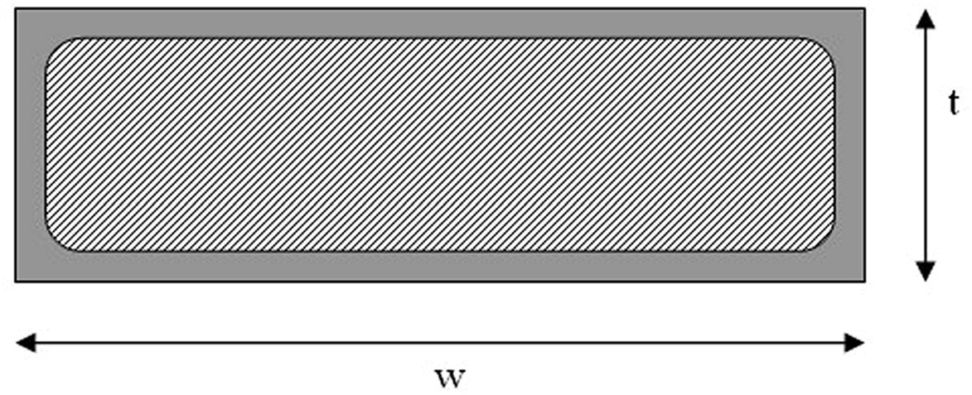

Fig. 5 Current distribution at high frequency

RAC ¼ rhﬃﬃﬃðﬃﬃRﬃﬃﬃDﬃﬃCﬃﬃÞﬃﬃ2ﬃﬃþﬃﬃﬃﬃðﬃﬃkﬃﬃRﬃﬃﬃHﬃﬃFﬃﬃÞﬃﬃ2ﬃﬃiﬃﬃ

ð16Þ

Giovannetti [22] proposed a comparison between birdcage coils with identical dimensions and tuned at the same resonant frequency, two of them constituted by strip conductors with different thickness and the third built using a wire conductor. The objective of the paper was to verify how the choice of the conductor geometry affected the coil’s overall performance and it was achieved by testing the coils with a workbench instrumentation for measuring different quality indices.
For RF coil design with strip conductor, literature suggested that the strip thickness should be at least six times the skin depth at the used frequency [23], to maximize the surface where the current flows and to minimize the conductor resistance. Being the birdcage tuned at 7.66 MHz (¹H frequency for 0.18 T magnetic field), the corresponding penetration depth resulted 23 lm and a 138 lm strip thickness was a requirement at this frequency.
All the coils were tuned at the Larmor frequency using high-quality capacitors. The first coil was developed using a 1 cm strip conductor with 35 lm thickness, the second coil was built using a strip conductor 1 cm wide and 800 lm thick, which is much higher than the penetration depth at the working frequency, and third coil was realized using a wire conductor of 2.25 mm in radius to obtain the same value of conductor inductance, as according to the relationship that allows the evaluation of the equivalent width w of a wire of radius a:
w ¼ 4:482×a ð17Þ
Table 1 reports the workbench test results of the different birdcages in terms of Q factor, r ratio between unloaded and loaded (with a saline solution phantom) Q and coil sensitivity.
The results showed that the use of strips with the thickness much higher than the penetration depth allowed to increase the overall coil performance, due to conductor resistance reduction. However, the best performance was provided by the coil made of wire conductor, with an increase of 28 % in the Q, 26 % in the r index, and 22 % in sensitivity with respect to the best strip-based coil. The main result was that the improvement in coil performance due to conductor geometry was verified to be caused by only changes in the conductors resistance and not their inductance.
In [24] authors proposed a theoretical–experimental hybrid method, which permits to distinguish and to quantify the different skin effect contributions to the conductor resistance when the coil is built using strip conductor. For achieving this,

Table 1 Test results for the three birdcages
Conductor | Q | r | g (lT/w^{1/2})
Strip (w = 1 cm, t = 35 lm) | 228 | 2.05 | 34.61
Strip (w = 1 cm, t = 800 lm) | 374 | 2.33 | 42.74
Wire (a = 2.25 mm) | 477 | 2.93 | 52.31

two circular coil prototypes were designed and built with identical dimensions but different conductor geometry: the first one was constituted by a 0.45 cm wide and 40 lm thick strip and the second one by a 0.1 cm radius wire conductors. The cross- sectional sizes for the two conductors guaranteed the same coil L inductance value, as according to Eq. (17).
The strip coil resistance was calculated as the sum of the lateral skin effect and the classical skin effect resistances [24]:
Rcoil—strip ¼ Rclas—strip þ Rlat—strip ð18Þ
where R_{clas-strip} can be evaluated with Eqs. (6) and (7). Differently, the wire coil resistance is equal to the classical skin effect resistance due to the absence of conductor edges in such conductor:
Rcoil—wire ¼ Rclas—wire ð19Þ
where R_{clas-wire} can be theoretically calculated with Eq. (6).
From quality factor measurements, using Eq. (2) in the case of unloaded coils, the total loss resistances for both coils were estimated as:

Rtot—strip

Rtot—wire
2pfL
¼ Qstrip
2pfL
¼ Qwire
ð20Þ
ð21Þ

As stated previously, the coil constituted by wire conductors is affected by only classical skin effect, therefore the term R_{extra} can be estimates as:
Rextra ¼ Rtot—wire — Rclas—wire ð22Þ
while the strip coil resistance can be evaluated as:
Rcoil—strip ¼ Rtot—strip — Rextra ð23Þ
being the term R_{extra} the same for both coils, which are identical in sizes and tuned with the same capacitors.
Using Eq. (18), the contribution of the lateral skin effect can be evaluated as:
Rlat—strip ¼ Rcoil—strip — Rclas—strip ð24Þ The test results of both coils, tuned at low frequency (5.7 MHz), showed that the wire coil provided better performance, with an increase of 59 % in the Q factor with
respect to the strip coil. Moreover, the two contributions of the different skin effects
for the strip coil assumed very similar values, the classical skin effect and the lateral skin effect resistance contributions being equal to 51 and 49 % of the strip coil resistance, respectively.
Using the two same circular coils, a more recent work [25] evaluated the coil resistance at different tuning frequencies usually used in clinical scanner (21–128 MHz, corresponding to 0.5–3 T static field).
Figure 6 (top) shows the plot of the classical skin effect resistance in dependence on the coil tuning frequency, as calculated by Eq. (5), whereas the frequency dependent of the lateral skin effect resistance [see Fig. 6 (bottom)] showed a

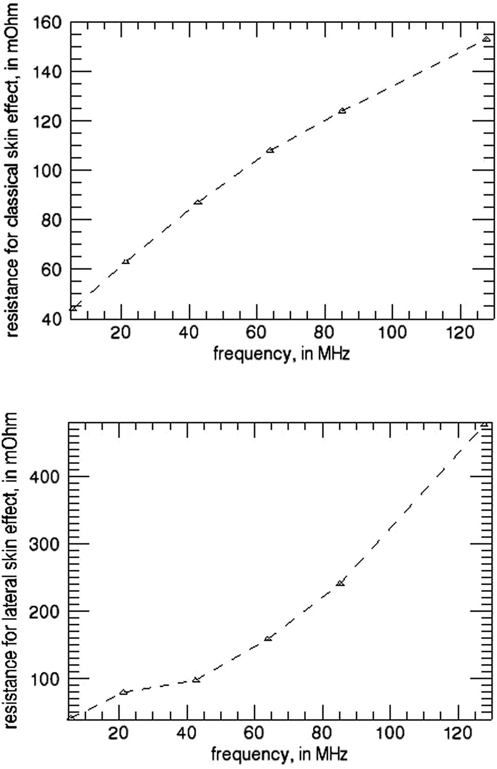

Fig. 6 Classical (top) and lateral (bottom) skin effect resistance in dependence on frequency

proportionality very similar to the square of the frequency. These results confirms literature data, since the frequency dependence of the lateral skin effect resistance term has been studied qualitatively assuming the strip conductor as the limiting case of a very thin elliptical cylinder [13] and the results showed proportionality to the square of the frequency until a certain frequency value depending on the strip sizes, where it reaches an asymptotic value. Although for higher frequencies the classical skin effect becomes the dominant mechanism and the coil resistance increases as the square root of the frequency according to Eqs. (6) and (7), in all frequency range

Table 2 | Strip and wire circular coil resistance
d (lm) | f (MHz) | Rstrip (mX) | R_{wire} (mX)
27.3 | 5.7 | 86 | 46
14.1 | 21.3 | 143 | 89
10.0 | 42.6 | 185 | 126
8.1 | 63.9 | 267 | 155
7.0 | 85.2 | 365 | 178
5.8 | 127.8 | 630 | 218

routinely used in MR clinical scanner (21–128 MHz) the lateral skin effect is the dominant mechanism and can not be neglected especially in high MR frequencies.
Table 2 shows a comparison between total resistance for the strip and wire coils as a function of the tuning frequency. The results underline the better performance of the coil constituted by a wire conductor, imputable to a better current distribution inside it with respect to the strip one, as predicted theoretically. However, it has to be noted that a wire conductor is difficult to handle for coil building and requires qualified mechanical personnel.
Even as described in recent literature [26], generally conductor loss models only consider the classical skin effect and neglects the discontinuities appearing at the conductor boundaries which determine the lateral skin effect. Some preliminary studies showed that the conductor geometry, the computational mesh, and the software tool employed for the coil simulation strongly influence the results [27], and an underestimation until a factor of 3 can result in the strip conductor losses calculation.

Conclusions

This paper summarized the different methods for estimating conductor losses in RF coils for NMR applications, whose designs is a fundamental task for maximizing the SNR.
Literature proposed different theoretical approaches for taking into account the skin effect losses in strip conductors, however their accuracy with respect to the geometries and frequencies encountered in NMR coil design has not been established. In fact, for strip geometry RF coils, the dominating loss mechanism at almost all practical frequencies is the lateral skin effect, which cannot be calculated as straightforwardly as the classical skin effect. Since no closed-form expression for strip conductors resistance is available, recent papers reported a theoretical/experimental method for calculating the coil resistance in the MHz range and providing a useful reference for RF coil designers. The presented data are applicable in several situations whenever the quality of RF coil is very important as in medical applications with MR imaging and in different area of NMR applications. We believe the review could be interesting for researchers working

in the field of NMR coil design and development, because the impact to coil loss from strip versus wire conductors is not something generally recognized and nor addressed in many other coil design works.

References

  - J. Jin, Electromagnetic Analysis and Design in Magnetic Resonance Imaging (CRC Press, Boca Raton, 1999)
  - D.I. Hoult, R.E. Richards, J. Magn. Reson. 24, 71–85 (1976)
  - D.I. Hoult, P.C. Lauterbur, J. Magn. Reson. 34, 415–433 (1979)
  - T. Claasen-Vujcic, H.M. Borsboom, H.J.G. Gaykema, T. Mehlkopf, Magn. Reson. Med. 36, 111–116 (1996)
  - G. Giovannetti, V. Hartwig, V. Positano, N. Vanello, Crit. Rev. Biomed. Eng. 42(2), 109–134 (2014)
  - D.I. Hoult, Concepts Magn. Reson. 12, 173–187 (2000)
  - A. Haase, F. Odoj, M. Von Kienlin, J. Warnking, F. Fidler, A. Weisser, M. Nittka, E. Rommel, T. Lanz, B. Kalusche, M. Griswold, Concepts Magn. Reson. 12(6), 361–388 (2000)
  - C.E. Hayes, W.A. Edelstein, J.F. Schenck, O.M. Mueller, M. Eash, J. Magn. Reson. 63(3), 622–628 (1985)
  - W.A. Edelstein, G.H. Glover, C.J. Hardy, R.W. Redington, Magn. Reson. Med. 3, 604–618 (1986)
  - S.E. Hurlston, G.P. Cofer, G.A. Johnson, Int. J. Imag. Syst. Technol. 8, 277–284 (1997)
  - C. Chen, D.J. Hoult, Biomedical Magnetic Resonance Technology (IOP, Bristol, 1989)
  - R.E. Matick, Transmission Lines for Digital and Communication Networks (McGraw–Hill, New York, 1969)
13. V. Belevitch, Philips Tech. Rev. 32(6/7, 18), 221–231 (1971)
- J.W. Carlson, Magn. Reson. Med. 3, 778–790 (1986)
- K. Schmidt, Approximate R. F. resistance of rectangular cross section conductors. http://fermi.la.asu. edu/w9cf/articles/equiv/equiv.html. Accessed 10 Jan 2016
- F.E. Terman, Radio Engineers’ Handbook (McGraw-Hill Book Comp., New York, London, 1943)
- D. Gerling, Approximate analytical calculation of the skin effect in rectangular wires. International Conference on Electrical Machines and Systems (ICEMS 2009), 15–18 November 2009, Tokyo, (2009), p. 1–6
- J. Guo, D. Kajfez, A.W. Glisson, Electr. Lett. 33(11), 966–967 (1997)
- R.A. Sainati, T.J. Moravec, I.E.E.E. Trans, Circuits Syst. 36, 533–540 (1989)
- J. Mispelter, M. Lupu, A. Briguet, NMR Probeheads for Biophysical and Biomedical Experiments
(Imperial College Press, London, 2015)
- R. Faraji-Dana, Y. Chow, in IEE Proceedings, 1990, vol. 137, Pt. H, no. 2
- G. Giovannetti, R. Francesconi, L. Landini, M.F. Santarelli, V. Positano, V. Viti, A. Benassi, Concepts Magn. Reson. Part B: Magn. Reson. Eng. 20B, 9–16 (2004)
- F.D. Doty, G. Entzminger Jr, C.D. Hauck, J.P. Staab, J. Magn. Reson. 138, 144–154 (1999)
- G. Giovannetti, V. Hartwig, L. Landini, M.F. Santarelli, Appl. Magn. Reson. 39, 391–399 (2010)
- G. Giovannetti, V. Hartwig, L. Landini, M.F. Santarelli, Conc. Magn. Reson. Part B 41B(2), 57–61 (2012)
- A. Kuehne, S. Goluch, P. Waxmann, F. Seifert, B. Ittermann, E. Moser, E. Laistler, Magn. Reson. Med. 74(4), 1165–1176 (2015)
- A. Kuehne, H. Waiczies, E. Moser, E. Laistler, in Proceedings of the ISMRM, Milan, Italy, 2014, p. 1363

