Skin Capacitive Imaging Analysis Using Deep Learning GoogLeNet

Xu Zhang1, Wei Pan2, Christos Bontozoglou3, Elena Chirikhina3, Daqing Chen3, and Perry Xiao3

1 Auckland Tongji Medical & Rehabilitation Equipment Research Centre, Tongji Zhejiang College, 168 Taining Road, Nanhu District, Jiaxing 314051, China

2 School of Computer Science and Engineering, Changshu Institute of Technology, Changshu, China

3 School of Engineering, London South Bank University, 103 Borough Road, London SE1 0AA, UK  
xiaop@lsbu.ac.uk

**Abstract.** Skin hydration measurement is very important for many clinical studies. Skin capacitive imaging is a novel technique that can be used for in-vivo skin hydration measurements [1-3]. It is based on permittivity measurement principle, and can generate a skin water content image using a matrix sensor. In this paper, we present our latest study on the skin capacitive imaging analysis using Deep Learning GoogLeNet [4]. The skin capacitive images are divided into three groups according to volunteers, gender (male and female), and skin sites (face, forearm, forehead, neck, palm, and lower leg). GoogLeNet is used for image classifications. The results show that GoogLeNet can effectively differentiate the different skin capacitive images from different categories. We will first present the skin capacitive imaging technology and then present the experimental results.

**Keywords:** Skin Capacitive Imaging, In-vivo Skin Hydration, Image Classification, GoogLeNet, CNN.

1. Introduction

The water in skin plays a key role in skin’s cosmetic properties and barrier function [1,2]. To measure the skin hydration is important for many clinical studies. Skin capacitive imaging is a novel technique that can be used for in-vivo skin hydration measurements [3-5]. It is based on permittivity measurement principle, and can generate a skin water content image using a matrix sensor. Different from other skin hydration measurement instruments, Epsilon is fully calibrated. This means with Epsilon, we can measure the absolute dielectric constant of skin, and with absolute dielectric constant of skin, we can also get the absolute water content, or hydration level, of skin [6]. Epsilon is also imaging based, which means apart from skin water content, we can also get skin information on micro-relief and skin surface texture [7]. In this paper, we present our latest study on skin capacitive imaging analysis, i.e. skin capacitive image classification by using Deep Learning GoogLeNet. We will first present the skin capacitive imaging technology and then present the experimental results.

1. Skin Capacitive Imaging Instrument

Skin capacitive imaging is achieved by using the Epsilon Permittivity Imaging System (Biox Systems Ltd, UK), as shown in Fig. 1. It is based on Fujitsu capacitive fingerprint sensor (Fujitsu Ltd, Japan), which has 256x300 pixels with 50µm spatial resolution. Each pixel is equivalent of a capacitive sensor, which measures the dielectric constant or permittivity of the sample, it has an 8-bit grey-scale capacitance resolution per pixel (0 - 255). Epsilon can be used for both in-vivo and in-vitro skin measurements.

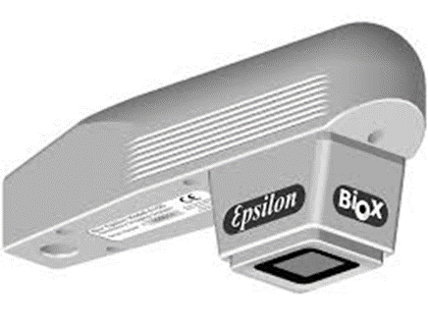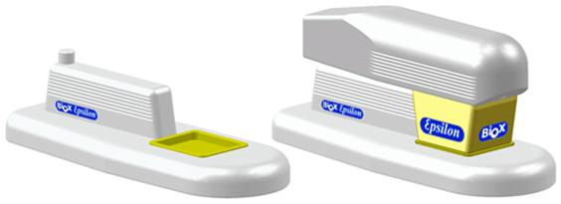

(A)

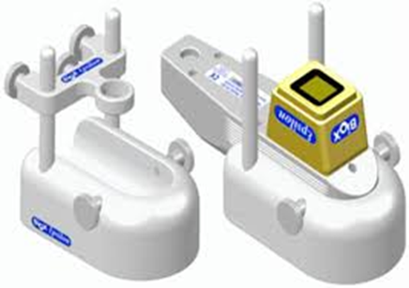

(B)

**Fig. 1.** Epsilon Permittivity Imaging System with in-vivo stand (A) and Epsilon with in-vitro stand (B).

1. Deep Learning and GoogLeNet

Neural networks, or artificial neural networks, are mathematical algorithms for problem solving. Inspired by the biological neural networks of human brain, artificial neural networks are made of layers of interconnected notes (representing neurons). Conventional neural networks are made of three layers, one input layer, one hidden layer and one output layer, see Fig. 2(A). Deep Learning uses neural networks with multiple hidden layers, see Fig. 2(B). This approach was more mathematically challenging, and was only possible since the 2010s, with the increasing computing power, particularly with graphical processing units (GPUs), and improved algorithms.

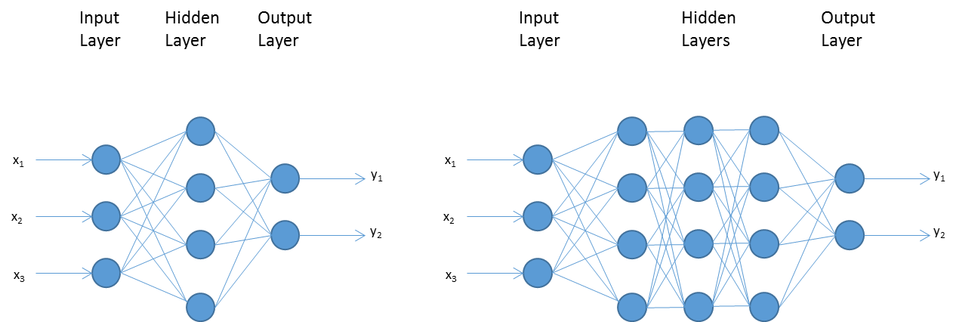

(A) (B)

**Fig. 2.** The conventional neural network with one hidden layer (A) and the Deep Learning neural network with multiple hidden layers (B).

GoogLeNet [8], developed by Google, is a convolutional neural network (CNN) that is trained on millions of images, and can recognize 1000 daily objects, such as keyboards, mouse, pens, cups and many animals. Comparing with other Deep Learning neural networks, such as AlexNet [9], GoogLeNet has dramatically reduced the number of variable from 60 millions to 4 millions, and is more accurate on prediction. It has 144 layers and requires input images with a size of 224 x 224 x 3, as shown in Table 1. To date, GoogLeNet is one of the most widely used Deep Learning neural networks with applications such as real time video processing [10] and diseases predictions [11] etc.

**Table 1.** The 144 layers of GoogLeNet.

|  |  |  |
| --- | --- | --- |
| Layer | Name | Comments |
| 1 | Image Input | 224x224x3 images |
| 2 | Convolution | 64 7x7x3 convolutions |
| 3 | ReLU | Rectified Linear Unit |
| 4 | Max Pooling | 3x3 max pooling |
| 5 | Cross Channel Normalization | Cross channel normalization |
| 6 | Convolutions | 64 1x1x64 convolutions |
| 7 | ReLU | Rectified Linear Unit |
| … | **…** | … |
|  |  |  |
| 140 | Average Pooling | 7x7 Average Pooling |
| 141 | Dropout | 40% Dropout |
| 142 | Fully Connected | Fully Connected |
| 143 | Softmax | Softmas |
| 144 | Classification Output | V1, V2 or V3  Male or female etc. |

1. Results and Discussions
   1. Capacitive Images of Different Skin Sites

All the measurements in this study were performed on three healthy volunteers (two male and one female, aged 25 – 40). Six different skin sites were chosen on each volunteer, e.g. face, forearm, forehead, lower leg, neck and palm. The measurement conditions are 21±1°C in temperature, and 40 – 50% in relative humidity.

Fig. 3 shows the typical capacitive images of three different volunteers (V1, V2, V3), two different genders (male and female), and six different skin sites (face, forearm, forehead, lower leg, neck and palm). As we can see, different volunteers, different genders, different skin sites, have different textures and different hydration levels, which is expressed as the brightness, e.g. the brighter the more water, the darker the less water.

All the skin images are divided into three categories:

* Volunteers (V1, V2, V3)
* Gender (male and female)
* Skin sites (face, forearm, forehead, lower leg, neck and palm)

Each category’s images were also divided into two parts, images (75%) and testing images (25%). Training images were using for training the GoogLeNet, and testing images were used to test and validate the GoogLeNet’s prediction after training.

|  |  |  |  |  |  |
| --- | --- | --- | --- | --- | --- |
| V1 | V2 | V3 |  |  |  |
|  |  |  |  |  |  |
| Male | Female |  |  |  |  |
|  |  |  |  |  |  |
| Face | Forearm | Forehead | Lower Leg | Neck | Palm |
|  |  |  |  |  |  |

**Fig. 3.** The capacitive images of three different volunteers (V1, V2, V3), two different genders (male and female), and six different skin sites (face, forearm, forehead, lower leg, neck and palm).

* 1. GoogLeNet Classification Results

Fig. 4 shows the GoogLeNet training progress for the three different volunteer images. The training cycle has 6 epoch and 42 iterations. The final validation accuracy is 83.33%. This mean after training on training images, for any randomly chosen testing image, GoogLeNet can predict whether it is volunteer 1 (V1), volunteer 2 (V2) or volunteer 3 (V3) with 83.33% accuracy.

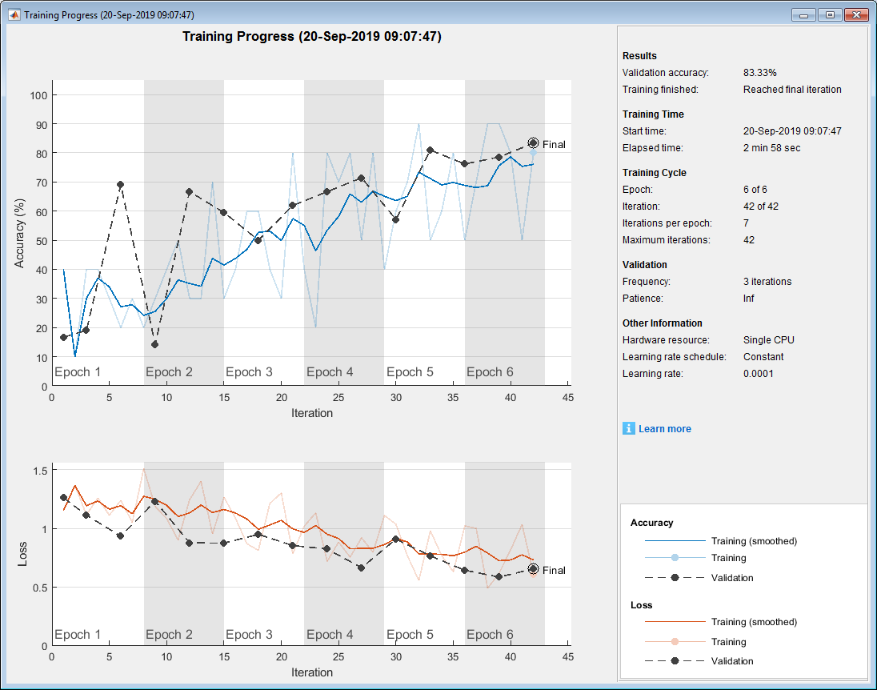

**Fig. 4.** The GoogLeNet training progress for the three different volunteer images..

Fig. 5 shows the GoogLeNet training progress for the two different gender images. The training cycle has 6 epoch and 42 iterations. The final validation accuracy is 55.56%. This mean after training on training images, for any randomly chosen testing image, GoogLeNet can predict whether it is male or female with 55.56% accuracy.

Fig. 6 shows the GoogLeNet training progress for the six different skin site images. The training cycle has 6 epoch and 42 iterations. The final validation accuracy is 94.44%. This mean after training on training images, for any randomly chosen testing image, GoogLeNet can predict whether it is face, forearm, forehead, lower leg, neck or palm with 94.44% accuracy.

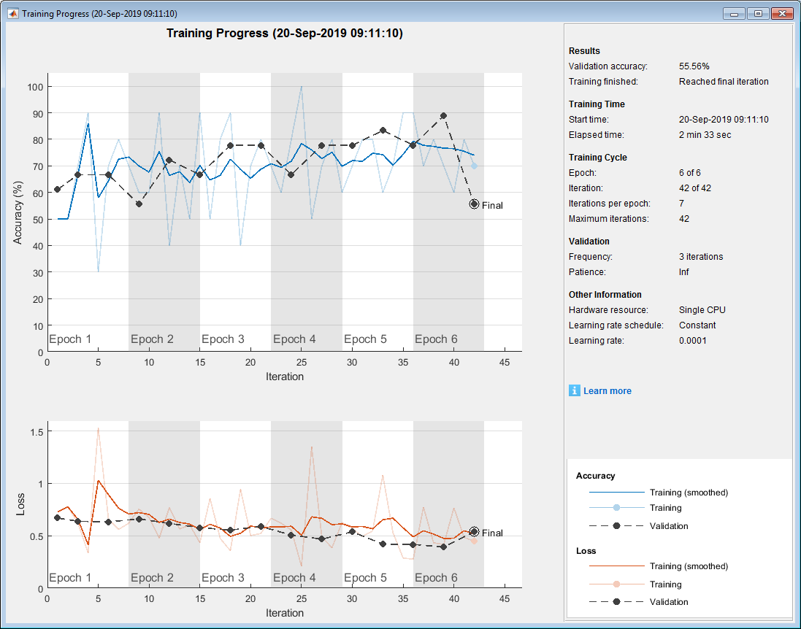

**Fig. 5.** The GoogLeNet training progress for the two different gender images.

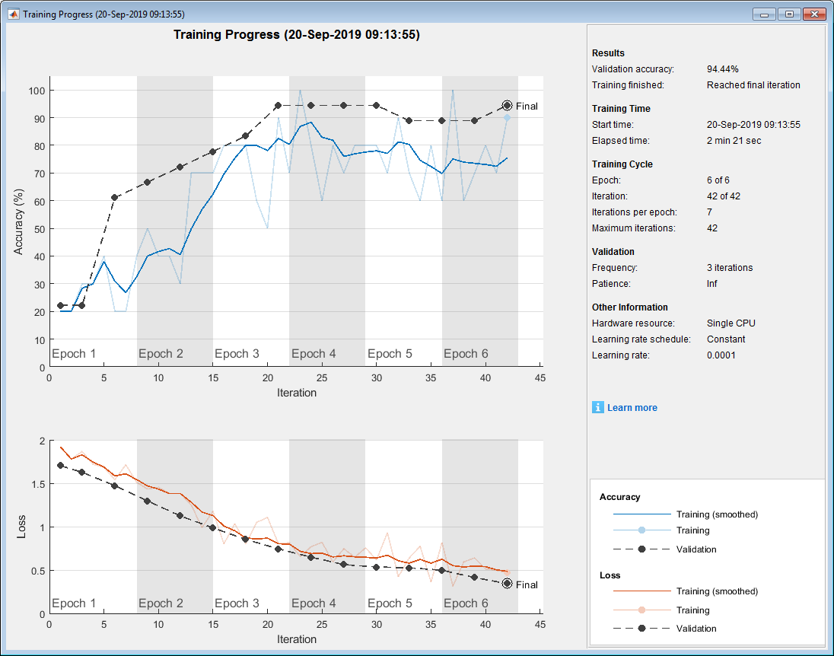

**Fig. 6.** The GoogLeNet training progress for the six different skin site images.



**Fig. 7.** The GoogLeNet prediction accuracy of six randomly selected skin capacitive images of three different volunteers, V1, V2 and V3.



**Fig. 8.** The GoogLeNet prediction accuracy of six randomly selected skin capacitive images of three different gender, male and female.

Fig. 7 shows the GoogLeNet prediction accuracy of six randomly selected skin capacitive images of three different volunteers, V1, V2 and V3. The results show that the prediction accuracy is reasonable, but varies significantly from volunteer to volunteer.

Fig. 8 shows the GoogLeNet prediction accuracy of six randomly selected skin capacitive images of two different gender, male and female. The results show that the prediction accuracy is also reasonable, but varies significantly from male to female.

Fig. 9 shows the GoogLeNet prediction accuracy of six randomly selected skin capacitive images of six different skin sites, face, forearm, forehead, lower leg, neck and palm. The results show that the prediction accuracy is also generally high, but varies to certain degree from skin site to skin site.



**Fig. 9.** The GoogLeNet prediction accuracy of six randomly selected skin capacitive images of six different skin sites, face, forearm, forehead, lower leg, neck and palm.

The overall results show that GoogLeNet can be effectively used for capacitive skin image classification. Different from traditional images, such as images from digital cameras, which are significantly different from each other, skin capacitive images are much similar, this makes it more difficult for classification. The results show that GoogLeNet classification works best on images from different skin sites, or different skin parts, then is on images from different volunteers, the worst is on images from different gender. This is understandable, as the images on the same skin site from different volunteers, or genders, are more similar than the images of different volunteers, genders, on different skin site, and hence reduced the GoogLeNet performance.

1. Conclusions

We present our latest study on the skin capacitive imaging analysis using Deep Learning GoogLeNet. The results show that GoogLeNet can be effectively used for skin capacitive image classifications despite of the skin capacitive image similarities. The best classification results are on images from different skin sites, then is on images from different gender, the worst is on images from different volunteers. Image classification is a very important aspect of skin image analysis, which can open doors to many potential applications. The next step is to use GoogLeNet to classify capacitive images of different skin status, i.e. normal skin and dry skin, healthy skin and damaged skin, skin on its own and skin with topically applied substances etc.

1. Acknowledgement

We thank London South Bank University for the financial support and we also thank Biox Systems Ltd for sponsoring the PhD studentship for CB.

References

Bioengineering of the Skin: Water and the Stratum Corneum (Dermatology: Clinical & Basic Science Book 23) 2nd Edition. In: Fluhr, J. W., Elsner, P., Berardesca, E., Maibach, H. I. (eds), CRC Press, (2004)

Xiao, P., “Optothermal Measurement of Water Distribution within Stratum Corneum”, Agache’s Measuring the Skin, 2nd Edition, (Editors: Philippe Humbert, Ferial Fanian, Howard I. Maibach, Pierre Agache,), ISBN: 978-3-319-32381-7, pp 355, Chapter 31, Springer (2017).

Singh, H., Xiao, P., Berg, E.P., and Imhof, R.E., “In-vivo Skin Imaging For Hydration and Micro Relief Measurements”, Stratum Corneum V, Cardiff, UK, July 11 - 13, (2007).

Imhof, R. E., and Xiao, P., "Biox Epsilon - A New Permittivity Imaging System", the ISBS World Congress, Copenhagen, Denmark, November 28-30, (2012).

Ou, X., Pan, W., and Xiao, P., “In-Vivo Skin Capacitive imaging Analysis by using Grey Level Co-occurrence Matrix (GLCM)”, International Journal of Pharmaceutics, Volume 460, Issues 1–2, Pages 28–32, 2 January (2014).

Xiao, P., Bontozoglou, C., “Capacitive contact imaging for in-vivo hair and nail water content measurements”, H&PC Today, Vol. 10(5), pp62-65, September/October (2015).

Bontozoglou, C., Zhang, X., Xiao, P., “Micro‐relief analysis with skin capacitive imaging”, Skin Research and Technology 25(2):165-170 (2019).

Szegedy, C., Liu, W., Yangqing Jia, Pierre Sermanet, Scott Reed, Dragomir Anguelov, Dumitru Erhan, Vincent Vanhoucke, Andrew Rabinovich, “Going Deeper With Convolutions”, The IEEE Conference on Computer Vision and Pattern Recognition (CVPR), pp. 1-9, (2015).

1. Krizhevsky, A., Sutskever, I., and Hinton, G. E., "ImageNet classification with deep convolutional neural networks," in International Conference on Neural Information Processing Systems, pp. 1097-1105 (2012).
2. Lu, S., Wang, B., Wang, H., Chen, L., Ma., L., Zhang, X., “A real-time object detection algorithm for video”, Computers & Electrical Engineering, Volume 77, Pages 398-408 (2019).
3. Zhou, T., Han, G., Li, B., Lin, Z., Ciaccio, E.J., Green, P.H., Qin, J., “Quantitative analysis of patients with celiac disease by video capsule endoscopy: A deep learning method”, Computers in Biology and Medicine, Volume 85, Pages 1-6, (2017).