Biological Basis to Child Health: The Immune System

Kate Davies RN (Child), Dip HE, BSc (Hons), MSc, NMP, PGCert, PGDip
Children’s Advanced Nurse Practitioner
Senior Lecturer in Non-Medical Prescribing
London South Bank University
Honorary Research Fellow in Paediatric Endocrinology
Queen Mary University of London / Barts and The London NHS Trust

Rebecca Batt RGN/RSCN, BSc Hons, MSc, NMP
Advanced Nurse Practitioner in Paediatric Allergy
Evelina Children’s Hospital, London
Visiting Lecturer Advanced Clinical Practice / Non-Medical Prescribing
London South Bank University
Visiting Lecturer for Allergy MSc Imperial College, London

Doreen Crawford MSc PGCE BSc (Hons) SRN RSCN
Consultant Nurse Editor Nursing Children and Young People
Committee Member RCN CYP Specialist Care Forum.

Abstract
This article is the X article in the Biological Basis to Child Health. Understanding how the immune system develops and functions is vital knowledge for a children’s nurse. This article introduces microbiology, considers the development of the immune system and reviews innate and adaptive immunity. There is an emphasis on childhood immunisations, and it will explore elements of immune dysfunction.

Keywords
Immunity, Immunisations, Antibody, T cell, B cell, immune dysfunction, embryology.

Introduction
The immune system is vital for the preservation of life. It is recognised as a ‘functional system’ and the key structures involved are dispersed throughout the body (Figure 1). Understanding how the immune system develops and functions is vital knowledge for a children’s nurse. This CPD provides a foundation on which further knowledge can be built. It reviews the structures and functions of the immune system with a focus on innate and adaptive immunity, considers childhood immunisations and herd immunity and summarises the embryology. It will explore elements of immune dysfunction and provide examples of childhood conditions.

Aims and Outcomes
Following the completion of this CPD the reader should be able to:
Define some key characteristics of microorganisms
Have an overview of the functions of the immune system and outline the differences between innate and adaptive Immunity
Discuss the development of the immune system
Recount the importance of immunisations
Make links between the immune system and common conditions.

TIME OUT 1
Make a list of the infectious conditions you have heard of. Note by each condition whether there is a vaccination of not. Revisit this list at the end of the CPD or use the green book link and see how many you correctly identified.

The immune system is a complex collection of cells and proteins that protect the individual from invading pathogens such as foreign antigens, microbes, parasites, fungi, bacteria, viruses, cancer cells and toxins (Warrington, Watson, Kim, & Antonetti, 2011) see table 1.

Table 1 Introduction to microorganisms

VIRUS | BACTERIA | FUNGI | PARASITE
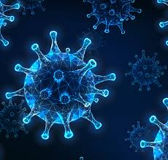 | 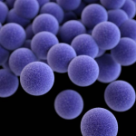 | 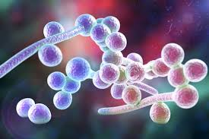
Not classified as a cell, carries either DNA or RNA, can only reproduce inside a plant, the cells of an animal, or a person. | Usually single celled. Can reproduce outside the body. | May be single celled or complex multicellular organisms.  Reproduction either sexually and/or asexually. | Complex living organisms  Can live in Gastrointestinal (GI) tract or bloodstream
No nucleus | Nucleoid region, but no nuclear membrane | Nucleus with nuclear membrane | Nucleus with nuclear membrane
Varies but usually requires electron microscope, example the Covid 19 virus particle is around 0.12 μm. | Microscopic size and size varies according to type. Methicillin-resistant Staphylococcus aureus (MRSA) has a particle size between 0.542 and 1.197 µm | Varies, usually requires microscope detection some can be seen with a hand lens. Candida albicans, a yeast responsible for infant thrush, is 10-12 µm | Varies ,  some can be seen with naked eye for example the length of the roundworm ranges from a few millimetres to up to two metres
Unique in appearance | Round, rod or spiral shaped | Varies in shape: yeasts are round, moulds have long threads. | Living organisms, e.g. fleas, ticks, or mites
Chicken pox  Measles  HIV / AIDS  Influenza  Cold sores  Norovirus  Coronavirus / SARS  Common cold | Tuberculosis  Salmonella  Pneumonia  Strep throat  Lyme disease Staphylococcus  Urinary tract infection  Tetanus | Ringworm  Oral /GI Candidiasis  Athlete’s foot  Toxoplasmosis | Roundworm  Tapeworm  Cryptosporidiosis  Malaria

Fig 1 The structures of the immune System (check source and redraw)
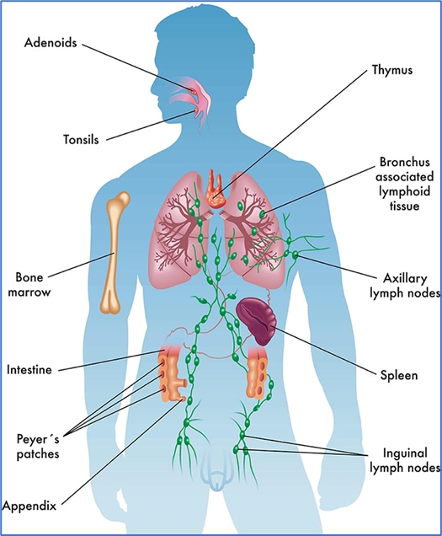

Structures of the immune system

The Thymus gland
The Thymus gland is located behind the sternum: it is large in infancy till age 3, when it begins to shrinks in size, by a process called involution (Zdrojewicz, Pachura, & Pachura, 2016). T cells develop in the Thymus gland throughout adulthood, and are one of the principle components in the adaptive immune system, including responding to pathogens, tumours and allergens (Kumar, Connors, & Farber, 2018)

Spleen
This is a large lymphoid organ, located behind the stomach on the left side of the abdomen. It has an important role in haematopoiesis, and antigen presenting cells in the spleen regulate the T and B cell responses. If a part of the spleen is removed, it can regenerate, but a full splenectomy will carry an increased risk of bacterial infection (Boam et al., 2017). Children who need splenectomy should be vaccinated against pneumococcal infections, influenza, Haemophilus influenza type b (Hib), Meningitis C, and should also take antibiotics for the remainder of their lives (NHS, 2019).

Lymph nodes
These are around 200 bean shaped structures, about 20mm in size, located throughout the body, interconnected by lymphatic channels. The channels contain lymphatic fluid which drains from body tissues. The lymph nodes, act like a filter (West & Jin, 2016). The outer layer of the lymph node (cortex) contains B cells, and the middle layer (paracortex) mostly contain T cells and dendritic cells (Abraham et al., 2018). The lymphocytes multiply during cancer or infection, causing enlarged lymph nodes, known as lymphadenopathy (West & Jin, 2016).

Peyer’s Patches
Peyer’s Patches are part of the gut associated lymphoid tissue (GALT) and important for immune response. Another part of GALT is the appendix, located where the small and large intestine meet. It contains dense lymphoid tissue, B cells and T cells, and is the main site of Immunoglobulin A (Ig A) which is the most abundant immunoglobulin in the GALT (Girard-Madoux et al., 2018). Acute appendicitis is common in children often resulting in surgical removal, removal has no effect on the immunity in the gastrointestinal tract, although IgA levels are lower (Girard-Madoux et al., 2018). Not all defence mechanisms are helpful. Crohn’s disease, an inflammatory bowel disease, is associated with an abnormal T cell mediated immune response towards gut flora (Jung, Hugot, & Barreau, 2010).

Tonsils and adenoids
The tonsils and adenoids are located in the oropharynx and help prevent pathogens from entering the respiratory system and GI tract, they produce IgG, IgA and IgM immunoglobulins as inflammation and infection of these tissues are common. Adenoidectomy and tonsillectomy are among the most common surgical procedures in the UK (Green, Woodman, McLernon, Patrn, & Engelhardt, 2020) The removal of these structures do not deplete the immune system, unlike removal of the spleen (Bitar, Dowli, & Mourad, 2015; Catalano et al., 2018), although there is an associated reduction in serum IgA levels (Andreu-Ballester et al., 2007).

Functions of the Immune System
The immune system provides physical and chemical barriers to pathogens and other foreign substances (Warburton, 2018). It protects the body from infection, fights infection, and promotes tissue repair following damage (Gargani, 2015).

Body defence
There are two main types of defence, innate immunity (natural immunity) and adaptive immunity, which function synergistically. Innate immunity includes the physical barriers, such as the mucous membranes and the skin, the gastric pH, the natural immune response, the functioning of some specialist cells, such as the phagocytes, neutrophils, natural killer cells, and mast cells.

Natural body secretions can help trap and wash off organisms: tears and saliva contain lysosome, an enzyme which kills bacteria by breaking down cell walls (Mahmoudi, 2016), acidic sweat and secretions from sebaceous glands contain antibacterial and antifungal chemicals, and macrophages, a type of phagocyte which ingests and destroys invading microorganisms.

Innate Immunity has three main characteristics:
1 – It reacts very quickly to pathogens
2 – It responds the same way each time
3 – The process starts again each time it meets a pathogen (Boore, Cook, & Shepherd, 2016)

If the skin or mucus membranes are breached an inflammatory process may commence to prevent the spread of the damage to tissues nearby, dispose of damaged tissue, and start the healing process (Waugh & Grant, 2018). The signs of inflammatory response at tissue level include redness, heat, swelling and pain. At microcirculatory level, the process includes vascular permeability changes, leukocyte recruitment and accumulation, and inflammatory mediator release see table 2 (Chen, Deng, Cui et al 2018).

Adaptive immunity acts with innate immunity but is antigen specific. This consists of B cells (a humoral immune response) and T cells (a cell mediated response).

Table 2 Specialist cells of the immune system
Cell type | Function / action
Phagocytes | These are cells which ‘engulf’ foreign cells and debris. They include Neutrophils and Macrophages. Receptors on the cell membranes of Phagocytes detect the foreign particles and prepare them for ingestion.
Macrophages | The action of Neutrophils and Monocytes change when infection occurs. Neutrophils and Monocytes can develop into macrophages.
Natural Killer Cells | These are lymphocytes from the same family as T and B cells. They respond quickly to a variety of pathological challenges.
Eosinophils | Acts against parasites, supports the allergic response and the inflammatory process.
Mast cells | Release histamine as part of the inflammatory response, a signalling molecule which indicates cell injury /distress and is part of a cascade of events in body defence.
T lymphocytes (T cells) | T Helper Cells (CD4+) support the maturation of B cells into plasma cells and/or memory cells and Macrophages which help enhance their efficiency.  T Cytotoxic Cells (CD8+) function to destroy cells that have been infected by foreign pathogens.  T Regulatory Cells help control the immune response  T Memory Cells include memory helper T cells and memory cytotoxic T cells and are involved in discovering antigens on subsequent immune response occasions, enabling a rapid immune response.
B cells | These enable the Humoral Immune Response (Antibody-Mediated Immunity) triggered when they encounter a specific antigen. They are capable of rapid division and produce antibodies. Antibodies are known as surface immunoglobulins (Ig) found on cell surfaces and are classified as antigen receptors, or B cell receptors (BcR). There are five different types of immunoglobulins: IgG, IgA, IgM, IgE, and IgD which differ in shape and function.
Gargani (2015), Rosales & Uribe-Querol, (2017) Waugh & Grant, (2018) Mahmoudi, (2016). Playfair & Chain, 2013) Boore et al., 2016) Warrington et al., (2011) Ygberg & Nilsson, (2012) Hoffman et al., 2016).

Hormones, chemicals, and compounds which support the immune system.
The Complement System / Complement Cascade work as part of the Innate Immune response for dealing with infections. It consists of a number of plasma proteins which facilitates the phagocytosis of invading bacteria by the way of opsonisation – where a microbe binds, or is coated by an antibody or a ‘complement’: these molecules bind to the microbe but need to be activated (Mahmoudi, 2016). There are several pathways to achieve activation. The complement system plays a critical role in inflammation and defence. It is also activated during reactions against incompatible blood transfusions, where the donor cells are treated as a pathogen (Stowell et al., 2012), or in autoimmune disease, such as Systemic Lupus Erythematosus (SLE) (Chen, Daha, & Kallenberg, 2010), by initiating an autoimmune response .

Histamine is formed and released by mast cells located in connective tissue, and by basophils and platelets in the circulation (Tortora & Derrickson, 2010). It increases capillary permeability and vasodilates (Boore et al., 2016). Histamine release is not always useful and antihistamine medication is used in treating allergic responses. Leukotrienes are compared to histamine, causing vasoconstriction of the airways, they attract and activate eosinophils.

Prostaglandins are hormone-like and have several roles during inflammation, they contribute to smooth muscle contraction and modulate pain because of their action on nociception (Boore et al., 2016).

Interleukins
Interleukins, or cytokines (Playfair & Chain, 2013), originate from leukocytes, the white blood cells that protect against disease (Mahmoudi, 2016). They play an important role in the development and communication between T and B lymphocytes.

Interferons
Interferons are proteins categorized as cytokines, which help cells prevent viruses from replicating. Some cells secrete interferons (IFNs) which can help cells that have not yet been infected. The IFNs can diffuse to nearby cells and ‘interfere’ with the viral replication of the healthy cells by interfering with protein synthesis and destroying the viral RNA (Mahmoudi, 2016).

Embryology of the Immune System
Development of the immune system is a complex process and closely intertwined with the cardiovascular and gastrointestinal systems (see earlier CPD in this series). Maternal antibodies are transferred from the mother to the foetus for protection from the first trimester. These are mainly Immunoglobulin G (Ig G) which is made and released by B cells (Niewiesk, 2014).

Table 3 Milestones in embryological development of the immune system

Cells /structure | Timeline | Functions
Maternal antibody transfer | From 8-week gestation increasing to 50% of maternal levels by 30 weeks gestation. | Foetal defence. It is important to note that this is taken into account when offering the mother vaccinations during pregnancy
Leukocytes and neutrophils blood cells | Appear at 8-week gestation in liver, thymus, and spleen then the generation of large numbers in the bone marrow by term | Weak foetal defence, important to note that the newborn, particularly the premature, are at increased risk from infection
Thymus | Develops from post fertilisation day 22 from the 3rd pharyngeal pouch, extending backwards into the mesoderm and mesenchyme to locate in front of the ventral aorta. | Develop T cells. T cells start to leave the thymus from 14 weeks gestation.
Spleen | Develops from post fertilisation week 5. | Generates red and white cells from 2nd trimester. Initiates immune response to antigens by phagocytes and lymphocytes
Lymphoid tissue and Peyer’s patches (intestine) | Develops from 12- week gestation | Follicles similar to lymph nodes. Generates immune response in the gut mucosa
Niewiesk (2014) Ygberg & Nilsson, (2012) Hill (2020) Lawerence, Corriden and Nizel (2018) Fouda, Martinez, Swamy, & Permar, 2018) Simon, Hollander, & McMichael (2015) .

Developing Immunity
When B cells encounter antigens and produce antibodies against them this is active humoral immunity. There are various ways in achieving this, either naturally or artificially, and then either actively or passively (see Figure below ).

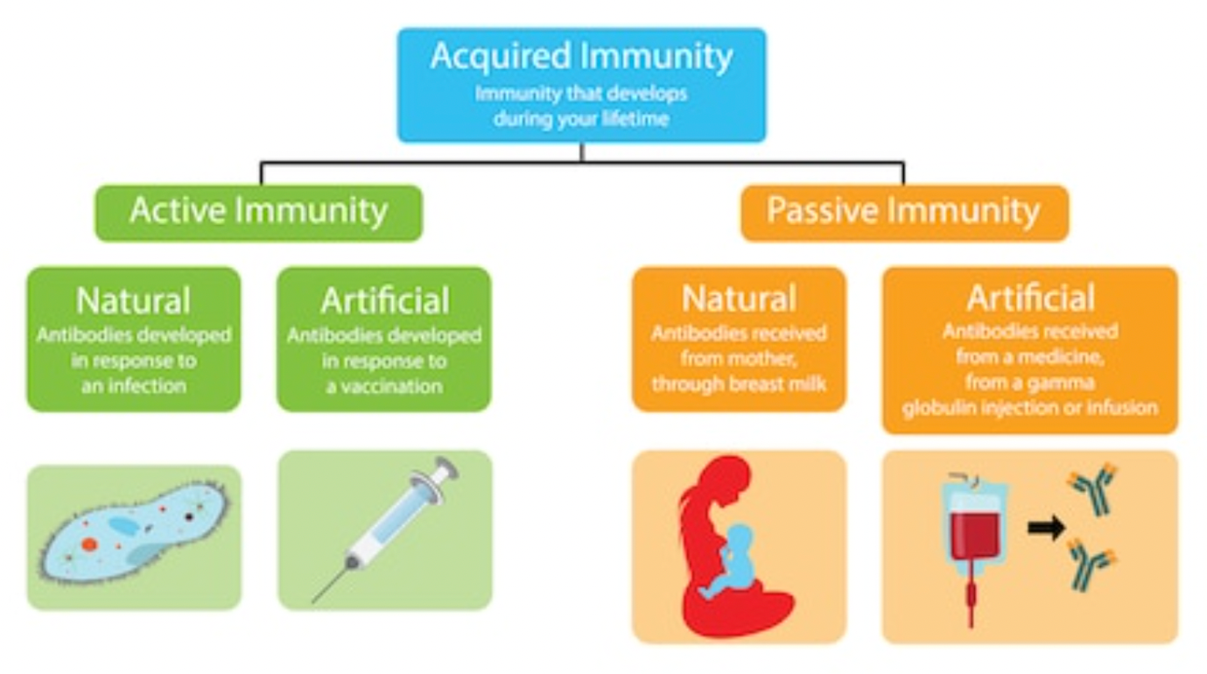

Fig3 Types of acquired immunity shutterstock image, please redraw

Naturally acquired immunity occurs when someone encounters a live pathogen and becomes immune as part of the immune response, usually this immunity is long term. This immunity can be passively acquired if antibodies are passed through the placenta, or through breastmilk. Breastfed infants receive a range of ‘bioactive components’ from the colostrum and established milk ((Palmeira & Carneiro-Sampaio, 2016). Various protective factors within colostrum include enzymes, immunoglobulins, cytokines, leucocytes, and hormones that interact with each other, and also the gastrointestinal and respiratory tract mucous membranes, which help provide immunity. As well as the IgG antibodies that were transferred across the placenta, and after birth, IgA antibodies are present in breast milk, the most predominant immunoglobulin, and it is believed that vaccine responses are also enhanced in breast fed infants (Hanson et al., 2003)

TIME OUT 2
An opportunity arises to influence the feeding choice of a pregnant mum. How might you explain the benefits of breastfeeding ?

You might use the NHS and WHO resources on breastfeeding.
https://www.nhs.uk/common-health-questions/childrens-health/how-long-do-babies-carry-their-mothers-immunity/

https://www.who.int/health-topics/breastfeeding#tab=tab_1
(NHS, 2018; WHO, 2020)

Immunisations
Immunisations are vital to the public health programme. Table 3 presents the current immunisation programme.

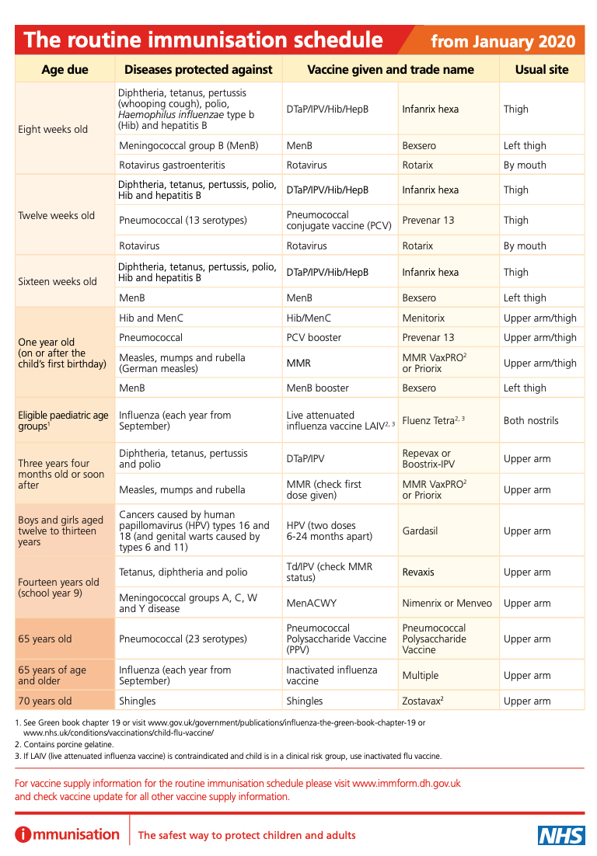

Fig 4 UK Immunisation Schedule (DoH, 2019) (could be ideally retabulated and remove the last 3 rows )

Vaccines work by providing an antigen designed to stimulate an immune response, there are two types of responses: Primary, or Secondary.

The primary response results in the production of IgM and small amounts of IgG, which remembers the antigen for future defence. The secondary response occurs a few days later and results in the production of antibodies to the antigen (Nazarko, 2013). Vaccines can include a dead form of the microorganism, be attenuated (a weakened form of virus), such as the MMR (Measles, Mumps, Rubella), chicken pox, polio, or the BCG (Bacillus Calmette-Guérin: (tuberculosis) or in the case of approved vaccines for Covid-19, a synthetic portion of RNA. There is a small risk with live vaccines as the person being vaccinated could develop the disease, which can be due to factors such as the individual’s inability to produce enough antibodies (which can be up to 10% of MMR vaccine recipients NG), or when enough antibodies are made, but the levels fall over time. This is when a booster vaccine would need to be given (Lahariya, 2016). These vaccines are contraindicated in those who are immunocompromised, or in pregnancy.

The debate about herd immunity has resurfaced during the Covid-19 Pandemic. To acquire herd immunity the vaccination coverage rates need to be about 93 – 95% of the population (Casey, 2016). This incidence is required so the immunocompromised people, who remain unvaccinated are protected (Mallory, Lindesmith, & Baric, 2018). Immunisations prevent up to three million deaths a year worldwide, so are regarded as one of the greatest inventions of all time (Tinsley, 2018).

Non-live vaccines do not contain any infectious particles, so cannot cause disease, consequentially the duration and protection is reduced and usually require several doses to gain immunity.

Issues with the safety aspects of vaccines, need to be discussed sensitively with concerned parents (Tinsley, 2018), so it is vital that children’s nurses are well informed regarding immunisation (Donovan & Craig, 2018).

TIME OUT 3
You are caring for a child who has not been immunised, as the mother thinks they are dangerous, how might you open up a discussion with the parents? The RCN website on immunisation could provide advice and guidance: https://www.rcn.org.uk/clinical-topics/public-health/immunisation (RCN, 2020).

Table 4 Examples of Immune Dysfunction and autoimmune conditions
Condition | Pathophysiology
Hypersensitivity / Allergy | Is caused when there is an excessive, and inappropriate, inflammatory response to an antigen, this can be classified into four categories:  1 – Anaphylactic hypersensitivity  2 – Antibody-mediated hypersensitivity  3 – Immune complex-mediated hypersensitivity  4 – Delayed type (cell-mediated) hypersensitivity  Some allergies are very severe and cause anaphylaxis: a life-threatening situation, causing respiratory and circulatory problems. The most common trigger in childhood is food; cow milk, egg, nuts, shellfish, sesame, soya, and wheat for example. Other causes include reactions to medications, bee and wasp venom or latex. Management of anaphylaxis is life threatening, and requires adrenaline and emergency hospital care.
Human Immunodeficiency Virus (HIV) | HIV causes immune deficiency by attacking CD4 cells. The transmission of HIV from an HIV-positive mother to her child can take place during pregnancy, labour, delivery or breastfeeding and is called mother-to-child transmission. Without intervention, transmission rates range from 15% to 45%. This can be reduced to below 5% with effective interventions during pregnancy, labour, delivery, and breastfeeding. See WHO ‘Mother to Child transmission of HIV’
Autoimmune disease | Is caused when the usual tolerance of self-antigens breaks down, creating an abnormal immune response to its own tissue. Common autoimmune diseases in children include  Hashimoto thyroiditis  Multiple Sclerosis  Coeliac disease  Rheumatoid arthritis  Eczema and psoriasis
Systemic Lupus Erythematosus (SLE) | SLE causes inflammation in various parts of the body, it affects around 1 in every 20,000 people. The presence of LE (lupus erythematosus) cells, which are types of neutrophils or macrophages in the bone marrow confirms the diagnosis of SLE There can be genetic factors associated with the likelihood of developing SLE Any organ system can be affected, ultimately leading to glomerulonephritis and central nervous system involvement. Presenting symptoms can include a rash, fever, fatigue, loss of appetite, weight loss, hair loss and painful joints, as well as lymphadenopathy and hepatosplenomegaly. The disease is lifelong, and many children require long term immunosuppressive treatment, as well as steroids, non-steroidal inflammatory drugs (NSAIDS) or other anti-inflammatory drugs.
Sepsis | Results from an impaired immune response to infection. The usual inflammatory response to infection becomes dysregulated and results in widespread systemic effects, such as capillary leak, tissue oedema, reduced circulating volume; with the potential to cause hypovolaemic shock, organ dysfunction. Clinical signs and symptoms of sepsis in children can be subtle, but fever and tachycardia are red flags.  The implementation of early warning scores (NEWS / PEWS) help nurses recognise the signs of sepsis early and escalate care. Severe sepsis is a clinical emergency, and healthcare professionals must follow the Sepsis 6 Guidelines in clinical practice.
Gargani, (2015), (Waugh & Grant, (2018) Reber, Hernandez, & Galli, (2017) Fischer et al., 2018) Warrington et al., (2011) Pearce, 2016) Zharkova et al., 2017) Gargani, (2015) (Deep, 2020)Levy & Kamphuis, (2012).

Age of onset in autoimmune disease is not necessarily associated with a worse prognosis, but it may be a contributing factor in some, for example SLE or Type 1 diabetes, so knowledge of childhood presentation symptoms, with optimum educational support and transition into adult services, will provide children affected by autoimmune disease with more advantageous outcomes (Amador-Patarroyo et al., 2012).

TIME OUT 4
Two out of three schools in the UK have children at risk of anaphylaxis (Muraro et al., 2010) and need to be prepared to deal with the situation. Draw up a checklist for children who have allergy. The following resource might be helpful https://www.allergyuk.org/information-and-advice/for-schools (UK, 2020)
Conclusion
This CPD has provided an introduction to the immune system. Further knowledge can be gained from additional reading and the use of the links provided. An understanding of the immune system is vital, there are many circumstances where it will feature in discussions regarding clinical care, for example why a child may need antibiotics, or not, and why they should be immunised. Understanding of the mechanisms of body defence can also assist when explaining to families the impact on the child when things go wrong.

References

NOTE – Please change ‘NHS’ to ‘National Health Service’ below, and change ‘DoH’ to ‘Department of Health’

Abraham, M. B., Jones, T. W., Naranjo, D., Karges, B., Oduwole, A., Tauschmann, M., & Maahs, D. M. (2018). ISPAD Clinical Practice Consensus Guidelines 2018: Assessment and management of hypoglycemia in children and adolescents with diabetes. Pediatr Diabetes, 19 Suppl 27, 178-192. doi:10.1111/pedi.12698
Andreu-Ballester, J. C., Perez-Griera, J., Ballester, F., Colomer-Rubio, E., Ortiz-Tarin, I., & Penarroja Otero, C. (2007). Secretory immunoglobulin A (sIgA) deficiency in serum of patients with GALTectomy (appendectomy and tonsillectomy). Clin Immunol, 123(3), 289-297. doi:10.1016/j.clim.2007.02.004
Bitar, M. A., Dowli, A., & Mourad, M. (2015). The effect of tonsillectomy on the immune system: A systematic review and meta-analysis. Int J Pediatr Otorhinolaryngol, 79(8), 1184-1191. doi:10.1016/j.ijporl.2015.05.016
Boam, T., Sellars, P., Isherwood, J., Hollobone, C., Pollard, C., Lloyd, D. M., . . . Garcea, G. (2017). Adherence to vaccination guidelines post splenectomy: A five year follow up study. J Infect Public Health, 10(6), 803-808. doi:10.1016/j.jiph.2017.01.006
Casey, G. (2016). Vaccines: How and why they work. Kia Tiaki Nursing New Zealand, 22(1), 20 - 24.
Catalano, M., Rizzo, D., Coccia, P., Maurizi, P., Nanni, L., & Ruggiero, A. (2018). Can partial splenectomy preserve humoral immunity in pediatric patients? Risks and benefits of partial splenectomy. Signa Vitae, 14(1), 17 - 19.
Chen, M., Daha, M. R., & Kallenberg, C. G. (2010). The complement system in systemic autoimmune disease. J Autoimmun, 34(3), J276-286. doi:10.1016/j.jaut.2009.11.014
Deep, A. (2020, 9 Jan). Sepsis in children. BMJ Best Practice. Retrieved from https://bestpractice.bmj.com/topics/en-gb/1201
DoH. (2019). Guidance: Complete routine immunisation schedule. Retrieved from https://www.gov.uk/government/publications/the-complete-routine-immunisation-schedule
Donovan, H., & Craig, L. (2018). Why immunisation training matters. Primary Health Care, 21 - 24. doi:10.7748/phc.2018.e1440
Gargani, Y. (2015). Haematology and Immunology (4th ed.). Oxford: Elsevier.
Green, Z., Woodman, N., McLernon, D. J., Patrn, & Engelhardt, T. (2020). Incidence of paediatric unplanned day-case admissions in the UK and Ireland: a prospective multicentre observational study. Br J Anaesth. doi:10.1016/j.bja.2019.11.035
Hanson, L. A., Korotkova, M., Lundin, S., Haversen, L., Silfverdal, S. A., I., M.-B., . . . Telemo, E. (2003). The transfer of immunity from mother to child. Ann NY Acad Sci, 987, 199 - 206.
Jung, C., Hugot, J. P., & Barreau, F. (2010). Peyer's Patches: The Immune Sensors of the Intestine. Int J Inflam, 2010, 823710. doi:10.4061/2010/823710
Kumar, B. V., Connors, T. J., & Farber, D. L. (2018). Human T Cell Development, Localization, and Function throughout Life. Immunity, 48(2), 202-213. doi:10.1016/j.immuni.2018.01.007
Lahariya, C. (2016). Vaccine epidemiology: A review. J Family Med Prim Care, 5(1), 7-15. doi:10.4103/2249-4863.184616
Mahmoudi, M. (2016). Immunology made ridiculously simple. Miami: Medmaster Inc.
Mallory, M. L., Lindesmith, L. C., & Baric, R. S. (2018). Vaccination-induced herd immunity: Successes and challenges. J Allergy Clin Immunol, 142(1), 64-66. doi:10.1016/j.jaci.2018.05.007
Muraro, A., Clark, A., Beyer, K., Borrego, L. M., Borres, M., Lodrup Carlsen, K. C., . . . Zanchetti, M. (2010). The management of the allergic child at school: EAACI/GA2LEN Task Force on the allergic child at school. Allergy, 65(6), 681-689. doi:10.1111/j.1398-9995.2010.02343.x
Nazarko, L. (2013). How do vaccines work to protect people from disease? Nursing & Residential Care, 15, 770 - 774.
NHS. (2018). How long do babies carry their mother’s immunity? Retrieved from https://www.nhs.uk/common-health-questions/childrens-health/how-long-do-babies-carry-their-mothers-immunity/
NHS. (2019). Spleen problems and spleen removal. Retrieved from https://www.nhs.uk/conditions/spleen-problems-and-spleen-removal/
Palmeira, P., & Carneiro-Sampaio, M. (2016). Immunology of breast milk. Rev Assoc Med Bras (1992), 62(6), 584-593. doi:10.1590/1806-9282.62.06.584
Playfair, J. H. L., & Chain, B. M. (2013). Immunology at a Glance (10th ed.). Chichester: Wiley-Blackwell.
RCN. (2020). Immunisation. Retrieved from https://www.rcn.org.uk/clinical-topics/public-health/immunisation
Stowell, S. R., Winkler, A. M., Maier, C. L., Arthur, C. M., Smith, N. H., Girard-Pierce, K. R., . . . Hendrickson, J. E. (2012). Initiation and regulation of complement during hemolytic transfusion reactions. Clin Dev Immunol, 2012, 307093. doi:10.1155/2012/307093
Tinsley, E. (2018). ‘Children’s immune systems are being overloaded with all these vaccines’. Nursing in Practice, 1 - 3.
UK, A. (2020). For Schools. Retrieved from https://www.allergyuk.org/information-and-advice/for-schools
Warburton, K. (2018). Care of children and young people with immunological problems. In J. Price & O. McAlinden (Eds.), Essentials of Nursing Children and Young People (pp. 350 - 360). London: Sage.
Warrington, R., Watson, W., Kim, H. L., & Antonetti, F. R. (2011). An introduction to immunology and immunopathology. Allergy, Asthma & Clinical Immunology, 7, 1 - 8.
West, H., & Jin, J. (2016). Lymph Nodes and Lymphadenopathy in Cancer. JAMA Oncol, 2(7), 971. doi:10.1001/jamaoncol.2015.3509
WHO. (2020). Breastfeeding. Retrieved from https://www.who.int/health-topics/breastfeeding#tab=tab_1
Zdrojewicz, Z., Pachura, E., & Pachura, P. (2016). The Thymus: A Forgotten, But Very Important Organ. Adv Clin Exp Med, 25(2), 369-375. doi:10.17219/acem/58802

