PATHOLOGICAL DEMAND AVOIDANCE (PDA): ITS FOUR SCHOOLS OF THOUGHT.

Richard Woods

Originating from Nottingham, United Kingdom (UK) in 1980, Elizabeth Newson proposed the Disorder, Pathological Demand Avoidance (PDA, sometimes among other names, it is alternatively called Extreme Demand Avoidance). There is no consensus over what PDA is, or how to assess it (https://tinyurl.com/y72yt729; https://tinyurl.com/s82vc788; https://tinyurl.com/3yszvkhj), however recent research suggests core PDA traits of: (1) Avoidance of everyday demands; (2) Comfortable in role play and pretence; (3) Frequent and intense actions; (4) Social avoidance behaviours, are developed and maintained by a generic negative feedback cycle (https://tinyurl.com/3zhan7pj), as shown in Image 5.
Discussions of PDA frequently invoke strong passions in those for its use as an autism subtype (profile) (https://tinyurl.com/u9y79r2t), and in those against (https://tinyurl.com/txjb5czm). Presently, PDA is a culturally bound construct to the UK (https://tinyurl.com/3wvaexbf), and interest has substantially outstripped its evidence base (https://tinyurl.com/24f7p8t2. A recent a systematic review observed substantial methodological limitations (REF), and a general lack of consideration for alternative explanations for features being observed. The authors argue that we cannot be sure of what features are associated with PDA, and how they present over lifespan. They conclude that PDA lacks evidence to suggest it is either distinct: Disorder, autism subtype, or trait specific to autistic persons (https://tinyurl.com/na4abkkr). PDA’s behaviour profile is unstable, and subsequently it has multiple competing diagnostic profiles.

Its first profile conceptualised PDA as an independent syndrome, yet, related to autism (https://tinyurl.com/z86e5tsf). Those advocating for it to be an autism subgroup then removed its developmental traits (https://tinyurl.com/s82vc788), followed by further revision of the profile to conform to autism understandings (https://tinyurl.com/5kzttmcb). Most recently, the PDA criteria were revised again to add Sensory Differences to the list of PDA traits by XXX et al (https://tinyurl.com/ynjdms57). Consequently, these four behaviour profiles have been combined to create the Aggregated PDA Profile (See Figure 1).

Figure 1: DSM-5 Autism criteria on the left and the Aggregated PDA Profile on the right.
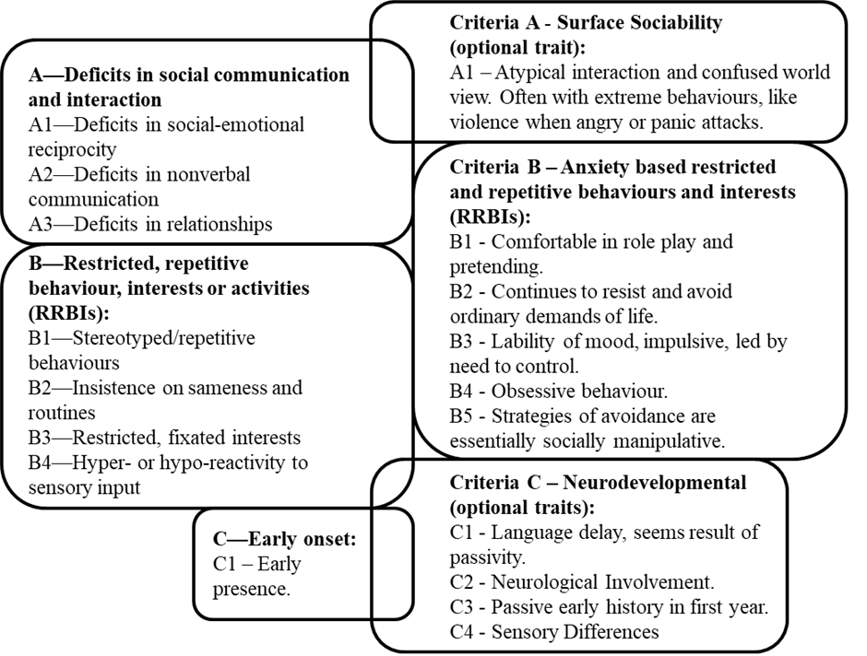

PDA’s specificity and validity as a (developmental?) disorder has been consistently challenged since 2002 (https://tinyurl.com/e2cf3s9k; https://tinyurl.com/vvkn6fzb). Some clinicians have contested that its features can be found in persons across the entire autistic population, such as gaining reward by upsetting others (https://tinyurl.com/y3cmth7w). Critical Autism Studies scholars have refined this outlook, positing that PDA represents the pathologising of actions many persons express to assert their self-agency (https://tinyurl.com/vvkn6fzb), while distressed (https://tinyurl.com/4d6uhsst). Autistic actions are frequently pathologised for transgressing non-autistic cultural norms and not complying with the wishes of others (https://tinyurl.com/yc7r59ze).
Since the first critical PDA article in 2003, it has been posited that PDA contains features attributed to co-occurring conditions alongside autism, such as: Attention deficit hyperactivity disorder (ADHD), Social Anxiety Disorder, Oppositional Defiant Disorder and Schizotypal Personality precursors (https://tinyurl.com/482ypr5n). This view was revisited in 2018, with PDA being conceptualised as a pseudo-syndrome, but traits manifesting from the simultaneous interaction of autism and various co-occurring conditions (https://tinyurl.com/5kzttmcb); other possible conditions contributing to PDA include: Attachment difficulties (https://tinyurl.com/vkpmw5bx), Anxiety Disorders, Conduct Disorders (https://tinyurl.com/5kzttmcb), Catatonia (https://tinyurl.com/22ch2dzd), depression; Eating Disorders (https://tinyurl.com/mf2yu5er); undiagnosed learning impairments (https://tinyurl.com/u9y79r2t). There are ongoing debates that PDA behaviours can be seen in trauma-based constructs (https://tinyurl.com/3yf6ww4f; https://tinyurl.com/jpc7ay2y), and its behaviours can be caused by aversive experiences, such as hold restraints used in educational settings (https://tinyurl.com/x2pxthcu). Broader research indicates PDA can be predicted by anxiety (https://tinyurl.com/ywkt3mf6), anxiety, conduct problems and hyperactivity (https://tinyurl.com/5kzttmcb); as well as personality precursors, ADHD features and emotional dysregulation (https://tinyurl.com/5f4hu3k4). Figure 2 conceptualises these disparate research results and demonstrates that PDA itself has a “spiky profile” of features. Moreover, PDA can be conceptualised as a “triple-hit” of anxiety, autism, and conduct problems (https://tinyurl.com/2j8s94hw). In addition to these findings, research shows that at lower diagnostic thresholds, PDA is neither pervasive nor developmental in nature (https://tinyurl.com/y3cmth7w). It appears that Newson’s outlook of PDA being a distinct clustering of characteristics, separate of autism (https://tinyurl.com/z86e5tsf), is valid. The disagreement over PDA’s clinical nature is reflected in its many different diagnostic thresholds (https://tinyurl.com/y3cmth7w).
Figure 2: How PDA can be viewed as a collection of features from recognised constructs.
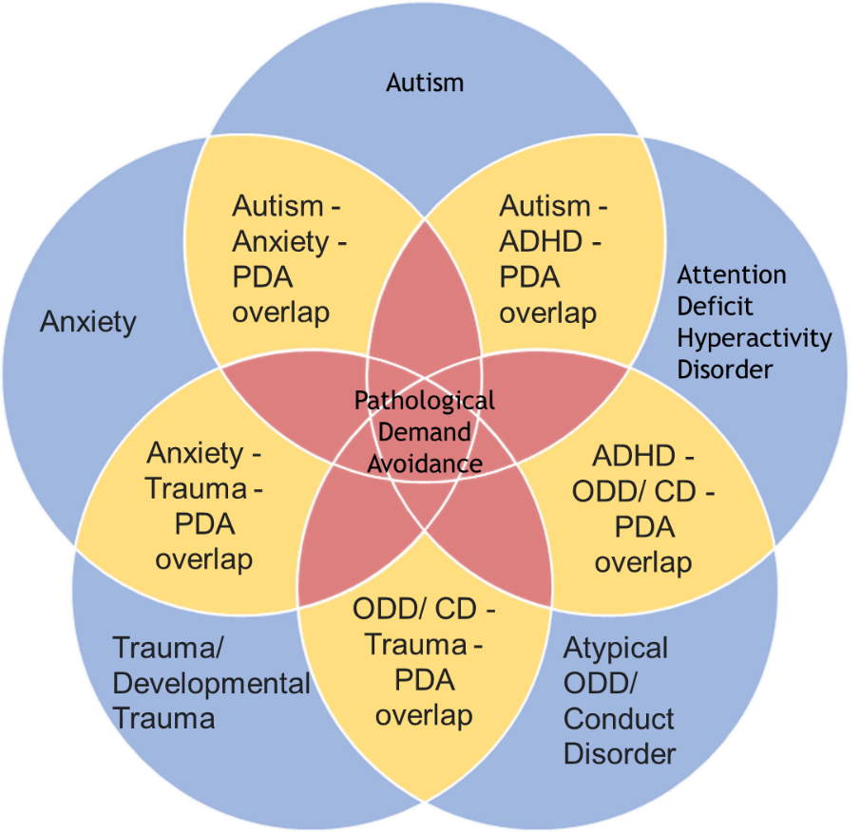
Recent research has shown that PDA is seen in non-autistic persons (https://tinyurl.com/y9xj6cvv). If PDA is not exclusive to autism, it logically cannot be an autism subtype. PDA’s central feature is anxiety (https://tinyurl.com/akm5n6n2; https://tinyurl.com/3wvaexbf; https://tinyurl.com/24f7p8t2), which is transactional with the environment (https://tinyurl.com/5kzttmcb; https://tinyurl.com/vvkn6fzb). It is widely accepted that anxiety is not an intrinsic feature of autism, but a co-occurring difficulty (https://tinyurl.com/5hayna6n; https://tinyurl.com/mumpmkka).

Overall, there are four primary competing outlooks on PDA, with mixed evidence in support of each. There is a need for a more balanced overview of PDA presented in its main discourse, with each outlook being investigated to discover the most accurate and valid way to conceptualise PDA. Until such a time the debates surrounding PDA are resolved through good quality scientific method-based research, it will remain a controversial construct and should be treated with caution. Perhaps, even with extreme demand avoidant behaviour?

Disclosure.
Richard Woods receives funds for delivering autism and PDA training.

Richard Woods
London South Bank University
Email address: richardwoodsautism@gmail.com
ORCID: 0000-0002-8292-632X

