Alkaline pretreatment of walnut shells increases surface hydrophilicity of derived biochars
Meredith Rose Barr,^{[a]} Luke Forster,^{[b]} Dr Carmine D’Agostino,*^{[b]} Dr Roberto Volpe*^{[a]}

[a] M. R. Barr, Dr R. Volpe
Division of Chemical Engineering and Renewable Energy, School of Engineering and Materials Science
Queen Mary University of London
Mile End Road, London, E1 4NS, UK
E-mail: r.volpe@qmul.ac.uk

[b] L. Forster, Dr C. D’Agostino
Department of Chemical Engineering and Analytical Science
The University of Manchester
Oxford Road, Manchester M13 9PL, UK
E-mail: carmine.dagostino@manchester.ac.uk

Abstract
The surface chemistry and morphology of biochars produced by pyrolysis of walnut shells affects their utility for adsorption applications such as wastewater treatment. Here, the surface chemistry of walnut shells and derived biochars were investigated using NMR spectroscopy and X-ray photoelectron spectroscopy. Alkaline pretreatment, known to remove lignin from lignocellulosic biomass, was found to increase the hydrophilicity of both walnut shells and derived biochars. It was found to increase surface interactions with hydroxyl groups, and to decrease those with methyl groups. Results were contextualised by thermogravimetric analysis, scanning electron microscopy, and previous X-ray imaging results that relied on the same materials and methodology. Taken together, results showed that alkaline pretreatment may be used to modulate responses to pyrolysis temperature of several factors that affect adsorption properties including surface hydrophilicity, particle size, porosity & pore accessibility, and surface texture. This is a level of control over biochar properties heretofore thought possible only by harsher post-pyrolysis treatments.

Introduction
The high surface area to volume ratio of biochars makes them an ideal candidate for adsorption-dependant environmental applications, such as air, water, and soil treatment; energy storage; and sustainable catalysis. Controlling both the chemistry and morphology of this surface area is key to optimising biochars for specific applications. Here, we propose a relatively low-environmental-impact low-energy-input method for tuning these properties in biochars produced from the agricultural waste biomass feedstock walnut shells.
Walnut shells, the lignified endocarp of the walnut drupe, are an abundant waste product of shelled walnut production. They are composed of interlocking polylobate sclereid cells,^{[1,2]} a form of lignified structural support tissue in plants. These cells have a primary cell wall surrounding a multi-layered secondary wall composed of cellulose microfibrils in an incrementing helicoidal arrangement^{[2,3]} surrounded by a porous mass of lignin and hemicellulose (see ‘Raw’, ‘Untreated’ micrograph in Figure 3). The primary walls contain semi-permeable pit membranes, and the secondary walls microscopic pit canals, which allow cells to maintain symplastic transport as they mature and lignify.^{[2]} In general, walnut shell cells have thicker secondary walls and more narrow pits towards the exterior of the shell.^{[1,4]}
In terms of chemical composition, walnut shells contain approximately 38% w/w lignin and 62% w/w holocellulose (cellulose and hemicellulose) on a dry ash-free basis.^{[4]} Of the holocellulose, approximately 44% w/w is composed of d-glucose monomers and 39% w/w is composed of d-xylose monomers.^{[4]} Lignin is composed of guaiacyl (G), syringyl (S), and p-hydroxyphenyl (H) units, which differ only in number of methoxy groups. In walnut shells, the ratio of G:S:H lignin is approximately 13:21:1.^{[4]} Thus, to represent the chemistry of the holocellulose and lignin fractions of walnut shells, electrostatic potential maps (MEPs) of a glucose-xylose and a GS lignin dimer, respectively, are presented in Figure 1.
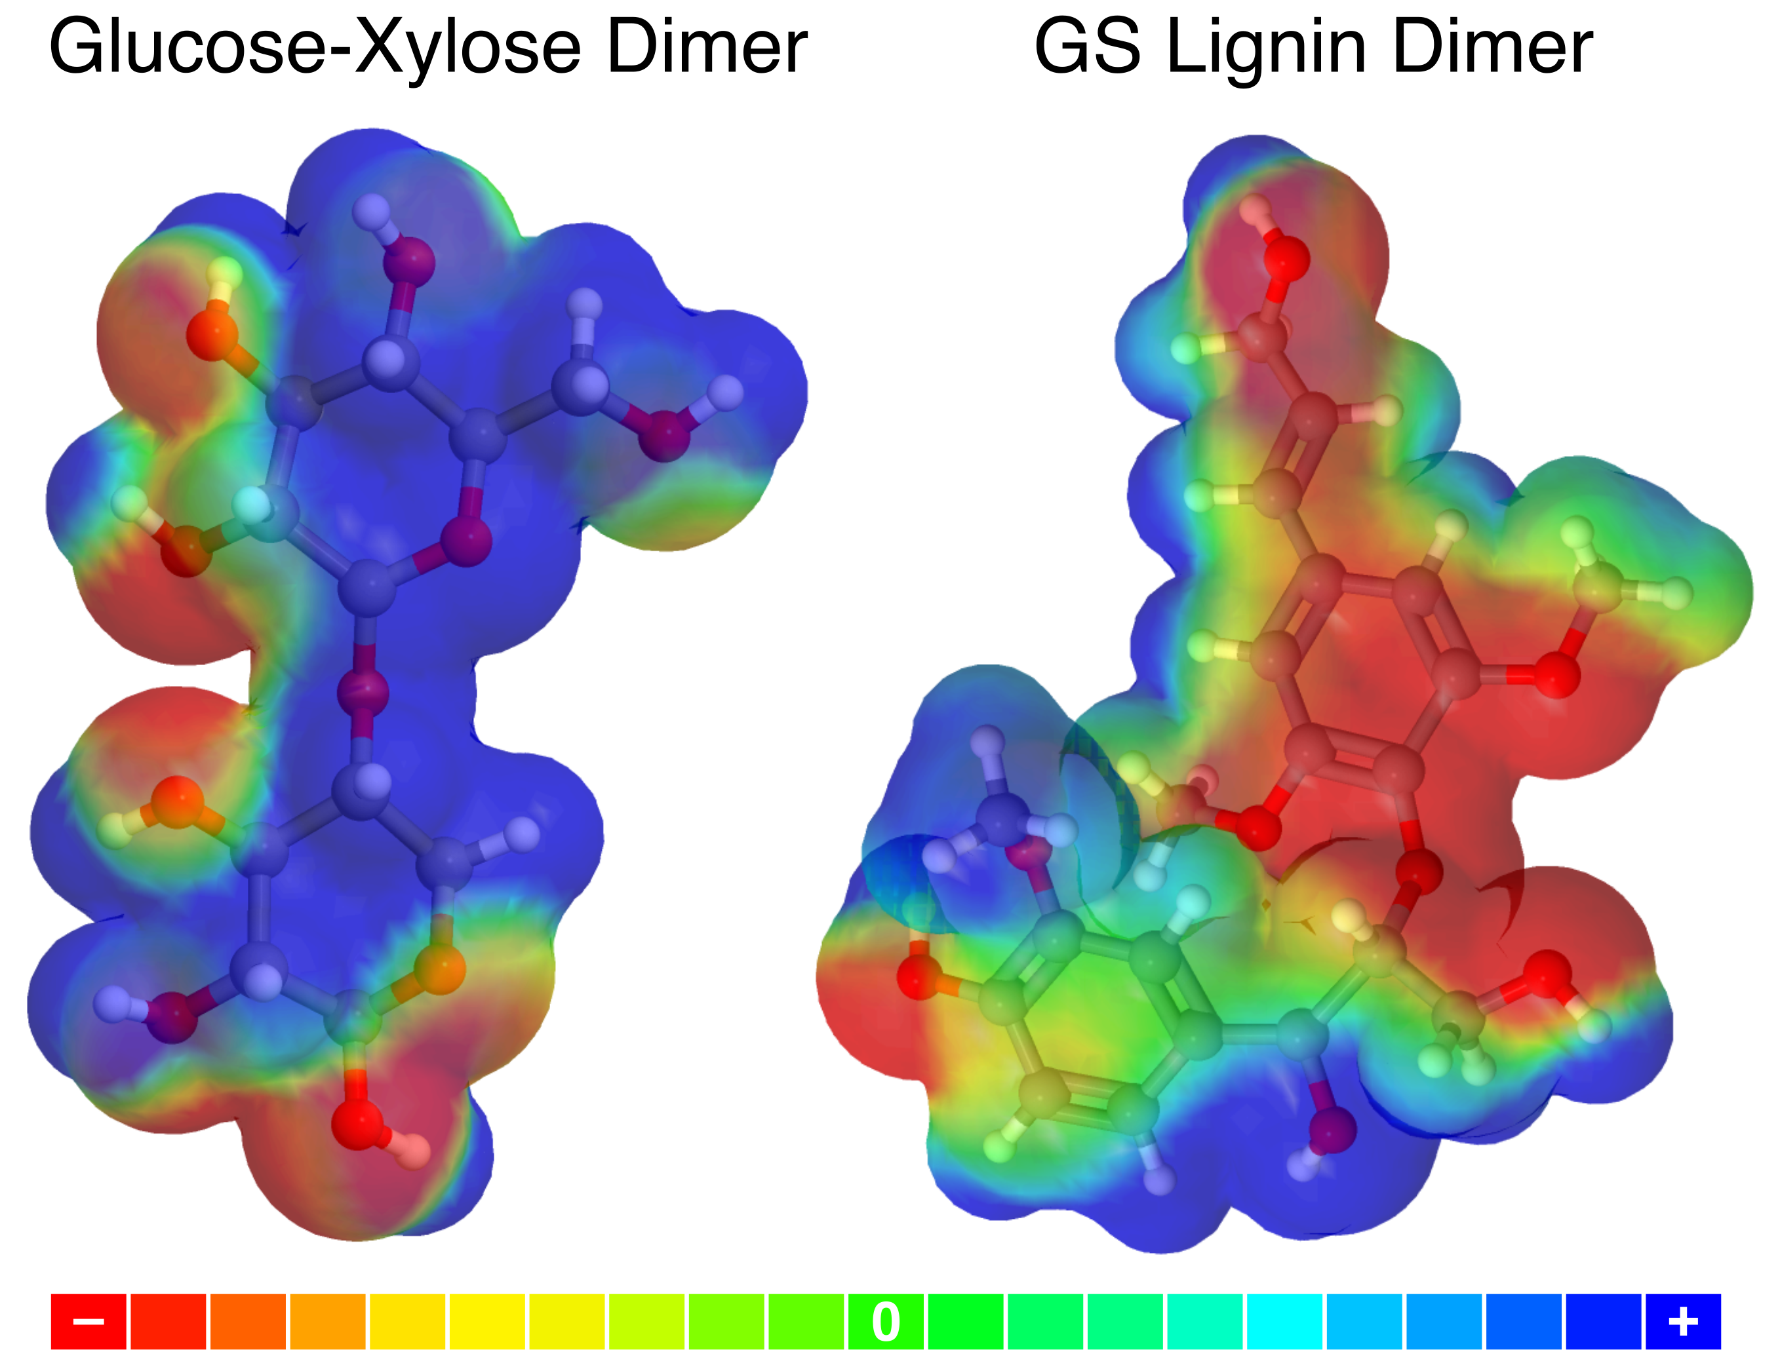
Figure 1. Electrostatic potential maps (MEPs) of molecules chosen to represent the chemistry of the holocellulose and lignin fractions of walnut shells. The ‘Glucose-Xylose Dimer’, chosen to represent the holocellulose fraction, is 4-O-α-d-glucopyranosyl-d-xylopyranose^{[5]} (PubChem CID: 14885840). The ‘GS Lignin Dimer’, chosen to represent the lignin fraction, is coniferyl alcohol (G-Lignin precursor) β-O-4 aryl ether linked to synapyl alcohol (S-Lignin precursor) (PubChem CID: 21637751). Colour scale indicates electrostatic potential in arbitrary units (with red being the most negative and blue the most positive) a fixed arbitrary distance from the molecule. Ball colour indicates element: grey is carbon, red is oxygen, and white is hydrogen. MEPs were created using CheMagic Virtual Molecular Model Kit (Vmols).
These MEPs show that at the same distance from these reference molecules, the lignin dimer has a greater area of near-zero electrostatic potential (see Figure 1), meaning it is more likely to participate in hydrophobic interactions than is the holocellulose dimer. Furthermore, the holocellulose dimer contains a greater percentage of oxygen and lesser percentage of carbon atoms than does the lignin dimer (see Table 1). While all the carbon atoms in the holocellulose dimer are sp³ hybridised and bonded to oxygen, two thirds of those in the lignin dimer are sp² hybridised, and just over half are bonded to oxygen (see Table 1). These distinctions are important to interpretation of results in the context of alkaline pretreatment, which is known to decrease the lignin content of biomass.^{[6–9]}
Table 1. Elemental and carbon bonding state compositions of molecules chosen to represent the chemistry of the holocellulose and lignin fractions of walnut shells.
 |  |  |  | Carbon bonding state [at%]
 | Elemental composition [at%] |  |  | Hybridisation state |  | Oxygen bonding
Molecule | C | O | H | sp³ | sp² | Yes | No
GS lignin dimer^{[a]} | 40 | 15 | 45 | 33 | 67 | 57 | 43
Glucose-xylose dimer^{[b]} | 28 | 25 | 48 | 100 | 0 | 100 | 0
[a] The ‘GS Lignin Dimer’, chosen to represent the lignin fraction, is coniferyl alcohol (G-Lignin precursor) β-O-4 aryl ether linked to synapyl alcohol (S-Lignin precursor) (PubChem CID: 21637751). [b] The ‘Glucose-Xylose Dimer’, chosen to represent the holocellulose fraction, is 4-O-α-d-glucopyranosyl-d-xylopyranose^{[5]} (PubChem CID: 14885840).

The mechanism of this delignification is the saponification of ester bonds linking lignin to carbohydrates.^{[7,10]} However, ether bonds between lignin and carbohydrates are relatively stable under alkaline conditions.^{[11]} Additionally, alkaline pretreatment may affect the holocellulose fraction of biomass. It is thought to decrease the degree of cellulose polymerisation,^{[6,7]} to remove acetyl and uronic acid substitutions from hemicellulose,^{[8]} and even to solubilise and remove some hemicellulose.^{[6,9]} Furthermore, alkaline pretreatment is known to increase the accessible surface area of biomass.^{[7–9]} All of these effects serve to increase the accessibility and therefore reactivity of holocellulose in the feedstock.
In previous work, we investigated effects of alkaline pretreatment on the volume loss behaviour of walnut shells during pyrolysis using a combination of in-situ and ex-situ synchrotron X-ray imaging techniques.^{[12]} We showed that alkaline pretreatment of walnut shells led particles to shrink at lower temperatures and to gain less porosity with respect to their magnitude of shrinkage during pyrolysis (see reference ^{[12]}, Figure 3).
Porosity was found to increase mostly towards the centre of particles.^{[12]} This was thought to be the result of a shrinking low-temperature internal region of the particle wherein the rate of heat transport is faster than that of reaction. This means that within this region, the temperature is relatively even, leading to reaction, and thus porosity gain, throughout. As the particle heats up, this internal region shrinks until the entire particle is sufficiently hot for the rate of reaction to exceed that of heat transport. In this regime, the particle reacts at its surface before heat can penetrate further, leading the particle to shrink without gaining porosity.
The observed effects of alkaline pretreatment were thought to be due to this internal region receding more quickly in pretreated shells, meaning less concentration of porosity towards particle centres occurs. Therefore, internal surface area of pretreated walnut shell biochars may be more accessible than that of untreated biochars.
Here, we employ a range of material characterisation techniques to gain further insight into the effects of alkaline pretreatment on the pyrolysis behaviour of walnut shells, and the resulting surface chemistry and morphology of their derived biochars.
Thermogravimetric analysis (TGA) was used to examine the mass loss behaviour of walnut shells at different temperatures. Though pyrolysis results obtained using thermogravimetric (TG) balances have limited applicability to pyrolysis in fixed-bed reactors,^{[13–15]} like that used to produce biochars in this work (see Figure 9), TGA results have been compared internally to study differences in pyrolysis behaviour of untreated and alkali-pretreated walnut shells.
Scanning electron microscopy (SEM) was used to visualise surface morphological changes resulting from alkaline pretreatment and/or pyrolysis of walnut shells.
X-ray photoelectron spectroscopy (XPS) was used to quantify the bonding state composition of carbon atoms in walnut shell biochars. Effects of alkaline pretreatment, peak pyrolysis temperature, and distance from particle surface were investigated.
Nuclear magnetic resonance (NMR) relaxation measurements were used to investigate the surface chemistry, namely the wettability, of internal nutshell and biochar surfaces by determining interaction strengths of guest molecules with different functionalities imbibed in the pores of these materials with their surfaces. This technique has been successfully used to characterise a range of porous materials, including porous catalysts^{[16–18]} and construction materials.^{[19–21]} In this work, we extend its use to study changes in the internal surface chemistry of walnut shells and their derived biochars resulting from pyrolysis and/or alkaline pretreatment.
Combining this work with previous results, we show that this relatively mild pretreatment may be used to modulate responses to pyrolysis temperature of several factors that affect adsorption properties of biochars including surface hydrophilicity, particle size, porosity & pore accessibility, and surface texture. This is a level of control over biochar properties popularly thought possible only by post-pyrolysis treatment of biochars, which tends to rely on much harsher reagents and/or conditions. This level of control allows for optimisation of biochar morphologies and surface chemistries for a given adsorbate via relatively mild process conditions. The system we propose to achieve this is a relatively low-environmental-impact low-energy-input method for tuning this waste valorisation process to engineer biochar properties for specific environmental adsorption applications.

Results and discussion

Thermogravimetric analysis
Mass loss trends of treated and untreated walnut shells upon heating in a TG balance were essentially similar. Nonetheless, a few key differences indicate more cellulosic character of pretreated shells. Arguably, the ‘onset’ of mass loss occurs at a slightly lower temperature, and more mass is lost at very low temperatures (<250 °C), in untreated than pretreated shells (see Figure 2). This is consistent with reduced lignin content of pretreated shells.^{[13]}
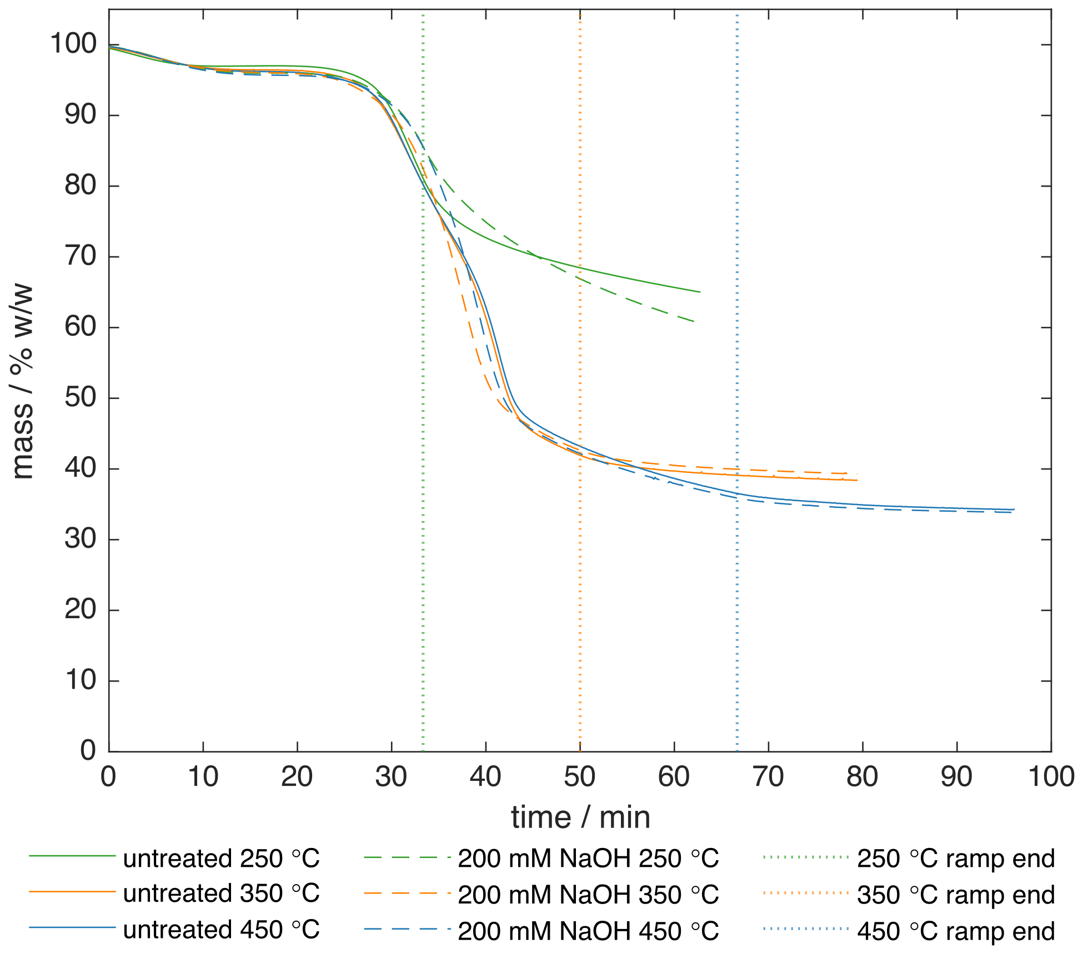
Figure 2. Mass loss of untreated and alkali-pretreated walnut shells upon heating from 50 °C at a rate of 6 °C min⁻¹ to peak temperatures between 250 and 450 °C. Single particles (1-2 mm) were heated in a thermogravimetric balance to the peak temperatures indicated and held for 30 min.
In isolation, and at sufficiently low heating rates, lignin begins to lose mass at lower temperatures than does cellulose and continues to lose mass relatively slowly over a wide range of temperatures (<150 to >900 °C).^{[13]} Conversely, in isolation, cellulose degrades almost entirely within a very narrow range of temperatures (~225 to 325 °C, though this varies greatly with reactor configuration and experimental design).^{[14,15]}
Likewise, pretreated shells lost the majority of their total mass loss over a slightly smaller temperature range than did untreated shells (see Figure 2), which is consistent with a more cellulosic feedstock.^{[13]} However, total solid yields at 350 °C and 450 °C were similar.
During a 30 min hold at 250 °C, untreated shells lost mass substantially more slowly than did pretreated shells (see Figure 2). Co-pyrolysis of lignin in plant material has been shown to shift cellulose decomposition to higher temperatures compared to both mixtures of isolated lignocellulosic components and models of their independent pyrolysis.^{[13]} It follows that reduced lignin content in pretreated walnut shells would increase reaction rates at temperatures greater than the onset temperature of cellulose pyrolysis in isolation, but less than that in situ.

Scanning electron microscopy
Micrographs of unpyrolysed walnut shells consistently show some removal of visually apparent lignin build-up from between sclereid cell secondary wall layers (see Figure 3) and cell interiors. As this analysis was limited to external surfaces of large particles, it is unclear from micrographs whether lignin was similarly removed from deeper within particles.
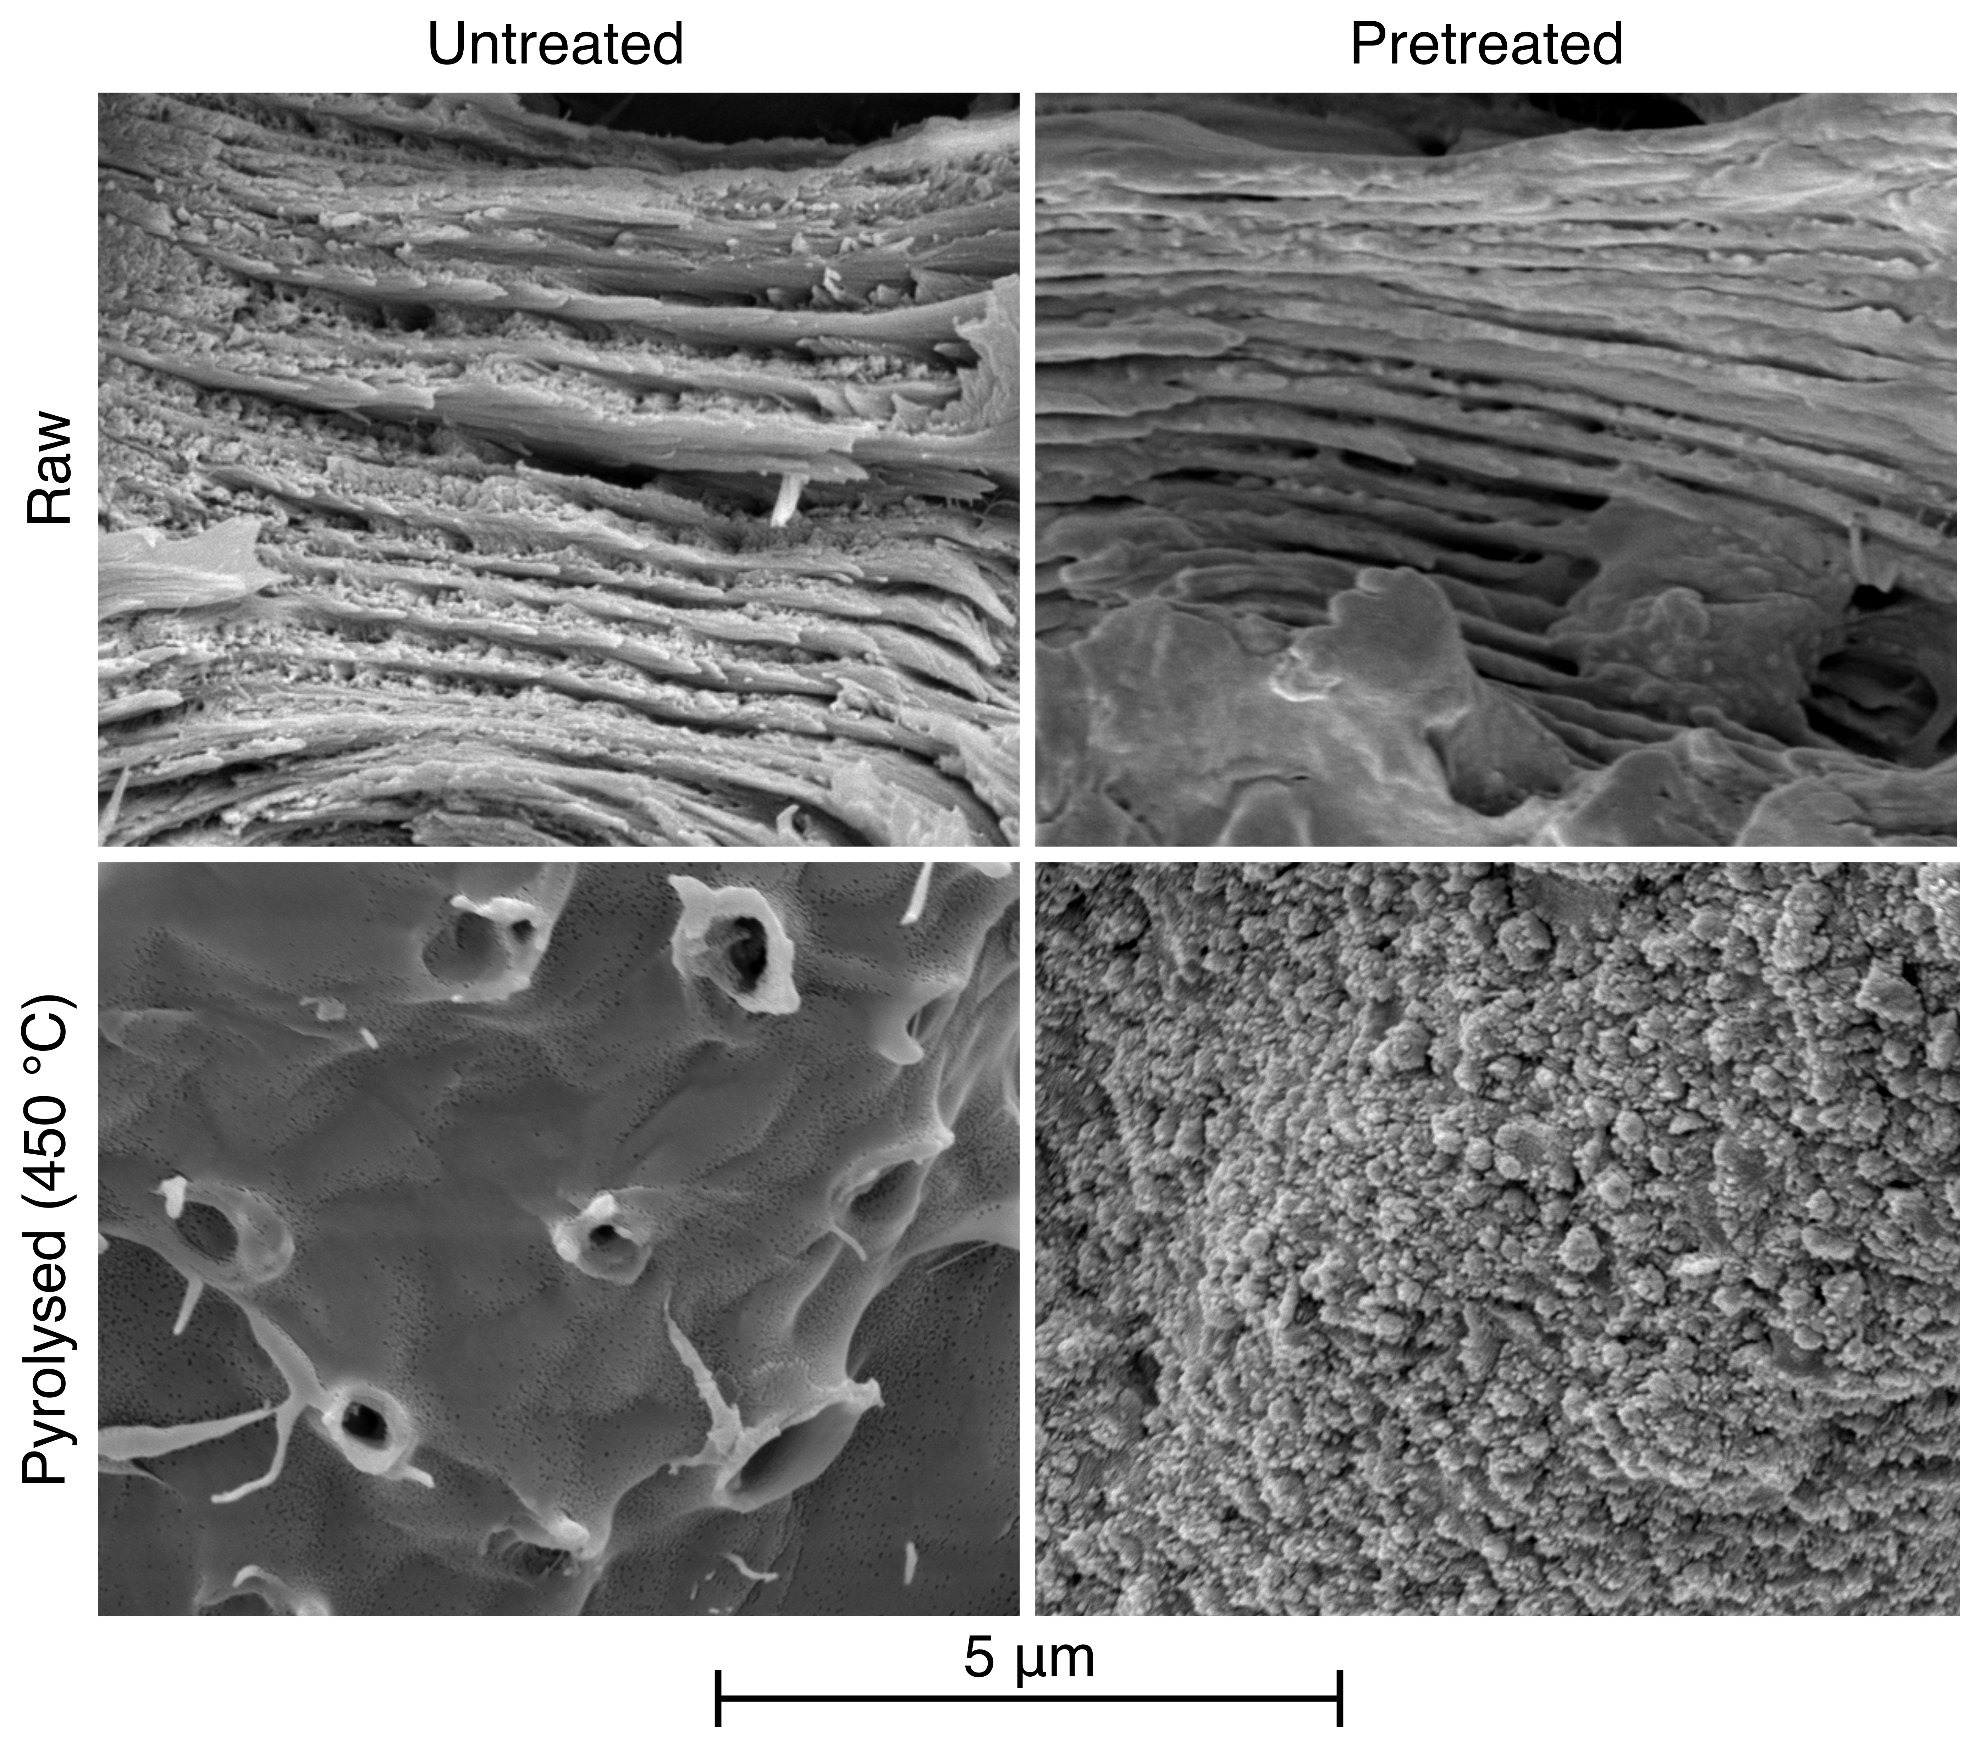
Figure 3. Scanning electron micrographs of raw and pyrolysed, untreated and alkali-pretreated walnut shells. Micrographs of raw shells show partial removal of lignin from between secondary wall layers. Micrographs of pyrolysed shells highlight the difference in external surface texture between untreated and pretreated biochars.
Micrographs also revealed a difference in the surface texture of untreated and pretreated walnut shell biochars. In pretreated biochars, a rough surface texture develops by 450 °C, which visually appears to be a deposition (see Figure 3). Conversely, in untreated biochars, external surfaces are largely smooth with a glossy appearance by 450 °C, with some surfaces having the appearance of being slightly etched in a texture reminiscent of that of gasified biochars. This texture was especially prevalent near burst pit membranes like those pictured in Figure 3, implying it may be related to reaction with reactive gases released from within particles via pit canals. Overall, rough texture was far more prevalent in pretreated biochars, giving them an advantage in terms of surface area to volume ratio, a key parameter in adsorption performance.

X-ray photoelectron spectroscopy
A greater fraction of carbon atoms was found to be bonded to oxygen at the surface of walnut shell biochars than in the bulk of the particle (see Figure 4). The exact depth of this ‘bulk’ cannot be specified as etch rates of the materials are unknown. This trend was particularly pronounced in biochars produced at low peak temperatures (250 °C). This is thought to be related to condensation of highly oxygenated compounds that are volatilised preferentially. As temperature increases, condensation of these volatiles becomes less favourable as cracking to lighter gases becomes more favourable.
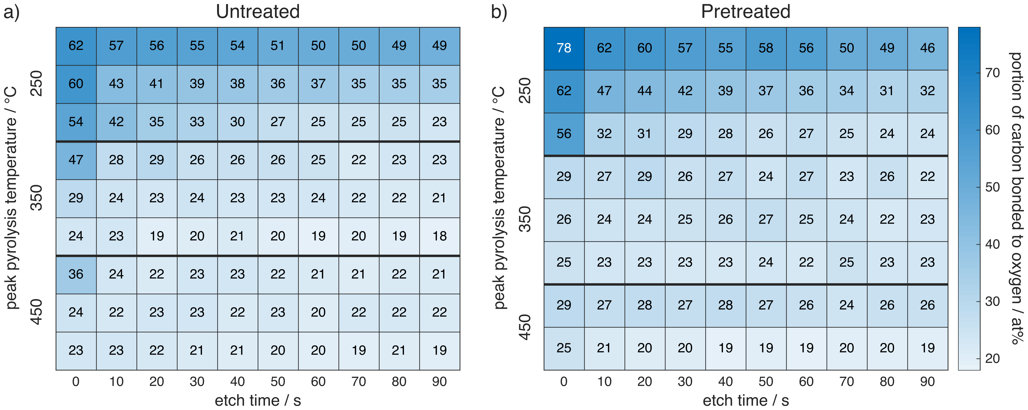
Figure 4. Heatmaps of the percentage of carbon atoms bonded to oxygen in untreated and alkali-pretreated walnut shell biochars by peak pyrolysis temperature and proximity to particle surface. Carbon bonding state was quantified by fitting four peaks (C=C, C-C, & C-H; C-O; C=O; and O-C=O) to the C1s region of X-ray photoelectron spectra. Atomic percentage of the latter three peaks was taken as the percentage of carbon atoms bonded to oxygen. Between sets of scans, particles were etched for 10 s using a 2 keV monatomic Ar ion beam. Each row within a given peak temperature represents a unique particle of biochar from the same production batch. Particles were selected to represent the full range of colour variation in the batch.
While this surface proximity effect was essentially eliminated by 350 °C in pretreated biochars, it continued to decrease gradually with peak temperature in untreated biochars over the range of temperatures tested (see Figure 4). Figure 5 shows that this effect is due to a difference in carbon bonding state composition at the particle surface, but not in the particle bulk.
Surfaces of pretreated particles may react first for a few reasons. Firstly, as discussed in the ‘Thermogravimetric analysis’ section, co-pyrolysis of lignin increases the onset temperature of cellulose decomposition.^{[13]} Secondly, as discussed in the ‘Introduction’ section, analysis of in-situ radiographs acquired using the same setup used to produce the biochars discussed here showed that alkali-pretreated walnut shells lose volume externally at lower temperatures than do untreated shells (see reference ^{[12]}, Figure 3a).
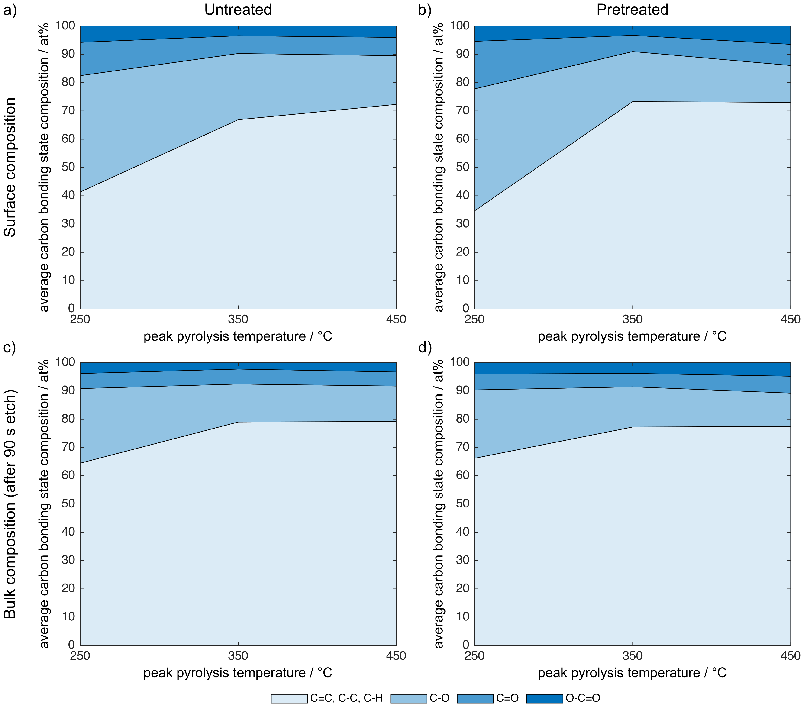
Figure 5. Carbon bonding state composition in untreated (a and c) and alkali-pretreated (b and d) walnut shell biochars at the particle surface (a and b) and in the particle bulk (c and d). Measurements refer to three discrete peak temperature conditions (250 °C, 350 °C, and 450 °C). Carbon bonding state was quantified by fitting four peaks to the C1s region of X-ray photoelectron spectra. Bulk composition was determined after 90 s etching with a 2 keV monatomic Ar ion beam. Values are average compositions of two to three particles of biochar from the same production batch.

Nuclear magnetic resonance spectroscopy
Low-field NMR spectroscopy has been used previously to elucidate mass transport phenomena occurring within porous materials^{[22,23]} and to determine the impact of surface interactions between guest molecules and the porous material surface upon processes occurring in the porous matrix.^{[18,24,25]} To investigate the internal surface chemistry of walnut shells and their biochars, NMR relaxation measurements were performed to assess the relative adsorption strengths of solvents to the internal surfaces of these materials.
In brief, for a fluid confined in a porous medium, the measured spin-lattice (T₁) and spin-spin (T₂) relaxation times at low field are given by Equations 1 and 2.^{[26,27]}
$$\begin{aligned}\frac{1}{T_{1,pore}}=\frac{1}{T_{1,bulk}}+ρ_{1}\frac{S}{V} \#\left(1\right)\end{aligned}$$
$$\begin{aligned}\frac{1}{T_{2,pore}}=\frac{1}{T_{2,bulk}}+ρ_{2}\frac{S}{V}\#\left(2\right)\end{aligned}$$
In the first term on the right-hand side of Equations 1 and 2, the bulk liquid term, T_{x} is the relaxation time of the bulk solvent. In the final term of Equations 1 and 2, which is attributed to solvent close to or in contact with the surface, ρ_{x} is the surface relaxivity, which depends on the intrinsic surface chemistry of the material and is effectively a measure of how strongly the guest molecule interacts with the surface.
For materials with a high surface area to volume ratio (S/V) the bulk liquid term is generally negligible as the T_{x} of a bulk liquid is usually much greater than that of the same liquid confined within a porous matrix. Hence, in this case, Equations 1 and 2 may be expressed as in Equation 3.^{[28]}
$$\begin{aligned}\frac{1}{T_{x,pore}}≈ρ_{x}\frac{S}{V} \#\left(3\right)\end{aligned}$$
A change in T_{x} of a solvent imbibed in a porous medium can therefore be due either to a change in adsorbate/adsorbent interactions, reflected in ρ_{x}, or to a change in internal surface area and/or pore dimension, reflected in S/V. It follows that when T₁ and T₂ are determined for the same guest molecule within the same porous medium, S/V is constant, and thus the ratio T₁/T₂ is independent of the internal morphology of the porous medium. Under these assumptions, this ratio is a measurement only of the surface interactions occurring between the guest molecule and internal surfaces of the porous medium, as defined by Equation 4.
$$\begin{aligned}\frac{T_{1}}{T{}_{2}}≈\frac{ρ_{2}}{ρ_{1}} \#\left(4\right)\end{aligned}$$
Indeed, it has been shown that this ratio is related to the molecular mobility (tumbling) of molecules. Previous work has shown that the T₁/T₂ ratio is related to surface adsorption and can be directly correlated to adsorption energies determined using temperature programmed desorption.^{[29]} As such, the T₁/T₂ ratio is of much use in the fields of catalysis and surface science to quantify the strength of surface interactions and to explain phenomena such as solvent effects.^{[16,30,31]}
NMR relaxation measurements revealed similar trends with respect to peak pyrolysis temperature in the degree to which water interacts with surfaces of untreated and alkali-pretreated walnut shell biochars as the percentage of surface carbon atoms bonded to oxygen discussed above (cf. Figure 6a and Figure 6b). This similarity is logical given the hydrophilicity of oxygen-rich functionalities like those present in holocellulose and, to a lesser extent, lignin (see Figure 1).
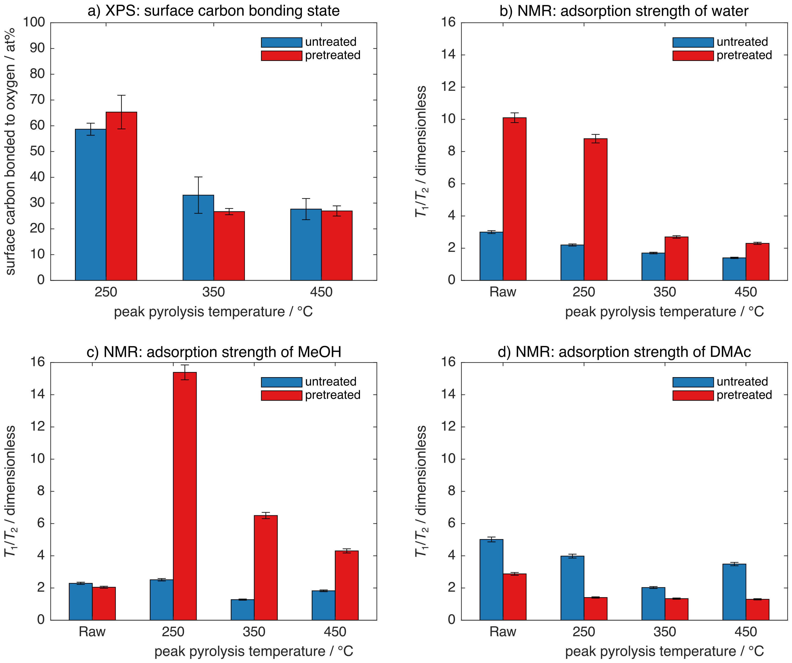
Figure 6. Surface chemistry of walnut shell biochars by X-ray photoelectron spectroscopy (XPS) and nuclear magnetic resonance (NMR) spectroscopy. (a) Percentage of surface carbon atoms bonded to oxygen in untreated and alkali-pretreated walnut shell biochars by peak pyrolysis temperature. Carbon bonding state was quantified by fitting four peaks (C=C, C-C, & C-H; C-O; C=O; and O-C=O) to the C1s region of X-ray photoelectron spectra. Atomic percentage of the latter three peaks was taken as the percentage of carbon atoms bonded to oxygen. Error bars represent standard error of this value among two to three particles of biochar from the same production batch. (b-d) Ratios of NMR spin-lattice (T₁) and spin-spin (T₂) relaxation times (T₁/T₂) of (b) water, (c) methanol (MeOH), and (d) N,N-dimethylacetamide (DMAc) in the pore space of untreated and alkali-pretreated walnut shells and their biochars by peak pyrolysis temperature. Error bars represent a standard error of approximately 3% for all T₁/T₂ values.
Measured T₁/T₂ ratios of water imbibed in the pores of walnut shell biochars were much higher in alkali-pretreated than untreated biochars, suggesting stronger interactions between water and internal surfaces of pretreated than untreated biochars (see Figure 6b). This supports reduction of relatively hydrophobic lignin-derived surface structures (see Figure 1) by alkaline pretreatment.
Unlike pretreatment-specific trends with temperature, the substantial difference in magnitude of T₁/T₂ values between pretreated and untreated biochars was not seen in XPS results (see Figure 6a). This implies the effect of pretreatment on hydrophilicity is related to carbon-carbon bond order, which would not be captured by the peak fitting protocol used for XPS analysis (see ‘X-ray photoelectron spectroscopy’ methods section). A substantial proportion of carbon atoms in lignin are double bonded to one another, whereas none are so bonded in holocellulose (see Table 1), thus an effect of pretreatment on carbon-carbon bond order further substantiates the effect of alkaline pretreatment on lignin.
Adsorption strengths of two additional solvents were also tested: methanol (MeOH – CH₃OH) and N,N-dimethylacetamide (DMAc – C₄H₉NO). All the solvents tested, including water, are polar, but vary in numbers of methyl and hydroxyl groups (see Figure 7). Water and MeOH are both protic solvents, the only difference being the single methyl group in MeOH, whereas aprotic DMAc contains 3 methyl groups and a dipole driven by a carbon-oxygen double bond, rather than the hydroxyl groups that drive the polarity of water and MeOH. As such, water and MeOH may participate in hydrogen bonding, MeOH and DMAc may participate in hydrophobic interactions, and all three solvents may participate in dipole-dipole interactions.
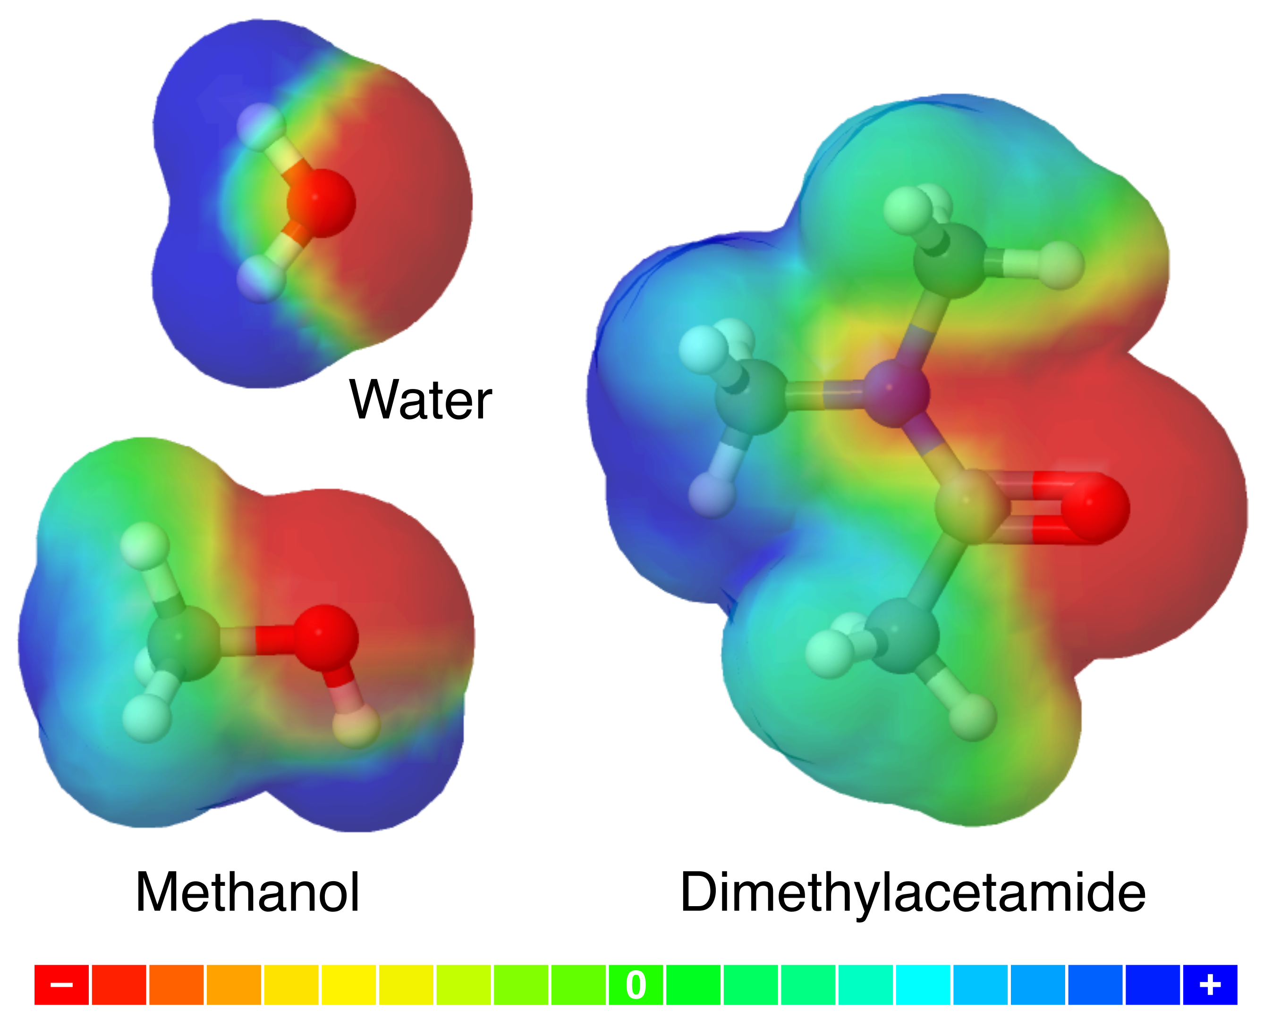
Figure 7. Electrostatic potential maps (MEPs) of the solvents used in NMR experiments. Colour scale indicates electrostatic potential in arbitrary units (with red being the most negative and blue the most positive) a fixed arbitrary distance from the molecule. Ball colour indicates element: grey is carbon, red is oxygen, white is hydrogen, and blue is nitrogen. MEPs were created using CheMagic Virtual Molecular Model Kit (Vmols).
Undeniably, protic solvents interacted more with surfaces of pretreated biochars, and aprotic solvents with surfaces of untreated biochars (see Figure 6b-d). Surfaces of pretreated biochars interacted more with hydroxyl groups and less with methyl groups than did those of untreated biochars. This is once again consistent with alkaline pretreatment reducing lignin content given the relative electrostatic neutrality of lignin compared to holocellulose (see Figure 1).
Solvent-specific trends in T₁/T₂ values with temperature are far more complex than those with pretreatment. In untreated samples, surface interactions with polar groups (including hydroxyl groups) purely decreased with peak pyrolysis temperature. A similar effect has been explained previously using low-field NMR relaxation for the case of alumina carbon molecular sieve membranes.^{[25]} Increasing interactions with methyl groups began to outweigh this between 350 and 450 °C. This resulted in minimum T₁/T₂ values at 350 °C in solvents containing methyl groups (see Figure 6c-d). Interactions of untreated sample surfaces with DMAc were greater than those with MeOH or water at all temperatures (see Figure 6c-d), implying untreated surfaces are more liable to interact with methyl groups than hydroxyl groups.
In alkali-pretreated biochars, like untreated biochars, interactions with hydroxyl groups purely decreased with peak pyrolysis temperature (see Figure 6b-c). However, interactions with MeOH in particular were much less strong in raw pretreated walnut shells than in pretreated biochars (see Figure 6c). Given this was not the case in water (see Figure 6b) nor DMAc (see Figure 6d), it must be related to the presence of both methyl and hydroxyl groups in MeOH. This implies the surface of raw pretreated walnut shells are far more resistant to interactions with methyl groups than are their biochars.
One explanation for this phenomenon is that the alkaline pretreatment removed lignin only from the surfaces of walnut shells, leaving lignin, shielded by cellulose relatively unaffected by the alkali (see ‘Raw’ micrographs in Figure 3), to be revealed upon low-temperature degradation of cellulose (see ‘Thermogravimetric analysis’ section). The more heterogeneous surface is then free to interact with both methyl and hydroxyl groups.
T₁/T₂ values of DMAc in pretreated biochars were uniformly low and did not perceptibly change with peak temperature (see Figure 6d). This implies that in DMAc, unlike in protic solvents, decreasing dipole-dipole interactions with peak pyrolysis temperature did not outweigh increasing interactions of methyl groups with biochar surfaces within the range of temperatures tested. This is logical given the greater strength of hydrogen bonding relative to other dipole-dipole interactions, as well as the greater number of methyl groups in DMAc relative to MeOH.

Conclusion
Alkaline pretreatment increased the hydrophilicity of both walnut shells and their biochars. It was found to increase surface interactions with hydroxyl groups, and to decrease those with methyl groups. Results are consistent with removal of lignin from surfaces of walnut shells by alkaline pretreatment.
As one of the main applications of biochars is adsorption of contaminants in aqueous systems (e.g. wastewater filtration, soil remediation), hydrophilicity is often an advantage. Assuming as much, the advantage of pretreatment is far greater at very low peak pyrolysis temperatures (<250 °C – see Figure 8). Two major regimes exist with respect to trends in this advantage with peak temperature. Below a certain temperature threshold (between 350 and 450 °C), the hydrophilicity advantage of pretreatment decreases with peak pyrolysis temperature, while above this threshold, it likely increases (assuming observed trends continue at higher temperatures), albeit a smaller advantage (see Figure 8).
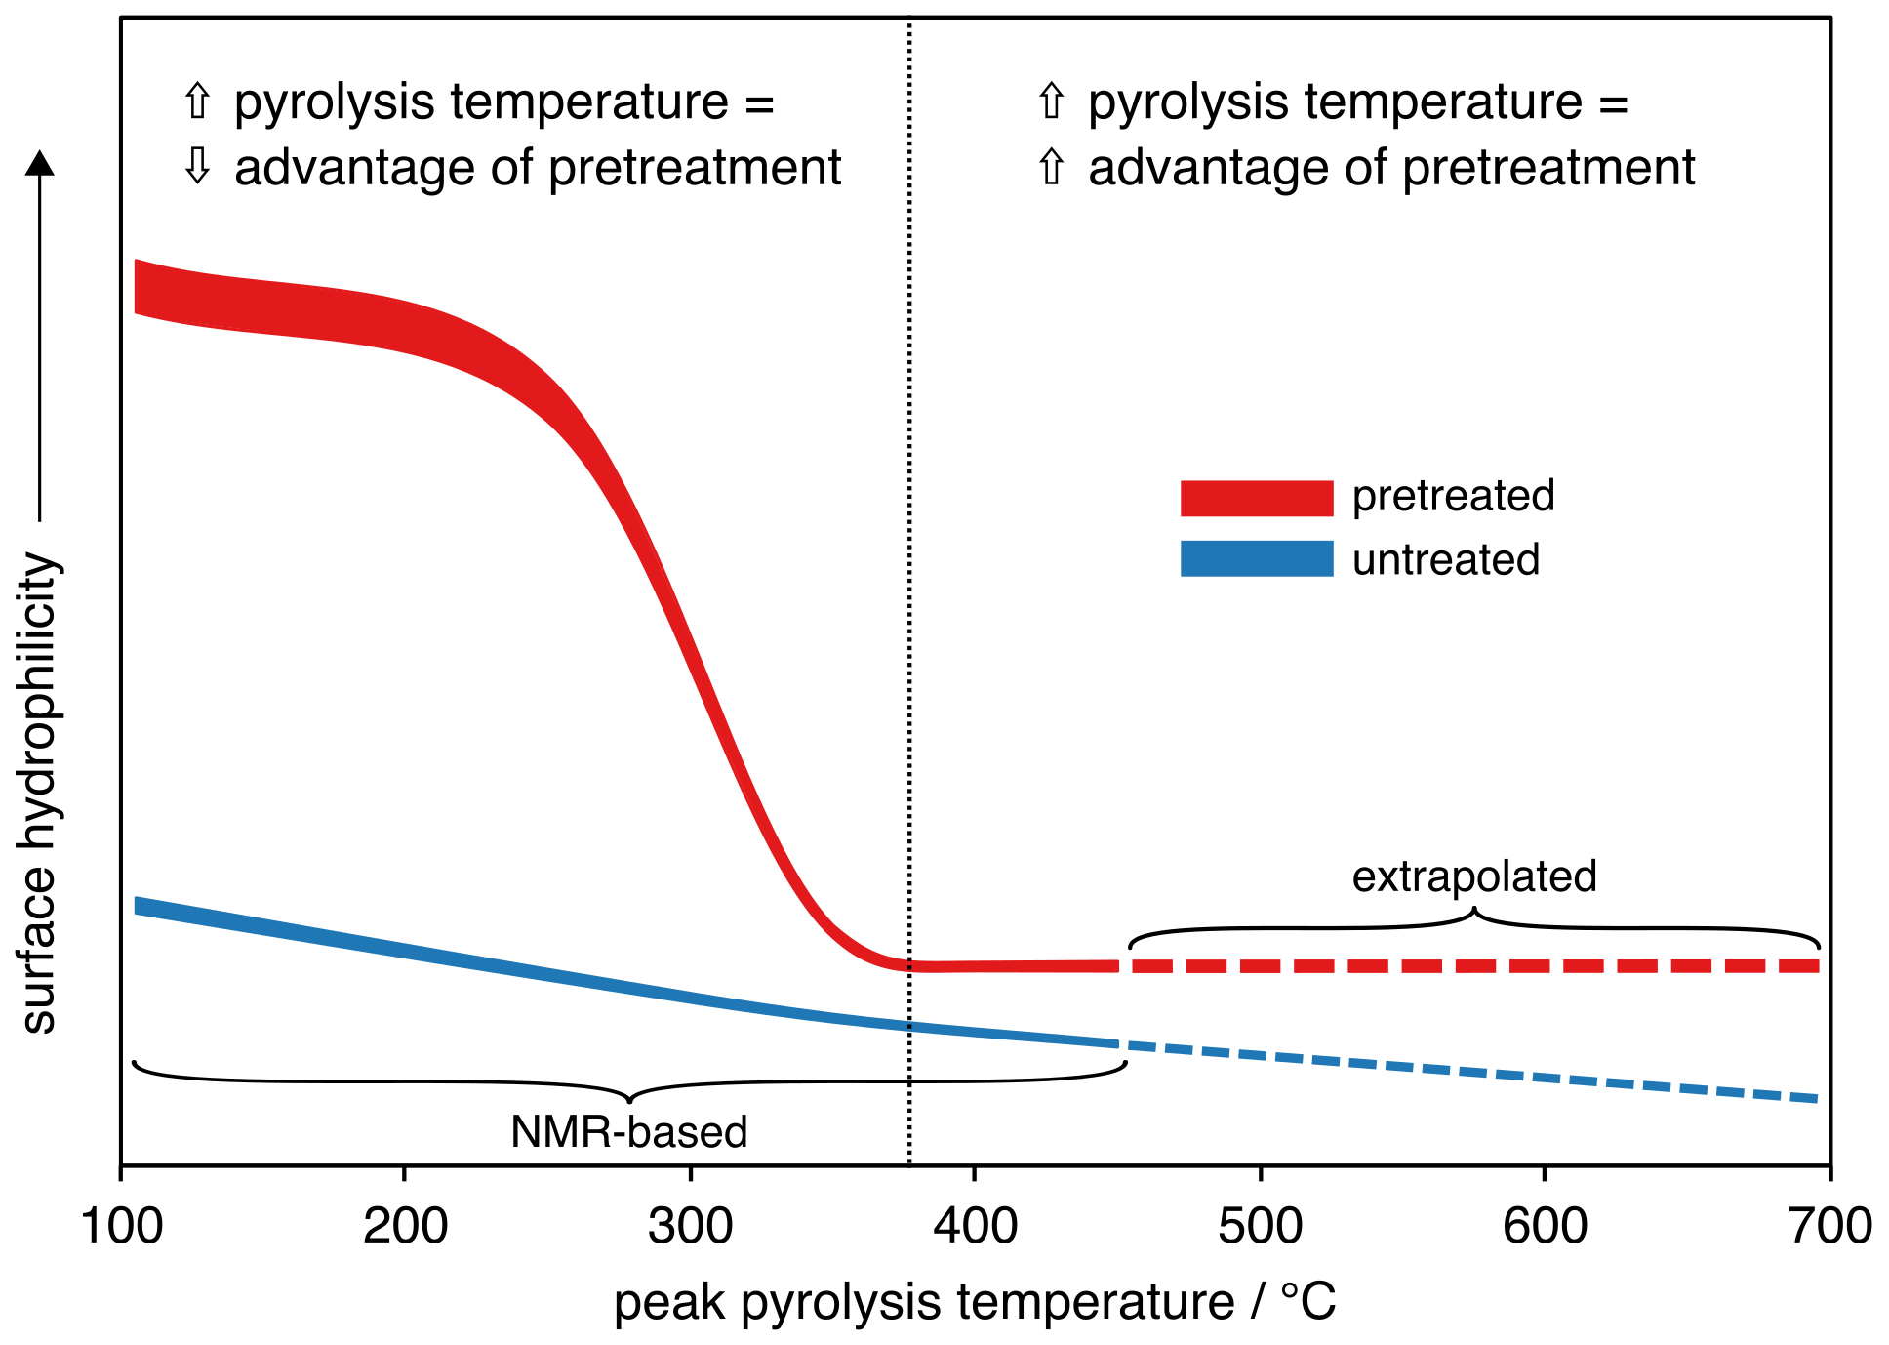
Figure 8. Broad surface hydrophilicity trends of untreated and alkali-pretreated walnut shell biochars with peak pyrolysis temperature. Values are based on nuclear magnetic resonance (NMR) spectroscopy data for water imbibed in the pores of walnut shells and their biochars up to 450 °C (see Figure 6b) and extrapolated linear trends thereafter. Labels indicating trends with respect to ‘pyrolysis temperature’ in ‘advantage of pretreatment’ assume hydrophilicity is desirable.
Though there are many reasons to use low pyrolysis temperatures (also called torrefaction), such as maximising energy density and preserving oxygen-rich surface functionalities, biochars are typically produced at temperatures greater than this threshold. Beyond the increasing hydrophilicity advantage of pretreatment in this temperature regime, pretreated biochars may offer relative stability in hydrophilicity at higher temperatures due to their presumed reduced total aromatic content.
Alkaline pretreatment offers several further benefits. Previous work revealed that alkaline pretreatment of walnut shells sped up bulk shrinkage and reduced relative porosity gain during pyrolysis (see reference ^{[12]}, Figure 3). As porosity was found to concentrate towards the centre of particles during pyrolysis, this concentration may also be reduced by pretreatment. Therefore, internal surface area of pretreated walnut shell biochars may be more accessible than that of untreated biochars.
Furthermore, the far rougher surface texture of pretreated biochars at higher temperatures (see ‘Pyrolysed’ micrographs in Figure 3) means they increase in surface area on pyrolysis independent of changes in porosity. This is ideal given pretreatment also reduces relative porosity gain.
Overall, alkaline pretreatment may be used to modulate responses to pyrolysis temperature of several factors with respect to walnut shell biochar surface chemistry and morphology: (1) surface hydrophilicity, as well as interactions with specific moieties; (2) particle size; (3) porosity and pore accessibility; and (4) surface texture. Controlling these parameters by choice of production conditions is key to engineering biochars for specific applications.

Experimental Section

Materials
Walnut shells sourced from Italy were of the same batch used in previous work.^{[12]} Similar walnut shells characterised by Queirós et al. (2020)^{[4]} contained approximately 38% w/w lignin and 62% w/w holocellulose on a dry ash-free basis.
Samples were prepared as described by Barr et al. (2021):^{[12]} walnut shells were milled using a 2 mm grate in a Retsch ZM 200 Ultra Centrifugal Mill. A particle size of 1-2 mm was then obtained using a 1 mm sieve at an amplitude of 1.7 mm for 6 min in a Retsch AS 200 Vibratory Sieve Shaker. Shells were then dried for 48 h at 105 °C. Some shells then underwent further pre-pyrolysis treatment; pretreated shells were soaked at a concentration of 50 g L⁻¹ in a 200 mM solution of NaOH in deionised (DI) water for 68 h at room temperature, then washed with DI water via vacuum filtration until neutral filtrate pH was achieved. Pretreated shells were then dried for an additional 48 h at 105 °C.

Methods

Biochar production
Beds of untreated and alkali-pretreated walnut shell particles (6 mm tall) were fixed between two stainless steel meshes in 3 mm inner diameter, 1.5 mm thick quartz tubes. Using a custom pyrolysis reactor built for in-situ X-ray imaging (see reference ^{[12]}, Figure 8), beds were convectively heated by a 3 L min⁻¹ stream of resistively preheated argon at a rate of 6 °C min⁻¹ to peak temperatures of 250, 350, and 450 °C. Beds were held at peak temperature for 30 min before cooling to 70 °C under the same gas flowrate. Biochars used for SEM were produced in the reactor during X-ray imaging, while those used for XPS and NMR were produced in the same reactor with no simultaneous imaging (see Figure 9).
Figure 9. Schematic of the pyrolysis reactor used to produce biochars. Modified from Barr et al. (2021).^{[12]}

Thermogravimetric analysis
Using a TA Instruments Q500 TG balance with a nitrogen flowrate of 240 mL min⁻¹, single untreated and alkali-pretreated walnut shell particles (1.5-4 mg) in 100 µL platinum sample pans were first equilibrated at ambient temperature for 15 min, then heated at a rate of 6 °C min⁻¹ to peak temperatures of 250, 350, and 450 °C. Particles were then held at peak temperature for 30 m.
While feedstocks and temperature programs were conserved between TG-balance experiments and ‘Biochar production’, reactor configuration, atmosphere, and flowrate were not. While nitrogen should not be more reactive than argon at the low temperatures used, the maximum possible flowrate in the TG balance was much lower than that used for ‘Biochar production’. Along with the configuration of the TG balance (gas flowing over, rather than through the sample), this difference may alter pathways of pyrolysis by promoting condensation of volatiles back onto biochar surfaces.^{[14,15]} Thus, while TGA results may be compared internally, they may not be directly comparable to results relating to biochars produced in the reactor diagrammed in Figure 9. Even within TG-balance experiments, it must be considered that some variation in results may be a function of variation in sample mass between particles.^{[13–15]}

Scanning electron microscopy
Samples were mounted on aluminium stubs using EM-Tec CT6 high purity conductive double sided adhesive carbon tabs and gold coated at a current of 20 mA under a 0.08 mbar vacuum for a minimum of 3 min using an Agar Scientific Automatic Sputter Coater in manual mode. Samples were then imaged in an FEI Inspect F SEM using a field emission source with an accelerating voltage of 5 kV and an objective lens aperture of 30 µm. Images were taken at working distances between 9 and 11 mm. Images were acquired with a dwell time of 3 µs per pixel using four image integrations and the in-built ‘Drift Correction’ function.

X-ray photoelectron spectroscopy
For each sample, two to three particles of biochar from the same production batch were mounted in a Thermo Fisher Scientific Nexsa XPS using EM-Tec CT6 high purity conductive double sided adhesive carbon tabs. Spectra were acquired as averages of 10 scans using an Al Kα X-ray source in constant analyser energy mode with a spot size of 100 µm, a pass energy of 50 eV, and a step size of 0.1 eV. An electron flood gun was used to reduce charging of samples in the beam. Between each of 10 sets of scans, the 100 µm analysis region was etched for 10 s with a 2 keV monatomic Ar ion beam. It must be noted that damage from this ion beam etching may have affected the results of subsequent measurements. In fact, it has been shown that cluster ion sources are more suitable than are monatomic ion sources for depth profiling of organic polymers. ^{[32]}
The carbon core-electron binding region (~281-293 eV, C1s) was then background-adjusted, charge-shifted, and fit with four peaks to quantify the bonding state of carbon atoms using ‘Thermo Avantage’ software (v5.9921) from Thermo Fisher as follows.
First, 4 peaks were added with an ‘Enhanced’ Shirley background using the ‘Peak Add’ function. From least to greatest peak binding energy (BE), these peaks were defined as C=C, C-C, & C-H; C-O; C=O; and O-C=O. Peaks in each spectrum were then constrained to have the same Gaussian-Lorentzian products and full widths at half maximum, and fit was optimised using Powell’s method with ‘Convergence’ set to 0.0001 and a maximum of 100 iterations. All spectra for a given sample (10 etch levels) were then uniformly charge shifted such that the maximum peak BE of the first peak (C=C, C-C, C-H) was 285 eV. In some cases, where variation between etch levels was particularly great, it was necessary to instead use the adaptive charge fitting function of the software, shifting each level’s first peak to 285 eV. Next, the latter three peaks (carbon bonded to oxygen) were constrained to ranges taken from literature (see Table 2),^{[33]} and fit optimisation was repeated. Then, if needed, charge shifting of all spectra in a given sample was repeated to bring the first peak within the range specified by Table 2, and fit optimisation was repeated once again. Finally, if needed, either the first peak was constrained to the range specified in Table 2, or individual levels were manually charge shifted, and fit optimisation was repeated once more.
Table 2. Peak binding energy range constraints for the four peaks fit to C1s X-ray photoelectron spectra. Based on ranges from Singh et al. (2014).^{[33]}
Carbon bonding state | Peak binding energy range [eV]
C=C, C-C, C-H | 284.81-285.03
C-O | 286.42-286.73
C=O | 287.81-288.03
O-C=O | 288.60-289.55

Carbon bonding state composition was then quantified by integrating the fitted peaks. Example fits showing the characteristic difference in shape of XPS spectra, and thus relative magnitudes of fitted peaks, between the particle surface and its bulk are provided in Supplementary Figure 1.

Nuclear magnetic resonance spectroscopy

Sample preparation
Samples were prepared for NMR measurements by soaking in solvent (DI water, >99% MeOH, or >99% DMAc) for at least 48 hours. Samples were then dried on solvent-soaked filter paper to remove excess liquid on the external surface and transferred to 5 mm NMR tubes. To ensure a saturated atmosphere in the NMR tube, hence minimizing errors due to evaporation of volatile liquids, filter paper soaked in solvent was placed under the cap of the NMR tube. The tube was then left in the magnet for approximately 15 minutes to achieve thermal equilibrium before beginning measurements. NMR experiments were performed in a Magritek SpinSolve benchtop NMR spectrometer operating at a ¹H frequency of 43 MHz.

Spin-lattice relaxation time (T₁) measurements
T₁ was measured using the inversion recovery technique^{[34]} (Figure 10). 16 different inversion delay times (τ) were used for each sample and 16 scans were performed for each value of τ.
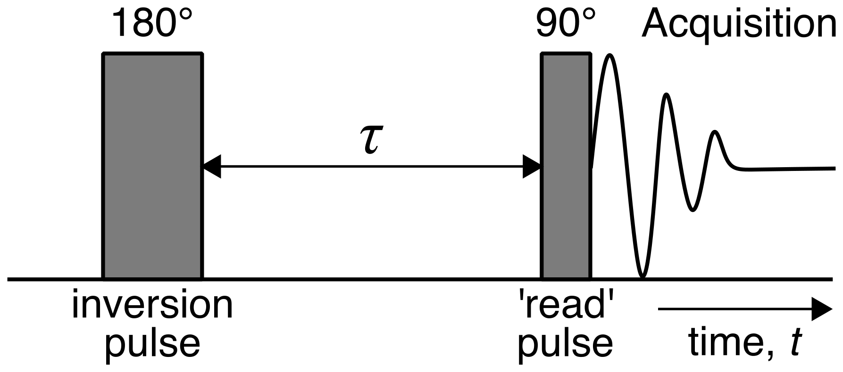
Figure 10. Inversion recovery pulse sequence used to measure spin-lattice relaxation time (T₁) showing a 180° inversion pulse followed by a 90° ‘read’ pulse. Pulses are followed by signal acquisition and separated by a variable inversion delay time, τ. The pulse sequence was repeated for 16 values of τ. All measurements were performed at 20 °C under atmospheric pressure.
T₁ was determined by plotting the acquired signal intensities as a function of t=τ in accordance with Equation 5, where M_{z}(t) is the signal intensity as a function of the time delay, and M₀ is the signal intensity at equilibrium. The typical error of all T₁ measurements was approximately 3%.
$\begin{aligned}\frac{M_{z}\left(t\right)}{M_{0}}=1-2 e^{-\frac{t}{T_{1}}} \#\left(5\right)\end{aligned}$

Spin-spin relaxation time (T₂) measurements
T₂ was measured using the Carr-Purcell-Meiboom-Gill pulse sequence^{[35]} (Figure 11). For a single data point, between 75 and 200 echoes, each echo with a duration t_{e} = 1 ms, were acquired. Sixteen experimental data points were acquired with 16-32 scans for each data point.
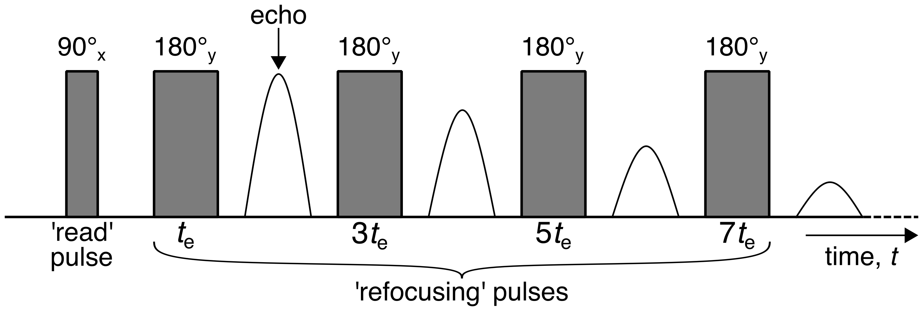
Figure 11. Carr-Purcell-Meiboom-Gill pulse sequence used to measure spin-spin relaxation time (T₂) showing a 90° ‘read’ pulse followed, after a time delay t_{e} = 1 ms, by a series of 180° ‘refocusing’ pulses (not all shown) at intervals of 2t_{e}. All measurements were performed at 20 °C under atmospheric pressure.
T₂ was determined by plotting the acquired signal intensities as a function of the number of echoes, and therefore the total time delay t, in accordance with Equation 6, where M_{x,y}(t) is the signal intensity as a function of the total time delay, and M_{x,y}(0) is the signal intensity at equilibrium. The typical error of all T₂ measurements was approximately 3%.
$$\begin{aligned}M_{x, y}\left(t\right)=M_{x,y}\left(0\right)e^{-\frac{t}{T_{2}}}\#\left(6\right)\end{aligned}$$
Raw T₁ and T₂ values are provided in Supplementary Table 1.

Acknowledgements
This research was supported by Queen Mary University of London. C. D. would like to acknowledge the EPSRC (grant number EP/S019138/1) for supporting his research activities.

Keywords: biomass • electron microscopy • NMR spectroscopy • photoelectron spectroscopy • surface chemistry
[1] S. J. Antreich, N. Xiao, J. C. Huss, N. Horbelt, M. Eder, R. Weinkamer, N. Gierlinger, Adv. Sci. 2019, 6, 1900644.
[2] D. Reis, B. Vian, C. R. Biol. 2004, 327, 785–790.
[3] A. M. C. Emons, B. M. Mulder, Trends Plant Sci. 2000, 5, 35–40.
[4] C. S. G. P. Queirós, S. Cardoso, A. Lourenço, J. Ferreira, I. Miranda, M. J. V. Lourenço, H. Pereira, Biomass Convers. Biorefinery 2020, 10, 175–188.
[5] E. W. Putman, C. F. Litt, W. Z. Hassid, J. Am. Chem. Soc. 1955, 77, 4351–4353.
[6] G. Brodeur, E. Yau, K. Badal, J. Collier, K. B. Ramachandran, S. Ramakrishnan, Enzyme Res. 2011, 2011, 1–17.
[7] M. Misson, R. Haron, M. F. A. Kamaroddin, N. A. S. Amin, Bioresour. Technol. 2009, 100, 2867–2873.
[8] N. Mosier, C. Wyman, B. Dale, R. Elander, Y. Y. Lee, M. Holtzapple, M. Ladisch, Bioresour. Technol. 2005, 96, 673–86.
[9] S. K. Sharma, K. L. Kalra, H. S. Grewal, Biomass and Bioenergy 2002, 23, 237–243.
[10] N. Takahashi, T. Koshijima, Wood Sci. Technol. 1988, 22, 231–241.
[11] J. W. Choi, D. H. Choi, O. Faix, J. Wood Sci. 2007, 53, 309–313.
[12] M. R. Barr, R. Jervis, Y. Zhang, A. J. Bodey, C. Rau, P. R. Shearing, D. J. L. Brett, M.-M. Titirici, R. Volpe, Sci. Rep. 2021, 11, 2656.
[13] M. R. Barr, R. Volpe, R. Kandiyoti, ACS Sustain. Chem. Eng. 2021, 9, 5603–5612.
[14] M. R. Barr, M. Volpe, A. Messineo, R. Volpe, Fuel 2020, 276, 118069.
[15] M. R. Barr, R. Volpe, R. Kandiyoti, ACS Sustain. Chem. Eng. 2019, 7, 13734–13745.
[16] C. D’Agostino, M. R. Feaviour, G. L. Brett, J. Mitchell, A. P. E. York, G. J. Hutchings, M. D. Mantle, L. F. Gladden, Catal. Sci. Technol. 2016, 6, 7896–7901.
[17] G. Di Carmine, D. Ragno, A. Massi, C. D’agostino, Org. Lett. 2020, 22, 4927–4931.
[18] G. Filippini, F. Longobardo, L. Forster, A. Criado, G. Di Carmine, L. Nasi, C. D’Agostino, M. Melchionna, P. Fornasiero, M. Prato, Sci. Adv. 2020, 6, 9923–9934.
[19] J.-P. Korb, Curr. Opin. Colloid Interface Sci. 2009, 14, 192–202.
[20] K. M. Song, J. Mitchell, H. Jaffel, L. F. Gladden, J. Phys. D. Appl. Phys. 2012, 45, 105302.
[21] V. Bortolotti, P. Fantazzini, R. Mongiorgi, S. Sauro, S. Zanna, Cem. Concr. Res. 2012, 42, 577–582.
[22] L. Forster, M. Lutecki, H. Fordsmand, L. Yu, C. D’Agostino, Mol. Syst. Des. Eng. 2020, 5, 1193–1204.
[23] Y. Jiao, L. Forster, S. Xu, H. Chen, J. Han, X. Liu, Y. Zhou, J. Liu, J. Zhang, J. Yu, C. D’Agostino, X. Fan, Angew. Chemie Int. Ed. 2020, 59, 19478–19486.
[24] G. Campos-Villalobos, F. R. Siperstein, C. D’Agostino, L. Forster, A. Patti, Appl. Surf. Sci. 2020, 516, 146089.
[25] L. Forster, C. D’Agostino, M. Anabell Llosa-Tanco, V. Spallina, C. Brencio, F. Gallucci, M. Lindley, S. J. Haigh, D. Alfredo Pacheco-Tanaka, Chem. Eng. J. 2021, 129313.
[26] K. . Brownstein, C. . Tarr, J. Magn. Reson. 1977, 26, 17–24.
[27] J. H. Strange, J. Mitchell, J. B. W. Webber, Magn. Reson. Imaging 2003, 21, 221–226.
[28] N. Robinson, L. F. Gladden, C. D’Agostino, Faraday Discuss. 2017, 204, 439–452.
[29] C. D’Agostino, J. Mitchell, M. D. Mantle, L. F. Gladden, Chem. - A Eur. J. 2014, 20, 13009–13015.
[30] C. D’Agostino, G. L. Brett, P. J. Miedziak, D. W. Knight, G. J. Hutchings, L. F. Gladden, M. D. Mantle, Chem. - A Eur. J. 2012, 18, 14426–14433.
[31] C. D’Agostino, T. Kotionova, J. Mitchell, P. J. Miedziak, D. W. Knight, S. H. Taylor, G. J. Hutchings, L. F. Gladden, M. D. Mantle, Chem. - A Eur. J. 2013, 19, 11725–11732.
[32] Y. J. Hofstetter, Y. Vaynzof, arXiv 2019.
[33] B. Singh, Y. Fang, B. C. C. Cowie, L. Thomsen, Org. Geochem. 2014, 77, 1–10.
[34] E. Fukushima, S. B. W. Roeder, Experimental Pulse NMR: A Nuts and Bolts Approach, CRC Press, 1981.
[35] H. Y. Carr, E. M. Purcell, Phys. Rev. 1954, 94, 630–638.

Entry for the Table of Contents

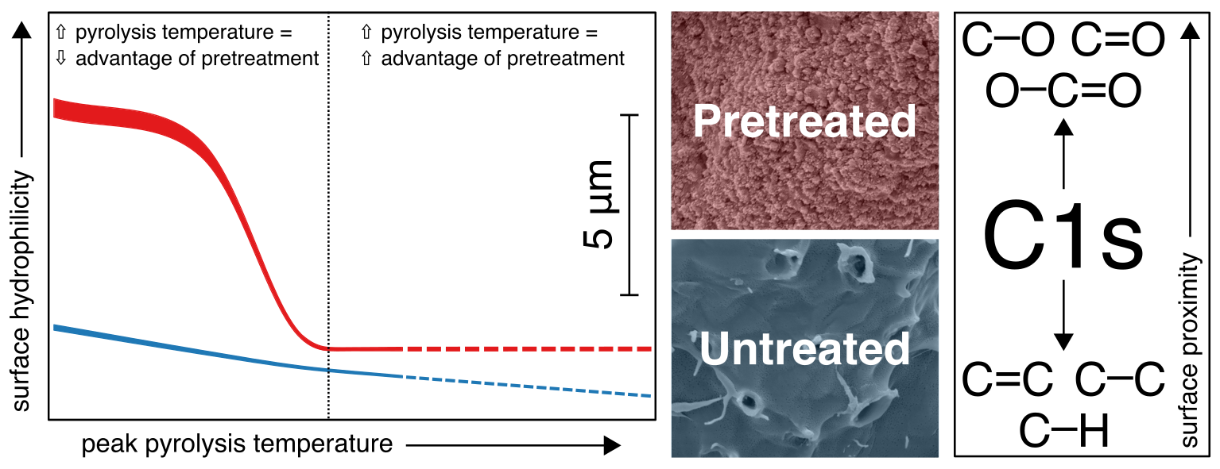

Tuning biochar surface properties: Biochars have a high surface area to volume ratio, making them ideal for adsorption-dependant environmental applications like wastewater treatment. Controlling both the chemistry and morphology of this surface area is key to optimising biochars for specific applications. Mild alkaline pretreatment of walnut shells is shown to modulate responses of these properties in derived biochars to production temperature.

Institute and/or researcher Twitter usernames:
@Mez_theEngineer (M.R.B.)
@TCRxLab (R.V.)
@QMULSEMS (R.V., M.R.B.)
@CarmineDAgosti6 (C.D.)
@ChemEngManUni (L.F., C.D.)

