An Eye on the Future of Heating & Cooling Technologies- Electrocaloric Refrigeration
By Dr Metkel Yebiyo and Professor Andy Ford

This article will review innovative upcoming heating and cooling technology and describe how it works. The article will also cover the potential benefits, applications and challenges in bringing this niche technology to market.

Refrigeration, air conditioning and heat pumps (RACHP) account for 19% of UK electricity demand or around 10% of total greenhouse gas (GHG) emissions. At the 2015 EU meeting in Paris, the EU agreed to intensify reductions in carbon emission further from 2020 to 2030. This will include a further 40% GHG reduction, through much greater use of renewable technologies and a massive increase in energy efficiency.

Several promising alternative innovative heating and cooling technologies are under development such as elastocaloric, magnetocaloric, thermoelectric, barocaloric and electrocaloric. While the magnetocaloric effect has been extensively studied since the discovery by Emil Warburg in 1881. Electrocaloric cooling (EC) has had much less interest since it was first observed in 1887 ⁴ but is an emerging, innovative and potential low carbon technology. Although the first experimental measurement of the EC effect was reported in the early 1930s, the scale was very small. This changed with the recent discovery of ‘giant EC effect’ since then the practical application of EC heating and cooling has been subject to much research, and commercial applications are now on the radar.

Basic working principles
The principle of EC cooling is based on a phenomenon known as the EC effect, the ability of a material to change temperature when an electric field is applied. An EC device has two thin materials separated by a vacuum layer. The application of the electric field causes the most energetic electrons on the negative side to jump across to the positive side. As the electrons leave the negative side it gets colder. The figure below helps to demonstrate how to use this effect.
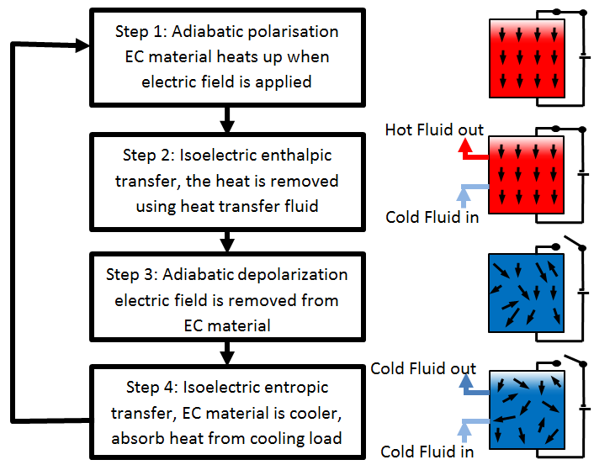
Schematics showing basic working principle of Electrocaloric Refrigeration
To date, related studies have been conducted on numerous thin films, thick films, ceramics, single crystals and polymers for larger electrocaloric temperature. Among all, ceramics have more advantages due to its high breakdown field, higher electrocaloric efficiency, and larger cooling capacity³. The main limitation of the EC system shown in the figure is the relatively small temperature difference that can be achieved between the cold and hot source. A number of techniques have been used to increase this exchange such as active caloric regenerative process. The principle of this cycle uses a heat transfer fluid in contact with the EC materials flowing from the cold side to the hot side when the material is heated and from the hot side to the cold side when the material is cooled down. This progressively increases the temperature difference between the cold and hot source to about 40K ¹ making the system potentially suitable for a range of commercial applications. In addition one of the obstacles to achieving a sufficient EC effect is related to the exposure of the material to very high electric fields.

Potential Applications
There are various potential applications for this technology ¹. The most intuitive application would be:
- Replacement of vapour compression in small refrigerators
- Small heat pumps
- Thermal management of power electronics in integrated circuits and
- Air conditioning of Hybrid and electric vehicles.
Benefits
Similar to magnetocaloric, the demand is likely to be driven by environmental regulations since EC cooling does not use any refrigerant gas but instead a cooling fluid which could be water based. As such, there are no direct CO₂ emissions, and EC heat pumps fully comply with all regulations such as F-gas in Europe or environmental protection EPA regulations in the US. Its major advantage over the magnetocaloric cooling is in the fact that the high electric fields required for the refrigeration cycle are much easier and less expensive to generate than the high magnetic fields required for the magnetocaloric refrigeration. No dependence on rare-earth materials and no moving parts except the pumps. Compared to existing refrigeration and heat pump technologies, EC refrigerators or heat pumps are predicted to have efficiencies of 60-70% ².

Challenges
EC refrigeration still requires major research efforts to reach the development stage; there still remain some challenges:
- To improve and implement new manufacturing and processing methods for materials and regenerators
- Lead-containing ferroelectric ceramics show great potential for EC refrigeration technologies, but they are environmentally not acceptable. With this in mind, more research on lead-free materials is required.
- Advances in materials, which support the absorption of large amounts of heat from a cold reservoir, have been established as a priority. As such, good progress has been noted over the last 5 to 10 years, with the improvement of EC temperature change from 2.5 K (in ceramics) to 40 K (in thin films) ¹.
- Use the EC principles to generate electric energy

Current market development
Although there is a lot of academic work by scientists & engineers from worldwide universities and research institutions, the exploitation of EC effect in refrigeration applications is still in its early stages, and several fundamental and technical features have yet to be resolved.

- Kitanovski, A., Plaznik, U., Tomc, U., Poredoš, A. (2015). Present and future caloric refrigeration and heat-pump technologies, International Journal of Refrigeration.
- O_zbolt, M., Kitanovski, A., Tu_sek, J., Poredo_s, A., 2014. Electrocaloric vs. magnetocaloric energy conversion. Int. J. Refrigeration 37, 16e27. ttp://dx.doi.org/10.1016/j.ijrefrig. 2013.07.001.
- E. Defay, R. Faye, G. Despesse, H. Strozyk, D. Sette, S. Crossley, X. Moya & N. D. Mathur (2018). Enhanced electrocaloric efficiency via energy recovery. Nature Communications 9, Article number: 1827 (2018)
- Tanya Jamwal1, Raju Kumar1, Satyendra Singh (2019). Giant electrocaloric effect in 0.75PbZrO3 - 0.25Bi(Mg1/2Ti1/2)O3 ceramics. Ceramics International, Volume 45, Issue 11, 1 August 2019, Pages 14411-14414

