NUMERICAL STUDY OF AIRFLOW AND TEMPERATURE DISTRIBUTION IN A LOADED COLD STORE
Pierre Coldreyª, Jean Mourehª, Graciela Alvarezª, Denis Leducqª, Alain Foster^{b}, Mohammed Youbi-Idrissi^{c}, Alain Damas^{c}, Judith Evans^{b}

ª IRSTEA, 1 rue Pierre-Gilles de Gennes, CS 10030; 92761 Antony Cedex,
^{b} London South Bank University; 103, Borough Road; SE10AA London
^{c} Chemin de la porte des Loges, 78354 Les Loges en Josas

KEYWORDS
Airflow, Cold store, Cold distribution, Ventilation, Numerical modelling, Computational fluid dynamics
ABSTRACT
The aim of this study is to analyze the effects of ventilation and cooling power distribution on air temperature and products temperature levels in a cold store by means of computational fluid dynamics. The refrigerated space under study has a set of six fans and six heat exchangers (HEs) with different mass flow rates and blowing velocities arranged back to back at the middle of the domain. For this purpose, three cases have been simulated with different operating conditions involving various combinations between HEs and fans, while maintaining the same cooling power in the warehouse. In the author’s knowledge, very few articles have been written on airflow in loaded enclosures ventilated by several heat exchangers.

NOMENCLATURE
P……...........................Power kW
T……...........................Temperature °C
$y^{+}=y\sqrt{υ{\left(\frac{∂u}{∂y}\right)}_{y=0}}$…..Dimensionless wall unit
SUBSCRIPTS
max Maximum
min Minimum
in Inlet of the HE
out Outlet of the HE
ave Average

INTRODUCTION
In refrigerated enclosures, the conservation of the organoleptic and sanitary quality of foodstuffs is directly governed by the temperature field which depends of the airflow patterns inside the cool store. Hence, the analysis of the airflow is very meaningful from the point of view of the sanitary quality. The main industrial issue is to increase the temperature homogeneity of products at appropriate levels inside the refrigerated warehouse. With the increasing availability and power of computers, Computational Fluid Dynamics (CFD) became a very convenient tool to investigate the air and thermal distribution in a cold store.
Many studies have been performed to characterize numerically and/or experimentally the influence of enclosure’s geometry and stacking arrangement of HEs inlet temperature and of HEs location on airflow and temperature distribution in rather small cold stores (< 100 $m^{3}$) (M.T. Karimipana, 1999; Jing Xie and al., 2006; Mitoubkieta Tapsoba and al. 2007; M.K. Chourasia T.K. Goswami, 2007; Hsin Yu, 2006; Brajesh Tripathi S.G. Moulic, 2007; Hsin Yu and al., 2007; B. Bjerg and al., 2002; Son H. Ho and al., 2010). However, this paper focuses the particular case of a large cold store (57 344 $m^{3}$) refrigerated by different types of HEs and ventilated by several fans. To the author’s knowledge, very few articles concerning 3D CFD simulations on a large warehouse refrigerated by several heat exchangers with different mass flow rates and inlet temperatures have been performed.
Many article deal with the influence of enclosure geometry on air flow patterns. M. Tapsoba and al. (2007) show that the presence of product in a typical refrigerated truck configuration modifies strongly the flow patterns even if the velocity levels are similar with the empty enclosure. It leads to a reduction of the jet penetration and a diminution of recirculation especially at the rear part of the enclosure. Jing Xie and al., (2006) demonstrate that design parameters as corner’s smoothness or presence of stacked foodstuff strongly affect the flow field and temperature field. Smoothness of the corners affect adverse pressure gradient favorable to the reverse flow in the enclosure. The more round these corners are the less adverse pressure gradient there is and the more homogeneous the temperature is distributed. Eventually, presence of a loading in the middle of the room increases greatly the number of eddy and breaks the flow field homogeneity. This will be the case in this paper because we have only modelled a large loaded warehouse filled with 25 pallets rows.
Another parameter affecting the air-jet trajectory is the inlet temperature of the HEs. In most CFD modelling, HEs are considered as non-isothermal jets. The influence of inlet temperature on the airflow can be characterized by the dimensionless Archimed number (Ar) comparing buoyancy forces with inertial forces. (Hsin Yu, 2006; Brajesh Tripathi S.G. Moulic, 2007; Hsin Yu and al., 2007) have numerically and experimentally determined several critical values of Ar corresponding to different forms of airflow patterns for a jet in an enclosure. Typically, if Ar<0.005 the air flow pattern is fully rotary and if Ar>0.018 the jet falls immediately at the entry (Brajesh Tripathi S.G. Moulic, 2007; Hsin Yu, 2006). Hsin Yu managed to predict analytically the trajectory of a horizontally diffused wall jet, in the primary flow region, depending of the Archimed number. Yu emphasizes that at high Ar, air-jet trajectory becomes analytically unpredictable because of the predominance of buoyancy forces over inertial forces and because of the apparition of a secondary recirculation making the trajectory simulation more complex. In this paper it is difficult to calculate an overall Archimed number because of the different blowing temperature of the HEs. Moreover, the interactions between the fans and the HEs help the cold jets not to fall directly at the entry even if the local Archimed number is above 0.018.
Unsteady simulations were performed in loaded small enclosures where stacked products are modelled as porous medium (M.K. Chourasia T.K. Goswami, 2006; M.K. Chourasia T.K. Goswami, 2007). These calculation allow the investigation of the rate of metabolic heat generation, porosity of the bulk medium, resistance of the product skin preventing moisture loss and cool down time. It has been demonstrated that the higher the porosity of the medium, the lower the cool down time is. But even for a porosity of 0.5, cool down time is about 50h (M.K. Chourasia T.K. Goswami, 2006). Such calculation can be performed in a small 2D enclosure (grid size < 500 000 cells) but not in a large 3D refrigerated warehouse (grid size > 10 000 000 cells) due to too important computational time and computational resources it would take. Thus, this CFD study will be made in stationary regime.
In order to take into account turbulence effects impacting the airflow, one must properly choose the turbulence model. Many authors find very different results when comparing turbulence models on the non-isothermal jets in confined enclosure (E. Pula H.A. Ersan, 2015; F. Kuznik and al., 2007). H.A. Ersan compares three two-equations turbulence models on a 2D non-isothermal jet confined in an enclosure with inlet and outlet located face to face. If RNG k-ԑ model fits well with the experimental data, predicting a clockwise recirculation, std k-ω and SST k-ω fail to predict the correct behavior. Instead, they predict the fall of the jet at directly at the entry and the formation of a counter clockwise recirculation in the enclosure. More discrepancy is found on the velocity profiles for the cold confined wall jet modelled with k-ԑ model (F. Kuznik and al., 2007). Near the inlet the velocity and temperature profiles are in good agreement but the numerical model is less reliable as the profile is far from the air inlet overestimating the maximal velocity and miss-predicting the location of this maximum. The author note that these discrepancies only occur for the cold wall jet, otherwise the turbulence model correctly predicts velocity and temperature profiles for the hot and the isothermal jet. This last remark echo Hsin Yu (2006) on the difficulty to predict the air-jet trajectory for cold wall jets in confined enclosure far from the inlet region.
Many studies use the first order closure standard k-ԑ model described by Launder and Spalding (1974), since it is easy to program and has a large field of application. However, particular effects appear in confined enclosure as high streamlines curvature effects and secondary recirculation. For these complex flows, different authors (M.L. Hoang and al., 2000; J. Moureh, D. Flick, 2003; M. Tapsoba and al., 2007) agree on the superiority of second order closure models as RSM to predict airflow patterns.
In 2000, M.L. Hoang and al. used computational fluid dynamics (CFD) to investigate the airflow pattern in an operational cold store for the long-term storage of fruits and vegetables. The cold store is rather small (2.5m x 2.7m x 4.5m) and ventilated by only one heat exchanger. 3D numerical simulations were performed for the empty cold store and the loaded cold store filled with 4 wooden pallet boxes. Validation was made by a comparison of the calculated time-averaged velocity magnitudes with the measured mean velocities. An important averaged difference of 40% between calculations and measured velocities has been found for k-ԑ model in the empty cold store. Model predictions for the loaded cold store were better with an absolute difference between measurement and numerical results of 26% for k-ԑ model. RNG model gave less precise prediction with an absolute difference of 28.5%. The authors hope that enhanced turbulence models such as Reynold Stress models (RSM) could contribute to improve the numerical predictions.
J.Moureh and D.Flick study the wall air-jet characteristics and the airflow patterns within a slot ventilated enclosure in 2003. Three turbulence models were compared: SKE, RNG and the second order closing model RSM. The latest is a second order closure model is generally more precise on the modelling of flows with strong anisotropic behavior, high streamline curvature and flow separation. Only the RSM allows predicting the complexity of airflow leading to the jet separation from the ceiling and the creating of two contra-rotative recirculations in accordance to experimental data obtained on a scale model. On the contrary, the other models fail to predict the jet separation which, in turn, leads to one recirculation within the whole enclosure. This clearly underlines the superiority of RSM for internal flows including adverse pressure gradient, turbulence anisotropy and streamline curvature.
In 2007, M. Tapsoba and al. performed experiment on a reduced scale model and CFD simulations to study an enclosure loaded with slotted box supplied by a ceiling-jet. They compared experimental measurements on velocities with predictions given by two turbulence models: RSM and k-ԑ. The results on velocity field were very similar in high velocity zones. However, RSM gave better predictions on the adherence point of Couanda effect as well as on the penetration distance and the deflection of the jet. The authors think that this clearly indicates that k-ԑ model lacks sensitivity with respect to the adverse pressure gradient located at the rear part of the enclosure.
According to the previous articles, RSM seems to be the best model for the prediction of turbulent flow patterns inside enclosures. Thus, we choose RSM for the turbulence modelling in all our computations.

WAREHOUSE GEOMETRY
Warehouse’s geometry involves 6 heat exchangers, 6 fans, 50 rows of stacked products and one door for a total volume of ${57,165 m}^{3}$ (64m x 56m x 16m) and a maximal capacity of 3 900 pallets. Due to the presence of a symmetry plane in the warehouse, we only model half the cold store to save computational time. Thus, the new geometry is twice as small: ${28, 582 m}^{3}$ (32m x 56m x 16m), involves 3 heat exchangers, 3 fans, 25 rows of stacked products and half a door. Fig.1 shows a top view sketch of the warehouse and a 3D modelling of the half the geometry that is used as computational domain. Moreover, two sectional views are presented Fig.2 to indicate the main geometrical characteristic of the cold store. Note that heat is extracted from the warehouse by two types of heat exchangers (type 1 and 2), their different characteristics are listed in the boundary condition part.

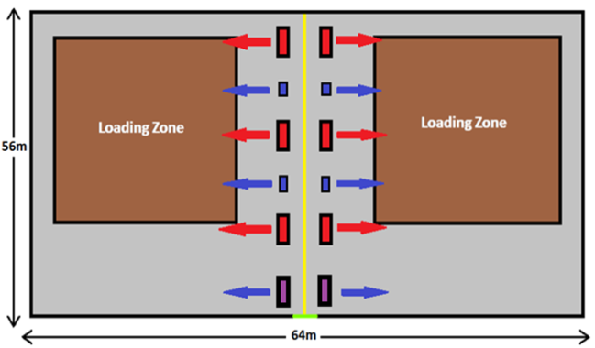
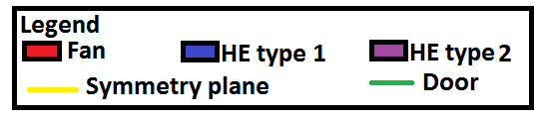
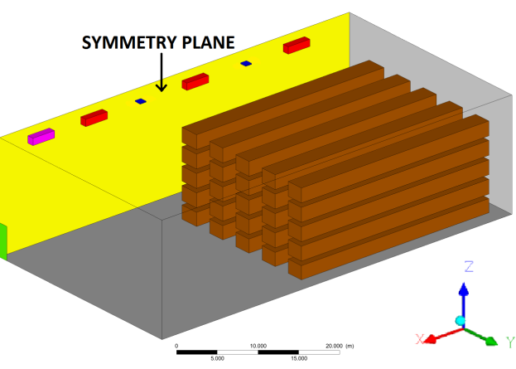
Fig.1. Geometry modelling of the cold store. Sketch of the whole geometry, top view (top). 3D modelling of half geometry, isometric view (bottom).

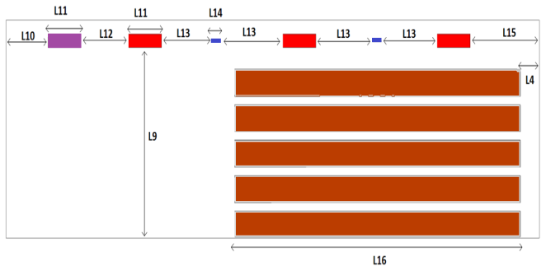
Fig.2. Cross sections showing the main dimensions of the warehouse. ZY plane (top); XZ plane (bottom).

The relevant lengths L1 through L16 are given in the following values: L1=0.98m, L2=12.5m, L3=2.5m, L4=L4’=2.0m, L5=0.6m, L6=0.1m, L7=1.4m, L8=4.6m, L9=14.0m, L10=4.0m, L11=3.5m, L12=5.0m, L13=6.0m, L14=1.0m, L15=7.0m, L16=30.0m. Eventually, velocity field will be displayed on the blowing plane of the jets presented Fig.3.

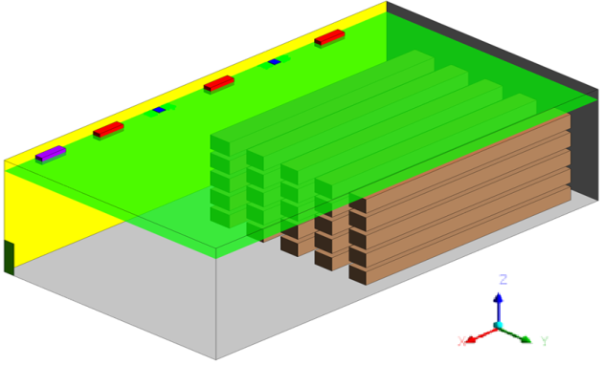
Fig.3. Location of the blowing plane of the loaded cold store ($z=14.5m$)
MESHING, NUMERICAL SIMULATIONS AND BOUNDARY CONDITIONS
Meshing
Meshing was realized on ICEM, a mesh generator specialized in hexahedral meshes. The same mesh, composed of 13 806 606 cells, has been used for every simulations. Wall’s refinement is used for the good implementation of wall functions in the flow computation. These wall functions generally model flow behavior at near wall region by use of a logarithmic law between the mean velocity and the dimensionless wall distance. That is the case of FLUENT Standard Wall Function which is the most widely used wall function for industrial flows. In this study, Standard Wall Function will be used in every simulation. For RSM, the log-law between the mean velocity and the dimensionless wall distance is valid in regions where 30< $y^{+}$ <300, with $y^{+}$ the dimensionless wall distance. For all configurations, $y^{+}$<300 on the ceiling, except for some cells in the rear part of the ceiling where $y^{+}$<30 due to small wall shear stress. In this case, FLUENT applies the laminar stress-strain relationship which is a proportionality equation between the wall distance and the mean velocity of the fluid.
Refined zones correspond to first layer size of 1 cm. Non-refined zones have a first cell size of 13 cm which is the maximum length cell of all the configurations performed. Due to the small space between the bottom of the pallets and the floor (10 cm), we slightly refined the mesh near the floor in order to have at least 3 layers between the floor and the pallet. We refined the ceiling, the top of the highest pallets and the vertical walls of the pallets close to the air inlets. Fig.4 shows a transversal section of the mesh and the mesh refinement at the top of the pallets.

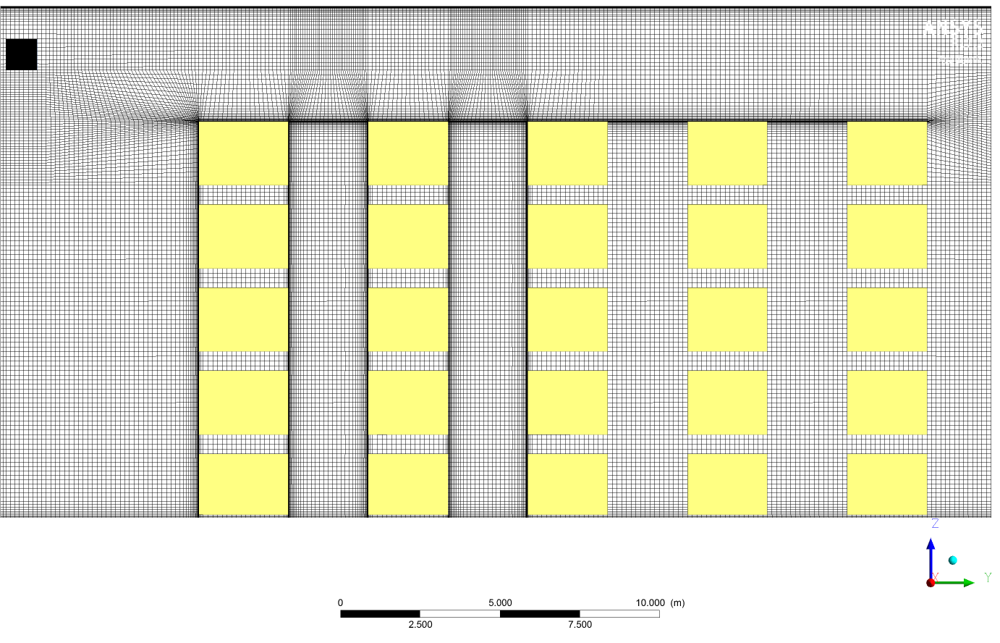
Fig.4. Transversal section of the mesh. Overall lateral view (top), pallets close up (bottom). Pallets colored in yellow.

Numerical simulation
Simulations were performed with the finite volume method CFD code ANSYS Fluent 17.2 on a 64 bits Windows7 computer with a 3.70 GHz Intel® Xeon® CPU E5-1630 v4 and 192 Go (RAM). Calculations were first launched in stationary mode with pressure-velocity coupling scheme “COUPLED”. First, we decreased the under-relaxation factors for few hundred iterations. Then, default under-relaxation factors were applied for few hundred iterations more. Eventually, pseudo transient mode is activated for few hundred iterations to improve heat balance. A total of one thousand iterations is needed to satisfy convergence criteria.
In order to analyze the effects of cold distribution and ventilation on air temperature and product temperature levels in a cold store, three cases have been simulated:
- The first one (reference case) one with six HEs and six fans working,
- The second one with only four HEs and six fans working and
- The last one with six HEs and no fans working.
It is important to note that, in every case, the overall cooling power distributed in the warehouse is the same: P = 68 kW. In order to check the numerical solution, global energy balance was performed by applying the first law of thermodynamics. For the steady state problems under study, the rate of heat gained from the walls, the ceiling, the floor and the door should equal the rate of equivalent heat extracted from the HEs. This relationship can be expressed as:
$$P_{floor}+P_{walls}+P_{ceiling}+P_{door}= P_{HE}$$
Global energy balance was satisfied with a reasonably low error: maximal error of 1.5% for case1.
Boundary Conditions

At the inlets of fans and heat exchangers, uniform distribution is assumed for velocity components. All HEs and fans are blowing in the positive y direction. Fans have the same properties than type 2 HEs except they blow at warehouse’s ambient temperature (they generate no cold). HEs characteristics are listed tab.1 for all cases. External temperature is set to 25°C and heat transfer coefficient on the walls and the ceiling is 0.1 $W.m^{-2}.K^{-1}$. The floor is at constant temperature of -17°C. No slip condition is applied on every wall and on the surface of the pallets. A symmetry condition is put on the symmetry plane. Heat load of the products was ignored but heat coming from door opening has been taken into account: P = 9,7 kW (according to A.M. Foster, 2003, [4]). The number of door openings was estimated at one opening every two minutes. Eventually, natural convection is taken into account (ideal gas law).

 | HE Type 1 | HE Type 2
Blowing Section ($m^{2}$) | 0.13 | 3.38
Air flow rate ($m^{3}.h^{-1}$) | 2 500 | 23 000
Inlet Velocity ($m.s^{-1}$) | 5.2 | 1.9
Blowing Temperature case 1 (°C) | -23.2 | -21.4
Blowing Temperature case 2 (°C) | -27.7 | -21.4
Blowing Temperature case 3 (°C) | -22.7 | -21.4
Tab.1 Physical characteristics of the different types of HEs for all configurations
RESULTS AND DISCUSSION
Fig.5 presents the streamlines generated by HEs for the three cases. Comparing cases 1 and 2, we notice a strong reduction of the penetration distance for jet flowing from type 1 HEs (blue streamlines) in case 2. This could be explained by the greater temperature differences between the ambient air ($T_{ave}\sim -18.3 °C$) and the air coming from the HEs (case 1: $T_{in}=-23.2°C$; case 2: $T_{in}=-27.7°C$) causing an increase of jet’s deflection by buoyancy effect.
Comparing cases 1 and 3, we also see a lateral deviation of the jets towards the positive x direction in case 3. This deviation is due to dynamic interaction between the primary jet flow and a free thermal air convection generated upwards along the rear and lateral walls generating a deviation of the jets in the lateral direction.
To better illustrate dynamic interactions between jets, Fig.6 presents the top view of velocity contours over the blowing plane for all cases. We see that the jets close to the lateral walls tends to be deviated towards the center of the enclosure. Moreover, we notice an increase of jets lateral deviation coming from type 1 HEs in case 3 compared to case 1. This clearly indicates that ventilation generated by the additional fans tends to stabilize the longitudinal jet development and acts like a dynamic air barrier preventing lateral interactions with crossflow coming from lateral walls. As a consequence, the use of additional fans increases the stability and the penetration distance of primary jets while limiting their lateral interactions.

Fig.7 presents temperature contours over the pallets in isometric view and product’s extremal temperatures. Even if the overall cooling power is the same in every simulation (P=68 kW), we observe an increase of vertical thermal stratification and temperature heterogeneity from case 1 to case 2 as cold is distributed to fewer HEs: $∆T=1.57 °C$ for case 1, $∆T=2.60 °C$ for case 2. Thus, cold distribution has a notable impact on products temperature homogeneity. On the other hand, there is no significant difference on products temperature between case 1 and 3 indicating that fan’s ventilation has no meaningful incidence on pallets temperature levels. For all cases, maximal temperature zone is located at the bottom of the pallets. Indeed, in the thin zone between the floor and pallet’s bottom (10 cm), velocities are very low and air is rapidly warmed up by the floor ($T_{floor}=-17°C$), creating hot spots. Eventually, the average temperature on the pallets is the same for every case and is really close to the ambient temperature of the warehouse ($T_{ave}\sim -18.3 °C$).
To better illustrate local effects generated by the additional fans, Fig. 8 (a) compares air temperature contours over the blowing plane of the middle fan (x= -3m) for cases 1 and 3. We clearly see an increase of thermal heterogeneity and vertical thermal stratification near the ceiling in case 3. Obviously, the lack of ventilation gives rise to stagnant air zones in the upper parts of the warehouse and enhances the thermal stratification by buoyancy effect. Fig.8 (b) compares velocity vector field colored by temperature for cases 1 and 3. A zoom has been made near the front wall to better visualize air currents. In case 3, we see upwards currents rising all along the front wall due to free thermal air convection along the wall.
In case 1, , whereas primary jet flow mainly governs the airflow in the upper regions inducing downward currents near the front wall and upwards currents only appear near the floor. Thus, ventilation reduces the impact of natural convection on airflow in the rear part of the cold store and extends the primary jet flow region.

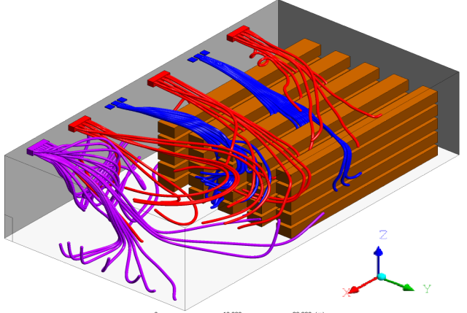
Case 1
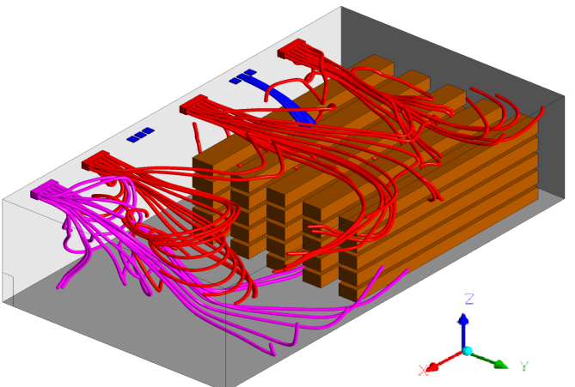
Case 2
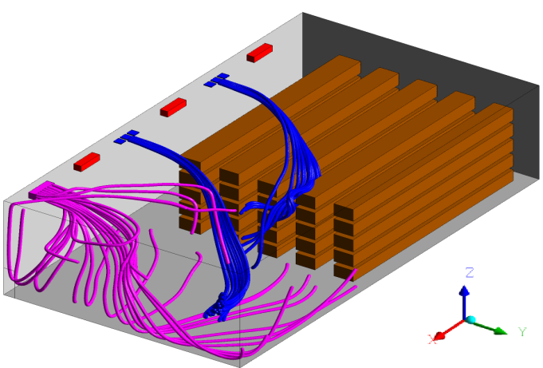
Case 3
Fig.5 Streamlines coming from the HE. Mechanical HE (red), Blueeze (blue), secondary refrigerant HE (green). Isometric view

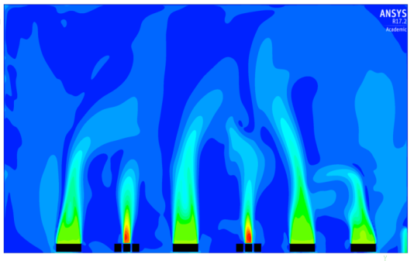
Case 1
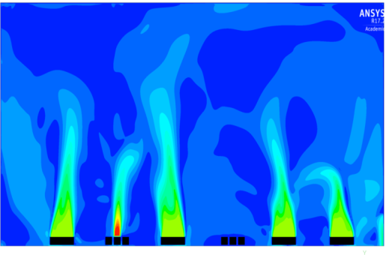
Case 2
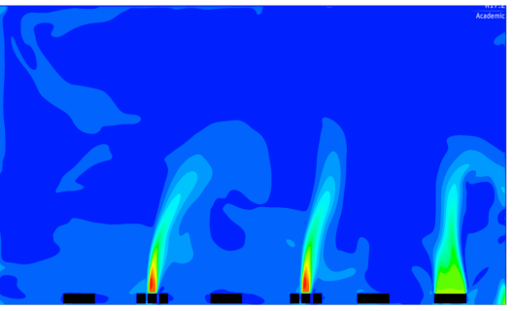
Case 3
Fig.6 Velocity contours in blowing plane. Half warehouse, top view.

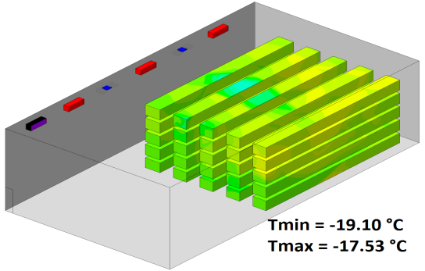
Case 1
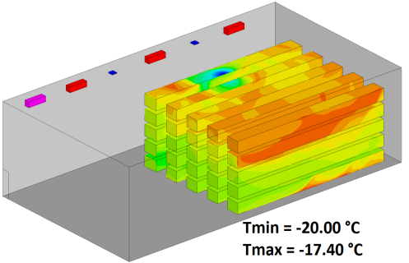
Case 2
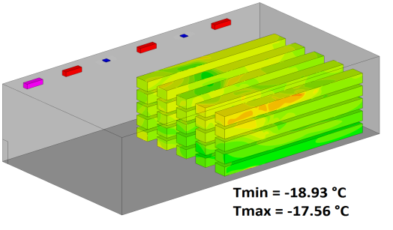
Case 3
Fig.7 Temperature contours on the pallets. Isometric views

Case 1 |  | Case 3
(a)
 |  | 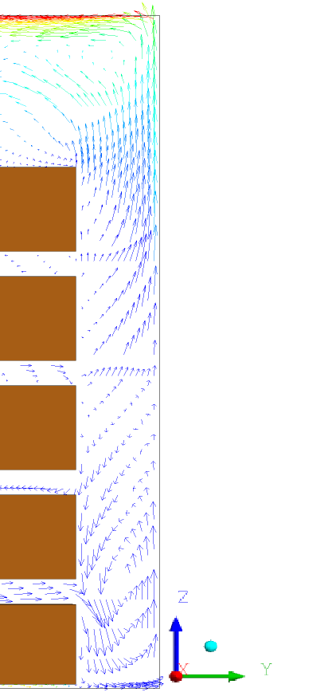
Case 1 |  | Case 3
 | (b)
Fig.8 (a) Temperature contours in the blowing plane of the middle fan for cases 1 and 3, zoom near the ceiling. (b) Velocity vector field colored by temperature in the blowing plane of the middle fan for cases 1 and 3, zoom near the front wall. Pallets colored in brown.

CONCLUSION
In this study, numerical simulations performed using the CFD code Fluent were carried out in order to analyze the effect of cold distribution and fans ventilation on temperature and flow patterns in a large cold store loaded with pallets.
Results show that, for a fixed cooling power P= 68kW, reducing the number of HEs (case 2) requires to decrease jet’s blowing temperature causing the jets to deflect by buoyancy effect, reducing their penetration distance in the warehouse. Moreover, in case 2, temperature heterogeneity and thermal stratification on the pallets increases compared to case 1, even if the global temperature levels are similar in all cases. Thus, cooling power need to be more homogenously distributed in the warehouse in order to lower temperature differences and natural convection effects such as jet’s deflection and thermal stratification. In case 3, the lack of ventilation generated by the fans increase lateral deviation, decrease the jet penetration and enhances thermal stratification in the upper part and natural convection in the rear part of the warehouse.

CALCULATION NOTE
We find in the literature (A.M Foster, M.J Swain, R. Barrett and S.J. James; (2003) [18]) an analytical expression of the outgoing debit I during the opening of the doors:
$$I=0.333K_{fL}A{\left(gH\right)}^{0.5}{\left(\frac{ρ_{i}-ρ_{0}}{ρ_{i}}\right)}^{0.5}{\left(\frac{2}{1+{\left({ρ_{0}}/{ρ_{i}}\right)}^{0.333}}\right)}^{1.5}$$
with $K_{fL}=0.48+0.004(T_{0}-T_{i})$, the indications i and o meaning respectively inside and outside. A indicates the surface of the door, H its height and g the acceleration of gravity. We took $ρ_{i}=1.4 kg.m^{3}$, $T_{i}=-18.5 °C$, $ρ_{o}=1.2 kg.m^{3}$and $T_{o}=25.0 °C$ . We find $I=11.36 m^{3}.s^{-1}$.
The number of door openings was estimated, using a previous study, at one opening every two minutes. The door puts 5 seconds to open, remains open during 10 seconds and closes in 5 seconds and there is 1 opening every 2 minutes. We counted 12 hours of activity in a day. Moreover, according to Foster, during opening and closing time we have to reduce by a half the incoming debit. Eventually, we find that 61 344 $m^{3}$of air is exchanged through the door every day.
Multiplying this volume by the heat capacity of air, the air density and temperature difference between the inside and the outside of the warehouse, we find that $4.3 {10}^{9}J$ of heat is delivered by the door in the warehouse every day. Dividing this quantity by the number of seconds in a day and by the surface of the door we finally find the average heat power density on the door: $P_{s}=1486 W.m^{-2}$.

REFERENCES
Bjerg, B., Svidt, K., Zhang, G., Morsing, S., Johnsen, J.O., 2002. Modeling of air inlets in CFD prediction of airflow in ventilated animal houses. Computers and Electronics in Agriculture 34 223 – 235
Chourasia, M.K., Goswami, T.K., 2006. Simulation of Transport Phenomena during Natural Convection Cooling of Bagged Potatoes in Cold Storage, Part II: Mass Transfer. Biosystems Engineering 94 (2), 207–219
Chourasia, M.K., Goswami, T.K., 2007. Simulation of Effect of Stack Dimensions and Stacking Arrangement on Cool-down Characteristics of Potato in a Cold Store by Computational Fluid Dynamics. Biosystems Engineering 96 (4), 503–515
Chourasia, M.K., Goswami, T.K., 2007. Three dimensional modeling on airflow, heat and mass transfer in partially impermeable enclosure containing agricultural produce during natural convective cooling. Energy Conversion and Management 48 2136–2149
Chourasia, M.K., Goswami, T.K., 2007. CFD simulation of effects of operating parameters and product on heat transfer and moisture loss in the stack of bagged potatoes. Journal of Food Engineering 80 947–960
Foster, A.M., Swain, M.J., Barrett, R., James, S.J., 2003. Experimental verification of analytical and CFD prediction of infiltration through cold store entrances. International Journal of Refrigeration 26 918-925

Ho, S. H., Rosario, L., Rahman, M.M., 2010. Numerical simulation of temperature and velocity in a refrigerated warehouse. International Journal of Refrigeration 33 1015 – 1025
Hoang, M.L., Verboven, P., De Baerdemaeker, J., Nicolaï, B.M., 2000. Analysis of the air flow in a cold store by means of computational fluid dynamics. International Journal of Refrigeration 23 127-140

Karimipana, M.T., 1999. Deflection of wall-jets in ventilated enclosures described by pressure distribution. Building and Environment 34 329-333
Kuznik, F., Rusaouen, G., Brau, J., 2007. Experimental and numerical study of a full scale ventilated enclosure: Comparison of four two equations closure turbulence models. Building and Environment 42 1043–1053

Launder, B.E., Spalding, D.B., 1974. The numerical computation of turbulent flows. Computer Method in Applied Mechanics and Energy 3, 269-289.

Moureh, J., Flick, D., 2003. Wall air–jet characteristics and airflow patterns within a slot ventilated enclosure. International Journal of Thermal Sciences 42 703–71

Pula, E., Ersan, H.A., 2015. Numerical simulation of turbulent airflow in a ventilated room: Inlet turbulence parameters and solution multiplicity. Energy And Buildings 93 227–235
Tapsoba, M., Moureh, J., Flick, D., 2007. Airflow patterns in a slot-ventilated enclosure partially loaded with empty slotted boxes. International Journal of Heat and Fluid Flow 28 963-977

Tripathi, B., Moulic, S.G., 2007. Investigation of the buoyancy affected airflow patterns in the enclosure subjected at the different wall temperatures. Energy and Buildings 39 906–912
Yu, H., 2006. A Modified Estimation of a Plane Wall Jet Trajectory Horizontally diffused from a Ceiling Slot in Non-isothermal Ventilated Enclosures. Biosystems Engineering 95 (2), 255–269
Yu, H., Liao, C.M., Liang, H.M., Chiang, K.C., 2007. Scale model study of airflow performance in a ceiling slot-ventilated enclosure: Non-isothermal condition. Building and Environment 42 1142–1150
Xie, J., Qu, X.H., Shi, J.Y., Sun, D.W., 2006. Effects of design parameters on flow and temperature fields of a cold store by CFD simulation. Journal of Food Engineering 77 355–363

