37th Cement and Concrete Science Conference Paper Number 66
11-12 September 2017
University College London

Investigation of Distribution and Orientation of Fibres in Steel Fibre Reinforced Concrete using X-Ray Computed Tomography

S.J. Barnett, O.A. Ige, A.Y. Nassif, J.B. Williams
School of Civil Engineering and Surveying, University of Portsmouth

J. Chiverton
School of Engineering, University of Portsmouth

A. Parry
Nottingham Transportation Engineering Centre, University of Nottingham

ABSTRACT

Inclusion of steel fibres in concrete is a means of improving the properties of the material, especially its ductility. This study investigates the distribution and orientation of fibres in steel fibre reinforced concrete (SFRC) examining various factors influencing the distribution/orientation and the subsequent effects on post-cracking performance of SFRC. Variables selected for the study were fibre length (50 mm and 60 mm) and aspect ratio (45, 50 and 60) and maximum aggregate size (10 mm and 20 mm). 600 mm square slabs were tested under central loading and then cores were taken from the tested slabs for imaging using X-ray computed tomography (XCT). Image analysis was performed using the Toolkit software along with a bespoke programme to obtain numerical values summarising the distribution and orientation of the fibres. The results show a remarkable improvement in maximum failure load of all slabs containing fibres as well as improved performance when smaller aggregates were used. XCT image analysis highlighted a higher degree of randomness in fibre distribution and orientation when smaller aggregates were used in combination with any of the fibre types.

1. INTRODUCTION
Steel fibres are known to improve the ductility and toughness of concrete as well as its durability [1-2]. This is achieved by the ability of steel fibres to transfer stress across a crack. The level of improvement in post-cracking load capacity is controlled by the number of fibres bridging a crack, their geometry and the strength of the bond between the fibres and the cementitious matrix.
The effects of different types and geometry of steel fibres on the post-cracking strength of steel fibre reinforced concrete (SFRC) have been studied previously. Several workers have found that hooked end steel fibres showed the best performance [3-4] with the hooked ends providing a mechanical anchorage effect.
The number of fibres bridging a crack is dependent on the fibre dosage but also on the distribution and orientation of fibres within the concrete. Research has shown that this can vary significantly and is largely responsible for the variability in the post-cracking properties of SFRC [5-6]. However, experimental results on monitoring of distribution and orientation of steel fibres in SFRC and how they affect mechanical performance of the resulting concrete are considered few.
This paper describes part of a PhD research project to investigate the effects of some key factors (aggregate size, fibre length and aspect ratio) on the distribution and orientation of fibres, while also investigating the effects of these fibres on flexural properties. Ultimately, the work aims to establish the role of the fibre distribution and orientation in determining the flexural performance.
2. EXPERIMENTAL PROCEDURE

Steel fibre reinforced concrete slabs measuring 600 mm square by 100 mm thick were manufactured. Mix proportions were kept constant but the maximum coarse aggregate size (d_{max}) and the geometry of the fibres used were varied as shown in Table 1. For each aggregate/fibre combination, three replicate slabs were produced. The slabs were tested at 28 days, following the procedure of BS EN 14488-5 [7].

Table 1. Matrix of experimental variables
d_{max} (mm) | Fibre Type | Fibre dosage (kg/m³) | Fibre length (mm) | Fibre aspect ratio (length  /diameter)
10 | - | 0 | - | -
 | 45/50 | 50 | 50 | 45
 | 65/50 | 50 | 60 | 65
 | 80/60 | 50 | 60 | 80
20 | - | 0 | - | -
 | 45/50 | 50 | 50 | 45
 | 65/50 | 50 | 60 | 65
 | 80/60 | 50 | 60 | 80

After mechanical testing, two 100 mm diameter cores were cut from each of the 18 slabs containing fibres. X-ray computed tomography images were then collected from the cores. 2D “slices” approximately 1 mm apart throughout the height of the core were obtained. A Linux based program was developed in house to perform image processing. The program interpolated between these images to obtain a 3D volume and then extract information on nearest neighbour distances and a measure of Shannon’s entropy which defines the randomness of the fibre orientation within each core, with higher values of entropy indicating more random fibre orientation. Full details of the image processing can be found in [8].

3. RESULTS AND DISCUSSION

Figure 1 shows typical load-deflection curves for the slabs. Average values of maximum load and energy absorption (i.e. area under the curve) showed similar trends to those seen in the figure. The concrete slabs with no fibres had significantly lower maximum loads and energy absorption values than those with fibres and no difference was observed between the two aggregate sizes. For each maximum aggregate size, the maximum load and energy absorbed both showed an increase as the aspect ratio increased, with a bigger increase seen for the absorbed energy. However, the maximum aggregate size had a much larger effect on the maximum load and energy absorption, with the 10 mm maximum aggregate giving higher values for all fibre types.

Examples of three-dimensional rendering based on the two-dimensional XCT images collected are shown in Figure 2. Each image represents a separate core.
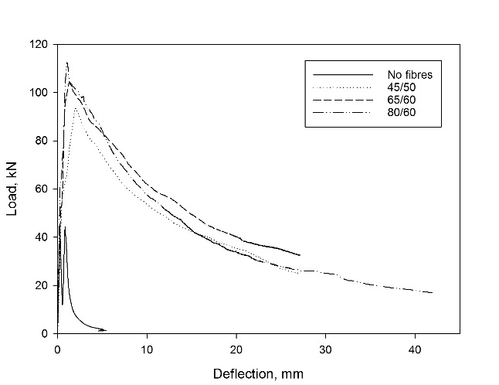
- 10 mm maximum aggregate size
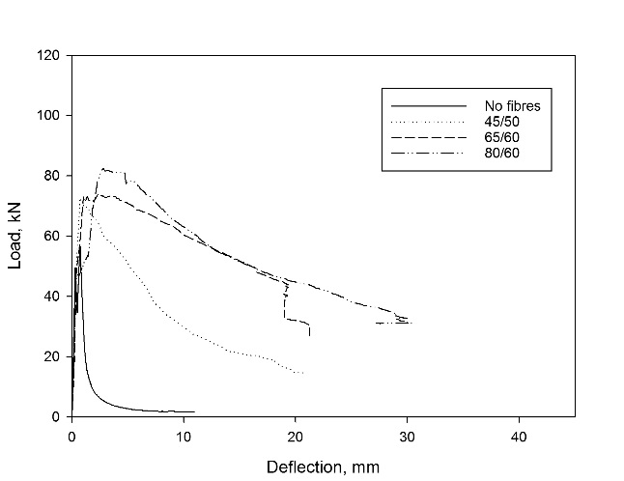
- 20 mm maximum aggregate size

Figure 1. Load-deflection curves of slabs.

Visually, these images tend to show a more uniform distribution of fibres through the cores for larger aspect ratios. There is also an apparently more uniform distribution of fibres when the lower aspect ratio fibres are combined with smaller aggregates than with larger ones (Figure 2, a and b). These observations are likely explained by a combination of two effects. An individual fibre’s position (and orientation) in the concrete is affected by its interaction with other fibres and aggregate particles as well as the boundaries of the concrete specimen. This interaction is more significant for higher aspect ratios and larger aggregate particles. In Figure 2a, the effect of the larger aggregate particles is clearly visible. Fibre position and orientation are restricted in images C and D by the presence of larger aggregate particles and the distribution is less uniform than with the smaller aggregate particles (images A and B in Figure 2a). The same effect is observed in Figure 2b for the 65/60 fibres although is less pronounced. At the highest aspect ratio (Figure 2c), there is no longer a visible difference in uniformity of the fibre distribution when the aggregate size is changed.
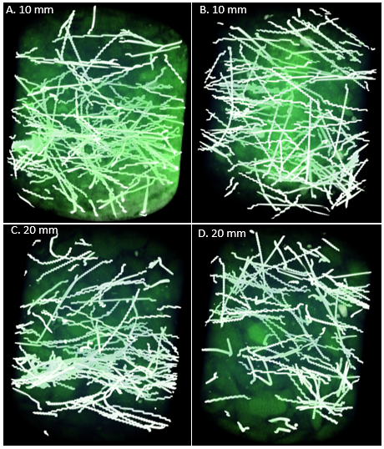
- 45/50 fibres
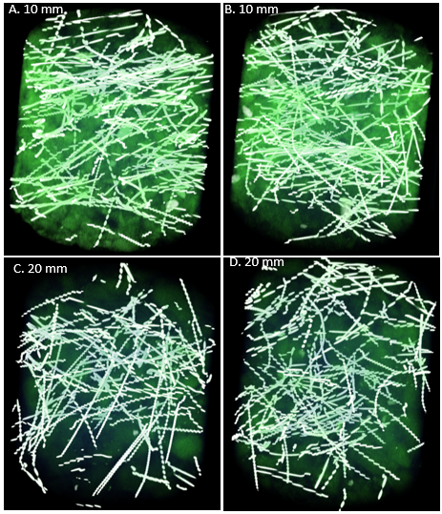
- 65/60 fibres
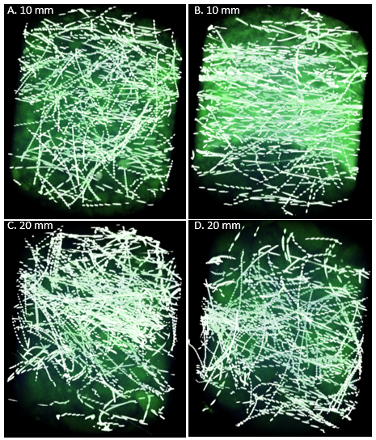
- 80/60 fibres

Figure 2. 3D volumes generated through image analysis.

This could be due to interaction of fibres with each other becoming the more dominant effect rather than interaction with the aggregate particles. It is also possible that the effect of the aggregate size is being masked in the images by the increased number of fibres. For a fixed fibre dosage in the mix, there is a higher number of fibres per unit volume as the aspect ratio increases. Calculated number of fibres in a core for 45/50, 65/60 and 80/60 fibres are 110, 125 and 180 respectively.

Further analysis of the images was focussed on extracting numerical values to represent the overall fibre distribution and orientation. Average nearest neighbour distances were obtained for each fibre core (shown as a function of height from the base of the core in Figure 3). These show no real trend in the data, except for a sharp increase in nearest neighbour distance close to the top of the cores, consistent with some settlement of fibres within the fresh concrete.

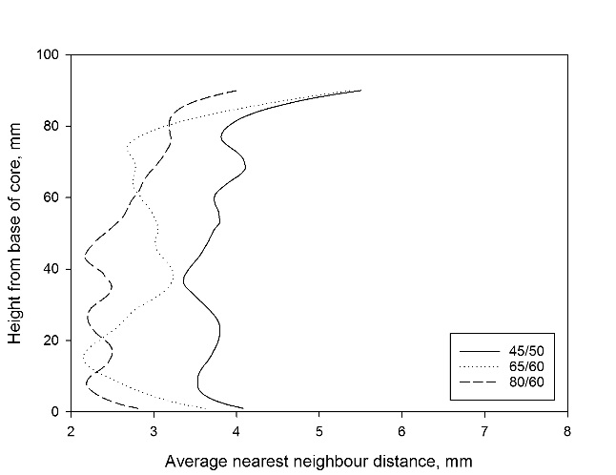
- 10 mm maximum aggregate size
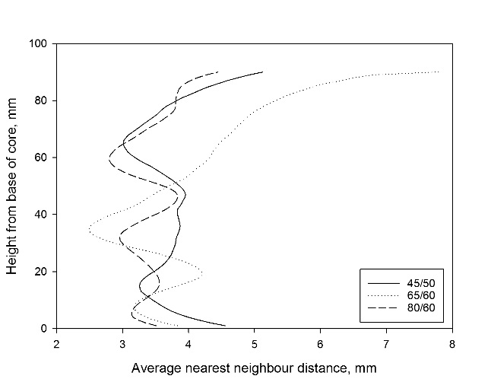
- 20 mm maximum aggregate size

Figure 3. Average nearest neighbour distances

Figure 4 shows the Shannon’s entropy values [8]. This is a single number for each core sample and is a measure of the randomness of the fibre distribution and orientation within the core. While the figure shows some scatter in the replicate cores from each aggregate size/fibre type combination, there is a clear drop in entropy when aggregate size is increased. The 80/60 fibres also show lower entropy than the other types of fibres. This is consistent with the visual observations from Figure 2, suggesting that fibres are more randomly distributed and orientated when 10 mm aggregates are used and for lower aspect ratios. Less randomness for the 20 mm aggregate sizes and the 80/60 fibres can be explained by the same factors as those controlling the distribution as discussed above.

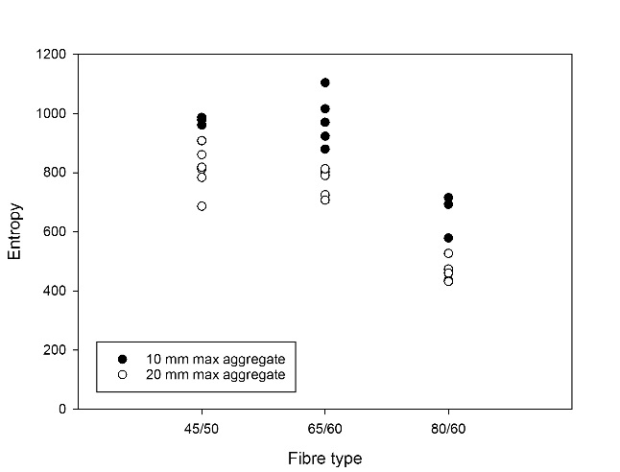

Figure 4. Shannon’s entropy values.

What is less clear at this stage is whether the observed differences in fibre distribution and orientation are responsible for the improved mechanical performance in the slabs made with 10 mm aggregates. These slabs showed both better mechanical performance and more random distribution and orientation of fibres. However, while uniformity is desirable from a design point of view, mechanical performance of these slabs would be maximised by a non-random orientation in which fibres tended to lie horizontally within the cores. If the fibre distribution and orientation are playing a role in the mechanical performance of the slabs described here, the fibres in the 20 mm aggregate slabs would need to be less random in a way that makes them less likely to lie horizontally and/or less likely lie close to the base of the slabs. Further analysis of the data is now being carried out to extract further information to establish whether this is the case.

4. CONCLUSIONS

The work described here investigated the effects of two key parameters (maximum aggregate size and fibre type) which are expected to have a significant effect on fibre orientation and distribution in fibre reinforced concrete. Both were shown to have effects on the distribution and orientation of fibres and on the mechanical performance. Fibres were more randomly distributed and orientated for smaller aggregates and lower aspect ratios. Smaller maximum aggregate size also resulted in improved mechanical performance (maximum load and energy absorption), while increasing aspect ratio resulted in a slight increase. Analysis of the data is continuing to determine what, if any, role the fibre orientation and distribution in the slabs played in their mechanical performance.

ACKNOWLEDGEMENTS

Olubisi Ige acknowledges the financial support of Tertiary Education Trust Fund, Nigeria. The authors thank Mr Christopher Fox, University of Nottingham for XCT data collection and the technical staff of the School of Civil Engineering and Surveying, University of Portsmouth for their assistance with production and testing of samples. Finally, Bekaert are acknowledged for kindly supplying the fibres used in this work.

REFERENCES

[1] Bencardino F, Rizzuti L, Spadea G, Swamy RN. 2013. Implications of test methodology on post-cracking and fracture behaviour of Steel Fibre Reinforced Concrete. Composites Part B: Engineering, 46:31-38.
[2] Michels J, Christen R, Waldmann D. 2013. Experimental and numerical investigation on postcracking behavior of steel fiber reinforced concrete. Eng. Fract. Mech., 98:326-349.
[3] Soulioti D, Barkoula N, Paipetis A, Matikas T. 2011. Effects of Fibre Geometry and Volume Fraction on the Flexural Behaviour of Steel‐Fibre Reinforced Concrete. Strain, 47:535-541.
[4] Soutsos M, Le T, Lampropoulos A. 2012. Flexural performance of fibre reinforced concrete made with steel and synthetic fibres. Const. Build. Mat., 36:704-710.
[5] Dupont D, Vandewalle L. 2005. Distribution of steel fibres in rectangular sections. Cem. Concr. Comp., 27:391-398.
[6] Stahli P, Custer R, Van Mier JGM. . 2008. On flow properties, fibre distribution, fibre orientation and flexural behaviour of FRC. Mater. Struct., 41:189-96.
[7] CEN, 2006. Testing sprayed concrete - Determination of energy absorption capacity of fibre reinforced slab specimens (EN 14488-5:2006). Brussels, Belgium.
[8] Chiverton J, Ige O, Barnett SJ, Parry A. 2017. Multiscale Shannon’s Entropy Modeling of Orientation and Distance in Steel Fibre Micro-Tomography Data. Trans. Im. Proc., in press.

