**Introduction**

Fingermarks are generally regarded as the most reliable method of personal identification and, therefore, are viewed as some of the most important contact evidence recoverable from a crime scene [1]. In order for the successful retrieval of fingermarks from a scene, they first have to be detected. In order to achieve this, a range of techniques have been developed to visualise such marks. A number of chemical and physical methods are currently employed to develop latent fingermarks that are invisible to the naked eye [2]; however, these visualisation techniques are constantly evolving. Recent years have seen researchers exploring novel approaches to fingermark development, both instrumental and chemical in nature, and in some instances even repurposing techniques not normally utilised for fingerprint work [3-21] .

It was with the aforementioned repurposing in mind that phosphomolybdic acid (PMA) was considered as a possible fingermark development reagent. Phosphomolybdic acid (H3[PMo12O40]) [22] is a heteropolyacid commonly used in histology as a component of Masson’s Trichrome Stain and as an indicator in thin layer chromatography, where it is used to visualise a great many compounds including steroids [23], sterols [24], lipids [25], fatty acids [26] and triglycerides [27]. It was the PMAs versatility in identifying the aforementioned compounds that lead to its investigation as a possible fingerprint visualisation reagent [28], although this has not been pursued further in the following decades.

Phosphomolybdic acid has a 1:12 tetrahedral structure [22] (Figure 1) which is structurally identical to its species counterparts with the formula [XM12O40]n-, where X is the heteroatom (PV, AsV, SiV or GeIV, amongst others) and M is the addenda atom (usually MoVI or WVI). Phosphomolybdic acid is reduced to molybdenum blue in the presence of conjugated, unsaturated compounds. Burstein found that the blue colour becomes more intense with an increase in the number of double bonds in the molecule being stained [29]. This suggests that the primary use of PMA as a fingermark development reagent would be to detect the water insoluble, sebaceous constituents of fingermarks, as originally suggested by Vincent [28].

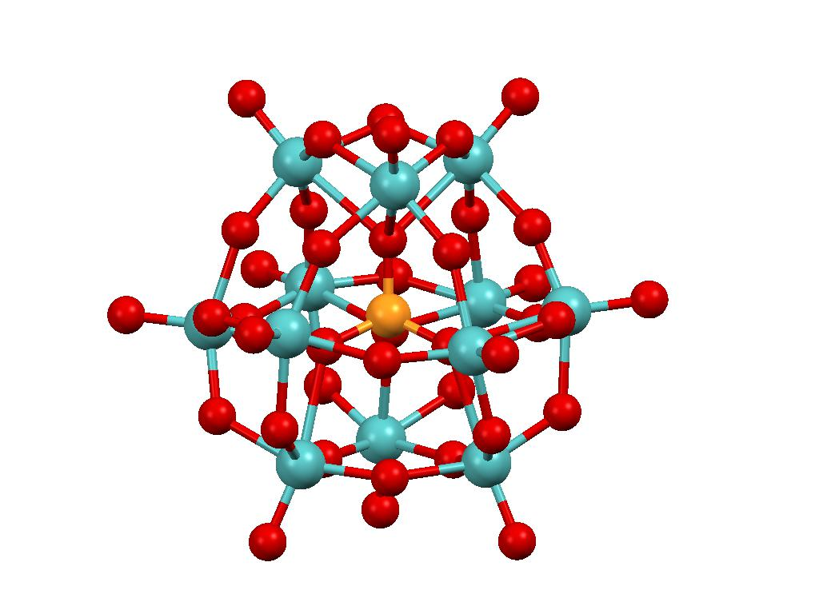

Figure : Phosphomolybdate anion

|  |
| --- |
| **Legend** |
| * Phosphorus |
| * Molybdenum |
| * Oxygen |

Vincent [28] originally considered PMA as a spray reagent for use on porous surfaces including fabrics and paper, and concluded in a report, that of 25 reagents tested for the purpose of fingerprint development, phosphomolybdic acid outperformed all except ninhydrin. Recent feasibility studies [30, 31] looked to optimise the technique by looking at different carriers as well as varying the development process and confirmed this development reagent merited further investigation for the purposes proposed by Vincent. There are a number of fingermark visualisation reagents which have been researched and/or recommended for staining fatty acids, lipoproteins and triglycerides on porous surfaces; Nile Red, Europium Chelate and Oil Red O [32]. Oil Red O (Figure 2) was chosen as a comparison reagent for this study due to the fact it is more widely used operationally, is cheaper than Nile Red and Europium Chelate to formulate and does not require fluorescent illumination conditions to view developed marks. Oil Red O (ORO) is a lysochrome, or lipid stain similar to Sudan Black (Solvent Black 3). Initially, Oil Red O was investigated as an azo-dye for the staining of lip prints deposited on tissue paper [33], then as a replacement for physical developer for the development of latent fingermarks on substrates which had been wetted [34]. Beaudoin (2004) reported a formulation of Oil Red O, which was capable of developing fingermarks, not just on porous surfaces, but also porous surfaces that had been wetted. It was also found to be effective on semi-porous and soiled paper. The process is completed in three stages, first an Oil Red O dip bath for up to 90 minutes followed by immersion in a buffer solution, and finally submersion in a water bath [35].



Figure : Oil Red O Structure

Figure 2: Oil Red O Structure

However, sebaceous fingermarks are not only encountered on porous surfaces and the application of PMA to non-porous surfaces has not yet been explored. On non-porous surfaces, the development reagent Solvent Black 3 [36, 37] is most widely recommended for the development of sebaceous and grease contaminated marks. On dark surfaces, Natural Yellow 3 has recently been suggested as an alternative [38]. Both reagents are prone to causing excess staining of the background for long exposure times, and alternative reagents are desirable. Although originally proposed for the development of sebaceous rich marks on porous surfaces, small particle reagent works well on non-porous substrates [39]. On adhesive surfaces, as well as non-porous, Basic Violet 3 (Gentian Violet) is recommended [40]. Iodine solution has been found to be effective on both porous and non-porous substrates [41].

There has also been continued interest in developing fingermarks on metal surfaces, particularly those capable of developing marks on the metals associated with gun and knife crime (e.g. brass and stainless steel). Recent focus has been on processes that are tailored towards different classes of metal surface, for example electrochromic deposition (stainless steel [14]), and longer established processes may also be used to target different metal types (gun blueing – brass and steel, aluminium black – aluminium).

The purpose of this initial study was to investigate the breadth of applications for PMA, looking at different types of non-porous substrates where it may exhibit different modes of development and also conducting an assessment of its performance in comparison to an existing lipid visualisation reagent (ORO) on porous surfaces.

**Materials and Method**

PMA Study

The substrates used in this study were paper, acetate, aluminium and stainless steel. These are substrates found in common everyday items. The substrates were prepared for fingermark deposition by cutting 12 cm by 3 cm sized samples; these were labelled using photographic twin check labels with the twinned label being logged with details of sample type, fingermark deposition method, donor number and development day. The 13 donors used in this study were a mix of males and females ranging in age from 22 – 40, and whose potential to leave fingermark deposits was unknown. Donors had not washed their hands for at least 30 minutes prior to depositing their fingermarks; no extra sebaceous deposits were loaded on to the hands, therefore providing more natural deposits from the donor’s hands. Fingermark deposition was carried out by having the donor deposit their marks either by depositing a mark from each finger of one hand; each donor deposited all their marks at the same time. After the fingermarks had been deposited, the samples were stored in cardboard boxes, in the dark, at room temperature for 1, 2, 4, 8, 14, 21 or 28 days before being processed. In total 182 samples of each substrate (13 donors, 7 different ages, 2 deposition methods) were used, 728 samples in total.

PMA vs Oil Red O Comparison Study

The substrate used in this study was paper, which was an 80 gsm copier paper made by Polaroid. The substrates were prepared for fingermark deposition by cutting 12 cm by 5 cm sized samples to allow ample space for the fingermark to be deposited and split down the centre, this allowed for the direct comparison between the chosen development reagents. Three donors were used in this study, they were a mix of males and females ranging in age from 22 – 40, and whose potential to leave fingermark deposits was unknown. Donors had not washed their hands for at least 30 minutes prior to depositing their fingermarks. Fingermark deposition was carried out by having the donor deposit a single mark from each finger along the centre of the substrate (five marks per sample). Each donor deposited all their marks at the same time.

PMA and Wetted Samples

Paper samples had a mixture of natural and sebaceous marks deposited on their surface. These were subsequently placed into a water bath to soak. Samples were allowed to either air dry, or were placed in an oven at around 50 °C to dry out. Once dry the samples were treated in the same manner as the previous samples.

Reagents

The prepared samples were treated with a 10% w/v phosphomolybdic acid (PMA) solution, prepared from phosphomolybdic acid hydrate (Sigma Aldrich – 221856) in absolute ethanol. The samples were sprayed with the PMA solution using an ECOSPRAY (Labo Chimie France) and developed for 15 minutes under a 15 W long wave UV lamp [42].

Treating fingermarks with Oil Red O is a three-part process; the ORO stain bath, a buffer solution and, finally a water bath. The ORO stain was prepared by adding 0.77 g Oil Red O (Sigma Aldrich – O0625) to 385 ml methanol, then separately adding 4.6 g sodium hydroxide to 115 ml of deionised water. These two solutions were then mixed together and filtered before being stored in a brown bottle away from light. The buffer solution was prepared by adding 26.5 g of sodium carbonate to 2 litres of deionised water while stirring until dissolved, to this solution 18.3 ml of concentrated nitric acid was added, finally the total volume was made up to 2.5 litres by adding more deionised water.

Samples treated with ORO could required up to 90 minutes in the stain bath, after which they were placed in the buffer solution for up to five minutes before being rinsed in the water bath and being left to dry.

Treated samples were then photographed using a Nikon D5200 [43] digital camera with a AF-S DX Nikkor 18-55mm F/3.5-5.6G VR [44] lens. The visualised marks were then graded using one of the “CAST” grading scales (Table 1) [45, 46].

|  |  |
| --- | --- |
| **Grade** | **Comment** |
| 0 | No development. |
| 1 | No continuous ridges.  All discontinuous or dotty. |
| 2 | One third of mark continuous ridges.  (Rest no development, dotty, smudge or infill). |
| 3 | Two thirds of mark continuous ridges.  (Rest no development, dotty, smudge or infill). |
| 4 | Full development.  Whole mark continuous ridges. |

Table 1: Fingermark Grading Scale

**Results and Discussion**

PMA Study

There were 728 total sample substrates treated, with 4 – 5 fingermarks on each. After treatment the best developed fingermarks from each sample were graded from 0 to 4 after a visual examination. Of the 728 samples, 45% were graded as a 1, 17% were graded 2 and 6% were graded 3 and above (Graph 1).

Graph 1: Group Study Distribution of Grading Values

Paper provided the most 0 graded marks (those containing no development); double the amount of some of the other substrates. Consequently the number of paper samples within each individual grading value above 0 was markedly less than those of the other substrates (Graph 2). The metal samples; aluminium and stainless steel both performed very similarly despite having slightly different finishes, slightly brushed compared with a clean smooth finish respectively. Performing slightly behind the metals were the acetate samples which exhibited problems due to high instances of background staining. The paper’s poorer performance was expected due to the fingermark residues being absorbed in to the paper’s porous surface, and also consistent with the recommended use of amino acid visualisation reagents on this type of surface because of the higher proportion of eccrine constituents present in natural sweat deposits. Conversely, all constituents of the fingermark residue sit on the surface of the non-porous metal and acetate substrates and are available to interact with the PMA.

Graph 2: Group Study Distribution per Substrate Type

The differences in the finishes of the metals made a difference in the visualisation of any fingermarks present on the surface. The slight brushed finish on the aluminium caused some marks to only be visible at an oblique angle, especially with faint marks. There were some instances where the phosphomolybdic acid caused high background staining on the substrate, leaving the surface awash with blue staining, although some did show signs of ridge detail which was broken and spotty in places (Figure 3). Many of the samples which presented useable prints were observed to have little in the way of background staining and the ridge detail appeared to be lighter than the background (Figure 4). This suggests for this metal surface, the primary interaction occurring is between the PMA and the aluminium metal substrate.

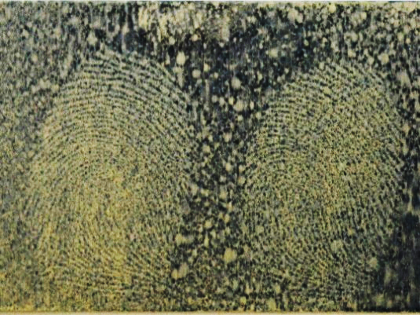

Figure 3: Aluminium Stained Background

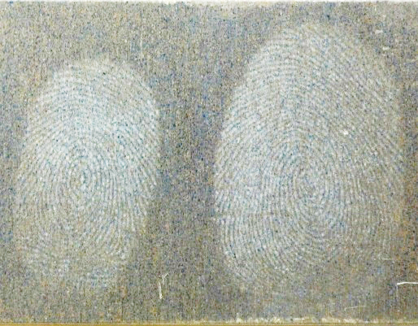

Figure 4: Aluminium with Ridge Detail

The steel had the greatest number of grade 2 and grade 3 marks, however, it also suffered from the occasional background staining issues that the aluminium had (Figure 5). The fingermarks on the steel substrates developed differently from the aluminium, with ridges presenting as a dark blue/black (Figure 6) and in some cases with some yellow staining between the ridges. This suggests that the principal interaction on stainless steel is between the PMA and the fingermarks, which represents a difference in development mode between the two metals used.

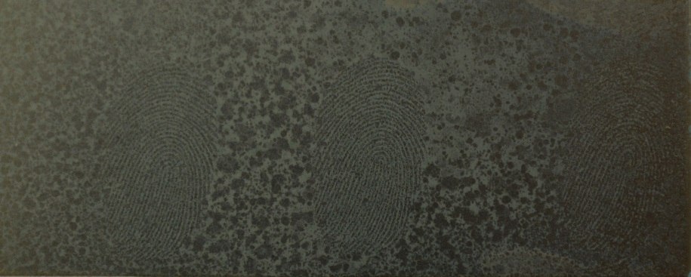

Figure 5: Stainless Steel Stained Background

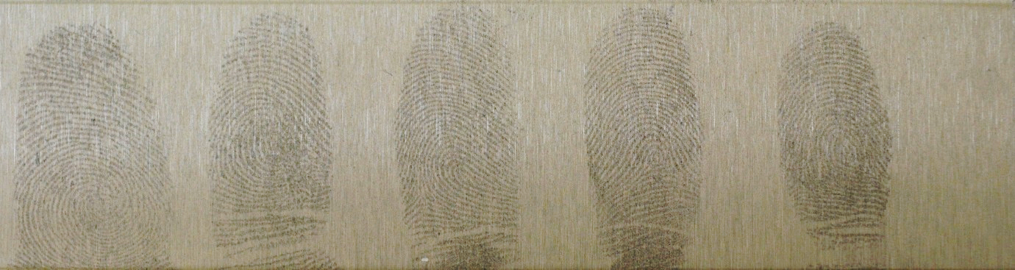

Figure 6: Stainless Steel with Ridge Detail

The acetate substrates performed better in terms of fingermark development than the aluminium samples, but to a lesser degree than the steel samples. When applying the phosphomolybdic acid to the acetate surface it would tend to produce a ‘halo’ where a mark was situated, most probably due to the solutions being repelled by the oils within the fingerprint residues. Out with these haloes, the phosphomolybdic acid would sit in pools and stain the acetate a colour similar to the yellow/green of the original solution (Figure 7). The marks/ridges within the voids, however, were visible as the characteristic dark blue/black of the molybdenum blue. The background staining observed is similar to that which occurs when using cyanoacrylate fuming and Basic Yellow 40 dye on certain substrates, e.g. tin foil [2]. The visualised marks on the acetate surface were very fragile and easily destroyed by light touches (Figure 8). Despite this fragility and the instances of high background staining, the acetate did produce high instances of grade 2 to 4 prints (Figure 9).

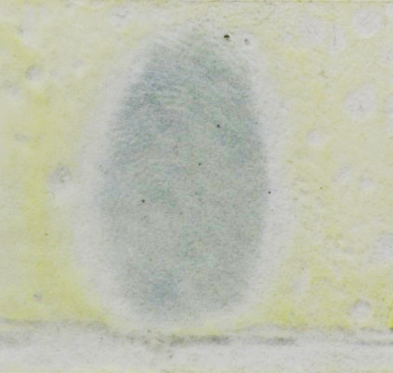

Figure 7: Acetate Background Staining

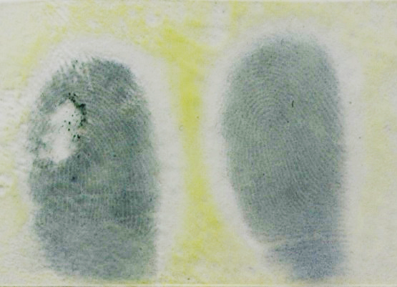

Figure 8: Damaged Print on Acetate

As mentioned previously the application of PMA to the paper substrates did not produce the same level of fingermark visualisation as the other samples. Over fifty percent of the paper samples returned no development whatsoever, with only fifteen percent giving marks of grade 2 and above. However, as stated above this is not inconsistent with operational observations that amino acid development reagents will be more effective on this substrate, and ideally PMA should be compared to another process targeting non-eccrine constituents to get a more representative measure of its effectiveness. Background staining was also noted in the paper samples, albeit to a lesser degree than the other substrates tested. The staining was observed to be of a variety of colours ranging from the aforementioned yellow/green through to a pale blue. Grade 2 and 3 marks present were often faint; however, some very good ridge detail was observed (Figure 10).

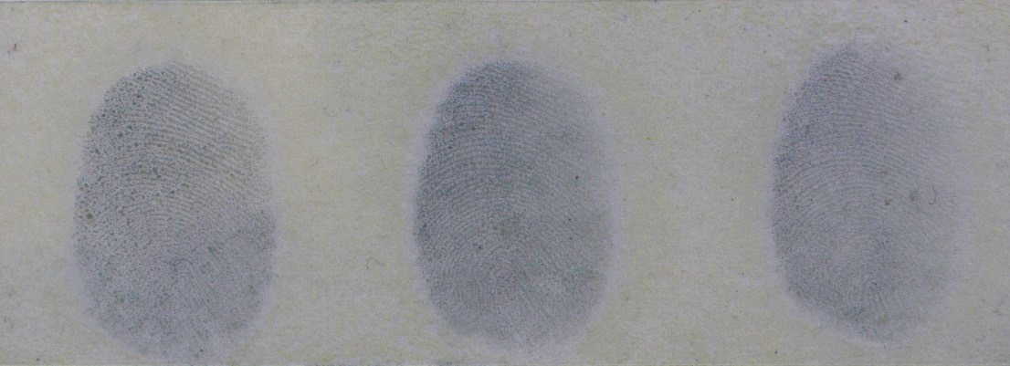

Figure 9: Ridge Detail on Acetate

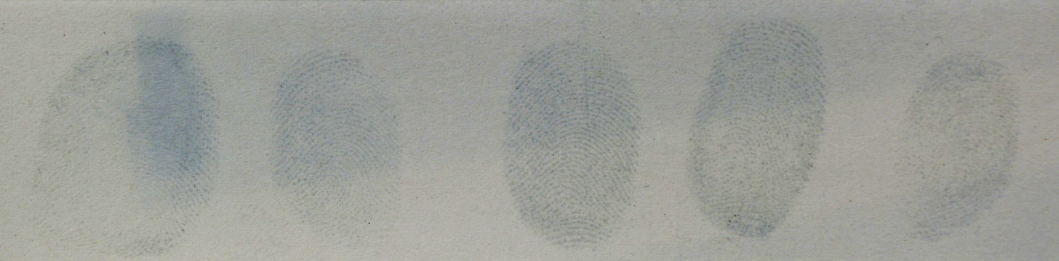

Figure 10: Ridge Detail on Paper

There was no clear pattern established within the results of the fingermark aging series, this was due to natural fingermarks being used for the study. Because phosphomolybdic acid primarily reacts with constituents of sebaceous secretions, which are present in varying and uncontrolled concentrations, and not all experiments commenced on the same day, the intra- and inter-donor variability made clear trends difficult to establish. To confirm the specificity of PMA to sebaceous constituents, two additional, shorter studies were conducted; one in which sebaceous material was artificially added to the finger tips and another where eccrine only fingermark deposits (sweat from the hands only) were used as a control. The number of donors was dropped from thirteen to four and the age of the fingermark deposits was lowered from twenty-eight days to eight (1, 2, 4 and 8 Days). The number of sample substrates remained the same at four.

For the eccrine study, the donors washed their hands then donned nitrile gloves for up to thirty minutes in order to allow the hands sufficient time to sweat. Marks were then deposited upon the sample substrates. When conducting the sebaceous study, donors were asked to rub their fingertips around their hairline and nose areas where sebaceous sweat glands are abundant. Marks were then deposited upon the sample substrates.

Eccrine Study

|  |  |  |  |  |
| --- | --- | --- | --- | --- |
|  | Acetate | Aluminium | Paper | Steel |
| Grade 0 | 16 | 16 | 16 | 16 |
| Grade 1 | 0 | 0 | 0 | 0 |
| Grade 2 | 0 | 0 | 0 | 0 |
| Grade 3 | 0 | 0 | 0 | 0 |
| Grade 4 | 0 | 0 | 0 | 0 |
| Total | 16 | 16 | 16 | 16 |
| % of Grade 2+ Marks | 0 | 0 | 0 | 0 |

Table 2: Eccrine Study Results

The eccrine study failed to yield any positive mark visualisation (Table 2), as expected. This occurred across all the substrate materials. Some showed signs of background staining due to the phosphomolybdic acid, but no signs of any ridge detail staining.

Sebaceous Study

|  |  |  |  |  |
| --- | --- | --- | --- | --- |
|  | Acetate | Aluminium | Paper | Steel |
| Grade 0 | 3 | 4 | 2 | 3 |
| Grade 1 | 3 | 4 | 3 | 3 |
| Grade 2 | 5 | 3 | 5 | 4 |
| Grade 3 | 5 | 5 | 4 | 4 |
| Grade 4 | 2 | 1 | 2 | 2 |
| Total | 16 | 16 | 16 | 16 |
| % of Grade 2+ Marks | 75% | 56.25% | 68.75% | 62.5% |

Table 3: Sebaceous Study Results

The sebaceous study provided many positive marks and high instances of fingermark development that could be used in an operational capacity to identify the depositer of the marks (Table 3). The acetate substrate showed the most grade 2 and above marks, although they still suffered from the delicacy mentioned before. The paper samples also showed a noticeable improvement in the amount of grade 2 and above marks developed (Figure 11). The age of the fingermark did not appear to influence the results gained over the time frame studied.

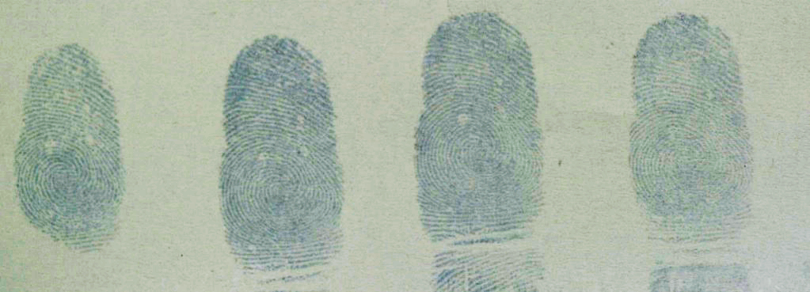

Figure 11: Sebaceous Study (Paper)

This discovery not only sheds some light on the high number of no detail results gained in the primary trial, as these contained marks which had not been artificially charged with sebaceous deposits, but these success rates are comparable to other visualisation reagents which target sebaceous constituents, such as ORO [47]. Despite this technique’s limitation in only developing fingermarks with sebaceous material present, there may well be merit in using PMA in sequence with DFO/Indandione and ninhydrin, much in the same way ORO is proposed for use at present [48].

PMA vs Oil Red O Comparison Study

Fresh samples which were treated within a day of the fingermarks being deposited showed developed marks which were comparable between the two processes. Once the individual halves were treated and recombined, it was relatively easy to follow the ridge flow of the fingermark from one half to the other. The only noticeable issue was that the halves of the fingermarks were slightly misaligned; this was due to shrinkage of the paper when being treated with Oil Red O (Figure 12). The Oil Red O treated halves were also prone to warping.

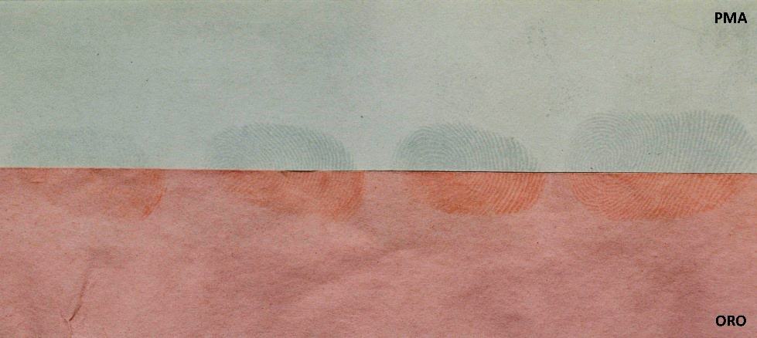

Figure : Oil Red O vs Phosphomolybdic Acid

Samples which had the fingermarks deposited then left for over 4 weeks before being developed looked markedly different from those that were developed the day after the fingermarks were deposited. The half treated with Oil Red O barely showed any marks from the fingermark residues, whereas the phosphomolybdic acid treated halves showed development albeit slightly fainter than previously achieved (Figure 13). This suggests that the constituents of fingermarks targeted by PMA are more persistent within the deposited mark than those targeted by ORO (Table 4).

Figure : ORO vs PMA (4+ Weeks)

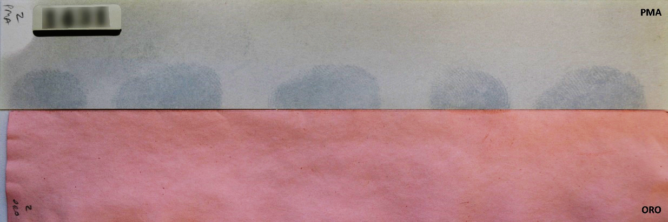

|  |  |  |  |
| --- | --- | --- | --- |
|  | 1 Day | 2 Weeks | 4 Weeks |
| PMA (% of Grade 2+ Marks) | 100% | 80% | 80% |
| ORO (% of Grade 2+ Marks) | 80% | 20% | 0% |

Table 4: Direct Comparison Percentage Grade 2+ Marks

Whilst experimenting with the two reagents sequentially, it was discovered that by using phosphomolybdic acid in the first instance, Oil Red O could be used additionally after 4 weeks. The developed fingermarks presented darker with a superior definition than if the Oil Red O was used alone after the same period (Figure 14). On these split comparisons the ORO developed 20% grade 2 marks and 80% at grade 1, whereas the PMA followed by ORO provided developed marks of 40% at grade 2 and 60% at grade 3.

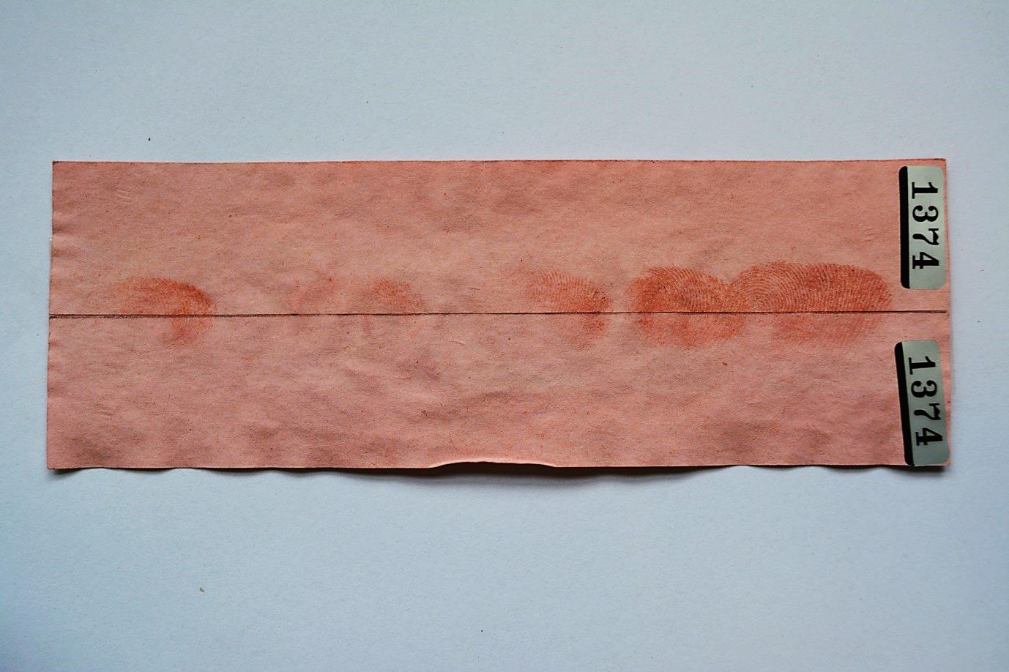

**PMA > ORO**

**ORO**

Figure : PMA + ORO Used in Sequence Vs ORO

Using phosphomolybdic acid after Oil Red O does nothing to enhance deposited fingermarks beyond what the Oil Red O has already achieved.

PMA and Wetted Samples

Once the paper had been placed in the water bath and had completely soaked, fingermarks could be observed on the paper’s surface (Figure 15). Once dry the samples were sprayed with phosphomolybdic acid solution in the same manner as the dry samples were. Once treated however, the marks were not developed to the same standard as dry samples. Although faint fingermarks were visible once the development process had been completed, these marks lacked any useable ridge detail (Figure 16).

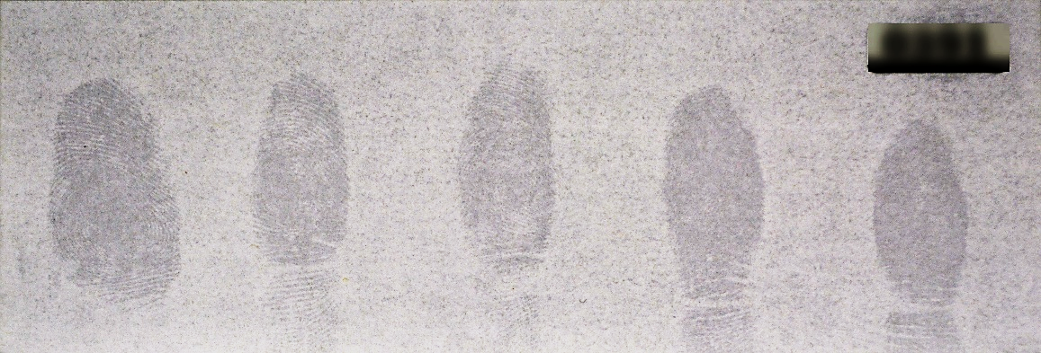

Figure : Fingermarks Visible on Wetted Paper

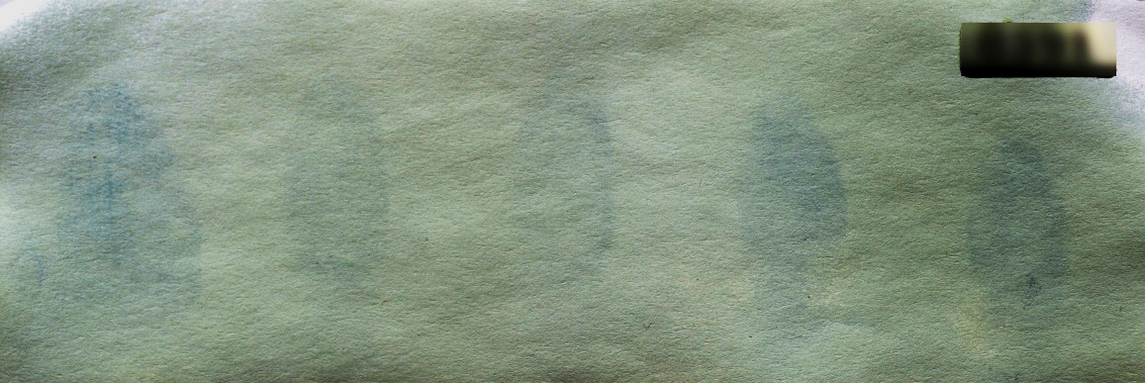

Figure : PMA Treatment of Fingermarks on Wetted Paper

The fact that phosphomolybdic acid is capable of developing fingermarks on both porous and non-porous substrates makes it a potentially more versatile visualisation reagent than Oil Red O. Although Oil Red O formulations have been explored for the visualisation of fingermarks on non-porous surfaces [2], it was found to be inferior to other dyes, such as basic violet 3 and solvent black 3, which are used for this purpose. While this pilot study has demonstrated the ability of PMA to develop marks on non-porous substrates, it is recognised that future phases of the work would also need to include comparisons with solvent black 3 and/or basic violet 3 formulations in order to establish whether it offers any benefit over these existing processes on non-porous surfaces.

**Conclusions**

Of the substrates tested it appears that the non-porous substrates provided more positive results than the porous substrates. On stainless steel the phosphomolybdic acid technique achieved 80% positive mark development, 28% of which were grade 2 and above. This was closely followed by the aluminium with positive mark development 76% of the time, 22% of these were grade 2 and above. The acetate substrate produced 68% positive mark development, of which 26% were grades 2 and above. The smooth non-porous surface of the acetate meant, however, that the fingermark developed was very fragile and easily wiped away. The paper substrate performed the worst, achieving 50% positive mark development, only 15% of which were grade 2 and above. Fingermarks aged up to 28 days were still enhanced to grade 2 and greater on all substrate surfaces except the paper.

An addendum trial, using a single donor, found that prints containing only eccrine sweat deposits returned no positive mark development whatsoever, whereas marks with charged sebaceous sweat deposits produced up to 75% positive mark development with greater ridge detail present.

When comparing the efficacy of phosphomolybdic acid against Oil Red O on porous substrates, the two seemed to be comparable on newer marks (those less than a week old). However, phosphomolybdic acid easily outperformed Oil Red O on older marks (those older than one week), possibly because it targets a wider range of constituents, some of which may be more persistent than the constituents targeted by ORO. The degradation observed with PMA after 4 weeks is less than that observed for ORO, so it would be expected that PMA would continue to develop marks for a little longer than the 4 week limit.

PMA struggled to develop marks on paper substrates which had been wetted. Developed marks were visible, however, these lacked any ridge detail. This was an instance where ORO outperformed the PMA. Future studies would further investigate whether this could be resolved, or if it is an instance where ORO would be the preferential treatment.

Phosphomolybdic acid could be considered as a cheaper (~$175/L vs. ~$250/L for ORO), faster alternative to Oil Red O for the same type of development. By using the phosphomolybdic acid as a precursor to Oil Red O, fingermarks were able to be developed long past the point where Oil Red O normally fails as a development reagent.

PMA has a potentially broad application across porous and non-porous surfaces; it is quicker and potentially more effective than ORO, and possibly physical developer on porous surfaces (particularly for marks older than a month). However, it is unlikely to outperform an amino acid development reagent and there are some health and safety issues in its flammability and corrosive nature, which would need to be addressed. Overall, PMA has shown significant promising trends in performance that merit further research, particularly with a larger study group to see if these observed trends are maintained. Other areas which warrant further investigation are the ability of PMA to work in concert with amino acid visualisation reagents and its performance comparative to other lipid development reagents on non-porous surfaces.

**References**

1. Ramotowski, R., *Lee and Gaensslen's Advances in Fingerprint Technology*. 3rd ed. 2012: CRC Press.

2. Bleay, S., et al., *Fingerprint Source Book*. Home Office Centre for Applied Science and Technology (CAST). 2013.

3. Szynkowska, M.I., et al., *ToF-SIMS application in the visualization and analysis of fingerprints after contact with amphetamine drugs.* Forensic Science International, 2009. **184**(1–3): p. e24-e26.

4. Szynkowska, M.I., et al., *Detection of exogenous contaminants of fingerprints using ToF-SIMS.* Surface and Interface Analysis, 2010. **42**(5): p. 393-397.

5. Fraser, J., et al., *Visualisation of fingermarks and grab impressions on fabrics. Part 1: Gold/zinc vacuum metal deposition.* Forensic Science International, 2011. **208**(1–3): p. 74-78.

6. Flynn, J., M. Stoilovic, and C. Lennard, *Detection and enhancement of latent fingerprints on polymer banknotes: a preliminary study.* Journal of Forensic Identification, 1999. **49**(6): p. 594.

7. Wilkinson, D., et al., *Recommended Protocols for Fingerprint Detection on Canadian Polymer Banknotes-Part I: Chemical Development.* J. Forensic Ident, 2014. **64**(4).

8. Lam, R., *Recommended Protocols for Fingerprint Detection on Canadian Polymer Banknotes--Part II: Photography, Lighting, and Digital Enhancement Techniques.* Journal of Forensic Identification, 2014. **64**(4): p. 402.

9. Davis, L.W.L., et al., *Visualisation of latent fingermarks on polymer banknotes using copper vacuum metal deposition: A preliminary study.* Forensic Science International, 2016. **266**(Supplement C): p. e86-e92.

10. Bond, J.W., *The Thermodynamics of Latent Fingerprint Corrosion of Metal Elements and Alloys.* Journal of Forensic Sciences, 2008. **53**(6): p. 1344-1352.

11. Bond, J.W., *Visualization of Latent Fingerprint Corrosion of Metallic Surfaces.* Journal of Forensic Sciences, 2008. **53**(4): p. 812-822.

12. Bond, J.W., *Visualization of Latent Fingerprint Corrosion of Brass.* Journal of Forensic Sciences, 2009. **54**(5): p. 1034-1041.

13. Goddard, A.J., A.R. Hillman, and J.W. Bond, *High Resolution Imaging of Latent Fingerprints by Localized Corrosion on Brass Surfaces.* Journal of Forensic Sciences, 2010. **55**(1): p. 58-65.

14. Beresford, A.L. and A.R. Hillman, *Electrochromic Enhancement of Latent Fingerprints on Stainless Steel Surfaces.* Analytical Chemistry, 2010. **82**(2): p. 483-486.

15. Beresford, A.L., et al., *Comparative Study of Electrochromic Enhancement of Latent Fingerprints with Existing Development Techniques*.* Journal of Forensic Sciences, 2012. **57**(1): p. 93-102.

16. Sapstead, R.M., N. Corden, and A. Robert Hillman, *Latent fingerprint enhancement via conducting electrochromic copolymer films of pyrrole and 3,4-ethylenedioxythiophene on stainless steel.* Electrochimica Acta, 2015. **162**(0): p. 119-128.

17. Williams, G. and N. McMurray, *Latent fingermark visualisation using a scanning Kelvin probe.* Forensic Science International, 2007. **167**(2–3): p. 102-109.

18. Knighting, S., et al., *Visualisation of fingermarks and grab impressions on dark fabrics using silver vacuum metal deposition.* Science & Justice, 2013. **53**(3): p. 309-314.

19. King, R.S.P., P.M. Hallett, and D. Foster, *Seeing into the infrared: A novel IR fluorescent fingerprint powder.* Forensic Science International, 2015. **249**(0): p. e21-e26.

20. King, R.S.P., P.M. Hallett, and D. Foster, *NIR−NIR fluorescence: A new genre of fingermark visualisation techniques.* Forensic Science International, 2016. **262**: p. e28-e33.

21. King, R.S.P. and D.A. Skros, *Sunlight-activated near-infrared phosphorescence as a viable means of latent fingermark visualisation.* Forensic Science International, 2017. **276**(Supplement C): p. e35-e39.

22. Keggin, J., *The structure and formula of 12-phosphotungstic acid.* Proceedings of the Royal Society of London. Series A, 1934. **144**(851): p. 75-100.

23. Kritchevsky, D. and M.R. Kirk, *Detection of steroids in paper chromatography.* Archives of Biochemistry and Biophysics, 1952. **35**(2): p. 346-351.

24. Sherma, J. and S. Bennett, *Comparison of reagents for lipid and phospholipid detection and densitometric quantitation on silica gel and C18 reversed phase thin layers.* Journal of Liquid Chromatography, 1983. **6**(7): p. 1193-1211.

25. Vinson, J.A. and J.E. Hooyman, *Sensitive fluorogenic visualization reagent for the detection of lipids on thin-layer chromatograms.* Journal of Chromatography A, 1977. **135**(1): p. 226-228.

26. Bringi, N., R. TIMMS, and F. PADLEY, *FATTY-ACID AND TRIGLYCERIDE COMPOSITIONS OF SHOREA-ROBUSTA FAT-OCCURRENCE OF CIS-9, 10-EPOXYSTEARIC ACID AND THREO-9, 10-DIHYDROXYSTEARIC ACID*. 1972, SOC CHEMICAL INDUSTRY 14 BELGRAVE SQUARE, LONDON SW1X 8PS, ENGLAND. p. 805-&.

27. Studer, A. and H. Traitler, *In-product jojoba determination using anticircular high performance thin layer chromatography.* Journal of High Resolution Chromatography, 1985. **8**(1): p. 19-22.

28. Vincent, S.E., *Investigation of Fingerprint Detection on Cloth by Chemical Aerosol*. Final Year Project, Bachelor of Science (Honours) Chemical Physics, University of Surry, June 1973.

29. Burstein, S., *Reduction of phosphomolybdic acid by compounds possessing conjugated double bonds.* Analytical Chemistry, 1953. **25**(3): p. 422-424.

30. Shah, B.C., *Novel fingerprint development techniques*. Doctor of Philosophy Chemistry, Loughborough University, 2013.

31. Nickolson, E., *Reinvestigation into the Detection of Latent Fingerprints with Phosphomolybdic Acid*. Final Project, Master of Chemistry, Loughborough University, 15th June 2012.

32. Bandey, H., *Fingermark Visualisation Manual.* Home Office Centre for Applied Science and Technology (CAST): Sandridge, UK, 2014.

33. Castello, A., et al., *Long-lasting lipsticks and latent prints.* 2002.

34. Morris, J., *The Detection of Latent Fingerprints on Wet Paper Samples.* Atomic Weapons Research Establishment, Aldermaston, 1975.

35. Beaudoin, A., *New technique for revealing latent fingerprints on wet, porous surfaces: Oil Red O.* Journal of Forensic Identification, 2004. **54**(4): p. 413.

36. Mitsui, T., et al., *Development of latent prints using a Sudan black B solution.* Ident. News, 1980. **30**(8): p. 9-10.

37. Cadd, S.J., S.M. Bleay, and V.G. Sears, *Evaluation of the solvent black 3 fingermark enhancement reagent: Part 2 — Investigation of the optimum formulation and application parameters.* Science & Justice, 2013. **53**(2): p. 131-143.

38. Perry, H. and V.G. Sears, *The use of natural yellow 3 (curcumin) for the chemical enhancement of latent friction ridge detail on naturally weathered materials.* Journal of Forensic Identification, 2015. **65**(1): p. 45.

39. Goode, G. and J. Morris, *Latent fingerprints: a review of their origin, composition and methods for detection*. 1983, Atomic Weapons Research Establishment: Aldermaston.

40. Haylock, S., *Carbolic gentian violet solution.* Fingerprint Whorld, 1979. **4**(15): p. 82-83.

41. Haque, F., A. Westland, and F.M. Kerr, *An improved non-destructive method for detection of latent fingerprints on documents with iodine-7,8-benzoflavone.* Forensic Science International, 1983. **21**(1): p. 79-83.

42. Philips. *Philips Facial Tanner HB175 - Product Information*. 2012 [cited 26th July 2014; Available from: <http://www.p4c.philips.com/cgi-bin/cpindex.pl?ctn=HB175/01&hlt=Link_ProductInformation&mid=Link_ProductInformation&scy=GB&slg=ENG>.

43. Nikon. *D5200*. 2016 [cited 18th July 2017; Available from: <http://www.europe-nikon.com/en_GB/product/discontinued/digital-cameras/2016/d5200>.

44. Nikon. *AF-S DX Nikkor 18-55mm F/3.5-5.6G VR*. 2016 [cited 18th July 2017; Available from: <http://www.europe-nikon.com/en_GB/product/nikkor-lenses/auto-focus-lenses/dx/zoom/af-s-dx-nikkor-18-55mm-f-3-5-5-6g-vr>.

45. Group, I.F.R., *Guidelines for the assessment of fingermark detection techniques.* J. Forensic Identif., 2014. **64**(2): p. 174-200.

46. Bandey, H., *The Powders Process, Study 2:  Evaluation of Fingerprint  Powders on Smooth Surfaces*, in *Fingerprint Development and  Imaging Newsletter:  Special Edition*Police Scientific Development Branch, Editor. 2006, Home Office: Sandridge, St Albans.

47. Sears, V.G., et al., *A methodology for finger mark research.* Science & Justice, 2012. **52**(3): p. 145-160.

48. Guigui, K. and A. Beaudoin, *The use of Oil Red O in Sequence with Other Methods of Fingerprinting Methods*. Journal of Forensic Identification. 2007. 550-581.