1
2
3 Comparative evaluation of AI-based intelligent GEP and ANFIS for model
4
5 prediction of thermophysical properties of Fe₃O₄-coated MWCNT hybrid
6
⁷ nanofluids for potential application in energy systems
8
9
10
11
12
- Prabhakar Sharma1, Zafar Said2,3,*, Saim Memon4, Rajvikram Madurai Elavarasan5,6,
- Mohammad Khalid7, Xuan Phuong Nguyen8,*, Müslüm Arıcı9, Anh Tuan Hoang10,*, Lan Huong
15
16 Nguyen11
17
18
- 1School of Engineering Sciences, Delhi Skill and Entrepreneurship University, Delhi, 110089, India
- 2Department of Sustainable and Renewable Energy Engineering, University of Sharjah, P. O. Box
21
22 27272, Sharjah, United Arab Emirates
23
- 3U.S.-Pakistan Center for Advanced Studies in Energy (USPCAS-E), National University of Sciences
- and Technology (NUST), Islamabad, Pakistan
26
- ⁴Solar Thermal Vacuum Engineering Research Group, London Centre for Energy Engineering, School
- of Engineering, London South Bank University, London, United Kingdom
29
30 5Clean and Resilient Energy Systems (CARES) Laboratory, Texas A&M University, Galveston, TX
31 77553, USA.
32
33 6Research & Development Unit (Power& Energy), Nestlives Pvt Ltd, Chennai 600091, India.
34
- 7Graphene & Advanced 2D Materials Research Group (GAMRG), School of Engineering and
- Technology, Sunway University, No. 5, Jalan Universiti, Bandar Sunway, 47500 Petaling Jaya,
37
- Selangor, Malaysia
- 8PATET Research Group, Ho Chi Minh City University of Transport, Ho Chi Minh City, Vietnam.
40
41 9Mechanical Engineering Department, Engineering Faculty, Kocaeli University, Umuttepe Campus
42
- 41001, Kocaeli, Turkey
- 10Institute of Engineering, HUTECH University, Ho Chi Minh City, Vietnam.
45
46 11School of Mechanical Engineering, Vietnam Maritime University, Vietnam.
47
48 Corresponding author:
49
50 Zafar Said (zsaid@sharjah.ac.ae; zafar.said@uspcase.nust.edu.pk)
51
- Anh Tuan Hoang (hatuan@hutech.edu.vn)
- Xuan Phuong Nguyen (phuong@ut.edu.vn)
54
55
56

1
2

3 Abstract
4
5 Hybrid nanofluids are gaining popularity due to the synergistic effects of nanoparticles,
6
7
8 which offer them improved heat transfer capacities than base fluids and regular nanofluids. The
9
10 thermophysical properties of hybrid nanofluids play a crucial role in shaping heat transfer
11
12 properties. Hence an in-depth analysis of thermophysical properties is important before its use
13
14
15 in industrial applications. In the present work, a metamodel framework is developed to forecast
16
17 the influence of nanofluid temperature and concentration on several thermophysical properties
18
19 of Fe₃O₄ coated MWCNT hybrid nanofluids. Evolutionary gene expression programming
20
21 (GEP) and an adaptive neural fuzzy inference system (ANFIS) were employed to develop the
22
23
24 prediction models. The model was trained using 70% of the datasets, with the remaining 15%
25
26 used for testing and validation. A variety of statistical measurements and Taylor's diagrams
27
28 were used to assess the proposed models. The Pearson’s correlation coefficient (R), coefficient
29
30
31 of determination (R2) was used for regression index, the error in the model was evaluated with
32
33 root mean squared error (RMSE). The model's comprehensive assessment additionally includes
34
35 modern model efficiency indices such as Kling-Gupta efficiency (KGE) and Nash-Sutcliffe
36
37
38 efficiency (NSCE). The proposed models demonstrated impressive prediction capabilities.
39
40 However, the GEP model (R> 0.9825, R2 >0.9654, RMSE = 0.7929, KGE > 0.9188, and NSCE
41
42 > 0.9566) outperformed the ANFIS model (R> 0.9601, R2 >0.9218, RMSE=1.495, KGE >
43
44 0.8015, and NSCE > 0.8745) for the majority of the findings. The generated metamodel was
45
46
47 robust enough to replace the repetitive expensive lab procedures required to measure
48
49 thermophysical properties.
50
51
52
53
54 Keywords: Thermophysical properties; Nanofluid; Artificial intelligence; Gene expression
55
56 programming; ANFIS models

1
2

3 Highlights
4
5 • Predictions of thermophysical properties of Fe₃O₄ coated MWCNT hybrid nanofluid
6
7
8 • AI-based ANFIS and GEP models performed well on statistical indices.
9
10 • ANFIS and GEP based prognostic models validated and compared with Taylor
11
12 diagrams
13
14
15
16
17
18
19
20
21
22
23
24
25
26
27
28
29
30
31
32
33
34
35
36
37
38
39
40
41
42
43
44
45
46
47
48
49
50
51
52
53
54
55
56
57
58
59
60

1
2

3 Abbreviations
4
5 AI Artificial intelligence KGE Kling-Gupta efficiency
6

- ANFIS Adaptive neuro-fuzzy inference
- system
9
ANN | Artificial neural network |  | Multi-walled carbon nanotubes
Al₂O₃ | Alumina | NSCE | Nash Sutcliffe efficiency
CuO | Cupric oxide | SiC | Silicon carbide
EA | Evolutionary algorithm | R | Pearson’s correlation coefficient
ET | Expression tree | R2 | Coefficient of determination
Fe₃O₄ | Magnetite | RMSE | Root mean squared error
GEP | Gene expression programming | RSM | Response surface methodology

10
11
12
13
14
15
16
17
18
19
20
21
22
23
24
25
26
27
28
29
30
31
32
33
34
35
36
37
38
39
40
41
42
43
44
45
46
47
48
49
50
51
52
53
54
55
56
57
58
59
60
ML Machine learning

MWCNT

1
2

3 1. Introduction
4
5 The usage of nanofluids, which are nano-sized materials suspended in a variety of
6
7
8 working fluids, increases thermophysical characteristics. It led to significant breakthroughs in
9
10 heat transfer applications [1]. Hybrid nanofluids are formed by the dispersion of two or more
11
12 distinct nanomaterial combinations in a base fluid or base fluids. They are frequently used in
13
14
15 heat transfer applications due to their higher thermal conductivity than regular nanofluids [2].
16
17 Another motivation for combining nanoparticles to form a hybrid nanofluid is to allow the
18
19 physio-chemical properties of the individual nanomaterials to synergize. Consequently, a
20
21 nanofluid with higher thermal conductivity and rheological properties than their thermal
22
23
24 conductivity is created [3]. The improved thermal transfer performance has resulted in a smaller
25
26 heat exchanger, needing fewer materials and energy. A modest number of nanoparticles floating
27
28 in the base fluid in energy storage systems or automotive radiator technology may cool and
29
30
31 disperse heat faster than a huge volume of traditional fluid without nanoparticles. This has a
32
33 huge impact on renewable energy systems and vehicle design since heat exchangers/radiators
34
35 of smaller sizes may be constructed with less weight, saving space and money while boosting
36
37
38 system efficiency [4][5][6].
39
40 The thermophysical characteristics of the test nanofluids play an important role in
41
42 determining heat transfer efficiency. To evaluate heat transfer capabilities, researchers are
43
44 interested in exact measurements of thermal conductivity, density, viscosity, and specific heat.
45
46
47 Thermal conductivity and viscosity were the two thermo-physical parameters of nanofluids that
48
49 scientists were most interested in. A couple of them looked at other factors like as density and
50
51 specific heat. Thermal conductivity and viscosity alone are insufficient to theoretically estimate
52
53
54 heat transfer coefficients. Heat transport information also requires density and specific heat.
55
56 These qualities must be calculated precisely since they have a significant impact on nanofluid
57
58 flow and heat transfer characteristics. Many restrictions exist in the experimental assessment of
59
60

1
2
3 nanofluid characteristics, such as challenges in producing monodisperse suspensions,
4
5 concentration, systematic issues in measuring particle size, and solution inhomogeneity. As a
6
7
8 result, the range of variables studied is constrained.
9
10 Various heat transfer augmentation tactics and flow conditions, on the other hand, have a
11
12 non-linear influence on the thermophysical properties of nanofluids. Many influencing
13
14
15 elements, nonlinearity, and rationales make nanofluid research challenging and limit its
16
17 potentially significant applications. In this context, machine learning (ML) approaches based
18
19 on artificial intelligence (AI) are proving to be particularly effective in nanofluid research for
20
21 predicting thermophysical characteristics and their performance in energy systems [7][8]. The
22
23
24 continual growth in computational power, along with the introduction of powerful AI & ML
25
26 approaches for regression and model prediction [9][10], has enabled reliable prediction of the
27
28 highly non-linear behavior of hybrid nanofluids characteristics [11]. AI-based approaches are
29
30
31 proven to be increasingly valuable as alternatives to established procedures or as elements of
32
33 integrated systems. They have been utilized to tackle complex practical problems in a range of
34
35 sectors and are growing increasingly popular at the time. AI approaches can train from patterns;
36
37
38 they are highly reliable in the notion that they can accommodate noisy data; they can handle
39
40 non-linear problems; and, once learned, they can do generalization and estimate at high speeds
41
42 [12]. Several studies have reported the efficient use of ML approaches for the model prediction
43
44 of hybrid nanofluid properties. For example, the ANN [13][14][15][16][17], random forest
45
46
47 regression [18][19], Bayesian regularization network [20], Multivariate adaptive regression
48
49 splines [21], genetic algorithm [22][23], and particle swarm optimization [24][25] was used for
50
51 mapping and predicting the thermophysical properties of hybrid nanofluids. The literature
52
53
54 survey reveals extensive use of ANNs for model prediction in the domain of nanofluid
55
56 characterization. Malika and Sonawane [26] estimated the thermal conductivity ratio of Fe₂O₃
57
58 doped SiC in water base fluid employing a combination of response surface methodology
59
60

1
2
3 (RSM) and artificial neural network. It was concluded that as the ultrasonication time,
4
5 temperature, and nanoparticle concentration were increased, the thermal conductivity ratio
6
7
8 improved. Even though the RSM-ANN hybrid strategy yielded second-order correlation
9
10 equations, the ANN outperformed the RSM in model prediction. Kumar et al. [27] investigated
11
12 the thermophysical properties of hybrid nanofluids as a function of temperature. An ANN-based
13
14
15 model was developed using the experimental data. The thermophysical properties of hybrid
16
17 nanofluids were predicted using the ANN technique with high efficiency.
18
19 ANFIS is a hybrid intelligence technique that combines a sharp decision-making ability
20
21 of fuzzy methods with the good training ability of neural networks. In essence, ANFIS
22
23
24 combines the advantages of these two models (ANN and FIS) into a cohesive solution for
25
26 addressing scientific and technical difficulties [28]. ANFIS has been widely used for complex
27
28 system modeling [29]. To solve some of the shortcomings of ANN, like poor speed and poor
29
30
31 adaptiveness, the ANFIS employs a hybrid approach with input clustering [30]. To model
32
33 predict the thermophysical properties of reduced graphene oxide/cobalt tetraoxide (rGO/Co₃O₄)
34
35 hybrid nanofluids, Said et al. [31] used an adaptive neuro-fuzzy inference system (ANFIS).
36
37
38 Subsequently, the ANFIS model’s output was optimized utilizing a marine predator algorithm.
39
40 The hybridization strategy produced more accurate modeling and optimization. In another study
41
42 by Said et al. [32], ANFIS was employed to predict the thermophysical characteristics of nano
43
44 diamond-water nanofluids. The experiential data was collected for modeling at various
45
46
47 temperatures and concentrations. The optimizer confirmed that the ideal values of the
48
49 thermophysical properties could be achieved even when no nanomaterial was utilized in the
50
51 multi-objective method and that the optimal temperature was determined to be 59.48 °C. The
52
53
54 literature survey shows that ANFIS can provide superior prediction performance with less
55
56 computing time. The literature in the realm of nanofluid characterization is overloaded with the
57
58 usage of ANNs. There is numerous published research that employs ANNs for model
59
60

1
2
3 prediction. Despite their advantages, ANN-based computational intelligence models are black
4
5 boxes. Black boxes are weight matrices with some difficult to interpret biases [33]. The issues
6
7
8 mentioned above can be resolved by generating explicit mathematical relations that may be
9
10 understood and employed in practical works. Evolution-based Gene expression Programming
11
12 (GEP) is one such machine learning method that improves upon the shortcomings of neural
13
14
15 networks. The GEP model may be shown as expression trees, which can be readily translated
16
17 to metathetical expressions. The key advantage of the GEP model is that it transmits its result
18
19 as an expression tree and an easy link between the design variables and the intended outcome.
20
21 Unlike many optimization strategies, which need prior knowledge of the relationship between
22
23
24 the model parameters and the output parameter. As a result, many optimization approaches'
25
26 rigors in establishing the model parameter combination that will produce the best outcomes
27
28 have been overcome [34][35]. GEP had been used effectively in the model prediction of
29
30
31 complex engineering problems such as combustion-emission modeling of biodiesel-powered
32
33 engines [36][37], modeming of green concrete properties [38], and model prediction of
34
35 meteorological data [39]. Despite being a very effective prognostic tool, GEP's prediction
36
37
38 potential has yet to be completely realized in the realm of hybrid nanofluid characterization. As
39
40 a result, the current initiative aims to fill a critical research gap in the rapidly developing study
41
42 domain of hybrid nanofluids. The primary goals of this research are as follows:
43
44 • Creating a prediction model using GEP and comparing it with benchmark ANFIS
45
46
47 • Modern statistical performance criteria like as Nash-Sutcliffe efficiency (NSE) and
48
49 Kling-Gupta efficiency (KGE), among others, were used to compare ANFIS with GEP
50
51 models.
52
53
54 • Graphically using Taylor diagrams to compare prediction models.
55
56
57
58
59
60

1
2

3 2. Methodology
4
5 The primary objective of employing soft computing techniques was to develop a
6
7
8 regression model between input and output. In this work, the volume percent nanoparticle
9
10 concentration in hybrid nanofluids and the nanofluid temperature were employed as input
11
12 variables. The output variables were thermal conductivity, density, specific heat, and viscosity.
13
14
15 The prediction model was developed using the evolutionary GEP approach and the Neuro-
16
17 Fuzzy based ANFIS. Four distinct prediction models were created, one for each output and a
18
19 wide range of temperature and mixture concentrations.
20
21
22
23

24 2.1 Data for modeling
25
26 The data for the modeling came from lab-based observations of the thermophysical
27
28 properties of nanofluids. Thermal conductivity, viscosity, density, and specific heat were
29
30
31 measured in 5 oC increments throughout a nanofluid temperature range of 20 oC to 60 oC. Data
32
33 was collected in a similar manner for different nanofluid concentrations, namely 0% (only base
34
35 fluid), 0.05% (0.05% hybrid nanoparticles + 99.95% base fluid), 0.10% (0.10% hybrid
36
37
38 nanoparticles + 99.90% base fluid), 0.20% (0.20% hybrid nanoparticles + 99.8% base fluid),
39
40 and 0.30% (0.30% hybrid nanoparticles + 99.7% base fluid). There was a total of 45 data points.
41
42 Thirty-one (70%) of the 45 datasets were used to train the model, with the remaining used for
43
44 testing and validation.
45
46
47
48

49 2.2 Gene expression programming
50
51 Ferreira [40] proposed the GEP method as an advancement over genetic programming
52
53
54 (GP). GEP is an evolutionary algorithm (EA) that is based on the notion of biological evolution.
55
56 Evolutionary algorithm-based computing is an approach for engineering optimization in which
57
58 solutions are developed through processes modeled after Darwinian evolution rather than being
59
60

1
2
3 built from fundamental principles. Heuristic search, often known as trial and error, is an
4
5 example of evolutionary computation. In EA, "trials" are alternative solutions, and "error" is
6
7
8 the measurement of how far a trial is from the anticipated conclusion. The error is used to
9
10 determine which trials will be used to generate new trials. GEP is recognized as superior to
11
12 other approaches. Since simple mathematical equations define GEP's output, it is more adaptive
13
14
15 and accurate [41]. GEP has a one-of-a-kind, multi-genic nature that allows for creating more
16
17 complicated programs. The GEP consists of two main components: chromosomes and
18
19 expression trees (ET). Each chromosome is composed of a set of mathematically represented
20
21 genes. A gene contains two parts: a head and a tail. The head is made up of mathematical
22
23
24 functions, variables, or constants. The tail of a gene consists of terminal symbols such as a fixed
25
26 value or variables that determine the terminal. A head connects the several gene terminals and
27
28 generates an encoding formula using arithmetic operators or mathematical functions [42][43].
29
30
31 The selection, crossover, and mutation are the main functions. The mutation improves the
32
33 chromosomes during the GEP optimization procedure. For greater fitness functions, crossover
34
35 operators are used. The GEP flowchart is shown in Fig .1.
36
37
38
39
40
41
42
43
44
45
46
47
48
49
50
51
52
53
54
55
56
57
58
59
60

1
2
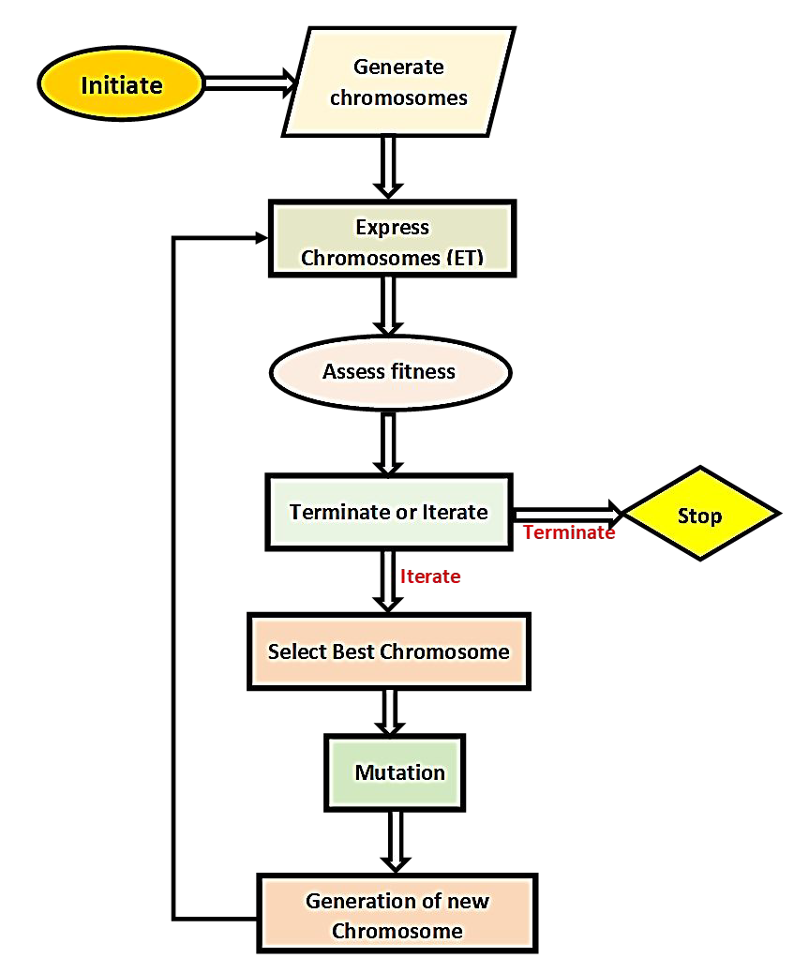
3
4
5
6
7
8
9
10
11
12
13
14
15
16
17
18
19
20
21
22
23
24
25
26
27
28
29
30
31
32
33
34
35
36
37
38
39
40
41
42
43
44 Fig. 1. Flow chart for gene expression programming
45
46
47
48 Fig. 2 illustrates the model developed with GEP in the form of an expression tree (ET).
49
50
51 It shows a total number of three trees for each model, and their addition forms the model. This
52
53 model is used to predict output using the entire range of input conditions. A higher degree of
54
- correlation observed between input and output indicates a robust prediction model.
56
57
58
59
60

1
2
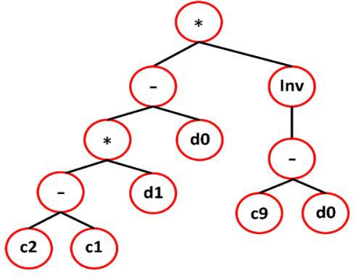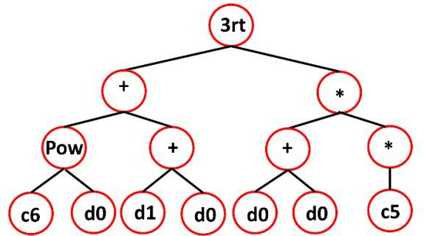3
Sub-ET 1

Sub-ET 2

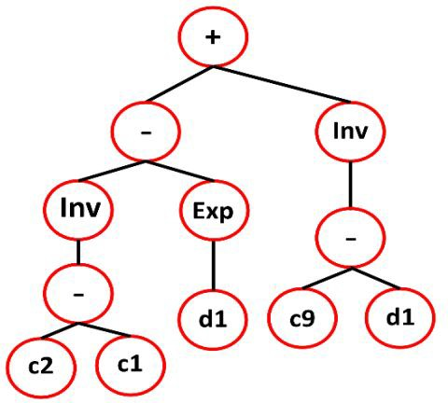
Sub-ET 3
Sub-ET 1

Sub-ET 2

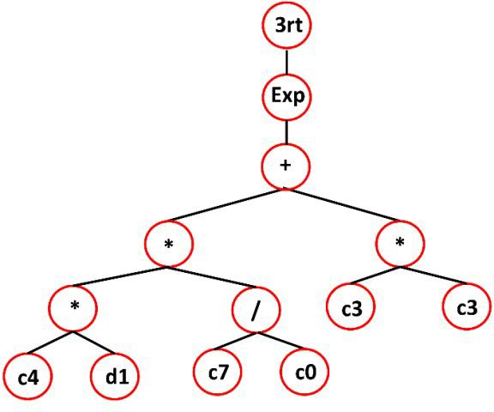
Sub-ET 3
4
5
6
7
8
9
10
11
12
13
14
15
16
17
18
19
20
21
22
23
24
25
26
27
28
29
30
31
32
33
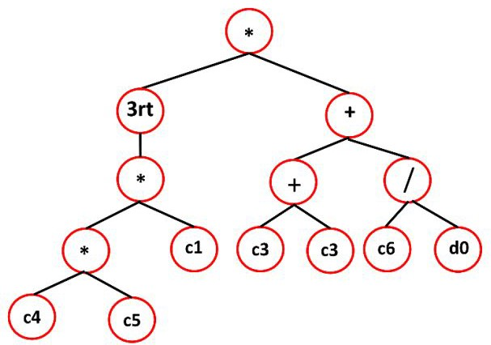
34
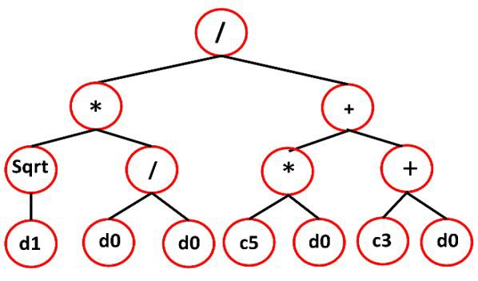
35
36
37
38
39
40
41
42
43
44
45
46
47 (a) (b)
48
49
50
51
52
53
54
55
56
57
58
59
60

1
2
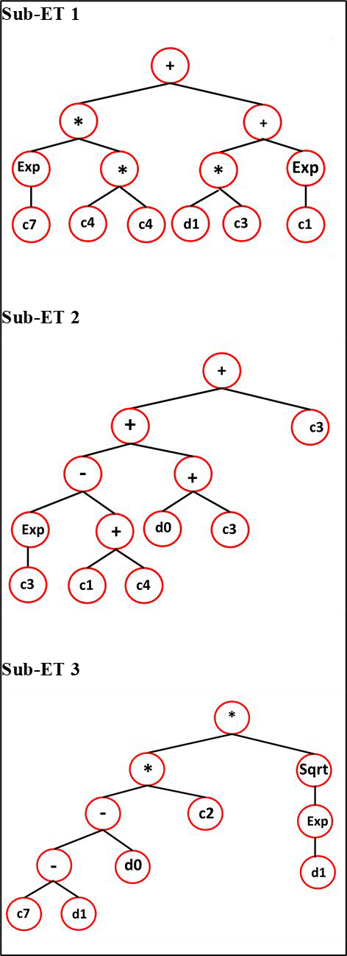
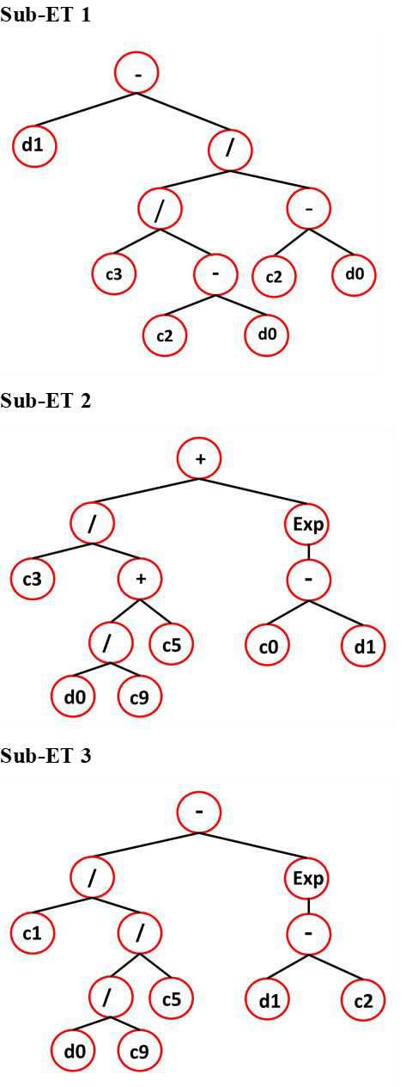3
4
5
6
7
8
9
10
11
12
13
14
15
16
17
18
19
20
21
22
23
24
25
26
27
28
29
30
31
32
33
34
35
36
37
38
39
40
41
42
43
44
45
46
47
48
49
50
51
52 (c) (d)
53
54
55
- Fig. 2. Illustration of GEP model in the form of expression trees (ET) for (a) thermal
- conductivity, (b) density, (c) viscosity, and (d) specific heat
58
59
60

1
2

3 2.3 Adaptive neuro-fuzzy inference system
4
5 The adaptive neuro-fuzzy inference system (ANFIS) is an intelligent computation
6
7
8 modeling technique. It combines the learning and logical reasoning abilities of ANNs and fuzzy
9
10 logic. ANFIS provides higher prognostic capabilities and is a preferable alternative to
11
12 conventional neural networks for complicated non-linear issues [25]. A typical fuzzy inference
13
14
15 system (FIS) has five steps, starting with the introduction of inputs to aid in the fuzzification of
16
17 fuzzy sets based on linguistic rule activation. Specialists design certain rules, which are
18
19 subsequently generated from test results. The next phase is inference, which involves mapping
20
21 fuzzy sets based on established criteria. The fuzzy sets are then defuzzied, yielding the final
22
23
24 output values. Consequently, the ANFIS strategy involves data preparation, ANFIS creation,
25
26 variable selection, training, validation, and output generation [28].
27
28 The ANFIS design is comprised of five separate levels, as seen in Fig. 3. The first layer
29
30
31 is the input layer, which accepts the input value and generates fuzzy values using membership
32
33 functions (MF). This layer contains adaptive type nodes, each with its node function. The
34
35 product layer is the second layer, and it multiplies the input signal. It is made up of fixed nodes
36
37
38 that assess the weight or firing strength. It often employs the fuzzy operator 'AND.' The nodes
39
40 in the third tier are all fixed nodes. The firing strength is computed in this layer. The normalized
41
42 firing strength represents the output. The fourth layer, which contains adaptive nodes, is utilized
43
44 to define the output membership function. The last layer is known as the output layer. It has a
45
46
47 single fixed node that summits all incoming signals from preceding layers [44][45]. To alter the
48
49 parameters of the membership functions throughout the ANFIS training process, a hybrid
50
51 learning strategy combining the least-squares estimate and the gradient descent approach is
52
53
54 used. The node outputs are processed in the forward pass until the least-squares estimate
55
56 determines the output membership function layer and the associated parameters. After the error
57
58 signals have been carried backward, the backward pass uses the gradient descent approach to
59
60

1
2
3 update the premise parameters. A fuzzy set's membership function is a mathematical extension
4
5 of the indicator function. It is an extension of valuation in fuzzy logic that indicates the degree
6
7
8 of validity. Because the ANFIS structure requires a better selection of acceptable form and
9
10 number of membership functions, every ANFIS application requires a firm grasp of fuzzy logic.
11
12 This has an impact on the ANFIS-based model's effectiveness and computation cost. The
13
14
15 number of rules in the ANFIS rule-base is determined by the number of input space partitioning
16
17 membership functions. In addition, the number of parameters in each membership function has
18
19 an effect on training costs. Because of its smooth representation of the input space, the Gaussian
20
21 form of the membership function has only two parameters and is the most commonly used in
22
23
24 the literature [46][32]. Fig. 4 shows the ANFIS flow chart. Fig. 5 illustrates the fuzzy logic and
25
26 membership function for each output model. As illustrated in Fig.6, the model's output may be
27
28 seen using a fuzzy inference system (FIS) designed for each output model.
29
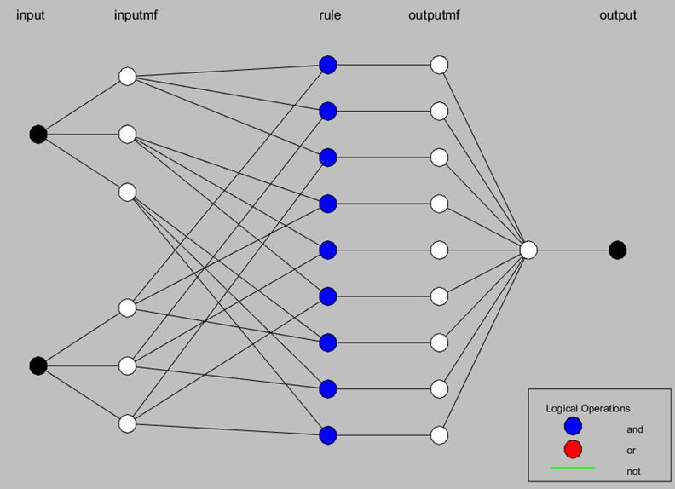30
31
Review
32
33
34
35
36
37
38
39
40
41
42
43
44
45
46
47
48
49
50
51
52
53
54
55
56
57
58 Fig. 3. ANFIS architecture
59
60

1
2
3
Select input variables
Start
4
5
6
7
8
9

Data partition
Testing
Training
10
11
12
13
14
15
16
17
18
MSE
Satisfactory?
No
Yes
MSE
Satisfactory?
No
Yes
Train & test
MF number decision
19
20
21
22
23
24
25
26
27
28
29
30
31
32
33
MF number decision
Train & test
34
35
36
37
38
39
40
41
42
43
44
45
46
47
Proposed model
48
49
50
51
% Error
Prediction
52
53
54
55
56

End
57
58
59
60

1
2
3 Fig. 4. The flow chart of implemented ANFIS modeling technique
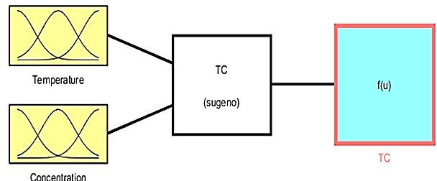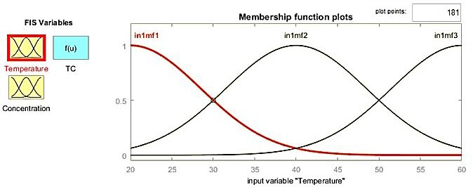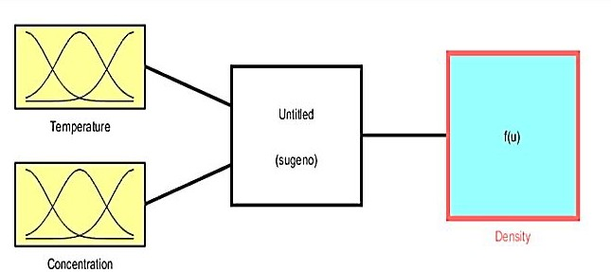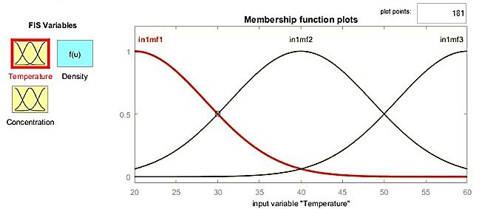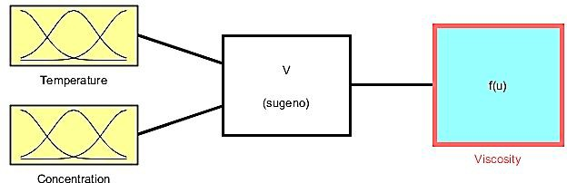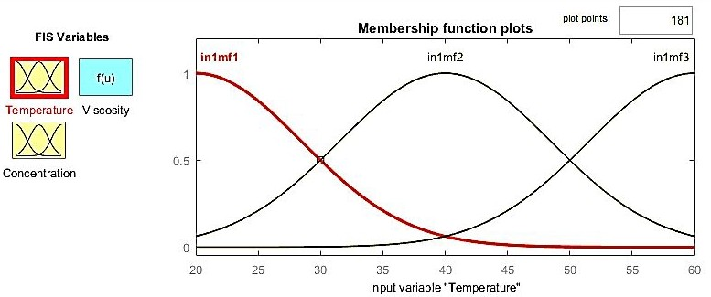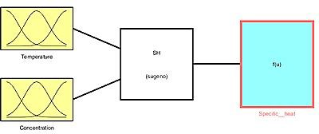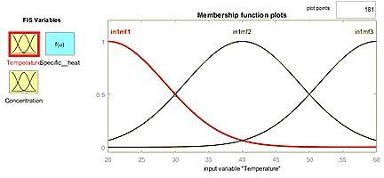4
5
6
7
8
9
10
11
12
13

14 Fuzzy logic Membership function
15 (a)
16
17
18
19
For
20
21
22
23
24
25
26

27 Fuzzy logic Membership function
28 (b)
29
30
31
32
33
34
35
36
37
38

39 Fuzzy logic Membership function
40 (c)
41
42
43
44
45
46
47
48
49
50
51
52

53 Fuzzy logic Membership function
54
55 (d)
56
57
58 Fig. 5. ANFIS fuzzy logic and membership function for (a) - Thermal conductivity
59
60 (b) - Density; (c) – Viscosity; (d) - Specific heat

1
2
3
4 The ANFIS helped in mapping the effects of input parameters on the physio-thermal
5
6 properties of hybrid nanofluids. The 3D surface diagrams depicting the effects of input
7
8
9 parameters are shown in Fig. 6.
10
11
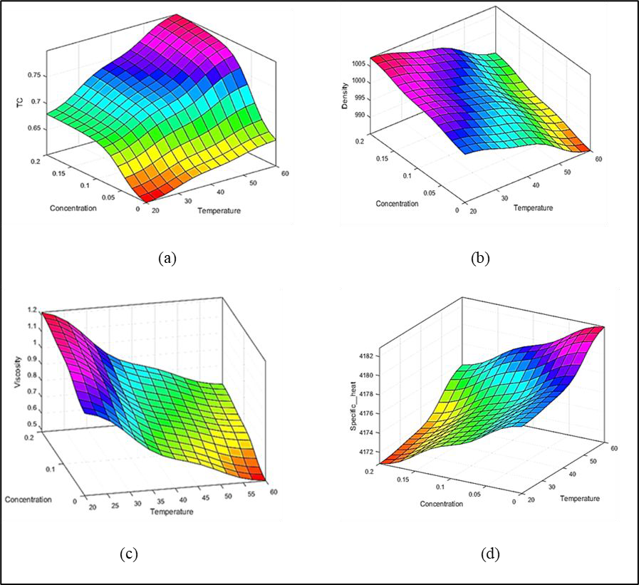
12
13
14
15
16
17
18
19
20
21
22
23
24
25
26
27
28
29
30
31
32
33
34
35
36
37
38
39
40
41
42
43
44
45
46
47
48
49
50
51
52
- Fig. 6. 3D surface diagrams for (a) - Thermal conductivity; (b) – Density; (c) – Viscosity; (d)
- - Specific heat
55
56
57
58
59
60

1
2

3 2.4. Statistical evaluation of prediction models
4
5 The current study investigates model reliability in depth by subjecting the created model
6
7
8 to different error metrics invariant to scale transformation, as well as uncertainty estimation
9
10 measures, to assess the robustness of the ANFIS and GEP-based models. Though commonly
11
12 used model evaluation metrics were used to compare model performance to similar studies,
13
14
15 each result was supported by values obtained from a correspondingly scaled variation of the
16
17 original metric to address the metric's inherent limitations while retaining the attribute of the
18
19 conventional measure.
20
21
22
23

24 2.4.1. Pearson’s coefficient of correlation (R)
25
26 To assess the relationship between measured and predicted output values, the Pearson
27
28 correlation coefficient (R) and coefficient of determination were employed [47]. R is just a
29
30
31 normalized measurement of covariance, with the result always lying between 0 and 1. It is the
32
33 product of the covariances of two variables and their standard deviations. Like covariance, the
34
35 measure may only represent a linear correlation of variables and ignores several other kinds of
36
37
38 linkage or relationship. R has limitations in reporting the correlation if one or more data points
39
40 are missing. The maximum likelihood estimator is utilized in such a case. The expression used
41
42 for the estimation of R is given in Eq. (1).
43

44
45 𝑅 =
46
47
48
49
50
∑𝑛
𝑖 = 1
∑𝑛
𝑖 = 1
(𝑥_{𝑖} ― 𝑥 )² ∑^{𝑛} ( 𝑦_{𝑖} ― 𝑦)²
𝑖 = 1
(𝑥_{𝑖} ― 𝑥)(𝑦_{𝑖} ― 𝑦)

(1)

51 2.4.2. Coefficient of determination (R2)
52
53 Correlation is a comprehensive measure of the strength of a link between variables. The
54
55
56 most common application of the term correlation in the sense of a linear link between two
57
58 continuous variables is Pearson product-moment correlation. A Spearman rank correlation can
59
60 be employed to measure monotonic association for nonnormally distributed continuous data,

1
2
3 ordinal data, or data with noteworthy outliers. Both correlation coefficients are scaled from –1
4
5 to +1, with 0 indicating no linear or monotonic association and 1 indicating a greater
6
7
8 relationship that eventually approaches a straight line [34][48].
9
(
)

10
11 𝑅² = 1 ―
∑𝑛
𝑖 = 1
∑𝑛
(𝑥_{𝑖} ― 𝑦_{𝑖})²
( 𝑦_{𝑖})²
(2)

12 𝑖 = 1
13
14
15
16

17 2.4.3. Mean absolute percentage error
18
19 MAPE is a measure for predicting accuracy. It is also known as a loss function and is
20
21 used to interpret relative error evaluation. A MAPE value can be any positive number between
22
23 0 and 1. The mean absolute percentage error (MAPE) is one of the most often used metrics of
24
25
26 forecast accuracy due to its scale independence and interpretability. On the other hand, MAPE
27
28 has a certain limitation of giving infinite or undefined answers for zero or close-to-zero real
29
30 numbers [49]. However, the combined usage of R2 and MAPE overcomes this difficulty by
31
32
33 presenting an overall quality of prediction. The following formula was used to compute MAPE:
34

35 𝑀𝐴𝑃𝐸 = 1∑𝑛
|𝑥𝑎𝑖 ― 𝑥𝑝𝑖| × 100

(3)

36 𝑛
37
38
39
40
𝑖 = 1
𝑥𝑎𝑖

41 2.4.4. Root mean squared error
42
43 The RMSE is a predictive ability statistic that considers the magnitudes of prediction
44
45 errors for several data points. The RMSE is a scale-dependent accuracy statistic used to
46
47
48 compare the prediction errors of many models on a single dataset rather than across datasets.
49
50 The RMSE number is never negative, and a value of 0 (which is seldom reached in practice)
51
52 implies that the data is perfectly matched. A lower RMSE is better than a higher RMSE in
53
54 general. Comparing different data types would be erroneous since the metric is susceptible to
55
56
57 outliers and relies on the quantity of the numbers used. The following expression was used for
58
59 the calculation of RMSE:
60

1
2
3
4 𝑅𝑀𝑆𝐸 =
5
6
7
[
∑
𝑛
𝑖 = 1
(𝑥𝑝𝑖 ― 𝑥𝑎𝑖)2]
𝑛

(4)

8 2.4.5. Nash-Sutcliffe efficiency (NSCE) and Kling-Gupta efficiency (KGE)
9
10 The Nash–Sutcliffe efficiency is a popular statistical index since it normalizes model
11
12 performance onto an understandable scale. The NSE metric measures how well-simulated data
13
14 predict output data in a model. It is a normalized statistical number between 0 and 1 that
15
16
17 indicates the ratio of residual variance ("noise") to real data variance ("information"). The
18
19 closest NSE value denotes a perfect match between experimental and model data. The Nash–
20
21 Sutcliffe Coefficient obscures fundamental behaviors that, if recast, might assist in
22
23
24 understanding model behavior in terms of bias, unpredictability, and other aspects. The
25
26 alternative "Kling-Gupta" efficiency bounds differ from those of the NSE [50][51]. The
27
28 following expressions were used for the estimation of NSCE and KGE.
}
29

30 |
31
𝑁𝑆𝐶𝐸 =
1 ― {

∑𝑛
𝑖 = 1
(5)

(𝑥
― 𝑥 )² |

32
33
34
35 𝐾𝐺𝐸 = 1 ―
(𝛿 ― 1)² + (𝛼 ― 1)² + (𝑅 ― 1)²
36
∑𝑛
𝑖 = 1
𝑎𝑖
𝑝𝑖
(𝑥_{𝑎𝑖} ― 𝑥_{𝑝})2

(6)

37 Where, (for Eq. (1) to Eq. (6)), ‘i’ represents term under consideration, ‘n’ represents total
38
39
40 elements, ‘x_{ai}’ denotes the actual value, ‘x_{pi}’ represents predicted value, ′𝑥_{𝑎}′ is mean actual values, 𝑥_{𝑝} is
41
42 mean predicted values, ‘δ’ denotes bias error, ‘α’ denotes error in flow variability, and correlation is
43
44 shown with ‘R’.
45
46
47

48 2.5 Taylor diagrams for model comparison
49
50 Taylor diagrams effectively demonstrate better models that use several model
51
52 performance metrics as a single visual comparison portrayal [52]. They are an excellent tool
53
54
55 for displaying improved models since they utilize several model performance criteria as a single
56
57 visual comparison depiction. Taylor diagrams are utilized in this research to compare
58
59 the statistical correlation between observed and ML-based model performance in simulating
60

1
2
3 the thermophysical characteristics of hybrid nanofluids. Correlation, standard deviation, and
4
5 root-mean-square error were determined for the graphical representation of the relationship
6
7
8 between observed and simulated data. The Taylor diagram facilitates model comparison by
9
10 showing them in a single figure. The radial distance from the origin represents the standard
11
12 deviation between observed and simulated data, whereas the distance from the observed point
13
14
15 on the x-axis represents the centered root-mean-square error (CRMSE) [53].
16
17
18

19 3. Results and discussion
20
21
22 The research study aims to characterize the different thermophysical characteristics of
23
24 Fe₃O₄ coated MWCNT hybrid nanofluids utilizing two clever AI-based approaches, GEP and
25
26 ANFIS. Thermal conductivity, viscosity, density, and specific heat of hybrid nanofluids were
27
28 investigated in a laboratory-scale experiment. The measurements were taken at various
29
30
31 temperatures and nanoparticle concentration ratios in the base fluid. The experiment data was
32
33 then utilized to build prediction models [54][55]. GEP was used for model generation and
34
35 prediction in the first phase, whereas in the second phase, ANFIS was used for model prediction
36
37
38 under comparable conditions. Each attribute was given its model using GEP and ANFIS. Their
39
40 prediction abilities are then compared using statistical markers and a Taylor diagram.
41
42
43
44

45 3.1 Model prediction of thermal conductivity
46
47 The developed models for thermal conductivity using ANFIS and GEP were evaluated
48
49 and found to be in good agreement with observed data, as shown in Fig. 7. The experimentally
50
51 determined thermal conductivity and predicted thermal conductivity are compared with trend
52
53
54 lines in Fig.7a. In Fig.7b, the performance of ANFIS and GEP projected values is shown for
55
56 the complete dataset. The ANFIS and GEP models both performed excellently and were found
57
58
59
60

1
2
3 to be in good agreement with experimental data of thermal conductivity over a wide range of
4
5 temperatures and concentration ratios.
6
7
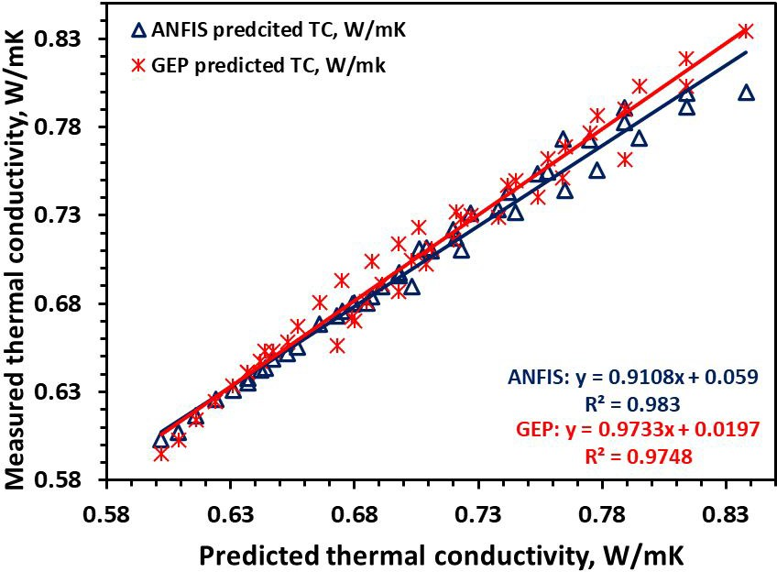
8
9
10
11
12
13
14
15
16
17
18
19
For
Peer
20
21
22
23
24
25
26
27
28
29
30
31
32
33 (a)
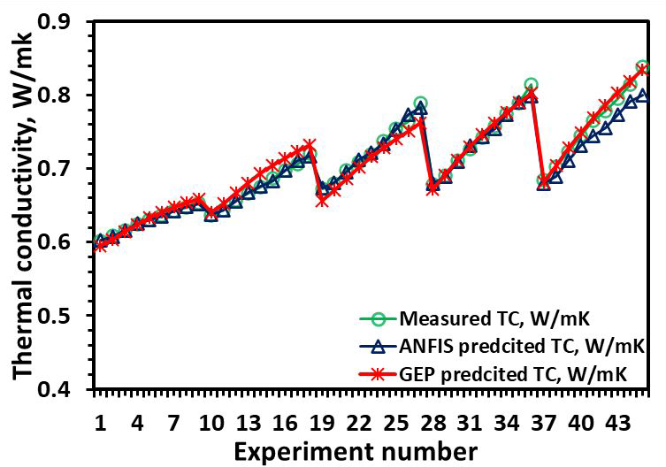
34
35
36
37
38
39
40
41
42
43
44
45
46
47
48
49
50
51
52
53
54
55
56
57
58 (b)
59
60

1
2
3 Fig .7. Shows comparison with ANFIS and GEP for (a) the measured versus predicted
4
5 thermal conductivities and (b) all the datapoints
6
7
8
9 Statistical indicators were used to evaluate the thermal conductivity model's prediction
10
11 effectiveness. In the case of ANFIS, the correlation value R was 0.9914; however, with the GEP
12
13 model, it was reduced to 0.9872. R2 values for ANFIS and GEP were 0.983 and 0.9748,
14
15
16 respectively. The RMSE values for ANFIS and GEP were 0.0098 and 0.0095, respectively,
17
18 while the MAPEs were 0.74 and 1.08%, respectively. The predictive effectiveness of the
19
20 models tested using KGE for ANFIS and GEP was 0.9182 and 0.9188, respectively; similarly,
21
22
23 the NSCE for ANFIS and GEP was 0.9735 and 0.9755, respectively. Table 1 shows the
24
25 statistical indicators of model evaluation employed in this study. The Taylor diagram, shown
26
27 in Fig. 8, is utilized to further compare the thermal conductivity models. The Taylor diagram
28
29 further proves the superiority of the ANFIS-based thermal conductivity model over the GEP
30
31
32 model since the ANFIS model is closer to the observed values.
33
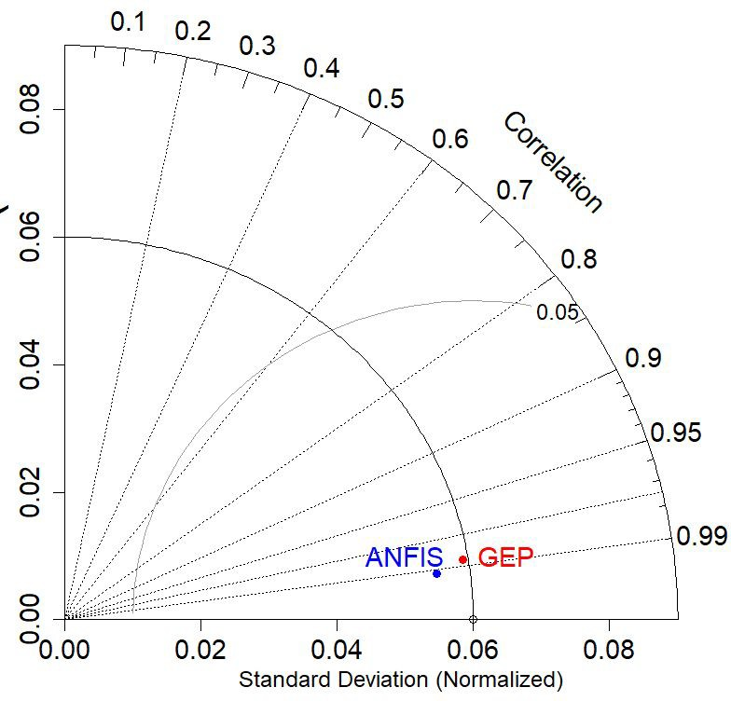
34
35
36
37
38
39
40
41
42
43
44
45
46
47
48
49
50
51
52
53
54
55
56
57
58
59
60

1
2
3 Fig. 8. Taylor diagram for thermal conductivity model
4
5
6
7

8 3.2. Model prediction of density
9
10 The relative prediction performance of ANFIS and GEP for the density model is depicted
11
12 in Fig. 9. Trendlines were used to compare the model projected density with observed density,
13
14
15 as shown in Fig. 9a. In Fig. 9b, the performance of ANFIS and GEP projected values is shown
16
17 for the entire density dataset. It was observed that the ANFIS and GEP models could forecast
18
19 density over a wide variety of test conditions. GEP, on the other hand, outperforms ANFIS in
20
21
22 the density model.
23
24 The predictive efficacy of ANFIS and GEP-based density models is assessed using
25
26 statistical indicators. In the instance of ANFIS, the correlation value R was 0.9816, but it
27
28
29 improved to 0.9974 for the GEP-based density model. While the R2 for ANFIS and GEP were
30
31 0.9636 and 0.9948, respectively. RMSE and MAPE were used to calculate model errors in the
32
33 present study. The RMSE for ANFIS and GEP was as low as 1.462 and 0.475, respectively
34
35 while MAPEs for ANFIS and GEP were exceedingly low, at 0.09% and 0.03%, respectively.
36
37
38 The predicted efficiencies of the density model were evaluated with KGE and NSCE. KGE was
39
40 0.8985 and 0.9965 for ANFIS and GEP based models, respectively; similarly, the NSCEs for
41
42 ANFIS and GEP were 0.98455 and 0.9985, respectively. Table 1 shows the statistical indices
43
44
45 obtained in this investigation. As demonstrated in Fig.10, all statistical indicators are depicted
46
47 in a single graph using a spider plot.
48
49
50
51
52
53
54
55
56
57
58
59
60

1
2
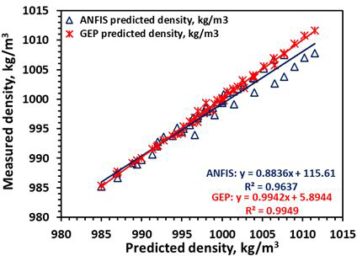
3
4
5
6
7
8
9
10
11
12
13
14
15
16
17
18
19
20
21
22
23
24
25
26 (a)
27
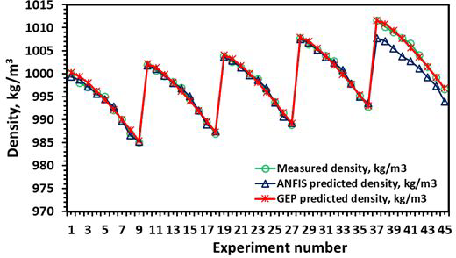
28
29
30
31
32
33
34
35
36
37
38
39
40
41
42
43
44
45
46
47
48
49
50 (b)
51
52
53 Fig. 9. Shows comparison with ANFIS and GEP of (a) the measured versus predicted densities
54
55 and (b) the density versus experiment number.
56
57
58
59
60

1
2
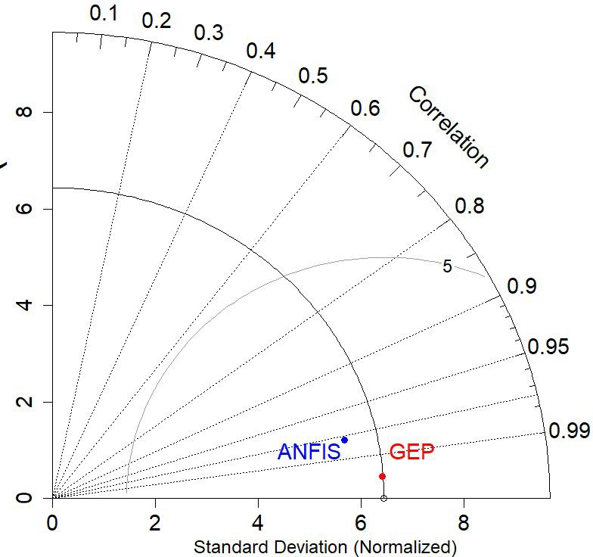
3
4
5
6
7
8
9
10
11
12
13
14
15
16
17
18
19
For
20
21
22
23
24
25
26
27
28 Fig. 10. Taylor diagram for density model
29
30
31
32

33 3.3 Model prediction of viscosity
34
35 The viscosity data of Fe₃O₄ Coated MWCNT hybrid nanofluids were employed to
36
37 develop predictive models with ANFIS and GEP. Fig. 11 compares and displays the predicted
38
39
40 outcomes of both models. A comparison graph comparing the observed and expected viscosity
41
42 is provided in Fig. 11a. The performance of ANFIS and GEP projected values for the entire
43
44 viscosity dataset is shown in Fig. 11b. The ANFIS and GEP models were validated using
45
46 measured viscosities and demonstrated excellent prediction performance over the whole range
47
48
49 of test conditions. In contrast, the GEP-based viscosity model outperformed the ANFIS-based
50
51 viscosity model.
52
53
54
55
56
57
58
59
60

1
2
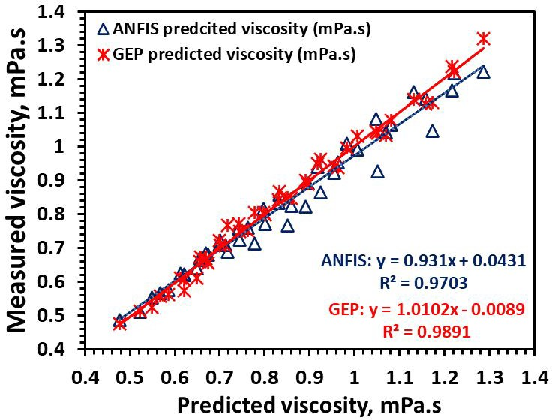
3
4
5
6
7
8
9
10
11
12
13
14
15
16
17
18
19
20
21
22
23
24
25 (a)
26
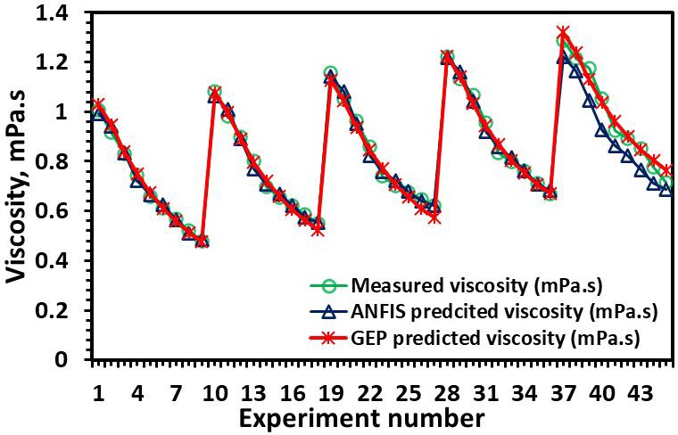
27
28
29
30
31
32
33
34
35
36
37
38
39
40
41
42
43
44
45
46
47 (b)
48
49 Fig. 11. Shows comparison with ANFIS and GEP of (a) the measured versus predicted
50
51 viscosity model (b) the viscosity versus experiment number.
52
53
54 The prediction performance of ANFIS and GEP-based viscosity models were evaluated
55
56
57 using statistical markers. R2 values for ANFIS and GEP were 0.9702 and 0.9891, respectively.
58
59 The correlation coefficient R for ANFIS was 0.9850, whereas it was 0.9945 for GEP. The errors
60

1
2
3 in the models were calculated using RMSE and MAPE. The RMSE values for ANFIS and GEP
4
5 were as low as 0.0396 and 0.0221, respectively. ANFIS and GEP MAPEs were 2.93 and 2.16%,
6
7
8 respectively. The prediction efficiencies for ANFIS and GEP KGE were 0.9402 and 0.9835,
9
10 respectively, while the NSCEs for ANFIS and GEP were 0.9645 and 0.9895. The statistical
11
12 indices acquired in the current study are shown in Table 1. The viscosity models created with
13
14
15 ANFIS and GEP were compared using Taylor diagrams (Fig .12). In terms of prediction, both
16
17 models were very efficient and accurate. In terms of statistical indices and the Taylor diagram,
18
19 the GEP model outperformed the ANFIS model.
20
21
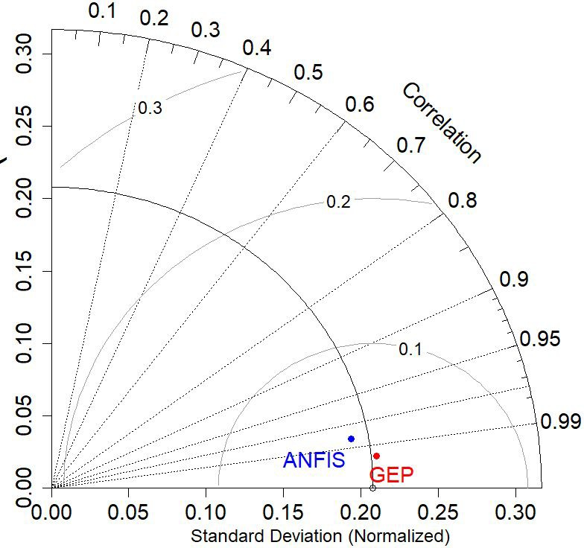
22
23
24
25
26
27
28
29
30
31
32
33
34
35
36
37
38
39
40
41
42
43
44
45
46 Fig. 12. Taylor diagram for viscosity model
47
48
49
50

51 3.4. Model prediction of specific heat
52
53 The observed specific heat data of Fe₃O₄ coated MWCNT hybrid nanofluids were used
54
55 to build prediction models utilizing ANFIS and GEP. In Fig. 13, the expected results of both
56
57
58 models are contrasted and shown by comparing graphs. Fig. 13a depicts a graph comparing
59
60 observed and predicted specific heat data. Fig. 13b depicts the performance of ANFIS and GEP

1
2
3 projected values throughout the whole dataset. The ANFIS and GEP models performed
4
5 admirably over the whole range of test conditions. On the other hand, the GEP-based particular
6
7
8 heat model outperformed the ANFIS-based specific heat model.
9
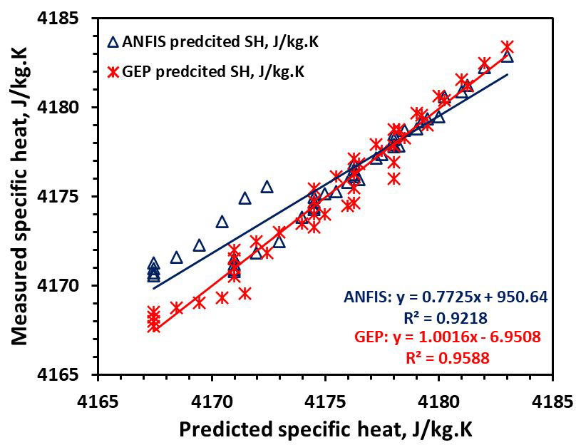
10
11
12
13
14
15
16
17
18
19
20
21
22
23
24
25
26
27
28
29
30
31
32 (a)
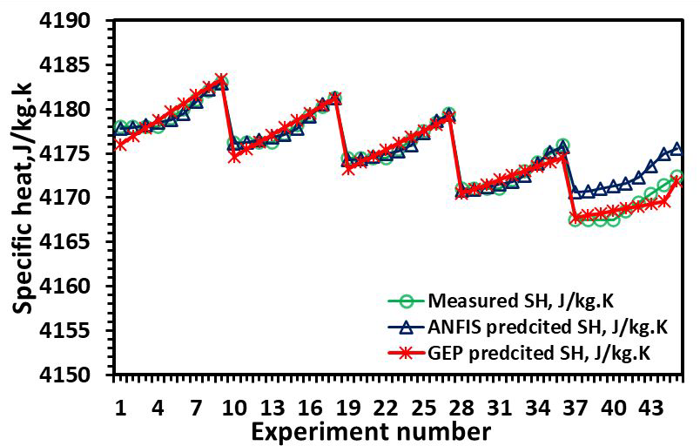
33
34
35
36
37
38
39
40
41
42
43
44
45
46
47
48
49
50
51
52
53
54
55
56 (b)
57 Fig .13. Shows comparison with ANFIS and GEP of (a) the measured versus predicted
58
59 specific heat model and (b) the specific heat versus experiment number.
60

1
2
3 The predictive capability of a specific heat model built using two AI-based intelligence
4
5 algorithms, ANFIS and GEP, was evaluated using statistical criteria. The correlation coefficient
6
7
8 R for ANFIS was 0.9601, while the GEP-based model increased to 0.9825. ANFIS and GEP
9
10 had R2 values of 0.9218 and 0.9654, respectively. The RMSE values for ANFIS and GEP were
11
12 1.495 and 0.7929, respectively, with MAPEs of 0.02% and 0.01%. KGE for ANFIS and GEP
13
14
15 were 0.8015 and 0.9695, respectively. The NSCE values for ANFIS and GEP were 0.8748 and
16
17 0.9566, respectively. The statistical indices acquired in this study are shown in Table 1. The
18
19 Taylor diagram was also used to compare the individual heat models (Fig .14). The GEP-based
20
21 specific heat model outperforms the ANFIS model, as evidenced by the Taylor diagram, which
22
23
24 demonstrates that the GEP model is closer to the baseline value. In Fig.15, all statistical
25
26 indicators are shown in a single graph using a spider plot.
27
28
29
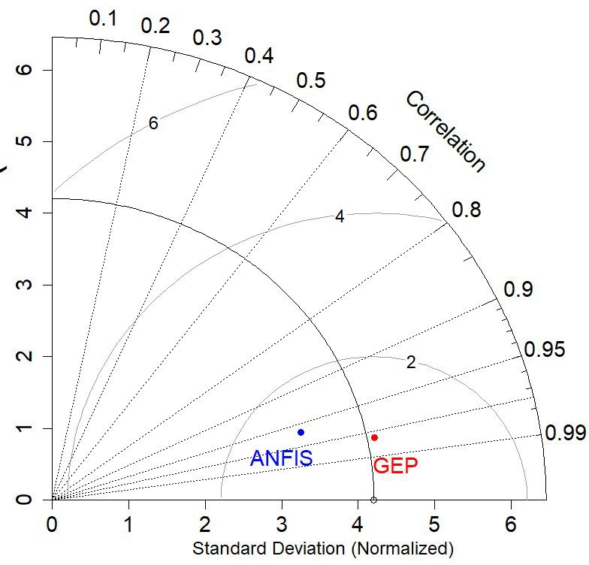
30
31
Review
32
33
34
35
36
37
38
39
40
41
42
43
44
45
46
47
48
49
50
51
52
53
54
55 Fig. 14. Taylor diagram for specific heat model
56
57
58
59
60

1
2
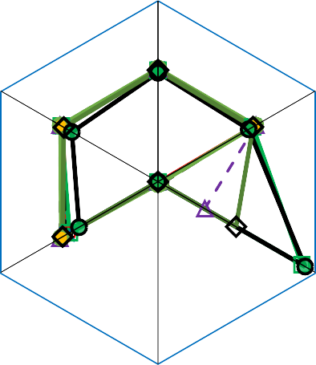3
Thermal conductivity ANFIS Density ANFIS
Viscosity ANFIS
Specific heat ANFIS
Thermal conductivity GEP Density GEP
Viscosity GEP
Specific heat GEP
R
NSCE
1.6
1.4
1.2
1
0.8
0.6
0.4
0.2
0
R2
KGE
RMSE
MAPE
4
5
6
7
8
9
10
11
12
13
14
15
16
17
18
19
For
Peer
20
21
22
23
24
25
26
27
28
29
30 Fig. 15. Spider plot of various statistical indices
31
32
33
34 Table 1. Statistical indices for ANFIS and GEP models
35

36 Parameter R R2 RMSE MAPE KGE NSCE
Thermal conductivity | ANFIS | 0.9914 | 0.983 | 0.0098 | 0.74% | 0.9182 | 0.9735
 | GEP | 0.9872 | 0.9748 | 0.0095 | 1.08% | 0.9188 | 0.9755
Density | ANFIS | 0.9816 | 0.9636 | 1.462 | 0.09% | 0.8985 | 0.9845
 | GEP | 0.9974 | 0.9948 | 0.4753 | 0.03% | 0.9965 | 0.9958
Viscosity | ANFIS | 0.985 | 0.9702 | 0.0396 | 2.93% | 0.9402 | 0.9645
 | GEP | 0.9945 | 0.9891 | 0.0221 | 2.16% | 0.9832 | 0.9895
Specific heat | ANFIS | 0.9601 | 0.9218 | 1.495 | 0.02% | 0.8015 | 0.8748
 | GEP | 0.9825 | 0.9654 | 0.7929 | 0.01% | 0.9695 | 0.9566

37
38
39
40
41
42
43
44
45
46
47
48
49
50

51 4. Conclusions and future perspective
52
53 The feasibility of AI-based GEP and Neuro-fuzzy techniques in modeling thermophysical
54
55 characteristics of Fe₃O₄ coated MWCNT hybrid nanofluid was explored in this work.
56
57
58 Laboratory analyses of the thermophysical characteristics of hybrid nanofluids provided the
59
60 data for the prognostic model. Thermal conductivity, viscosity, density, and specific heat were

1
2
3 determined in 5 ℃ increments throughout a 20 oC to 60 oC nanofluid temperature range and at
4
5 various nanofluid concentrations (0%, 0.05%, 0.10%, 0.20%, and 0.30%). The model was
6
7
8 trained using 70% of the datasets, with the remaining 15% utilized for testing and validation.
9
10 Thermal conductivity, density, viscosity, and specific heat of Fe₃O₄ coated MWCNT hybrid
11
12 nanofluid were effectively predicted using both GEP, and ANFIS approaches. The following
13
14
15 are the main outcomes of the study:
16
17 • The prediction of thermophysical properties by GEP outperformed those of ANFIS. The
18
19 GEP technique provides for an easier model development formulation and a higher
20
21
22 degree of consistency between simulated and experimental data.
23
24 • The ANFIS and GEP models both fared well on statistical regression indices. The R for
25
26 ANFIS was more than 0.9601 and greater than 0.9825 for GEP. In all situations, the R2
27
28
29 value for ANFIS was greater than 0.9218, whereas it was greater than 0.9654 for GEP.
30
31 • The mean absolute percentage error (MAPE) for the ANFIS and GEP models was less
32
33 than 2.93% and 2.16%, respectively. The root mean squared error (RMSE) for the
34
35
36 ANFIS and GEP models was less than 1.495 and 0.9729, respectively.
37
38 • Taylor diagrams were used to compare the ANFIS and GEP-based prognostic models.
39
40 These graphics demonstrate the GEP's superiority over ANFIS. For comparison, all
41
42 statistical markers were displayed using a spider diagram.
43
44
45 The proposed GEP and ANFIS-based prognostic models are efficient for forecasting the
46
47 thermophysical properties of hybrid nanofluids based on temperature and nanoparticle
48
49 concentrations, resulting in a cost-effective, time-saving, and dependable approach. Finally,
50
51
52 based on the results of this study, it is crucial to emphasize that AI techniques are incredibly
53
54 robust and effective tools for dealing with complicated processes, especially when mapping the
55
56 properties of hybrid nanofluids. An intelligent generalization of mathematical equations to
57
58
59 previously unknown data is possible. The author proposes that the current study be expanded
60

1
2
3 to cover various additional types of AI approaches. This may assist in the development of a
4
5 database that will aid in the selection of an appropriate AI technique.
6
7
8
9

10 Declaration of interests
11
12 The authors declare that they have no known competing financial interests or personal
13
14 relationships that could have appeared to influence the work reported in this paper.
15
16
17
18
19 References
20
21 [1] S. Lee, S. U.-S. Choi, S. Li, and J. A. Eastman, “Measuring Thermal Conductivity of
22
23 Fluids Containing Oxide Nanoparticles,” Journal of Heat Transfer, vol. 121, no. 2, pp.
24 280–289, May 1999.
25
- [2] Z. Said, M. Ghodbane, L. S. Sundar, A. K. Tiwari, M. Sheikholeslami, and B.
- Boumeddane, “Heat transfer, entropy generation, economic and environmental analyses
28
29 of linear fresnel reflector using novel rGO-Co3O4 hybrid nanofluids,” Renewable
30 Energy, vol. 165, pp. 420–437, Mar. 2021.
31
32 [3] L. Yang, W. Ji, M. Mao, and J. Huang, “An updated review on the properties, fabrication
33
- and application of hybrid-nanofluids along with their environmental effects,” Journal of
- Cleaner Production, vol. 257, p. 120408, Jun. 2020.
36
- [4] M. Jamei, I. A. Olumegbon, M. Karbasi, I. Ahmadianfar, A. Asadi, and M. Mosharaf-
- Dehkordi, “On the Thermal Conductivity Assessment of Oil-Based Hybrid Nanofluids
39
- using Extended Kalman Filter integrated with feed-forward neural network,”
- International Journal of Heat and Mass Transfer, vol. 172, p. 121159, Jun. 2021.
42
- [5] M. Jurčević, S. Nižetić, M. Arıcı, A. T. Hoang□, E. Giama, and A. Papadopoulos,
- “Thermal constant analysis of phase change nanocomposites and discussion on selection
45
46 strategies with respect to economic constraints,” Sustainable Energy Technologies and
47
- Assessments, vol. 43, no. February, p. 100957, 2021.
- [6] M. Subramanian et al., “A technical review on composite phase change material based
50
- secondary assisted battery thermal management system for electric vehicles,” Journal of
- Cleaner Production, p. 129079, 2021.
53
- [7] Z. Said, M. A. Abdelkareem, H. Rezk, and A. M. Nassef, “Fuzzy modeling and
- optimization for experimental thermophysical properties of water and ethylene glycol
56
57 mixture for Al2O3 and TiO2 based nanofluids,” Powder Technology, vol. 353, pp. 345–
58 358, Jul. 2019.
59
60 [8] V. H. Iyer, S. Mahesh, R. Malpani, M. Sapre, and A. J. Kulkarni, “Adaptive Range

1
2
3 Genetic Algorithm: A hybrid optimization approach and its application in the design and
4
- economic optimization of Shell-and-Tube Heat Exchanger,” Engineering Applications
- of Artificial Intelligence, vol. 85, pp. 444–461, Oct. 2019.
7
- [9] P. Sharma and A. K. Sharma, “Application of Response Surface Methodology for
- Optimization of Fuel Injection Parameters of a Dual Fuel Engine Fuelled with Producer
10
- Gas- Biodiesel blends,” Energy Sources, Part A: Recovery, Utilization, and
- Environmental Effects, vol. 0, no. 0, pp. 1–18, 2021.
13
- [10] S. D. Al-Majidi, M. F. Abbod, and H. S. Al-Raweshidy, “A particle swarm optimisation-
- trained feedforward neural network for predicting the maximum power point of a
16
17 photovoltaic array,” Engineering Applications of Artificial Intelligence, vol. 92, p.
18
19 103688, Jun. 2020.
20 [11] P. Sharma, “Artificial intelligence‐based model prediction of biodiesel‐fueled engine
21
- performance and emission characteristics: A comparative evaluation of gene expression
- programming and artificial neural network,” Heat Transfer, vol. 50, no. 6, pp. 5563–
24
25 5587, Sep. 2021.
26 [12] M. Bahiraei, S. Heshmatian, and H. Moayedi, “Artificial intelligence in the field of
27
28 nanofluids: A review on applications and potential future directions,” Powder
29 Technology, vol. 353, pp. 276–301, Jul. 2019.
30
31 [13] A. Pare and S. K. Ghosh, “A unique thermal conductivity model (ANN) for nanofluid
32
- based on experimental study,” Powder Technology, vol. 377, pp. 429–438, Jan. 2021.
- [14] Y. Peng et al., “Develop optimal network topology of artificial neural network (AONN)
35
- to predict the hybrid nanofluids thermal conductivity according to the empirical data of
- Al2O3 – Cu nanoparticles dispersed in ethylene glycol,” Physica A: Statistical
38
- Mechanics and its Applications, vol. 549, p. 124015, Jul. 2020.
- [15] P. K. Kanti, K. V. Sharma, Z. Said, M. Jamei, and K. M. Yashawantha, “Experimental
41
- investigation on thermal conductivity of fly ash nanofluid and fly ash-Cu hybrid
- nanofluid: prediction and optimization via ANN and MGGP model,” Particulate Science
44
45 and Technology, pp. 1–14, Jun. 2021.
46
- [16] M. Sadeghzadeh et al., “Prediction of Thermo-Physical Properties of TiO2-
- Al2O3/Water Nanoparticles by Using Artificial Neural Network,” Nanomaterials, vol.
49
50 10, no. 4, p. 697, Apr. 2020.
51 [17] M. H. Ahmadi, B. Mohseni-Gharyehsafa, M. Farzaneh-Gord, R. D. Jilte, R. Kumar, and
52
- K. Chau, “Applicability of connectionist methods to predict dynamic viscosity of
- silver/water nanofluid by using ANN-MLP, MARS and MPR algorithms,” Engineering
55
- Applications of Computational Fluid Mechanics, vol. 13, no. 1, pp. 220–228, Jan. 2019.
- [18] M. Jamei, I. Ahmadianfar, I. A. Olumegbon, M. Karbasi, and A. Asadi, “On the
58
59 assessment of specific heat capacity of nanofluids for solar energy applications:
60

1
2
3 Application of Gaussian process regression (GPR) approach,” Journal of Energy
4
5 Storage, vol. 33, p. 102067, Jan. 2021.
6 [19] M. Gholizadeh, M. Jamei, I. Ahmadianfar, and R. Pourrajab, “Prediction of nanofluids
7
8 viscosity using random forest (RF) approach,” Chemometrics and Intelligent Laboratory
9 Systems, vol. 201, p. 104010, Jun. 2020.
10
- [20] S. E. Awan, M. A. Z. Raja, M. Awais, and C.-M. Shu, “Intelligent Bayesian
- regularization networks for bio-convective nanofluid flow model involving gyro-tactic
13
- organisms with viscous dissipation, stratification and heat immersion,” Engineering
- Applications of Computational Fluid Mechanics, vol. 15, no. 1, pp. 1508–1530, Jan.
16
17 2021.
18
- [21] S. Alotaibi, M. A. Amooie, M. H. Ahmadi, N. Nabipour, and K. Chau, “Modeling
- thermal conductivity of ethylene glycol-based nanofluids using multivariate adaptive
21
- regression splines and group method of data handling artificial neural network,”
- Engineering Applications of Computational Fluid Mechanics, vol. 14, no. 1, pp. 379–
24
25 390, Jan. 2020.
26 [22] R. Khosravi, A. R. Teymourtash, M. Passandideh Fard, S. Rabiei, and M. Bahiraei,
27
- “Numerical study and optimization of thermohydraulic characteristics of a graphene–
- platinum nanofluid in finned annulus using genetic algorithm combined with decision-
30
31 making technique,” Engineering with Computers, vol. 37, no. 3, pp. 2473–2491, Jul.
32
33 2021.
34 [23] S. M. Javadpour, E. Abbasi Jannat Abadi, O. A. Akbari, and M. Goharimanesh,
35
- “Optimization of geometry and nano-fluid properties on microchannel performance
- using Taguchi method and genetic algorithm,” International Communications in Heat
38
- and Mass Transfer, vol. 119, p. 104952, Dec. 2020.
- [24] M. Nait Amar, A. Jahanbani Ghahfarokhi, and N. Zeraibi, “Predicting thermal
41
- conductivity of carbon dioxide using group of data-driven models,” Journal of the
- Taiwan Institute of Chemical Engineers, vol. 113, pp. 165–177, Aug. 2020.
44
45 [25] T. Salameh, P. P. Kumar, E. T. Sayed, M. A. Abdelkareem, H. Rezk, and A. G. Olabi,
46
- “Fuzzy modeling and particle swarm optimization of Al2O3/SiO2 nanofluid,”
- International Journal of Thermofluids, vol. 10, p. 100084, May 2021.
49
- [26] M. Malika and S. S. Sonawane, “Application of RSM and ANN for the prediction and
- optimization of thermal conductivity ratio of water based Fe2O3 coated SiC hybrid
52
53 nanofluid,” International Communications in Heat and Mass Transfer, vol. 126, p.
54 105354, Jul. 2021.
55
- [27] V. Kumar, A. Pare, A. K. Tiwari, and S. K. Ghosh, “Efficacy evaluation of oxide-
- MWCNT water hybrid nanofluids: An experimental and artificial neural network
58
59 approach,” Colloids and Surfaces A: Physicochemical and Engineering Aspects, vol.
60

1
2
3 620, p. 126562, Jul. 2021.
4
- [28] D. J. Armaghani and P. G. Asteris, “A comparative study of ANN and ANFIS models
- for the prediction of cement-based mortar materials compressive strength,” Neural
7
- Computing and Applications, vol. 33, no. 9, pp. 4501–4532, May 2021.
- [29] R. Razavi, A. Sabaghmoghadam, A. Bemani, A. Baghban, K. wing Chau, and E.
10
- Salwana, “Application of ANFIS and LSSVM strategies for estimating thermal
- conductivity enhancement of metal and metal oxide based nanofluids,” Engineering
13
- Applications of Computational Fluid Mechanics, 2019.
- [30] S. A. Fatima, N. Ramli, S. A. A. Taqvi, and H. Zabiri, “Prediction of industrial
16
17 debutanizer column compositions using data-driven ANFIS- and ANN-based
18
19 approaches,” Neural Computing and Applications, vol. 33, no. 14, pp. 8375–8387, Jul.
20 2021.
21
- [31] Z. Said, L. S. Sundar, H. Rezk, A. M. Nassef, H. M. Ali, and M. Sheikholeslami,
- “Optimizing density, dynamic viscosity, thermal conductivity and specific heat of a
24
- hybrid nanofluid obtained experimentally via ANFIS-based model and modern
- optimization,” Journal of Molecular Liquids, vol. 321, p. 114287, Jan. 2021.
27
- [32] Z. Said, L. S. Sundar, H. Rezk, A. M. Nassef, S. Chakraborty, and C. Li,
- “Thermophysical properties using ND/water nanofluids: An experimental study,
30
31 ANFIS-based model and optimization,” Journal of Molecular Liquids, vol. 330, p.
32
33 115659, May 2021.
34 [33] M. R. Dobbelaere, P. P. Plehiers, R. Van de Vijver, C. V. Stevens, and K. M. Van Geem,
35
- “Machine Learning in Chemical Engineering: Strengths, Weaknesses, Opportunities,
- and Threats,” Engineering, vol. 7, no. 9, pp. 1201–1211, Sep. 2021.
38
- [34] J. Abdulsalam, A. I. Lawal, R. L. Setsepu, M. Onifade, and S. Bada, “Application of
- gene expression programming, artificial neural network and multilinear regression in
41
42 predicting hydrochar physicochemical properties,” Bioresources and Bioprocessing, vol.
43 7, no. 1, p. 62, Dec. 2020.
44
45 [35] A. Ş. Şahin, E. Dikmen, and S. Şentürk, “A gene expression programming approach for
46
- thermodynamic properties of working fluids used on Organic Rankine Cycle,” Neural
- Computing and Applications, vol. 31, no. 8, pp. 3947–3955, Aug. 2019.
49
- [36] D. Kakati, S. Roy, and R. Banerjee, “Development and validation of an artificial
- intelligence platform for characterization of the exergy-emission-stability profiles of the
52
- PPCI-RCCI regimes in a diesel-methanol operation under varying injection phasing
- strategies: A Gene Expression Programming approach,” Fuel, vol. 299, p. 120864, 2021.
55
- [37] P. Sharma, “Gene expression programming-based model prediction of performance and
- emission characteristics of a diesel engine fueled with linseed oil biodiesel/diesel blends:
58
59 An artificial intelligence approach,” Energy Sources, Part A: Recovery, Utilization, and
60

1
2
3 Environmental Effects, pp. 1–15, Oct. 2020.
4
- [38] M. F. Iqbal et al., “Prediction of mechanical properties of green concrete incorporating
- waste foundry sand based on gene expression programming,” Journal of Hazardous
7
8 Materials, vol. 384, p. 121322, Feb. 2020.
9 [39] S. Wang, J. Lian, Y. Peng, B. Hu, and H. Chen, “Generalized reference
10
- evapotranspiration models with limited climatic data based on random forest and gene
- expression programming in Guangxi, China,” Agricultural Water Management, vol. 221,
13
14 pp. 220–230, Jul. 2019.
15 [40] C. Ferreira, “Gene Expression Programming: A New Adaptive Algorithm for Solving
16
17 Problems,” Complex Systems, vol. 13, no. 2, pp. 1–22, 2001.
18
- [41] H. Güllü, “Function finding via genetic expression programming for strength and elastic
- properties of clay treated with bottom ash,” Engineering Applications of Artificial
21
- Intelligence, vol. 35, pp. 143–157, Oct. 2014.
- [42] P. Sharma and A. K. Sharma, “AI-Based Prognostic Modeling and Performance
24
- Optimization of CI Engine Using Biodiesel-Diesel Blends,” International Journal of
- Renewable Energy Research (IJRER), vol. 11, no. 2, pp. 701–708, 2021.
27
- [43] F. E. Jalal, Y. Xu, M. Iqbal, M. F. Javed, and B. Jamhiri, “Predictive modeling of swell-
- strength of expansive soils using artificial intelligence approaches: ANN, ANFIS and
30
31 GEP,” Journal of Environmental Management, vol. 289, p. 112420, Jul. 2021.
32
- [44] H. Benbouhenni and O. Maurice, “Utilization of an ANFIS-STSM algorithm to
- minimize total harmonic distortion,” International Journal of Smart Grid, vol. 4, no. 2,
35
36 pp. 56–67, 2020.
37 [45] L. Naderloo, “Prediction of solar radiation on the horizon using neural network methods,
38
39 ANFIS and RSM (case study: Sarpol-e-Zahab Township, Iran),” Journal of Earth System
40 Science, vol. 129, no. 1, p. 148, Dec. 2020.
41
- [46] M. Aghbashlo, M. Tabatabaei, M. H. Nadian, V. Davoodnia, and S. Soltanian,
- “Prognostication of lignocellulosic biomass pyrolysis behavior using ANFIS model
44
45 tuned by PSO algorithm,” Fuel, vol. 253, pp. 189–198, Oct. 2019.
46
- [47] S. Q. Salih, M. Habib, I. Aljarah, H. Faris, and Z. M. Yaseen, “An evolutionary
- optimized artificial intelligence model for modeling scouring depth of submerged weir,”
49
- Engineering Applications of Artificial Intelligence, vol. 96, p. 104012, Nov. 2020.
- [48] P. J. García-Nieto, E. García-Gonzalo, and J. P. Paredes-Sánchez, “Prediction of the
52
- critical temperature of a superconductor by using the WOA/MARS, Ridge, Lasso and
- Elastic-net machine learning techniques,” Neural Computing and Applications, vol. 33,
55
56 no. 24, pp. 17131–17145, Dec. 2021.
57 [49] S. Kim and H. Kim, “A new metric of absolute percentage error for intermittent demand
58
59 forecasts,” International Journal of Forecasting, vol. 32, no. 3, pp. 669–679, Jul. 2016.
60

1
2
3 [50] S. Bhowmik, A. Paul, R. Panua, S. K. Ghosh, and D. Debroy, “Artificial intelligence
4
- based gene expression programming (GEP) model prediction of Diesel engine
- performances and exhaust emissions under Diesosenol fuel strategies,” Fuel, vol. 235,
7
8 pp. 317–325, Jan. 2019.
9 [51] S. Pool, M. Vis, and J. Seibert, “Evaluating model performance: towards a non-
10
11 parametric variant of the Kling-Gupta efficiency,” Hydrological Sciences Journal, vol.
12 63, no. 13–14, pp. 1941–1953, Oct. 2018.
13
- [52] H. Gholami, A. Mohamadifar, A. Sorooshian, and J. D. Jansen, “Machine-learning
- algorithms for predicting land susceptibility to dust emissions: The case of the Jazmurian
16
17 Basin, Iran,” Atmospheric Pollution Research, vol. 11, no. 8, pp. 1303–1315, Aug. 2020.
18
- [53] M. L. Simão, P. M. Videiro, P. B. A. Silva, L. P. de Freitas Assad, and L. V. S. Sagrilo,
- “Application of Taylor diagram in the evaluation of joint environmental distributions’
21
22 performances,” Marine Systems & Ocean Technology, vol. 15, no. 3, pp. 151–159, Sep.
23 2020.
24
- [54] A. K. Tiwari, N. S. Pandya, Z. Said, S. H. Chhatbar, Y. A. Al-Turki, and A. R. Patel,
- “3S (Sonication, surfactant, stability) impact on the viscosity of hybrid nanofluid with
27
28 different base fluids: An experimental study,” Journal of Molecular Liquids, vol. 329, p.
29 115455, May 2021.
30
31 [55] A. K. Tiwari, S. Javed, H. F. Oztop, Z. Said, and N. S. Pandya, “Experimental and
32
- numerical investigation on the thermal performance of triple tube heat exchanger
- equipped with different inserts with WO3/water nanofluid under turbulent condition,”
35
36 International Journal of Thermal Sciences, vol. 164, p. 106861, Jun. 2021.
37
38
39
40
41
42
43
44
45
46
47
48
49
50
51
52
53
54
55
56
57
58
59
60

