A comparison of the hearing acuity of classical musicians
Article for IOA Bulletin Jan/Feb 2016 issue
Stephen Dance of the Acoustics Group, School of the Built Environment and Architecture, London South Bank University, London, UK
dances@lsbu.ac.uk

Introduction
Performing artists must be able to practice, rehearse, and perform safely. With respect to hearing and the “noise” of performance however, the nature of their work and the dedication of performers themselves may mean that they are placed in a difficult position when complying with Control of Noise at Work Regulations 2005 (HSE, 2005) [1]. These regulations include a requirement for any employer to undertake hearing health surveillance for any employee at risk of high noise exposure. Being at the forefront of classical music education, the Royal Academy of Music decided to start the implementation of a health surveillance programme and to continuous collect data on the hearing acuity of their music students. This article presents the approach of the Royal Academy of Music on the issue of health surveillance for classical music students and discusses the findings of audiometric hearing tests conducted over eight year, 2007-2014, a total to date of 2576 students. The collaboration between the Acoustics Group and the Royal Academy has a wider scope which includes education, dosimetry and the pursuit of innovative solutions and is reported elsewhere [2-4].

The Approach

The Royal Academy of Music took an inclusive view whereby every new student had to compulsorily take an automated audiometric screening test during the first week of his or her studies at the Academy (Fresher’s week). The testing closely followed the methodology outlined in the Control of Noise at Work Regulations. Students, prior to testing, attended a targeted 1-hour hearing seminar, which amongst others, informed students on the purpose and procedure of the audiometric testing. To minimise the influence of any Temporary Threshold Shift (TTS), students were asked to avoid exposure to any loud noise a day before their testing and the use of smartphones while travelling to the test. One-to-one interviews with each student and an otoscopic examination were used to identify any factors, which may influence the health surveillance results.
The test was based on a pure-tone air conduction Bekesy test (frequencies 500 Hz to 8 kHz), using Amplivox automated screening audiometer with TDH49 audiocups. The test was conducted in the audiometric soundproof booths at the Acoustic Laboratory of London South Bank University (LSBU) in accordance to ISO 8253-1:2010 [5]. Once the test and questionnaire was completed, each audiogram was categorised according to the Health and Safety Executive (HSE) categorisation scheme (HSE, 2005), see Table 1. Students received a copy of their audiogram with the original being sent to the Academy for their records; the students improved on this system by taking a photograph of the audiogram. Results were discussed individually with each student and advice has been given on protection from noise exposure, including advice on most suitable hearing protection option based on lifestyle and instrument played. Each student is then given a pair of musician's earplugs, Happy Ears, www.happyears.se.

Results

As a result of the testing over the last eight years, a large audiometric database has been developed, holding over 2500 student audiograms. By categorising the audiometric according to HSE overall assessment criteria, a sum of 1, 2, 3, 4, 6 kHz hearing losses, 94% of the Academy students have what is considered to be good hearing, 4.5% of students showed a mild hearing impairment (warning) and only 1.5% of students had poor hearing (referral level). Among the later, most recorded referral cases were due to genetic hearing problems or accidents that occurred in the past and can’t therefore be associated with noise induced hearing loss. For the general population, percentages for warning and referral levels are set at 20% and 5% respectively. This indicates that young musicians have excellent hearing, see figure 1. Please note that another reason behind the excellent hearing results recorded among music students may be the fact that with their well-trained ears and developed sensitivity to sound/changes in pitch, music students could simply be better at detecting pure tones than general population of the same age. On the other hand, noise induced hearing loss has a dose-response relationship, and hence may take up to 20 years to become apparent. From the questionnaire data the students tend to have been playing for between 10 and 15 years depending on instrument.

Table 1: HSE categorisation scheme for 18-24 year olds.
Category | Calculation | HSE Criteria Male (dB) | HSE Criteria Female (dB) | Action
1 ACCEPTABLE HEARING ABILITY Hearing within normal limits | Sum of hearing levels at 1, 2, 3, 4 and 6 kHz. | <51 | <46 | None
2 MILD HEARING IMPAIRMENT  Hearing within 20th percentile. May indicate developing NIHL. | Sum of hearing levels at 1, 2, 3, 4 and 6 kHz. Compare value with figures given for appropriate age band and sex. | >51 | >46 | Warning
3 POOR HEARING  Hearing within 5th percentile. Suggests significant NIHL. | Sum of hearing levels at 1, 2, 3, 4 and 6 kHz. Compare value with figures given for appropriate age band and sex. | >95 | >78 | Referral
4 RAPID HEARING LOSS  Reduction in hearing level within 3yrs | Difference in the sum of hearing levels at 3,4, 6kHz. | >30 | >30 | Referral

Figure 1. Summed hearing loss (dBHL) of 2576 music students in ranking order

Once all 2576 student summed hearing losses have been put in ranking order, rather than categorised, it can be seen that half of the students achieve a negative result, see figure 1, with the left ear slightly worse than the right ear result. For comparison the latest published research on the hearing acuity of young people [6] found significantly worse hearing acuity, see table 2. The populations were similar, 1432 young people in education, 11-35 years old. The difference was found to be approximately 25 dBHL at all population fractions, or 5 dB at each frequency.

Table 2. Summed hearing loss of a fraction of the population for classical music students and young people, average of both ears.

Ranked Population fraction | Summed Hearing Loss for Young People in Education (dBHL) | Summed Hearing Loss for Classical Music Students (dBHL)
10% | 0 | -25
25% | 10 | -14
50% | 25 | -2
75% | 50 | 15
90% | 75 | 36

Figure 2 Summed hearing losses (dBHL) for the best 250 music students in ranking order
Upon closer inspection of figure 1, figure 2 focuses on the students with the highest hearing acuity, approximately 10% of the population. It can be clearly seen that the left ear is less sensitive than the right ear. It can also been seen that a handful of students had hearing more sensitive than the audiometer could measure, -50 which equates to -10 dB per frequency and more importantly, from the audiogram (not shown), the students were not struggling to achieve this result.

Figure 3 Summed hearing losses (dBHL) for the worst 250 music students in ranking order

Upon closer inspection of figure 1, figure 3 shows the students with the least hearing acuity, approximately 10% of the population. It can be clearly seen that that 40% (student 100) have a hearing acuity below the warning level, good hearing, and approximately 120 students have warning levels of hearing loss.

Figure 4 Summed hearing losses (dBHL) of individual music students in ranking order

Figure 4 shows the hearing acuity of 1.4% of the population. It should be remembered that every student at the Academy has to pass a strenuous audition. A hearing acuity score of 450 would indicate a hearing loss of 90 dB per frequency, a level where cochlear implants would be recommended by the NHS. It can also been seen that the left ear tends to have a higher hearing acuity and music students tend to suffer from unilateral hearing loss, students 10 to 29. This could be a consequence of the asymmetry of musical instruments, see [7] for further results.

Results by Instrument Group

When analysing the averaged audiometric data for each type of instrument it became apparent that every result showed an increase in hearing loss (although at very low levels) at 6 kHz compared to the 4 kHz normally associated with noise induced heairng loss, see figure 5.

Figure 5 Left and Right Ear Average Hearing Thresholds for 4 and 6 kHz for 2006 musicians

Figure 5 shows something interesting on the far left side of the graph, specifically for piano and piano accompanists (PA). By investigating the hearing of pianists and piano accompanists it is possible to study the effect of other music on musicians' hearing. The accompanists play for singers and hence are subjected to sound coming from their right hand side, where the vocalist always stands due to the design of the piano. The sound level produced by vocalists during practice is surprising high, typically L_{Aeq, 2 minutes} of 85-110 dBA [8].
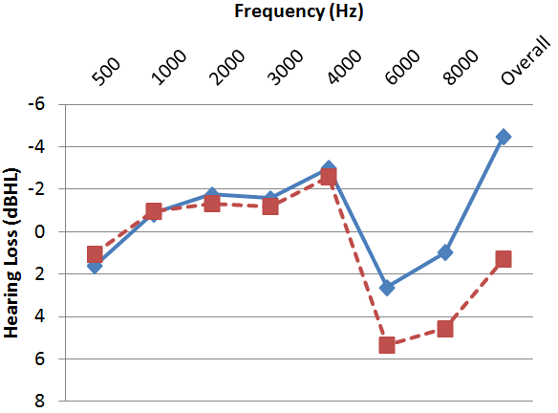
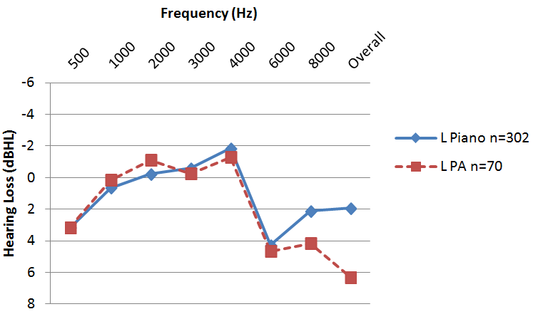

Figure 6: Left and right ear averaged hearing thresholds for Pianist and Piano Accompanists

The effect of the high singing levels on the pianists can be clearly seen from figure 6. The left ear has very similar average hearing losses for 4 and 6 kHz and a 2 dB difference at 8 kHz, with the a 4 dB difference in the overall criteria. However, looking at the right ear there is now a 4 dB difference at 6 and 8 kHz and a 6 dB difference in the overall criteria. There was no difference at 4 kHz between the 302 pianists and the 70 piano accompanists. The difference can only be accounted for by the introduction of the vocalist. Hence, it appears that musicians can protect themselves from their own instrument, but not from another instrument.

Conclusions

Since 2007, the Royal Academy of Music has been following a management policy to assess the hearing acuity of the musicians at the start of their career. Results of over 2500 hearing tests revealed that music students have excellent hearing and less hearing problems than those of general population, despite their high sound exposure dose. Highest incidence of students with mild hearing impairment or poor hearing was found amongst composers. Finally, averaged hearing thresholds per frequency for each instrument group showed a significant threshold notch at 6kHz for all instrument types. This clearly shows the effect of music is different from the effect of noise on hearing.
As a hypothesis: musicians have learnt to control their Stapedius Reflex, to protect themselves from their instrument's sound. The analysis of the hearing thresholds of pianists compared to piano accompanist indicated that there is evidence to suggest the validity of the hypothesis.

Acknowledgement

Thanks must go to the staff at the Royal Academy of Music: Philip White, Nicola Mutton, Hannah Melville-Smith and Rosie Larkins. The original data was collected with the valuable assistance of Georgia Zepidou and Ben Dymock.

References

[1] Health and Safety Executive (2005). Controlling noise at work. The control of noise at work Regulations 2005, Guidance on Regulations: HSE.
[2] G. Zepidou, S. Dance, Introducing acoustics to classical musicians, Proc. IoA/SFA, Nantes 2012

[3] S. Dance, Conservatoires - Acoustics and Music working together, Proc. Institute of Acoustics, Birmingham, 2014

[4] S. Dance, A. Losada, S. Large, S. Walters, G. Zepidou, L. Gomez, Improving orchestra pits for the benefit of musicians, Proc. ASA/WESPAC, Hong Kong 2012

[5] ISO 8253-1: 2010 Acoustic of Audiometric measurements - Part 1: Basic pure tone air and bone conduction threshold audiometry
[6] W. Warwick, Leisure noise and the hearing health of young people, The Hearing Journal, 68(12), pp28-30, 2015.

[7] S. Dance, B. Dymock. Sound exposure and the hearing of musicians, Proceedings of 10th Euronoise, Maastricht 2015.
[8] G. Okten, S. Dance. Pilot investigation into the vocal load of Opera singers, Proceedings of Forum Acusticum, Krakow 2013

