International Conference on Industry 4.0 and Smart Manufacturing

Digital Platforms for SMME Enablement

Arnesh Telukdarie1[1], Simon Philbin2, Bupe G Mwanza1, Megahnee Munsamy1

1University of Johannesburg, Bunting Campus, Johannesburg, 0093, South Africa

2London South Bank University, London, United Kingdom

Abstract

The challenges facing SMME's are diverse ranging from skills challenges to value chain optimization, concept management and operations management. The entrepreneur navigates a typical SMME cycle from idea generation to sustainable business single-handed. Each phase of SMME development is a challenge but is not unique to the individual SMME. Financial management, marketing, logistics, people management and general strategy to execution against challenges are endured and overcome by SMME's. SMME’s form the majority of businesses, in most economies and is a source of GDP growth. SMME failure rates are high across the globe with significant challenges to survive. Innovation centers, incubation models and various other interventions have impacted SMME survival but more should be done. The research presented in this paper revolves around a theoretical digital platform for SMME sustainability. The platform is evolutionary and based on large corporate processes and systems, subdued and modified for SMME support. Core SMME processes are digitalized and provide for a single strategy. The evolutionary platform builds over time and evolves to an intuitive digital SMME support system. An initial literature analysis leading onto a theoretical SMME framework and systems dynamics model is presented.

© 2021 The Authors. Published by ELSEVIER B.V.

This is an open access article under the CC BY-NC-ND license (<https://creativecommons.org/licenses/by-nc-nd/4.0>)

Peer-review under responsibility of the scientific committee of the 3rd International Conference on Industry 4.0 and Smart Manufacturing

*Keywords:*

1. Background

Small, Medium and Micro Enterprises (SMMEs) play an important role in job creation, driving global growth, meeting critical needs and enabling innovation [1]. Indeed, from a global perspective SMMEs are significant and represent around 95% of all enterprises. SMME’s are responsible for a significant level of employment, estimated at between 60% and 70% [2]. Over 50% of employment and 90% of businesses are constituted in SMMEs in developing economies thus depicting a major share of the GDP (gross domestic product) [3]. In the case of South Africa, SMMEs provide employment to approximately 60% of the labor force. SMMEs are a major growth driver with a significant impact on innovation [4], [5], [6].

Although SMME’s represent a large section of the market, many SMME s are facing significant challenges, such as lack of resources (i.e. human, financial and organizational), growth uncertainty, continuous changes in market demand and competition [7]. The ability to meet the requirements, as stipulated by financial institutions are a challenge for SMME’s [4], [5], thereby resulting in the inability to raise finance or attract only high interest rate loans [8]. On this matter, [8] argue that SMME owners should strive to find new products, markets and business opportunities to achieve growth. Development and introduction of new products can differentiate SMMEs in terms of new opportunities and growth. Moreover, studies have found that through R&D (research and development) SMMEs can develop unique products and services that differentiate them in the market [9],[10].

In the context of these challenges, SMME’s are not fully equipped to deliver financial and resource intensive 4IR (Industry 4.0) developments. SMMEs perform similar functions to larger businesses and more importantly SMME’s can be clustered based on their functions, i.e. many SMME’s perform similar activities or business function. The benefit of implementing collective digital systems for SMME’s has not been quantified and this study seeks to develop an active framework in the form of a systems dynamics model to provide insights into the construction of an integrated set of systems for SMME digital enablement.

1. Literature

The Fourth Industrial Revolution delivers various opportunities for business with significant financial, operations and other benefits [11] (Liao et al., 2017). Industry 4.0 and smart manufacturing are rapidly transposing businesses functions. The technological revolution enabled by smart manufacturing is extensively reshaping the basis of delivery and value creation in the manufacturing settings [12]. The incorporation of digital technologies to support every dimension of manufacturing and services is a strategic priority for modern business [13]. As the adoption of digital technologies advances with the pace of Industry 4.0 adoption, there is a need to ensure SMME’s are not left behind. Consequently, there is scope for SMME’s to adopt a range of advanced information digital technologies, such as augmented/virtual reality [14]; artificial intelligence [15]; industrial automation [16]; additive manufacturing technologies [17]; intelligent enterprise resource planning [18]; and cloud data and storage [11] to enhance operations across the value chain [19].

The need to respond to digitalization by SMME’s has resulted in many studies. Reference [20] investigated the effects of Technology-Organizational-Environmental (TOE) factors on Social Media (SM) adoption and the performance of SMME’s in developing economies. Reference [21] studied the possible effect of digitalization on SMME’s operating in offline retail markets through provision of cloud-based solutions that support business digitalization processes. Reference [22] explored System Dynamics (SD) modelling in order to furnish strategic business support to SMMEs. Reference [23] identified the adoption of Smart Manufacturing Information and Digital Technologies (SMIDT) within manufacturing SMME’s. Reference [24] used a mixed-model approach to analyze and model Software Process Improvement (SPI) enablers in software SMME’s. Social media adoption has also been a focus of studies [25]–[27]. Web 2.0 is considered critical for improving the performance of both corporate and SMME businesses in developing economies [28]. With effective implementation, web 2.0 enables companies to boost many activities, such as logistics maintenance, customer satisfaction, information sharing, international business operations and network linkages in developing economies [29]. The adoption of information and digital technologies (IDT) is a strategic priority for modern businesses [13] and may offer SMME’s performance improvement benefits, such as effective supplier and customer relationship, enhanced sales and promoting original organizational competences [30]. The above mentioned studies have all focused on SMME digitalization and this highlights the urgency for the development of suitable processes to enable digitalization by SMME’s.

The world is witnessing the expanding role of Digital Evolution (DE) in the corporate sector and DE is fast becoming a major driver of transforming the world economy by inducing technological changes. According to [31], a digital platform is a principal digital market value that simplifies, centralizes and orchestrates transactions and tasks (Herda, et al., 2018). It acts as a technical basis for furnishing smart services because of its connecting attributes [32]. Major digital platforms, such as those developed by Apple, Google, Amazon, Facebook, Alibaba, YouTube, Yahoo, Baidu, Tencent and Alphabet are existing large scale businesses, which are accompanies by digital platform ’unicorns’, such as Uber, Airbnb, Snapchat, WeWork and Didi Chuxing [33]. These platforms are the ‘powerful engines of commerce’ that are re-modelling economies globally and improving the quality of life of many people [33]. However, the challenges (such as gaining access to the required skills, time, finances) faced by many SMMEs hinders adoption of renowned digital platforms that have the capacity to transform the manner in which business is conducted.

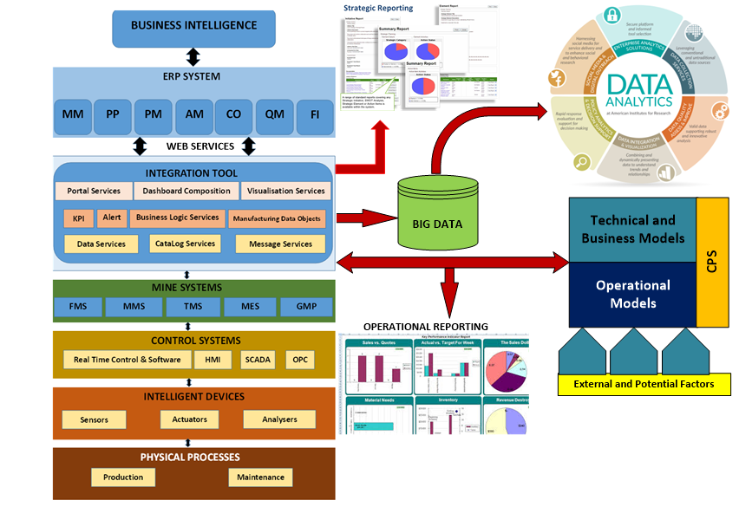In order to address this situation, the key is to define all the functions of the business into a collective, cohesive set of systems. Systems align to the SMME functions as defined by [29]. Figure 1 below illustrates a typical set of systems as defined for large business systems [34].

Fig. 1. Collection of systems, integrated

Digital transformation and restructuring of SMME’s is of fundamental importance for supporting economic growth and expanding globalization but it is also important to establish strategic perceptions into the adoption of these modern tools. To understand the process of SMME digitalization, it is necessary to understand the traditional platforms that companies have used to manage business operations. For example, print, television, radio and billboards have been used as traditional platforms for marketing purposes. The ability of 4IR deployment is subject to technological availability but also dependent on the available resources. The ability to deploy complex digital tools in the small enterprise space is a challenge. Nevertheless, Industry 4.0 is providing SMME’s with an opportunity to transform business operations in and this study focusses on addressing this existing gap. In this context, a suitable reference point is the unpacking of systems used by large enterprises.

Figure 1 focuses on various key aspects of a business from logistics, finance and operations through to reporting and optimization and ultimately business intelligence with or without artificial intelligence. The primary objective is the integration of the business with a focus on process automation and integration.

1. Methodology

The research study adopted an engineering modelling approach to resolve the research problem that was informed by the extant literature. Various techniques are adopted towards the development of the SMME digital platform, as illustrated in Figure 1 illustrated.

The initial approach included a comprehensive literature analysis to identify the key contributing factors to SMME digitalization and corporate business models with a focus on systems. The authors searched the Scopus database for publications on small enterprises and systems and identified around 68,000 relevant articles. The articles were filtered and sorted based on the functional areas defined in Figure 2, and an extract of 2,000 of the most cited articles were extracted. In order to further screen the articles, they were reviewed according to functions and systems through cross-referencing either Information Technology (IT) or Operational Technology (OT), which further reduced the literature to 1,986 articles. The constraints and drivers for small business, from a business functional perspective is initially evaluated from the literature. The research team also identified the challenges for SMMEs implementing systems via a South African specific instrument in the Food and Beverage (Foodbev) manufacturing sector. The frequency of the occurrence of the barriers and enablers from both the literature and the instrument were statistically analysed. A Systems Dynamics (SD) model is constructed to represent a simulation of the business. The statistical findings from the literature and instrument analysis are applied as inputs into the SD model. The SD simulation is modelled and the results analyzed.



Fig. 2: Method outline

1. Results

The initial research position references large business systems. As discussed in the literature, large businesses have the financial, skills and key resources to adopt 4IR systems. These systems have proven highly successful in business optimization [35].

The research team explore the development of a similar set of systems for smaller enterprises with due consideration of the limitations around finance, skills and time constraints for SMME’s. The research team reviewed literature with the aim of identifying the systems currently being identified and allocated as potentially beneficial for SMME digitalization. The comprehensive literature search in Scopus identified relevant articles with SMME as the primary keyword and the following functional areas as identified by Telukdarie [33], refer to Table 1.

Table 1: Keyword extractions for Business and SMME with the following additional keywords with “or”

|  |  |  |
| --- | --- | --- |
| "Planning"/ "Enterprise Resource Planning" / "Enterprise Resource Management"  “ERP" | "Information Management" /  "Information Technology" /  "Information Systems" | "Human Resource Management" / ”HR” |
| "Supply Chain Management" | "Scheduling" | “Quality Control" |
| "Supply Chains" | "Management Information Systems" | "Environmental Management" |
| "Project Management" | "Financial Management" | "Information Services" |
| "Business Planning" | "Inventory Control" | "Quality Assurance"  /”Quality” |
| “Logistics” | "Integration" | “ Operational Technologies”/ “OT” |

The keyword search determined the top 1,986 papers used to create the database of the most cited papers. These papers were analyzed to identify the level of importance of each of the keywords. The presence of each of these keywords in the 1, 986 papers is counted; an indication of importance. The weighting for inputs into the SD model was calculated based on the average of the cumulative i.e. the values above the average exceeds a weighting of 1 while the value below the average is below 1. The Enterprise Input Functions are EIF={ERP, IM, SC, BP, ERPS, PM, SP, MIS, FM, IC,QA, SCM, EM,IS, HR, LM, IN, SR, IoT}, which for the purpose of the calculation called EIF_1 to EIF_19. The equation to calculate the weighting is,

$EIF Weighting=\frac{\sum_{1}^{n}{EIF}}{Average\left(\sum_{1}^{n}{EIF}\right)}$ (1)

Where

*EIF*: Enterprise Input functions

*n*= Number of Enterprise Input functions

Table 1: Keyword representation and calculated weighting

|  |  |  |  |
| --- | --- | --- | --- |
| **Enterprise input function** | **Acronym (EIF)** | **Cumulative** | **Weighting** |
| "Planning"/ "Enterprise Resource Planning" / "Enterprise Resource Management" | ERP | 1274 | 2.06 |
| "Information Management" /  "Information Technology" /  "Information Systems" | IM | 1669 | 2.70 |
| "Supply Chains" | SC | 326 | 0.53 |
| "Business Planning" | BP | 1062 | 1.72 |
| "Enterprise Resource Planning Systems" | ERPS | 1753 | 2.84 |
| "Project Management" | PM | 702 | 1.14 |
| "Scheduling" / “Planning” | SP | 264 | 0.43 |
| "Management Information Systems" | MIS | 1575 | 2.55 |
| "Financial Management" | FM | 599 | 0.97 |
| "Inventory Control" | IC | 170 | 0.28 |
| "Quality Assurance"  /”Quality”/ “QA” /“Quality Control" | QA | 207 | 0.34 |
| "Supply Chain Management" | SCM | 326 | 0.53 |
| "Environmental Management" | EM | 229 | 0.37 |
| "Information Services" | IS | 344 | 0.56 |
| "Human Resource Management" / ”HR” | HR | 861 | 1.39 |
| “Logistics” | LM | 28 | 0.05 |
| "Integration" | IN | 94 | 0.15 |
| “ Strategy” | SR | 205 | 0.33 |
| “IoT” | IoT | 43 | 0.07 |

Figure 2 represents a Systems Dynamic model of the business functions that contribute towards the success of large businesses. The development of the SD model is based on the ability to deliver an improved operational performance of SMME’s. The inputs are separated according to the large business best practice enterprise functions as part of the constructed SD model. A key consideration for the model is the cluster of functions that contribute to a large business and this includes, HR, Quality, HSE, Planning, Logistics, Operations and Maintenance. The data is extracted from Table 2 and entered into the SD model as depicted in Figure 2. The additional inputs for consideration in regard to large enterprise operations are IT/IoT/Integration and Business and this allowed the theoretical SD model to be constructed.

A simplified mathematical view of the SD scenarios are;

$Baseline=\int_{0}^{t}{\sum_{1}^{n}{EBV}}$ (2)

$Digital inputs=\int_{0}^{t}{DIF\int_{0}^{t}{\sum_{1}^{n}{EBV}}}$ (3)

$With reinvestments=\int_{0}^{t}{RI\int_{0}^{t}{DIF\int_{0}^{t}{\sum_{1}^{n}{EBV}}}}$ (4)

Where

*EBV:* Enterprise Business Variables

t: time

*DIF*: Digital input factor

*RI*: Reinvestment

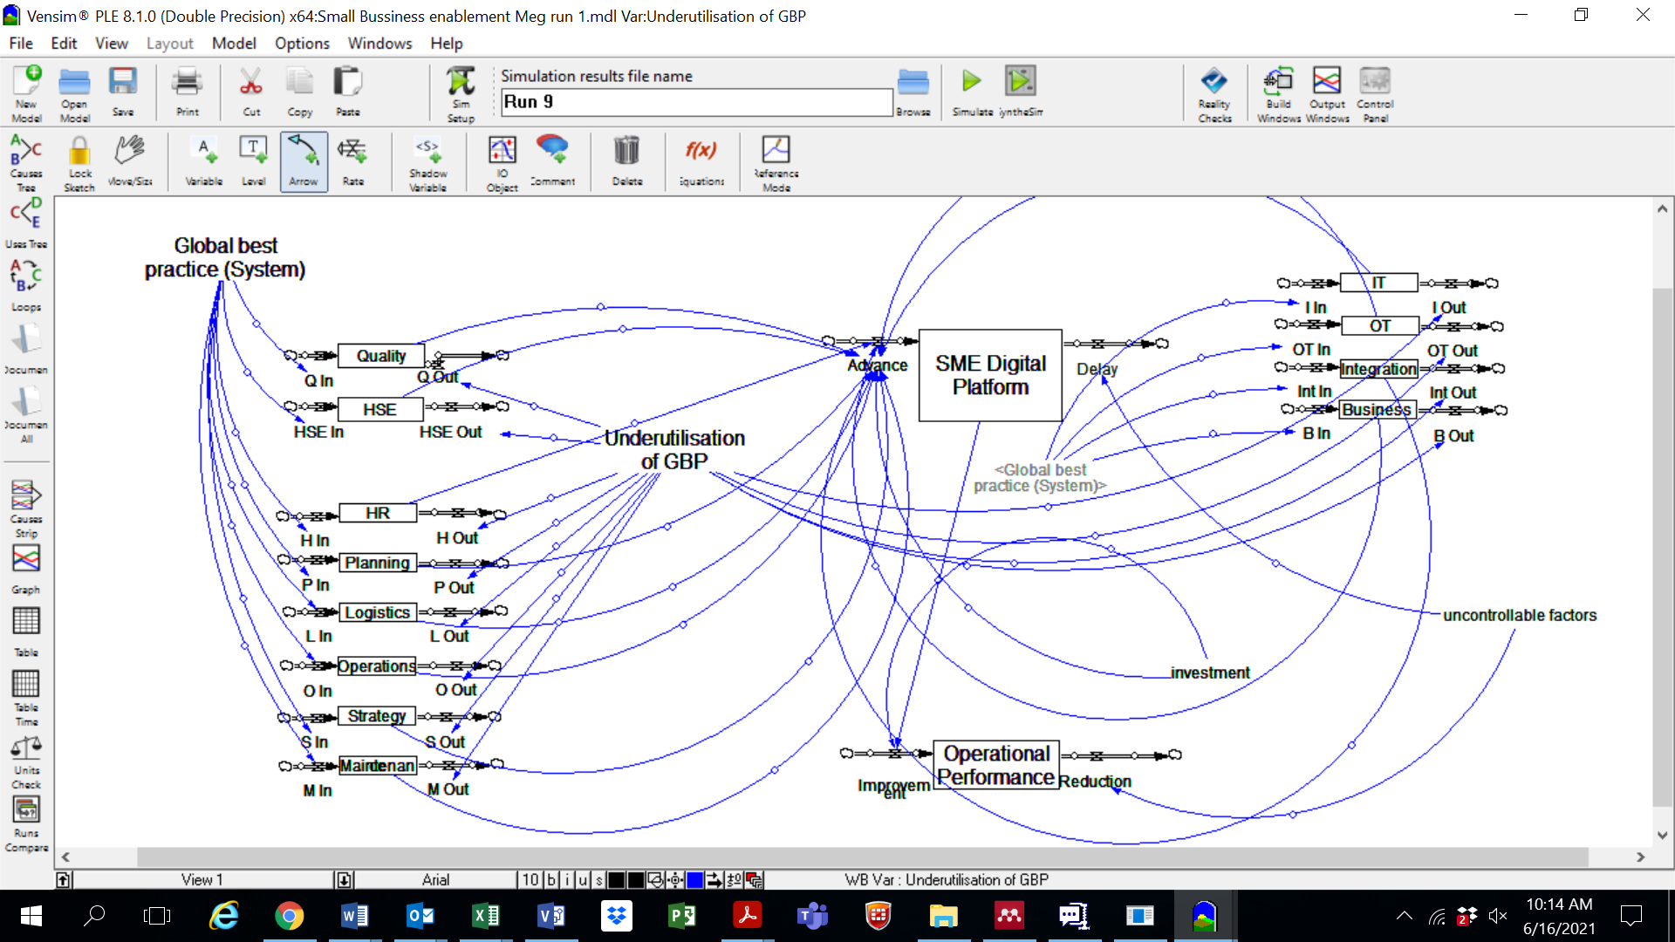

Fig. 2. SD model for SMME enablement.

The Vensim simulation software is used to model various scenarios, which provided insights into the potential of systems enablement on operational performance of an SMME. The baseline simulation is performed without any digital inputs or systems, resulting in no change to platform development or operational performance of an SMME. The simulation is subsequently run with various changes in inputs from partial improvements in the Global Best Practice (GBP), including full inclusion of GBP and reinvestments on platform improvements by SMME’s. The structure of the model allows for the development of the SMME platform and subsequent assessment of the impact of the platform and the sustainability of the SMME platform.

Maybe we state what the y-axis means just for clarity.

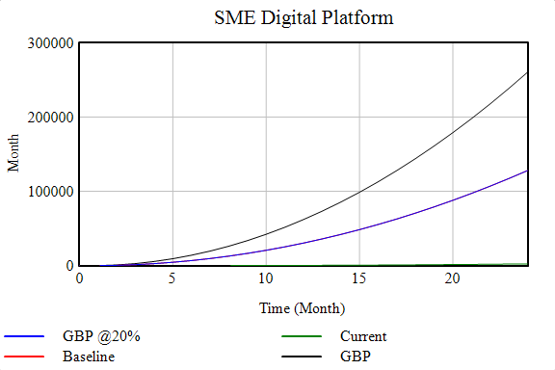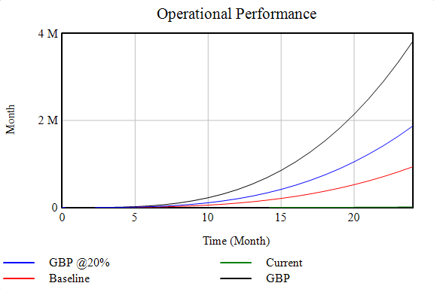

Fig. 3. Results from simulation

The results of the simulation scenarios described above are illustrated in Figure 3. The graphics provide insights on operational performance and the SMME platform maturity. The results of a baseline simulation without the implementation of GBP has a neutral to flat impact on SMME’s. Whereas the development of just GBP without SMMEs strategically/financially investing in the platform delivers partial benefits. Furthermore, the most significant benefits are derived from the scenario of the implementation of GBP combined with SMMEs continuous strategic and financial investment in a digital platform.

1. Conclusion

The objective of this research study was to develop a theoretical model to simulate the impact of implementing digital systems in support of SMME enablement. The approach was to screen for larger corporate systems that currently exist. The study identified a level of maturity in larger businesses specific to 4IR systems implementation. The system landscape was extracted as well as SMME literature extracted and tested relative to the business functions that were extracted. The data analysis of the literature is used as inputs into a systems dynamics model to attempt to sequence the potential for systems development in support of SMME and digital. The model developed is theoretical and part of an ongoing study on the potential to implement digital platforms for SMME enablement in the food and beverages manufacturing sector. The results provide strategic insights into project implementation including the potential of individual systems maturity, collective system maturity, impacts to business and also sustainability of SMMEs investing in the framework. Future work is suggested to further enhance the SD model through incorporating empirical data gained from SMMEs through employing a suitable method such as quantitative survey instrument or through qualitative interviews.

Acknowledgements

This research was supported by the Royal Academy of Engineering through the Engineering X Transforming Systems through Partnership programme (TSP2021\100320).

References

[1] Y. Wang, “What are the biggest obstacles to growth of SMEs in developing countries? – An empirical evidence from an enterprise survey,” *Borsa Istanbul Rev.*, vol. 16, no. 3, pp. 167–176, 2016, doi: 10.1016/j.bir.2016.06.001.

[2] P. Quartey, E. Turkson, J. Y. Abor, and A. M. Iddrisu, “Financing the growth of SMEs in Africa: What are the contraints to SME financing within ECOWAS?,” *Rev. Dev. Financ.*, vol. 7, no. 1, pp. 18–28, 2017, doi: 10.1016/j.rdf.2017.03.001.

[3] World Bank, “Small and Medium Enterprises (SMEs) Finance,” 2020. https://www.worldbank.org/en/topic/smefinance. (accessed May 18, 2021).

[4] IFC, “The Unseen Sector: A Report on the Msme Opportunity in South Africa,” 2018.

[5] BER, “The small, medium and micro enterprises sector of South Africa.” Cape Town: University of Stellenbosch, 2016.

[6] T. Furawo and C. A. Scheepers, “Factors impacting innovative capacity of small- and medium-sized enterprises in Cape Town,” *J. Manag. Adm.*, vol. 2, 2018.

[7] S. Nisar and M. Shafiq, “Framework for efficient utilisation of social media in Pakistan’s healthcare sector,” *Technol. Soc.*, vol. 56, pp. 31–43, 2019, doi: 10.1016/j.techsoc.2018.09.003.

[8] A. K. Garg and P. N. Phaahla, “Factors Affecting the Business Performance of Small Businesses in Sekhukhune,” *J. Econ. Behav. Stuides*, vol. 10, no. 4, pp. 54–67, 2018.

[9] H. Okamuro, J. Nishimura, M. Colombo, and E. Stam, “ME Policy Faced with Development of Financial Technology: Promoting SME R&D and Innovation.” G20 2019 Japan. Tokyo: Think T20, 2019.

[10] S. Ren, A. B. Eisingerich, and H.-T. Tsai, “How do marketing, research and development capabilities, and degree of internationalization synergistically affect the innovation performance of small and medium-sized enterprises (SMEs)? A panel data study of Chinese SMEs,” *Int. Bus. Rev.*, vol. 24, no. 4, pp. 642–651, 2015.

[11] Y. Liao, F. Deschamps, E. de F. R. Loures, and L. F. P. Ramos, “Past, present and future of Industry 4.0 - a systematic literature review and research agenda proposal,” *Int. J. Prod. Res.*, vol. 55, no. 12, pp. 3609–3629, 2017, doi: 10.1080/00207543.2017.1308576.

[12] H. P. Lu and C. I. Weng, “Smart manufacturing technology, market maturity analysis and technology roadmap in the computer and electronic product manufacturing industry,” *Technol. Forecast. Soc. Change*, vol. 133, pp. 85–94, 2018, doi: 10.1016/j.techfore.2018.03.005.

[13] H. Lasi, P. Fettke, H. G. Kemper, T. Feld, and M. Hoffmann, “Industry 4.0,” *Bus. Inf. Syst. Eng.*, vol. 6, no. 4, pp. 239–242, 2014, doi: 10.1007/s12599-014-0334-4.

[14] A. Moeuf, R. Pellerin, S. Lamouri, S. Tamayo-Giraldo, and R. Barbaray, “The industrial management of SMEs in the era of Industry 4.0,” *Int. J. Prod. Res.*, vol. 56, no. 3, pp. 1118–1136, 2018, doi: 10.1080/00207543.2017.1372647.

[15] F. Tao, Q. Qi, A. Liu, and A. Kusiak, “Data-driven smart manufacturing.pdf,” *J. Manuf. Syst.*, vol. 48, pp. 157–169, 2018.

[16] P. Zheng *et al.*, “Smart manufacturing systems for Industry 4.0: Conceptual framework, scenarios, and future perspectives,” *Front. Mech. Eng.*, vol. 13, no. 2, pp. 137–150, 2018, doi: 10.1007/s11465-018-0499-5.

[17] A. Gilchrist, *Industry 4.0: The industrial Internet of Things*. Springer, 2016.

[18] J. Wan *et al.*, “Software-Defined Industrial Internet of Things in the Context of Industry 4.0,” *IEEE Sens. J.*, vol. 16, no. 20, pp. 7373–7380, 2016, doi: 10.1109/JSEN.2016.2565621.

[19] M. Ghobakhloo, “The future of manufacturing industry: a strategic roadmap toward Industry 4.0,” *J. Manuf. Technol. Manag.*, vol. 29, no. 6, pp. 910–936, 2018, doi: 10.1108/JMTM-02-2018-0057.

[20] S. A. Qalati, L. W. Yuan, M. A. S. Khan, and F. Anwar, “A mediated model on the adoption of social media and SMEs’ performance in developing countries,” *Technol. Soc.*, vol. 64, 2021, doi: 10.1016/j.techsoc.2020.101513.

[21] S. Gavrila Gavrila and A. de Lucas Ancillo, “Spanish SMEs’ digitalization enablers: E-Receipt applications to the offline retail market,” *Technol. Forecast. Soc. Change*, vol. 162, 2021, doi: 10.1016/j.techfore.2020.120381.

[22] R. Viswanathan and A. Telukdarie, “A systems dynamics approach to SME digitalization,” *Procedia Comput. Sci.*, vol. 180, no. 2019, pp. 816–824, 2021, doi: 10.1016/j.procs.2021.01.331.

[23] M. Ghobakhloo and N. T. Ching, “Adoption of digital technologies of smart manufacturing in SMEs,” *J. Ind. Inf. Integr.*, vol. 16, 2019, doi: 10.1016/j.jii.2019.100107.

[24] P. Sharma and A. L. Sangal, “Building a hierarchical structure model of enablers that affect the software process improvement in software SMEs—A mixed method approach,” *Comput. Stand. Interfaces*, vol. 66, 2019, doi: 10.1016/j.csi.2019.04.009.

[25] H. Jin and F. Hurd, “Exploring the Impact of Digital Platforms on SME Internationalization: New Zealand SMEs Use of the Alibaba Platform for Chinese Market Entry,” *J. Asia-Pacific Bus.*, vol. 19, no. 2, pp. 72–95, 2018, doi: 10.1080/10599231.2018.1453743.

[26] J. W. Sohn and J. K. Kim, “Factors that influence purchase intentions in social commerce,” *Technology in Society*, vol. 63. 2020, doi: 10.1016/j.techsoc.2020.101365.

[27] S. S. Abed, “Social commerce adoption using TOE framework: An empirical investigation of Saudi Arabian SMEs,” *Int. J. Inf. Manage.*, vol. 53, 2020, doi: 10.1016/j.ijinfomgt.2020.102118.

[28] A. Daowd, M. M. Kamal, T. Eldabi, R. Hasan, F. Missi, and B. L. Dey, “The impact of social media on the performance of microfinance institutions in developing countries: a quantitative approach,” *Inf. Technol. People*, vol. 34, no. 1, pp. 25–49, 2021, doi: 10.1108/ITP-03-2018-0135.

[29] Y. Cao, H. Ajjan, P. Hong, and T. Le, “Using social media for competitive business outcomes: An empirical study of companies in China,” *J. Adv. Manag. Res.*, vol. 15, no. 2, pp. 211–235, 2018, doi: 10.1108/JAMR-05-2017-0060.

[30] H. B. Singhry, A. Abd Rahman, and N. S. Imm, “Effect of advanced manufacturing technology, concurrent engineering of product design, and supply chain performance of manufacturing companies,” *Int. J. Adv. Manuf. Technol.*, vol. 86, no. 1–4, pp. 663–669, 2016, doi: 10.1007/s00170-015-8219-3.

[31] P. C. Evans and A. Gawer, “The Rise of the Platform Enterprise A Global Survey,” 2016.

[32] M. Rabe, L. Asmar, A. Kühn, and R. Dumitrescu, “Planning of smart services based on a reference architecture,” in *Proceedings of International Design Conference, DESIGN*, 2018, vol. 6, no. October, pp. 2949–2960, doi: 10.21278/idc.2018.0425.

[33] S. D. Evans and R. Schmalensee, “The businesses that platforms are actually disrupting,” *Harvard Business Review*, 2016. https://hbr.org/2016/09/the-businesses-that-platforms-are-actually-disrupting.

[34] M. Sishi and A. Telukdarie, “Implementation of Industry 4.0 technologies in the mining industry - a case study,” *Int. J. Min. Miner. Eng.*, vol. 11, no. 1, 2020, doi: 10.1504/IJMME.2020.105852.

[35] A. Telukdarie, E. Buhulaiga, S. Bag, S. Gupta, and Z. Luo, “Industry 4.0 implementation for multinationals,” *Telukdarie A, Buhulaiga E, Bag S, Gupta S, Luo Z*, vol. 118, pp. 316–329, 2018.

1. * Corresponding author. Tel.: ; fax: .

   *E-mail address:*