FAM98A is a novel substrate of PRMT1 required for tumor cell migration, invasion, and colony formation

Khondker Ayesha Akter¹ & Mohammed A. Mansour¹ & Toshinori Hyodo¹ & Satoko Ito¹ & Michinari Hamaguchi¹ & Takeshi Senga¹

Abstract Protein arginine methylation, which is mediated by a family of protein arginine methyltransferases (PRMTs), is associated with numerous fundamental cellular processes. Ac-cumulating studies have revealed that the expression of mul-tiple PRMTs promotes cancer progression. In this study, we examined the role of PRMT1 in ovarian cancer cells. PRMT1 is expressed in multiple ovarian cancer cells, and the depletion of its expression suppressed colony formation, in vivo prolif-eration, migration, and invasion. To gain insight into PRMT1-mediated cancer progression, we searched for novel substrates of PRMT1. We found that FAM98A, whose physiological function is unknown, was arginine-methylated by PRMT1. FAM98A is expressed in numerous ovarian cancer cell lines and is important for the malignant characteristics of ovarian cancer cells. Our results indicate the possible role of the PRMT1-FAM98A pathway in cancer progression.

Keywords PRMT1 . FAM98A . Arginine methylation . Ovarian cancer

Introduction

The structural and functional diversity of proteins are depen-dent on the covalent posttranslational modification of their

Electronic supplementary material The online version of this article (doi:10.1007/s13277-015-4310-5) contains supplementary material, which is available to authorized users.

- Takeshi Senga tsenga@med.nagoya-u.ac.jp

- Division of Cancer Biology, Graduate School of Medicine, Nagoya University, 65 Tsurumai, Showa Nagoya 466-8550, Japan

amino acid residues [1]. One of these modifications, termed arginine methylation, results from the transfer of methyl groups from S- adenosyl- L- methionine to the guanido nitro-gen atom of arginine residues in protein substrates [2]. Argi-nine methylation is an abundant posttranslational modifica-tion, with approximately 0.5 % of arginine residues methylat-ed in mammalian tissues and approximately 2 % of arginine residues methylated in rat liver nuclei [3].

There are three different types of methylated arginine in cells. Asymmetric dimethylated arginine (ADMA) has two methyl groups on the same nitrogen atom of arginine, whereas symmetric dimethylated arginine (SDMA) has two methyl groups on different nitrogen atoms. Monomethylated arginine (MMA) has only one methyl group on the nitrogen atom of arginine. The attachment of the methyl group on arginine is mediated by a member of the protein arginine methyltransfer-ase (PRMT) family. There are nine PRMTs in mammals. PRMT1, PRMT2, PRMT3, PRMT4 (CARM1), PRMT6, and PRMT8 generate ADMA, whereas PRMT5 and PRMT7 produce SDMA and MMA, respectively [4, 5]. PRMT9 pro-duces both SDMA and MMA [6].

Among members of PRMT family proteins, PRMT1 is responsible for the majority of methylated arginine in mam-malian cells [7]. PRMT1 is highly conserved among the wide range of species and is expressed in most tissues. PRMT1 deletions in mice are embryonically lethal, and embryonic fibroblasts with PRMT1 deletions are defective in cell cycle progression, chromosome distribution, and DNA repair [8]. PRMT1 is known to methylate arginine residues in a sequence rich in arginine and glycine called RGG/RG or GAR motif [9]. There are a number of proteins with multiple RGG/RG motifs that are associated with numerous physiological func-tions [10]. The methylation of arginine residues in this motif increases the hydrophobicity of proteins, thereby regulating the association with other proteins or RNAs [9]. Although

accumulating evidence clearly shows that PRMT1 methylates proteins with RGG/RG motifs for the regulation of fundamen-tal physiological functions, most of the functions of these methylations remain unclear.

Recent studies have demonstrated that PRMT1 is associat-ed with the progression of various cancers. PRMT1 is aber-rantly expressed in various cancers, such as breast, prostate, lung, colon, and bladder cancer, as well as leukemia [11–17]. In lung cancer cells, PRMT1 induces the epithelial to mesen-chymal transition (EMT) for the promotion of cell invasion and migration [18]. PRMT1 has multiple isoforms, and one of them was shown to promote the survival and invasiveness of breast cancer cells [19]. To gain further insight into the role of PRMT1 in cancer progression, we tested whether PRMT1 is important for the malignancy of ovarian cancer cells. In this report, we show that the depletion of PRMT1 suppresses proliferation, colony formation and migration as well as invasion of ovarian cancer cells. We further show that FAM98A, a protein of unknown function, is a novel sub-strate of PRMT1 and is associated with cancer cell migra-tion and invasion.

Materials and methods

Cells, antibodies, and chemicals

All the ovarian cancer cells were cultured in RPMI with 10 % fetal bovine serum (EQUITEC, Hendra, Australia). 293T cells were maintained in DMEM with 10 % fetal bovine serum. ES2 and SKOV3 cells were obtained from the American Type Culture Collection (ATCC) in 2012. TTOV and TAOV cells were previously established in the Department of Obstetrics and Gynecology, Nagoya University, Graduate School of Medicine [20]. Antibod-ies were purchased from the following manufacturers: anti-β-actin antibody, Sigma-Aldrich (St. Louis, MO, USA); anti-asymmetric dimethyl-arginine (ADMA) anti-body, Active Motif (Carlsbad, CA, USA); Anti-PRMT1 antibody, Cell Signaling (Danvers, MA, USA); Anti-FAM98A antibody, Aviva Systems Biology (San Diego, CA, USA). Adenosine dialdehyde (Adox) was purchased from Sigma-Aldrich.

cDNA constructs

cDNAs for human PRMT1 and FAM98A were amplified by PCR from a cDNA library of HeLa cells. Each cDNA was cloned into the pQCXIP vector (TAKATA, Tokyo, Japan) with an N-terminal Flag or GFP tag. Deletion mutants were generated by PCR.

Mass spectrometry analysis

ES2 cells that constitutively expressed Flag-PRMT1 were gen-erated by retrovirus infection. The pQCXIP vector encoding Flag-PRMT1 was transfected into 293 T cells in combination with the pVPack-GP and pVPack-Ampho vectors (Stratagene, Tokyo, Japan) using Lipofectamine 2000 (Invitrogen, Carls-bad, CA, USA). Forty-eight hours after transfection, the super-natants were added to ES2 cells with 2 μg/mL polybrene (Sig-ma-Aldrich), and infected cells were selected with 1 μg/mL puromycin for 3 days. The Flag-PRMT1-expressing ES2 cells were lysed and immunoprecipitated with an anti-Flag antibody, and immunoprecipitates were mixed with a Flag peptide to elute immunoprecipitated proteins. The eluted proteins were digested with trypsin and subjected to mass spectrometry anal-ysis using the LC-MS/MS system (Paradigm MS4, Michrom Bioresources, Sacramento, CA, USA; HTS-PAL, CTC Analyt-ics AG, Zwingen, Swiss; LTQ Orbitrap XL, Thermo Scientific, Waltham, MA, USA). The proteins were identified using the Mascot software package (Matrix Science, London, UK).

siRNA transfection

The sequences of siRNA used to knockdown PRMT1 and FAM98A were as follows: 5´-GAGGGCACAUCGUGAC UG UGU -3´(PRMT 1siRNA1), 5´-G GU GGA CAUC UAUACCGUCAA-3´(PRMT1siRNA2), 5´-CCAAACCUC CAGCCAAUAUTT-3´(FAM98AsiRNA1), and 5´-CCGAAACGUUCAGUCUUAUTT-3´(FAM98AsiRNA2). The sequence of the control siRNA that targeted luciferase was 5´-CUUACGCUGAGUACUUCGATT-3´. All the siRNAs were obtained from the Hokkaido System Sciences (Sapporo, Japan). The cells were transfected with 20 nM of the siRNA using lipofectamine RNAiMAX (Invitrogen) ac-cording to the manufacturer’s instructions.

Generation of stable cell lines

To produce ES2 cells that constitutively expressed small hair-pin RNA or short hairpin RNA (shRNA), oligonucleotides e n c o d i n g s h R N A s p e c i f i c f o r P R M T 1 ( 5 ´ -

GCAACTCCATGTTTCATAATTCAAGAGATTATGAAA-C A T G G A G T T G C - 3 ´ ) a n d l u c i f e r a s e ( 5 ´ -

CCTTACGCTGAGTACTTCGATTCAAGAGATCGAAGT-ACTCAGCGTAAG-3´) were cloned into the pSIREN-RetroQ retroviral vector (Clontech, Mountain View, CA, USA). Next, 293 T cells were transfected with the pSIREN-RetroQ vector encoding each shRNA as well as the pVPack-GP and pVPack-Ampho vectors (Stratagene). The culture supernatant was col-lected 48 h later and applied to ES2 cells with 2 μg ⁄ mL of polybrene (Sigma-Aldrich). The cells were cultured for 24 h, and 1 μg ⁄ mL of puromycin (Sigma-Aldrich) was then added to the culture to select for infected cells.

Western blot analysis

Cell lysates were loaded on SDS-polyacrylamide gels for elec-trophoresis and transferred to polyvinylidene difluoride (PVDF) membranes (Millipore, Billerica, MA, USA). The membranes were blocked with 1 % skim milk for 1 h and then incubated with primary antibodies at 4 °C O/N. The mem-branes were washed with TBS-T buffer (10 mM Tris–HCl pH 7.4, 150 mM NaCl, 0.05 % Tween 20) for 15 min and incubated with HRP-labeled secondary antibodies. The sig-nals were detected with the ECL system (Nacalai tesque, Kyo-to, Japan) and Light Capture II equipped with CS analyzer (ATTO Corp., Tokyo, Japan). Signal intensities were mea-sured using ImageJ.

Proliferation assay

Cells were reverse transfected with siRNA using Lipofecta-mine RNAiMAX and cultured in 96-well plates. The next day of transfection was set as day 0, and the number of viable cells at the indicated time points were evaluated using the Cell Count Kit-8 (Dojindo, Tokyo, Japan).

Invasion assay

To measure cell invasion using 24-well Boyden chambers (8-μm pore size, 6.5 mm membrane diameter), the filter was pre-coated with Matrigel (BD Biosciences, San Jose, CA, USA), and 1×10⁵ cells were seeded onto the upper surface of the chamber. Twelve hours after seeding, the cells were fixed with 100 % ethanol and stained with 0.5 % crystal violet. Cells that invaded the lower surface of the filters were sur-veyed under a microscope at 10× magnification, and five fields were randomly selected. Three independent experi-ments were performed.

Wound healing assay

Wound healing assays were performed by scratching conflu-ent monolayers of siRNA-transfected cells with a 200-μL pi-pette tip and incubating the cells at 37 °C with 5 % CO₂. Every 6 h, the distance that the leading edge of the monolayer had traveled was measured in five randomly selected fields. Three independent experiments were performed.

Colony formation assay

ES2 cells (1 × 10⁴) and SKOV3 cells (5 × 10⁴) were mixed with 0.36 % agar in RPMI supplemented with 10 % FBS and overlaid onto a 0.72 % agarose layer in six-well plates. After 2 weeks of incubation, colonies in five randomly selected fields were counted. Three independent experiments were performed.

Animal experiments

Animal experiments were conducted in accordance with the regulations of the Faculty of Medicine of Nagoya University.

- total of 1 × 10⁶ shCtrl and shPRMT1 ES2 cells were suspended in 0.1 mL PBS and injected s.c. into both sides of the femoral area of five nude mice using a 23G needle. The tumors were measured with calipers, and tumor volume was calculated using the following formula: 1/2 (height×length× width). Eighteen days after tumor inoculation, the mice were killed, and the tumors were extracted to determine tumor weight.

Transfection and immunoprecipitation

To detect the association of Flag-PRMT1 with GFP-FAM98A and deletion mutants of GFP-FAM98A, 293 T cells cultured in a 3.5-cm dish were transfected with 1 μg of each plasmid using Lipofectamine 3000 (Invitrogen). After 24 h, cells were washed twice with cold PBS and lysed in TNE buffer (50 mM Tris–HCl pH 7.4, 150 mM NaCl, 0.1 % NP-40) with protease inhibitors for 15 min on ice and centrifuged at 15,000 rpm for 20 min to obtain clear cell lysates. The cell lysates were incu-bated with beads coupled with anti-Flag antibody at 4 °C with rotation overnight. The precipitates were washed with TNE buffer three times and suspended with Laemmli sample buffer for immunoblot analysis. Other experiments for interactions were performed in the same procedure.

Statistical analysis

All data are presented as the mean±SD. Statistical analysis for cell proliferation, migration, invasion, colony formation, and tumor formation in mice was performed by unpaired t test using Microsoft Office Excel. P values of <0.05 were consid-ered statistically significant.

Result

PRMT1 is required for anchorage-independent growth and in vivo proliferation

To determine the role of PRMT1 in ovarian cancer pro-gression, we first examined the expression level of PRMT1 in various ovarian cancer cell lines. Immuno-blot analysis showed that PRMT1 was expressed in all the ovarian cancer cell lines we examined, although TAOV and Kco7c cells showed comparably lower ex-pression (Fig. 1a). We next examined whether PRMT1 expression was required for the proliferation of cancer cells. ES2 and SKOV3 cells were transfected with two different siRNAs that targeted PRMT1 mRNA and

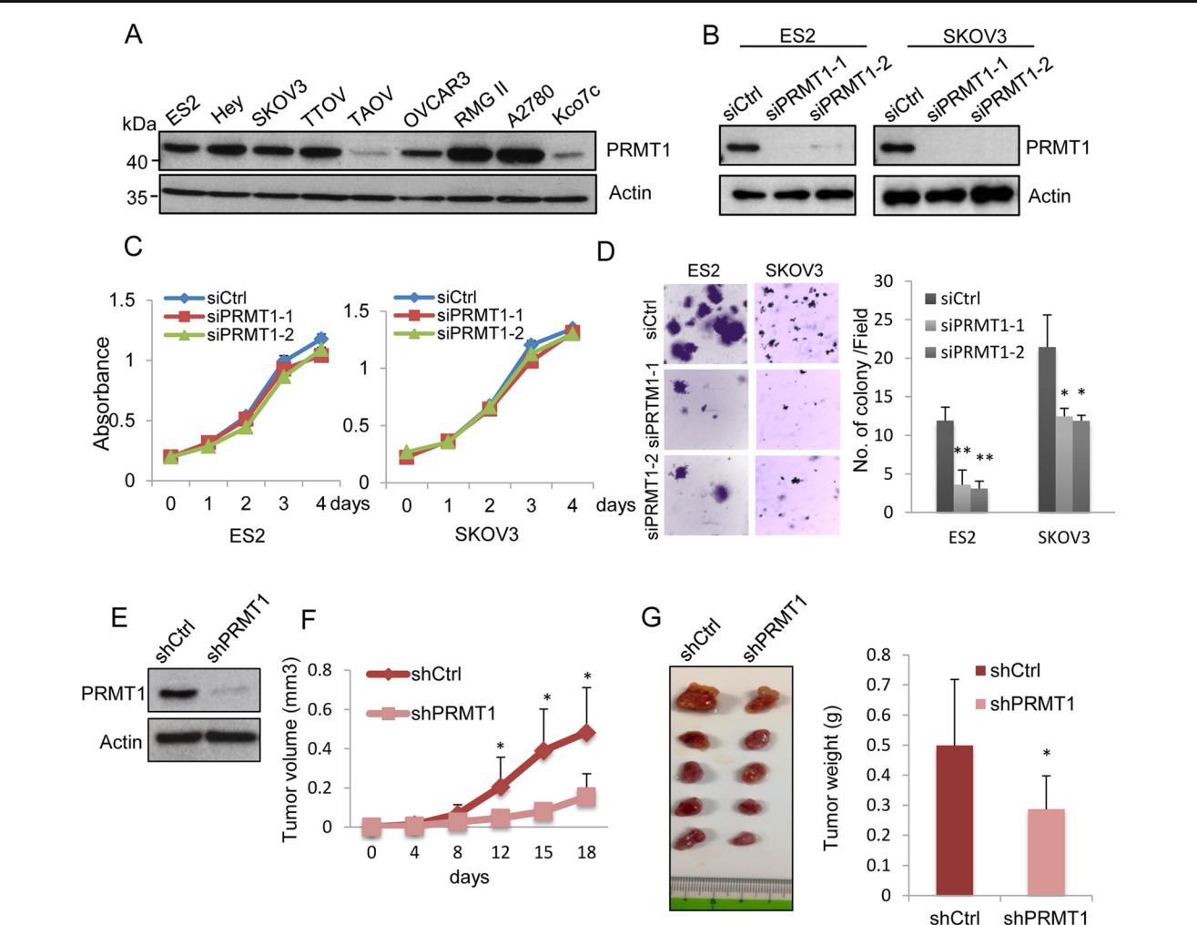

Fig. 1 Silencing of PRMT1 suppresses colony formation and the in vivo proliferation of ovarian cancer cells. (a) The expression of PRMT1 in ovarian cancer cell lines was examined by immunoblot analysis. (b) ES2 and SKOV3 cells were transfected with siRNAs, and the expression of PRMT1 was examined 72 h later. (c) Cells were transfected with siRNAs and the number of viable cells at the indicated time points was evaluated using the Cell Count Kit-8. (d) Cells transfected with siRNAs were subjected to soft agar colony formation assay. Representative images are shown, and the graphs indicate the average number of colonies per field. Three independent experiments

were carried out, and the data are shown as the mean±SD (*P<0.05) (e) ES2 cells that constitutively expressed either control or PRMT1 shRNA were generated, and the expression levels of protein were examined by immunoblot .(f) shCtrl and shPRMT1 ES2 cells were subcutaneously injected into the femurs of mice, and tumor volume was measured. The graph shows the average volume of five tumors from each cell line (*P<0.05). (g) Eighteen days after tumor injection, mice were sacrificed and tumor weight was measured. The picture shows the extracted tumors and the graph indicates the average tumor weight from the 5 tumors derived from each cell line (*P<0.05)

proliferation was evaluated. The transfection of PRMT1 siRNA sufficiently depleted PRMT1 expression (Fig. 1b), but the proliferation of cells was not sup-pressed by PRMT1 depletion (Fig. 1c).

One of the major characteristics of cancer cells is the ability to proliferate in the absence of cell adhesion to extracellular matrix, which is called anchorage-independent growth. To test whether PRMT1 is required for anchorage-independent growth, siRNA-transfected cells were cultured in soft agar for 2 weeks. As shown in Fig. 1d, the number of colonies was significantly sup-pressed by PRMT1 knockdown. We next explored wheth-er PRMT1 was crucial for the proliferation of cancer cells

in vivo. ES2 cells that constitutively expressed control shRNA (shCtrl) or PRMT1 shRNA (shPRMT1) were established by retroviral infection (Fig. 1e), and the cells were subcutaneously injected in the femoral regions of mice. Tumor volume was measured every 3 or 4 days, and 18 days after inoculation, tumors were excised and their weights were measured. The average tumor volume of shPRMT1 cells was significantly smaller than that of shCtrl cells (Fig. 1f). In addition, the average tumor weight of shPRMT1 cells was approximately 50 % of that of shCtrl cells (Fig. 1g). These results indicate that PRMT1 is required for anchorage-independent growth and proliferation in vivo.

PRMT1 is required for cell migration and invasion

We tested whether PRMT1 was associated with cell migration and invasion. To evaluate cell invasion, we used a matrigel-coated transwell chamber. siRNA-transfected cells were seed-ed onto the upper chamber and cells that invaded the lower surface were counted 12 h later. As shown in Fig. 2a, the invasion of both ES2 and SKOV3 cells was suppressed by
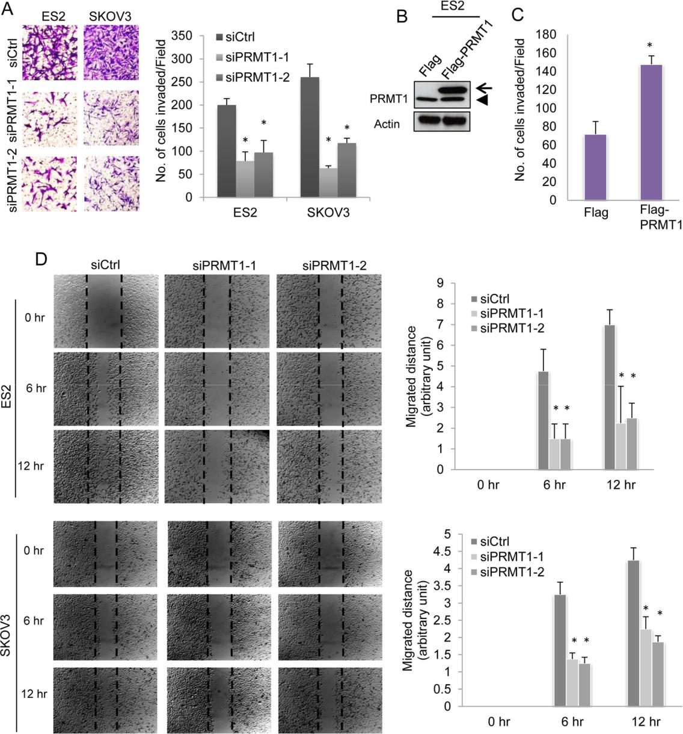

PRMT1 depletion. We established ES2 cells that constitutive-ly expressed Flag-PRMT1 by retrovirus infection. The expres-sion level of exogenous PRMT1 was approximately two-fold that of the endogenous protein (Fig. 2b). The overexpression of PRMT1 significantly promoted the invasion of ES2 cells (Fig. 2c). We next evaluated cell migration by wound healing assay. Confluent monolayers of siRNA-transfected ES2 or SKOV3 cells were scratched, and the migration of cells to

Fig. 2 PRMT1 regulates cell invasion and migration. (a) Cells transfected with siRNAs were subjected to in vitro invasion assay. Representative images of invading cells are shown. The graph indicates the average number of invaded cells per field. Three independent experiments were carried out, and the data are shown as the mean±SD (*P<0.05). (b) ES2 cells that constitutively expressed Flag or Flag-PRMT1 were established by retrovirus infection, and the expression of the indicated protein was examined by immunoblot. An arrow indicates

exogenous PRMT1 and an arrowhead indicates endogenous PRMT1. (c) The graph indicates the average number of invaded cells per field. Three independent experiments were performed, and the data are shown as the mean±SD (*P<0.05). (d) Confluent monolayers of siRNA-transfected ES2 and SKOV3 cells were scratched, and cell migration was examined 6 and 12 h later. Representative images of migrated cells are shown, and the graph shows the mean migrated distance at the indicated time points (*P<0.05)

the free space was observed 6 h and 12 h later. PRMT1 knock-down clearly suppressed the migration of both ES2 and SKOV3 cells (Fig. 2d).

PRMT1 methylates arginine residues of FAM98A

To gain insight into the function of PRMT1 in ovarian cancer cells, we tried to identify proteins associated with PRMT1. We first generated ES2 cells that constitutively expressed Flag-tagged PRMT1 by retroviral infection. Flag-PRMT1 was immunoprecipitated using an anti-Flag antibody, and the immunoprecipitated proteins were eluted with Flag peptide. The eluted proteins were identified by mass spectrometry analysis. In this analysis, we obtained many proteins that have RGG/RG motifs such as heterogeneous nuclear ribonucleo-protein K (HNRNPK) or heterogeneous nuclear ribonucleo-protein U (HNRNPU ) (Table S1). Most of the proteins we identified are known to regulate RNA processing. Among these proteins, we focused on an unknown protein called FAM98A, which has multiple RGG/RG motifs. To detect the association of PRMT1 and FAM98A, Flag-PRMT1-expressing ES2 cells were lysed and Flag-PRMT1 and its associating proteins were immunoprecipitated. The immuno-precipitates were subjected to immunoblot with anti-FAM98A antibody. As shown in Fig. 3a, endogenous FAM98A was co-precipitated with Flag-PRMT1. To further confirm the associ-ation, GFP-FAM98A was transiently expressed in 293 T cells with or without Flag-PRMT1, and cell lysates were immunoprecipitated with anti-Flag antibody. GFP-FAM98A was precipitated in the presence of Flag-PRMT1 but not in the absence of Flag-PRMT1 (Fig. 3b). FAM98A has multiple RGG/RG motifs in the C-terminal half and there is no partic-ular domain in the N-terminus. Because PRMT1 often meth-ylates arginines in the RGG/RG motifs, we speculated that the C-terminal region was responsible for the interaction with PRMT1. As expected, the C-terminal region interacted with PRMT1, but interestingly, the N-terminal region could also bind to PRMT1 (Fig. 3c). It appears that PRMT1 interacts with both the N- and C-terminal regions of FAM98A.

We next tested whether FAM98A is methylated by PRMT1. ES2 cells that constitutively expressed Flag-FAM98A or Flag-tag were lysed and subjected to immuno-precipitation with anti-Flag antibody. The immunoprecipitates were immunoblotted with an antibody that detects asymmetric dimethylated arginines (anti-ADMA antibody). As shown in Fig. 3d, immunoprecipitated Flag-FAM98A was clearly de-tected by the anti-ADMA antibody. The dimethylation of ar-ginine was diminished by the treatment of cells with a meth-ylation inhibitor, adenosine dialdehyde (Adox) (Fig. 3e). The N-terminal portion, which does not contain RGG/RG motifs, was not methylated, indicating that arginine residues in the RGG/RG motifs are methylated (Fig. 3f). To determine whether PRMT1, but not other PRMTs, is essential for

dimethylation, we examined the arginine methylation of FAM98A in the absence of PRMT1. The suppression of PRMT1 expression significantly reduced the dimethylation of FAM98A in cells (Fig. 3g). These results show that arginine residues of FAM98A are methylated by PRMT1 in cells.

Depletion of FAM98A suppresses colony formation, cell migration and invasion

To explore whether FAM98A is required for the malignancy of cancer cells, we depleted its expression in ovarian cancer cells. FAM98A was expressed at similar levels in all the cell lines we examined (Fig. 4a). We used ES2 and SKOV3 cells to examine the role of FAM98A in colony formation, cell migration and invasion. Transfection of two different siRNAs sufficiently depleted FAM98A expression in both cell lines (Fig. 4b). The anti-FAM98A antibody detected two bands in immunoblot analysis and both bands disappeared after siRNA transfection, indicating that two isoforms of FAM98A are expressed. The depletion of FAM98A did not affect the pro-liferation of ES2 cells (Fig. 4c). Although the growth of FAM98A siRNA-transfected SKOV3 cells was reduced com-pared to control siRNA-transfected cells, there was no signif-icant difference (P > 0.05) (Fig. 4c). The depletion of FAM98A significantly suppressed the ability of both ES2 and SKOV3 cells to form colonies in the soft agar (Fig. 4d). In addition, both cell migration and cell invasion were inhibited by FAM98A knockdown (Fig. 4e and f). These re-sults indicate that FAM98A is important to maintain the ma-lignant characteristics of cancer cells.

Discussion

In this report, we showed that PRMT1 was associated with the promotion of the malignant characteristics of ovarian cancer cells. Although PRMT1 suppression did not affect the prolif-eration of ES2 and SKOV3 cells, the ability of cells to grow in soft agar was significantly reduced by PRMT1 depletion. Consistently, the subcutaneous proliferation of ES2 cells in mice was reduced by PRMT1 knockdown. These results in-dicate that PRMT1 is specifically required for the proliferation of cancer cells in the absence of cell adhesion to the extracel-lular matrix. In addition to suppression of anchorage-independent growth, PRMT1 knockdown suppressed the mi-gration and invasion of both ES2 and SKOV3 cells. Com-bined with previous studies, our results further confirm the critical functions of PRMT1 for the progression of cancers.

To gain insight into the function of PRMT1 in cancer cells, we searched for PRMT1-associating proteins by mass spec-trometry analysis. Consistent with previous findings, we iden-tified a number of proteins with RGG/RG motifs, some of which have already been reported to be directly arginine-

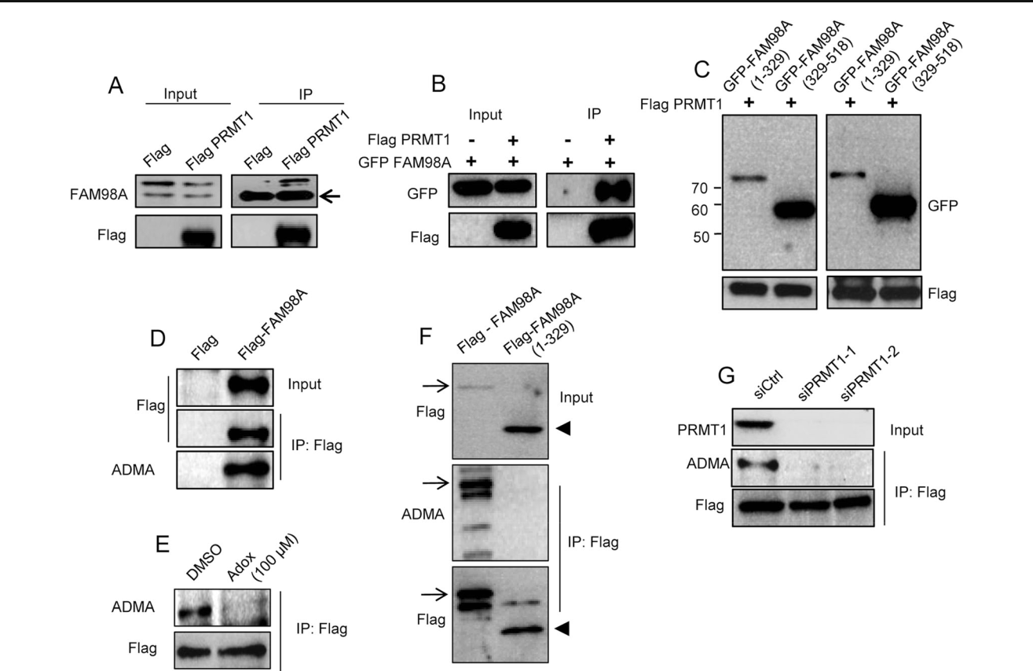

Fig. 3 FAM98A is a novel substrate of PRMT1. (a) ES2 cells that constitutively expressed Flag or Flag-PRMT1 were established by retro-virus infection. Flag-PRMT1 or the Flag tag was immunoprecipitated with anti-Flag antibody and the immunoprecipitates were immunoblotted for FAM98A and anti-Flag antibodies. The arrow indicates the heavy chain of the anti-Flag antibody. (b) 293 T cells cultured in 35 mm dishes were transfected with 1 μg of plasmid encoding Flag-PRMT1 and GFP-FAM98A, and cells were lysed 24 h later. Flag-PRMT1 was immunoprecipitated with anti-Flag antibody and immunoblotted for anti-Flag and anti-GFP antibodies. (c) 293 T cells cultured in 35 mm dishes were transfected with 1 μg of plasmid encoding Flag-PRMT1 together with GFP-tagged 1–329 FAM98A or 329–518 FAM98A. Twenty-four hours later, cells were lysed and Flag-PRMT1 was immunoprecipitated with anti-Flag antibody and immunoblotted with anti-Flag and anti-GFP antibodies. (d) ES2 cells that constitutively

expressed Flag-FAM98A were established by retrovirus infection. Flag-FAM98A was immunoprecipitated with anti-Flag antibody and immunoblotted with anti-Flag and anti-ADMA antibodies. (e) ES2 cells that constitutively expressed Flag-FAM98A were treated with DMSO or 100 μM of Adox, and Flag-FAM98A was immunoprecipitated 24 h later. The immunoprecipitates were immunoblotted with anti-Flag and anti-ADMA antibodies. (f) ES2 cells that constitutively expressed Flag-tagged full length FAM98A (1–518) or N-terminal FAM98A (1–329) were established by retrovirus infection. Flag-tagged proteins were immunoprecipitated and immunoblotted with anti-Flag and anti-ADMA antibodies. Arrows indicate full-length Flag-FAM98A and arrowheads indicate Flag-FAM98A (1–329). (g) ES2 cells that constitutively expressed Flag-FAM98A were treated with siRNAs, and Flag-FAM98A was immunoprecipitated 72 h later. The immunoprecipitates were immunoblotted with the indicated antibodies

methylated by PRMT1. For example, PRMT1 methylates ar-ginine residues of FUS/TLS (fused in sarcoma/translocated in liposarcoma), which is one of causative genes of ALS (famil-ial amyotrophic lateral sclerosis) and is involved in the regu-lation of nucleus-cytoplasm shuttling [21]. Among proteins identified by our mass spectrometry analysis, we focused on a protein with unknown function, FAM98A. The protein has multiple RGG/RG motifs and was expressed in all the ovarian cancer cell lines we examined. Although FAM98A has a ho-mologue called FAM98B, the level of FAM98B mRNA was more than 10 times lower than that of FAM98A in ovarian cancer cells (data not shown). Recent studies have shown that FAM98B formed a complex with transfer RNA (tRNA)

splicing ligase [22, 23]; however, whether FAM98B has any regulatory roles in tRNA splicing remains totally un-known. FAM98A and FAM98B are 58 % identical in ami-no acid sequence and both have multiple RGG/RG motifs, but it remains yet to be determined whether FAM98A sim-ilarly associates with the tRNA splicing complex. To ex-amine the role of FAM98A for cancer progression, we de-pleted FAM98A expression in ES2 and SKOV3 cells using siRNA. Similar to PRMT1 knockdown, we observed a sig-nificant reduction in colony formation, migration, and in-vasion. Although physiological functions of FAM98A are totally unknown, our results suggest an important role of FAM98A in cancer progression.

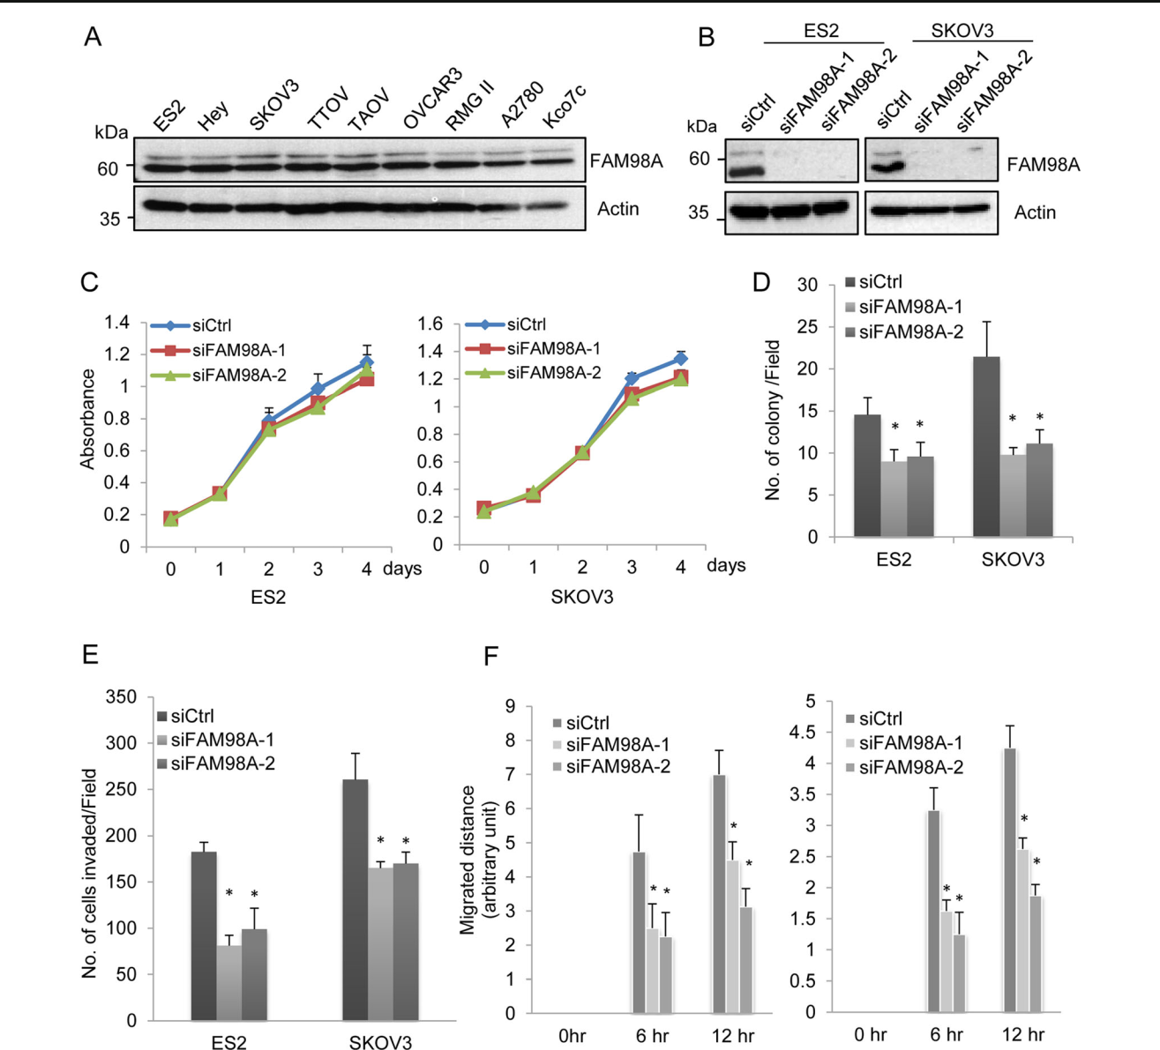

Fig. 4 Depletion of FAM98A suppresses colony formation, migration, and invasion. (a) Expression of FAM98A in ovarian cancer cell lines was examined by immunoblot. (b) ES2 and SKOV3 cells were transfected with siRNAs, and the expression of FAM98A was examined by immunoblot 72 h later. (c) Cells were transfected with siRNAs and the number of viable cells at the indicated time points was evaluated. (d) Cells transfected with siRNAs were subjected to soft agar colony formation assay. The graphs indicate the average number of colonies per field. Three independent experiments were carried out, and the data

are shown as the mean±SD (*P<0.05) (e) Cells transfected with siRNAs were subjected to in vitro invasion assays. The graph indicates the average number of invaded cells per field. Three independent experiments were carried out, and the data are shown as the mean±SD (*P<0.05). (f) Confluent monolayers of siRNA-transfected ES2 and SKOV3 cells were scratched, and cell migration was examined 6 and 12 h later. The graph shows the mean migrated distance at the indicated time points (*P<0.05)

We confirmed that FAM98A was arginine-methylated in cells using an antibody that specifically detected asymmet-ric dimethylated arginine. The C-terminal region with RGG/RG motifs, but not the N-terminal region, was arginine-methylated; thus, it is likely that arginine residues in RGG/RG motifs of FAM98A are methylated. However, a large number of arginine residues in the C-terminus hindered our attempts to determine the critical residues for methylation. Members of the PRMT family proteins

other than PRMT1 are present in ovarian cancer cells, but PRMT1 appears to be responsible for the methylation of FAM98A because depletion of PRMT1 significantly reduced methylated FAM98A. This is consistent with pre-vious reports that PRMT1 is responsible for more than 85 % of methylated arginine in mammalian cells. Our results clearly show that FAM98A is methylated by PRMT1, but the exact roles of the methylation require further investigation.

In summary, we have shown that PRMT1 is required for anchorage-independent growth, cell migration and invasion of ovarian cancer cells. We also identified a novel substrate of PRMT1, FAM98A, which was also necessary for the malig-nancy of ovarian cancer cells. The identification of novel PRMT1 substrates and their functions in cancer may reveal interesting molecular mechanisms for cancer progression.

Acknowledgments We appreciate the members of the Division of Can-cer Biology for their helpful discussions and technical assistance. This research was funded by the Ministry of Education, Culture, Sports, Sci-ence and Technology of Japan (Nanomedicine Molecular Science, 2306) and by the Takeda Science Foundation.

Compliance with ethical standards Animal experiments were con-ducted in accordance with the regulations of the Faculty of Medicine of Nagoya University.

References

- Karve TM, Cheema AK. Small changes huge impact: the role of protein posttranslational modifications in cellular homeostasis and disease. J Amino Acids. 2011;2011:207691.

- Gary JD, Clarke S. RNA and protein interactions modulated by protein arginine methylation. Prog Nucleic Acid Res Mol Biol. 1998;61:65–131.

- Boffa LC, Karn J, Vidali G, Allfrey VG. Distribution of NG, NG,-dimethylarginine in nuclear protein fractions. Biochem Biophys Res Commun. 1977;74:969–76.

- Feng Y, Hadjikyriacou A, Clarke SG. Substrate specificity of hu-man protein arginine methyltransferase 7 (PRMT7): the importance of acidic residues in the double E loop. J Biol Chem. 2014;21; 289(47):32604–16.

- Zurita-Lopez CI, Sandberg T, Kelly R, Clarke SG. Human protein arginine methyltransferase 7 (PRMT7) is a type III enzyme forming ω-NG- monomethylated arginine residues. J Biol Chem. 2012;287: 7859–70.

- Yang Y, Hadjikyriacou A, Xia Z, Gayatri S, Kim D, Zurita-Lopez C, et al. PRMT9 is a Type II methyltransferase that methylates the splicing factor SAP145. Nature Commun. 2015;6:6428.

- Bedford MT, Clarke SG. Protein arginine methylation in mammals: who, what and why. Mol Cell. 2009;33:1–13.

- Yu Z, Chen T, Hebert J, Li E, Richard S. A mouse PRMT1 null allele defines an essential role for arginine methylation in genome maintenance and cell proliferation. Mol Cell Biol. 2009;29:2982–96.

- Bedford MT, Richard S. Arginine methylation an emerging regula-tor of protein function. Mol Cell. 2005;18(3):263–72.

- Thandapani P, O’connor TR, Bailey TL, Richard S. Defining the RGG/RG motif. Mol Cell. 2013;50:613–23.

- Seligson DB, Horvath S, McBrian MA, Mah V, Yu H, Tze S, et al. Global histone modification patterns predict risk of prostate cancer recurrence. Nature. 2005;435:1262–6.

- Le Romancer M, Treilleux I, Bouchekioua Bouzaghou K, Sentis S, Corbo L. Methylation, a key step for nongenomic estrogen signal-ing in breast tumors. Steroids. 2010;75:560–4.

- Cheung N, Chan LC, Thompson A, Cleary ML, So CW. Protein arginine methyltransferase-dependent oncogenesis. Nature Cell Biol. 2007;9:1208–15.

- Yoshimatsu M, Toyokawa G, Hayami S, Unoki M, Tsunoda T, Field HI, et al. Dysregulation of PRMT1 and PRMT6, Type I argi-nine methyltransferases, is involved in various types of human can-cers. Int J Cancer. 2011;128:562–73.

- Mathioudaki K, Papadokostopoulou A, Scorilas A, Xynopoulos D, Agnanti N, Talieri M. The PRMT1 gene expression pattern in colon cancer. Br J Cancer. 2008;99:2094–9.

- Mathioudaki K, Scorilas A, Ardavanis A, Lymberi P, Tsiambas E, Devetzi M, et al. Clinical evaluation of PRMT1 gene expression in breast cancer. Tumour Biol. 2011;32:575–82.

- Zou L, Zhang H, Du C, Liu X, Zhu S, Zhang W, et al. Correlation of SRSF1 and PRMT1 expression with clinical status of pediatric acute lymphoblastic leukemia. J Hematol Oncol. 2012;5:42.

  - Avasarala S, Van Scoyk M, Karuppusamy Rathinam MK, Zerayesus S, Zhao X, Zhang W, et al. PRMT1 is a novel regulator of epithelial-mesenchymal-transition in non-small cell lung cancer. J Biol Chem. 2015;290(21):13479–89.

  - Baldwin RM, Morettin A, Paris G, Goulet I, Côté J. Alternatively spliced protein arginine methyltransferase 1 isoform PRMT1v2 promotes the survival and invasiveness of breast cancer cells. Cell Cycle. 2012;11(24):4597–612.

  - Kajiyama H, Kikkawa F, Suzuki T, Shibata K, Ino K, Mizutani S. Prolonged survival and decreased invasive activity attributable to dipeptidyl peptidase IV overexpression in ovarian carcinoma. Cancer Res. 2002;62:2753–7.

  - Yamaguchi A, Kitajo K. The effect of PRMT1-mediated arginine methylation on the subcellular localization, stress granules, and detergent-insoluble aggregates of FUS/TLS. PLoS One. 2012;7(11):e49267.

  - Pérez-González A, Pazo A, Navajas R, Ciordia S, Rodriguez-Frandsen A, Nieto A. hCLE/C14orf166 associates with DDX1-HSPC117-FAM98B in a novel transcription-dependent shuttling RNA-transporting complex. PLoS One. 2014;9(3):e90957.

  - Popow J, Jurkin J, Schleiffer A, Martinez J. Analysis of orthologous groups reveals archease and DDX1 as tRNA splicing factors. Nature. 2014;511(7507):104–7.

