A Framework for Smart Building Technologies Implementation in the Ghanaian Construction Industry: A PLS-SEM Approach

Frank Ato Ghansahª*, De-Graft Owusu-Manu^{b}, David John Edwards^{c}, Wellington Didibhuku Thwala^{d}, Daniel Yamoah Agyemang^{e} and Benjamin Kwaku Ababio^{f}

ª PhD Candidate, Department of Real Estate and Construction, Faculty of Architecture, The University of Hong Kong, Pokfulam, Hong Kong.

^{b} Professor, Department of Construction Technology and Management, Kwame Nkrumah University of Science and Technology, Ghana.

^{c} Professor, Department of the Built Environment, Birmingham City University, Birmingham,
United Kingdom.

^{d} Professor, Department of Civil Engineering, University of South Africa, Pretoria, Gauteng, South Africa.

^{e} Post-Doctoral Research Assistant, Department of Building and Real Estate, Hong Kong Polytechnic University, Hong Kong

^{f} PhD Candidate, Department of Real Estate and Construction, Faculty of Architecture, The University of Hong Kong, Pokfulam, Hong Kong

*Corresponding author, Email: fghansah@connect.hku.hk

Abstract
This study sought to identify the dimensions and the significant critical factors capable of enhancing Smart Building Technologies’ (SBTs’) implementation for smart building projects in developing countries. A desk literature review is first conducted to identify and categorize the potential factors. It is further analyzed using partial least square structural equation modelling (PLS-SEM) based on 227 valid data from experts in Ghana. The study revealed four underlying dimensions (i.e., ‘processes and control’[PC], ‘people and skills’[PS], ‘methods and techniques’[MT], and ‘knowledge sharing’[KS]) consisting 14 significant critical factors capable of enhancing SBTs implementation for smart building projects, with the top three comprising ‘appropriate procedures/practices for managing smart building projects (MT3)’, ‘appropriate tools/techniques to guide smart building projects to their delivery (MT2)’, and ‘skills and experience required to pick project team members for smart building projects (PS1)’. Further analysis with PLS-SEM revealed a significant positive effect of the four underlying dimensions and their positive interrelationships toward framework development. Besides the unique contribution of this study to the knowledge body, it also provides project managers and a construction design team with a structured knowledge of the skills, expertise, attitudes, decision-making, processes, control mechanisms, and effective delivery of smart building projects in developing countries.

Keywords: Intelligent buildings, Partial least squares-structural equation modelling, Smart building technologies, Smart building

Introduction
The integration of smart building technologies (SBTs) enhances buildings to embrace changeable characteristics that respond with minimum human interference in adjusting to the external and internal environments for the benefit and comfort of occupants - taking into consideration the financial perspective and reduction in energy use (Eini et al., 2021). To simply put, SBTs incorporate smartness, efficiency, and effective management features into buildings. Saunila et al. (2019) explained SBTs as the bundle of digital technologies (such as smart sensor-based networks) embedded into previously non-digital devices or systems to enhance their level of smartness. Specifically, smartness engenders greater building management efficiency regarding operations, waste reduction, accessibility, comfort, and safety (Sarkar et al., 2022). Given the palpable environmental benefits and the urgent need for sustainable development (Bowen, 2021; Chan et al., 2022), construction industry actors must agree on and manage processes to improve the sector’s capacity and effectiveness to meet the national economic demand for building and civil engineering products that achieve smart sustainability objectives (Ofori, 2015). Hence, construction professionals must consider SBTs in the design stage of buildings and their implementation throughout the buildings’ lifecycle to achieve efficiency and high performance of buildings.

Despite the pertinent research conducted on the adoption of SBTs to produce smart buildings and its associated benefits (Saunila et al., 2019; Tran et al., 2022; Acheng et al., 2022), the implementation in developing countries has not progressed due to notable lack of implementation framework within organisations on related building projects. This has received little attention in the literature. It is observed that studies, including Ock et al. (2016), Yadav et al. (2019), and Apanaviciene et al. (2020), have developed related frameworks to understand smart buildings and their operability in achieving efficiency in buildings. However, these studies do not shed light on factors capable of enhancing SBTs implementation, especially for developing countries in Sub-Saharan Africa. Opportunities to adopt a smart building concept are clear, but for many organisations in developing countries such as Ghana, harnessing it requires a better understanding and utilisation of SBTs (Ahiabor, 2019). Thus, factors of effective implementation of SBTs must be identified to develop a holistic framework that construction organisations can adopt to implement SBTs in smart building projects based on experts’/professionals’ viewpoints. Such a framework would delineate the sequence of activities, responsibilities, and data exchanged to implement SBTs in developing countries.

Given this contextualisation of the prevailing body of knowledge, this research seeks to: (1) identify the significant factors for the effective implementation of SBTs in developing countries and (2) evaluate the influence of the significant factors and their interrelationships on the SBTs implementation toward a framework development. The study focuses on the specific context of Ghana, a developing country in Sub-Saharan Africa (World Bank, 2022). To achieve the aim of the study, the partial least squares structural equation modelling (PLS-SEM) supported by literature review and descriptive analysis is adopted. The PLS-SEM can estimate the complex relationship among the significant factors on SBTs implementation in predicting an effective framework based on the perceptions of project managers and the construction design team. The findings presented can serve as a blueprint for effectively implementing SBTs within an integrated design and project management team in Ghana. However, other developing countries can learn a lesson from the Ghanaian context. The significant factors of effective implementation can help organisations integrate the smart building concept into specific project settings.

Brief Overview of Smart Building Technologies (SBTs) Implementation
Smart building denotes a residence equipped with a communications network – linking electronic sensors, domestic appliances, and devices that can be remotely monitored, accessed (or controlled) and provides automated services responding to occupants’ needs (Buckman et al., 2014; Habibi, 2016). The global smart building size was valued at USD 93.93 billion in 2022 and is expected to grow at a compound annual growth rate of 26.8% from 2023 to 2030, with emphasis on minimising energy consumption across both developed and developing countries (Global Market Insight, 2023). With the country breakdown, developing countries are noted with the lowest growth rate in the smart building market due to the decreasing implementation of SBTs in the execution and delivery of smart building projects (Global Market Insight, 2023). Also, the concept of smart building is still relatively new in developing countries, and its adoption and implementation rate may vary significantly depending on factors, such as economic development, government policies, and infrastructure.

Smart buildings are enabled by SBTs that enhance the building’s ability to reduce energy consumption, improve comfort and achieve users’ satisfaction (Attoue et al., 2018) whilst performing functions as stated by Habibi (2016). As such, Saunila et al. (2019) defined SBTs to include the bundle of digital technologies (such as smart sensor-based networks) embedded into previously non-digital devices or systems to enhance their level of smartness. Smart buildings incorporate these technologies to optimise building services and operations for the betterment of occupants. However, implementing SBTs into building projects to produce a smart building exceeds just the installation and integration of the technology systems (such as a building automation system (BAS), a telecommunication system, an office automation system, and a computer-aided facility management system) (Vattano, 2014). This extends to delineating the sequence of activities, responsibilities, and data exchanged to implement the SBTs.

For this study, following the concise definition by Saunila (2019), the term ‘smart building’ is defined as a building that uses a coalescence of advanced digital technologies (such as the Internet of Things [IoT] and sensor-based networks) to connect different building systems into a single central command and control system. This consists of software and hardware that work to make buildings “smarter”; meaning that operational processes are more automated, responsive to tenant needs and weather conditions, and generally efficient (Tran et al., 2022; Acheng et al., 2022). The SBTs may be referred to the digital technologies. A typical smart building with integrated smart component(s) systems could blend SBTs to support human needs. These SBTs integrated into buildings interact together to achieve high building performance, efficiently track to reduce energy usage in buildings, effectively monitor and achieve security, reduce the cost of maintenance, as well as providing users with a good building environment, resulting in satisfaction and comfortability (Junior et al., 2017; Rosenkranz, 2021; Ejidike et al., 2022). On the other hand, the disadvantages of the SBTs include high initial installation cost, cyber security risks, constant internet connectivity, and the user’s unfamiliarity with the SBTs usage (Junior et al., 2017; Rosenkranz, 2021).

Despite the definitions and associated benefits of SBTs, their implementation is not progressing in developing countries, and this has received little attention in the literature, leading to decreasing implementation of SBTs in the execution and delivery of building projects. Ock et al. (2016) conceptualised a framework for smart buildings to ensure efficient energy management. Yadav et al. (2019) developed a sustainable smart city structural framework in developing countries by focusing on the Indian economy. Apanaviciene et al. (2020) developed an evaluation framework for smart building integration into a smart city. However, among these studies, none has considered exploring the factors capable of enhancing SBTs implementation, especially for developing countries in Sub-Saharan Africa. Meanwhile, understanding these factors is necessary for successfully implementing SBTs in delivering smart building projects in developing countries.

This study, therefore, reviewed desk literature to explore the potential factors capable of enhancing the implementation of SBTs, and their relevance has been explained comprehensively toward effective SBTs implementation, as illustrated in Supplementary materials T1 & T2. The list of potential factors is then given to the Ghanaian construction professionals, including project managers and construction teams, to guide their choice of identifying the significant factors that could enhance SBTs implementation in Ghana.

Research Method
The study adopted a positivist research philosophy and quantitative research strategy, where the PLS-SEM approach is implemented to analyse the participants’ responses on the potential factors for effective SBTs implementation. The PLS-SEM approach is proven to be successful in other domains in different contexts in construction technology management, such as web-based project management systems (Doloi, 2014), construction organisations’ willingness to participate in e-bidding (Aibinu and Al-Lawati, 2010), and construction organisation BIM capabilities (Munianday et al., 2022). Following the five logical steps of PLS-SEM: specification, identification, parameter estimation, model estimation, and model modification (Kline, 2010), the study measured and examined the significant relationship between the observed and latent variables concerning the factors. The study met the PLS-SEM criteria, including the confirmatory stage of the study based on the potential factors and how they measured the categorisations for prediction, as well as the formative and reflective relationship nature of the study (Hair et al., 2019). Subsequently, this study followed the main steps illustrated in Figure 1.
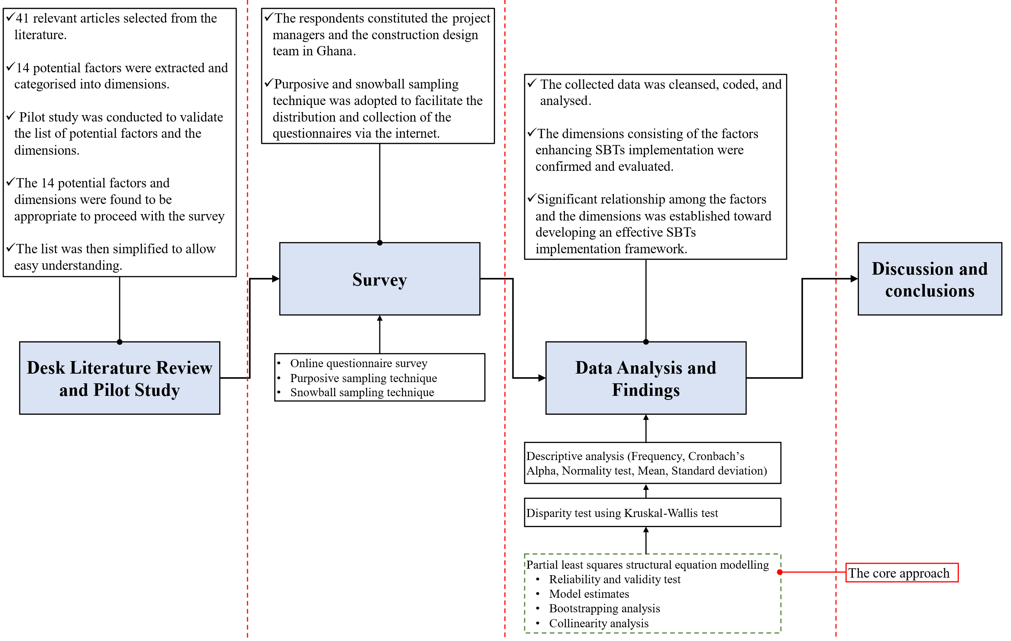
Figure 1: Flowchart of the research method

Identifying the potential factors for effective implementation of SBTs
This study extracted potential factors capable of enhancing the SBTs implementation using the desk literature review approach (Ghansah et al., 2022). After filtering, the study selected and validated 41 relevant articles. 14 potential factors for effective SBTs implementation were retrieved and categorised into four main dimensions based on the in-depth qualitative content analysis (QCA) approach using common critical themes (Kohlbacher, 2006) (see Supplementary material: T1). The four dimensions include processes and control (PC), people and skills (PS), methods and techniques (MT), and knowledge sharing (KS). Also, the factors were noted to appear in at least two sources. The relevance of the potential factors was then discussed comprehensively toward effective SBTs implementation (see Supplementary material T2).

The potential list was validated in a pilot study that included designers, construction/engineering-based academicians, contractors, service engineers, mechanical engineers, etc. The entry criteria were based on the study’s primary objective. The backgrounds of industry experts were investigated to select participants for the pilot study who had at least two years of experience designing and executing smart building projects of any kind/type. Academicians’ backgrounds were also scrutinised to see if they had at least one first- or second co-authored publication in a reputable journal (Q1, Q2, or Q3) or if they had won any form of research funding in the field of smart building of any type. With these knowledgeable persons, the list of potential factors was validated along with the dimensions and noted to enhance the SBTs implementation (see Table 1).
Table 1: Potential Factors after Piloting
Dimensions |  | Code | Potential Factors | Reference #
 | Processes and Control (PC) | PC1 | Review and Optimisation of Current Project Management Processes toward SBTs implementation | 1,2,3,30
 |  | PC2 | Control and performance assessment processes and techniques for delivering smart building projects | 4,5,6,7,31
 |  | PC3 | Multiple stakeholders’ participation in specific decision-making processes regarding SBTs’ implementation | 3,8,9,32
 |  | PC4 | Careful selection of Project Delivery System (PDS) and forming a project team that can deliver smart building projects | 3,10,11,33
 | People and Skills (PS) | PS1 | Skills and experience required to pick project team members for smart building projects | 3,12,13,34
 |  | PS2 | The right educational level and professional qualifications related to SBTs implementation | 3, 14, 35
 |  | PS3 | Project leadership for delivery of smart building projects | 15,16,17,36
 |  | PS4 | The right attitudes toward smart building projects delivery | 3,18,19,34
 | Method and Techniques (MT) | MT1 | Using time-tested methodologies and project framework for smart building project delivery | 20,21,37
 |  | MT2 | Appropriate tools/techniques to guide smart building projects to their delivery | 3,22,38
 |  | MT3 | Appropriate procedure/practices for managing smart building projects | 23,24,39
 | Knowledge Sharing (KS) | KS1 | Tacit to explicit knowledge of SBTs | 3,25,40
 |  | KS2 | Shared repositories on the SBTs implementation on the project | 26,27,31
 |  | KS3 | Exchange of knowledge among SBTs implementers/experts to capture knowledge embedded in different regional conditions and contexts | 28,29,41
For the detailed references #, refer to Table TR in Supplementary material.

Data collection via survey
Through an online questionnaire survey using “Google Forms” (Aboagye et al., 2021), the respondents were contacted to rank the significance of the related potential factors with minimal response biases introduced by the Likert scale viz.: 1-not significant, 2-less significant, 3-moderate, 4-significant, and 5-very significant (see Supplementary material: W2 for the questionnaire). The survey was selected for this study because of its ability to provide a high level of general capability in representing a large population, convenient gathering of data, and little or no observer subjectivity (Sincero, 2012). Before responding to the significance of the factors on SBTs’ implementation, the study determined the respondents’ level of knowledge on SBTs’ implementation: 1=Very Low; 2=Low; 3=Moderate; 4=High; and 5=Very High. Project managers and the construction design team in Ghana, a sub-Saharan African country, constituted the population because they play a vital role in successfully implementing SBTs into building projects during the design and construction process (Fewings and Henjewele, 2019) (known as implementers) in Ghana. Moreover, clients under a Design and Build procurement arrangement or clients with less construction knowledge rely heavily on contractors to offer informed advice on SBTs’ adoption. Also, the study’s goal was to consider the experts’ perspectives. Therefore, building users were excluded because their opinion was beyond the scope of the present study.

Due to the lack of a central database for experts in this study’s context, the online questionnaire link was distributed to the hugely dispersed population of project managers and the construction design team from different construction companies (both private and public) across Ghana via purposive sampling and snowball sampling (Braimah and Ndekugri, 2009). This approach has been used in construction research (Choi et al., 2017; Wuni and Shen, 2020). Respondents were eligible if (1) if they had extensive research experience and were theoretically versed with the application of digital technologies or SBTs in construction; (2) they had hands-on experience or exposure to the SBTs in construction; and (3) they had been involved in at least one smart building project involving any digital technology application. Academic respondents, who are Ghanaians, were identified from highly recognised journal papers with titles and content containing terms which include but are not limited to smart buildings, digital technologies, and SBTs. Industry respondents were identified from Ghana’s construction organisations, associations, and individual companies. The online survey followed the research ethics required by first seeking the consent of the experts and assuring them of the confidentiality of their personal data, if any (See Supplementary material W1-informed consent form). With the purposive and snowball sampling techniques, the data collection lasted almost four months.

Consequently, due to several constraints, including the busy schedules of respondents, 227 responses were gathered in Ghana. This is considered as acceptable and representative of the related population, as it satisfies the central limit (minimum sample size of 30) of any group, as recommended by Sproull (1995) and Ott and Longnecker (2015). This compares favourably with similar surveys in the construction domain in Ghana (for instance, Darko et al., 2018).

Data Analysis and Findings
Data cleansing was first conducted to remove double responses and uncompleted questionnaires. This was made possible after detecting double responses from the same email addresses appearing in the data. As a result, the study accepted older completed responses and removed the latest completed responses from the same email addresses. Before the main analysis, a demographic analysis is conducted.

Demographic Analysis of Respondents
The respondents’ job role is an indicative of their level of expertise, and more senior participants help increase the generalizability and credibility of the results accrued. The demographic analysis revealed that 54 quantity surveyors responded to the questionnaire, followed by construction managers = 37, project managers = 36, architects = 20, electrical engineers =15, structural engineers = 14, mechanical engineers =14, planner =14, IT specialists =12 and services engineers =11. Ascertaining the respondents’ working experience is important because it underscores the credibility of the information gathered (DeRue, 2009) by indicating the participants’ knowledge and implementation capabilities of SBTs on a project. Thus, 92 respondents have work experience of 5-10 years (or 40.53%), followed by: < 5 years = 84 respondents (37.01%); 11-15 years = 39 (17.18%); 16-20 years = 10 (4.40%); and ≥ 20 years = 2 (0.88%). These results depict that the respondents have accrued reasonable experience and can make an informed decision on SBTs’ implementation towards smart building delivery. Subsequently, the respondents’ level of knowledge on SBTs implementation was determined using a bar chart diagram with frequency, as illustrated in Figure 2. This sought to answer the question: what is your level of knowledge on implementing SBTs on a project?

Figure 2: The level of knowledge on implementing SBTs

Cronbach’s Alpha (CA), Normality Test, and Descriptive Analysis
The data depicted an excellent internal consistency with a CA value of 0.954 following the rule of thumb by Pallant (2001): a CA value<6.00 connotes low internal consistency, and it is unacceptable; 0.60-0.80 means moderate and acceptable; and finally, 0.80-1.00 connotes excellent internal consistency. Adopting Kolmogorov-Smirnov (K-S) test due to the sample size >50 following the thumb rule (normally distributed if P-value≤0.050) by Mishra et al. (2019), the study’s dataset depicted as not being normally distributed (i.e., non-parametric dataset) (see Table 2).

Descriptive statistics, including mean scores and standard deviation, were performed to understand the central tendency of the factors and the level of variability and dispersion among the respondents (Kenton, 2019) at a 95% confidence level, as seen in Table 2. The mean rating on the factors ranged from 3.73 – 4.05 based on the adopted Likert scale, with satisfactory standard deviations as <+/-1.000. Finally, the normalisation score (Ns) is estimated on the factors to identify their criticality in implementing SBTs. As a thumb rule, a normalisation score ≥0.500 is deemed critical (Adabre et al., 2020), as shown in Table 2.

Disparity Test
Due to the non-parametric nature of the data, the Kruskal-Wallis test was adopted to determine the degree of association of the experts’ rankings of the critical factors for the effective implementation of SBTs (Ostertagova et al., 2014). This determines if the categories of the profession of the respondents influence the pattern in which they rank the factors. With this, a null hypothesis (H₀) is set as “there is no significant disparity vis-à-vis the level of significance on the factors of SBTs implementation among the respondent with respect to their profession”.
The H₀ can be rejected if the P-value is less than or equal to the significant level of 0.050. Table 2 shows the results of the disparity test using the Kruskal-Wallis test.

Table 2: Result of Normality Test, Descriptive Analysis and Disparity Test
Code | Mean | SD | Ns | Rank | 95% Confidence level for mean |  | Kolmogorov-Smirnov (P-Value) | Kruskal-Wallis (P-value)
 |  |  |  |  | Lower bound | Upper bound
PC | 3.753 | 0.765 | 0.688 | 4
PC1 | 3.75 | 0.743 | 0.688 | 12 | 3.65 | 3.85 | 0.000 | 0.124
PC2 | 3.74 | 0.769 | 0.685 | 13 | 3.64 | 3.84 | 0.000 | 0.159
PC3 | 3.73 | 0.772 | 0.683 | 14 | 3.63 | 3.83 | 0.000 | 0.062
PC4 | 3.79 | 0.774 | 0.698 | 11 | 3.69 | 3.89 | 0.000 | 0.285
PS | 3.933 | 0.775 | 0.733 | 2
PS1 | 3.98 | 0.770 | 0.745 | 3 | 3.88 | 4.08 | 0.000 | 0.075
PS2 | 3.95 | 0.762 | 0.738 | 4 | 3.85 | 4.05 | 0.000 | 0.383
PS3 | 3.89 | 0.812 | 0.723 | 7 | 3.78 | 3.99 | 0.000 | 0.420
PS4 | 3.91 | 0.756 | 0.728 | 6 | 3.81 | 4.01 | 0.000 | 0.063
MT | 4.010* | 0.774 | 0.753 | 1
MT1 | 3.94 | 0.756 | 0.735 | 5 | 3.84 | 4.04 | 0.000 | 0.101
MT2 | 4.04* | 0.789 | 0.760 | 2 | 3.94 | 4.14 | 0.000 | 0.153
MT3 | 4.05* | 0.777 | 0.763 | 1 | 3.95 | 4.15 | 0.000 | 0.177
KS | 3.847 | 0.729 | 0.712 | 3
KS1 | 3.85 | 0.763 | 0.713 | 9 | 3.75 | 3.95 | 0.000 | 0.444
KS2 | 3.81 | 0.709 | 0.703 | 10 | 3.71 | 3.90 | 0.000 | 0.240
KS3 | 3.88 | 0.716 | 0.720 | 8 | 3.79 | 3.97 | 0.000 | 0.245
* Primary significant factors with Mean value > 4, where 4 = significance per the Likert Scale, SD = Standard deviation, Ns = Normalisation scores, Rank based on Ns

Partial Least Squares – Structural Equation Modelling (PLS-SEM)
The PLS-SEM was then adopted for further in-depth analysis using SPSS-AMOS software (version 28). It tests the relationship between the dimensions and the observable critical factors related to the SBTs implementation (Bentler and Wu, 2005). This approach identifies the significant variables based on the strength of the relationship among the factors. PLS-SEM is a robust tool comprising regression analysis, multiple correlations, and path analysis (Hair, 2011). It also considers the measurement error and may estimate and visualise the multiple interrelationships among factors (Ajayi et al., 2018). PLS-SEM was adopted as the study’s sample size meet the thumb rule proposed by Barclay et al. (1995): the minimum sample size should be greater than ten times the largest number of inner model path directed at a particular construct in the inner model.

Hypothetical Framework Development
The study developed an initial framework to facilitate the coding and analysis with PLS-SEM, i.e., the relationships among the four dimensions and the observable variables (measurement model) and the structural model consisting of a formative relation model of the dimensions for the SBTs implementation (Anderson et al., 1988), as illustrated in Figure 3.

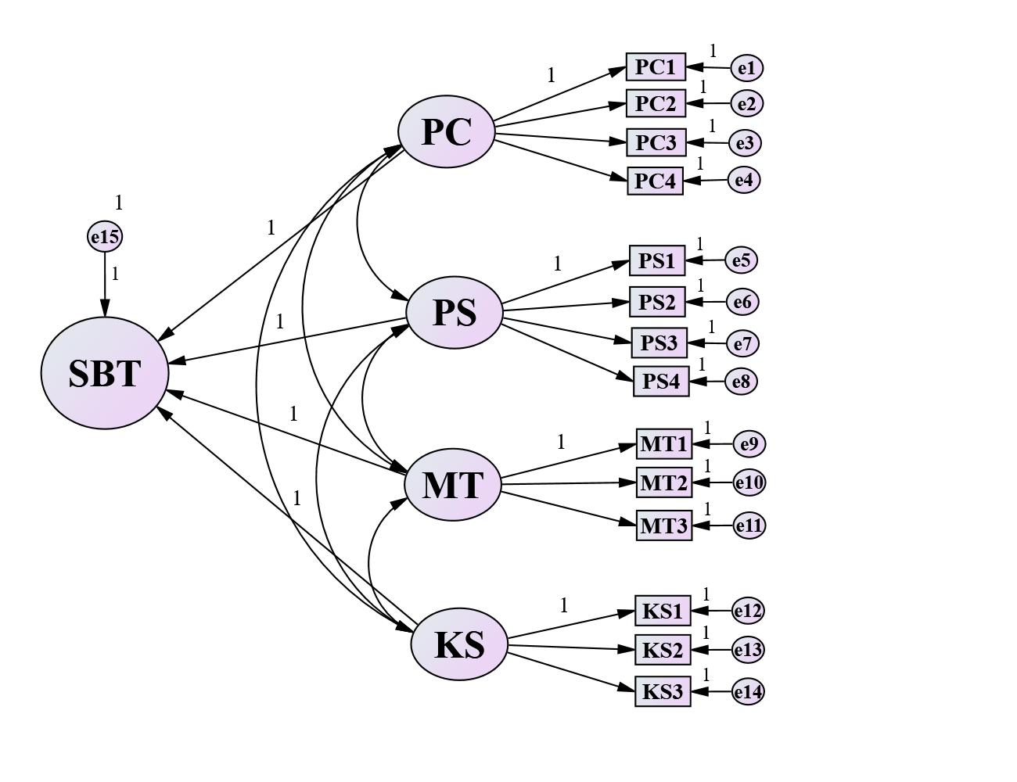
Figure 3: Initial Framework

Framework Testing
The hypothetical model was tested with the following criteria: (1) the outer loading of the measurement items on its associated construct/dimension ≥ 0.500 (Memon and Rahman, 2014); (2) composite reliability (CR) ≥0.700 (Hair et al., 2014); and (3) the average variance extracted (AVE) value of the construct ≥0.500 (Hair, 2011). The path coefficient was estimated using the PLS-SEM algorithms, and their significance level using the bootstrapping analysis (Oke et al., 2021) suggested a significant path at P ≤0.05 at a 95% confidence level. The variance inflation factor (VIF) among the dimensions was determined to check for multicollinearity issues. A VIF <5 signifies the absence of multicollinearity (Kwok et al., 2021). Finally, the coefficient of determination (R²) of the endogenous constructs was estimated to indicate the amount of variance that the predicting construct can explain. The final model was established after 13 iterations of analysis with the standardised factor loading facilitated by modification indices and other parameters (such as bootstrapping features).

From Table 3, the Cronbach’s Alpha (CA) values extend from 0.854 to 0.908, showing excellent internal consistency and confirming the categorisations (Pallant, 2001). Because of CA’s restrictions due to population, it is more appropriate to use Composite Reliability (CR). CR considers the different outer loadings of the indicator variables (Straub et al., 2004), and values vary between 0 and 1, with higher values indicating a higher level of reliability. From Table 3, the CR values of the indicator variables extend from 0.883 to 0.962, suggesting significant internal consistency reliability. From Table 3, the Average Variance Extracted (AVE) for the indicator variables ranges from 0.655 to 0.863 (>0.50), hence, suggesting that > half of the measured item’s variance is accounted for by the observed items whilst < half of the variance is due to measurement error (Hair, 2011).

Figure 4 shows a strong correlation between the latent variables (i.e., dimensions for enhancing SBTs’ implementation). This is because the correlation coefficient values range from 0.89 to 0.99 (Ratner, 2009). The measurement model comprising PC, PS, MT, and KS has a strong structural relationship with the observables variables as the standardised factor loadings span from 0.790 to 0.950. This denotes that the observable variables (factors) correlate well with the latent variables (dimensions) in designing the model/framework for this study. Per Ratner’s (2009) guidelines, a strong positive relationship occurred between the measured variables on the latent variables, showing a strong influence on the latent variables.

From Figure 4, the structural model showed that the four underlying dimensions positively enhance SBTs implementation, as the estimated coefficient ranges from 0.214 to 0.300; hence, PS has the highest effect. After determining the effect of the dimensions on SBTs implementation, the variance inflation factor (VIF) value was determined to explore further the collinearity amongst the contributory effect on SBTs implementation. From Table 3, all values of VIF were known to be < 10, following the threshold by Heckman (2015). Hence, the factors are in good shape, implying that the dimensions have independent contributions to the higher-order construct. In addition, bootstrapping analysis was adopted to predict the path coefficient’s significance. Table 3 revealed that all paths were statistically significant at the P≤0.05 (Anglim, 2014).

The measurement and structural model’s predictive accuracy were determined using the R² values (Hair et al., 2019). From Table 3, the R² ranges from 0.624 to 0.903, which denotes the level of measurement by the indicator values explaining about 62.4% of variance regarding the factors for enhancing SBTs’ implementation on building projects (measurement model). With the structural model, the R² was estimated to be 0.91, which shows a very good value indicating that the variance of PC, MT, PS, and KS explains 91% of the variance of SBTs implementation. Also, the indicator variables were all significant as P-value ≤0.05.

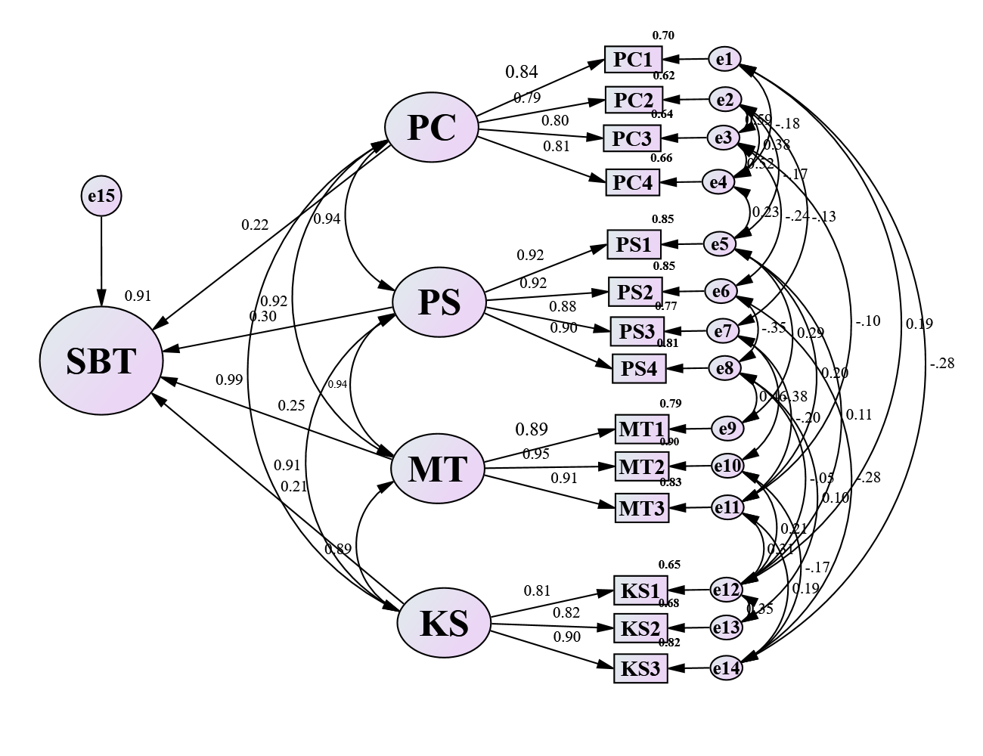
Figure 4: Final Framework

Table 3: Reliability and validity test, model estimates, bootstrapping analysis, and variance inflation factor
Paths |  |  |  | CA | CR | AVE | R² | P-Value | VIF
Structural model (
SBT |  |  | PC | - | - | - | 0.91 | 0.003 | 1.050
SBT |  |  | PS | - | - | - |  | 0.046 | 1.100
SBT |  |  | MT | - | - | - |  | 0.012 | 1.066
SBT |  |  | KS | - | - | - |  | 0.007 | 1.048
Measurement model
PC1 |  |  | PC | 0.876 | 0.884 | 0.655 | 0.701 | 0.004 | -
PC2 |  |  | PC |  |  |  | 0.624 | 0.007 | -
PC3 |  |  | PC |  |  |  | 0.638 | 0.012 | -
PC4 |  |  | PC |  |  |  | 0.655 | 0.016 | -
PS1 |  |  | PS | 0.896 | 0.962 | 0.863 | 0.848 | 0.016 | -
PS2 |  |  | PS |  |  |  | 0.854 | 0.007 | -
PS3 |  |  | PS |  |  |  | 0.772 | 0.012 | -
PS4 |  |  | PS |  |  |  | 0.806 | 0.003 | -
MT1 |  |  | MT | 0.908 | 0.940 | 0.839 | 0.789 | 0.008 | -
MT2 |  |  | MT |  |  |  | 0.903 | 0.007 | -
MT3 |  |  | MT |  |  |  | 0.827 | 0.021 | -
KS1 |  |  | KS | 0.854 | 0.883 | 0.715 | 0.651 | 0.007 | -
KS2 |  |  | KS |  |  |  | 0.675 | 0.010 | -
KS3 |  |  | KS |  |  |  | 0.819 | 0.015 | -
P-Value = Two-tailed significance level at 95% confidence level after bootstrapping, VIF = Variance inflation factor, R² = coefficient of determination

Discussion of Results

Level of Knowledge on SBTs’ Implementation
From Figure 3, most construction professionals have average knowledge of implementing SBTs on a project, and the question is, why not a high level? Ghansah et al. (2021) discovered an averagely low level of SBTs awareness and knowledge among Ghanaian construction professionals and suggested that ‘training’ was required. The respondents, known as SBTs implementers, were requested to assess the potential factors capable of enhancing SBTs’ implementation based on their significant influence.

Construction professionals in developing countries, especially Ghana, are shown to have an average level of knowledge of the SBTs’ implementation. This limits construction professionals from implementing the SBTs via effective technology transfer and threatens an organisation’s ability to remain relevant and competitive (Uribe-Echeberria et al., 2019). Moreover, construction companies are missing the availability of guidelines to understand and execute SBTs on a project (Ahiabor, 2019). The utilisation of SBTs remains a ‘hanging idea’ because of this. Hence, it is imperative to develop strategies for construction organisations to improve SBTs implementation. As a result, identifying the significant factors capable of enhancing such implementation is required. Construction companies in developing countries like Ghana must have knowledgeable personnel to implement and incorporate SBTs in buildings to gain a competitive advantage. The SBTs implementation may be effective and successful with a promising framework/guideline consisting of significant factors.

Significant Key Factors for Enhancing SBTs’ Implementation
The two factors considered to be significant are ‘appropriate procedure/practices for managing smart building projects’ and ‘appropriate tools/techniques to guide smart building projects to their delivery’, which have mean scores of 4.04 and 4.05, respectively, where according to the scale 4=significant. This finding suggests that ‘appropriate procedures and practices’ are a good guide for implementing SBTs in a smart building project. A clear and simple ‘best practice’ procedure and practice can help achieve and monitor the successful implementation of SBTs on a project (Grover and Froese, 2016). Dejaco et al. (2017) suggested integrating practices and procedures with emerging technologies to improve efficiency. For instance, building information modelling (BIM)-based procedures can be developed to enhance SBTs’ implementation. Practices and procedures can also be enhanced with emerging technologies such as IoT and blockchain to implement SBTs effectively.

The study revealed all the significant factors to be highly critical in enhancing the SBTs implementation, with the top three critical significant factors being appropriate procedure/practices for managing smart building projects (M3), appropriate tools/techniques to guide smart building projects to their delivery (M2), and skills and experience required to pick project team members for smart building projects (PS1). With the dimensions, method and techniques (MT) was revealed as the most critical. Techniques/tools and procedures/practices adopted by a construction organisation for SBTs’ implementation process in a smart building project are critical, including documents, frameworks, and systems that enable a company to achieve its objective (Moullin et al., 2020). A best practice guideline prescribed in various project management frameworks provides a suite of techniques and tools that could guide smart building project delivery. There should be an imperative need to integrate more tools and techniques to cater to smart building project requirements (Ram and Sutrisna, 2013). Tools, practices, and techniques are utilised to understand the practical and conceptual issues of managing and implementing SBTs (Ghadge et al., 2006) in different forms, leveraging emerging technologies (e.g., BIM, blockchain, and IoT). Tools/techniques and procedures/practices are, therefore, key significant critical factors capable of enhancing SBTs implementation on smart building projects in developing countries. Hence, effectively integrating them can help generate best practice guidelines for effective SBTs implementation in Ghana and other developing countries due to the expert-based knowledge induced.

Framework and Underlying Dimensions
As all the significant factors were critical (Ns≥0.500) and denoted no significant disparity among the respondent (using the Kruskal-Wallis test), PLS-SEM is adopted further to evaluate the relationship among them toward a framework development. The results of the PLS-SEM confirmed the categorisation of the 14 significant variables into four significant dimensions: PC, PS, MT, and KS. The dimensions are a significant pillar of this study’s framework proposed to achieve an effective SBTs implementation in developing countries. The framework developed is purported to guide project managers and the construction design team to take a holistic approach to deliver smart building projects successfully in developing countries, such as Ghana. The four dimensions positively correlated to developing a framework that explains 91.0% of the variance in enhancing SBTs implementation for building projects with a P-value≤0.05. It is, therefore, important to understand the dynamics of each of the dimensions as well as their associated relationship toward a framework development for SBTs implementation in developing countries, considering the Ghanaian context. These are discussed in the subsequent sections.

Methods and Techniques (MT)
A key dimension loaded significantly with effective SBTs’ implementation is MT, which had significant observables with R² ranging from 69.5% to 84.2% at P ≤0.05. MT was again noted to have a significant direct positive effect on SBTs implementation (β=0.248; P-value=0.012). The MT dimension constituted ‘time-tested methodologies and project framework for smart building project delivery’, ‘appropriate tools/techniques to guide smart building projects to their delivery’, and ‘appropriate procedure/practices for managing smart building projects’. The study regarded MT as the most prioritised among all the underlying dimensions, considering the Ghanaian context, thereby being in congruence with Grover and Froese (2016) and Ram and Sutrisna (2013), who suggested technology-integrated methods as a best practice for executing smart building projects.

In line with this study, MT is a key dimension for implementing SBTs in a smart building project. Methods can be integrated with other techniques to efficiently execute a smart building project. This finding aligns with Nelson (2017), who suggested that smart building projects can effectively be executed using time-tested methodologies and project frameworks. Techniques that facilitate estimation, risk assessment, quality management, and stakeholder management regarding the execution of smart building projects must be developed and incorporated into the SBTs’ implementation processes to allow successful delivery (Moullin et al., 2020). To enhance SBTs’ implementation towards a successful smart building project delivery in developing countries, such as Ghana, construction organisations must develop new efficient methods and techniques that are integrated with emerging technologies. MT integration with new knowledge of emerging technologies can augment the SBTs’ implementation processes toward smart building delivery. Existing methods and techniques can be improved with emerging technologies to provide best practices that can help in the efficient execution of smart building projects. This is necessary as evidence suggests that emerging technologies have the potential to uptake construction methods efficiently throughout the construction sector (Kapliński, 2018; Eini et al., 2021).

People and Skills (PS)
PS is an important dimension to be considered in the implementation process of SBTs for a smart building project. From the SEM analysis, PS constitutes significant factors with R² ranging from 63.7% to 79.8% at P≤0.05, meaning that the factors are fitting to measure the dimension PS towards SBTs’ implementation. It also had a significant positive direct effect on SBTs implementation (β=0.300; P-value=0.046); hence, noted to have the highest effect among the four dimensions. The PS dimension constitutes four factors, namely ‘skills and experience required to pick project team members for smart building project’, ‘the right education level and professional qualifications related to SBTs implementation’, ‘project leadership for the delivery of smart building projects’, and ‘the right attitudes towards smart building project delivery’. The finding is consistent with Hwang and Ng (2013) by describing people and skills as skill requirements, knowledge and expertise, educational qualification, criteria for professional endorsement, attitudes, and behavioural dimensions of individuals working on a smart building project.

This study recommends that organisations consider the smart building skills and knowledge required to employ project team members. This offers a benchmark and a good starting point for developing countries, such as Ghana, to determine the ability of people to work on smart projects throughout the implementation processes (Siew et al., 2016). Also, since the implementation of SBTs requires awareness of SBTs and a balance between technologies and experiences, it may be essential to upgrade the current level of skills inherent within the project teams. According to Ram and Sutrisna (2013), smart building project execution must be supported by people with the right education level and professional qualifications. Academic institutions and other professional training providers must collaborate with industry stakeholders to understand the latest developments and improve the tools and techniques required to effectively implement SBTs in a project.

Given the inherent difficulty of implementing SBTs in smart building projects in developing countries, leadership is critical to project success. The prevailing body of knowledge on project management recognises various soft skills and leadership qualities necessary to achieve project success (Hwang and Ng, 2013). Project managers should debate and use these skills and values for effective SBTs implementation on smart building projects. Smart building projects are also controlled and implemented by integrated project teams, which require a high degree of dependency between different facets of the project team (Maseko et al., 2018). Setting up ground rules, organising team building activities, monitoring team performance, and proactive issues management can engender the right attitudes to implement SBTs in developing countries, considering the Ghanaian setting.

Knowledge sharing (KS)
KS is confirmed as a key dimension for effective SBTs’ implementation for delivering smart building projects. The KS dimension consists of significant factors with R² ranging from 59.2% to 68.9% at P≤0.05, and a significant positive direct effect on SBTs implementation (β=0.214; P-value=0.007). This dimension lays out three factors, namely ‘tacit to explicit knowledge of smart building technologies’, ‘shared repositories on the SBTs’ implementation on the project’, and ‘exchange of knowledge among SBTs implementers/experts to capture knowledge embedded in different regional conditions and contexts”. This finding is consistent with Hwang and Ng (2013) by describing knowledge sharing as the need to develop, store and transfer information between professionals working on complex, innovative projects such as smart building projects. Hence, knowledge transfer and sharing are essential facets of effective SBTs implementation by construction organisations in developing countries.

Since each smart building project is bespoke, a considerable part of the construction-related activities and research is focused on the project worker’s expert judgment and prior experience (Ram and Sutrisna, 2013). As smart building projects could be more complex, transitioning tacit knowledge into developing best practices would be crucial to implementing SBTs in smart building projects (Dang and Le-Hoai, 2019). This can be achieved by feeding relevant related information into mutual libraries to create best practices for SBTs implementation. Also, organisations may create shared repositories at the organisational, local, or national levels to enhance smart building project delivery.

Despite the increasing research intensity and literature on various facets of the construction and operation of smart buildings (e.g., Wong et al., 2005), the exploration of project management in smart building projects has received scant attention. Project management provides a shared language and culture that could generate cooperation and knowledge transfer among professionals working in different industries, periods, and locations (Ram and Sutrisna, 2013). Such knowledge transfer could lead to incorporating good practices and procedures for effective SBTs implementation in developing countries.

Processes and control (PC)
PC constitutes significant factors with R² ranging from 46.7% to 55.3% at P≤0.05, and with a significant positive direct effect on SBTs implementation (β=0.218; P-value=0.003). These factors include ‘review and optimisation of current processes of project management toward SBTs implementation’, ‘control and performance assessment processes and techniques for delivering smart building projects’, ‘multiple stakeholders’ participation in the specific decision-making process regarding SBTs’ implementation’, ‘careful selection of project delivery system (PDS) and forming a project team that can deliver smart building projects’. This is consistent with the idea that PC is linked to the processes to manage innovative building projects across their lifecycle, including review and optimisation of project management processes, control, decision, and delivery (Lobaccaro et al., 2016).

As described by the Project Management Body of Knowledge (PMBOK) and PRINCE2, current project management processes could be used with subtle refinements, customisation, and new processes in smart building projects (Ram and Sutrisna, 2013). For example, smart building requirements documentation should be one of the inputs to these processes in the necessities-gathering phase and defining the scope and processes (per the PMBOK framework). Scoping the SBT requirement is essential to better starting its implementation. The sophisticated nature of smart building projects requires carefully selecting PDS and forming a project team that can deliver. PDS such as contracting, designing, and constructing the partnership, and build-operate-transfer offer good prospects for the successful SBTs implementation in developing countries.

The current control and performance assessment processes and techniques for delivering smart building projects require attention. Project execution and tracking are generally accomplished using Earned Value Management, modelling and working performance management, and reporting approaches. The complex nature of a smart building project involves a combination of different technologies and systems to promote smart and intelligent user interaction with a building and the requirements for green features that require changes in project management procedures and performance evaluation criteria (Lobaccaro et al., 2016). Thereby enhancing the SBTs’ implementation in developing countries, such as Ghana. Also, it is significant that clients, facility managers, and other potential stakeholders (such as suppliers and maintenance staff), be involved in decision-making at the project-planning and design level to help ensure that their opinions are gained and translated into project implementation to enhance SBTs’ implementation. The current project management processes are guided by customer aspirations. However, smart building project performance involves smooth interaction between users and the building (Kenley, 2017). Achieving this necessitates SBTs integration into buildings, which is associated with project cost increment, constraining the SBTs implementation in the construction industry. This includes purchasing and installing SBTs (Junior et al., 2017; Ejidike and Mewomo, 2022; Ejidike, 2022). Thus, the cost element becomes an important factor to be considered in planning an effective SBTs implementation framework in the construction industry of developing countries, considering the processes and procedures involved. Also, other critical issues to be considered under this dimension are the maintenance, upkeep, and connectivity, which involve the seamless connection of various SBTs to achieve common user satisfaction in buildings, including less energy efficiency, security, monitoring, etc. (Junior et al., 2017). Hence, to achieve a successful SBTs implementation in developing countries, such as Ghana, the cost involved, maintenance, upkeep, connectivity, and infrastructure needs must be considered in the planning process.

Theoretical and Practical Contribution
From a theoretical perspective, this is one of the few studies that has specifically focused on the implementation stage of SBTs as a crucial phase for the successful delivery of smart building projects, considering the emergence of the smart building concept. Using PLS-SEM strengthens the findings, which identified the four key dimensions (i.e., PC, PS, MT, and KS) for effective SBTs’ implementation towards the successful delivery of smart building projects in developing countries, considering the Ghanaian context. This confirms the relevance of institutional theory, which advocates for such confirmed dimensions to be established as authoritative guidelines for institutions toward the execution of smart building projects in developing countries. The study builds knowledge on management approaches needed for SBTs implementation to deliver smart building projects. Indirectly, the critical project management areas that need attention for SBTs’ implementation have been highlighted, such as project skill requirements, review of earned value management and other control techniques, performance review, creation of shared repositories, etc. The study has also contributed to knowledge by exploring the significant factors capable of enhancing the SBTs implementation on building projects by involving project management principles such as human resources, tools, and processes. Therefore, the study’s outcome provides a reliable basis for considering how to effectively implement SBTs and enhance their reliability in smart building projects in developing countries.

Practically, the framework can be utilised as a guideline for SBTs implementation to successfully deliver smart building projects in developing countries due to the expert-based knowledge engaged. While adopting the smart building concept, the implementers (i.e., project managers and construction design teams) should focus on optimising processes that help implement SBTs in smart building projects. The framework then serves as a unique tool, providing project managers and a construction design team with a structured knowledge of the skills, expertise, attitudes, decision-making, processes, control mechanisms, and effective delivery of smart building projects in developing countries. The study also suggests that effectively integrating tools/techniques into procedures/practices can help generate best practice guidelines for a successful SBTs implementation. That is, if workers are trained adequately with the requisite skills and competencies to uptake and understand the BIM-integrated SBTs implementation process. The study then suggests the industry to consider smart building skills and knowledge on SBTs implementation as requirements to employ project team members. This can help organisations to work more efficiently on smart building projects and boost confidence in the delivery. Overall, the results will inform decision-making on efficient training of project managers and construction design teams on SBTs implementation towards smart building projects delivery.

Conclusions
A framework for implementing SBTs is crucial in the era of smart buildings, where the most advanced digital technologies are being promoted in buildings. There could be smooth and successful delivery of smart building projects to augment the activities of building users if the construction professionals are enlightened and encouraged with an effective framework to implement SBTs in building projects. Though this may be challenging due to the varying definitions of smart buildings, it is crucial to consider a cogent framework, especially in developing countries that have not experienced SBTs implementation progressively. This study adopted a positivist research philosophy and quantitative method focusing on the factors capable of enhancing SBTs implementation in developing countries using Ghana as a scenario. After the quantitative data was collected, descriptive statistics and PLS-SEM were conducted.

The study revealed 14 significant critical factors capable of SBTs enhancing implementation for building projects in developing countries, with the top three comprising appropriate procedures/practices for managing smart building projects (MT3), appropriate tools/techniques to guide the smart building project to their delivery (MT2), and skills and experience required to pick project team members for smart building projects (PS1). The results again illustrate that tools/techniques and procedures/practices are significant critical factors that enhance SBTs’ implementation in smart building projects. Moreover, four underlying dimensions (PC, PS, MT, and KS) were revealed to have a significant positive direct effect on SBTs implementation; hence attention needs to be given to them to enable effective SBTs implementation towards smart building project delivery in developing countries, especially Ghana. Subsequently, a framework is developed from the four underlying dimensions toward an effective SBTs implementation in developing countries to aid in delivering smart building projects.

The findings of this study depict theoretical and practical contributions for proactive design and construction of smart building project. It bridges the link between knowledge, policy and practice by significantly helping construction organisations and academia to understand, create awareness, and implement SBTs in developing countries by focusing on the four main dimensions: PS, PC, KS, and MT.

As previously indicated, this research was conducted in Ghana. Other studies could look at the generalisability of the study’s findings to the global construction industry by collecting data from other countries and comparing it to the results of this study, using different approaches. Such approaches could aid in determining whether there are regional disparities in the elements that enhance SBTs implementation in delivering smart building projects. As a limitation, it is important to note that some of the factors identified in the study are not general, while others are peculiar to some specific technologies. Hence, future research can consider focusing on specific SBTs to identify unique factors to aid specific SBTs implementation, if any. Given that the study’s focus is on developing a framework (to guide project managers and the construction design team to take a holistic approach to deliver smart building projects successfully), there is a lack of validation of the proposed framework, which acts as a limitation of the study. Hence, case studies of construction projects employing SBTs could also be conducted to further quantify and validate the influence of the identified dimensions on SBTs’ implementation in smart building project delivery. Overall, the relevance of the study’s outcomes remains due to the candid and rigorous analysis tools adopted.

Data Availability Statement
Some or all data, models, or code generated or used during the study are available from the corresponding author by request.

Disclosure statement
“No potential competing interest was reported by the authors.”

References
Aboagye, E., Yawson, J.A. and Appiah, K.N. (2021). COVID-19 and E-learning: The challenges of students in tertiary institutions. Social Education Research, pp.1-8.
Adabre, M.A., Chan, A.P., Darko, A., Osei-Kyei, R., Abidoye, R. and Adjei-Kumi, T. (2020). Critical barriers to sustainability attainment in affordable housing: International construction professionals’ perspective. Journal of Cleaner Production, 253, p.119995.
Acheng, P.O., Kibwami, N., Mukasa, T.J., Odongkara, B.B., Birungi, R., Semanda, J. and Manga, M. (2022). Building information modelling adoption in Uganda’s construction industry. International Journal of Construction Management, pp.1-24.
Ahiabor, G. (2019). Smart buildings are coming: But who holds the keys? https://www.graphic.com.gh/news/general-news/smart-buildings-are-coming-but-who-holds-the-keys.html, Accessed: 17/08/2019.
Aibinu, A.A. and Al-Lawati, A.M. (2010). Using PLS-SEM technique to model construction organizations' willingness to participate in e-bidding. Automation in construction, 19(6), pp.714-724.
Ajayi, S.O. and Oyedele, L.O. (2018). Critical design factors for minimising waste in construction projects: A structural equation modelling approach. Resources, conservation and recycling, 137, pp.302-313.
Anderson, J.C. and Gerbing, D.W. (1988). Structural equation modelling in practice: A review and recommended two-step approach. Psychological bulletin, 103(3), p.411.
Anglim, J. (2014), Rule of thumb for number of bootstrap samples, https://stats.stackexchange.com/questions/86040/rule-of-thumb-for-number-of-bootstrap-samples, Accessed: 5 February 2022.
Apanaviciene, R., Vanagas, A. and Fokaides, P.A. (2020). Smart building integration into a smart city (SBISC): Development of a new evaluation framework. Energies, 13(9), p.2190.
Attoue, N., Shahrour, I. and Younes, R., (2018). Smart building: Use of the artificial neural network approach for indoor temperature forecasting. Energies, 11(2), p.395.
Barclay, D.W., Higgins, C.A. and Thompson, R. (1995), The partial least squares approach to causal modeling: personal computer adoption and use as illustration, Technology Studies, 2(2), pp. 285-309.
Bentler, P.M. and Wu, E.J. (2005), EQS 6.1 for Windows, Multivariate Software, Encino, CA.
Bowen, M. (2021). Four ways smart building technology creates sustainable environments, https://www.intelligentcio.com/north-america/2021/05/28/four-ways-smart-building-technology-creates-sustainable-environments/#, Accessed: 5 February 2022.
Braimah, N. and Ndekugri, I. (2009). Consultants’ perceptions on construction delay analysis methodologies. Journal of construction engineering and management, 135(12), pp.1279-1288.
Buckman, A.H., Mayfield, M. and B.M. Beck, S. (2014), What is a Smart Building? Smart and Sustainable Built Environment, 3(2), pp. 92-109. https://doi.org/10.1108/SASBE-01-2014-0003.
Choi, B., Ahn, S. and Lee, S. (2017). Role of social norms and social identifications in safety behavior of construction workers. I: Theoretical model of safety behavior under social influence. Journal of construction engineering and management, 143(5), p.04016124.
Chan, A.P.C., Darko, A., Olanipekun, A.O. and Ameyaw, E.E. (2018). Critical barriers to green building technologies adoption in developing countries: The case of Ghana. Journal of cleaner production, 172, pp.1067-1079.
Chan, D.W., Olawumi, T.O., Saka, A.B. and Ekundayo, D. (2022). Comparative analysis of the barriers to smart sustainable practices adoption in the construction industry between Hong Kong and Nigeria. International Journal of Construction Management, pp.1-11.
Dang, C.N. and Le-Hoai, L. (2019). Relating knowledge creation factors to construction organisations’ effectiveness: Empirical study. Journal of Engineering, Design and Technology, 17(3), pp.515-536.
Dejaco, M.C., Cecconi, F.R. and Maltese, S. (2017). Key performance indicators for building condition assessment. Journal of Building Engineering, 9, pp.17-28.
DeRue, D.S., (2009). Quantity or quality? Work experience as a predictor of MBA student success. GMAC Research Reports RR-09, 9.
Doloi, H. (2014). Rationalizing the implementation of web-based project management systems in construction projects using PLS-SEM. Journal of Construction Engineering and Management, 140(7), p.04014026.
Eini, R., Linkous, L., Zohrabi, N. and Abdelwahed, S. (2021). Smart building management system: Performance specifications and design requirements. Journal of Building Engineering, 39, p.102222.
Ejidike, C. C. (2022). An assessment of the adoption of smart building concept in the Nigerian construction industry (Doctoral dissertation).
Ejidike, C. C., and Mewomo, M. C. (2022). A review of barriers to the adoption of smart building concepts (SBCs) in developing countries. In Construction in 5D: Deconstruction, Digitalization, Disruption, Disaster, Development: Proceedings of the 15th Built Environment Conference (pp. 29-37). Cham: Springer International Publishing.
Fewings, P. and Henjewele, C. (2019). (3rd ed), Construction project management: an integrated approach, pp. 524, Routledge.
Ghadge, A., Er Kara, M., Moradlou, H. and Goswami, M. (2020), "The impact of Industry 4.0 implementation on supply chains", Journal of Manufacturing Technology Management, Vol. 31 No. 4, pp. 669-686. https://doi.org/10.1108/JMTM-10-2019-0368
Ghansah, F.A., Chen, J. and Lu, W. (2022). Developing a user perception model for smart living: A partial least squares structural equation modelling approach. Building and Environment, p.109399.
Ghansah, F.A., Owusu-Manu, D.-G., Ayarkwa, J., Edwards, D.J. and Hosseini, M.R. (2021), Assessing the level of awareness of smart building technologies (SBTs) in the developing countries, Journal of Engineering, Design and Technology. https://doi.org/10.1108/JEDT-11-2020-0465.
Global Market Insight (2023), Smart Building Market Size by Component, https://www.gminsights.com/industry-analysis/smart-building-market#:~:text=What%20is%20the%20outlook%20for,across%20developed%20and%20developing%20economies.
Grover, R., and Froese, T.M. (2016). Knowledge management in construction using a SocioBIM platform: A case study of AYO smart home project. Procedia Engineering, 145, pp.1283-1290.
Habibi, S. (2016). Smart innovation systems for indoor environmental quality (IEQ). Journal of building engineering, 8, pp.1-13.
Hair, J.F., 2011. Multivariate data analysis: An overview. International encyclopedia of statistical science, pp.904-907.
Hair, J., Hult, G.T.M., Ringle, C. and Sarstedt, M. (2014). A Primer on Partial Least Squares Structural Equation Modeling (PLS-SEM), Los Angeles: SAGE Publications, Incorporated, https://www.researchgate.net/profile/Qais_Almaamari3/post/How_can_I_justify_in_a_reflective_second-order_construct_to_drop_some_dimensions_which_not_perform_well/attachment/5a79c437b53d2f0bba5042d9/AS%3A591053426008064%401517929526701/download/3b.+Hair+Bo.
Hair, J.F., Risher, J.J., Sarstedt, M. and Ringle, C.M., (2019). When to use and how to report the results of PLS-SEM. European business review. Vol. 31 Issue: 1, pp.2-24.
Heckman, E. (2015). What in the World Is a VIF? https://blog.minitab.com/en/starting-out-with-statistical-software/what-in-the-world-is-a-vif#:~:text=There%20are%20some%20guidelines%20we,can%20proceed%20with%20our%20regression. Accessed: 02/06/2022.
Hwang, B.G. and Ng, W.J., (2013). Project management knowledge and skills for green construction: Overcoming challenges. International Journal of Project Management, 31(2), pp.272-284, https://doi.org/10.1016/j.ijproman.2012.05.004.
Junior, J. A. G., Souza, M. G. Z. N. D., and Gobbo, S. C. D. O. (2017). Barriers and challenges to smart buildings' concepts and technologies in Brazilian social housing projects. International Journal of Sustainable Real Estate and Construction Economics, 1(1), 31-50.
Kapliński, O. (2018). Innovative solutions in construction industry. Review of 2016–2018 events and trends. Engineering Structures and Technologies, 10(1), pp.27-33.
Kenley, H. (2017). Transferring project management knowledge: lessons learned in open standards projects. In Project Management Institute Australia Conference, pp. 1-16.
Kenton, W. (2019). Descriptive Statistics, Investopedia, Retrieved December 20, 2022, https://www.investopedia.com/terms/d/descriptive_statistics.asp.
Kline, R.B. (2010). Principles and Practice of Structural Equation Modelling, 3rd ed. Guilford publications, New York, https://books.google.com/books?hl=en&lr=&id=Q61ECgAAQBAJ&oi=fnd&pg=PP1&dq=Kline,+R.B.,+2010.+Principles+and+Practice+of+Structural+Equation+Modelling,+3rd+ed.+Guilford+publications,+New+York.&ots=jFjk3xv9om&sig=z-gibnSfg6SenHrvJ284UULe2c8.
Kohlbacher, F. (2006). The use of qualitative content analysis in case study research. In Forum Qualitative Sozialforschung/Forum: Qualitative Social Research (Vol. 7, No. 1, pp. 1-30). Institut für Qualitative Forschung.
Kwok, P.K., Yan M., Qu, T., and Lau, H.Y. (2021) User acceptance of virtual reality technology for practicing digital twin-based crisis management. International Journal of Computer Integrated Manufacturing, 34(7-8) (2021) 874-887. https://doi.org/10.1080/0951192X.2020.1803502.
Lobaccaro, G., Carlucci, S. and Löfström, E. (2016). A review of systems and technologies for smart homes and smart grids. Energies, 9(5), pp.348.
Maseko, L., Root, D. and Senthilkumar, V., (2018). Conceptual Framework for Collaborative Risk Management during the Design Phase of Green Building Projects using DSM. In International Dependency and Structure Modeling (DSM) Conference (p. 23).
Memon, A.H. and Rahman, I.A. (2014). SEM-PLS analysis of inhibiting factors of cost performance for large construction projects in Malaysia: perspective of clients and consultants. The Scientific World Journal.
Mishra, P., Pandey, C.M., Singh, U., Gupta, A., Sahu, C. and Keshri, A. (2019). Descriptive statistics and normality tests for statistical data. Annals of cardiac anaesthesia, 22(1), p.67.
Moullin, J.C., Dickson, K.S., Stadnick, N.A., Albers, B., Nilsen, P., Broder-Fingert, S., Mukasa, B. and Aarons, G.A. (2020). Ten recommendations for using implementation frameworks in research and practice. Implementation science communications, 1, pp.1-12.
Munianday, P., Radzi, A.R., Esa, M. and Rahman, R.A. (2022). Optimal strategies for improving organizational BIM capabilities: PLS-SEM approach. Journal of Management in Engineering, 38(3), p.04022015.
Nelson, E.N., (2017). An Assessment of the Level of Adoption of Information Communication Technology by Local Building Contractors During Project Implementation (A Case for Kenya) (Doctoral dissertation, COETEC, JKUAT).
Ock, J., Issa, R.R. and Flood, I. (2016). Smart building energy management systems (BEMS) simulation conceptual framework. In winter simulation conference (WSC) (pp. 3237-3245). IEEE.
Ofori, G., (2015). Nature of the construction industry, its needs and its development: A review of four decades of research. Journal of construction in developing countries, 20(2), pp.115, http://eprints.usm.my/41472/1/JCDC_20(2)_2015-Art._7(115-135).pdf.
Oke, A.E., Farouk Kineber, A., Abdel-Tawab, M., Abubakar, A.S., Albukhari, I. and Kingsley, C. (2021), Barriers to the implementation of cloud computing for sustainable construction in a developing economy, International Journal of Building Pathology and Adaptation, https://doi.org/10.1108/IJBPA-07-2021-0098
Ostertagova, E., Ostertag, O. and Kováč, J. (2014). Methodology and application of the Kruskal-Wallis test. In Applied mechanics and materials (Vol. 611, pp. 115-120). Trans Tech Publications Ltd.
Ott, R. L., and M. T. Longnecker. (2015). An introduction to statistical methods and data analysis. Toronto: Nelson Education.
Pallant, J. (2001). SPSS survival manual: A step by step guide to data analysis using SPSS for Windows (versions 10 and 11): SPSS student version 11.0 for Windows. Open University Press.
Ram, J. and Sutrisna, M. (2013), Intelligent Green Building Projects: Exploring The Role Of Project Management, AUBEA Conference, Australia, https://www.library.auckland.ac.nz/external/finalproceeding/Files/Papers/46530final00066.pdf/, Accessed: 11/11/2019.
Ratner, B. (2009), The correlation coefficient: Its values range between +1/−1, or do they? Journal of Targeting, Measurement and Analysis for Marketing, 17, pp.139-142, https://doi.org/10.1057/jt.2009.5.
Rosenkranz, E. (2021). Advantages and Disadvantages of Smart Buildings in 2023, https://smart-cre.com/advantages-and-disadvantages-of-smart-buildings-in-2021/#:~:text=Currently%2C%20the%20most%20important%20advantages,internet%20connection%20and%20the%20usability.
Sarkar, D., Patel, H. and Dave, B. (2020). Development of integrated cloud-based Internet of Things (IoT) platform for asset management of elevated metro rail projects. International Journal of Construction Management, pp.1-10.
Saunila, M., Nasiri, M., Ukko, J. and Rantala, T. (2019). Smart technologies and corporate sustainability: The mediation effect of corporate sustainability strategy. Computers in Industry, 1.
Siew, R.Y., Balatbat, M.C. and Carmichael, D.G. (2016). Measuring project sustainability maturity level-a fuzzy-based approach. International Journal of Sustainable Development, 19(1), pp.76-100.
Sincero, M.S. (2012) Advantages and Disadvantages of Surveys, https://explorable.com/advantages-and-disadvantages-of-surveys, Accessed: 17 December 2020.
Sproull, N. (1995). Handbook of research methods. London: Scarecrow.
Straub, D., Boudreau, M.C. and Gefen, D. (2004). Validation guidelines for IS positivist research. Communications of the Association for Information systems, 13(1), pp.24.
Tran, C.N., Tat, T.T.H., Tam, V.W. and Tran, D.H. (2022). Factors affecting intelligent transport systems towards a smart city: a critical review. International Journal of Construction Management, pp.1-17.
Uribe-Echeberria, R., Igartua, J.I. and Lizarralde, R. (2019). Implementing open innovation in research and technology organisations: Approaches and impact. Journal of Open Innovation: Technology, Market, and Complexity, 5(4), p.91.
Vattano, S. (2014). Smart Buildings for A Sustainable Development. Journal of Economics World, 2, pp.310-324.
Watkins, M.W. (2018). Exploratory factor analysis: A guide to best practice. Journal of Black Psychology, 44(3), pp.219-246.
White, I.R., Barrett, J.K., Jackson, D. and Higgins, J.P. (2012). Consistency and inconsistency in network meta‐analysis: model estimation using multivariate meta‐regression. Research synthesis methods, 3(2), pp.111-125.
Wong, J.K., Li, H. and Wang, S.W. (2005). Intelligent building research: a review. Automation in construction, 14(1), pp.143-159.
World Bank (2022) Ghana Overview: Development news, research, data, https://www.worldbank.org/en/country/ghana/overview, Accessed: 06 February 2023.
Wuni, I.Y. and Shen, G.Q. (2020). Fuzzy modelling of the critical failure factors for modular integrated construction projects. Journal of Cleaner Production, 264, p.121595.
Yadav, G., Mangla, S.K., Luthra, S. and Rai, D.P. (2019). Developing a sustainable smart city framework for developing economies: An Indian context. Sustainable Cities and Society, 47, p.101462.

