July 2, 2019
JAB.2019-0087.R1

Mechanisms to attenuate load in the intact limb of transtibial amputees when performing a unilateral drop landing

Sarah C. Moudy,¹ Neale A. Tillin,¹ Amy R. Sibley,^{1,2} Siobhán Strike¹
¹Department of Life Sciences, University of Roehampton, London, UK
²Department of Health and Social Care, London South Bank University, London, UK

Conflict of Interest Disclosure: None.

Correspondence Address:
Sarah C. Moudy
Department of Life Sciences, Whitelands College
Holybourne Avenue
London, UK SW15 4JD
Email: Sarah.Moudy@unthsc.edu
Abstract
Individuals with unilateral transtibial amputations experience greater work demand and loading on the intact limb compared to the prosthetic limb, placing this limb at a greater risk of knee joint degenerative conditions. It is possible that increased loading on the intact side may occur due to strength deficits and joint absorption mechanics. This study investigated the intact limb mechanics utilised to attenuate load, independent of prosthetic limb contributions and requirements for forward progression, which could provide an indication of deficiencies in the intact limb. Amputee and healthy control participants completed three unilateral drop landings from a 30 cm drop height. Joint angles at touchdown, range of motion, coupling angles, peak powers, and negative work of the ankle, knee and hip were extracted together with isometric quadriceps strength measures. No significant differences were found in the load or movement mechanics (p ≥ .312, g ≤ 0.42), despite deficits in isometric maximum (20%) and explosive (25%) strength (p ≤ .134, g ≥ 0.61) in the intact limb. These results demonstrate that, when the influence from the prosthetic limb and task demand are absent, and despite deficits in strength, the intact limb adopts joint mechanics similar to able-bodied controls to attenuate limb loading.

Keywords: quadriceps strength, knee osteoarthritis, joint loading, amputee

Word Count: 4290/4000
Introduction
Previous research on individuals with a transtibial amputation (ITTAs) has suggested that the mechanics of the prosthetic limb may influence the intact limb mechanics, and subsequently the magnitude and rate of load experienced in walking^{1,2}, running^{3,4}, and start-stop tasks.⁵ This is postulated to result from the inability of the prosthesis to generate the propulsion required to continue forward progression¹ or, in bilateral jump landings, from inadequate absorption of high forces through the prosthesis.⁶ These interactions between the prosthetic and intact limb mechanics may explain the altered shock absorption approach observed in the intact limb (i.e., reduced joint angles and powers) during the initial loading response phase of running, step/stair negotiation, and bilateral jump landing.^{4,6-8} Thus, the intact limb must perform greater work to either continue forward progression or arrest the lowering of the centre of mass⁹, which results in high load compared to the prosthetic limb.¹⁰ However, no research has assessed the shock absorption approach of the intact limb to attenuate load without the influence of the prosthetic limb and the requirement to continue forward progression. This could provide an indication of deficiencies in the intact limb following amputation, which may be useful for informing rehabilitation protocols.
A unilateral drop landing onto the intact limb can be used to examine joint mechanics and load attenuation in response to a consistent vertical momentum. Reducing vertical momentum is required in many movements such as walking, running, and jump landings, and occurs through joint flexion and eccentric work to efficiently absorb rapid impact forces. Deficiencies in muscle strength of the knee extensors may also play a role in load attenuation. Decreased maximum muscle strength has been identified as a key risk factor accompanying degenerative loading diseases¹¹ and has been suggested as an indication of increased limb loading.^{12,13} Furthermore, frontal plane knee valgus motion can be increased 3-fold from decreased quadriceps muscle force,^{14,15} which has been identified as a risk factor associated with joint degeneration.¹⁶ Increasing trunk flexion when landing has been found as a compensatory strategy to reduce the reliance on the eccentric contraction of the quadriceps. Greater trunk flexion is related to greater flexion at all lower-limb joints when landing from a jump which could aid in reducing knee joint loading.^{17,18} Substantial deficits in quadriceps muscle strength of 30-39% have previously been reported in the intact limb of ITTAs compared to able-bodied individuals;^{13,19} however, it is currently unknown how the intact limb may accommodate for decreased quadriceps strength.
When landing from a jump, the time to develop muscular force to control joint motion is limited. Generation of rapid muscle force has been shown to be important for re-stabilisation of the lower-limb joints following mechanical perturbations.²⁰⁻²² The inability to stabilise and prevent the rapid flexion of the knee joint during jump landings can lead to various acute and repetitive knee overloading injuries, e.g. osteoarthritis and non-specific knee pain.²³ Rapid muscle force production has not been examined in ITTAs yet could provide important information on the ability to initially stabilise the joints upon landing.
A study assessing bilateral jump landings⁶ found that the intact limb of ITTAs underwent a smaller range of motion (ROM) at all lower-limb joints compared to the control population and experienced significantly greater peak vertical ground reaction force (vGRF). This suggests that ITTAs utilise a more extended landing strategy in the intact limb. However, the ITTA study assessed a bilateral landing, thus, the restricted mechanics from the prosthesis could have influenced the results. Reduced lower-limb joint flexion is possibly a compensation to limit the eccentric work required from the knee joint musculature²⁴, yet this may lead to the impact forces being absorbed by the surrounding tissue structures.²⁵ Individuals who perform a more extended landing strategy also utilise a different joint absorption approach as measured by joint power and work.^{26,27} While the knee joint is a consistent contributor to dissipating the kinetic energy, the percentage contribution of the ankle and hip joint work can be altered as the degree of knee flexion during landing changes.²⁶⁻²⁸ These studies suggest that specific coordination strategies of the lower-limb joints may be related to the load experienced. It is possible that without the influence from the prosthetic limb, the intact limb may be able to adopt a more flexed landing strategy thereby reducing the limb and joint load experienced.
In ITTAs, the intact limb is at a greater risk of experiencing knee pain, subsequent joint degeneration, and the development of comorbidities when compared to the prosthetic limb and the general population.²⁹⁻³¹ The pathogenesis of joint degeneration is thought to stem from repetitive overloading in a limb³², however, only one study has been conducted on landings in the ITTA population⁶ where only the peak vGRF was assessed. Research assessing overloading injuries has examined various discrete features within the GRF³³, knee joint moment^{34,35}, and knee intersegmental force^{36,37} waveforms. There is no clear consensus on the most appropriate reduction of these loading waveforms to assess overloading associated with joint degeneration. Statistical parametric mapping is an approach which analyses a waveform in its original temporal-spatial format³⁸ to remove the bias from an a priori approach when assessing limb or joint loading.
The purpose of this study was, therefore, to investigate limb loading in the intact limb of ITTAs compared to able-bodied controls during a unilateral drop landing, independent of prosthetic limb interactions and the requirement of forward progression; and assess the mechanisms underpinning any differences, including quadriceps maximal and rapid muscle force production and joint absorption mechanics. It is hypothesised that, compared to the control limb, the intact limb will 1) present with reduced quadriceps muscular strength and rapid muscle force production, 2) experience a greater magnitude of load throughout the absorption phase as assessed by examining the loading pattern using statistical parametric mapping, and 3) perform altered discrete joint mechanics in the sagittal plane for the ankle, knee, and hip joints and altered trunk flexion and knee joint valgus motion.
Methods
Eight recreationally active ITTAs and twenty-one controls volunteered to participate in the study (Table 1). Ethical approval was obtained from the University of Roehampton’s Ethic Committee (LSC 16/176) and the National Health Services Health Research Authority (17/NW/0566). All participants provided written informed consent prior to any assessment. Inclusion criteria required all participants to be physically active (i.e. requiring moderate or greater physical effort) a minimum of 2-3 days per week. Participants were excluded if they had sustained a musculoskeletal injury in the six months prior or were experiencing pain in their back or lower-extremities. ITTAs included in the study had a grading of K3/K4, as determined by their physicians, to ensure that the participants could perform high impact movements safely. A K3/K4 level is defined as an amputee that has the ability or potential to negotiate environmental barriers and for prosthetic ambulation that exhibits high impact, stress, or energy levels. ITTA participants had amputations due to traumatic incidents (e.g., automobile accident) and were a minimum of 6-months post-amputation (mean ± SD: 12.2 ± 11.5, range: 1.5-29 years) (Table 1).
All strength and biomechanical features were extracted from the intact limb of ITTAs (n = 8) and the dominant control limb (n = 21). Dominance was defined as the limb that was chosen first to complete a unilateral landing. Participants attended three data collection sessions each separated by 3-7 days: 1) familiarisation of strength measures, 2) strength data collection, and 3) biomechanical testing of drop landings. The data were collected in the order presented below for all participants.
Strength Data Collection: Quadriceps isometric strength data were collected using an isokinetic dynamometer (Humac Norm, Massachusetts, USA). The knee joint angle was set so that the angle during active maximal extension was 110° and the hip angle was set to 100° (full extension = 180°). Adjustable straps across the pelvis and shoulders were tightened to ensure no extraneous movement. Arm placement during contractions was chosen by the participants and typically consisted of crossed arms over the chest or by their sides holding handles. The torque signal was sampled at 2000 Hz using an external A/D converter (16-bit signal recording resolution; Micro 1401, CED, Cambridge, UK) and interfaced with a PC using Spike 2 software (version 8; CED). All torque data were filtered using a fourth-order Butterworth filter with a cut-off frequency of 10 Hz, and were corrected for the weight of the limb by subtracting baseline resting torque.
Participants performed a series of warm-up contractions of increasing torque values for 2-3 minutes. Following the warm-up, three maximal voluntary isometric contractions lasting ~3 s each were performed with a ~45 s rest in between each attempt. Additional attempts were required if peak force continued to increase with each subsequent effort. The only instruction provided was to ‘push as hard as possible’ and strong verbal encouragement was given throughout the contraction to encourage maximal effort. Real-time biofeedback of the torque-time curve and the peak torques achieved in each contraction were provided on a computer monitor in front of the participants. Maximum voluntary torque (MVT, considered a measure of maximum strength), was determined as the greatest peak torque recorded during any maximal or rapid muscle force contractions (see below), and normalised to body mass.
Rapid muscle force contractions were performed separate to the maximal contractions.^{39,40} Participants completed 10 rapid muscle force isometric contractions each separated by ~20 s rest. Participants were instructed to ‘push as fast and as hard as possible’ for ~1 s, with an emphasis on ‘fast’, and aimed to achieve a minimum of 80% of MVT as quickly as possible. Real-time biofeedback was again provided to denote the participant’s best performance; the peak rate of torque development (RTD) was highlighted from the slope of the torque-time curve (15 ms time-constant). Resting torque was additionally monitored to ensure that no countermovement or pre-tension occurred before the contraction. Peak RTD was averaged from the three rapid muscle force voluntary contractions with the highest peak RTDs⁴¹ and expressed relative to body mass.
Biomechanical Data Collection: Joint motion data were captured at 200 Hz using twelve Vicon Vantage V5 motion capture cameras (Vicon, Oxford, UK) and force data were sampled at 1000 Hz using Kistler force platforms (Type 9281c; Kistler, Hampshire, UK). Kinematic and kinetic data were filtered using a fourth-order low-pass Butterworth filter with cut-off frequencies of 15 Hz and 200 Hz, respectively, in Vicon Nexus 2.6.1.⁴² Data extraction and analysis was performed using custom-made code in MATLAB (R2017a, The Mathworks Inc, Natick, MA).
Retroreflective markers (14 mm) were placed on the skin according to the Plug-In-Gait full-body marker set.⁴³ Drop landings were performed from a custom-made hanging frame that was vertically adjusted to ensure all participants landed from a drop height of 30 cm based on the distance of the heel of the shoe from the ground as measured by a ruler. Participants were given time to become comfortable with the required movement (typically 2-5 trials) to ensure stable recovery. Trials were excluded if the participants raised their centre of mass by pulling themselves up on the bar prior to dropping, did not land with their foot fully on the force platform, or were unable to recover from the drop as denoted by stepping with their contralateral limb. Data collection continued until three ‘successful’ trials were captured.⁴⁴ Data were averaged from the three trials to be used in further analysis.
All loading and movement features were extracted from the absorption phase of landing. This phase was defined from touchdown, based on a 20N threshold in the vGRF, through to maximal knee flexion. The duration of the absorption phase was calculated in seconds as a measure of the time taken to absorb the impact forces from landing. The loading waveforms extracted for analysis including the GRF, knee moments, and intersegmental knee forces in all three planes of motion. Knee moments and intersegmental knee forces were derived from inverse dynamic calculations using the Plug-In-Gait model in Vicon. Loading waveforms were linearly time-normalised to 100% of the absorption phase based on the average length of the phase across all participants (40 frames) to avoid over-stretching or -shrinking of the data.⁴⁵
Discrete movement features were extracted from the sagittal plane ankle, knee and hip joints including touchdown angles, ROM, coupling angles, peak absorption powers, and negative joint work. ROM was determined as the difference from minimal to maximal flexion during the absorption phase. Joint coordination coupling angles were derived from angle-angle plots (Figure 1A) and represents the angle of the vector between two adjacent points relative to the right horizontal (Figure 1B).^{46,47} The calculated coupling angle can lie anywhere between 0° and 360°, where 0°, 90°, 180°, and 270° represent single joint movement and 45°, 135°, 225°, and 315° indicate equal motion between the two joints⁴⁸ (see Figure 3). The average coupling angles were calculated for the ankle-knee, knee-hip, and hip-ankle joint pairs from touchdown to peak vGRF to assess the initial loading coupling strategy.⁴⁹ Negative joint work was calculated as the area under the negative portion of the power-time curve using the trapezoidal rule. Trunk flexion angle at touchdown and ROM during the absorption phase were additionally extracted. This ROM was calculated based on angular change of the vertical axis and the vector defined by the shoulder and anterior superior iliac spine markers during the absorption phase. Lastly, in the frontal plane, knee joint touchdown angle and ROM were extracted.
All data were normally distributed as determined by the Shapiro-Wilk test of normality for the discrete features and D'Agostino-Pearson K2 normality tests in SPM for the loading waveforms. To assess differences between the intact and control limbs, independent t-tests were performed for all strength, loading, and movement features. Loading waveforms were assessed using statistical parametric mapping.³⁸ Hedge’s g was calculated to aid in the understanding of the results and was interpreted as a small (0.2), medium (0.5), or large effect (0.8).⁵⁰
Results
Participant demographics were not significantly different between groups for age, height, or mass, although there was a moderate-to-large effect (g = 0.69) for ITTAs to be older than controls (Table 1). Average drop landing height for both groups was 30.7 ± 3.4 cm and was not significantly different between groups (p = .170, g = 0.34; ITTA: 31.6 ± 3.4 cm, Control: 30.4 ± 3.4 cm). The duration of the absorption phase was also similar between groups (p = .798, g = 0.05; ITTA: 0.21 ± 0.04 s, Control: 0.20 ± 0.13 s).
For the strength measures, there was a medium-to-large effect (g = 0.61) for MVT to be lower in the intact limb although this difference was not statistically significant (Table 2). There was also a medium-to-large effect (g = 0.72) for peak RTD to be lower in the intact limb compared to the control limb.
SPM results of the loading waveforms found no significant differences between the intact limb of ITTAs and control limbs for any loading waveform for the duration of the absorption phase (Figure 2 & Supplementary Figure 1).
Within the movement features, the intact and control limbs did not differ significantly at any lower-limb joint or at the trunk for the touchdown angles (p ≥ .312, g ≤ 0.42) or ROM (p ≥ .339, g ≤ 0.39) in the sagittal and frontal planes (Figure 3A). Joint coordination strategies were not significantly different between groups for any lower-limb joint pair (p ≥ .385, g ≤ 0.21; Figure 3B). Peak negative absorption powers were also not significantly different completed (Figure 4A) was not significantly different between groups at the ankle (p = .950, g = 0.03; Intact limb: -1.23 ± 0.35 J/kg, Control limb: -1.22 ± 0.28 J/kg), knee (p = .457, g = 0.29; Intact limb: -0.57 ± 0.28 J/kg, Control limb: -0.67 ± 0.36 J/kg) or hip joints (p = .406, g = 0.33; Intact limb: -0.34 ± 0.25 J/kg, Control limb: -0.27 ± 0.20 J/kg). Both the intact and control limbs utilised the ankle joint as the primary joint to perform the negative work to reduce the momentum of the centre of mass (56-58%; Figure 4B). Small effect sizes were present for all movement feature comparisons.
Discussion
This study investigated intact limb loading and the mechanisms utilised to attenuate this load without the influence of the prosthetic limb or the requirement for forward progression. The main finding of this study was that there were no significant differences between groups for the strength features, the joint mechanics utilised to absorb the impact from landing or in the load experienced at the ground or at the knee joint. These results provide evidence to suggest that high load in the intact limb, compared to controls, that has been found in other studies and movements (e.g., walking, step negotiation) is due to either the influence of the mechanics from the prosthetic limb or the specific task demands. This suggests that the intact limb of ITTAs is not at a greater risk of injury in the intact limb when performing a unilateral landing from a drop height of 30 cm.
MVT was 20% and peak RTD was 25% lower in the intact limb of ITTAs compared to controls and medium-to-large effect sizes were apparent (0.61 and 0.72, respectively). The MVT deficits are smaller than those found in other ITTA studies that included amputees with a similar mean and range of ages as that of the current study. These studies have indicated that the intact limb produces 30-39% less maximum strength than an able-bodied control.^{13,19} However, these earlier studies included individuals whose amputation occurred due to vascular diseases, thus, the greater deficiencies in muscular strength may be due to the effects of the disease that are not present in traumatic amputations. Further, these studies did not present the activity level of their participants and the Pedrinelli et al.¹⁹ study included participants who used walking aids (20% of total participants). It is additionally possible that the recreationally active nature of the participants in the current study may have attributed to the lower percentage deficits.
Past research has found negative correlations between quadriceps strength and peak vGRF in quadriceps inhibition⁵¹ and anterior cruciate ligament injury jump landing studies⁵² when landing from a height of 30 cm. Additionally, it is well known that quadriceps weakness is associated with joint degenerative diseases where strength deficits from 15-18% may be present prior to disease development.^{53,54} Previous research has suggested that isometric MVT deficits in the quadriceps of greater than 15% can negatively impact the loading patterns and alter the joint mechanics when landing from a jump.⁵⁵ This can result in the absorption of impact forces by the tissue structures rather than by the bigger muscle groups, increasing the incidence of developing degenerative diseases.^{25,26} However, the current study found no differences in loading patterns between groups suggesting that the strength deficits did not influence the magnitude or rate of load experienced. Maximal production of strength may not have been required for the movement performed in this study. Further research could assess the height about which compensations may occur in response to reduced quadriceps strength.
As far as the authors are aware, the current study is the first to assess RTD strength in the intact limb of ITTAs. Previous research has found that greater RTD can aid in dynamic balance recovery,⁵⁶ such as that seen in sporting movements, by rapid stabilisation of the lower-limb joints. Without stabilisation, the joints could move into injurious positions (e.g. reduced knee joint flexion) placing the load demand onto the cartilage.⁵⁷ However, in the current study, the intact limb did not exhibit significantly different lower-limb motion, coordination patterns, or a shift in the shock absorption approach as both groups completed the majority of energy absorption in the ankle joint (56-58%). Additionally, small effect sizes were present in all movement features further confirming that no differences were present between the intact limb of ITTAs and controls. As the ITTA population in the current study did not experience greater limb or joint load, it is possible that both groups had sufficient quadriceps strength and were able to rapidly produce muscle force that allowed an adequate degree of joint flexion to attenuate the load during landing.⁵¹
Reduced quadriceps strength can be compensated for through a number of mechanisms including frontal plane knee valgus motion⁵⁸ and trunk flexion.⁵⁹ The current study, however, found no significant differences in the frontal plane knee motion or the sagittal plane trunk flexion, possibly as no significant differences were found in the strength measures. These results differ from previous research. Goerger et al.⁶⁰ suggested that when vGRF is similar, frontal plane motion may be altered as a possible compensation to absorb load when deficits in quadriceps strength are present. This was also reported by Palmieri-Smith et al.⁵⁸ who demonstrated that reduced quadriceps prepatory activation prior to touchdown was associated with increased peak knee valgus angles. Healthy participants, who landed with greater peak trunk flexion, had a reduced quadriceps activity and landing forces suggesting a reduced reliance on the eccentric contraction of the quadriceps to attenuate load.¹⁸ Greater active trunk flexion during landing is also associated with a more flexed strategy at the knee and hip joints¹⁷ potentially contributing to the reduced landing forces. That there were no significant differences between the intact limb ITTAs and control limbs in the current study, suggests that the 20% deficit in quadriceps maximal strength and 25% deficit in peak RTD did not elicit compensations in the landing mechanics. Additionally, these deficits did not impact the magnitude and rate of load experienced when landing from a drop height of 30 cm.
Both groups performed an ankle dominant joint absorption approach when landing (Figure 4B). Greater utilisation of the ankle joint to attenuate load has been found to be associated with increases in peak vGRF, knee flexor moment, and anterior knee intersegmental force magnitudes.^{26,27,61} Healthy individuals who performed a more extended landing strategy at all joints utilised the ankle joint to perform ~50% of the total joint work.^{26,27} Rowley & Richards⁶² determined that an optimal ankle plantarflexion angle at touchdown between 20-30° would limit the peak vGRF and vGRF loading rate when landing from a jump. Additionally, within this optimal plantarflexion range, the lower-limb joints’ contribution relative to the support moment were found to be relatively equal (ankle, knee and hip joints between 30-40% of total). This suggests that in-phase joint flexion coordination could potentially reduce load at the ground and at the knee joint by absorbing the load equally at the lower-limb joints.⁴⁹ The ITTA and control participants in the current study landed with an ‘optimal’ ankle plantarflexion angle. However, there was greater utilisation of the distal joints with 56-58% of the total joint work completed by the ankle. In comparison to unilateral drop landing research, the joint mechanics were similar to that in the current study.^{51,63} It was suggested that a more extended landing strategy is performed in unilateral landings to maintain balance, despite the greater risk of injury when utilising this approach.⁶³ It is also possible that the extended landing strategy was performed by ITTAs in this study to limit the eccentric work required from the quadriceps. Thus, a unilateral landing did not elicit greater joint flexion in the intact limb when the prosthetic limb contribution was absent. Single-limb balance and quadriceps strength training may enable the intact limb to adopt a more flexed landing strategy which could be important in reducing load in many sporting manoeuvres.
Landing height has been shown to influence the landing joint mechanics as greater momentum is experienced as landing height increases.⁶⁴⁻⁶⁶ Schoeman et al.⁶ found greater vGRF was experienced in the intact limb compared to the control limb. However, the ITTA group landed from a significantly lower jump height than the controls. This could suggest that the vGRF should have been significantly greater when ITTAs landed from the same height as the controls. However, the vGRF experienced in the intact limb in the current study was similar to that experienced in the intact limb of the Schoeman et al.⁶ study. This occurred despite landing from almost double the height (15 cm vs 30 cm). One possible reason is that the intact limb in the current study performed greater joint ROM compared to the intact limb of the ITTAs who landed from half the height (15 cm). Further, the intact limb in the current study performed similar ROM at all lower-limb joints to the control group in the Schoeman et al.⁶ study who landed from the same height (31 cm). This shock absorption adaptation has been seen in able-bodied individuals who increase joint flexion angles as the drop height increases thereby limiting the load experienced.⁶⁶ Therefore, the results from the current study suggest that ITTAs can adapt to the higher landing height and attenuate load without the influence from the prosthetic limb, by adopting shock absorption strategies similar to those of a control population.
The intact limb of ITTAs does not experience significantly different load and does not perform significantly different joint absorption mechanics compared to an able-bodied control, when landing on this limb from a drop height of 30 cm. This was despite deficits in the knee extensor MVT and peak RTD in the intact limb that were greater than deficits that have previously indicated altered joint mechanics and loading patterns. It is therefore plausible that without the influence from the prosthetic limb or the requirement for continued forward progression, the intact limb of ITTAs can attenuate load when landing from a jump up to 30 cm in height similar to able-bodied controls. Further, the ITTA participants included in this study (otherwise healthy and recreationally active) would suggest that the risk for joint degeneration is potentially similar to those in uninjured persons. Utilisation of unilateral drop landings in rehabilitation and exercise programmes for less-active or non-established ITTAs could aid in the development of strength and coordination and increase participation in sport and exercise.
References
1. Morgenroth DC, Segal AD, Zelik KE, et al. The effect of prosthetic foot push-off on mechanical loading associated with knee osteoarthritis in lower extremity amputees. Gait Posture. 2011;34(4):502-507.
2. Grabowski AM, D’Andrea S. Effects of a powered ankle-foot prosthesis on kinetic loading of the unaffected leg during level-ground walking. Journal of neuroengineering and rehabilitation. 2013;10(1):49.
3. McGowan CP, Grabowski AM, McDermott WJ, Herr HM, Kram R. Leg stiffness of sprinters using running-specific prostheses. Journal of the Royal Society Interface. 2012;9(73):1975-1982.
4. Strike SC, Arcone D, Orendurff M. Running at submaximal speeds, the role of the intact and prosthetic limbs for trans-tibial amputees. Gait & Posture. 2018;62:327-332. doi: https://doi.org/10.1016/j.gaitpost.2018.03.030.
5. Haber CK, Ritchie LJ, Strike SC. Dynamic elastic response prostheses alter approach angles and ground reaction forces but not leg stiffness during a start-stop task. Human Movement Science. 2018;58:337-346. doi: https://doi.org/10.1016/j.humov.2017.12.007.
6. Schoeman M, Diss CE, Strike SC. Asymmetrical loading demands associated with vertical jump landings in people with unilateral transtibial amputation. Journal of Rehabilitation Research & Development. 2013;50(10).
7. Grabowski AM, McGowan CP, McDermott WJ, Beale MT, Kram R, Herr HM. Running-specific prostheses limit ground-force during sprinting. Biol Lett. 2010;6(2):201-204. doi: 10.1098/rsbl.2009.0729 [doi].
8. Schmalz T, Blumentritt S, Marx B. Biomechanical analysis of stair ambulation in lower limb amputees. Gait Posture. 2007;25(2):267-278.
9. Donelan JM, Kram R, Kuo AD. Simultaneous positive and negative external mechanical work in human walking. J Biomech. 2002;35(1):117-124.
10. Sanderson DJ, Martin PE. Lower extremity kinematic and kinetic adaptations in unilateral below-knee amputees during walking. Gait Posture. 1997;6(2):126-136. doi: http://dx.doi.org/10.1016/S0966-6362(97)01112-0.
11. Petterson SC, Barrance P, Buchanan T, Binder-Macleod S, Snyder-Mackler L. Mechanisms undlerlying quadriceps weakness in knee osteoarthritis. Med Sci Sports Exerc. 2008;40(3):422.
12. Egloff C, Hügle T, Valderrabano V. Biomechanics and pathomechanisms of osteoarthritis. Swiss Med Wkly. 2012;142(0).
13. Lloyd CH, Stanhope SJ, Davis IS, Royer TD. Strength asymmetry and osteoarthritis risk factors in unilateral trans-tibial, amputee gait. Gait Posture. 2010;32(3):296-300.
14. Hewett TE, Myer GD, Ford KR, et al. Biomechanical measures of neuromuscular control and valgus loading of the knee predict anterior cruciate ligament injury risk in female athletes: A prospective study. Am J Sports Med. 2005;33(4):492-501.
15. Markolf KL, Graff-Radford A, Amstutz H. In vivo knee stability. A quantitative assessment using an instrumented clinical testing apparatus. The Journal of bone and joint surgery.American volume. 1978;60(5):664-674.
16. Miyazaki T, Wada M, Kawahara H, Sato M, Baba H, Shimada S. Dynamic load at baseline can predict radiographic disease progression in medial compartment knee osteoarthritis. Ann Rheum Dis. 2002;61(7):617-622.
17. Blackburn JT, Padua DA. Influence of trunk flexion on hip and knee joint kinematics during a controlled drop landing. Clin Biomech. 2008;23(3):313-319.
18. Blackburn JT, Padua DA. Sagittal-plane trunk position, landing forces, and quadriceps electromyographic activity. Journal of athletic training. 2009;44(2):174-179.
19. Pedrinelli A, Saito M, Coelho R, Fontes R, Guarniero R. Comparative study of the strength of the flexor and extensor muscles of the knee through isokinetic evaluation in normal subjects and patients subjected to trans‐tibial amputation. Prosthet Orthot Int. 2002;26(3):195-205.
20. Tillin NA, Pain MTG, Folland J. Explosive force production during isometric squats correlates with athletic performance in rugby union players. J Sports Sci. 2013;31(1):66-76.
21. Andersen LL, Aagaard P. Influence of maximal muscle strength and intrinsic muscle contractile properties on contractile rate of force development. Eur J Appl Physiol. 2006;96(1):46-52.
22. Aagaard P, Simonsen EB, Andersen JL, Magnusson P, Dyhre-Poulsen P. Increased rate of force development and neural drive of human skeletal muscle following resistance training. J Appl Physiol. 2002;93(4):1318-1326.
23. Aerts I, Cumps E, Verhagen E, Verschueren J, Meeusen R. A systematic review of different jump-landing variables in relation to injuries. J Sports Med Phys Fitness. 2013;53(5):509-519. doi: R40Y2013N05A0509 [pii].
24. Bisseling RW, Hof AL, Bredeweg SW, Zwerver J, Mulder T. Relationship between landing strategy and patellar tendinopathy in volleyball. Br J Sports Med. 2007;41(7):e8. doi: bjsm.2006.032565 [pii].
25. Yeow CH, Lee PVS, Goh JCH. Regression relationships of landing height with ground reaction forces, knee flexion angles, angular velocities and joint powers during double-leg landing. The Knee. 2009;16(5):381-386. doi: https://doi.org/10.1016/j.knee.2009.02.002.
26. DeVita P, Skelly WA. Effect of landing stiffness on joint kinetics and energetics in the lower extremity. Medicine & Science in Sports & Exercise. 1992;24(1):108.
27. Zhang S, Bates BT, Dufek JS. Contributions of lower extremity joints to energy dissipation during landings. Med Sci Sports Exerc. 2000;32(4):812-819.
28. Norcross MF, Lewek MD, Padua DA, Shultz SJ, Weinhold PS, Blackburn JT. Lower extremity energy absorption and biomechanics during landing, part I: Sagittal-plane energy absorption analyses. Journal of athletic training. 2013;48(6):748-756.
29. Struyf PA, van Heugten CM, Hitters MW, Smeets RJ. The prevalence of osteoarthritis of the intact hip and knee among traumatic leg amputees. Arch Phys Med Rehabil. 2009;90(3):440-446.
30. Norvell DC, Czerniecki JM, Reiber GE, Maynard C, Pecoraro JA, Weiss NS. The prevalence of knee pain and symptomatic knee osteoarthritis among veteran traumatic amputees and nonamputees. Arch Phys Med Rehabil. 2005;86(3):487-493.
31. Griffin TM, Guilak F. The role of mechanical loading in the onset and progression of osteoarthritis. Exerc Sport Sci Rev. 2005;33(4):195-200.
32. Arokoski J, Jurvelin J, Väätäinen U, Helminen H. Normal and pathological adaptations of articular cartilage to joint loading. Scand J Med Sci Sports. 2000;10(4):186-198.
33. Esposito ER, Wilken JM. Biomechanical risk factors for knee osteoarthritis when using passive and powered ankle–foot prostheses. Clin Biomech. 2014;29(10):1186-1192.
34. Morgenroth DC, Medverd JR, Seyedali M, Czerniecki JM. The relationship between knee joint loading rate during walking and degenerative changes on magnetic resonance imaging. Clin Biomech. 2014;29(6):664-670.
35. Vanwanseele B, Eckstein F, Smith RM, et al. The relationship between knee adduction moment and cartilage and meniscus morphology in women with osteoarthritis. Osteoarthritis and Cartilage. 2010;18(7):894-901. doi: http://dx.doi.org/10.1016/j.joca.2010.04.006.
36. Silverman AK, Neptune RR. Three-dimensional knee joint contact forces during walking in unilateral transtibial amputees. J Biomech. 2014;47(11):2556-2562.
37. Fey NP, Neptune RR. 3D intersegmental knee loading in below-knee amputees across steady-state walking speeds. Clin Biomech. 2012;27(4):409-414.
38. Pataky TC. One-dimensional statistical parametric mapping in python. Comput Methods Biomech Biomed Engin. 2012;15(3):295-301.
39. Sahaly R, Vandewalle H, Driss T, Monod H. Maximal voluntary force and rate of force development in humans - importance of instruction. Eur J Appl Physiol. 2001;85(1):345-350.
40. Dirnberger J, Wiesinger H, Wiemer N, Kösters A, Müller E. Explosive strength of the knee extensors: The influence of criterion trial detection methodology on measurement reproducibility. Journal of human kinetics. 2016;50(1):15-25.
41. Folland J, Buckthorpe M, Hannah R. Human capacity for explosive force production: Neural and contractile determinants. Scand J Med Sci Sports. 2014;24(6):894-906.
42. Roewer BD, Ford KR, Myer GD, Hewett TE. The 'impact' of force filtering cut-off frequency on the peak knee abduction moment during landing: Artefact or 'artifiction'? Br J Sports Med. 2014;48(6):464-468. doi: 10.1136/bjsports-2012-091398 [doi].
43. Davis RB, Ounpuu S, Tyburski D, Gage JR. A gait analysis data collection and reduction technique. Human movement science. 1991;10(5):575-587.
44. Diss CE. The reliability of kinetic and kinematic variables used to analyse normal running gait. Gait Posture. 2001;14(2):98-103.
45. Page A, Epifanio I. A simple model to analyze the effectiveness of linear time normalization to reduce variability in human movement analysis. Gait Posture. 2007;25(1):153-156.
46. Sparrow W, Donovan E, Van Emmerik R, Barry E. Using relative motion plots to measure changes in intra-limb and inter-limb coordination. J Mot Behav. 1987;19(1):115-129.
47. Tepavac D, Field-Fote EC. Vector coding: A technique for quantification of intersegmental coupling in multicyclic behaviors. Journal of Applied Biomechanics. 2001;17(3):259-270.
48. Hamill J, Haddad JM, McDermott WJ. Issues in quantifying variability from a dynamical systems perspective. Journal of Applied Biomechanics. 2000;16(4):407-418.
49. Hughes G, Watkins J. Lower limb coordination and stiffness during landing from volleyball block jumps. Research in Sports Medicine. 2008;16(2):138-154.
50. Hedges LV, Olkin I. Statistical methods for meta-analysis. . 1985.
51. Palmieri-Smith RM, Kreinbrink J, Ashton-Miller JA, Wojtys EM. Quadriceps inhibition induced by an experimental knee joint effusion affects knee joint mechanics during a single-legged drop landing. Am J Sports Med. 2007;35(8):1269-1275.
52. Ward SH, Blackburn JT, Padua DA, et al. Quadriceps neuromuscular function and jump-landing sagittal-plane knee biomechanics after anterior cruciate ligament reconstruction. Journal of athletic training. 2018;53(2):135-143.
53. Slemenda C, Brandt KD, Heilman DK, et al. Quadriceps weakness and osteoarthritis of the knee. Ann Intern Med. 1997;127(2):97-104.
54. Segal NA, Glass NA. Is quadriceps muscle weakness a risk factor for incident or progressive knee osteoarthritis? The Physician and sportsmedicine. 2011;39(4):44-50.
55. Schmitt LC, Paterno MV, Ford KR, Myer GD, Hewett TE. Strength asymmetry and landing mechanics at return to sport after anterior cruciate ligament reconstruction. Med Sci Sports Exerc. 2015;47(7):1426-1434. doi: 10.1249/MSS.0000000000000560 [doi].
56. Behan FP, Pain MTG, Folland JP. Explosive voluntary torque is related to whole-body response to unexpected perturbations. Journal of Biomechanics. 2018;81:86-92. doi: https://doi.org/10.1016/j.jbiomech.2018.09.016.
57. Winters JD, Rudolph KS. Quadriceps rate of force development affects gait and function in people with knee osteoarthritis. Eur J Appl Physiol. 2014;114(2):273-284.
58. Palmieri-Smith RM, Wojtys EM, Ashton-Miller JA. Association between preparatory muscle activation and peak valgus knee angle. Journal of Electromyography and Kinesiology. 2008;18(6):973-979.
59. Hughes G. A review of recent perspectives on biomechanical risk factors associated with anterior cruciate ligament injury. Research in sports medicine. 2014;22(2):193-212.
60. Goerger BM, Marshall SW, Beutler AI, Blackburn JT, Wilckens JH, Padua DA. Anterior cruciate ligament injury alters preinjury lower extremity biomechanics in the injured and uninjured leg: The JUMP-ACL study. Br J Sports Med. 2015;49(3):188-195. doi: 10.1136/bjsports-2013-092982 [doi].
61. Norcross MF, Blackburn JT, Goerger BM, Padua DA. The association between lower extremity energy absorption and biomechanical factors related to anterior cruciate ligament injury. Clin Biomech. 2010;25(10):1031-1036.
62. Rowley KM, Richards JG. Increasing plantarflexion angle during landing reduces vertical ground reaction forces, loading rates and the hip’s contribution to support moment within participants. J Sports Sci. 2015;33(18):1922-1931.
63. Pappas E, Hagins M, Sheikhzadeh A, Nordin M, Rose D. Biomechanical differences between unilateral and bilateral landings from a jump: Gender differences. Clin J Sport Med. 2007;17(4):263-268. doi: 10.1097/JSM.0b013e31811f415b [doi].
64. Seegmiller JG, McCaw ST. Ground reaction forces among gymnasts and recreational athletes in drop landings. J Athl Train. 2003;38(4):311-314.
65. Yeow CH, Lee PV, Goh JC. Effect of landing height on frontal plane kinematics, kinetics and energy dissipation at lower extremity joints. J Biomech. 2009;42(12):1967-1973. doi: 10.1016/j.jbiomech.2009.05.017 [doi].
66. Yeow CH, Lee PVS, Goh JCH. Sagittal knee joint kinematics and energetics in response to different landing heights and techniques. The Knee. 2010;17(2):127-131. doi: https://doi.org/10.1016/j.knee.2009.07.015.

Tables

Table 1 Participant demographics (mean ± SD) for ITTAs and able-bodied controls
 | ITTA | Control | p-value | Hedges g
Age (years) | 40.0 ± 9.0 | 34.0 ± 6.5 | .064 | 0.69
Mass (kg) | 84.5 ± 18 | 83.4 ± 11 | .769 | 0.08
Height (cm) | 177 ± 7.4 | 179 ± 6.2 | .400 | 0.30

Table 2 Maximal voluntary isometric torque (MVT) and peak rate of torque development (RTD) for the intact limb of ITTAs and dominant control limb, mean ± SD
 | Intact Limb | Control Limb | p-value | Hedges g
MVT (Nm/kg) | 2.29 ± 1.2 | 2.79 ± 0.6 | .134 | 0.61
Peak RTD (Nm/kg/s) | 19.6 ± 9.9 | 25.3 ± 6.7 | .084 | 0.72

Figure Captions
Figure 1 – A) Angle-angle plot example of one healthy participant with touchdown denoted by the black circle and the coupling angle denoted by $θ$. B) Coupling angle calculated from the angle-angle plot for the absorption phase.
Figure 2 - Each row presents the 3-dimensional loading waveforms for the A) GRFs, B) knee moments, and C) intersegmental knee forces (KF) in the intact limb (IL; red dashed) and dominant control limb (DCL; black solid). Loading waveforms are presented for the duration of the absorption phase. Positive values are denoted first: GRFx = lateral-medial, GRFy = anterior-posterior, external knee adduction moment (KAM) = adduction-abduction, external knee flexion moment (KFM) = flexion-extension, external knee rotational moment (KMz) = internal-external, KFy = lateral-medial, KFx = anterior-posterior, and KFz = compression.
Figure 3 - A) Joint angular position at touchdown (TD) and joint range of motion (ROM) in the sagittal and frontal planes, B) joint coordination coupling angle for the ankle-knee (AK), knee-hip (KH) and hip-ankle (HA), and C) peak joint absorption powers when landing at the ankle, knee, and hip joints in the intact limb (IL) and dominant control limb (DCL).
Figure 4 - A) Individual joint work and B) joint percentage contribution of the total negative joint work performed at the ankle, knee, and hip joints for the intact limb (IL) and dominant control limb (DCL) during the absorption phase of landing.
Supplementary Figure 1 – SPM {t}-statistic results for the loading waveform analysis (Figure 2). The horizontal red dashed lines represent the boundaries for statistical significance.

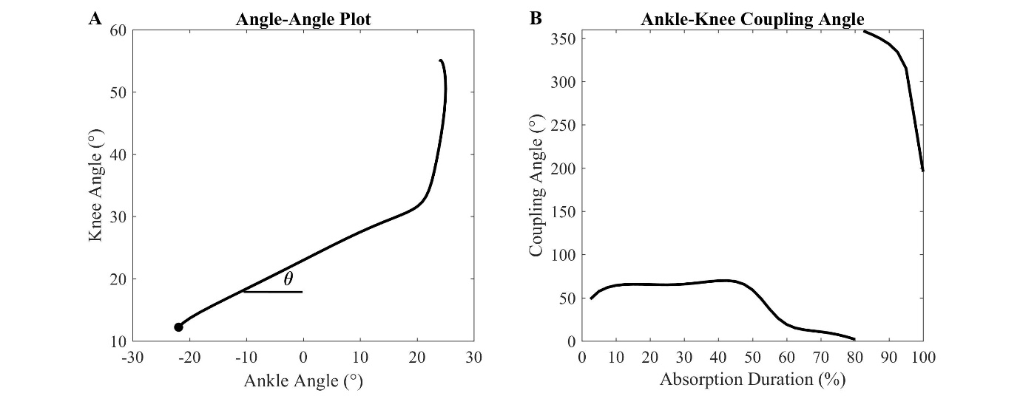
Figure 1 – A) Angle-angle plot example of one healthy participant with touchdown denoted by the black circle and the coupling angle denoted by $θ$. B) Coupling angle calculated from the angle-angle plot for the absorption phase.

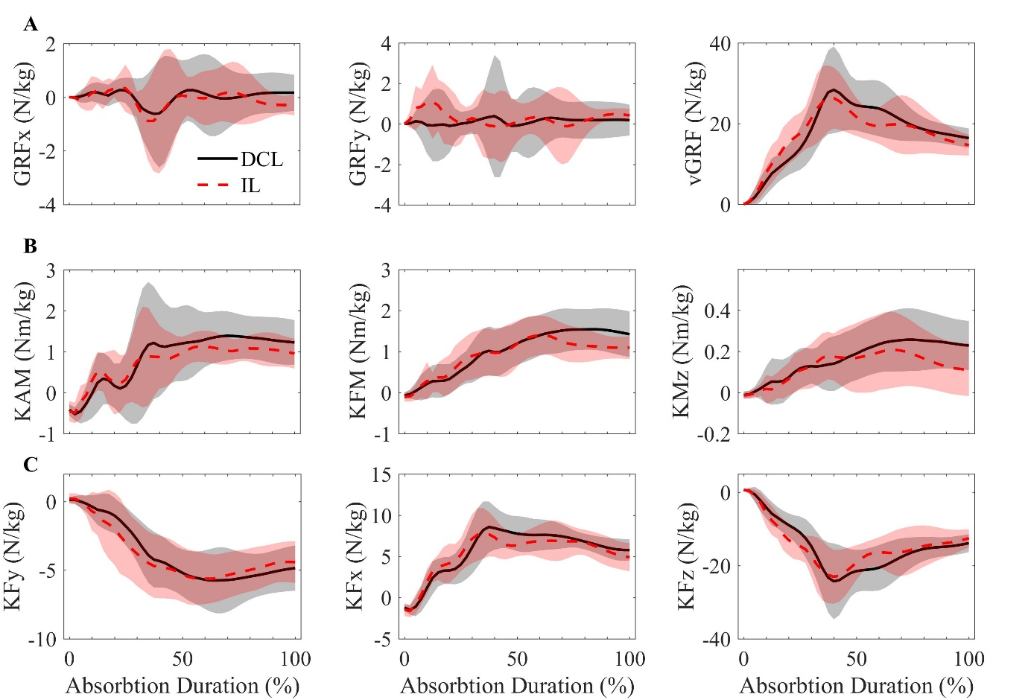
Figure 2 - Each row presents the 3-dimensional loading waveforms for the A) GRFs, B) knee moments, and C) intersegmental knee forces (KF) in the intact limb (IL; red dashed) and dominant control limb (DCL; black solid). Loading waveforms are presented for the duration of the absorption phase. Positive values are denoted first: GRFx = lateral-medial, GRFy = anterior-posterior, external knee adduction moment (KAM) = adduction-abduction, external knee flexion moment (KFM) = flexion-extension, external knee rotational moment (KMz) = internal-external, KFy = lateral-medial, KFx = anterior-posterior, and KFz = compression.

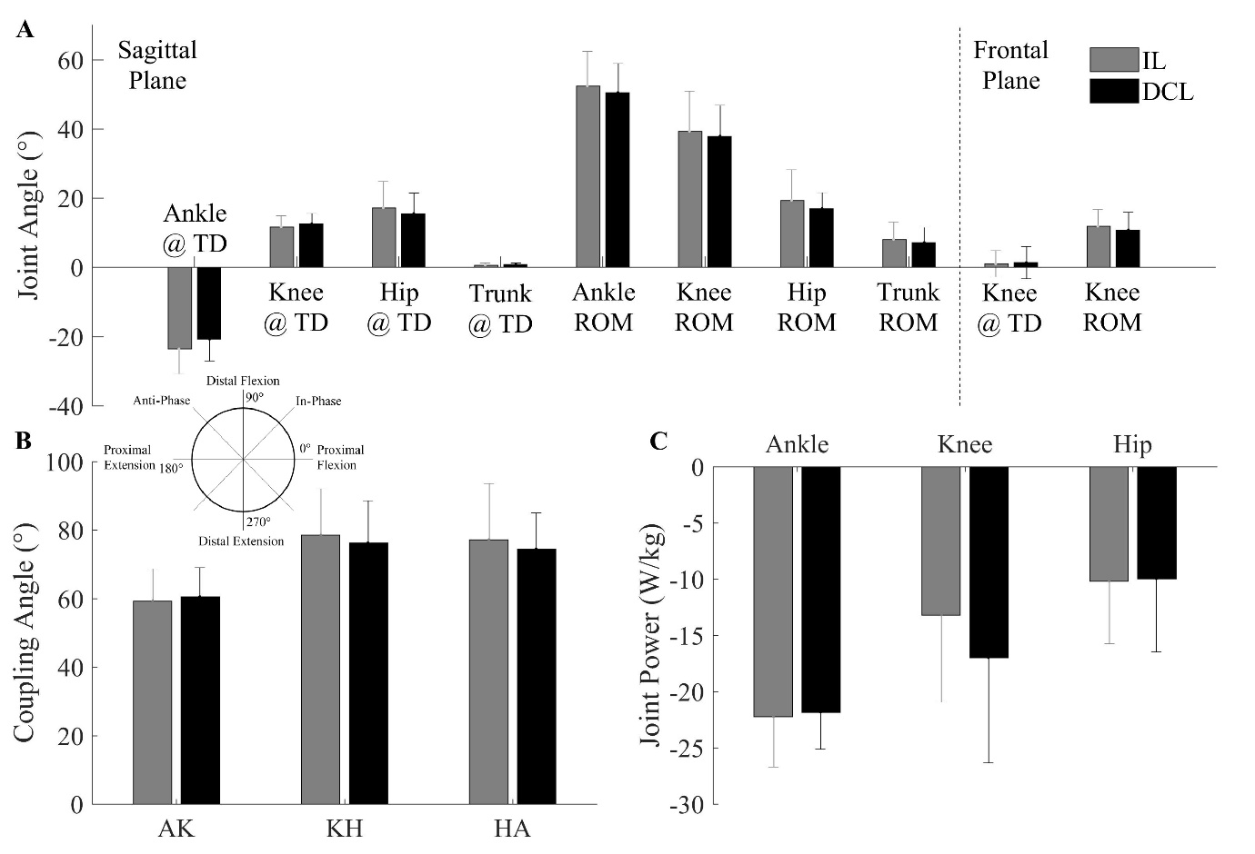
Figure 3 - A) Joint angular position at touchdown (TD) and joint range of motion (ROM) in the sagittal and frontal planes, B) joint coordination coupling angle for the ankle-knee (AK), knee-hip (KH) and hip-ankle (HA), and C) peak joint absorption powers when landing at the ankle, knee, and hip joints in the intact limb (IL) and dominant control limb (DCL).

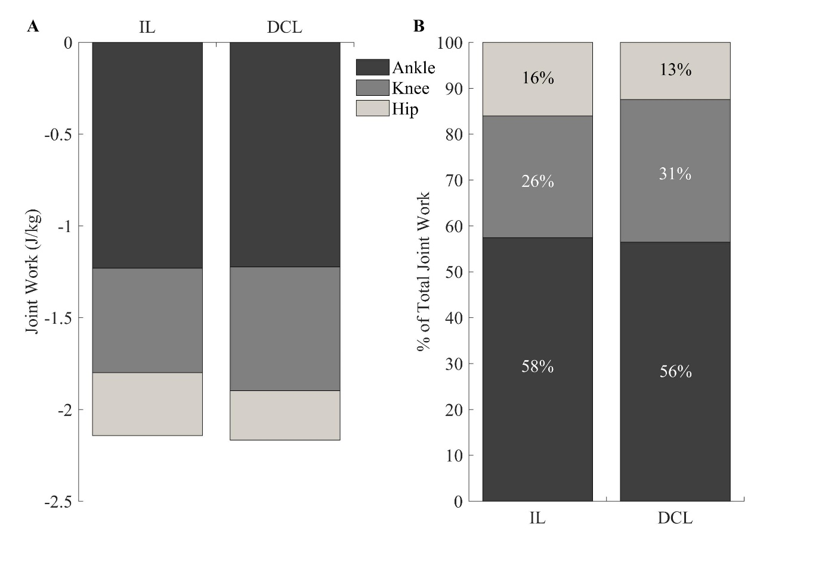
Figure 4 - A) Individual joint work and B) joint percentage contribution of the total negative joint work performed at the ankle, knee, and hip joints for the intact limb (IL) and dominant control limb (DCL) during the absorption phase of landing.

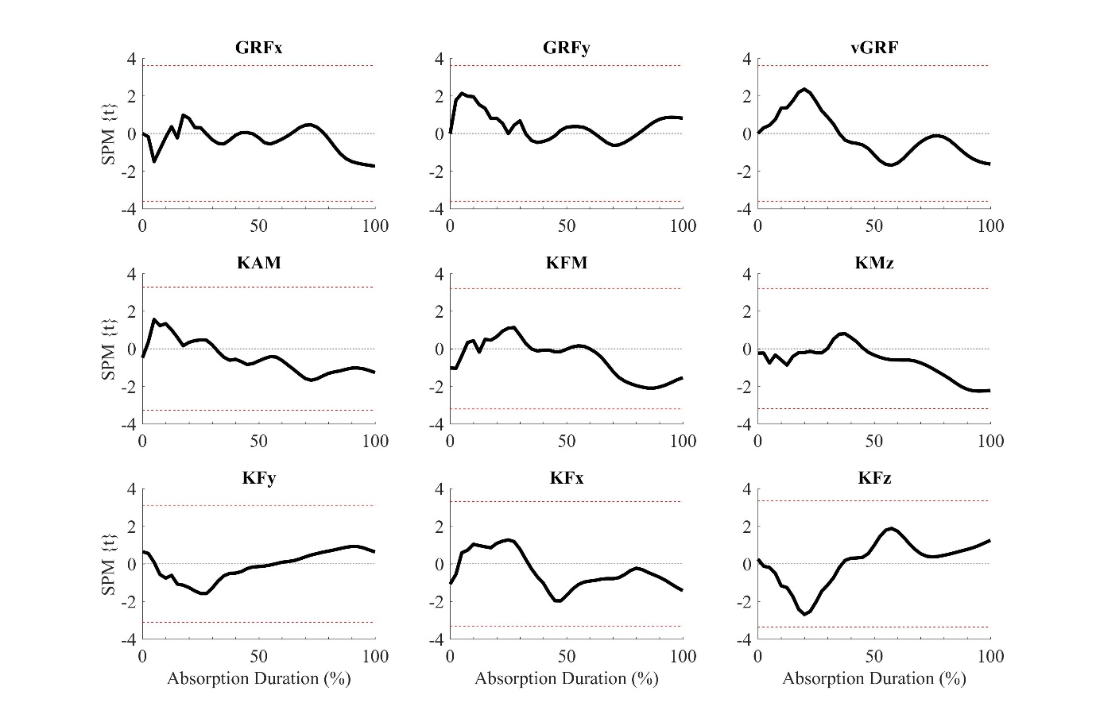
Supplementary Figure 1 – SPM {t}-statistic results for the loading waveform analysis (Figure 2). The horizontal red dashed lines represent the boundaries for statistical significance.

