**Novel 3D Stereoscopic Film Compression using Multiwavelet**

Nada Alramahi,

*School of Engineering,*

*London South Bank University*

*nadaalramahi@yahoo.com*

Martin Bush,

*School of Engineering,*

*London South Bank University*

*martin.bush@lsbu.ac.uk*

M. Rafiq Swash,

*Dept of Electronic and Computer Engineering,*

*Brunel University London*

*rafiq.swash@brunel.ac.uk*

**Abstract**

*In this paper using signal processing transform to compress 3D stereoscopic film. The proposed algorithm offerings an application of 3D RGB volumetric images using Multiwavelet Transform (MWT) decomposition spatial domain into 16 sub-band. The outcome is a novel small film in the editing by using just LL sub-band as a new part of the frame. Thus, firstly, resizes the frame to (1080x1080) that is may be evenly divided into three sub-matrices. Secondly, each sub-matrix to be processed in MWT. Thirdly, the resultant will be half size frame to create the new film from the LL sub-band MWT with less frequency. The contributions of this paper are Optimum broadcasting time and High compressibility ratio. Optimum broadcasting time of 79 Megapixel/second compared to that of the 373 Megapixel/second original time for each 60 frame/ second. The optimum transmitting time ration is 5-fold. High compressibility ratio of (79%). That means the new frame size is just (21%) of the original one.*

***Keywords****: Stereoscopic Film; Film Compression; Multiwavelet (MWT); broadcasting time; Compressibility ratio.*

1. Introduction

The Multiwavelet Transform decomposition is accomplished with orthogonal filters. MWT works with an equal dimension image [1] [2]. The coding is based on the observation that the huge sequences of images in the 3D film are contiguous on the temporal axis [3] [4] [5]. Therefore, the MWT can fully exploit the inter-slices correlations. The set partitioning techniques involve a progressive coding of the MWT coefficients. The Rate-distortion (Peak Signal-to-Noise Ratio (PSNR) vs. bit rate) performances exploit the colour space relationships as well as maintain the full embedded compression required by colour image sequences. That gives better performance in terms of the PSNR and compression ratio. This paper clarifies how can compress the 3D stereoscopic frames of the film without decompressing or losing the quality of the film [6] [7] [8] [9].

MWT filters, analyses, enhances and reacts the new image, additionally, keeps implemented with a minimum size of the image to avoid the overhead. In which images are assembled to created new film with minimum size. The performance of this works based on observing the parsing evaluation of the compression. In addition, the importance of annotation to enhance the performance of the quality of the 3D film is assessed as well [8] [9].

Therefore, MWT plays a crucial role in facilitating search and match modules, of which extra knowledge from a query could be inferred to make the retrieval results more efficient and accurate and help to compress the image context. This method efficiently outperforms 3D stereoscopic films compression and, clearly, carries out computer simulation without losing the data and enhance the quality.

The contributions of this paper can be summarised in the following short list:

* Optimum broadcasting time of 79 Megapixel/second compared to that of the 373 Megapixel/second original time for each 60 frame/ second. The optimum transmitting time ration is 5-fold.
* High compressibility ratio of (79%). That means the new frame size is (21%) of the original one.

1. Multiwavelet Transform

One of Multiwavelet current application is compressed, enhance and denoise any image. The Multiwavelet system may simultaneously provide perfect reconstruction while preserving length (orthogonality) with a high order of approximation. The MWT will decompose the image into low frequency components. MWT Mathematics is explained [1] in details of how to develop the wavelet for MWT and its advantage compared with other transforms.

A general procedure for computing a single-level 2-D MWT using GHM filter as in equation (5). This filter is transforming a frame into the matrix, W, using two or more scaling function φ(t) and wavelet functions ψ(t) as in equations (3) and (4). That is investigated by Geronimo, Hardian and Massopust as low and high pass GHM filters [7] [8] [9]:

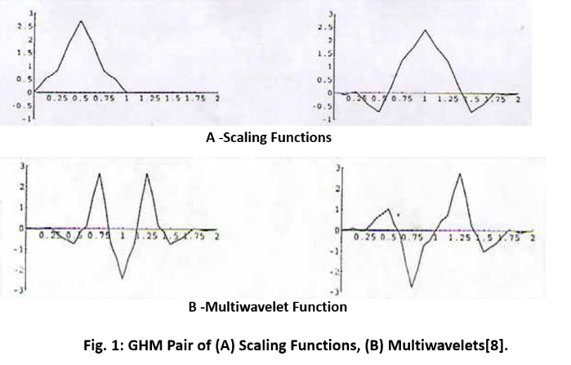

Likewise, the set of wavelet functions, as shown in Fig. 2, can be formulated as

* The set of scaling functions, as shown in Fig. 1, can be written as;

 … (1)

 … (2)

* The Multiwavelet two-scale equations are:

$\left[\begin{matrix}φ_{1 }\left(t\right) \\ φ_{2}\left(t\right)\end{matrix}\right]=\sqrt{2}\sum_{k}{H_{k}}\left[\begin{matrix}φ_{1 }\left(2t-k\right) \\ φ_{2}\left(2t-k\right)\end{matrix}\right]$… (3)

$\left[\begin{matrix}φ_{1 }(t) \\ φ_{2}(t)\end{matrix}\right]= \sqrt{2}\sum_{k}{G_{k}}\left[\begin{matrix}φ_{1 }(2t-k) \\ φ_{2}(2t-k)\end{matrix}\right]$… (4)

The GHM basis offers a combination of orthogonality, symmetry and compact support. Where GHM system has four scaling matrices low-pass filter H0, H1, H2, and H3:

, ,

… (5)

, ,

Also, four wavelet matrices high pass filter G0, G1, G2, and G3 [8]:

, ,

… (6)

, 

The filter achieves compression in the following steps:

1. Low pass filter — ignore high frequency noise components.
2. Only store lower frequency components.
3. High Pass Filter — Spot Gradual Changes.

The Multiwavelet coefficients are N by N matrices that during the transformation step to be the multiply vectors (instead of scalars). This means that multifilter banks need n input rows.

The most obvious way to get two input rows from a given signal is to repeat the signal. Two rows go into the multifilter bank. This procedure is called "repeated row" which introduces oversampling of the data by a factor of 2. Thus, if the 2-D input is N x N matrix elements after row pre-processing the result are 2N x N matrix. The odd rows 1, 3… 2N-1 of this resultant matrix are the same original matrix rows values 1,2,3…,N respectively. While the even rows numbers 2, 4…2N are the original rows values multiplied by α. For GHM system functions α=1/√2.

The aim of pre-processing is to associate a given scalar input signal of a length N to a sequence of length-2 vector in order to start Multiwavelet transformation process. In other words, because a given scalar signal consists of one stream but the Multiwavelet transformation algorithm requires the input data have multiple streams; the method of mapping the scalar data to the multiple streams is called pre-processing. As previously said; the most obvious way to get two inputs from a given signal is to repeat the signal using repeated row pre-processing. For computing Discrete Multiwavelet Transform, a transform matrix can be written as follows:



… (7)

Multiwavelet filter requires a valued input signal. This is another issue to be addressed when Multiwavelets are used in the transform process, a scalar-valued input signal must somehow be converted into a suitably valued signal. This conversion is called pre-processing. There are a number of ways to produce such a signal from 2D image data.

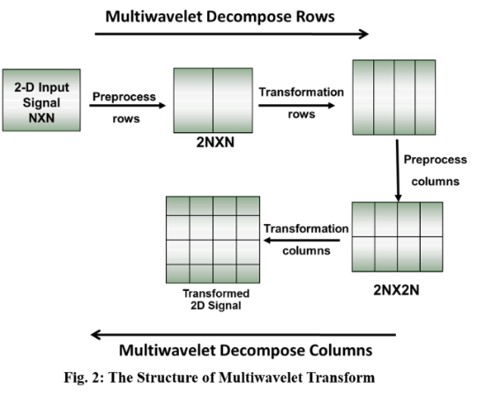

The most obvious way to get two input rows from a given signal is to repeat the signal using repeated row pre-processing. This procedure introduces oversampling of the data by a factor of 2. Oversampling representations have proven useful in feature extraction; however, they require more calculation than critically sampled representations. Furthermore in data compression applications, one is seeking to remove redundancy not otherwise as in the case of repeated row pre-processing. Hence, Approximation-Based Pre-processing Algorithms have been studied and verified as a critically sampled representation of the signal. These minimise redundancy for data compression applications.

In the Multiwavelet transform domain, there is first and second, low-pass coefficients followed by first and second high pass filter coefficients [10]. Practical image sub-band coding techniques mostly use separable decomposition, i.e., the one-dimensional filter is used in order to separate the frequency bands both horizontally and vertically. Finally, the image in the Multiwavelet case is split into sixteen sub-images as demonstrated in Fig. 2.

The main purpose behind using the sub-band coding technique for digital image applications is the acquisition of a set of sub sampled frequency bands where each band contains various structural features of the original image. The base band of the image presents a smaller replica of the original signal which consists of all the low frequency components that are of major perceptual importance as shown in Fig. 2 and Fig. (3), [6] [7] [8] [9] .

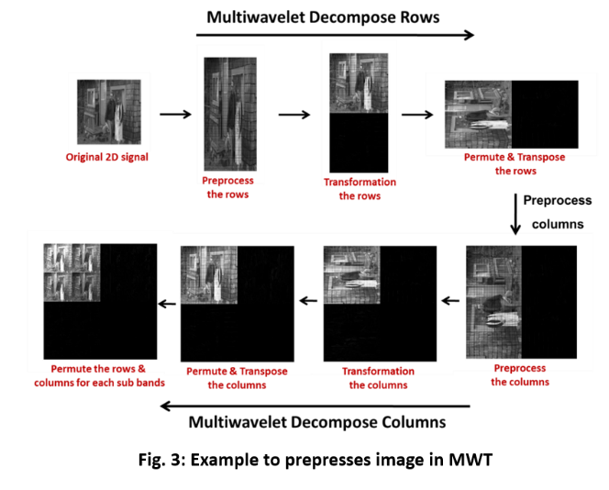

1. Stereoscopic Compression

MWT functions on NxN matrix, where N must be a power of two [11]. While, each matrix size is (1920x1080) so it will be resized to (1620x1080) fulfill the power of two conditions [12], then, divided to three equal matrices of dimensions, as shown in Fig. 4.

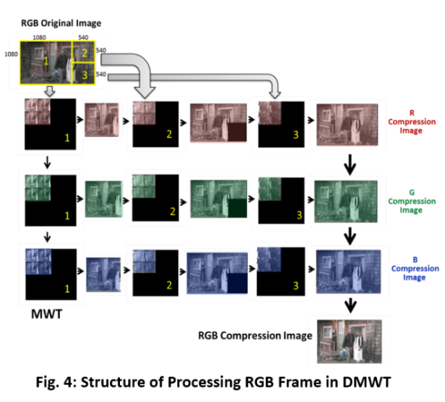

Consequently, each matrix will be divided into three equally dimensioned sub-matrices, then, processed each sub-matrix in MWT to be decomposed for a certain number of iterations, as shown in Fig. 3 and Fig. 4. The benefit gained in energy compaction becomes rather negligible compared to the extra computational effort [13].

The Multiwavelet decompositions iterate on the low pass coefficients from the previous decomposition, the Multiwavelet transform is utilised; the quarter image of the low pass coefficients is actually a 2x2 block of sub-bands. At that point, a new matrix is reconstructed from lowest frequency of sub-bands matrices. The image will be reconstructed from new compressed RGB matrices, as shown in Fig. 4 and Fig. 5 and Fig. 6 [6] [7] [8] [9]. The steps to be followed are:

1. Resize to new (1620x1080) pixel dimension for all frames to be processed with MWT, after equally divided matrix dimension.
2. Read the three matrices of the first RGB frame.
3. Divide the red matrix to three equally dimensioned sub-matrices, (one of them (1080x1080) pixels and two other sub-matrices to (540x540) pixels), as shown in Fig. 4 and Fig. 5.
4. Process each sub-matrix in MWT to produce 16 sub-bands.
5. Save the LL sub-band for the three sub-matrix to reconstruct the feature of the Red matrix.

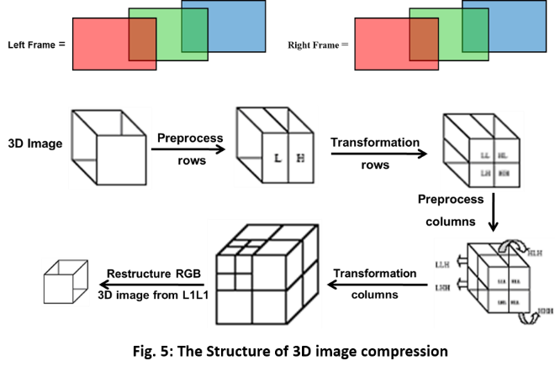

1. The new size of the red matrix will be half the input frame size of (810x540) pixels.
2. Repeat step 3 to step 6 for the green and blue matrices.
3. The new size of RGB frame will be half the input frame size so to respect the dimension ratio display will resize it to (906x540).
4. Reconstruct the frame by new RGB matrices
5. Repeat from step 2 to step 9 for all the frames.
6. Save the new compressed frames.
7. Use all the compressed frames to reconstruct the video film.

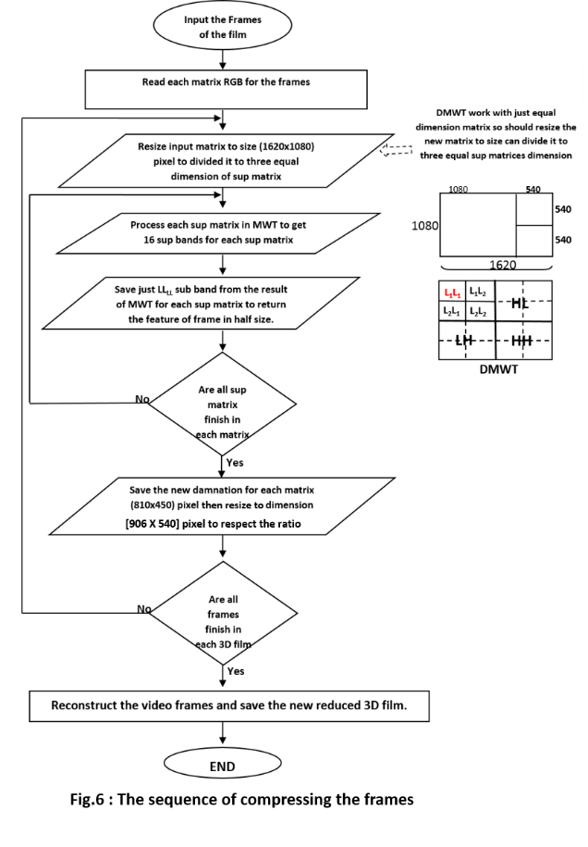

1. Result verification

The Study provides additional evidence with respect the result by calculating Peak Signal to Noise Ratio (PSNR) and Mean Square Error (MSE) are used to comparing the squared error between the original image and the reconstructed image. However, there is an inverse relationship between PSNR and MSE higher PSNR value indicates the higher quality of the image. The mean square error between the two signals is thus defined as:

**Bits per pixel = Size of the compressed image in bits / Total number of pixel**

(10)

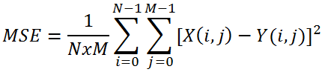

… (8)

The more Y is similar to X, the more MSE is small. Obviously, the greatest similarity is achieved when MSE equal to 0, PSNR is so defined as:

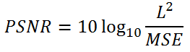

… (9)

The result for PNSR is (57.685) and for MSE is (0.111), Fig.7.

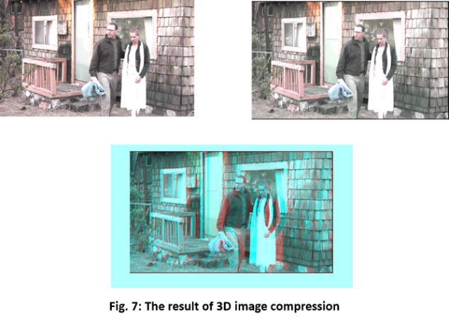

The second major is that by using MWT that findings enhance our understanding of compression the video frames. The new size of one matrix is (810 x 540) but to return the proportional between the height and width of display screen so resize it to (906 x 540 pixels) of RGB frame, the new size of RGB frame has got (724 KB) or (744,377bytes) while the original size for the same image was (3.9 MB) or (4,093,151bytes).

The following results can be drawn from the present study the project technique has succeeded to compress (79%), that means the new frame size is (21%) from the original which this is the first study has got this result Fig. 7.

Finally, where 64-bit processing per pixel of images can give improved colour quality and can lead to improving colour correction, Chroma removal, filtering, scaling, compositing, and anti-aliasing at video resolution. To test the resolution of the result compressing image will calculate how many bits per pixel:

If the bit rate increases, the results in improvement in the quality of the reconstructed image and the result has got 63.165 bpp.

The paper demonstrated the efficiently and novel 3D Stereoscopic Film Compression using, also should look at the time, how many minimum numbers of bit need to transmit per second.

1. Conclusion and future work

The new proposed method by using MWT to reduce the frames, achieve better in compression 79%. Showed this method outperform compressing stereoscopic films efficiently and carry out all the objectives of this project which measured the efficiency and work about the results clearly to show that simulcast without losing the data and enhance the quality. Also, belittle transmitting cost in broadband and the time for broadcasting.

However, the method still performs better generally, which means that it is indeed more efficient. Considering competing methods, those based on variable block size have a big potential for stereoscopic sequence compression. Therefore, temporal scalability is a suitable standard to support stereoscopy, for example in future can develop it in the future to auto-stereoscopic like to enhancement or develop it to use extra display compression.

# **References**

|  |  |
| --- | --- |
| [1] | H. Kuroda and et al., "A novel image compression method using watermarking technique in JPEG coding process," in *ACIVS'07 Proceedings of the 9th international conference on Advanced concepts for intelligent vision systems, PP: 1072-1083*, Delft, The Netherlands, August 28 - 31, 2007. |
| [2] | N. N. Al-Ramahi and . W. A. Al- Jowher, "Image Identification and Labeling using Hybrid Transformation and Neural Network," in *DCCA2007 1st International Conference on Digital Communications and Computer Applications*, 2007. |
| [3] | S. K. Hasan, *FPGA implementations for parallel multidimensional filtering algorithms,* Newcastle Upon Tyne: University of Newcastle, PhD thesis, 2013. |
| [4] | S. Hasan, "Performance-vetted 3-D MAC processors for parallel volumetric convolution algorithm: A 256×256×20 MRI filtering case study," in *2016 Al-Sadeq International Conference on Multidisciplinary in IT and Communication Science and Applications (AIC-MITCS)*, Baghdad, 2016, pp. 1-6.. |
| [5] | S. Hasan, "Performance-Aware Architectures for Parallel 4D Color fMRI Filtering Algorithm: A Complete Performance Indices Package," *IEEE Transactions on Parallel and Distributed Systems,* vol. 27, no. 7, pp. 2116-2129, July 1 2016. |
| [6] | V. Strela and A. T. Walden. , “Signal and Image Denoising via Wavelet Thresholding: Orthogonal and Biorthogonal, Scalar and Multiple Wavelet Transforms,” STATISTICS SECTION TECHNICAL REPORT TR-98-01, Dept. of Mathematics, Imperial College of Science, Technology and Medicine, London. |
| [7] | N. N. Al-Ramahi, "Automatic Image Identification and Labeling Using Wavelet Transform," *I-manager’s Journal on Software Engineering,* vol. 1, no. 3, pp. 24-29, 2007. |
| [8] | N. N. Al-Ramahi and H. M. Al-Bayatti, "Novel Techniques for Face Recognition Identification and Labeling," *Medwell Journals (International Journal of Soft Computing ISSN: 1816-9503),* pp. 216-224. |
| [9] | N. N. Al-Ramahi., "New Techniques for Face Image Recognition Identification and Labeling," *I-manager’s Journal on Software Engineering,* vol. 1, no. 4, pp. 62-69., 2007. |
| [10] | A. H. Kattoush and et al, "Multiwavelet Computed Radon-Based Ofdm Trasceiver Designed and Symulation under Different Channel Conditions," *Journal of Information and Computing Science,* vol. 5, no. 2, pp. 133-145, 2010. |
| [11] | A. Vetro, T. Wiegand and G. J. Sullivan, "Overview of the Stereo and Multiview Video Coding Extensions of the H.264/MPEG-4 AVC Standard," *in Proceedings of the IEEE,* vol. 99, no. 4, pp. 626-642, April 2011. |
| [12] | V. Nordling, Efficient Compression of Stereoscopic Video Using the MPEG Standard, Master’s Thesis in Computer Science at the School of Computer Science and Engineering: Royal Institute of Technology, 2003. |
| [13] | P.V.N.Reddy and K. Prasad , "Multiwavelet based Texture Features for Content based Image Retrieval," *International Journal of Computer Applications (0975 –8887) ,* vol. 17, no. 1, pp. 39-44, March2011. |
| [14] | P. W. Gorley, Metrics for Stereoscopic Image Compression, A Thesis for the degree of Doctor of Philosophy,University of Durham United Kingdom. Available at Durham E-Theses Online: http://etheses.dur.ac.uk/3471/., 2012. |