**APPLICATION OF VIPs IN COMMERCIAL SERVICE CABINETS**

**E. HAMMOND AND C. MARQUES**

London South Bank University, 103 Borough Road,

London, SE1 0AA, England

[e.hammond@lsbu.ac.uk](mailto:e.hammond@lsbu.ac.uk)

# ABSTRACT

Published attempts to use VIPs (Vacuum Insulation Panels) to improve the thermal performance of cool boxes had found that VIPs do not yield their expected benefits, often only realising 2.5 to 3 times the improvement over PU (Polyurethane) rather than the expected 5 fold benefit (Kacimi and Labranque, 2011; Brown *et al.*, 2007). Later work (Hammond and Micic, 2013) relating to ULT (Ultra low temperature) freezers showed that around 86% of the expected benefit of VIPs would be realised though embedding them into the wall of the PU foam.

This paper expands previous work with ULT systems by embedding VIPs into a PU foamed cavity of a multi temperature commercial service refrigerator / freezer and presents the test results of the cabinet in both modes of operation. The resulting reduction in energy consumption was then measured to estimate payback periods.

The overall thermal conductivity was calculated for the insulation the cabinet, with and without VIPs inset. The measured thermal performance was then assessed based on energy consumption measured in a temperature controlled test chamber.

# Introduction

VIPs consist of an open cell foam slab enclosed in a barrier film (Figure 1) (Swain and Brown, 2004). A high vacuum is achieved within the enclosure, maintained by the impermeability of the barrier film and by the presence of a gas absorber (or getter) within the enclosure. The foam slab maintains the physical dimensions of the panel, supporting the barrier film, reduces convection by the remaining gas molecules and the radiant heat transfer across the panel. The getter absorbs water vapour, atmospheric gasses and gasses emitted by the slab during the life of the panel to maintain the vacuum.

VIPs typically have a thermal conductivity of around 3 mW/m.K (measured at the centre of a panel). However, the film material does influence the conductivity of the panel as a whole and 5 mW/m.K would be more typical when considering the complete panel; Figure 2 compares the thermal conductivity of complete VIP panels to a range of conventional insulations. The data was taken from multiple sources (Kacimi and Labranque, 2011; Porextherm; ASHRAE, 2001; VensilResil, 2003; TAASI Corporation; Manini *et al.*, 2003; Dominguez-Munoz *et al.*, 2009; The Engineering Toolbox, 2012; Bing, 2006; Nanonpore inc., 2008a; Nanopore inc., 2008b; Hans-FriederEberhardt, 2010) to demonstrate a typical performance range for each insulation material.

The use of VIPs has been widely acclaimed as the future for low energy cold appliances but practical results have so far shown that despite the thermal conductivity of a VIP being typically one fifth of that of conventional foams, such as polyurethane, savings measured show VIPs to be only two to three times better. The difference is usually associated with “edge effects” or “thermal bridges” but Kacimi and Labranque (2011) claimed that the metallisation layer on the VIPs was too thin for the thermal conductivity of the barrier film to cause any significant edge effects.

Work by Hammond and Micic (2013) has shown that embedding VIPs into the insulated foam wall of cold appliances is a practical method of applying VIP technology in the cold chain and achieves better results than a layer of VIPs overlapping at corners as previously trialled in cold transport boxes with 86% of the expected benefit of embedding VIPs into the PU foam being realised.



Figure .Schematic of a typical Vacuum Insulating Panel (VIP) (Swain and Brown, 2004).

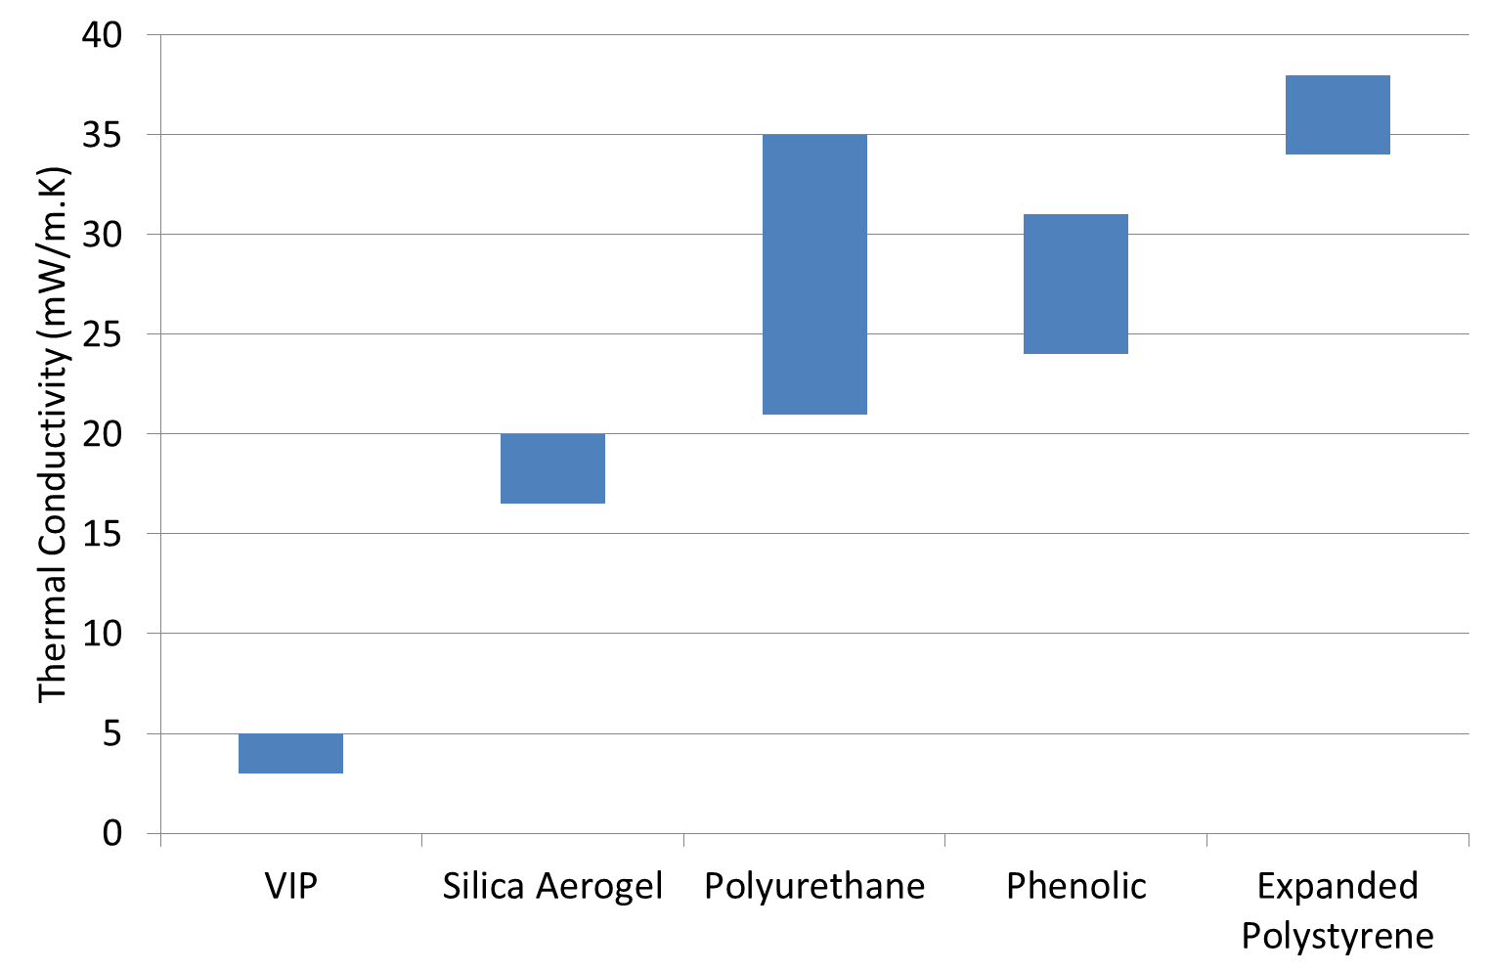

Figure . Ranges of typical thermal conductivity of insulation materials and VIPs. Values based on material manufacturers’ datasheets and other technical manuals (sources referenced in text).

VIPs are currently integrated into refrigerating (and other low temperature) appliances, where space and energy efficiency are both of high importance, on a production scale. Typically the construction appliance would use solid panels of VIP secured against the outer wall of the insulation cavity and foamed into the PU insulation to reduce heat gain without reducing internal volume. These panels would typically cover around 80 % of the surface area of a cabinet wall but would not extend to the edges or corners of any individual wall. The VIPs are secured to the outer skin using adhesive tape prior to filling the insulation cavity with PU foam. The PU foaming process, which would ordinarily fill the entire cavity between the inner and outer skins with PU foam, is unaltered as a result the addition of VIPs except to reduce the volume of foam. The reduced volume is used to account for the reduction in cavity volume resulting from insertion of VIPs. Figure 3 shows a diagram of the construction of a PU foamed cabinet with embedded VIPs.

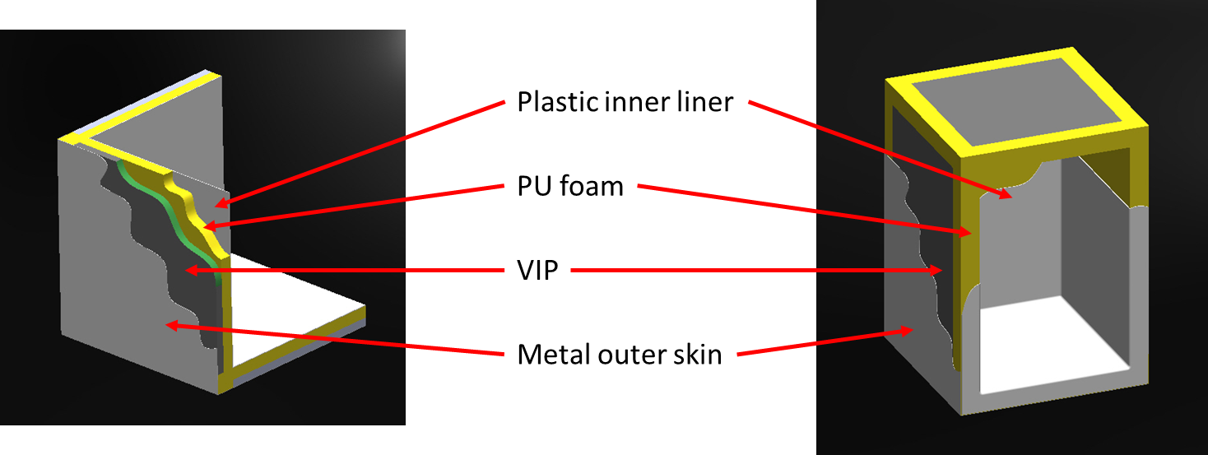

Figure . Construction of appliance with VIPs embedded into the PU foamed walls.

## Barriers to application

### Cost of VIP

The present cost of VIPs is more than that for PU foam but the energy savings achievable can still make them an economic option. Any increase in the production cost of applications represents a hurdle or barrier to the take up of the technology and the only way of overcoming the hurdle is to demonstrate that the value of the benefit outweighs the extra cost. The payback for the cabinet described in this study is calculated in the Results section below.

The main benefits of VIPs are the reduced thermal transmission for the same thickness, the reduced space taken by the insulation for the same thermal transmission or a combination of these two, especially where the appliance energy index is calculated based on internal volume and external dimensions are constrained. It is possible that weight of the materials used may also be important to some users, especially in transport applications.

### Application fabrication cost

Since the VIPs considered in this paper were smaller than the total wall area and were inserted into the existing foamed cavity (by taping inside the outer skin), displacing only a small part of the polyurethane foam, no additional structural changes were required to the cabinets and additional fabrication costs were small.

In applications where existing insulation panels can be directly replaced by VIPs there will be no significant change in fabrication cost. However, if in the application the existing foam insulation is an integral part of the structure, the insertion of VIP’s is an extra step in the production process and may require strengthening of the structure in other ways; this will add to the product cost. In appliances where the VIP’s barrier film could be vulnerable to damage there may be an additional cost for protection.

### Vulnerability of the barrier film

VIPs are vulnerable during manufacture, transport, and fabrication, during applications and in use since the barrier film is very easily punctured. A simple puncture will immediately reduce the insulation value of the panel to no better than a PU foam. The method of installation studied in this paper leaves the VIP extremely well protected but care must be taken during manufacture.

# Method

In order to assess the benefit of the panels, both simulations using Finite Element Analysis (FEA) software and measurement of the direct energy consumption of the cabinet were used.

## Modelling

The thermal modelling was carried out using Flow Simulation software within the SolidWorks CAD package that was used to create the cabinet geometries.

### Geometry

The cabinet simulated, modified and tested was an Adande VCS system (Figure 4). The cold part of the cabinet comprised an insulated container with ABS inner and outer skins with PU foam between, and a lid component (also housing the evaporator) with ABS inner skin and PU foam above. Two cabinet geometries were produced using SolidWorks, one for the purely PU foam insulation and the second with the VIPs inset. The seal component was omitted; each component was assessed independently with heat transfer co-efficient boundaries on all walls in order to simplify the model and eliminate the need to model the air volume.

The net volume of the cold space was 84 litres. The for the cabinet described in this paper, 52% of the outer surface area of the cabinet was covered by VIPs with a thickness of 20 mm; one slab was inserted against each of the six major walls (Figure 5).

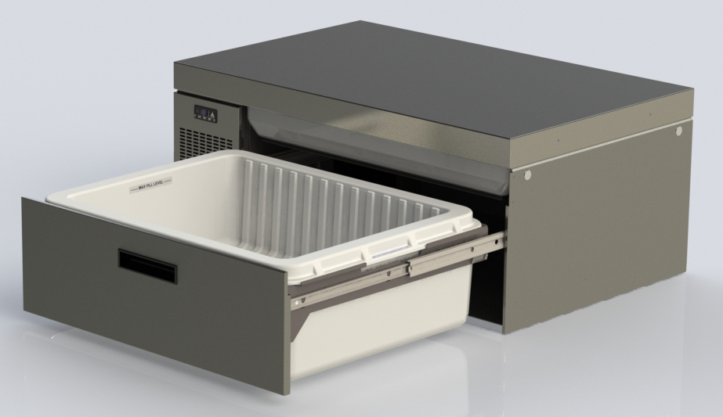

Figure 4. Image of the commercial service cabinet tested.

|  |  |
| --- | --- |
| D:\ECH ENGINEERING\JOBS FILES\ADANDE\VIP insulation in drawers\insulated drawer assembly (VCS-Cobra).JPG | D:\ECH ENGINEERING\JOBS FILES\ADANDE\VIP insulation in drawers\insul lid assy.JPG |

Figure 5. Images of the insulated container and lid with VIPs place. VIPs coloured green.

### Boundary conditions

On the internal (cold) surfaces of the cabinet, where the evaporator would normally be fitted, fixed temperature boundary conditions of ‑10 and -30 °C were used for the fridge and freezer respectively.

On the internal surfaces of the cabinet, where the wall would be in contact with cold air rather than an evaporator, a typical heat transfer co-efficient for natural convection of 5 W/m.K was used with reference temperatures of 3 and ‑20 °C for the fridge and freezer respectively; this was an approximation to eliminate the air volume from the model and reduce computational time.

The boundary condition on all external surfaces was a heat transfer co-efficient of 5 W/m2.K with a reference temperature of 25 °C; similarly to the internal walls, a heat transfer co-efficient was used as an approximation eliminate the need to model the air flow around the cabinet; 5 W/m2.K has been found by the authors to provide a good approximation in previous studies (Hammond and Micic, 2013).

Table 1. Model boundary conditions.

|  |  |  |  |
| --- | --- | --- | --- |
| **Surface** | **Type** | **Value as Fridge** | **Value as Freezer** |
| External (ambient) facing surfaces | Heat transfer co‑efficient | 5 W/m2.K  Reference temperature 25 °C | 5 W/m2.K  Reference temperature 25 °C |
| Internal (cool) surfaces | Heat transfer co‑efficient | 5 W/m2.K  Reference temperature 3 °C | 5 W/m2.K  Reference temperature ‑20 °C |
| Evaporator mounting surface | Fixed temperature | ‑10 °C | ‑30 °C |

### Material thermal properties

The thermal properties of the materials were taken from the manufacturers’ datasheets and reports. The values used are detailed in Table 2 below.

Table 2. Thermal conductivity values used (W/m.K).

|  |  |
| --- | --- |
|  | **Thermal**  **conductivity** |
| **PU foam** | 0.025 |
| **VIP** | 0.004 |
| **ABS** | 0.180 |

### Model output

The flow simulation software was configured to output average heat flux and total heat flow rate for all of the outer surfaces of the geometry. The ratio of heat transfer through the insulation of the standard (PU only) cabinet and the modified (PU + VIP) cabinet was then calculated.

## Energy consumption test

The two test cabinets, a Standard cabinet with PU foam insulation and a modified cabinet with VIPs embedded into the PU foam were both tested in a temperature controlled test chamber (ambient temperature within the chamber 25 °C). The cabinets were both tested at fridge (set point 3°C) and freezer (set point -18°C) conditions.

T-type thermocouples connected to an IOTech data logger were used to monitor the cold space and ambient air temperatures. A Multi-cube PM390 power meter connected to the same data logger was used to monitor the energy consumption.

Each cabinet was run until stable operating conditions were achieved (for each operating mode, set points 3 °C and ‑18 °C); energy was then recorded over a 24 hour period beginning and ending at the start of the post defrost recovery.

The cabinet was not opened during the test; since the installation of VIPs was not expected to influence the COP of the refrigeration system is was considered that the energy saving resulting would only be a function of the steady state heat gain of the cabinet.

# Results

## Modelling

Table 3 presents the heat flow rates across the insulation that were calculated by the FEA model.

Table 3. Results from modelling, calculated heat flow rate (W).

|  |  |  |  |
| --- | --- | --- | --- |
|  | **Standard** | **VIP** | **Saving** |
| **Fridge:**  Lid  Drawer | 5.3  10.1 | 3.2  5.9 | 39.6 %  41.6 % |
| **Freezer:**  Lid  Drawer | 9.6  20.7 | 5.9  12.2 | 38.5 %  41.1 % |

## Energy consumption test

Table 4 presents the direct energy consumption measured for the standard cabinet and the VIP cabinet operating in both fridge and freezer modes.

Table 4. Results from measured data (kWh/24h).

|  |  |  |  |
| --- | --- | --- | --- |
|  | **Standard** | **VIP** | **Saving** |
| **Energy consumption: Fridge** | 1.068 | 0.935 | 12.5% |
| **Energy consumption: Freezer** | 2.643 | 2.314 | 12.4% |

### Other heat loads

In order to compare the calculated reduction in heat gain through the insulation and the measured energy consumption, it was necessary to understand the other parasitic loads and heat gains on the system, such as defrost, evaporator fans, condenser fan and controller power. These were identified through direct measurement of components and from the power trace recorded. Table 5 below summarises the findings.

Table 5. Other heat and energy loads (W).

|  |  |  |
| --- | --- | --- |
|  | **Fridge** | **Freezer** |
| **Defrost (Wh/h)** *(Averaged over 24h)* | 1.2 | 3.3 |
| **Seal** | 5.6 | 8.5 |
| **Seal heating** | 9.6 | 9.6 |
| **Evaporator fans** | 2.7 | 2.7 |
| **Condenser fan** | 6 | 6 |
| **Controller** | 0.6 | 0.6 |

## Payback time

The energy savings measured were 0.133 and 0.329 kWh/24h for the fridge and freezer respectively. The cost of the VIP panel sets installed was quoted as £43.20 each in production quantities. At a typical energy price of 11.64p/kWh (Energy Saving Trust, 2014), the payback time for the VIPs would be 7.6 and 3.1 years for the fridge and freezer respectively.

# Discussion

Table 6 presents the COPs calculated from the measured energy data and the calculated heat gains from the thermal modelling. The COP values presented were calculated as total heat gain to the cold space divided by the power supplied to the compressor. It was expected that the COP of the refrigeration system would not alter as a result of installing the VIPs. Furthermore, based on the manufacturer’s data sheet COPs of around 1.8 and 0.9 were expected for the fridge and freezer respectively.

Table 6. Compressor COPs calculated from measured power and modelled heat gains.

|  |  |  |  |
| --- | --- | --- | --- |
|  | **Standard** | **VIP** | **Expected** |
| **Fridge** | 1.57 | 1.71 | 1.8 |
| **Freezer** | 0.64 | 0.59 | 0.9 |

Discrepancies in the COP values could have arisen from inaccuracies in the thermal model or other un-accounted for heat gains to the system such as off-cycle losses; further investigation is required.

Despite the notable errors in the COPs from the measured data, the resulting saving was close to that expected; based on the expected COPs of 1.8 and 0.9 and the reduction in heat gain from the FEA model of 6.3 and 12.2 W for the fridge and freezer respectively, the energy savings expected were 0.084 and 0.325 kWh/24h. Comparing to the measured energy saving, it can be seen that the savings achieved in freezer mode were very close (0.2 W difference) and were slightly better (2 W difference) than predicted in fridge mode (see Table 7).

Table 7. Comparison of measured savings with those predicted from the thermal modelling work (kWh/24h).

|  |  |  |  |
| --- | --- | --- | --- |
|  | **Measured** | **Predicted** | **Difference** |
| **Fridge** | 0.133 | 0.084 | 0.049 |
| **Freezer** | 0.329 | 0.325 | 0.004 |

# Conclusion

Embedding VIPs into the insulated foam wall of cold appliances is a practical method of applying VIP technology in the cold chain.

FEA modelling of the insulation of refrigerators and freezers is a valid means to predict energy savings through the use of VIPs and, furthermore, the expected energy savings may be realised when with this method of application.

VIPs may be viable in freezer applications but payback periods are likely to be too long to entice most end users to pay the premium required for VIPs to be incorporated into refrigerated commercial service equipment.

# Acknowledgements

Thanks to Adande Refrigeration Ltd, Lowestoft, England for providing the donor cabinet for conversion and also to ECH Engineering Ltd., Bristol, England for the use of thermal analysis software used in this research.

# References

1. ASHRAE Fundamentals, 2001.
2. Bing, Av. E. Van Nieuwenhuyse 6, 1160 Brussels, Belgium. 2006. Thermal insulation materials made from rigid polyurethane foam.
3. Brown, T. Evans J.A., Swain, M.V.L., 2007. Use of vacuum insulated panels to improve performance of refrigerators and insulated shipping containers. International Congress of Refrigeration, Beijing.
4. Domínguez-Muñoz, F., Anderson, B., Cejudo-López, J.M., Carrillo-Andrés, A., 2009. Uncertainty in thermal conductivity of insulation materials. Eleventh International IBPSA Conference, Glasgow, Scotland. July 27-30, 2009.
5. Energy Savings Trust. <http://www.energysavingtrust.org.uk/Energy-Saving-Trust/Our-calculations>. (last accessed February 2014).
6. Hammond, E. and Micic, G., 2013. Simulation versus experimental results of VIPs embedded within PU insulation. International Cold Chain Conference, Paris, April 2013.
7. Hans-FriederEberhardt, 2010. Comparison of Vacuum Insulation Panels based on fumed silica core against other core materials. PorexthermDämmstoffe GmbH, HeisingerStraße 8/10, 87437 Kempten.
8. Kacimi, A. and Labranque, G., 2011. Vacuum insulated panels (VIP) in insulated packaging. International Congress of Refrigeration, Prague. August 21-26.
9. Nanoporeinc., 2525 Alamo Ave. SE, Albuquerque, NM 87106. 2008a. “Nanopore thermal insulation”. [www.nanopore.com](http://www.nanopore.com). (last accessed April 2012).
10. Nanoporeinc., 2525 Alamo Ave. SE, Albuquerque, NM 87106. 2008b. “Vacuum insulated panels”. [www.nanopore.com](http://www.nanopore.com). (last accessed April 2012).
11. Paolo Manini, EneaRizzi, Guido Pastore, and Pierattilio Gregorio, 2003. Advances in VIP Design for Super Insulation of Domestic Appliances. APPLIANCE Magazine June 2003.
12. Porextherm GmbH, Heisingerstrasse 8/10, D-87437 Kempten, Germany. Vacupor NT product data sheet version 1.06/09-12-22/GE.
13. Swain, V. and Brown T. 2004. Feasibility study on potential applications of vacuum insulated panels. Food Refrigeration and Process Engineering Research Centre, Bristol, UK.
14. TAASI Corporation, 548 West Central Avenue, Delaware, Ohio 43015, USA. “Insulation properties of aerogels”. <http://www.taasi.com/pdf/insul.pdf> (downloaded April 2012).
15. The Engineering ToolBox. 2012, Thermal conductivity of some common materials and gases. [www.engineeringtoolbox.com](http://www.engineeringtoolbox.com) (last accessed, April 2012).
16. VensilResil Ltd., 2003. Jablite EPS Technical Information. [www.Jablite.co.uk](http://www.Jablite.co.uk), [technical@vencel.co.uk](mailto:technical@vencel.co.uk) (last accessed, April 2012).