Manuscript ID: 306
DOI: 10.18462/iir.icr.2019.0306
Design and application of a novel cold chain pallet using a phase change material
Guanghai LIU(a), Junzhang WU(a), Ruhe XIE(a), Judith EVANS(b), Alan FOSTER(b)
(a) Management School, Guangzhou University, Guangzhou 510006, China
broadsea@gzhu.edu.cn
(b⁾ School of Engineering, London South Bank University,
Bristol, BS40 5DU, UK, alan.foster@lsbu.ac.uk
ABSTRACT
Transport vehicles have low utilisation rates in developing countries. This is due to the initial cost of the refrigerated transport vehicles and the high operating costs consisting of energy consumption and manual labour. A novel cold chain pallet incorporating water as a phase change material (PCM) has been designed. When in use, the PCM pallet is put into a cold store and the water is frozen. In transportation, the foods are stored in an insulated vehicle along with PCM pallets. The latent heat of water is used to maintain the temperature inside the vehicle. Air temperature inside the carriage was measured for different PCM mass (100, 200, 300 kg), different time (24, 48, 72h), with and without forced convection. The experimental results show that the time the air temperature was <10ºC was 66.3%, 92.1% and 94.7% of the duration without forced convection and 92.5%, 97.3% and 98.6% with forced convection, when the PCM mass was 100, 200 and 300 kg respectively. Because no special refrigeration system is needed and the number of PCM pallets can be selected according to the required cooling capacity, the initial investment and operating costs of PCM pallets is much lower than existing refrigerated trucks.
Keywords: Refrigerated Transport, Phase Change Material, Energy Consumption, Temperature Distribution.
- INTRODUCTION
With improvements in living standards and the demand for perishable food increasing, the use of refrigerated transport equipment has grown rapidly in developing countries. China Federation of Logistics & Purchasing (2018) shows that the number of refrigerated transport vehicles increased from 41,000 to 134,000 in China in the past 5 years. The average annual growth rate in this sector is expected to be more than 10% over the next 5-10 years. Despite rapid growth, there is a significant difference in the number of refrigerated vehicles per capita between China and developed countries (for example, 1/10,000 in China and 14/10,000 in the UK) (Rai and Tassou 2017).
China's perishable food transportation capacity was more than 300 million tons in 2017. Non-refrigerated transport vehicles (insulated or uninsulated) are often used in transportation of fresh fruits and vegetables. These issues result in the food waste associated with food logistics being more than 30% (China Federation of Logistics & Purchasing, 2018). In 2016 annual food loss was valued at RMB 100 billion (Chinese Association of Refrigeration, 2016).
In China, less than 20% of goods are transported by pallets (Ministry of Commerce of China, 2017). Although reducing the initial investment in logistics, it is inefficient, time-consuming and costly. According to China Federation of Logistics & Purchasing (2017), energy consumption and labour cost account for more than 80% of the total cost in China's cold chain logistics operation. Therefore the transporter must balance the quality of the food and the cost of transportation. To ensure food is of high quality and to reduce the cost of transporting food it is necessary to reduce the energy consumption of refrigerated transportation and improve mechanization.
Phase change material (PCM) based refrigerated vehicles have been used for many years in many countries to reduce costs (Chinese Association of Refrigeration, 2016). PCMs have the following advantages compared with mechanical refrigerated transport compartments. They make rational use of power resources, allowing charging of the PCM at night, when electricity is cheap and using/discharging the PCM during the day. They can replace fossil energy (diesel fuel) with electrical energy. This has the potential to reduce greenhouse gas emissions (as grid energy becomes decarbonised), air pollution and heat island effects in the city (as combustion is moved from away from the city) (Li, et al., 2018).
Countries, such as the United States, Britain and Italy, have developed PCM refrigerated trucks, and the related technologies and performance have been rapidly improved (Li, et al., 2018). Liu et al. (2012) simulated a mobile refrigeration system incorporating PCM and used this in refrigerated trucks in Australia. The simulation showed that the PCM could maintain the refrigerated space at -18ºC for 10 hours using 250 kg PCM without opening the door. Darzi et al. (2016), Zarma et al. (2017) and Xie et al. (2017) analysed the PCM heat transfer structure, heat transfer performance and layout respectively. Zhan et al. (2008) analysed the effect of the PCM at different positions in the refrigerated vehicle. Zhang et al. (2013) simulated the temperature field of the PCM refrigerated vehicle by different cargo stacking methods. The above research provides a reference for the improvement and optimization of the cold storage transportation equipment.
In this paper, a novel PCM pallet was designed to aid cold chain logistics and improve operational efficiency for developing countries. The PCM was frozen using off peak night electricity in a cold store and moved through the cold chain with the perishable product. The PCM can be used in insulated and unrefrigerated vehicles. The paper presents information on temperature within the transport vehicle and the effect of air distribution in the vehicle.
- METHOD
  - The size and structure of the PCM pallet
The pallet’s structure and physical drawings are shown in Figure 1 and Figure 2.
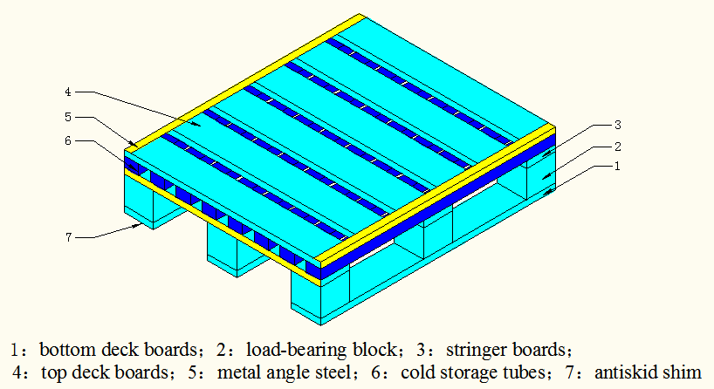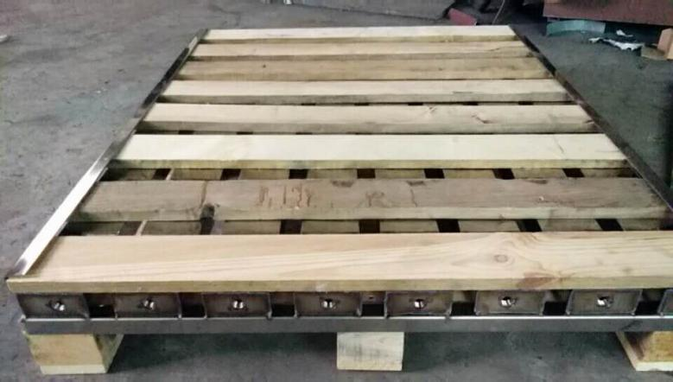
Figure 1: The schematic diagram of PCM pallet Figure 2: Photograph of PCM pallet
The pallet was composed of bottom deck boards, top deck boards, load-bearing blocks, stringer boards and cold storage tubes. The cold storage tubes were made of food grade No.304 hollow rectangular stainless steel pipes (wall thickness, 1.5mm) with the PCM sealed in them. Eight cold storage tubes were evenly placed below the top deck boards with dimensions of 100 (W) × 50 (H) × 1200 (L) mm. Each cold storage tube could contain up to 5 kg of the PCM, therefore, each pallet could carry up to 40 kg of PCM. The bottom deck boards, top deck boards, load-bearing blocks and stringer boards were made of wood and angle steel was used to protect the cold storage tubes. The bottom of the pallet was provided with an antiskid shim to avoid the pallet sliding on water or ice. The above components were connected by fastening bolts so that any damaged parts could be replaced separately according to actual needs during use. On the basis of considering the convenience of circulation between companies, the size of the cold chain pallet used in this study was standardised to 1.0 × 1.2 m.
  - The selection of the PCM
In China, frozen trucks which are used to transport meat and fish account for more than 90% of the cold-chain trucks. Fruits and vegetables are often transported without temperature control causing the loss of vitamins and other nutrients (Chinese Association of Refrigeration, 2016). Due to the lack of refrigerated transport for fruit and vegetables the focus of this study was chilled transportation.
The PCM therefore needed to control temperature between 0 and 10ºC, have a large latent heat phase change, stable chemical composition, be non-toxic and have a low price. Water, was selected for this study for the following reasons. Firstly the phase transition temperature of water is 0ºC, which meets the transportation needs of most chilled products. Secondly, the chemical properties of water are stable and non-toxic, even if the pallet is damaged during use, it will not contaminate the food. In addition, the latent heat of fusion of water is high (334 kJ/kg), and the price is almost negligible.
  - Design of test platform
In order to investigate the effect of the PCM pallets, a test was carried out using an insulated truck, as shown in Figure 3.
Figure 3: The insulated truck for testing
(1) The outside and inside dimensions of the containers (in m) were 5.80×2.28×2.24 and 4.98×2.04×2.00 (length×width×height) respectively. The walls of the container and inner partition between the fan section and container were all polyurethane insulation board, and the inner and outer skin used fibre reinforced polymer/plastic (FRP) composite. The thickness of the walls of the carriage were 0.12 m and the floor was pattern aluminium plate.
(2) The truck had a forced convection air system which was located at the front end of the vehicle and was connected with the vehicle through the air inlet and the return air outlet. The air inlet was located on both sides of the front end of the vehicle, which was 0.05 m and 0.10 m from the roof and side walls, respectively. The inlet hole was circular, 0.25 m in diameter. The return air inlet was located near the floor at the front of the carriage. The rectangular structure was 1.7 × 0.04 m (length × height). The air circulation was controlled by the fan in the forced convection system.
(3) In order to investigate the temperature stability of the PCM pallet, the system was tested to conform with refrigerated transportation equipment standards, such as ISO 1496-2, GB/T 7392, GB 29753, etc.
When the temperature field was tested, the refrigerated carriage and PCM pallets remained empty of product. Eleven temperature sensors were arranged 0.10 m from the outer surface of the carriage, (Figure 4a). Fifteen temperature sensors were arranged 0.10 m from the inside of the carriage (Figure 4b). The semi-conducter temperature sensors (TZ-Tag06B, Tzone Digital Technology Co. Ltd.), had an accuracy of ± 0.3K over the range -40ºC to +125ºC.
a) Temperature sensor layout outside the carriage b) Temperature sensor layout inside the carriage
Figure 4: Temperature sensor layout of the carriage
  - Experiment design
The concept of the PCM pallet was different from the traditional cold storage vehicle in its application. Firstly, the PCM pallet was put into a cold store and the PCM was frozen by the refrigeration system in the cold store (for freezing quickly, the air temperature of cold store should be below -18ºC). When fruits and vegetables are picked, they are packed in boxes and crates, then transported to cold store and placed on PCM pallets. When they need to be transported, the fruits/vegetables and PCM pallets are transported together in a thermal insulated vehicle (no refrigeration). The latent heat of the PCM was used to maintain the temperature inside the vehicle during its delivery.
A stationary prototype thermally insulated vehicle was constructed and tested. The insulated carriage of corresponding sizes and construction were manufactured following strict criterions designed by Guangzhou Baier Cold-Chain Polyurethane Technology Co.,Ltd (www.pvc123.com/b-gzbaier/). The use of thermally insulated materials and polyurethane foaming technology is the most stable and safe practice within the insulated truck industry. The heat leakage rate of the carriage was measured as 24 W/K by previous experiments. All test behavior were monitored in Guangzhou, the largest city in the south of China. Although the ambient temperature may have been different during the testing, it was still well controlled in which the ambient conditions were at approximately 31ºC in the day and at approximately 25ºC at night.
The following two problems should be solved when designing the PCM pallet.
(1) The calculation of cold storage capacity
The PCM relies mainly on the latent heat of phase change at 0°C rather than the sensible heat to maintain the temperature in the vehicle. To test the effect of the cold chain pallet, the researchers tested 100, 200 and 300 kg of PCM in a vehicle (pallets of 12.5, 25 and 37.5 kg, respectively) over 24, 48 and 72 h, respectively. The timescales selected from the trials were based on transportation temperatures in China for most fruits and vegetables being no more than 10ºC (based on GB 22918/T, China's Recommended National Standards) and the transportation times being less than 3 days. The PCM pallets were cooled for 10 hours in the cold store (using low tariff electricity price from 10 pm to 8 am). Previous experiments using a temperature sensor in the PCM showed that the temperature dropped below freezing temperature in this time. During cooling the air temperature in cold store was -18ºC. The pallets were then transferred to an insulated vehicle and laid evenly in the base of the vehicle. The vehicle door was closed and the temperature changes in the carriage were recorded.
(2) The distribution of temperature in the carriage
The PCM pallet was located at the base of the vehicle, to reduce the center of mass and increase the available storage space. However, due to buoyancy, temperatures would likely stratify without forced convection. So, the same group of pallets with the same weight were tested twice, with and without forced convection.
- Results
  - Influence of different PCM mass and forced convection on temperature control
Figure 5 shows the effect of cold storage capacity and convection on vehicle temperature control. When the PCM was 100, 200 and 300 kg in the vehicle.
- A total of 100 kg of PCM

b) A total of 200 kg of PCM
c) A total of 300 kg of PCM
Figure 5: Average temperatures measured in the carriage with or without forced convection
Table 1 shows the variation of mean temperature and temperature <10ºC in the truck under different PCM weights and with or without forced convection. So, transporters can therefore choose the number of PCM pallets needed according to the transportation time, avoiding the shortcomings of traditional PCM trucks which have fixed PCM weight. Measurements also shows a significant difference in cooling time (from ambient temperature to 10 ºC) with and without forced convection. Without forced convection, as the PCM pallets are located at the bottom of the carriage, they do not drive natural convection and the convection heat transfer between the cold chain pallets and the air in the vehicle is slow, thus the time to cool the vehicle is long.
Figures 6 and figure 7 show the distribution of air temperature in each group of experiments without and with forced convection. It can be seen that when there is no forced convection in the vehicle, the vertical stratification of temperature in the carriage is significant, and the difference in temperature between the section 4 and section 6 is approximately 3 K. When forced convection is applied in the carriage, temperature stratification is reduced. The temperature fluctuation range between section 1 to section 6 is less than 0.7 K.

Table 1. The temperature in the carriage under different condition
PCM mass (kg) | Forced convection condition | Mean temperature (ºC) | Percentage of temperature  < 10ºC in the test period
100 | No | 10.4 | 66.3
 | Yes | 6.2 | 92.5
200 | No | 7.3 | 92.1
 | Yes | 4.6 | 97.3
300 | No | 7.0 | 94.7
 | Yes | 3.7 | 98.6

（a）
（b）
（c）
Figure 6: Average temperature history of each section of carriage without forced convection: (a) 100 kg of PCM, (b) 200 kg of PCM, and (c) 300 kg of PCM.

（a）
（b）
（c）
Figure 7: Average temperature history of each section of carriage with forced convection: (a) 100 kg of PCM, (b) 200 kg of PCM, and (c) 300 kg of PCM.
- CONCLUSIONS
A novel PCM pallet has been designed. The PCM pallet enables the use of cheap electricity at night to store energy, instead of using diesel fuel from a refrigerated vehicle. When in use, the PCM in the pallet can be frozen by the refrigeration system of a cold store. In transportation and distribution, foods are stored on the PCM pallet in a thermal insulation vehicle (no refrigeration). The weight of PCM can be selected according to the transportation time when using the PCM pallets. When forced convection is applied, the temperature distribution in the carriage is uniform. Because no special refrigeration system is needed, the initial investment and operating costs of PCM pallets are much lower than most existing refrigerated trucks. It can effectively reduce the transportation cost while guaranteeing the quality and safety of goods, and provides the potential for the application of the PCM refrigerated truck in developing countries. Further work will consider the effects of food loading, environmental temperature, PCM material and humidity.
ACKNOWLEDGEMENTS
This work was done collaboratively between Guangzhou University and London South Bank University. The authors would like to thank the financial support from Department of Science and Technology of Guangdong Province (No.2017B020206006) and Department of Commerce of Guangdong Province in China.

References
China Federation of Logistics & Purchasing, 2018. The current situation and trend of cold chain logistics in China. China Fortune Press, Beijing, 31-36.
China Federation of Logistics & Purchasing, 2017. The current situation and trend of cold chain logistics in China. China Fortune Press, Beijing, 16-29.
Chinese Association of Refrigeration, 2016. Research Report on the strategic development of China's refrigeration industry. China Architecture & Building Press, Beijing, 256-269.
Darzi, A.A.R., Jourabian, M., Farhadi, M., 2016. Melting and solidification of PCM enhanced by radial conductive fins and nanoparticles in cylindrical annulus. Energy Conversion and Management, 118, 253-263.
Chinese Automobile Standardization Technical Committee, 2014. Safety requirements and test methods for refrigerating van for transporting food and biological products on road: GB 29753, China Standards Publishing House, Beijing, 1-15.
Chinese Refrigeration Standardization Technical Committee, 2008. Technical requirements for temperature-controlled transportation of perishable food: GB/T 22918, China Standards Publishing House, Beijing, 1-23.
Chinese Freight Containers Standardization Technical Committee, 2008. Series 1 thermal containers--Specification and testing: GB/T 7392. China Standards Publishing House, Beijing, 1-46.
Li, J., Xie, R., Liu, G., Foster, A., 2018. Development of New Low Temperature Phase Change Storage Material and Equipment Used in Refrigerated Transportation. Journal of refrigeration 39(4), 32-37.
Liu, M., Saman, W., Bruno, F., 2012. Development of a novel refrigeration system for refrigerated trucks incorporating phase change material. Applied Energy 92, 336-342.
Ministry of Commerce of China, 2017. Monitoring and analysis report on China's pallet standardization development in 2016. Beijing.
Rai, A., Tassou, S.A. 2017. Energy demand and environmental impacts of alternative food transport refrigeration systems. Energy Procedia 123, 113-120.
The Freight Containers Technical Committee of International Organization for Standardization, 2008. Series 1 freight containers-Specification and testing - Part2: Thermal containers: ISO 1496-2-2008. International Organization for Standardization, Geneva. 1-20.
Xie, R., Tang, H., Tao, W., Liu, G., Liu, K., Wu J., 2017. Optimization of cold-plate location inrefrigerated vehicles based on simulation and test of no-load temperature field. Transactions of the Chinese Society of Agricultural Engineering 33(24), 290-298.
Zarma, I.H., Hassan, H., Ookawara, S., Ahmed, M., 2017. Thermal energy storage in Phase Change Materials: - applications, advantages and disadvantages. 1st International Cnferecne of Chemical, Energy and Environmental Engineering, Egypt, 1-11.
Zhang, Z., Gu, Y., Tian, J., Li, M., 2013. Numericalsimulationand experiment of temperature fielddistribution in box of coldplate refrigerated truck. Transactions of the Chinese Society of Agricultural Engineering 29(25), 18-24.
Zhan, Y., Dong, Q., Wang, S., 2008. Simulation on inner temperature field of railroad cold-plate refrigerator car with cold plates laid on side. Cryogenics (3), 61-64.

