Existing Sustainability Assessment Tools used in Measuring Urban Spaces

¹ Job Momoh, ² Olubisi Ige ³ Bert Young ⁴ Yusuf Ibraheem

¹Department of Construction, Property and Surveying, School of Built Environment and Architecture/London South Bank University, 103 Borough Road London SE1 0AA

Email: ¹momohj@lsbu.ac.uk, ²igeo4@lsbu.ac.uk

Abstract: It is projected that more than half of the world’s population currently reside in towns and urban cities. This can be seen as a result of urban growth, urban development alongside population explosion. This uncontrolled growth has resulted in the degradation of agricultural lands, urban congestion, drastic climatic change, various forms of pollution, and the creation of slums/urban sprawl. The application of sustainability theories in the design of urban spaces emphasises how spaces should be built with sustainability and resilient principles throughout the whole life cycle from design/planning, construction and operation of cities to achieve a better quality of life. This has led to the development of sustainability assessment tools which are broadly defined as processes that direct the planning and decision-making process towards achieving sustainable development with the use of a selected set of indicators.
This paper presents an overview of the current existing sustainability tool used in measuring the level of sustainability achieved within urban spaces in developing countries. The result shows the need to develop a robust assessment tool as current assessment tools do not comprise of most pressing indicators.

Index terms: Environment, Indicators, Sustainability, Assessment Tools, Urban Sustainability Assessment.

- INTRODUCTION

Sustainable urban development and planning are vital in protecting the both built and natural environment alongside the people and the society at large, as improper urban planning and development methods can significantly affect these spaces (Bai et al, 2012). Climate change has been one of the key areas of focus that has resulted in an adverse change in rainfall, temperature, quality of air, water and soil condition (Gonzalez et al, 2005). This can be largely linked to the high level of carbon emissions as a result of construction activities and energy usage in urban cities. It is known that over 50% of CO2 emission is generated from buildings that harm the environment (Kolbadi, 2015). Although there have been concerns in the need to adopt sustainability within urban spaces, current practices within urban development, consequent prevalent planning and design practices as a result of economic and population increase has resulted in high consumption of non-renewable natural resources alongside waste generation, high level of pollution and increase in heat levels within cities (Galanis, 2017). In today's practice due to emphasis on environmental sustainability current practices relation sustainable urban development to focus on energy management, waste management, water usage reduction with little emphasis on public transportation, natural environment and socio-cultural indicators.
This calls for developing these spaces based on sustainability principles and attributes. However, the process of implementing these systems is seen from different perspectives, depending upon the role played by key professionals and agencies involved in the design, development and adaptation of urban development (Fisher and Newig, 2016). Although there are no blueprints as well as a single approach to resolving this complex problem, researchers, governance, policies and cities have a significant role in ensuring that sustainability principles are being adopted in its development. It is known that cities around the world are currently designing methods, strategies and techniques to deal with complex problems of global change and sustainability. Among other methods, these strategies and action plans are informed by a diverse array of assessment tools that function as decision support systems (Ayyoob et al, 2020).
There are various sustainability assessment tools designed to assess a variety of spaces within the built environment which includes buildings, urban neighbourhoods and cities (Sharifi, 2019). Urban stakeholders across the globe have shown interest in developing sustainability assessments to employ them in the rapid development of urban spaces (Ayyoob et al, 2020). There have been various tools designed for sustainability assessment which has been in practice since the early 1990s. The UK and the USA have been at the forefront of realising smart sustainability assessment tools for building sustainable neighbourhoods. As discussed above, the most useful or well-known assessment tools include Leadership in Energy and Environmental Design (LEED), Building
Establishment Environmental Assessment Method (BREEAM), CASBEE and Green Star. Other assessment tools include SUPD, IGBC Green Township, GRIHA-LD and GBI Township. (Sharifi and Yamagata, 2016; Ayyoob, 2020).
To understand sustainability from a holistic perspective this paper aims to understand the concepts, approaches, methods, tools and techniques utilised in the assessment of the sustainability of urban spaces.

- AN OVERVIEW OF URBAN SUSTAINABILITY ASSESSMENT

Sustainability assessment is known to bridge the gap between buildings and cities, as well as to support the evaluation of the degree of sustainability within urban developments. Sustainability assessment is a combination of procedures, methods and tools by which a policy, programme or project may be assessed as to its potential, economic, social and geographical impacts as well as the distribution of those impacts within a population, a geographical area, a market, or across a generation (Curwell et al., 2005, pg.21; Haapio, 2012). Sustainability assessment is used as a tool that can assist decision- and policymakers to know the best possible actions to be taken - or not to be taken - in an approach to make the society, environment or policy more sustainable (Devuyst, 2001). The simplest definition of sustainability assessment is that it is a process that suggests and helps in decision making in achieving sustainability over the long run. The main reason for sustainability assessment is to ensure that visions, plans, activities and agendas make an optimum relevant contribution or addition to the overall aim of sustainable development (Verheem, 2002). In regards to the measurement of urban spaces and urban neighbourhoods, sustainability assessment methods have recently been seen as a means of evaluating the performance of the urban environment across various ranges of sustainability criteria. This is to say: how urban space is rated is based on the level of key performance indicators used as well as the extent to which it has been initiated (Fiksel et al., 2012). Urban Sustainability Assessment is a complex appraisal methodology that is conducted for enhancing decision-making and policy in a broad environmental, economic and social context and transcends a systemic evaluation of urban spaces (Sala et al, 2015).

Since the Brundtland Report in 1987, sustainability has grown to become a global terminology and its widespread popularity has led to adoption and implementation (Cole, 1999, pg.234). This has also influenced the development of successful tools and their application has created strong needs to reinforce their role in creating a more sustainable urban future. The first sustainability assessment tool, BREEAM, was developed by the Building Research Establishment (BRE) and has been in use in the UK, since 1990. This first building assessment tool has influenced other assessment tools like LEED (USA), Green Star (Australia/South Africa), and CASBEE (Japan), among others (Happio, 2012). Another existing urban sustainability assessment rating tool created in the UK in 2004 was CEEQUAL. China also came up with EcoCITY, China EcoGarden, Enterprise, and Green Neighbourhood rating tool. Australia also developed EnviroDevelopment in 2006. GBI Township rating system was created in Malaysia. IGBC green Township system was created in 2010 and GRIHA-LD was developed in 2015 both in India (Harsimran and Pushplata, 2019).
Sustainability assessment can be assessed on qualitative and quantitative sustainability indicators looking at building and neighbourhood scale to a larger level like city/urban developments. Some of the indicators selected looks into social, economic and environmental pillars of sustainability. It is also typical for rating tools to be sub-divided into themes/major categories. Common major categories used across all levels of sustainability assessment tools include the choice of materials, water, land-use, waste management, energy and indoor air quality, site selection, planning, social well-being, governance, innovation and transportation (Sala et al., 2015). Sustainability assessment in most rating tools is conducted in percentile 100% or point-based system which has equal weighting allocated to each indicator and in some instances, different weightings approach (Retzlaff, 2008). It is therefore important to understand how decisions on which category and sub-category of sustainability indicators have been used to design these assessment tools alongside its grading or weighting system employed.
Looking at sustainability assessment from the perspective of the neighbourhood and urban schemes the most commonly known assessment are BREEAM-Communities, CASBEE-UD, Green Star and LEED-ND. Other existing upcoming assessment tools include GBI Township, GRIHA-LD, IGBC Green Townships which will be the area of focus within this research.

- BREEAM Communities
BREEAM is the first foremost environmental assessment tool for buildings and infrastructures, designed by the Building Research Establishment Limited in the United Kingdom and developed in 1990 (Harsimran and Pushplata, 2019). It was initially designed for the assessment of buildings but later incorporated schemes that looked at neighbourhood designs which are known as BREEAM communities.
The model concentrates on deriving a tool that mitigates the impact of development projects on the built environment. It was launched in 2008 with the most recent version BREEAM Communities 2012 looking into 12 prerequisites, 5 themes and 40 criteria of which one set has an extended set of assessment indicators criteria (Appu, 2012). The criteria to be assessed are grouped under the following Governance; Social and Economic well-being; Transport and Movement; Land use and Ecology; Resource and Energy and Innovation (Momoh, 2016). Also, social and well-being was sub-divided into three aspects which are Local economy, Environmental Conditions and Social wellbeing (BREEAM, 2012) see table 1 below. The rating system is further divided using six scales rating system based on a percentage of the score and categories valued on one to three points.

Table 1: Characteristic of selected urban sustainability tools. [CASBEE (2014); BREEAM Communities (2012); IGBC (2010); GRIHA-LD (2015)].
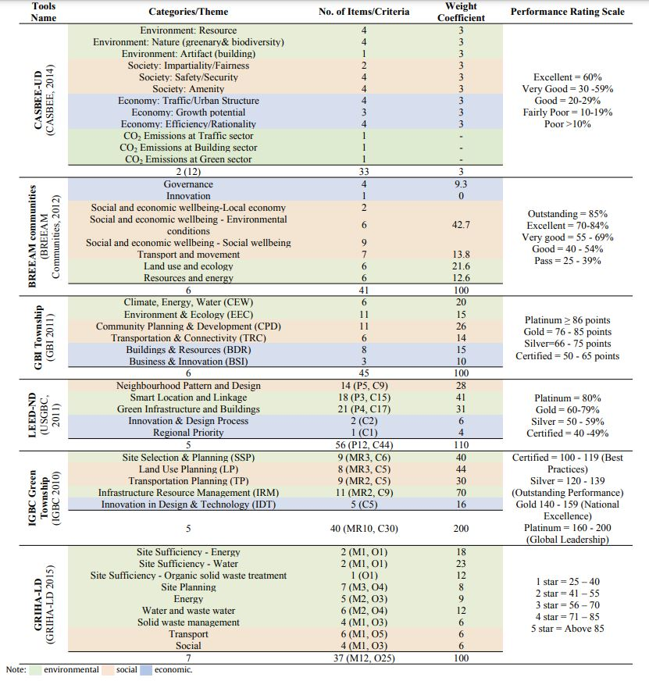
Source: (Harsimran and Pushplata, 2019)

- CASBEE for Urban Development

CASBEE for urban development is a joint research and development project of the Japanese government, industry and academia which was certified by the Institute for Built Environment and Energy Conservation (IBEC) was launched in 2006 and the most recent version was developed in 2007. This sustainability assessment has 6 themes with 31 criteria’s and 82 sub-indicators. CASBEE stands for Comprehensive Assessment System for Building Environmental Efficiency and is developed for the assessment of a group of buildings (CASBEE, 2014). CASBEE for Urban Development framework divides two sections which are QUD (Environment Quality of Urban Development) within the site boundary and LUD (Environment Load of Urban Development) which is beyond the site boundary (Momoh, 2016). QUD is then categorised into Environment, Social and Economy with subcategories such as resource, nature and artefact (building); impartiality/fairness, safety/security and amenity; and traffic/urban structure, growth potential and efficiency/rationality respectively (Yoon and Park, 2015). Also, LUD is more environmental which has sub-categories such as CO2 emission from the transport sector, building sector and absorption in the green sector (Harsimran and Pushplata, 2019). CASBEE is graded into five scale ratings based on the attained points in which each category is allocated equal weighting.
- LEED-ND
LEED-ND is the most recognised tool used in most environmental assessment projects. It is been used in more than 120 countries worldwide to measure and assess sustainability within building designs and urban planning projects (Sleeuw, 2011).
The first piloted version was created in 2007 but launched in 2010 and at the moment the most recent version is 2014 which has 12 prerequisites, 5 themes and 44 criteria’s. LEED-ND was developed by the US Green Building Council in collaboration with the Congress for New Urbanism (CNU) and the Natural Resources Defense Council (USGBC, 2011). It was founded in 1999/2000 and since then it has been the foremost neighbourhood assessment model in America mainly for the urban development scale (Yudelson, 2004). LEED-ND is based on a set of prerequisite indicators. Each set of indicators refers to one of the following aspects – smart site location, linkage neighbourhood pattern and design, green infrastructure/building, innovation and regional priority (Momoh, 2016). In LEED-ND v4 major changes were highlighted in materials credit when it was updated in 2014 (USGBC, 2016; Yoon and Park, 2015). Overall, LEED was designed and intended to develop high-performance neighbourhoods and sustainable buildings (USGBC-LEED, 2014). The assessment criteria are based on different values and ratings placed on each category varying from one to ten points.

- IGBC Green Townships
IGBC stands for Indian Green Building Council which created a flagship Green Township rating system that helps urban designers initiate green design concepts in the planning of urban spaces intending to reduce measurable environmental impacts. The rating system is designed to tackle problems resulting from urban sprawl, traffic problems, social and environmental disconnect by the use of development concepts like Environmental Planning, Land-Use planning, resource management and community development (IGBC, 2010). This assessment tool comprises of five core categories which include “Site Selection & Planning (SSP), Land Use Planning (LP), Transportation Planning (TP), Infrastructure Resource Management (IRM), Innovation in Design & Technology (IDT)” with further division into 40 minor categories. IGBC is assessed by multiplying the points by two for each category. Two being the least and 16 being the maximum points awarded (Harsimran and Pushplata, 2019).

- GRIHA (for large development)
GRIHA is translated to Green Rating for Integrated Habitat Assessment and it’s known as India’s national rating system. In 2015, GRIHA-LD was created by both the Energy and resource institute and the Ministry of New and Renewable Energy for assessing how environmental impact influences large scale development. The range of indicators associated with GRIHA includes carrying capacity and carbon footprint: site sufficiency energy, water, organic solid waste treatment alongside core categories which includes site planning, energy, water and wastewater, solid waste management, transport and social. The rating scheme for GRIHA has energy, water and waste given the highest ratings while infrastructure management, mobility and social well-being are given an equal weighting (Harsimran and Pushplata, 2019).
- GBI Township
Green Building Index (GBI) Township assessment tool was designed in Malaysia in 2011 and its principle is based on reducing energy and water usage; ensuring the environment and ecological systems are not damaged; a well-connected urban area with sustainable transport systems; renewable materials with lower environmental impact and improved health and well-being; and lastly creating job opportunities and employment. The assessment tool is based on six main categories which are “Climate, Energy, Water; Environment and Ecology; Community Planning and Development, Transportation and Connectivity (TRC) and Business and Innovation” (GBI, 2011). In GBI Township, the criteria are assessed differently. Some criteria have 8 points while some have six and one points. Also, the grading system is based on four scale rating classification (GBI, 2011; Harsimran and Pushplata, 2019).

- METHODOLOGY

This paper aims to understand the concepts, approaches, methods, tools and techniques utilised in the assessment of the sustainability of urban spaces. To achieve this stated aim up to date urban sustainability methods and tools are reviewed based on high-level documents, books, journal papers, websites, government proceedings from agencies and governmental organisations and manuals on sustainable urban development and urban assessment.
The research is based on Qualitative Content Analysis (QCA) which was adapted to categorise and identify the different themes linked with various dimensions of sustainability which can span from environmental, economic, social, cultural, political, planning and institutional tiers of sustainability (Haapanen and Tapio, 2016). The paper also identifies the similarities, gaps and differences in the identified assessment tools.
The research focused on the use of Google Scholar alongside web of science and academic search premier to capture the additional sources.

- DISCUSSION AND RESULTS
It is imperative to note that sustainable urban development indicators should be concise, clear, attainable, measurable and showcase the key priorities and objectives of the native urban environment (Ameen et al, 2015). It is also important that their method of selection is based on a series of scientific and methodological approaches to ensure the key criteria needed to ensure urban spaces are captured. These criteria are important as they inform the decision-making process within the urban development projects to attain sustainability goals (Wedding and Crawford-Brown, 2007). This report showcased the review of six well-established sustainability assessment tools which shows 41 core sustainability indicators alongside 252 sub-indicators.
This covers a significant amount of key sustainability areas. Also, looking at the United Nations Division for sustainable development which proposes 58 indicators covering different criteria’s and sub-indicators within four sustainability dimensions (environmental, social, economic and cultural) (UNDSD, 2004).
Key sustainability dimensions used for developing assessment tools normally fall with three or four dimensions. In some instances, it has been categorised under five dimensions which are “resources (ecological, environmental & natural); economic performance & equity; ethical considerations; socio-cultural issues; political governmental functions” (Portney, 2003). It is encouraged according to UN-Habitat agenda 2004 that indicators should be developed using both quantitative and qualitative indicators (UN HABITAT, 2004).

The indicators used in the design of these six highlighted sustainability assessment tools are interrelated and interconnected based on various dimensions of sustainability. Two of the six assessment tools showcase an overlapping of the sustainability dimensions and its indicators looking at LEED-ND and BREEAM communities. They both had overlap between LEED-ND (Neighbourhood patterns & Design and Green Infrastructure) and BREEAM (Social & Economic Well-being). Based on table 2 below there are three out of six assessment tools that did not have any form of overlap of indicators within the same dimension (Environmental and Ecology). BREEAM, CASBEE-UD and GBI Township showed no common similarities and overlapping in indicators (Harsimran and Pushplata, 2019). Based on various studies conducted which include mapping out core indicators and sub-indicators as showcased in figure 1 below. The figure shows the different categories for the five dimensions of sustainability which is listed below after reviewing indicators suggested by top-rated journals, research articles, international and national agencies. It features 23 themes/categories under five urban sustainability dimensions (Environmental, Social, Economic, Cultural and Institutional) that were used in these research urban sustainability assessment tools.

Table.2: Common categories and their indicators in urban sustainability assessment tools
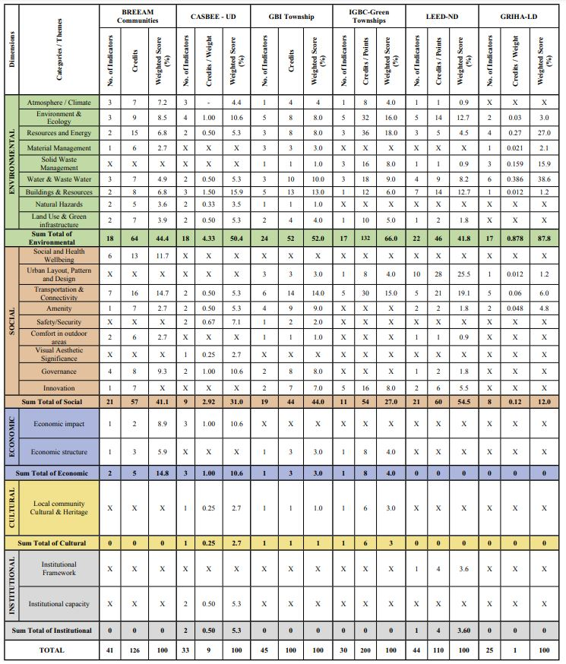
Source: (Harsimran and Pushplata, 2019)

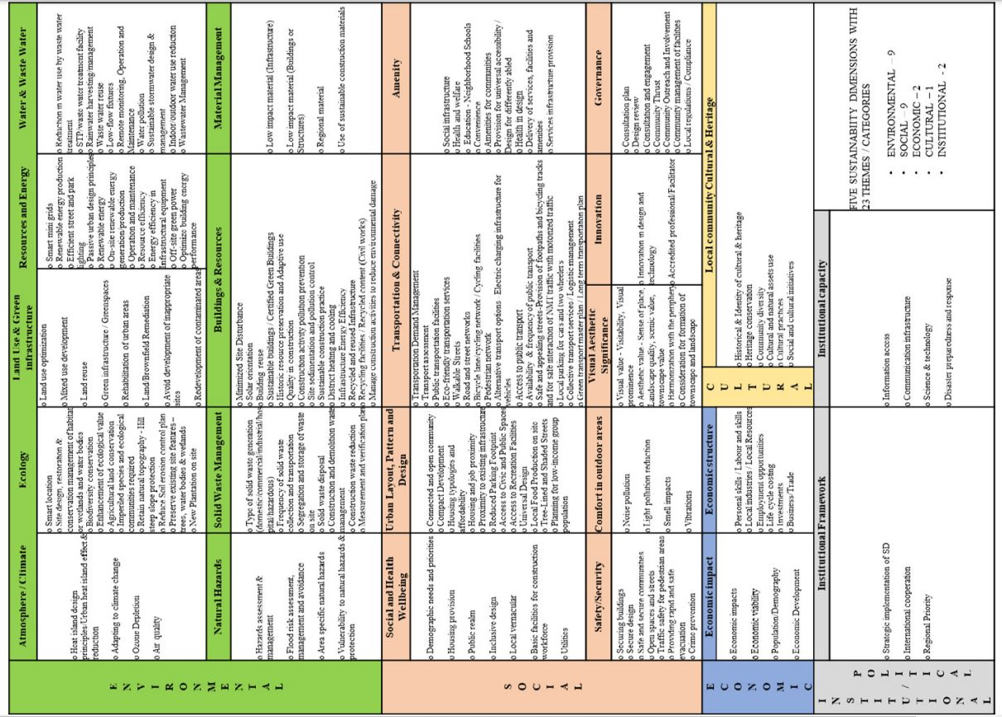
Figure 1: Various aspects covered in selected urban sustainability assessment tools for
different dimensions of Sustainable Development.

CONCLUSION

The identified and listed categories and their sub-indicators can be selected and used to develop a framework for the assessment of urban spaces in both developed and developing countries. The most important factor in prioritising the indicators that are the most vital within that specific region. Also, indicators that are identified to be of relevance within that region can be added to the list to create assessment tools that are adapted to that region or area.
Urban sustainability assessment tools are vital concepts for building, assessing, monitoring and upgrading urban spaces to achieve sustainable development. It is imperative to note that most assessment tools have fewer indicators used in the design of its urban sustainability assessment tool which is perceived as a shortcoming as some pressing indicators address in figure 1 are aspects that should be included in later versions of these tools (Bradon and Lombardy, 2011)

This study will be supportive in the development of innovative urban sustainability assessment tools and/or modifying the current tools to create a more comprehensive, and covers a holistic approach to sustainability assessment. These along with the development of assessment tools is an effective approach in adopting sustainability principles that can lead to urban development being more sustainable for both rural, urban spaces and the entire globe at large. More especially in developing countries where sustainability assessment is still a new approach in designing urban spaces.

REFERENCES

[1] Ameen, R., Mourshed, M., Li, H., 2015. A critical review of environmental assessment tools for sustainable urban design. Environ. Impact Assess. Rev. 55, 110e125

[2] Appu. H, (2012) "Towards sustainable urban communities" Environmental Impact Assessment Review, 32, 165-169 doi.10,1016/jeiar2011.08.02

[3] Ayyoob Sharifi, Shun Kawakubo, Anastasia Milovidova (2020) Urban sustainability assessment tools: toward integrating smart city indicators. Journal of Urban Systems Design ISBN: 978-0-12-816055-8https://doi.org/10.1016/B978-0-12-816055-8.00011-7

[4] Bai, X., Nath, I., Capon, A., Hasan, N., Jaron, D., (2012). Health and Wellneing in the changing urban environment: complex challenges, scientific responses, and the way forward, Curr. Opin. Environ. Sustain. 4 (4). 465 – 472

[5] Brandon, P.S., Lombardi, P., 2011. Evaluating Sustainable Development in the Built Environment, second ed. Wiley-Blackwell, Hoboken, NJ.

[6] BREEAM Communities, 2012. SD202 Technical Manual. www.breeam.org.
[7] CASBEE (2014) CASBEE for Urban Development. Comprehensive Assessment System for Building Environmental Efficiency. Technical Manual 2014 Edition.
[8] Cole, R. J. (1999). “GBC” Building Environmental Assessment Methods: Clarifying Intentions'. Building Research & Information 27, no. 4/5, pp. 230-246.

[9] Curwell S, Deakin M, Lombardi P (2005) “The bequest framework: A vision and methodology” Sustainable Urban Development, Vol.1: The framework and protocols for environmental assessment. London: Routledge, pp.19-42

[10] Devuyst, D, Hens L. et al (2001) “How green is the city? Sustainability assessment and the management of urban Environments. New York, Columbia University Press

[11] Fikel Joseph, Eason Tarsha and Frederickson Herbert (2012). A framework for sustainability Indicators at EPA National Risk Management Research Laboratory. U.S Environmental Protection Agency EPA/600/R/12/6871 October 2012/www.epa.gov/org.

[12] Fisher, L., Newig, J., 2016. Importance of actors and agency in sustainability transitions: a systematic exploration of the literature. Sustainability 8 (5), 476.

[13]Gonzalez, J., Luvall, J., Rickman, D., Comarazamy, D., Pic on, A., Harmsen, E., Parsiani, H., Vasquez, R., Ramírez, N., Williams, R., Waide, R., Tepley, C., 2005. Urban heat islands developing in coastal tropical cities. Eos, Trans. Am. Geophys. Union 86 (42), 397.

[14] Haapanen, L., Tapio, P., 2016. Economic growth as phenomenon, institution and ideology: a qualitative content analysis of the 21st century growth critique. J. Clean. Prod. 112, 3492e3503.

[15] Happio, Appu (2012) Towards sustainable urban communities Article in Environmental Impact Assessment Review Vol 3 2(1):165-169 January 2012

[16] Harsimran Kaur and Pushplata Garg (2019) Urban Sustainability Assesment Tools: A review. Published in the Journal of Cleaner Production 210 (2019) 146e158

[17] Indian Green Building Council, 2010. IGBC Green Townships Rating System - Abridged Reference Guide. Pilot Version ed. Hyderabad: IGBC, Confederation of Indian Industry.

[18] Kolbadi, N., Mohammadi, M., Namvar, F., 2015. Smart growth theory as one of the main paradigms of sustainable city. Int. J. Rev. Life Sci. 5 (9), 209e219.

[19] Momoh, J. (2016), “Sustainability urbanism and it assessment”, Unpublished PhD Thesis, Nottingham
Trent University

[20] Portney, K.E., 2003. Taking Sustainable Cities Seriously: Economic Development, the Environment, and Quality of Life in American Cities. MIT Press, Cambridge, MA.

[21] Retzlaff, R.C., 2008. Green building assessment systems: a framework and comparison for planners. J. Am. Plann. Assoc. 74 (4), 505e519.

[22] Sala, S., Ciuffo, B., Nijkamp, P., 2015. A systemic framework for sustainability assessment. Ecol. Econ. 119, 314e325

[23] Sleuw Martin (2011) “A comparison of BREEAM and LEED Environmental Assessment Methods” A report to the university of East Anglia Estates and Building November 2011

[24] Sharifi, A., Yamagata, Y., 2016. On the suitability of assessment tools for guiding communities towards disaster resilience. Int. J. Disaster Risk Reduct. 18, 115e124.

[25] United Nations Human Settlements Programme (UN HABITAT), 2004. Global Urban Observatory. http://www.unchs.org/programmes/guo/urbanjndicators.asp.

[26] USGBC (2011) “LEED for Neighbourhood Development [Online]”. U.S. GREEN BUILDING COUNCIL.Available:http://www.usgbc.org/DisplayPage.aspx?CMSPageID=148.

[27] USGBC (2016) LEED v4 Building Design + Construction Guide. Available online http://www.usgbc.org/guide/bdc (accessed on 5th January 2022).

[28]Wedding, G., Crawford-Brown, D., 2007. Measuring site-level success in brownfield redevelopments: a focus on sustainability and green building. J. Environ. Manag. 85 (2), 483e495.

[29] Yoon Jungwon and Park Jiyoung (2015) “Comparative Analysis of Material Criteria in Neighborhood Sustainability Assessment Tools and Urban Design Guidelines: Cases of the UK, the US, Japan, and Korea” Journal for Sustainability 2015, Vol. 7, 14450-14487; doi:10.3390/su71114450

[30] Yudelson L (2004) “The Insider's Guide to Marketing Green Building's” 217.p

