Foot strike alters ground reaction force and knee load when stepping down during ongoing walking

Sarah Moudy*^{1,2}, Neale A. Tillin¹, Amy R. Sibley^{1,3}, Siobhán Strike¹
¹Department of Life Sciences, University of Roehampton, London, United Kingdom
²Present Address: Department of Family Medicine, University of North Texas Health Science Center, Fort Worth, Texas, United States of America
³Present Address: Department of Allied Health Sciences, London South Bank University, London, United Kingdom

*Corresponding author
E-mail: Sarah.Moudy@unthsc.edu (SM)

Author contact details:
s.strike@roehampton.ac.uk (SS); neale.tillin@roehampton.ac.uk (NT), amy.sibley@lsbu.ac.uk (AS)

Acknowledgements: This research did not receive any specific grant from funding agencies in the public, commercial, or not-for-profit sectors.
Declaration of interest: None
Word Count: 3196/3000

Abstract
Background: When stepping down from a raised surface, either a toe or heel contact strategy is performed. Increased vertical momentum is likely to be experienced during a step descent, yet the extent to which these descent strategies influence the development of load at the ground and knee has not been examined.
Research Question: Does descent strategy influence ground and knee joint loading? Does the contribution from leading and trailing limb joint mechanics differ between descent strategies?
Methods: Twenty-two healthy male participants (age: 34.0 ± 6.5 years, height: 179 ± 6.3 cm, mass: 83.5 ± 13 kg) walked along a raised platform, stepped down from a 14 cm height utilising either a toe (n = 10) or heel (n = 12) initial contact, and continued walking. Vertical ground reaction forces and knee external adduction and flexor moments were extracted for the duration of the braking phase. Joint work was calculated for the ankle, knee, and hip in both the leading and trailing limbs.
Results: Waveform analysis of the loading features indicated that a toe-contact strategy resulted in significantly reduced loading rates during early braking (1-32% of the braking phase) and significantly increased magnitude in late braking (55-96% of the braking phase). Individuals performing toe landings completed 33% greater overall work (p = 0.091) in the lead limb and utilised the lead limb ankle joint as the main shock absorber (79% of total lead limb work). Concurrently, the trailing limb performed 29% and 21% less work when lowering the centre of mass and propulsion, respectively, compared to a heel landing.
Significance: A toe-contact strategy results in reduced limb and knee joint loading rates through greater utilisation of the lead limb ankle joint. A heel-contact strategy, however, can reduce loading during late braking by utilising the functionality of the trailing limb.

Highlights
- Descent strategy can affect the development of vertical force and knee joint load
- A toe initial contact can reduce vertical force and medial knee loading rates
- Waveform analysis identified midstance loading as an additional feature of load
- Reduced trailing limb work to control vertical momentum may affect lead limb load

Introduction
The ability to descend from a raised surface during ongoing walking, such as a kerb descent, is an important function regularly performed in daily living. Relative to level-walking gait, when stepping down from a raised surface, the limbs must respond to the altered potential and kinetic energy while maintaining forward progression. The trailing limb must safely control the lowering of the centre of mass (CoM) through increased eccentric muscular activation. Concurrently, if the trailing limb is ineffective, the leading limb must absorb increased kinetic energy [1-4]. The biomechanical strategies adopted to achieve a step descent are not well understood. Two step descent strategies, heel or toe initial contact, have been identified, based on the contact area of the foot [5]. Factors that have been suggested to lead to the choice of descent strategy include step height [4,6], walking speed [4], age [7], ankle joint stability [6], and whole body stability [7]. However, the effect of the descent strategy on the load experienced when performing either a heel initial contact or toe initial contact is not well understood. As there is an increased loading demand during step descent [8] and stair descent [9-11], it is important to understand the role of the descent strategy in the development of load.
Repetitive overloading, specifically at the knee joint, has been associated with joint cartilage degeneration [12] which can lead to knee pain and subsequently knee osteoarthritis [13,14]. Typically, loading is assessed through only the peak vertical ground reaction force (vGRF) during a step descent and, as far as the authors are aware, only one study has assessed the knee flexor moment [4]. Peak knee external adduction moment (KAM) is a commonly researched feature to represent medial compartment loading of the knee joint as it has been associated with the severity of joint degeneration, rate of disease progression, and treatment outcomes [14-16]. Recent research has suggested that peak knee external flexor moment (KFM) is also important to consider in relation to medial knee joint loading [17-20]. Thus, changes in KAM and KFM when descending a step should be examined. As limited research has been completed on limb loading during a step descent, waveform analysis should be utilised. Waveform analysis can remove bias in selecting discrete features, specifically when there is limited evidence to suggest their importance. Further, waveform analysis can assess how load is developed over the phase of the movement.
van Dieën et al. [4] examined peak vGRF in the leading limb during a step descent. Their results indicated that a toe-contact strategy reduced the vertical impact force compared to a heel-contact strategy, thought to be due to the increased ankle joint work done in the leading limb. The dynamic walking theory has also demonstrated that the trailing limb can influence the leading limb joint mechanics in the production of efficient movement [21,22]. Thus, the trailing limb mechanics will likely influence the descent strategy mechanics of the leading limb and subsequently the development of load. While not well-defined, previous studies suggest that there are two ‘key’ requirements for completion of a step descent in the trailing limb: lowering of the CoM and propulsion [2,4]. The only study to compare trailing limb mechanics between heel-contact and toe-contact strategies found no significant differences in the propulsive mechanics [4]. Investigation into the single support phase when lowering the CoM could provide insight on the between-limb influence, as controlled eccentric contractions from the trailing limb are necessary to attenuate the kinetic energy from descent. Reduced work by the trailing limb could potentially lead to higher load in the leading limb, as a greater impulse must be generated to lower the CoM and continue forward progression [22].
Therefore, the purpose of this study was to examine the development of load when utilising either a toe-contact or heel-contact strategy during a step descent while controlling for influencing factors (e.g. age, health, step height). A secondary aim of this study was to determine differences in the joint work done in the leading and trailing limbs between descent strategies that may be associated with differences in the loading patterns. It was hypothesised that a toe-contact strategy performed at a self-selected pace, compared to a heel-contact strategy, would result in 1) reduced vertical forces and knee external flexor and adduction moments in the leading limb, 2) increased joint work in the leading limb, and 3) reduced joint work in the trailing limb during both sub-phases.

Methods
Twenty-two healthy, injury-free, recreationally active male individuals (age: 34.0 ± 6.5 years, height: 179 ± 6.3 cm, mass: 83.5 ± 13 kg) provided written informed consent. Participants were excluded if they sustained a lower extremity musculoskeletal injury in the previous 6-months. There were no exclusion criteria for this study based on sex. The participants in this study were recruited as the control cohort of a larger project investigating load in those with a pathological condition. No females with the pathological condition volunteered to participate, therefore, a male only control cohort was included in this study. Therefore, a male only control cohort was included in this study. Ethical approval was obtained from the University of Roehampton’s Ethics Committee (LSC 16/176) and the National Health Services Health Research Authority (17/NW/0566).
Data were collected using twelve Vicon Vantage V5 motion capture cameras (200 Hz; Vicon, Oxford, UK) and synchronised with three force platforms (1000Hz; 9281C Kistler, Hampshire, UK). Retroreflective markers (14 mm) were placed on the skin according to the Plug-In-Gait full-body marker set. A custom raised-surface walkway (5 m length by 1 m width) was constructed with a step height of 14 cm, representing standard kerb height. The step platform was placed in the middle of a 10 m walkway with force platform placement as depicted in Figure 1A to collect data from both the leading and trailing limbs. Participants walked the length of the step platform at a self-selected habitual pace, stepped down, and continued to the end of the laboratory. Participants wore their own exercise shoes for data collection. The leading limb was chosen by the participant (Figure 1A) and no instruction was given with regards to the performance of a specific descent strategy. All participants maintained their chosen descent strategy for all trials. Descent strategies were determined by the ankle flexion angle at initial contact after data processing. An ankle flexion value greater than zero, representing dorsiflexion, denoted a heel-contact strategy (range: 10.4 – 25.8°) and a value less than zero denoted a toe-contact strategy (range: -14.4 – -28.1°). Participants performed five good trials, as determined by visual analysis of force platform strikes, with their preferred self-selected leading limb. The three trials with the most similar walking speeds were averaged for use in further analysis.

Features extracted
Kinematic and kinetic data were filtered using a fourth-order low-pass Butterworth filter with cut-off frequencies of 10 Hz and 200 Hz, respectively. Data extraction was performed using custom-made code in MATLAB (R2017a, The Mathworks Inc, Natick, MA). Inverse dynamics were calculated using the Vicon Plug-In Gait dynamic model. Kinetic data were normalised by body mass.
Loading waveforms extracted for analysis included the vGRF, KAM, and KFM for the duration of the braking phase in the leading limb. The braking phase was defined from initial contact, based on a 20N threshold in the vGRF, to the first positive point in the leading limb anterior-posterior GRF (Figure 1B). Loading waveforms were linearly time-normalised to 100% of the braking phase based on the average length of the phase across all participants (60 frames) to avoid over-stretching or -shrinking of the data. To account for inherent waveform timing/phase variability between participants, that was not reduced by time-normalisation (Figure 2A), landmark registration was performed. Landmark registration is a time-warping technique that ‘stretches’ or ‘shortens’ phases of a task that occur between specified landmarks to align physiological events or phases (Figure 2B&C). Landmark registration ensures direct magnitude comparisons are made during waveform analysis, and has been found increase prediction power to performance indicators [23]. The method utilised in this study to perform landmark registration is discussed in full in Moudy et al. [23]. In short, a warping function is created that determines the time-warping required between specified landmarks in the waveform (Figure 2C and Figure 3). The landmark chosen in this study was the average time point at which peak magnitude for each loading waveform occurred across all participants. Landmark registration was applied to the loading waveforms magnitude-domain and each participant’s respective time-domain (i.e. the time, in seconds, spent in the braking phase). Analysis of the time-domain can provide additional information of the temporal differences between descent strategies (Figure 3). A landmark registered time-domain and warping function represents the variability of the time leading to and following the specified landmark (Figure 2C and Figure 3). An increased magnitude of a landmark registered time-domain or warping function would suggest greater time was taken to reach the specified landmark and can represent typical biomechanical features such as loading rates. This approach can remove the possibly biased a priori approach and reduce issues surrounding calculations of timing related discrete features.
The temporal-spatial parameters extracted were stepping speed, step length, and the vertical and horizontal CoM velocity at initial contact. Stepping speed was calculated based on the displacement over time of the CoM from initial contact of the trailing limb on the step platform to toe-off of the leading limb on the ground. Step length was defined as the distance taken by the leading limb during descent, measured from the trailing limb toe marker to the leading limb toe marker.
Sagittal plane joint work was calculated for the leading and trailing limbs during the phases defined in Figure 1B. Trailing limb sub-phases represent the phases in which the majority of lowering the CoM (Phase 1) and propulsion to continue forward progression (Phase 2) occurs. Trailing limb phase 1 was defined as the single support phase from the first positive value in the trailing limb anterior-posterior GRF to leading limb initial contact. Trailing limb phase 2 was defined as the double support phase from leading limb initial contact to trailing limb toe-off. Individual joint work was calculated as the area under the power-time curve using the trapezoidal rule. Total joint work was calculated as the sum of the absolute work performed at each joint.

Statistical analysis
Data review showed that twelve participants performed a heel-contact, and ten performed a toe-contact. To determine differences in the loading waveforms between groups, independent t-tests were performed using statistical parametric mapping (v.M0.4.5, www.spm1d.org) on the magnitude-domain, time-domain, and warping function. To determine differences in the temporal-spatial parameters and individual and total joint work, independent t-tests were performed using the statistics toolbox in MATLAB. Additionally, analyses of covariance (ANCOVA) were performed, with stepping speed as the covariant, for both loading waveforms and movement features. The addition of the ANCOVA is a novel approach that can provide clarity on whether a feature of interest is independent of speed or could be influenced by changes in speed. This distinction can only be made when comparing the results from the t-test and ANCOVA.

Results
There were no significant differences between groups for age (p = 0.257; heel-contact: 32.5 ± 6.4, toe-contact: 35.7 ± 6.4 years), height (p = 0.669; heel-contact: 179 ± 6.6, toe-contact: 180 ± 6.2 cm), or mass (p = 0.098; heel-contact: 79.3 ± 15, toe-contact: 88.4 ± 8.9 kg). Stepping speed was not significantly different between groups; however, the toe-contact group utilised a significantly shorter step length and had a significantly reduced horizontal CoM velocity at initial contact (Table 1). These significant differences were maintained after covarying for speed (p ≤ 0.021) suggesting that step length and horizontal CoM velocity at initial contact were significantly different due to the step descent mechanics.

Loading waveforms
In the magnitude-domain, the toe-contact group initially had a significantly greater KFM (5-9%) followed by significantly reduced KFM from 13-18%. Additionally, KAM magnitude was significantly greater in the toe-contact group from 9-12% and 15-19%. Waveform analysis found no significant differences at peak magnitude for any loading feature (Figure 3); however, the time-domain and warping functions were significantly different in the toe-contact group for vGRF and KAM indicating a lower loading rate.
Waveform analysis identified a second phase of difference during late braking. The late braking phase magnitude in the vGRF was significantly greater in the toe-contact group from ~73-98% of the braking phase. After covarying for speed, the toe-contact group tended to maintain a significantly greater KAM from 57-95% (†red phase in Figure 3). The time-domain during late braking (~85-100% of braking phase) was found to be significantly shorter in the toe-contact group, indicating that less time was spent in the braking phase.
All significant phases of difference in the loading waveforms remained significant after speed covariation which suggests that differences in load between descent strategies were independent of speed. The additional late braking KAM phase that became significant after speed covariation indicates that the toe-contact group may have, on average, performed the descent slower to reduce the load in this phase.

Joint Mechanics
In the leading limb, the toe-contact group completed 33% greater total negative joint work than the heel-contact group (p = 0.091; Figure 4A). The toe-contact group performed significantly more work at the ankle joint (p < 0.001, ANCOVA: p < 0.001) and significantly less work at the knee joint (p = 0.003, ANCOVA: p = 0.014). No significant difference was found at the hip joint (p = 0.176, ANCOVA: p = 0.346). The toe-contact ankle joint performed 79% of the total lead limb work, while the heel-contact group utilised the knee joint as the primary shock absorber (55%; Figure 4B).
In the trailing limb when lowering the CoM (phase 1), the total negative work completed was 29% lower (p = 0.036) in the toe-contact group (Figure 4A). The toe-contact group completed significantly less work at the hip joint (p = 0.013) which did not remain significant after speed covariation (p = 0.151). No significant differences were found at the ankle (p = 0.349, ANCOVA: p = 0.754) and knee joints (p = 0.087, ANCOVA: p = 0.102). Both the heel-contact and toe-contact groups utilised the ankle joint to the greatest extent to lower the CoM (48% and 70%, respectively; Figure 4B).
The trailing limb joint work completed during propulsion (phase 2) was 21% less (p = 0.044) in the toe-contact group (Figure 4A). The negative work completed at the knee joint (p = 0.311; ANCOVA: p = 0.260) and the positive work completed at the ankle (p = 0.104, ANCOVA: p = 0.202) and hip joints (p = 0.149, ANCOVA: p = 0.718) were not significantly different between groups. To propel the CoM forward, both groups utilised the ankle joint to the greatest extent (52-56%; Figure 4B), followed by the knee (25-27%) then the hip (19-21%).

Discussion
This study aimed to investigate differences in lead limb vGRF and knee joint loading between toe-contact and heel-contact descent strategies and to determine differences in joint work in the leading and trailing limbs between groups. To determine how the descent strategy explained variability in load, these aims were investigated independent of any joint health or age-related deficiencies and other influencing factors (e.g. step height) that have been suggested to cause the adoption of different descent strategies. A toe-contact strategy resulted in a decreased rate of vGRF and KAM; no significant differences at peak magnitude; differences in KFM and KAM magnitudes in early stance; and increased vGRF magnitude during late braking (Figure 3). Analysis of the joint work suggests that the descent strategies utilised the joints differently in the leading and trailing limbs to control the vertical and horizontal momentum which influenced the load experienced.
Although the participants who performed a toe-contact strategy walked slower, the differences in vGRF, KAM, and KFM were maintained when accounting for speed. While previous step descent research imposed fixed speeds, the current study utilised self-selected speeds to examine the spontaneous selection of descent strategy under more natural conditions. Other factors thought to influence the selection of descent strategies (e.g. step height) were additionally controlled in the study design. Thus, the variability in load between groups was most likely due to the choice of descent strategy. The causation of differences in walking speed is currently unclear; it is possible that a toe-contact strategy cannot be performed at greater walking speeds. Additionally, speed could be used to compensate for deficiencies in joint mechanics or to mediate loading patterns. The novel approach of comparing t-test and ANCOVA results provides additional clarity on the impact of speed to load and joint mechanics.
When the vGRF data were landmark registered, no significant difference was found at peak magnitude; however, the warping function was significantly different indicating an effect of the descent strategy on the rate of force. Loading rates have been suggested as a more relevant measure than peak magnitudes in assessing joint loading and injury occurrence [24-26]. The results from the current study indicate that a toe-contact strategy reduced the initial vGRF and KAM loading rates, despite experiencing similar peak magnitudes to the heel-contact group. Waveform analysis identified an additional phase of interest (late braking phase, consistent with midstance). The toe-contact group maintained greater vertical load during late braking. When speed was considered, an additional phase of interest was identified during late braking for KAM, which possibly suggests that those individuals who performed a toe-contact were able to reduce late braking KAM magnitude by walking at slower speeds. However, it is unclear if sustained late braking load is a risk factor in the onset and progression of degenerative diseases. Therefore, a toe-contact strategy may be the preferred descent strategy as there are reduced loading rates, which has been determined as a possible risk factor for joint degeneration, despite the increased late braking load.
The differences in load between descent strategies possibly stemmed from differences in the leading and trailing limb joint mechanics as alterations in load were independent of speed. In stepping down, the vertical momentum is controlled by eccentric contractions in the trailing and leading limbs. Dynamic walking models have demonstrated that a between-limb influence is present in the production of efficient movement. The toe-contact group performed 29% less total work in the trailing limb when lowering the CoM (p = 0.036), 21% less total work during propulsion (p = 0.044), and 33% increased total work on the leading limb (p = 0.091). Overall, both strategies completed similar amounts of total combined work (leading and trailing limb; 1.3% difference). The toe-contact trailing limb performed 48% of the total combined work while the heel-contact trailing limb performed 62.7%. The greater total work in the leading limb of the toe-contact group was required to absorb the greater kinetic energy not absorbed by the trailing limb prior to initial contact, and to aid in continuing forward progression after trailing limb toe-off, as reduced propulsion was performed by the trailing limb [22,27,28].
In the leading limb, the ankle joint was utilised as the main shock absorber (79% of total work done) in the toe-contact group compared to the heel-contact group which utilised the knee as the main shock absorber (55% of total work done; Figure 4B). Our results indicate that a toe-contact strategy is a potential method to reduce load at the knee joint. However, the increased ankle joint work that is required to perform a toe-contact strategy may not be available in those persons who experience knee pain, or have or are at risk of joint degenerative diseases. This may be further supported by the significant reduction in work completed at the knee joint after covarying for speed in the toe-contact group (p = 0.014; Figure 4A). These findings are consistent with previous step and stair descent research [2-4]. It is possible that, by utilising the ankle as the main shock absorber, rather than the knee, a toe-contact strategy may be more efficient at reducing the rate of vGRF and KAM loading and, therefore, subsequently reducing the risk of developing knee joint comorbidities.
The toe-contact group utilised the trailing limb ankle joint to complete 70% of the total work when lowering the CoM, while the heel-contact group utilised the ankle joint to complete 48% of the work (Figure 4B). It is possible that the toe-contact group may not have required greater work from the knee and hip joints (Figure 4A) as the extended leading limb reduced the amount of vertical displacement required prior to initial contact. However, significant differences in joint work of the trailing limb when lowering the CoM did not remain significant after covarying for speed. This indicates that, when performed at the same speed, the toe-contact and heel-contact groups utilised trailing limb strategies that were not significantly different to lower the CoM. However, during propulsion, significant differences between both groups were maintained in the trailing limb after speed covariation. The ankle joint was the greatest contributor to propulsion (52-56%) in both groups yet was significantly reduced in the toe-contact group (Figure 4B). Reduced propulsion from the trailing limb has been found to result in a shorter step length [29] and, as exhibited in the toe-contact group, may contribute to the descent strategy. It is currently unclear if the toe-contact strategy was adopted due to the inability to effectively utilise the trailing limb or as an attempt to the reduce loading rates.
A limitation of the study is the variable footwear worn by participants. While footwear can have different stiffness and compliance, the participants wore their own exercise shoes with the aim of providing a more natural gait pattern. The results from this study may have a limited generalisation due to the inclusion of only young, healthy male participants. Further research is needed to understand the development of load in both descent strategies in females and older individuals who may present with different loading patterns and joint mechanics.

Conclusion
The foot contact strategy when stepping down during ongoing walking can affect the development of load. Independent of stepping speed, a toe-contact strategy was associated with a significantly lower rates of vGRF and KAM load and greater late braking magnitudes. The toe-contact group leading limb mechanics utilised the ankle joint, rather than the knee, as the primary shock absorber possibly indicating a knee-avoidance strategy. There is evidence to suggest that the trailing limb mechanics influenced the descent strategy of the leading limb and the subsequent magnitude and rate of load. Given the limited evidence on the relationship between late braking load and joint degeneration, a toe-contact strategy can be utilised to reduce loading rates and, therefore, possible reduce the risk of joint degeneration.

References
[1] Jones SF, Twigg PC, Scally AJ, Buckley JG. The mechanics of landing when stepping down in unilateral lower-limb amputees. Clin Biomech 2006;212:184-93.
[2] van Dieën JH, Spanjaard M, Konemann R, Bron L, Pijnappels M. Balance control in stepping down expected and unexpected level changes. Journal of Biomechanics 2007;4016:3641-9.
[3] Barnett C, Polman R, Vanicek N. Longitudinal changes in transtibial amputee gait characteristics when negotiating a change in surface height during continuous gait. Clin Biomech 2014;297:787-93.
[4] van Dieën JH, Spanjaard M, Könemann R, Bron L, Pijnappels M. Mechanics of toe and heel landing in stepping down in ongoing gait. Journal of Biomechanics 2008;4111:2417-21.
[5] Freedman W, Kent L. Selection of movement patterns during functional tasks in humans. J Mot Behav 1987;192:214-26.
[6] Gerstle EE, O’Connor K, Keenan KG, Cobb SC. Foot and Ankle Kinematics During Descent From Varying Step Heights. Journal of applied biomechanics 2017;336:453-9.
[7] van Dieën JH, Pijnappels M. Effects of conflicting constraints and age on strategy choice in stepping down during gait. Gait & Posture 2009;292:343-5.
[8] Christina KA, Cavanagh PR. Ground reaction forces and frictional demands during stair descent: effects of age and illumination. Gait Posture 2002;152:153-8.
[9] Mian OS, Thom JM, Narici MV, Baltzopoulos V. Kinematics of stair descent in young and older adults and the impact of exercise training. Gait Posture 2007;251:9-17.
[10] Paquette MR, Zhang S, Milner CE, Fairbrother JT, Reinbolt JA. Effects of increased step width on frontal plane knee biomechanics in healthy older adults during stair descent. The Knee 2014;214:821-6.
[11] Novak AC, Brouwer B. Sagittal and frontal lower limb joint moments during stair ascent and descent in young and older adults. Gait & Posture 2011;331:54-60.
[12] Arokoski J, Jurvelin J, Väätäinen U, Helminen H. Normal and pathological adaptations of articular cartilage to joint loading. Scand J Med Sci Sports 2000;104:186-98.
[13] Hensor E, Dube B, Kingsbury SR, Tennant A, Conaghan PG. Toward a Clinical Definition of Early Osteoarthritis: Onset of Patient‐Reported Knee Pain Begins on Stairs. Data From the Osteoarthritis Initiative. Arthritis care & research 2015;671:40-7.
[14] Miyazaki T, Wada M, Kawahara H, Sato M, Baba H, Shimada S. Dynamic load at baseline can predict radiographic disease progression in medial compartment knee osteoarthritis. Ann Rheum Dis 2002;617:617-22.
[15] Vanwanseele B, Eckstein F, Smith RM, Lange AK, Foroughi N, Baker MK, Shnier R, Fiatarone Singh MA. The relationship between knee adduction moment and cartilage and meniscus morphology in women with osteoarthritis. Osteoarthritis and Cartilage 2010;187:894-901.
[16] Thorp LE, Sumner DR, Block JA, Moisio KC, Shott S, Wimmer MA. Knee joint loading differs in individuals with mild compared with moderate medial knee osteoarthritis. Arthritis & Rheumatism 2006;5412:3842-9.
[17] Creaby MW. It's not all about the knee adduction moment: the role of the knee flexion moment in medial knee joint loading. Osteoarthritis Cartilage 2015;237:1038-40.
[18] Richards RE, Andersen MS, Harlaar J, van den Noort JC. Relationship between knee joint contact forces and external knee joint moments in patients with medial knee osteoarthritis: effects of gait modifications. Osteoarthritis and Cartilage 2018;269:1203-14.
[19] Manal K, Gardinier E, Buchanan TS, Snyder-Mackler L. A more informed evaluation of medial compartment loading: the combined use of the knee adduction and flexor moments. Osteoarthritis and Cartilage 2015;237:1107-11.
[20] Walter JP, D'lima DD, Colwell Jr CW, Fregly BJ. Decreased knee adduction moment does not guarantee decreased medial contact force during gait. Journal of Orthopaedic Research 2010;2810:1348-54.
[21] Kuo AD. The six determinants of gait and the inverted pendulum analogy: A dynamic walking perspective. Human Movement Science 2007;264:617-56.
[22] Donelan JM, Kram R, Kuo AD. Simultaneous positive and negative external mechanical work in human walking. J Biomech 2002;351:117-24.
[23] Moudy S, Richter C, Strike S. Landmark registering waveform data improves the ability to predict performance measures. J Biomech 2018;78:109-17.
[24] Boyd R, Walker E, Wu D, Lukoschek M, Burr D, Radin E. Morphologic and morphometric changes in synovial membrane associated with mechanically induced osteoarthrosis. Arthritis & Rheumatology 1991;345:515-24.
[25] Morgenroth DC, Medverd JR, Seyedali M, Czerniecki JM. The relationship between knee joint loading rate during walking and degenerative changes on magnetic resonance imaging. Clin Biomech 2014;296:664-70.
[26] Mündermann A, Dyrby CO, Andriacchi TP. Secondary gait changes in patients with medial compartment knee osteoarthritis: increased load at the ankle, knee, and hip during walking. Arthritis & Rheumatology 2005;529:2835-44.
[27] Adamczyk PG, Kuo AD. Redirection of center-of-mass velocity during the step-to-step transition of human walking. J Exp Biol 2009;212Pt 16:2668-78.
[28] Houdijk H, Pollmann E, Groenewold M, Wiggerts H, Polomski W. The energy cost for the step-to-step transition in amputee walking. Gait Posture 2009;301:35-40.
[29] Browne MG, Franz JR. The independent effects of speed and propulsive force on joint power generation in walking. J Biomech 2017;55:48-55.

Table 1. Temporal-spatial features (mean ± SD) presented for the heel-contact and toe-contact groups
 | Heel-Contact | Toe-Contact | p-value
Stepping Speed (m/s) | 1.54 ± 0.3 | 1.37 ± 0.1 | 0.124
Step Length (m) | 0.86 ± 0.1† | 0.72 ± 0.1 | 0.002
Vertical VIC (m/s) | -0.34 ± 0.1 | -0.32 ± 0.0 | 0.421
Horizontal VIC (m/s) | 0.87 ± 0.2† | 0.74 ± 0.1 | 0.012
VIC = velocity at initial contact
†p < 0.05 significant differences after covarying for speed
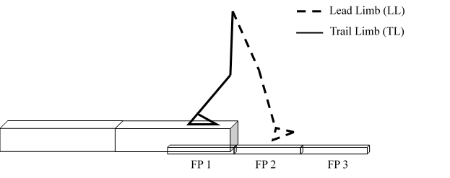
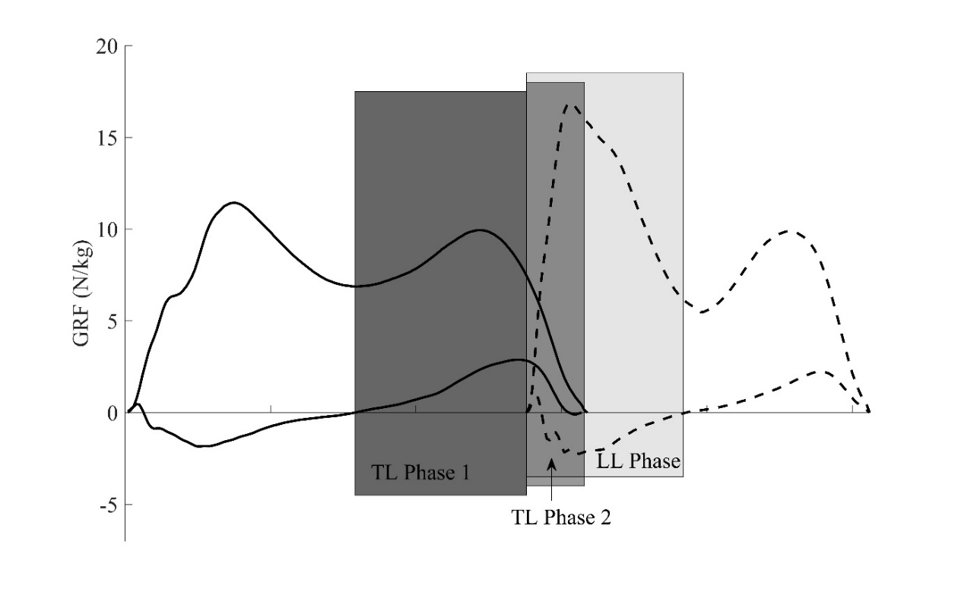
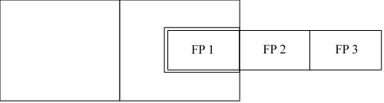
Figure 1. A) Side and top-view depictions of the step descent with force platform placements noted. The set-up of the walkway included a separate structure over force platform 1 to ensure valid collection of trailing limb data. B) Definitions of step descent sub-phases for the leading limb (LL; dashed lines) and trailing limb (TL; solid lines) based on the vGRF and anterior-posterior GRF.
A
B
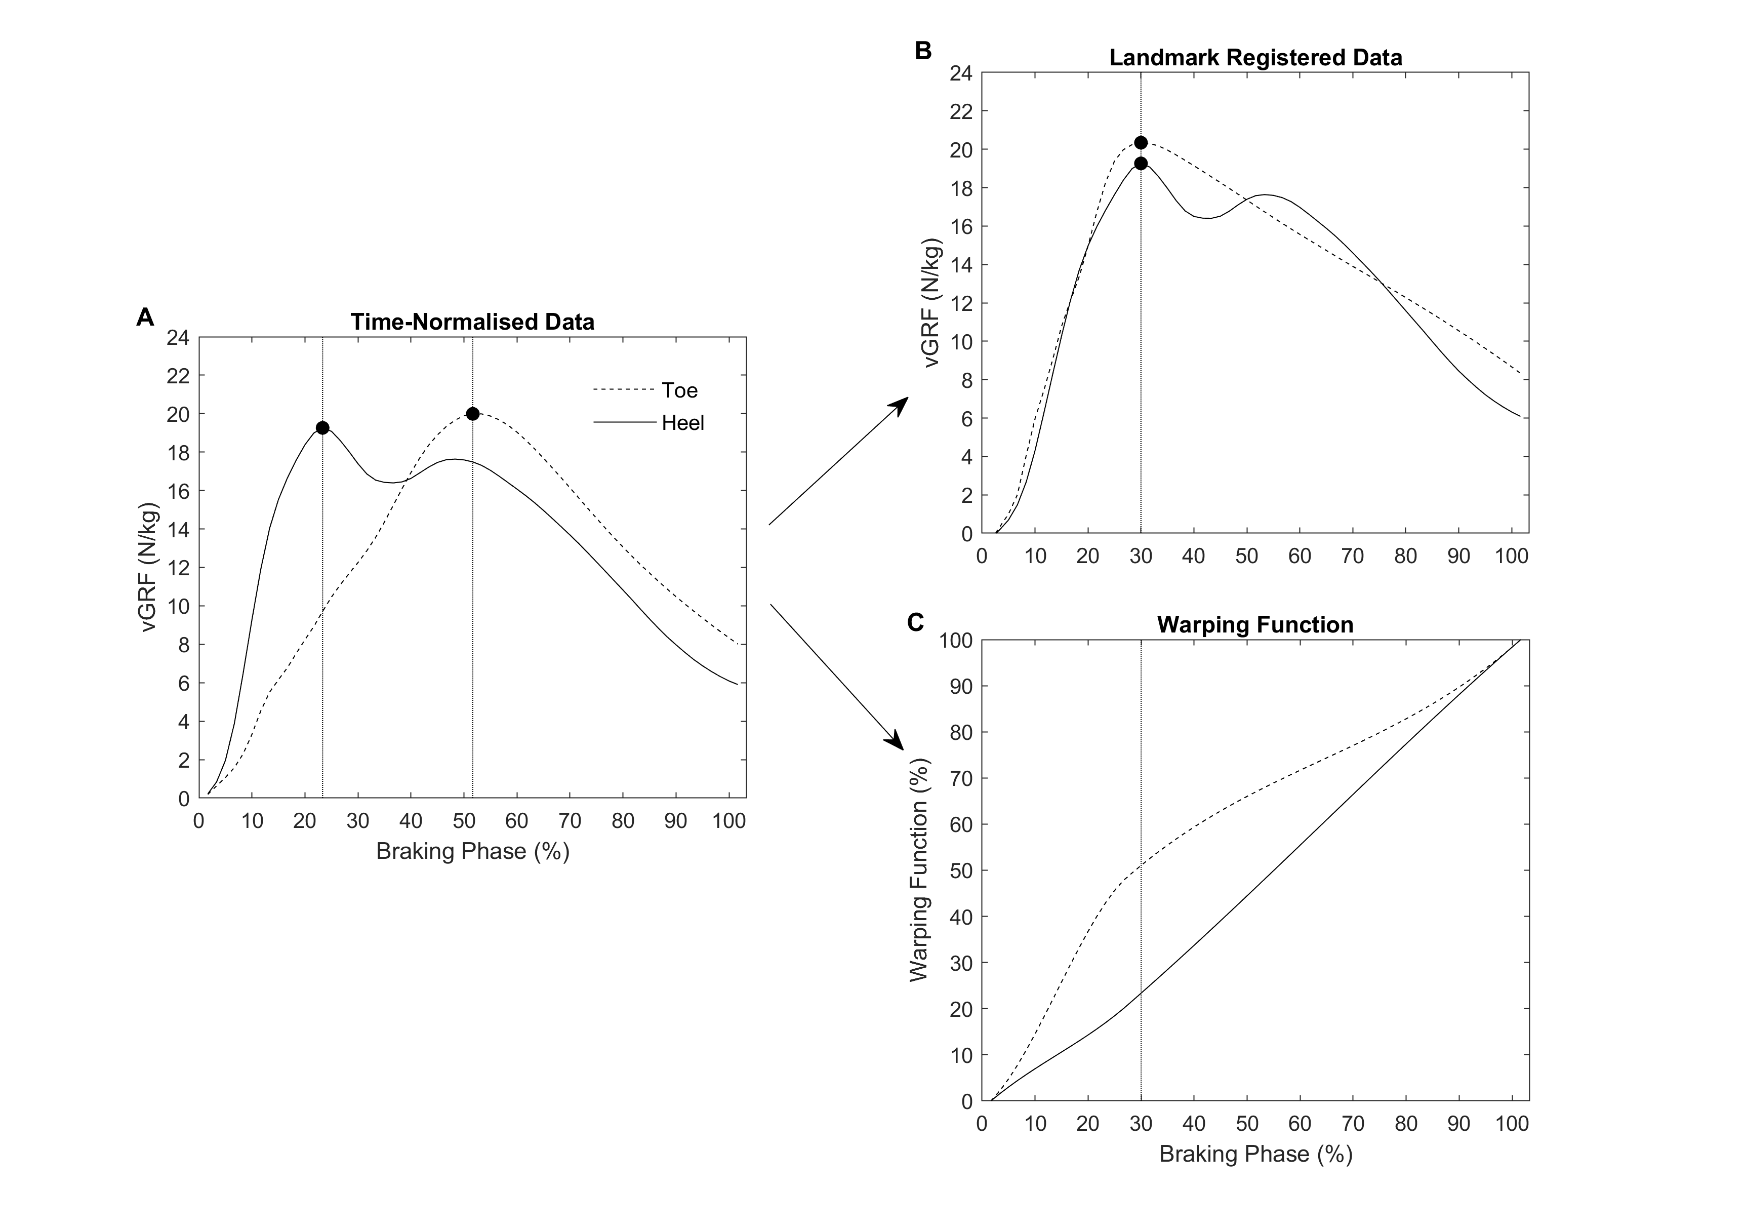Figure 2. A) Time-normalised and B) landmark registered vGRF data for two participants and C) warping function for these two participants; one heel-contact and one toe-contact. Timing of the peak vGRF is denoted by the vertical dashed lines and circle markers before and after landmark registration. Data were landmarked registered based on the average time point that peak vGRF occurred across all participants included in the study. A greater warping function, as seen by the toe-contact person, indicates that the phase between initial contact and peak vGRF was shortened (i.e. greater time was taken to reach peak vGRF).
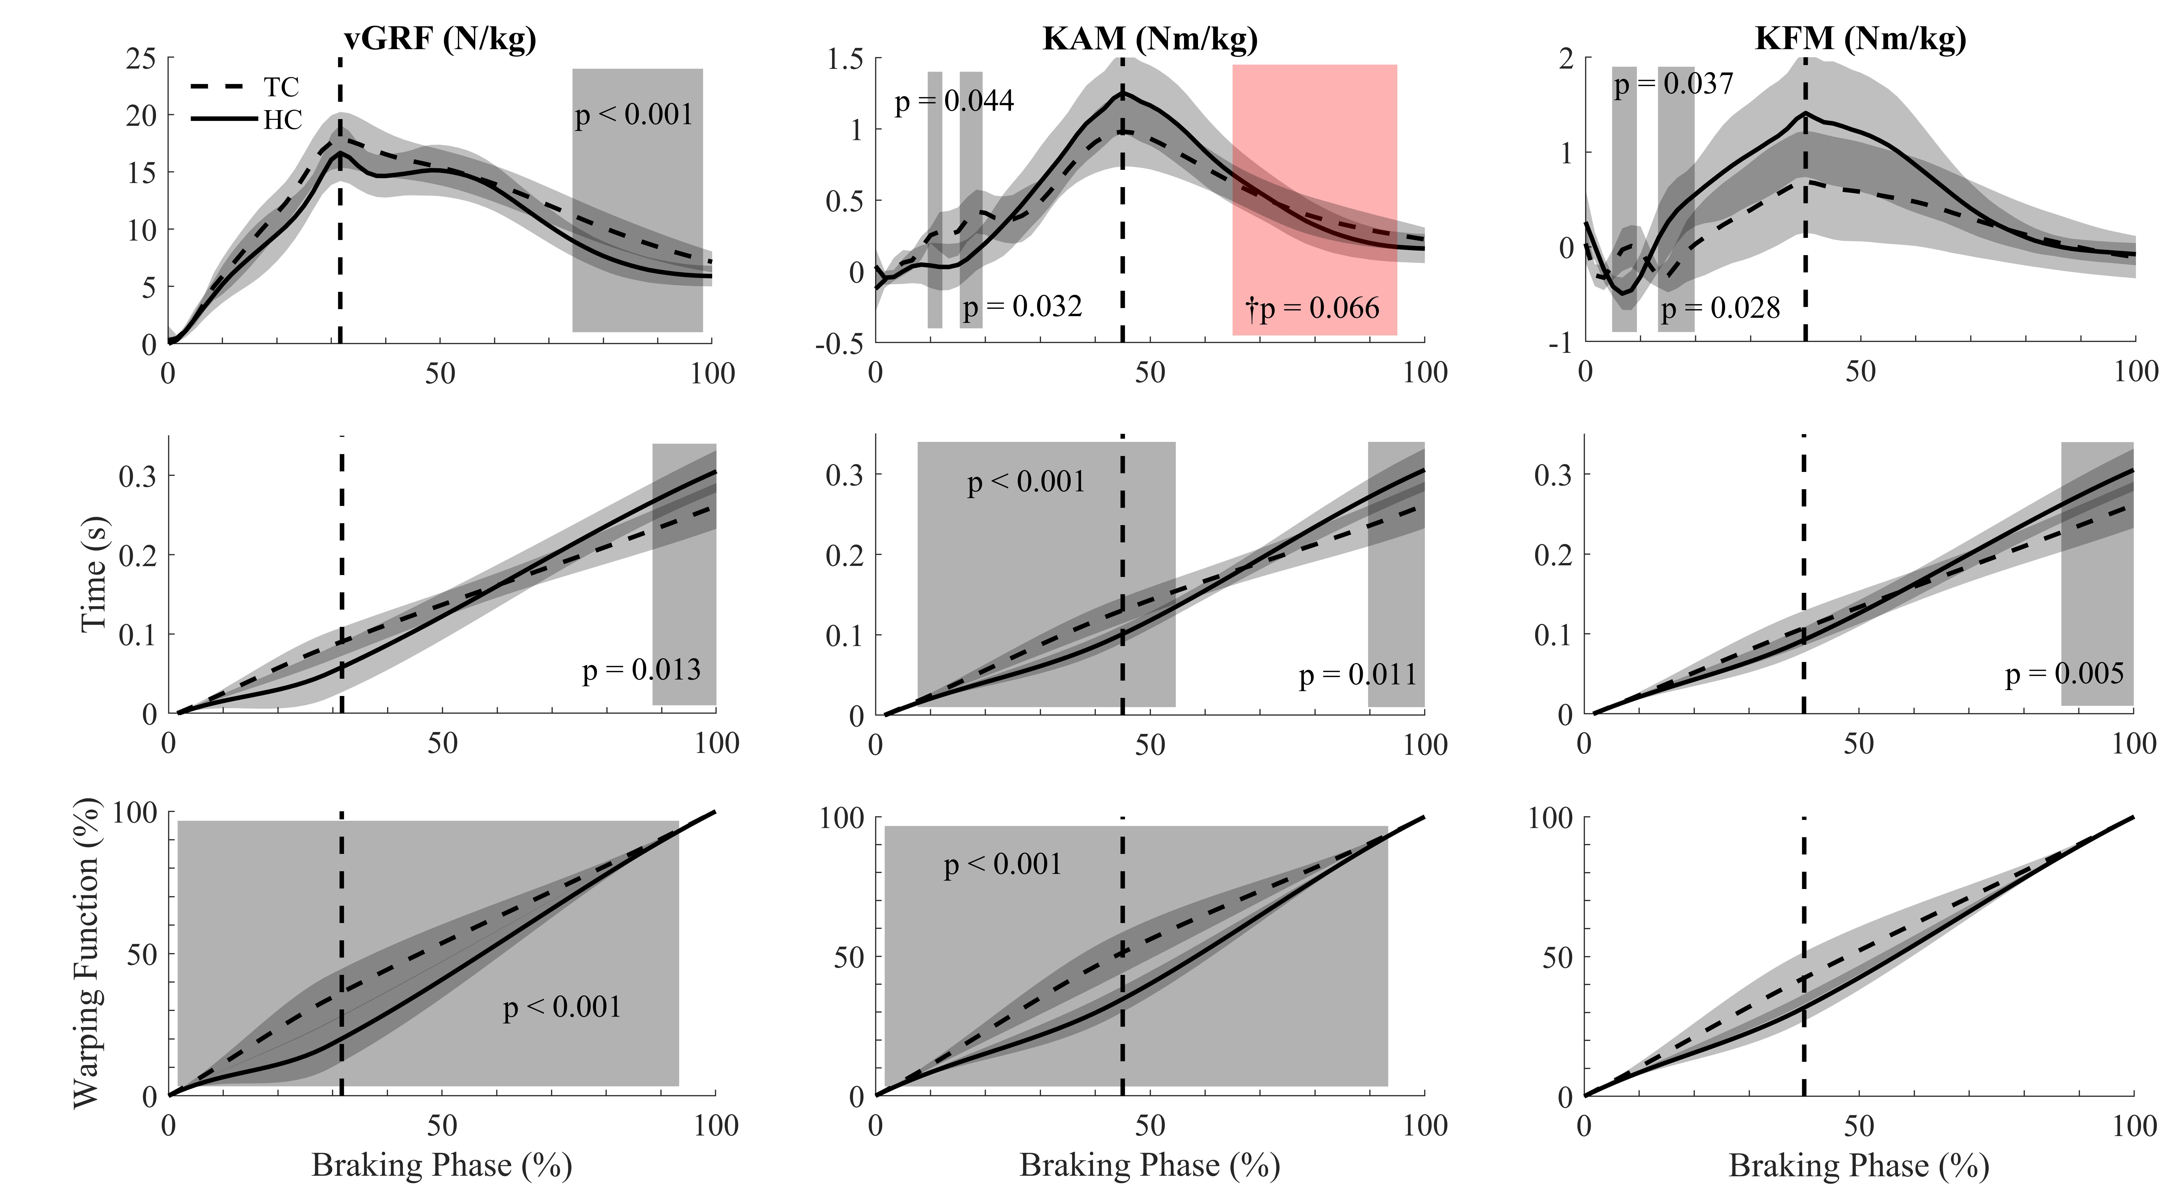
Figure 3. Landmark registered GRF, KAM, and KFM magnitude-domain (top row), time-domain (middle row), and warping function (bottom row) waveforms when performing a toe-contact strategy (dashed line) and a heel-contact strategy (solid line). Positive KAM and KFM values indicate adduction and flexor moments, respectively. The vertical dashed line represents the landmark event. A warping function value closer to 0% indicates a shift in the landmark to the right (i.e. increasing the time to reach the landmark). Significant phases of difference are highlighted in grey with p-values noted.
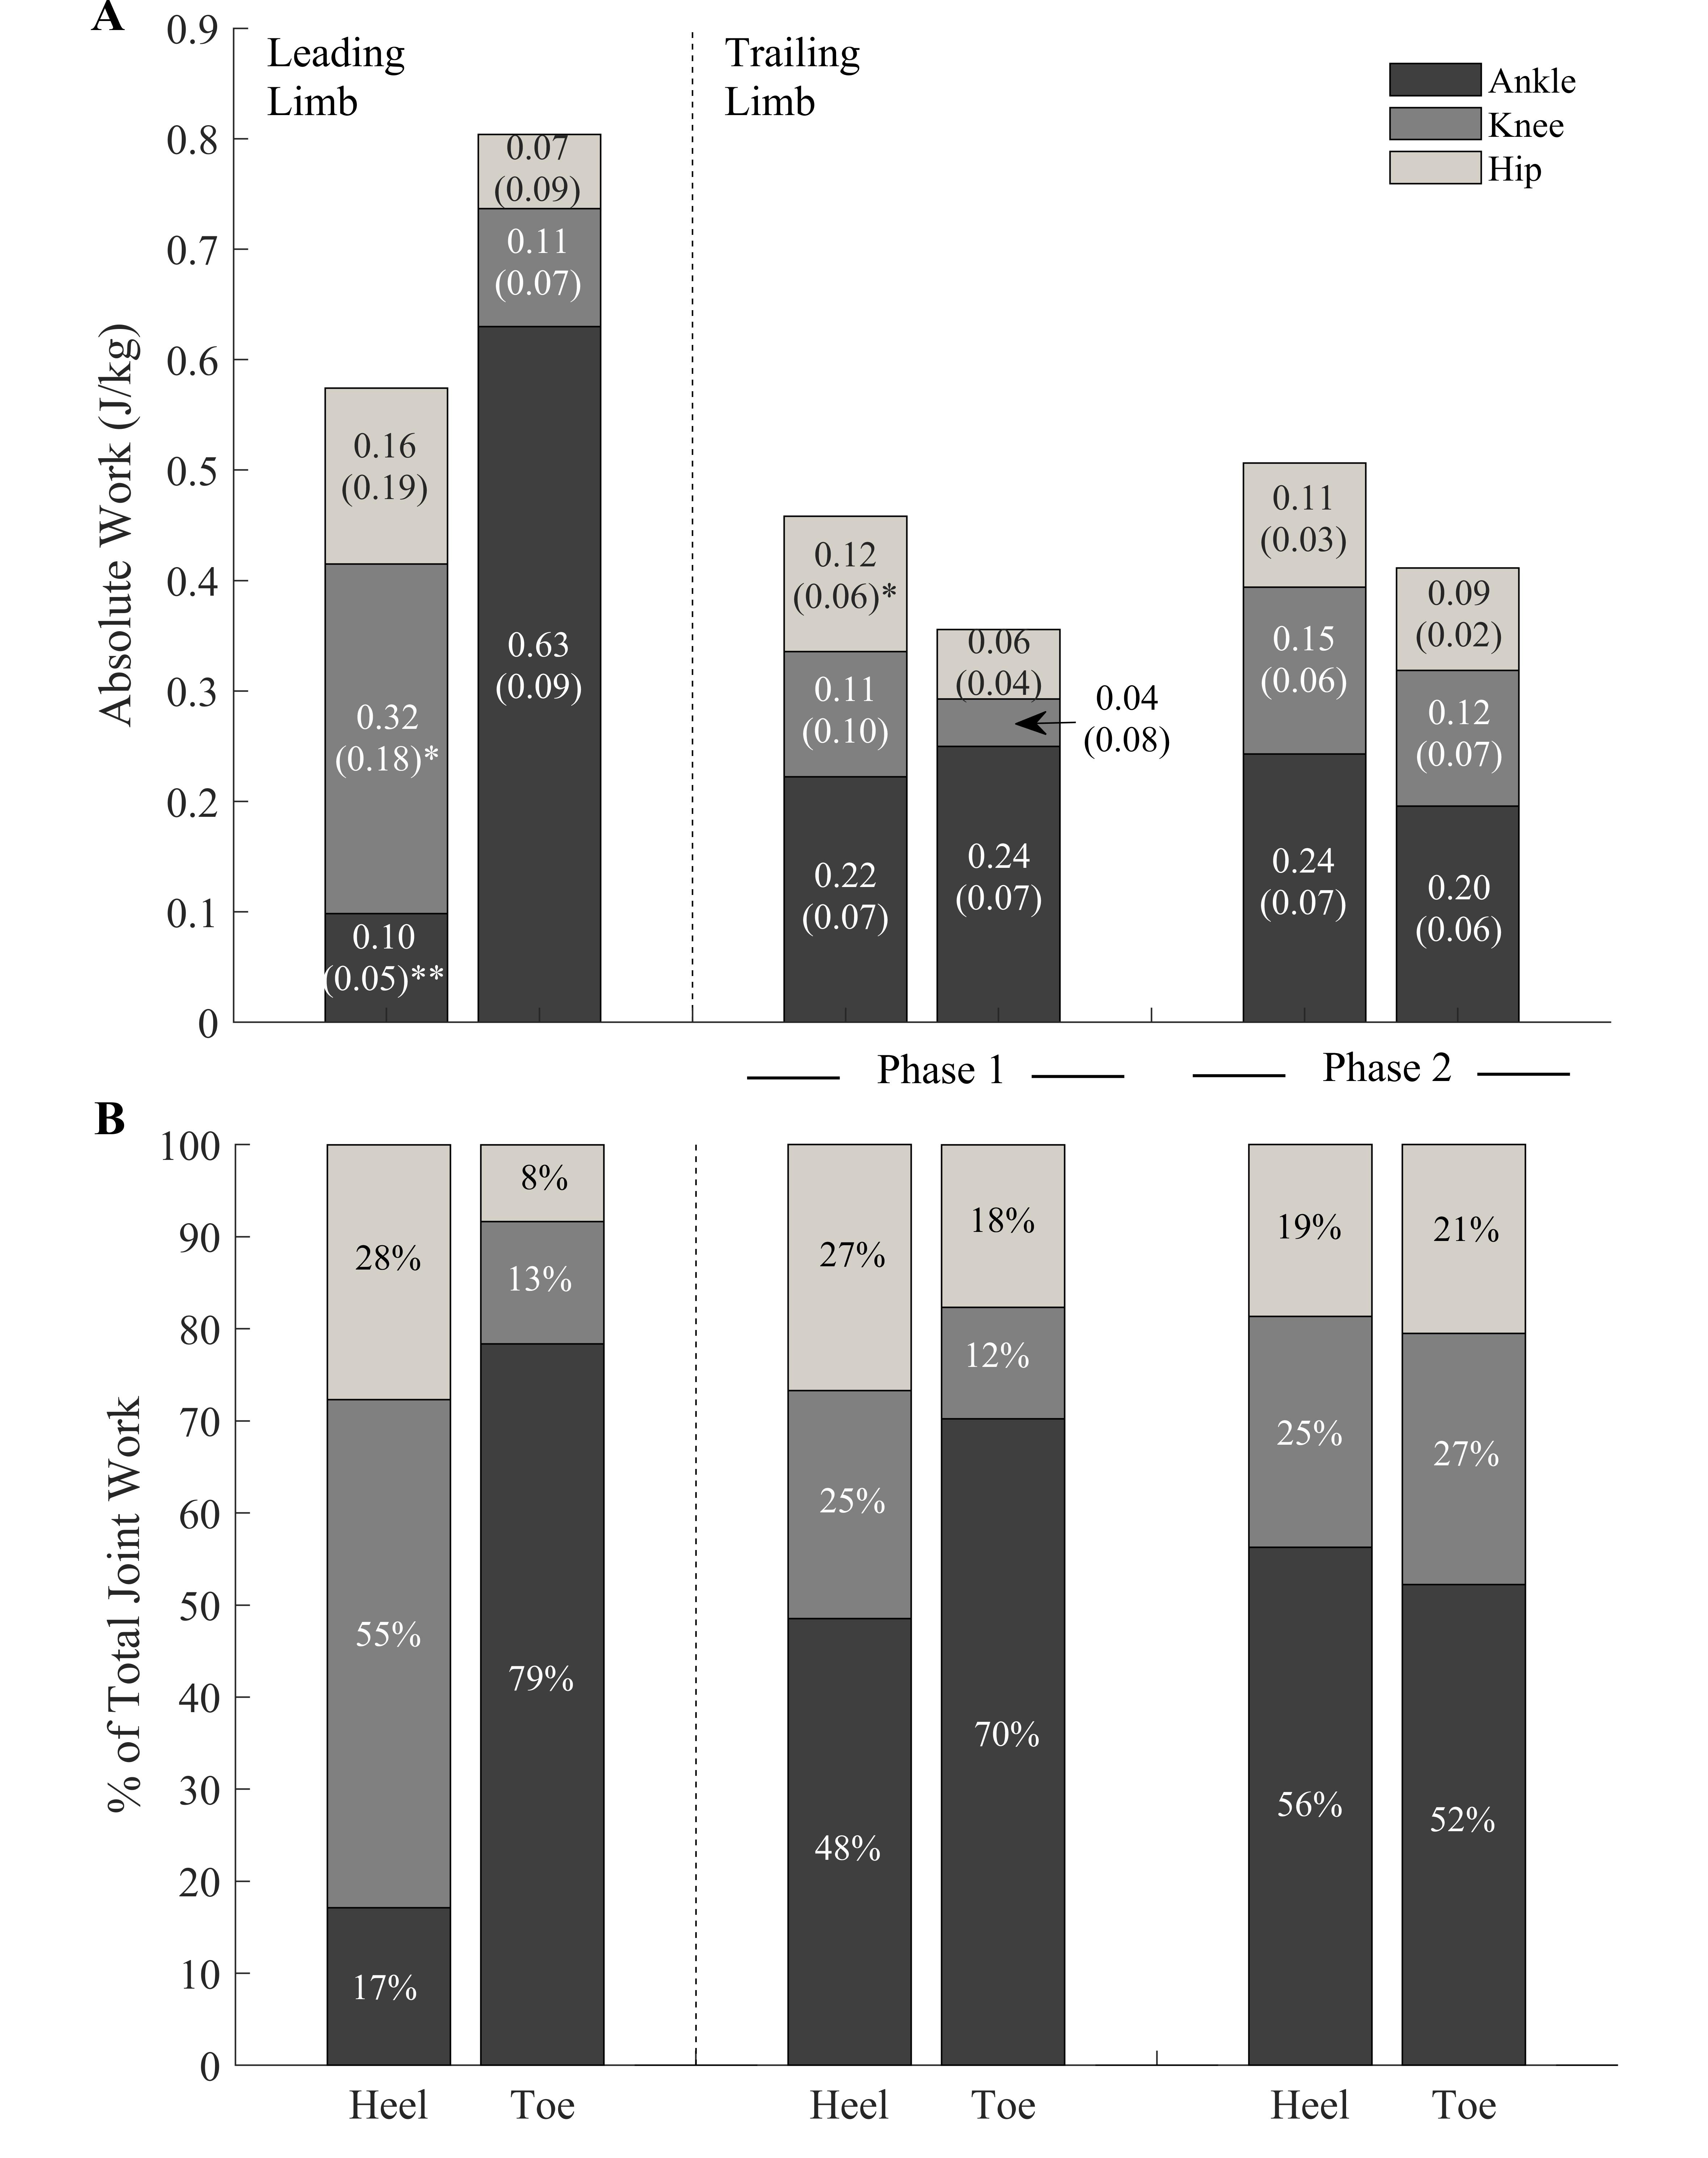
Figure 4. A) Absolute mean (SD) joint work completed and B) percentage of total negative joint work contribution at the ankle (bottom), knee (middle), and hip (top) for the leading limb and trailing limb phases for the heel-contact and toe-contact groups. *p < 0.05, **p < 0.001 between groups for the same joint.

