A cylinder pressure-based knock detection method for pre-chamber ignition gasoline engine.

Abstract
Pre-chamber ignition system has the potential to reduce burn duration of lean-burn gasoline engine combustion and can achieve reduced knock occurrence from the distributed ignition sources. Pre-chamber ignition produces high velocity turbulent jets and these jets often reach sonic velocity and produce shock waves inside the combustion chamber. These shock waves make knock detection difficult with a conventional surface mounted acoustic knock sensor. This paper discusses how an acoustic knock sensor works with pre-chamber ignition and evaluates different cylinder pressure-based knock detection strategies and proposes a method which eliminates the influence of jet induced oscillations on knock detection.

Keywords
Pre-chamber ignition, turbulent jet ignition, lean-burn gasoline engine, engine knock detection.

Introduction
Motor-sport engines often lead the way to how gasoline engines can be designed to achieve high thermal efficiency. To make motor-sport road relevant and attract automotive manufactures, motor-sport regulatory authorities such as FIA (International Auto-mobile Federation) have emphasized focus on fuel efficiency. This was carried out by restricting the maximum fuel flow rate available to the engine and by limiting the total fuel quantity for a race [1]. Such a restriction has resulted in motor-sport engine manufacturers focus on reducing the Brake Specific Fuel Consumption (BSFC). As per Formula One engine regulations, cylinder geometry including the compression ratio is defined and restricted [1]. So, one possible direction to reduce the BSFC is to increase the dilution. Higher dilution can deteriorate combustion performance and often require novel ignition systems such as pre-chamber ignition.
A pre-chamber is an auxiliary small volume combustion chamber with multiple orifices connecting to the main combustion chamber, with a spark plug mounted inside, with or without an injector inside and usually replaces the normal spark plug in a gasoline engine. In pre-chamber ignition system, multiple turbulent flame jets from a pre-chamber burn main combustion chamber mixture in much shorter duration compared to otherwise slow burning lean mixture with a conventional spark ignition system [2]. The shorter burn duration leads to a reduction in end gas residence time at elevated pressure and temperature and hence has the potential to reduce engine knock. The pre-chamber jet ignition concept involves the use of a chemically active, turbulent jet to initiate the combustion in lean mixtures.
A passive pre-chamber ignition system was developed for a lean-burn gasoline direct injection motor-sport engine, achieving lower BSFC and improved knock resistance [3]. This research found that conventional acoustic knock sensor failed to detect spark knock with pre-chamber ignition due to the presence of additional pre-chamber jet induced pressure oscillations. Researchers have already mentioned witnessing knock like pressure oscillations with the pre-chamber in previously published works. While studying a pre-chamber ignition, Robinet et al [4] observed that pressure oscillations inside the main chamber from the start of combustion. Whereas in a spark ignition case, pressure oscillations were reported from the peak of the pressure curve. The oscillation fundamental frequency is the same as that generated by knock and hence, it becomes difficult to differentiate knock from pre-chamber induced oscillations. Attard et al. [5] also reported jet knock from pre-chamber even when the engine operated at heavily retarded spark timing where there is no chance of auto-ignition in an SI engine. The author explained that jet knock is characterized by small pressure oscillations like conventional end-gas knock, only significantly smaller in magnitude and initiated just after the start of ignition instead of towards the end of combustion. These jet knocks caused pre-chamber ignited engines to always operate at some knock level, which may not be as damaging as spark knock. Due to limited literature available on jet knock phenomenon present in pre-chamber ignited engines, a detailed study on pre-chamber induced jet knock was undertaken and an alternate cylinder pressure-based knock detection strategy, which can work with a pre-chamber ignition system is discussed in this paper.

Experimental Setup
A single-cylinder research engine (SCRE) was developed based on an existing V6 turbocharged spark-ignition GDI motor-sport engine, with the main objective of studying lean burn combustion on a high BMEP engine. The single-cylinder research engine design specifications were modified from its base engine to give a consistent performance. This single cylinder engine had a geometrical compression ratio of 13 and can operate at relative equivalence ratio (λ) of up to 1.4. Key engine geometry specifications are provided in Table 1. The pre-chamber used had 4 nozzles of 1.5 mm diameter and 2% of combustion chamber volume. Additional engine design specifications are not discussed here due to engine design confidentiality. A two-stage supercharger rig driven by the engine dyno and an exhaust back pressure valve were utilized to simulate the turbo-charged air supply of the base engine. AVL X-ion data acquisition system and AVL CONCERTO was utilized to measure and post process cylinder pressure data. The engine calibration was carried out ensuring constant fuel flow rate at full-load and at all the speed points tested.

Combustion chamber | Pent-roof with bowl piston
Compression ratio | 13.0
Maximum operating speed | 8000
Displacement | 500 cc
Fuel | Gasoline with 20% ethanol
Number of valves per cylinder | 4
Max. fuel injection pressure | 500 Bar
Max. fuel flow rate | 13.33 kg-hr (1/6th of 80 kg-hr, fuel flow rate of V6 engine)
Relative equivalence ratio (λ) | 1.2
ECU | LifeRacing F90F
Table 1: Design specifications of the single cylinder research engine

Knock limited spark advance (KLSA) strategy
The SCRE is equipped with an acoustic knock sensor mounted close to the combustion chamber on the cylinder block outer surface, which detects the surface vibrations produced during combustion. ECU decides the knocking state by analyzing the vibration signal measured by the knock sensor and then retards the ignition timing when a knocking cycle is detected. This momentary ignition retard is required to prevent ``runaway knock" [6]. Runaway knock is defined as the continuous knocking cycles and it happens when an initial knocking event destroys the thermal boundary layer inside the combustion chamber and results in very high combustion chamber wall temperature and thus creates hot spots, increasing knock probability for next cycles. Ignition angle is reinstated in subsequent cycles.

There are different strategies employed in engine calibration to detect a knocking cycle. One strategy proposed by Biehl and Meister [7], and similar to the strategy employed for the SCRE is discussed here. In this method, ECU looks for the signal in a calibrated measurement window close to TDC_{firing} where the knock is expected to occur. This signal is then band filtered around the knocking frequencies, rectified and integrated to obtain a measure of energy within the window. A normalized value of this energy value is used to compute the final knock intensity. One example for normalizing variable is the measure of energy associated with a heavy knocking cycle, which can damage the engine. A knock threshold value is also defined in the testing by confirming an actual knocking cycle, either by analyzing the cylinder pressure data or by listening to the characteristic metal hitting noise associated with the engine knock. When an individual cycle knock intensity crosses the knock threshold value, ECU detects it as knocking. This knock threshold is defined as a function of speed and load. Fig. 1 shows implementation of this knock detection strategy for SCRE and shows momentary retarding of ignition angle and reinstating to the base ignition angle in subsequent cycles.
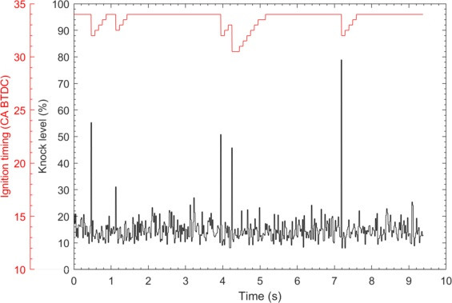
Figure 1: Knock Limited Spark Advance at 6000 rpm, full load.

Pre-chamber ignition
Full load performance measurements were carried out for both SI and pre-chamber ignition systems at 6000 and 7500 rpm at relative equivalence ratio of 1.2. Fuel flow rate was maintained constant at both speed points tested. With the pre-chamber ignition system, knock level measured by the knock sensor was observed to be very high and uneven compared to the base spark ignition level, as shown in Fig. 2a and Fig. 2b. Despite changing measuring window and filtering frequency on the knock sensor calibration settings, these oscillations remained. During the full-load test, cylinder pressure was simultaneously measured for 100 continues cycles at a resolution of 0.1º CA. A mean value filter was used to generate high-pass filtered pressure signals. With the pre-chamber ignition, the high-pass filtered cylinder pressure data shows knock like distinct peaks between 10º to 0º deg before TDC (Fig. 3 and Fig. 4). These peaks occurred even before MFB10% point (0-2º BTDC) and hence could not be associated with end gas auto-ignition. There was another peak observed immediately after TDC with increased amplitude, which occurred before MFB50% (>10º ATDC) point and cannot be associated to spark knock. The correlated pre-chamber ignition engine CFD model [2] had shown that the jets exit from the pre-chamber between 10 to 0º before TDC as shown in Fig. 5.
Thus, it can be concluded that pre-chamber jet flow resulted in producing high frequency pressure oscillations due to jet reaching sonic velocity. These jet induced shock waves and its reflections excited the structure similar to normal knock induced shock waves and these signals were interpreted as knock signal by the knock sensor. Thus, these additional high frequency vibrations make it difficult to use an acoustic knock sensor for its intended purpose.
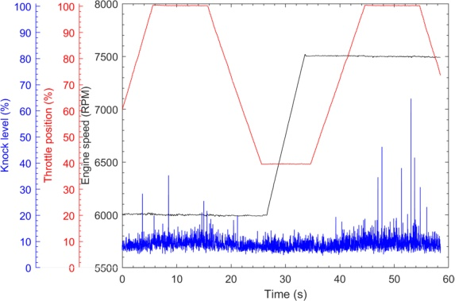
Figure 2a: Knock level against engine speed and throttle position for spark ignition.
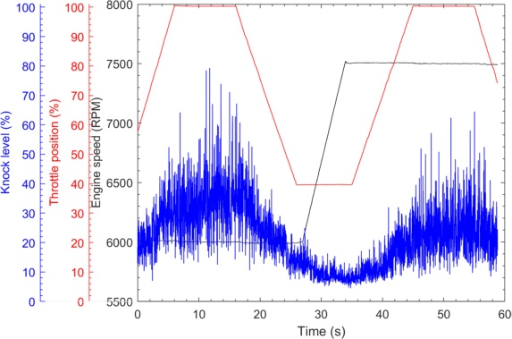
Figure 2b: Knock level against engine speed and throttle position for pre-chamber ignition.

Jet induced oscillations are observed to be higher at 6000 rpm, as shown in Fig. 4. As fuel flow rate is maintained constant at both speeds, fuel consumed per cycle and manifold pressure is less for a higher engine speed, for given air-fuel ratio. Hence, average operating pressure during compression stroke at 7500 rpm is lower compared to 6000 rpm which results in less charge entering the pre-chamber and thus a reduced charge burning inside the pre-chamber. Peak pressure was found to be lower at 7500 rpm as peak pressure produced inside the pre-chamber is a function of charge burned inside the pre-chamber. The reduced peak pressure resulted in lower pressure difference across the chambers and resulting in lower jet velocities. It was observed that with higher dilution and for the same fuel flow rate, knock oscillations observed to be much lower as shown in Fig. 4c. This was found to be due to reduced pressure difference at higher dilution due to higher cylinder pressure inside the cylinder, resulting in lower pressure difference between the chambers.
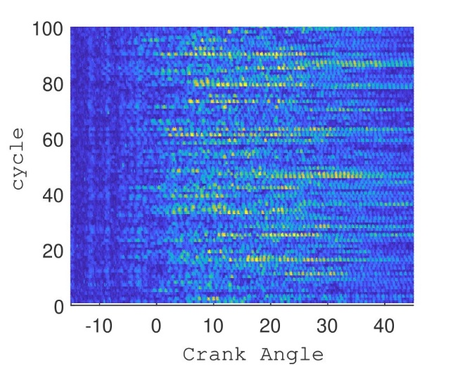  a: Spark Ignition, 6000 rpm | 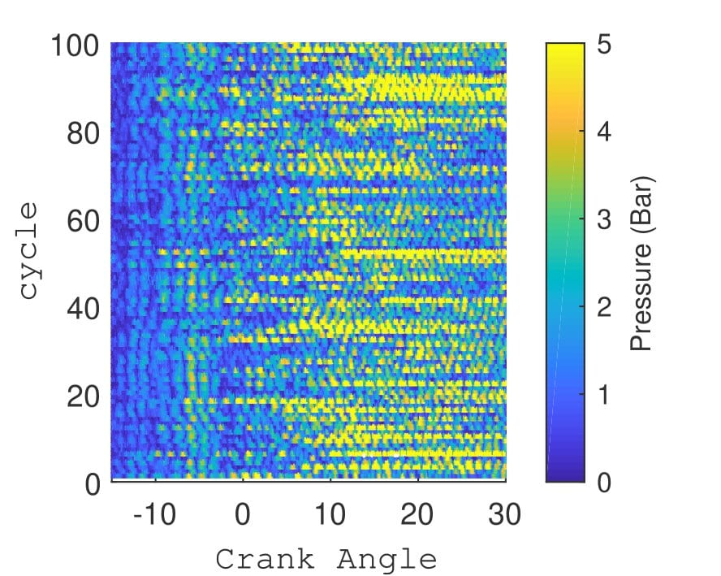  b: Spark Ignition, 7500 rpm
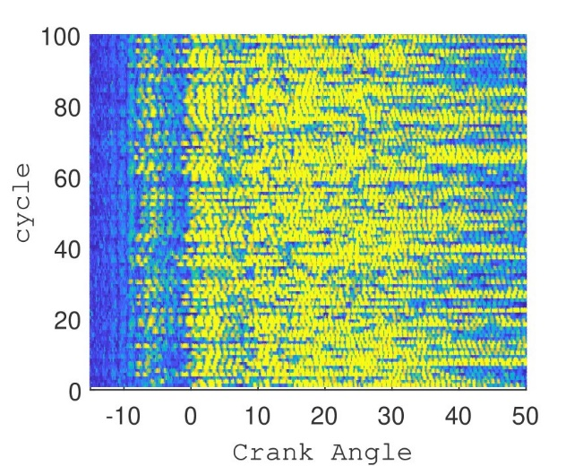  c: Pre-chamber, 6000 rpm | 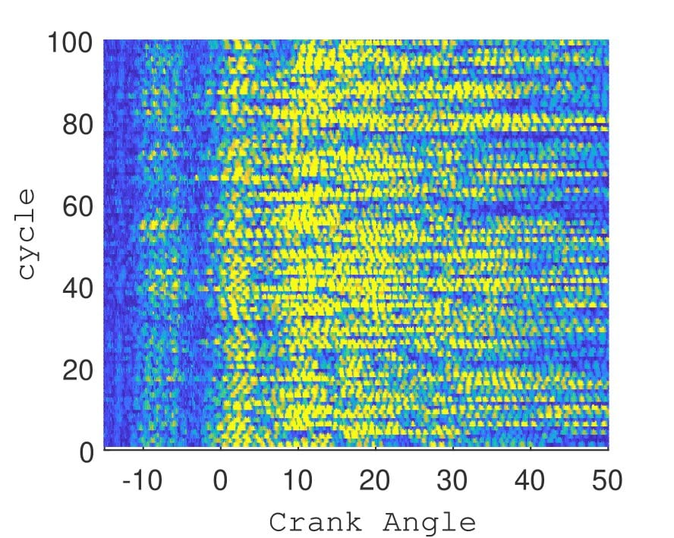  d: Pre-chamber, 7500 rpm
Figure 3: High-pass filtered pressure signals for 100 continuous cycles
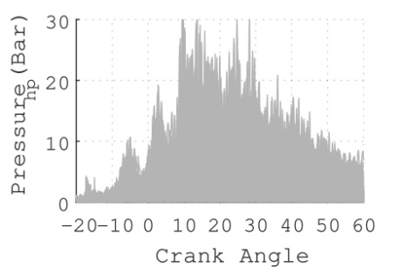  a: Pre-chamber, 6000 rpm, λ =1.2 | 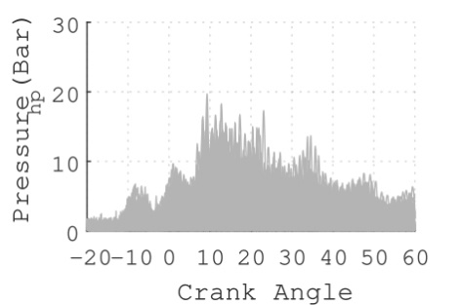  b: Pre-chamber, 7500 rpm, λ =1.2 | 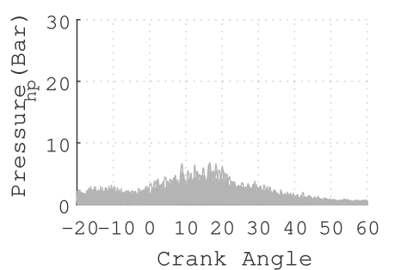  c: Pre-chamber, 7500 rpm, λ =1.4
Figure 4: High-pass filtered pressure signals, 100 continuous cycles overlaid.
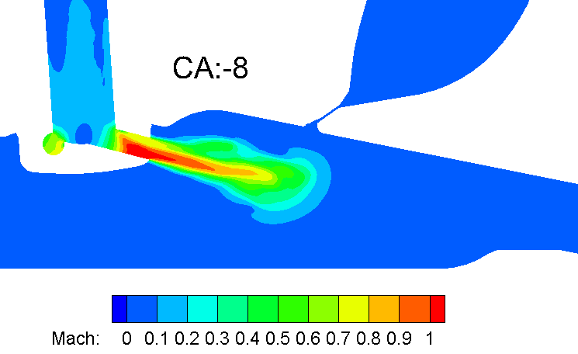
Figure 5: CFD result for variation of Mach number at 8º CA BTDC, when the jet comes out of the pre-chamber, with jet velocity near the nozzle crossing Mach 1, resulting in shock waves inside the combustion chamber.

Cylinder pressure-based knock detection
In this section, an alternate knock detection strategy based on instantaneous cylinder pressure was investigated to address the problem of difficulty in detecting engine knock with an acoustic knock sensor. Cylinder pressure based knock detection is already utilized in motor-sports engines for accurate prediction of knock [8,9], as a motor-sport engine normally operates at higher engine speeds where the signal to noise ratio is low which makes it difficult to utilize an acoustic sensor. This section covers investigation of various cylinder pressure based knock parameters available in the literature and how effective these methods are in detecting knock in a pre-chamber ignited engine. This study was done as a post test analysis and was not implemented as a live detection strategy.

MAPO, IMPO and DKI
One of the earliest and widely utilized used pressure-based knock indicator is the maximum amplitude of pressure oscillations (MAPO). MAPO is defined as the peak of pressure oscillations due to knock [6,10,11]. The crank angle resolved pressure signal is high pass filtered to obtain oscillations and must be compared with a threshold to determine a knocking cycle. Another equally popular knock index is integral of modulus of pressure oscillations (IMPO), initially proposed by Arrigoni [12]. IMPO is a method to represent the energy contained in the high frequency oscillations of the measured pressure signal. A threshold must be identified for IMPO as well to determine a knocking cycle. Both MAPO and IMPO have dimensions and Brecq et al. proposed a dimensionless knock indicator (DKI) based on both MAPO and IMPO [13]. MAPO, IMPO and DKI for one cycle is given by

 | $$MAPO=\left|P_{hp}\right|$$ | Eq: 1
 | $$IMPO=\int_{0}^{W}{\left|P_{hp}\right|d}$$ | Eq: 2
 | $$DKI=\frac{IMPO}{MAPO×W}$$ | Eq: 3

Where P_{hp} is high pass filtered pressure signal and W is the measuring window in crank angle degrees. DKI can be interpreted as ratio of two areas: First, IMPO is the area under high pass filtered pressure signals and the second term, MAPO times W is the area of computational window [13]. A knocking cycle results in a lower DKI value. By virtue of this definition, DKI has the potential to be more effective when the signal noise is high. MAPO, IMPO and DKI were calculated for 100 continuous cycles for a measuring window of 40º CA for both ignition systems which is shown in Fig. 6. The measuring window starts from TDC_{firing} and this window is same as what was utilized for the acoustic knock sensor.
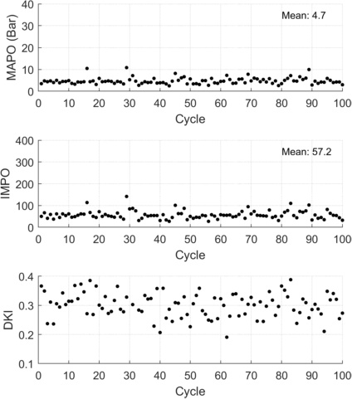  (a) SI, 6000 rpm | 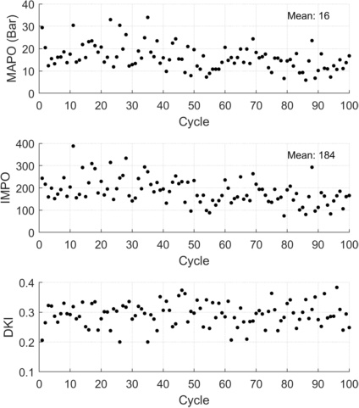  (b) PC, 6000 rpm
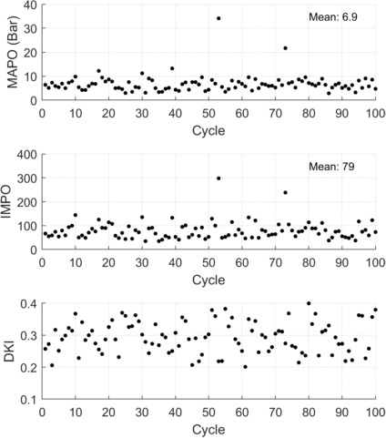  (c) SI, 7500 rpm | 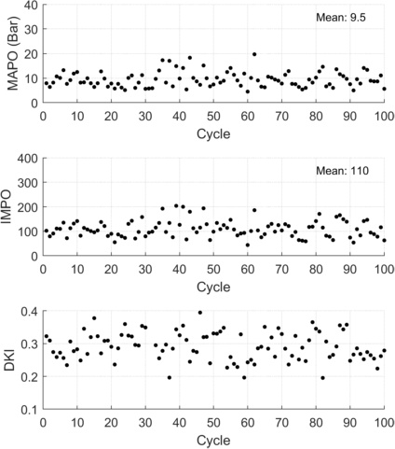  (d) PC, 7500 rpm
Figure 6: MAPO, IMPO and DKI

Both MAPO and IMPO can distinguish knocking cycles accurately for spark ignition combustion. For pre-chamber ignition, MAPO and IMPO were found to be influenced by the jet oscillations and these indicators were found to overpredict knock. It is worth mentioning that with the pre-chamber ignition, KLSA was not achieved and thus knock events were not expected. For both ignition systems, DKI was inaccurate in detecting knocking cycles.

LKI
A logarithmic based knock indicator was formulated based on the findings by Hudson et al. [14] as given in Eq: 4.

 | $$LKI=ln\left(C×\frac{\sum_{n}{P_{hp}^{2}\left(n\right)}}{n}\right)$$ | Eq: 4

The constant C was tuned to read knocking events as a positive value. The value of mean LKI can be utilized to advance ignition time to ensure operating point is close to KLSA. n is the number of samples in the measuring window. For the same constant C, LKI was found to over predict the knock level with the pre-chamber ignition as shown in Fig. 7.
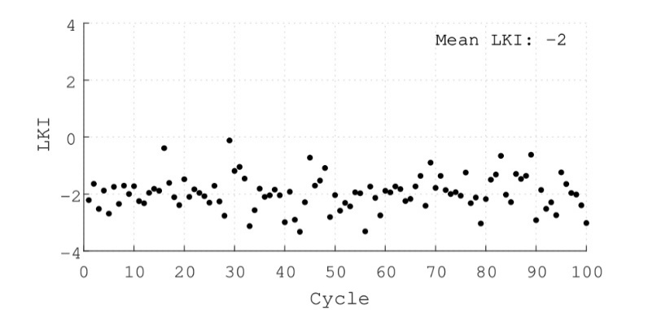  (a) SI, 6000 rpm | 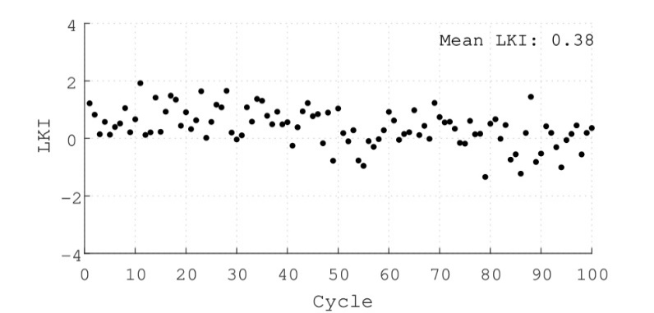  (b) PC, 6000 rpm
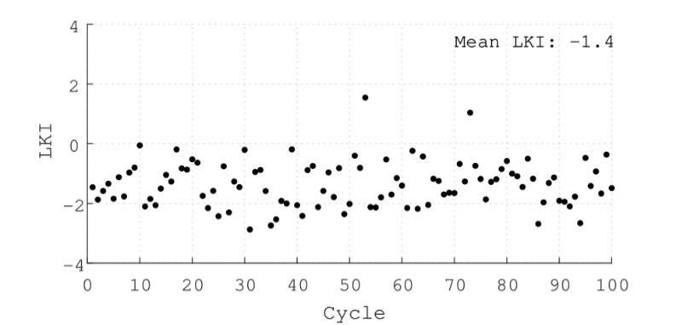  (c) SI, 7500 rpm | 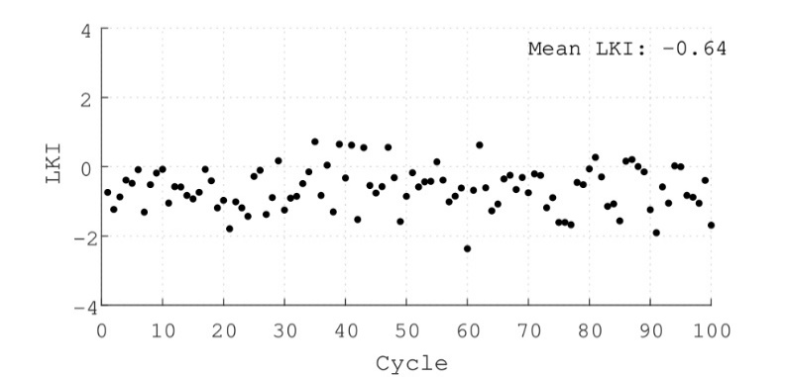  (d) PC, 7500 rpm
Figure 7: Logarithmic Knock Index (LKI) results

Though MAPO, IMPO and LKI methods failed to capture low knock level with pre-chamber ignition system, it is still possible to use these methods for pre-chamber ignition system by further tuning to keep the threshold level above jet induced pressure oscillations. It is worth mentioning that when the jets exit the pre-chamber, cylinder temperature is much lower compared to end gas auto-ignition state, where cylinder temperature is much higher. Cylinder temperature decides the sound velocity and thus, frequency of pressure oscillations. Thus, there is a possibility to segregate pre-chamber jet induced pressure oscillations from end gas auto-ignition. Oscillation frequencies which were calculated based on cylinder temperature before and after combustion and in the radial direction resulted in difference of 1.5kHz. It requires further analysis to understand whether this difference is sufficient enough to segregate knock oscillations from jet oscillations in actual testing conditions. But no further work was undertaken on this as the objective was to utilize same knock detection method for both spark ignition and pre-chamber ignition.

KI2
This dynamic knock detection method proposed by Galloni [15] is able to resolve knock intensity on a cycle by cycle case without defining a pre-determined threshold. This method benefits from the fact that the fastest combustion cycle results in higher pressure oscillations and knock. In this method, whole combustion event is divided into two phases. A knock threshold ($Mapo_{th,j}$)is defined based on the maximum pressure oscillation in the first phase of combustion.
 | $$Mapo_{th,j}=k.max\left(P_{knock,j}\left(θ\right){\left.​\right|}_{SA}^{θ_{60\%}}\right)$$ | Eq: 5

Where k is a constant where a value of 2 was utilized for this study. The maximum oscillation in the second phase is compared to the threshold calculated in the first phase to define the knock intensity as follows:
 | $$I2_{j}=\frac{max\left[\left(P_{knock,j}\left(θ\right){\left.​\right|}_{θ_{60\%}}^{θ_{99\%}}-Mapo_{th,j}\right),0\right]}{Mapo_{th,j}}$$ | Eq: 6

This method seeks a knock event only after 60% of charge is burned which is based on comparing with a dynamic threshold defined for that cycle. Heat release calculations were undertaken with a low-pass filtered signal and jet oscillation had no influence on this calculation. Amplitude of jet oscillations contributed towards defining the dynamic threshold level and otherwise had no effect on determining a knocking cycle. As previously discussed, amplitude of jet oscillations is a function of cylinder loading and it helps in capturing a knock event with varying engine loading, without any tuning. It is worth to mentioning that amplitude of knock pressure oscillations also increases with cylinder loading. A graphical explanation for how this method works is shown in Fig. 8.
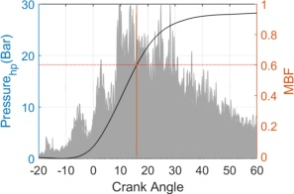  - 100 cycles data with average heat release | 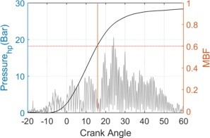  - Knocking cycle, cycle:60
Figure 8: Heat release and pressure oscillations, PC, 6000 rpm

The knock intensity at the operating point has been calculated using the following equation:
 | $$KI2\%=\frac{\sum_{j=1}^{N_{cyc}}{I2_{j}}}{N_{cyc}}.100$$ | Eq: 7

Now KLSA can be achieved by operating within a range of KI2%, the lower limit representing knock free and higher limit representing maximum allowable knock. Fig. 9 shows KI2 results for the same100 cycles for both SI and pre-chamber ignition systems and with this method, pre-chamber results show a lower knock level, something all other knock detection methods, that were previously discussed, failed to capture. Fig. 10 shows all knocking cycles for both ignition systems predicted as knock by KI2 knock index.
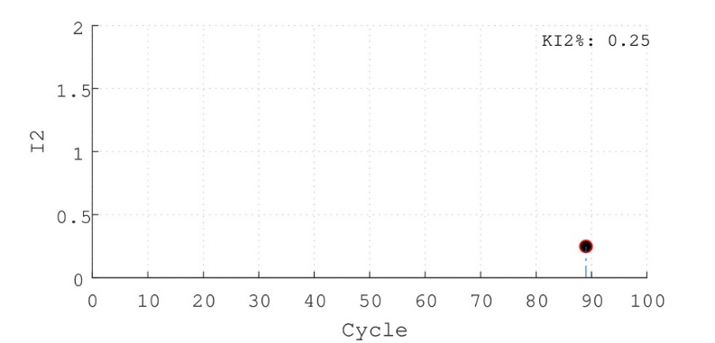  - SI, 6000 rpm | 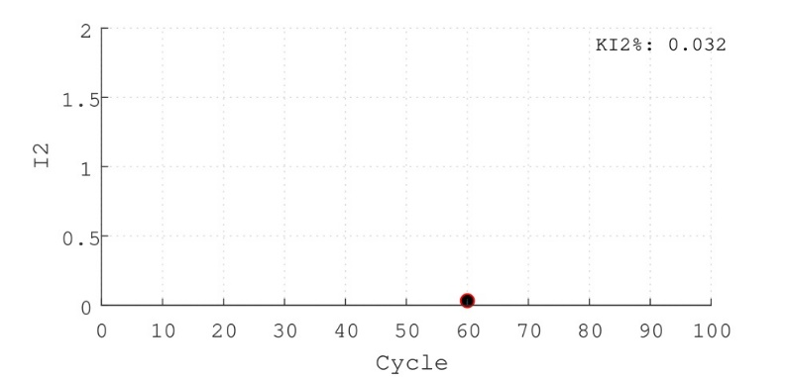  - PC, 6000 rpm
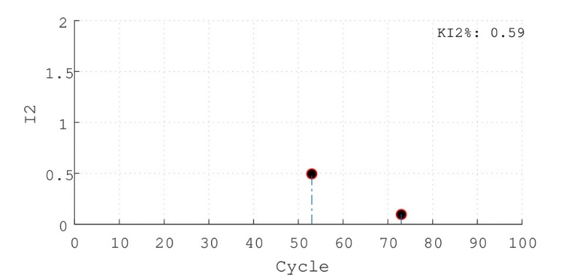  - SI, 7500 rpm | 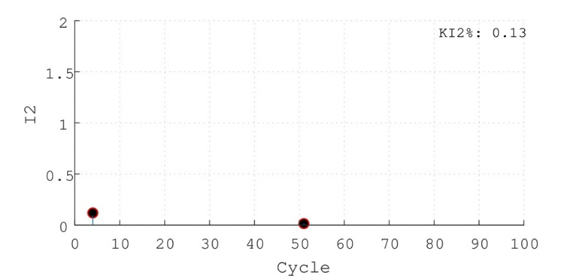  - PC, 7500 rpm
Figure 9: Knock Index (KI2) results
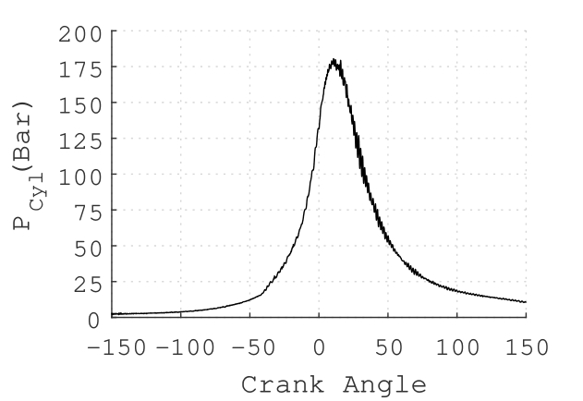  - SI, 6000 rpm, cycle:89 | 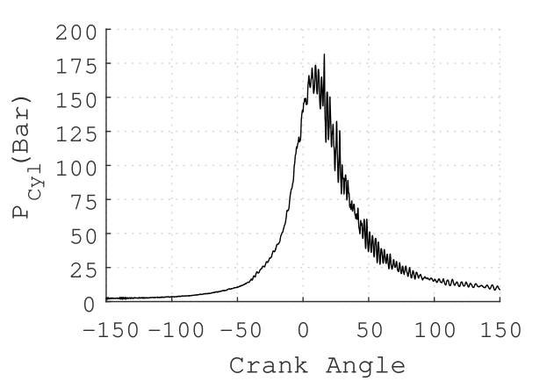  - SI, 7500 rpm, cycle:53
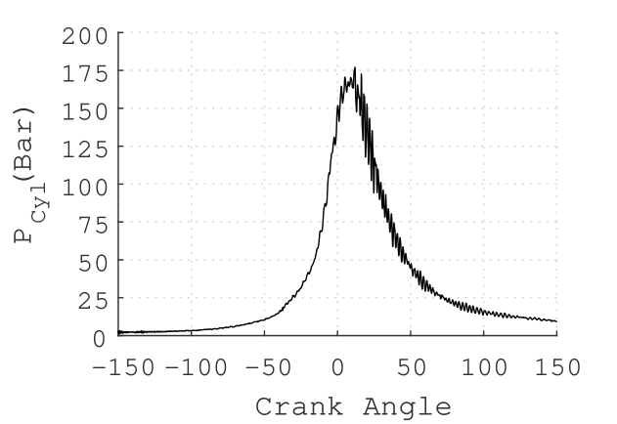  - SI, 7500 rpm, cycle: 73 | 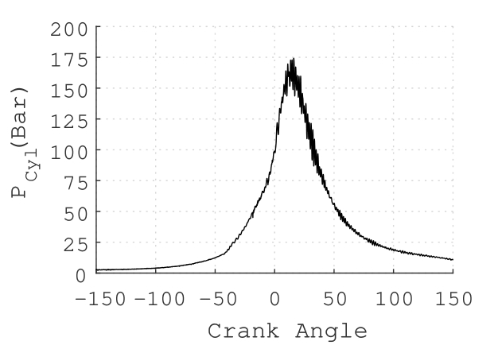  (d) PC, 6000 rpm, cycle: 60
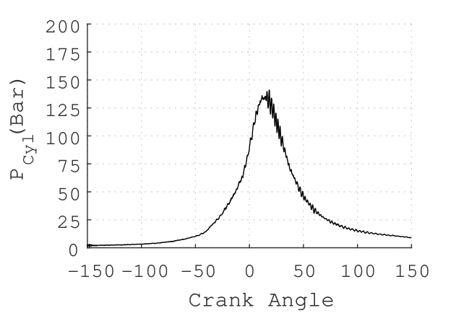  - PC, 7500 rpm, cycle: 4 | 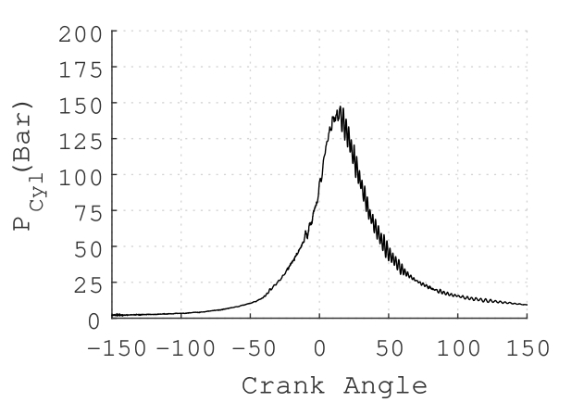  (f) PC, 7500 rpm, cycle: 51
Figure 10: Knocking cycles

As pre-chamber testing was done with ignition timing retarded from KLSA, the pressure oscillations were not clearly visible on the pressure traces shown in Fig. 10. Test attempts were made to operate closer to KLSA ignition timing, but this resulted in run-away knock and pre-ignitions, due to absence of a live knock detection system. For pre-chamber ignition at 6000 rpm, test run with 1º ignition advance from the finalized ignition timing, resulted in pre-ignition event as shown in Fig. 11. A pre-ignition event is identified by earlier heat release and resultant pressure rise, even before the ignition event. With pre-chamber ignition, heat dissipation from the pre-chamber tip area was observed to be crucial in deciding the knock limit of the engine, as this area takes heat from both chambers and pre-chamber tip area can act as a hot-spot which results in pre-ignitions, with high heat release rate from ignition advance or from a previous knock cycle. KI2 method is also able to detect this pre-ignition event, characterized by very high I2 value and a calibration strategy can be devised based on this value to protect the engine from damage.
The fact that KI2 method can detect a pre-ignition event is also validating the assumption used in this method: which is knock occurs only after 60% of charge is burned. A knocking cycle is characterized by earlier combustion start and shortest burn duration compared to other cycles with same operating parameters including ignition angle. Though not initiated by spark ignition, pre-ignition results in earliest combustion start and earliest knock event with respect to what fraction of charge is burned. Pre-ignition also results in high magnitude of pressure oscillations, due to increased fraction of unburned gas present at knock onset. Though it is possible to adjust this 60% limit based on detailed testing, covering all speed and load points, it is a good starting point.

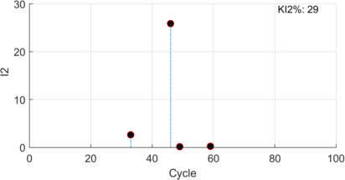  - KI data for 100 cycles | 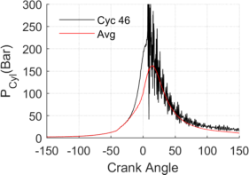  - Pre-ignition cycle and average pressure
Figure 11: Knock Index (KI2) results at a KLSA operating point

Conclusion

This article discussed the difficultly of using an acoustic knock detection and other conventional cylinder pressure-based knock indicators for an engine with pre-chamber ignition system. KI2 method is identified as a potential cylinder pressure based knock detection method for pre-chamber ignition engine and this knock index eliminates influence of pre-chamber jet oscillations on knock detection. This knock analysis was done as a post test analysis and was not implemented as live a knock detection strategy. Because cylinder pressure-based knock detection requires ECU upgrade to include additional channels for pressure sensors. The main difficulty is piezoelectric pressure sensor outputs a very low voltage signal and it requires an amplifier to boost signals prior to reach ECU. With external amplifiers like AVL MiniAmp [16], pressure sensors can be connected to ECU using existing analog input channels. Implementation of KI2 also requires simultaneous heat release calculations which results in more calculation per cycle. Implementation of KI2 for live knock detection is planned as a future work with the required hardware upgradation.

References
- FIA Formula one world championship regulations, 2018, https://www.fia.com/regulation/category/110.
- Toulson, E., Schock, H., and Attard, W., "A Review of Pre-Chamber Initiated Jet Ignition Combustion Systems," SAE Technical Paper 2010-01-2263, 2010, https://doi.org/10.4271/2010-01-2263.
- Palakunnummal, M. F., Sahu, P., Ellis, M., and Nazha, M. (July 9, 2020). "Simulation Aided Development of Pre-Chamber Ignition System for a Lean-Burn Gasoline Direct Injection Motor-Sport Engine." ASME. J. Eng. Gas Turbines Power. doi: https://doi.org/10.1115/1.4047767.
- Couet, S., Higelin, P., and Moreau, B., "APIR: A New Firing Concept for the Internal Combustion Engines - sensitivity to knock and in-cylinder aerodynamics," SAE Technical Paper 2001-01-1954, 2001, https://doi.org/10.4271/2001-01-1954.
- Attard, W., Blaxill, H., Anderson, E., and Litke, P., "Knock Limit Extension with a Gasoline Fueled Pre-Chamber Jet Igniter in a Modern Vehicle Powertrain," SAE Int. J. Engines 5(3):1201-1215, 2012, https://doi.org/10.4271/2012-01-1143.
- Chun, K. M., & Heywood, J. B. (1989). Characterization of knock in a spark-ignition engine. In SAE Technical Papers. https://doi.org/10.4271/890156.
- Biehl, M., & Meister, M. (2017). Model Based Knock Detection. In 5th International Conference on Knocking in Gasoline Engines. Springer.
- Neo, G. H., & Collings, N. (1997). Pressure data analysis of formula one racing engines. SAE Technical Papers, 970061(412). https://doi.org/10.4271/970061.
- Randolph, A. (1994). Cylinder Pressure Based Combustion Analysis in Race Engines. SAE Technical Paper, 942487.
- Leppard, W. R. (1982). Individual-cylinder knock occurrence and intensity in multi-cylinder engines. SAE Technical Papers, 820074. https://doi.org/10.4271/820074
- Benson, G., Fletcher, E. A., Murphy, T. E., & Scherrer, H. C. (1983). Knock (Detonation) Control by Engine Combustion Chamber Shape. In SAE International Congress and Exposition. SAE International. https://doi.org/https://doi.org/10.4271/830509
- Arrigoni, V., Cornetti, G., Gaetani, B., & Ghezzi, P. (1972). Quantitative systems for measuring knock. In Proceedings of the Institution of Mechanical Engineers.
- Brecq, G., Bellettre, J., & Tazerout, M. (2003). A new indicator for knock detection in gas SI engines. International Journal of Thermal Sciences, 42(5), 523–532. https://doi.org/10.1016/S1290-0729(02)00052-2
- Hudson, C., Gao, X., & Stone, R. (2001). Knock measurement for fuel evaluation in spark ignition engines. Fuel, 80(3), 395–407. https://doi.org/10.1016/S0016-2361(00)00080-6
- Galloni, E. (2012). Dynamic knock detection and quantification in a spark ignition engine by means of a pressure based method. Energy Conversion and Management, 64, 256–262. https://doi.org/10.1016/j.enconman.2012.05.015.
- AVL, “Product catalog: Sensors for combustion analysis”, 2019, https://www.avl.com/documents/10138/0/Sensorenkatalog2018_web.pdf/4453ec83-b818-42e4-8218-f02bb91f5943

Abbreviations

ATDC - After top dead center
BTDC - Before top dead center
BSFC - Brake specific fuel consumption
CA - Crank angle in degrees
CFD - Computational fluid dynamics
DKI - dimensionless knock indicator
ECU – Engine Control Unit
GDI - Gasoline direct injection
IMPO - Integral of modulus of pressure oscillations
LKI – Logarithmic knock indicator
MAPO - Maximum amplitude of pressure oscillations
MFB - Mass fraction burnt
SCRE - Single cylinder research engine
SI – Spark ignition
TDC - Top dead center

