Mechanical Properties of PVC Concrete and Mortar Modified with Silane Coupling Agents
Zhihong Pan^{a,*}, Jiaming Chenª, Qiwei Zhanª, Shugang Wangª, Ruoyu Jin^{b}, Rabee Shamass^{b} ,Federico Rossi^{b}
ª School of Civil Engineering and Architecture, Jiangsu University of Science and Technology, Zhenjiang, Jiangsu 212003, China
^{b}School of Built Environment and Architecture, London South Bank University. 103 Borough Rd, London SE1 0AA, UK.
*Corresponding authors. E-mail addresses: zhhpan@just.edu.cn (Z. Pan)

Abstract: This study investigates the surface modification of waste polyvinyl chloride (PVC) particles with encapsulated silane coupling agents (SCA) to improve the performance of PVC concrete and mortar. Concrete and mortar were prepared by replacing fine aggregates with equal volumes of PVC particles before and after modification, with volume replacement ratios of 5%, 10%, 15%, 20% and 25%. Experiments were performed to investigate the density, compressive strength and flexural strength of different contents of PVC concrete and mortar. Scanning Electron Microscope (SEM) was used to examine the surface morphology of PVC particles and the interface between the PVC particles and the cementitious material in the mortar. The results showed that the density of concrete and mortar gradually decreased with increasing PVC content; the 28d compressive strength of concrete and mortar increased by 10%-20% after modification with SCA; the 28d flexural strength of concrete and mortar increased by 5%-9%. The SEM results revealed that SCA on the surface of PVC particles improved the mechanical properties of the mortar by better combining the particles with the cementitious material.
Key words: Modified PVC concrete; Coupling agent; Surface treatment; Compressive strength; Flexural strength

1.Introduction
Polyvinyl chloride (PVC) is currently one of the most widely used plastics in China. It is extensively used in many fields such as building materials, daily necessities, pipes, wires and cables, membrane material, bottles, fibers. PVC membrane material is attractive, energy-efficient and easy to manufacture. It has been used as tensioned membrane structures in stadiums, car parks and other buildings ^{[1]}. However, PVC membrane materials are less durable, with a typical service life of 15-25 years ^{[2]}. The membrane becomes municipal waste after disposal, seriously polluting the environment and restricting economic development ^{[3]}. Globally, recycling of plastic waste has also been a difficult issue ^{[4]}. Traditional landfills are environmentally polluting and require large landfill sites ^{[5]}. Due to the lack of efficient and environmentally friendly recycling methods, a large amount of plastic waste is left in the natural environment and cannot be recycled ^{[6, 7]}.
Sand and gravel aggregates are essential raw materials in the production of concrete, accounting for more than 75% concrete volume ^{[8]}. Due to the rapid development of society and the increased demand for concrete construction in recent years, sand and gravel resources have been over-exploited, resulting in a global shortage of sand and gravel resources. In order to alleviate this shortage, scholars have begun to investigate the use of alternative materials to replace natural sand and gravel aggregates, with recycled waste materials ^{[9-12]}. The use of waste materials to replace natural aggregates in concrete can alleviate the shortage of sand and gravel resources, contributing to both scientific research and circularity practice of wastes.
Currently, more research is being conducted into the addition of polypropylene (PP) and polyethylene terephthalate (PET) to concrete. Numerous studies have shown that using waste PET replace natural aggregate in concrete can result in concrete with good mechanical, physical and durability properties ^{[13-15]}. Some studies concluded that although incorporating waste PET bottle scrap as fiber reinforcement in concrete mixture reduced compressive strength, splitting tensile strength and modulus of elasticity, and ductility, durability and corrosion resistance of concrete increased ^{[16-20]}. Some studies have found that PP waste plastics fibers and sand can be used for non-load-bearing lightweight concrete with better insulation properties ^{[21]}. However, research on replacing the aggregates with PVC plastics is relatively rare which are incorporated in concrete.
Research has shown that composite mortars prepared from PVC instead of natural sand are lightweight, corrosion resistant, ductile and have good thermal insulation properties ^{[22-24]}. However, the mechanical properties of the mortar decreased significantly as the substitution rate increased. The reason for this may be due to the large difference between the mechanical properties of PVC and the matrix, which affects the bond between the matrix and PVC. The use of PVC to concrete as fine aggregates ^{[25-27]} or coarse aggregates ^{[28, 29]} can improve the wear resistance, reduce the density but lower the modulus of elasticity of concrete. The compressive and tensile splitting strength of concrete decreases as the rate of substitution increases, which is also consistent with the trend in mortar. The main reason for the poor mechanical properties of recycled plastic concrete is that the recycled plastic surface which is smooth and hydrophobic is difficult to bond with the cementitious material ^{[30]}. Therefore, reasonable surface chemical or physical modification of the PVC aggregate surface can be performed to reduce the effect of PVC on the mechanical properties of mortar and concrete, thereby improving the bond between the PVC aggregate and the cement matrix. The widespread use of PVC concrete is hampered by the fact that there is no economic and efficient surface treatment available.
Surface modification methods can be broadly classified into physical and chemical modification methods according to the principle. The physical modification method mainly consists of water-soaking treatment ^{[31-33]} and pre-coating of the cementitious material ^{[34-37]}. Chemical modifications include mainly acid and base solutions ^{[30,38-40]}, silane coupling agents (SCA) ^{[37,41]} and latexes ^{[42]}. However, the widespread use of PVC concrete is hampered by the fact that there is no economic and efficient surface treatment available. Krylova ^{[43]} modified the surface of PVC by using thermo-chemical treatment to improve its hydrophilicity, but was unable to use it to the preparation of concrete. SCA which contain both organic and inorganic functional groups can react with inorganic substances and organic polymer bonding after hydrolysis, so it is widely used in the surface modification of materials ^{[44]}. The use of SCA modification can effectively improve the bonding effect between plastic and cement to increase the strength of concrete. Wang ^{[45]} modified ABS/PC plastics with SCA and incorporated them into concrete to improve the mechanical properties of the concrete. Therefore, the application of SCA to the surface modification of PVC plastics has a very important research value.
This study investigates the effect of silane coupling agent modified PVC particles on the properties of concrete and mortar. Mortars and concretes with 5%, 10%, 15%, 20% and 25% volume replacement of fine aggregates were investigated. Density, compressive and flexural strengths of concrete and mortar were investigated to assess the effect of SCA on the properties of PVC concrete and mortar. SEM was used to examine the surface morphology of the PVC particles and the microstructure of the mortar to reveal the reasons for the performance improvement.
2.Experimental program
2.1 Materials
The cement used for all mortar mixtures and concrete is the Portland cement class 42.5 produced by Helin Cement in China. The chemical composition of the cement is shown in Table 1. The fly ash used is Grade II fly ash manufactured in China by Yuanheng Environmental Protection Company. The chemical composition of fly ash is shown in Table 2. The water reducing agent is a naphthalene based water reducing agent (RH). The fine aggregate used in the experiments was natural river sand with a density of 2.61 g/cm³ and a fineness modulus of 2.7. Fig. 1 shows the grain gradation of the river sand used. The coarse aggregate used is granite aggregates with a grain size of 5-20 mm.

Table 1. Chemical composition of cement
Component | SiO₂ | Al₂O₃ | Fe₂O₃ | CaO | MgO | SO₃ | L.O.I.
Content (%) | 24.99 | 8.26 | 4.03 | 51.42 | 3.71 | 2.51 | 3.31

Table 2. Chemical composition of fly ash
Component | SiO₂ | Al₂O₃ | Fe₂O₃ | CaO | MgO | SO₃ | L.O.I.
Content (%) | 50.6 | 27.1 | 7.1 | 2.8 | 1.4 | 0.5 | 8.2

The raw material for the recycled PVC particles comes from PVC film waste of the abandoned carports in engineering. As shown in Fig. 2, the PVC particles are short cylindrical in shape, black in colour and have a particle size of 2-3mm.The real density of the PVC waste was 1.6 g/cm³. The silane coupling agent (SCA) used was KH-570. SCA was applied to the surface of the PVC particles in the experiment. The SCA solution is made by combining anhydrous ethanol and water in a 4:1 ratio and then adding anhydrous acetic acid to adjust the pH to around 3.5. Subsequently, a certain amount of SCA is added to prepare a 1% mass fraction of SCA solution. The recycled PVC particles are immersed in the SCA solution for 30 minutes before being removed and dried at room temperature for 12 hours ^{[46]}.

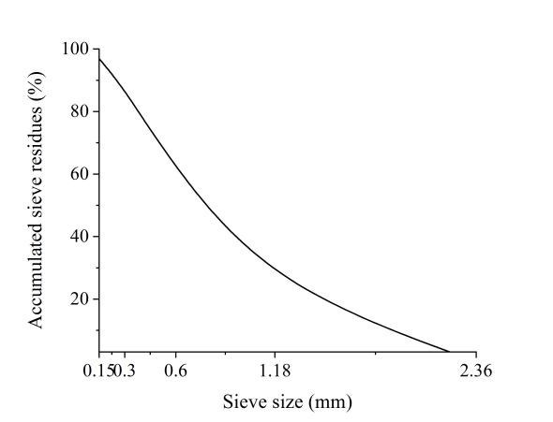 | 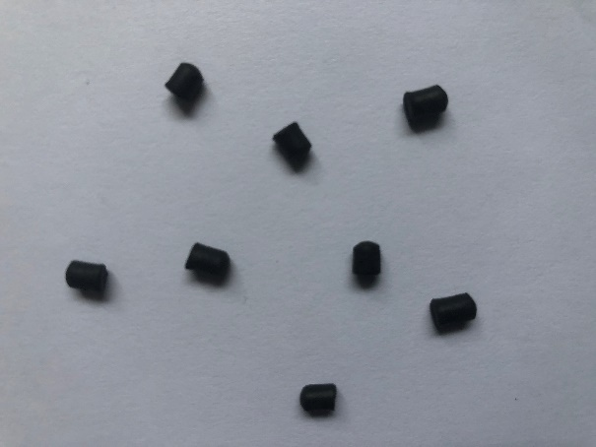
Fig. 1. Particle size distributions of sand | Fig. 2. Recycled PVC plastic aggregates

2.2 Mixture proportions and test methods
Mortar mixtures and concretes were prepared with PVC particles mixed with 0%, 5%, 10%, 15%, 20% and 25% volume replacement of fine aggregates. The mortar's mix design was chosen based on the conventional mix design described in the Specification for Mix Proportion Design of Masonry Mortar (JGJ/T 98-2010) ^{[47]}. For reference mortar samples without PVC particles, were denoted as NM and mortars samples containing 5% to 25% PVC particles were denoted as M5, M10, M15, M20 and M25 respectively. Mortars samples containing 5% to 25% modified PVC particles were denoted as GM5, GM10, GM15, GM20 and GM25 respectively. The mortar mix proportions are summarized in Table 3. The concrete's mix design was chosen based on the conventional mix design described in the Specification for Mix Proportion Design of Ordinary Concrete (JGJ 55-2011) ^{[48]}. For reference concrete samples without PVC particles were denoted as NC and concrete samples containing 5% to 25% PVC particles were denoted as C5, C10, C15, C20 and C25 respectively. Concrete containing 5% to 25% modified PVC particles were denoted as GC5, GC10, GC15, GC20 and GC25 respectively. The mix proportions of the concrete are summarized in Table 4.

Table 3
Mixture proportions of mortar
 | Mortar mix design ${kg/m}^{3}$
 | Cement | Flyash | Sand | PVC | Water
NM | 360 | 90 | 1350 | 0 | 270
M5 | 360 | 90 | 1282.5 | 41.4 | 270
M10 | 360 | 90 | 1215 | 82.8 | 270
M15 | 360 | 90 | 1147.5 | 124.2 | 270
M20 | 360 | 90 | 1080 | 165.6 | 270
M25 | 360 | 90 | 1012.5 | 207 | 270
GM5 | 360 | 90 | 1282.5 | 41.4 | 270
GM10 | 360 | 90 | 1215 | 82.8 | 270
GM15 | 360 | 90 | 1147.5 | 124.2 | 270
GM20 | 360 | 90 | 1080 | 165.6 | 270
GM25 | 360 | 90 | 1012.5 | 207 | 270

Table 4
Mixture proportions of concrete
 | Concrete mis design ${kg/m}^{3}$
 | Water | Cement | Flyash | Sand | PVC | Coarse aggregates | RH
NC | 146 | 292 | 73 | 605 | 0 | 1285 | 5.5
C5 | 146 | 292 | 73 | 574.8 | 18.5 | 1285 | 5.5
C10 | 146 | 292 | 73 | 544.5 | 37.1 | 1285 | 5.5
C15 | 146 | 292 | 73 | 514.3 | 55.6 | 1285 | 5.5
C20 | 146 | 292 | 73 | 484.1 | 74.2 | 1285 | 5.5
C25 | 146 | 292 | 73 | 453.9 | 92.7 | 1285 | 5.5
GC5 | 146 | 292 | 73 | 574.8 | 18.5 | 1285 | 5.5
GC10 | 146 | 292 | 73 | 544.5 | 37.1 | 1285 | 5.5
GC15 | 146 | 292 | 73 | 514.3 | 55.6 | 1285 | 5.5
GC20 | 146 | 292 | 73 | 484.1 | 74.2 | 1285 | 5.5
GC25 | 146 | 292 | 73 | 453.9 | 92.7 | 1285 | 5.5

In order to investigate the effect of PVC replacement rates and surface modification method using SCA on the physical and mechanical properties of the mortar, 70.7mm cubic specimens and 40mm×40mm×160mm prismatic specimens were prepared and used to measure the density at 28 days and the compressive and flexural strengths at 3, 7 and 28 days. The density, compressive strength and flexural strength of mortar specimens were tested and evaluated according to the Standard for test method of performance on building mortar (JGJT70-2009) ^{[49]}. 150mm×150mm×150mm cubes specimens were also prepared to study the density of the concrete at 28 days and the cubic compressive strength of the concrete at 3, 7 and 28 days. Testing and assessing the density, cubic compressive strength of concrete specimens according to the Standard for test method of mechanical properties on ordinary concrete (GB/T 50081-2019) ^{[50]}.
Scanning electron microscopy (SEM) is a high-resolution microscopic morphology analysis precision device that is commonly used to analyze the morphology and composition of the ultrastructure of various solid material surfaces. SEM was used to observe the microstructure of interfacial transition zone of PVC composite mortar.
- Results and discussion
  - Density
The changes in density of the recycled PVC concrete and mortar after 28d of standard curing are shown in Fig. 3 and Fig. 4, respectively. The densities of the recycled PVC concrete and mortar gradually reduced with increasing PVC volume replacement ratio. The density of ordinary concrete is 2516 kg/m³. When the volume replacement ratio of recycled PVC particles is 25%, the density of recycled PVC concrete is 2380 kg/m³, which is 5.4% lower than that of the ordinary concrete. The density of ordinary mortar is 2079 kg/m³. When the content of recycled PVC particles is 25%, the density of recycled PVC mortar is 1983 kg/m³, which is 6.6% lower than that of the ordinary mortar. Mohammed ^{[29]} found that there was a greater loss of concrete density when shredded PVC sheets were used to replace natural fine aggregates. This is owing to the fact that recycled PVC particles have a lower density than natural sand, resulting in a decrease in the density of PVC concrete and mortar.

Fig. 3. Relationship between concrete density and recycled PVC particle volume replacement ratio
Fig. 4. Relationship between mortar density and recycled PVC particle volume replacement ratio

  - Compressive strength
The experimental results for the compressive strength of concrete are shown in Fig. 5. As shown in Fig. 5, the Day 3 cube compressive strength of concrete can reach around 50% of the design strength and the Day 7 cube compressive strength can reach around 70% of the design strength when the volume replacement ratio of recycled PVC does not exceed 15%. This essentially satisfies the requirements for early concrete strength in engineering applications. Similarly for concretes with modified PVC, the strength enhancement becomes 5.7%, 4.5% and 4% at day 3,7 and 28, respectively. This can be explained that the particle size of recycled PVC particles is between stone and natural sand, at small volume replacement ratio of recycled PVC particles can better densify the stacking structure of concrete and can increase the cubic compressive strength of concrete to a small extent. As amount of recycled PVC particles increases beyond 5% volume replacement ratio, the compressive strength of the concrete decreases rapidly again. For instance, for 25 % volume replacement ratio of unmodified recycled PVC, the compressive strength of concrete at day 3, 7 and 28 decreases by 17%, 20.1% and 20%, respectively, compared to that of normal concrete. The compressive strength of the unmodified concrete is in general agreement with the results of Kou ^{[26]} and Haghighatnejad ^{[51]}. Haghighatnejad ^{[51]} found that the 28d compressive strength decreased by 13.3% and 18% relative to standard concrete when substitution rates were 20% and 30%. However, the reduction in the strength is less when the modified recycled PVC was used due to improved bond interface between the PVC particles and cementitious composite. Recycled PVC particles are organic polymer materials and the cementation strength between them and inorganic cementing materials is much lower than that between natural aggregates and cementing materials. As the amount of replacement increases, the number of weak interfaces increases accordingly, hence reducing the strength of the concrete. This trend in compressive strength is also consistent with the findings of Senhadji ^{[27]} and Haghighatnejad ^{[51]}.
A comparison of the compressive strength of the concrete at day 28 before and after the PVC particles modification is shown in Fig. 6.The chemical modification of the recycled PVC particles improved the compressive strength of the concrete in all cases. At 5% and 10% replacement of recycled PVC particles, the cube compressive strength of the concrete at all ages exceeded that of normal concrete, with strengths increased by around 5% and 2% respectively. As seen in the Fig. 6, the compressive strength at day 7 increased by 5.7%, 9.3% and 18.6% and the compressive strength at day 28 increased by 6.5%, 10.2% and 17.7% compared to unmodified concrete with 15 %, 20 % and 25 % volume replacement ratio, respectively. The rate of improvement in concrete compressive strength was seen to rise with the amount of modified recycled PVC particles incorporated. However, the tendency for the compressive strength to decrease remains obvious after the modification. This may be the result of the still very different mechanical properties between the PVC particles and the natural aggregate, as well as the poor interface contact between the PVC particles. As the replacement ratio increases, the PVC particles come into more contact with each other and the poor interfacial contact properties lead to a reduction in the modification effect.

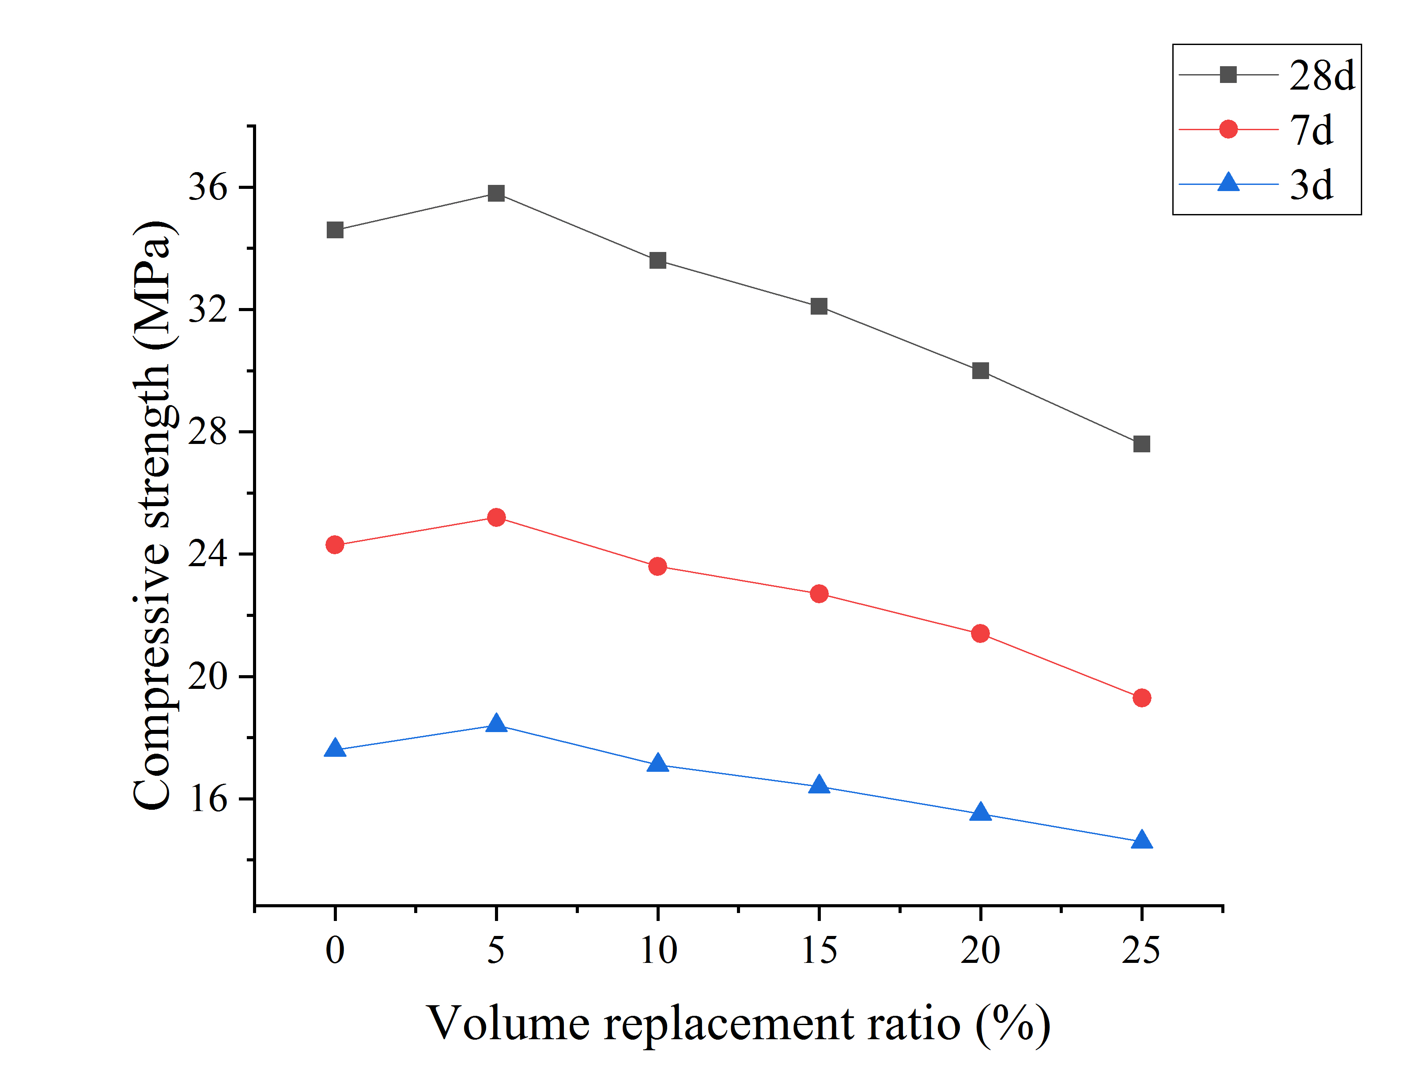 | 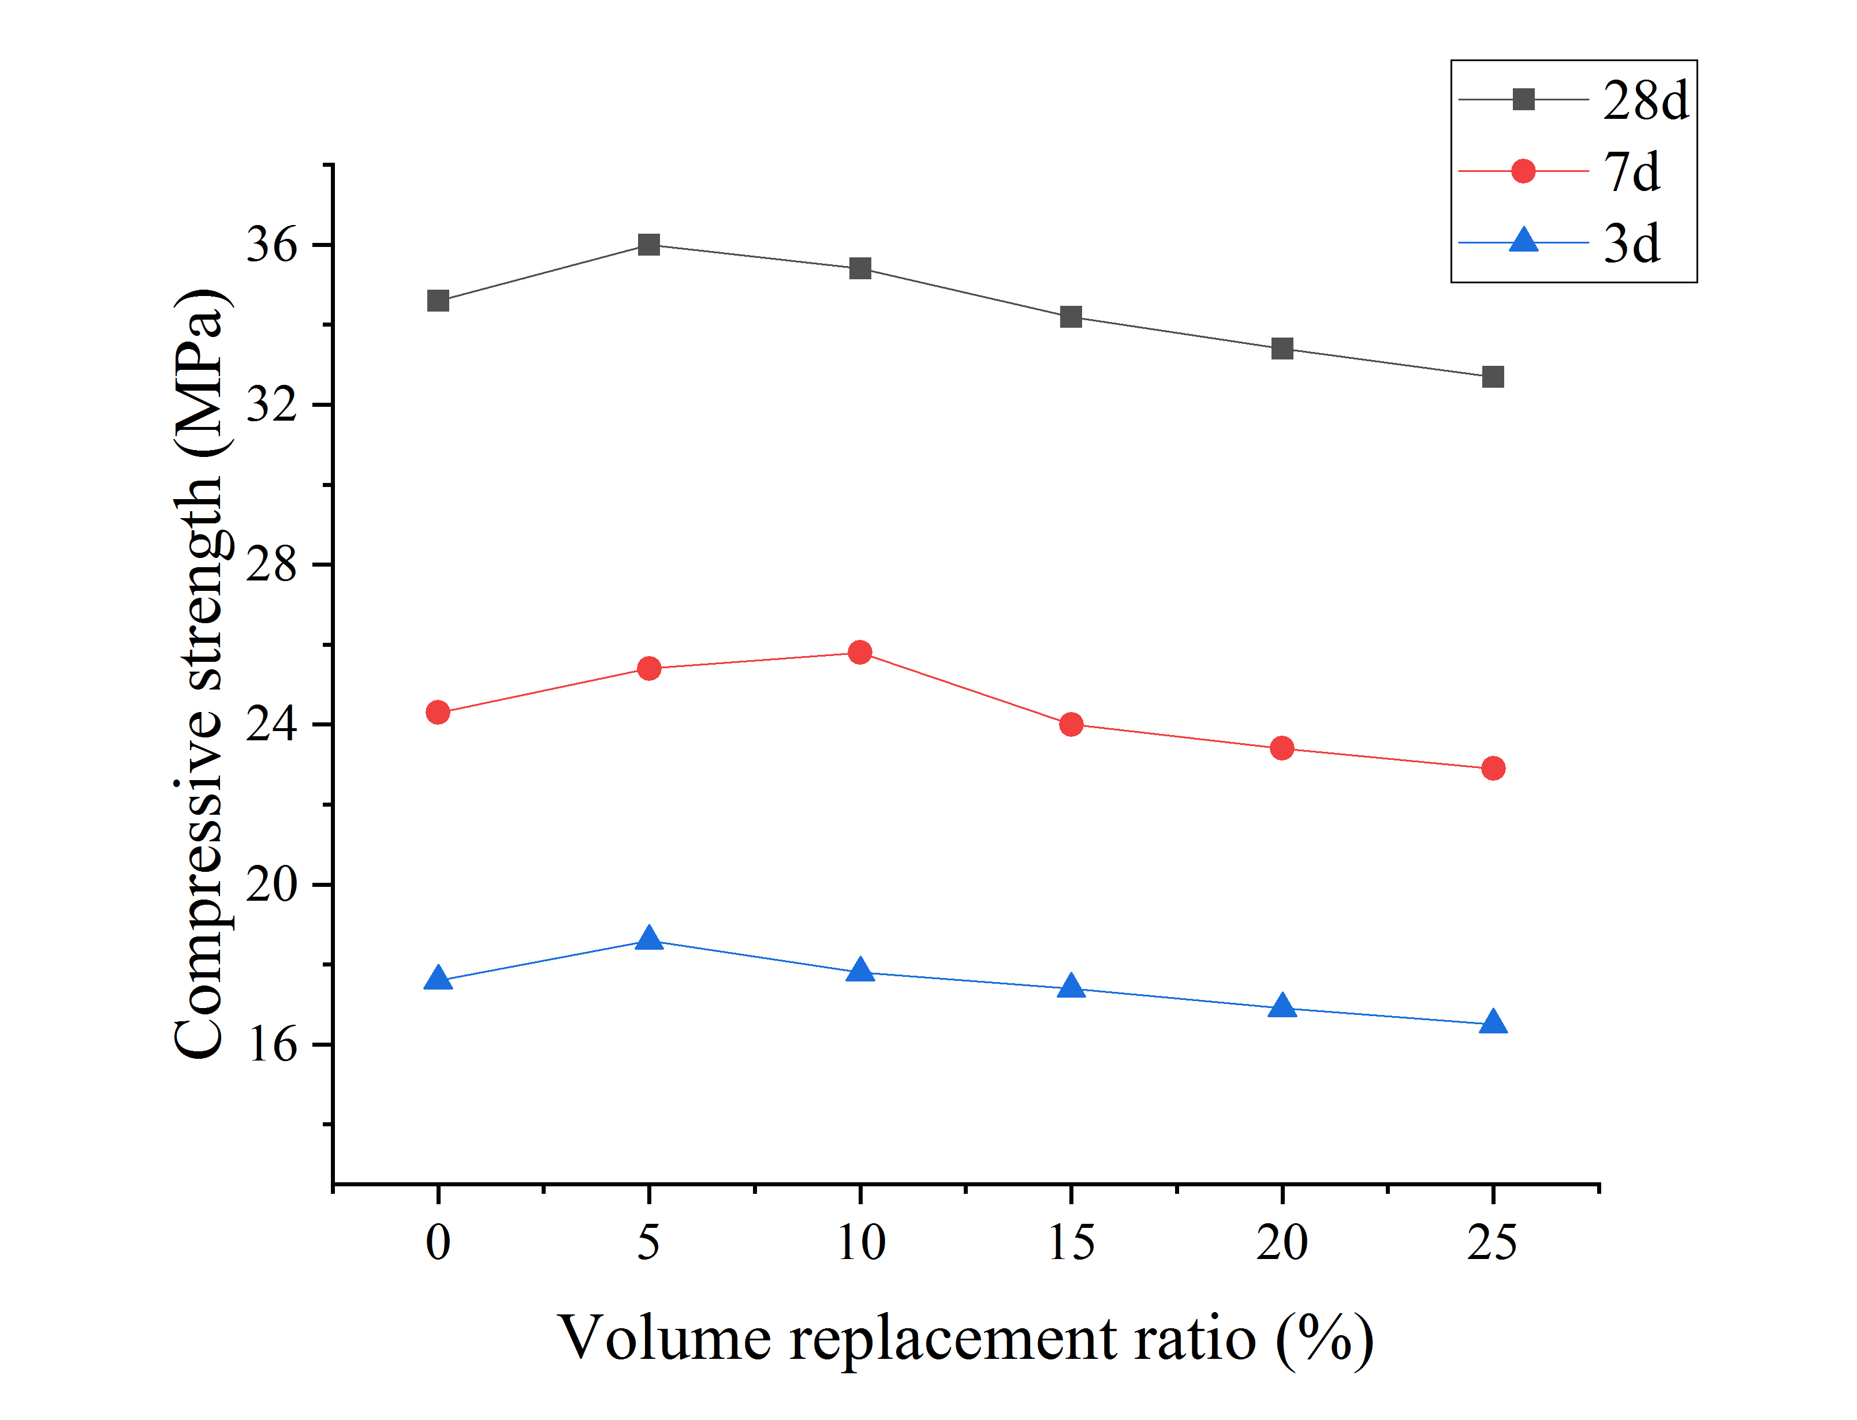
Fig. 5. Concrete compressive strength:(a) unmodified concrete, (b) modified concrete
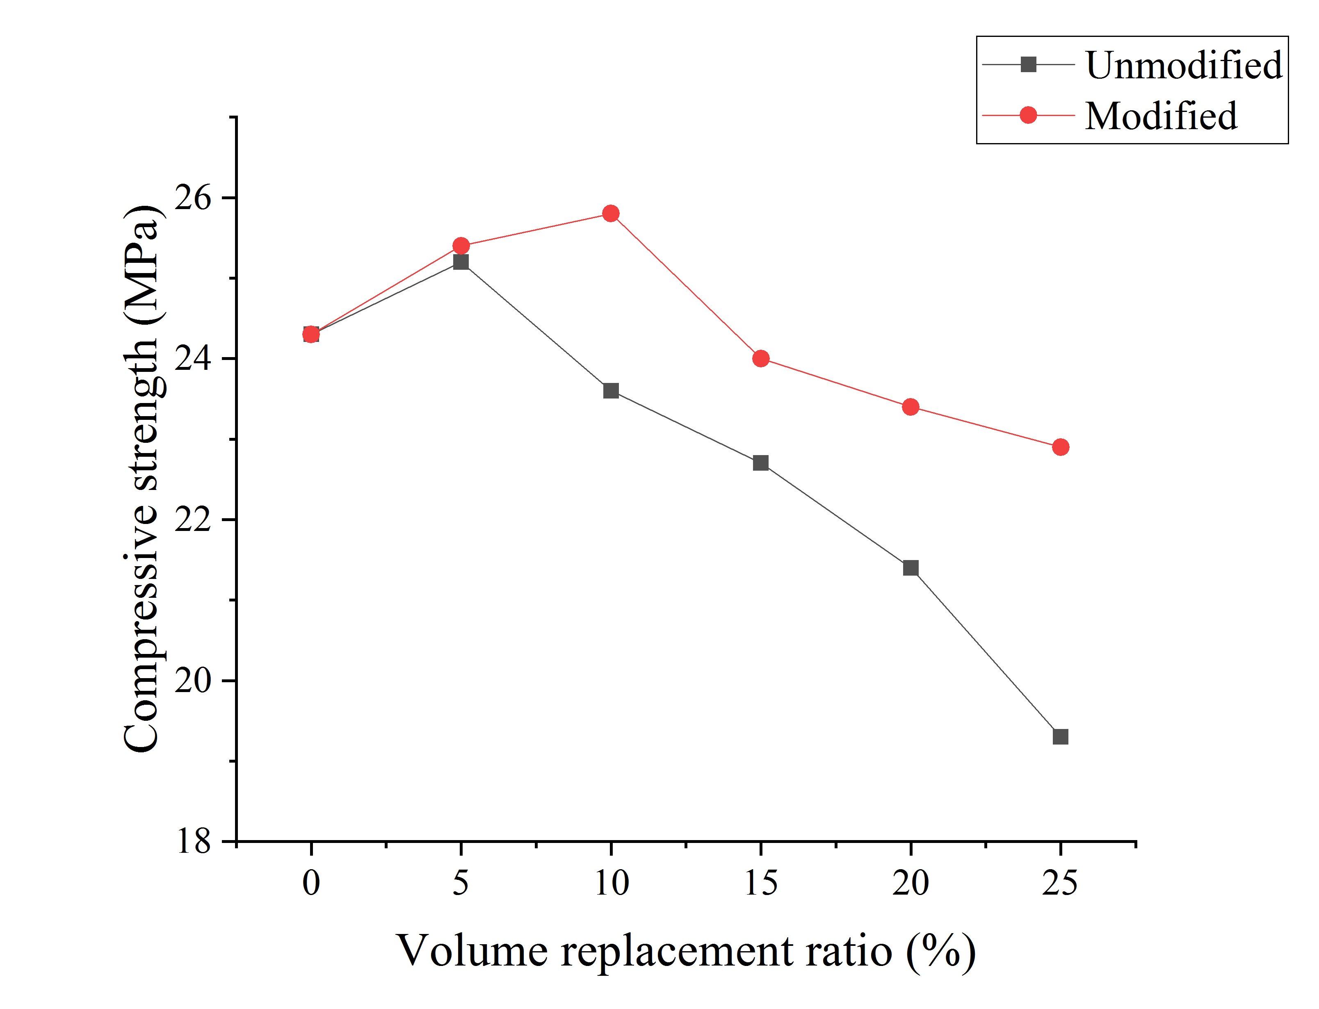 | 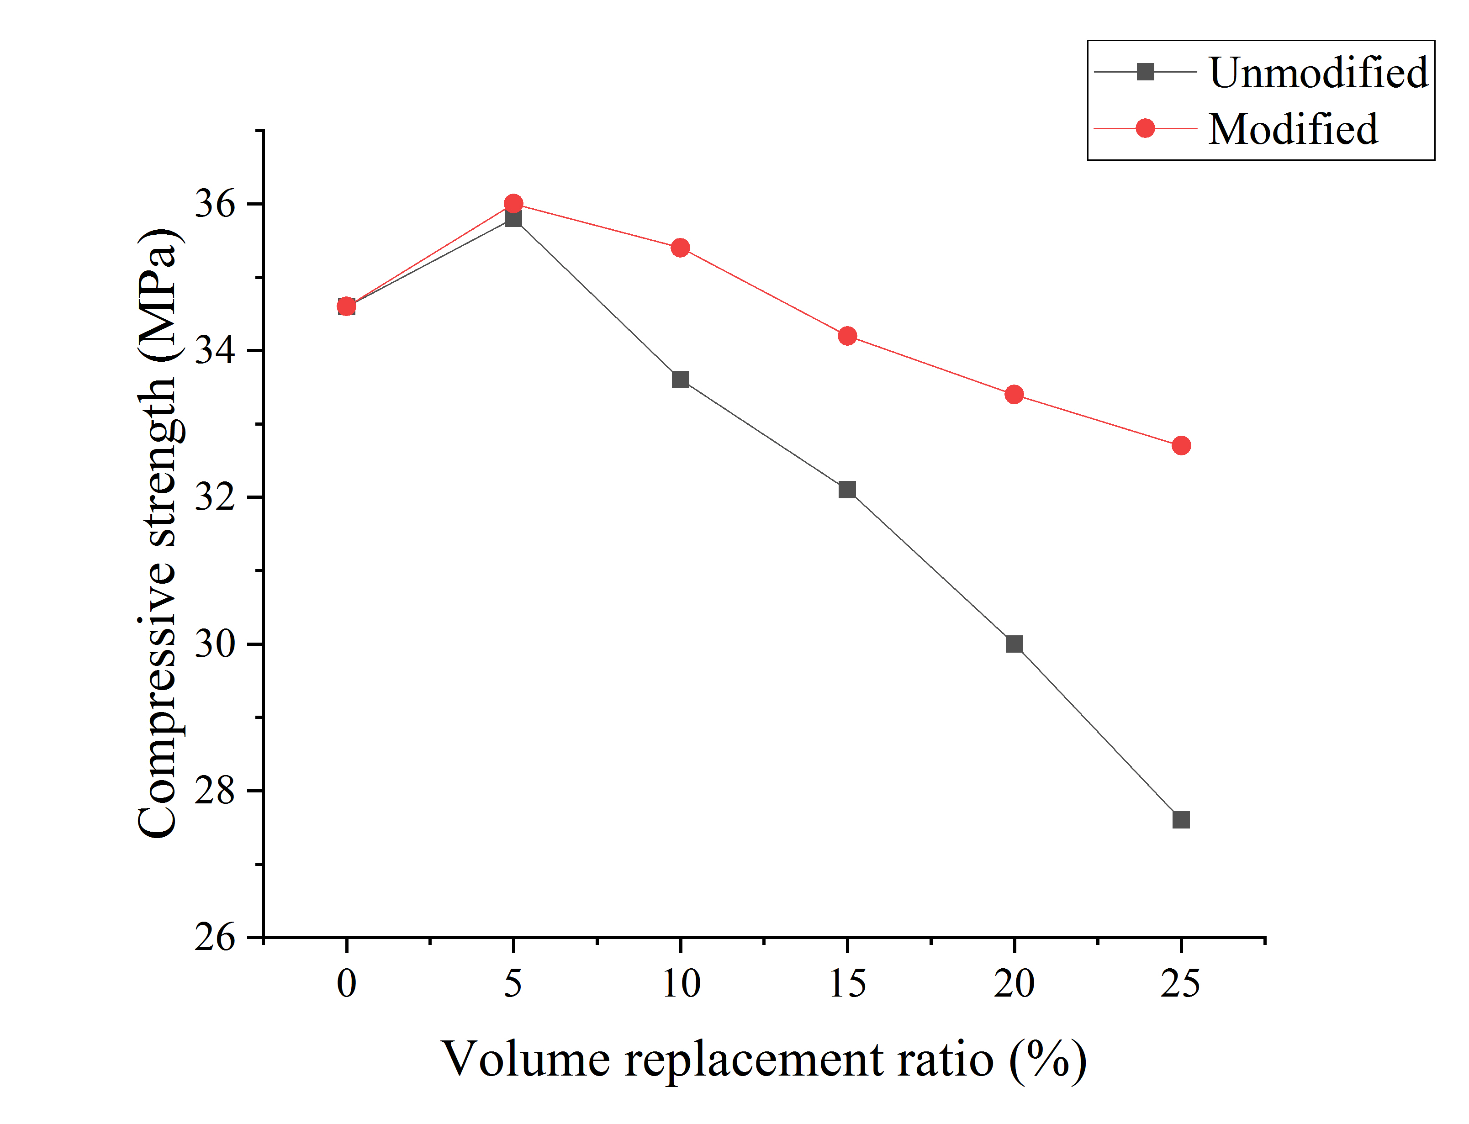
(a) | (b)
Fig. 6. Comparison of compressive strength of concrete at different ages: (a) 7d, (b) 28d

As can be seen from Fig. 7, the admixture of recycled PVC particles has a significant effect on the compressive performance of the mortar. When the volume replacement ratio of modified recycled PVC particles is less than 10%, the compressive strength of the recycled PVC composite mortar is higher than that of the normal mortar. Mortar with modified recycled PVC particles can still maintain a compressive strength higher at all ages than that of the normal mortar when the volume replacement ratio reaches 20%. The compressive strength of the PVC mortar in this experiment was higher compared to the results of the study with Merlo ^{[27]}. This is probably caused by the PVC particles used in this experiment having a higher modulus and a higher tensile strength. The compressive strength of the modified recycled PVC composite mortar could reach more than 95% of that of the reference mortar when the volume replacement ratio reaches 25%. When the volume replacement ratio of unmodified recycled PVC particles was less than 15%, the compressive strength of the mortar improved. For instance, for mortar with 5% volume replacement ratio, the compressive strength of recycled PVC composite mortar is the highest, and the compressive strength is increased by about 11.5%, compared to the ordinary mortar. When the volume replacement ratio is 10%, the compressive strength of recycled PVC composite mortar is higher than that of ordinary mortar by 9%. At 15% of unmodified recycled PVC particles, the compressive strength of the recycled PVC mortar still reaches 96% of the normal mortar. The compressive strength curve of the mortar tends to decrease when the volume replacement ratio exceeds 15%, and the compressive strength of the mortar decreases by 15.7% when the volume replacement ratio of unmodified recycled PVC particles is 25%. This shows that the small amount of recycled PVC particles can improve the compressive strength of the mortar and still meet the requirements of practical engineering applications before the volume replacement ratio of recycled PVC particles reaches 15%.
It is seen from Fig. 8 that the modification of SCA can obviously improve the compressive strength of the recycled PVC mortar. When the volume replacement ratio of recycled PVC particles was less than 10%, the compressive strength curve of the recycled PVC mortar showed an increasing trend, and the highest compressive strength of the mortar was achieved when the replacement amount of recycled PVC particles was 10%. it was 24% higher than that of the ordinary mortar and was 11.5% higher than that of the unmodified mortar. The compressive strength of the modified recycled PVC mortar can reach more than 95% of that of the ordinary mortar. Interestingly to observe that when the amount of modified recycled PVC particles reaches 25%, the compressive strength of the composite mortar is reduced by 4.2% while the compressive strength of unmodified mortar decreased by 15.7%, compared with the ordinary mortar. The trend in compressive strength at 7d is consistent with that at 28d and the strength increase at 7d is slightly higher than that at 28d. This is probably due to the early hydration reaction being faster and the SCA being able to bond better with the cement material to improve the bond between PVC and cement.
The recycled PVC particles significantly improve the compressive strength loss of the mortar after modification with SCA. On the premise of ensuring that the compressive strength of the composite mortar is not lower than that of ordinary mortar, the recommended admixture of recycled PVC particles can be increased from 10% to 20% by modification with SCA. This is of great significance for the consumption of waste PVC, which is highly polluting, and greatly accelerates the construction of a recycling system for waste materials, which can effectively promote the construction of "waste-free cities".

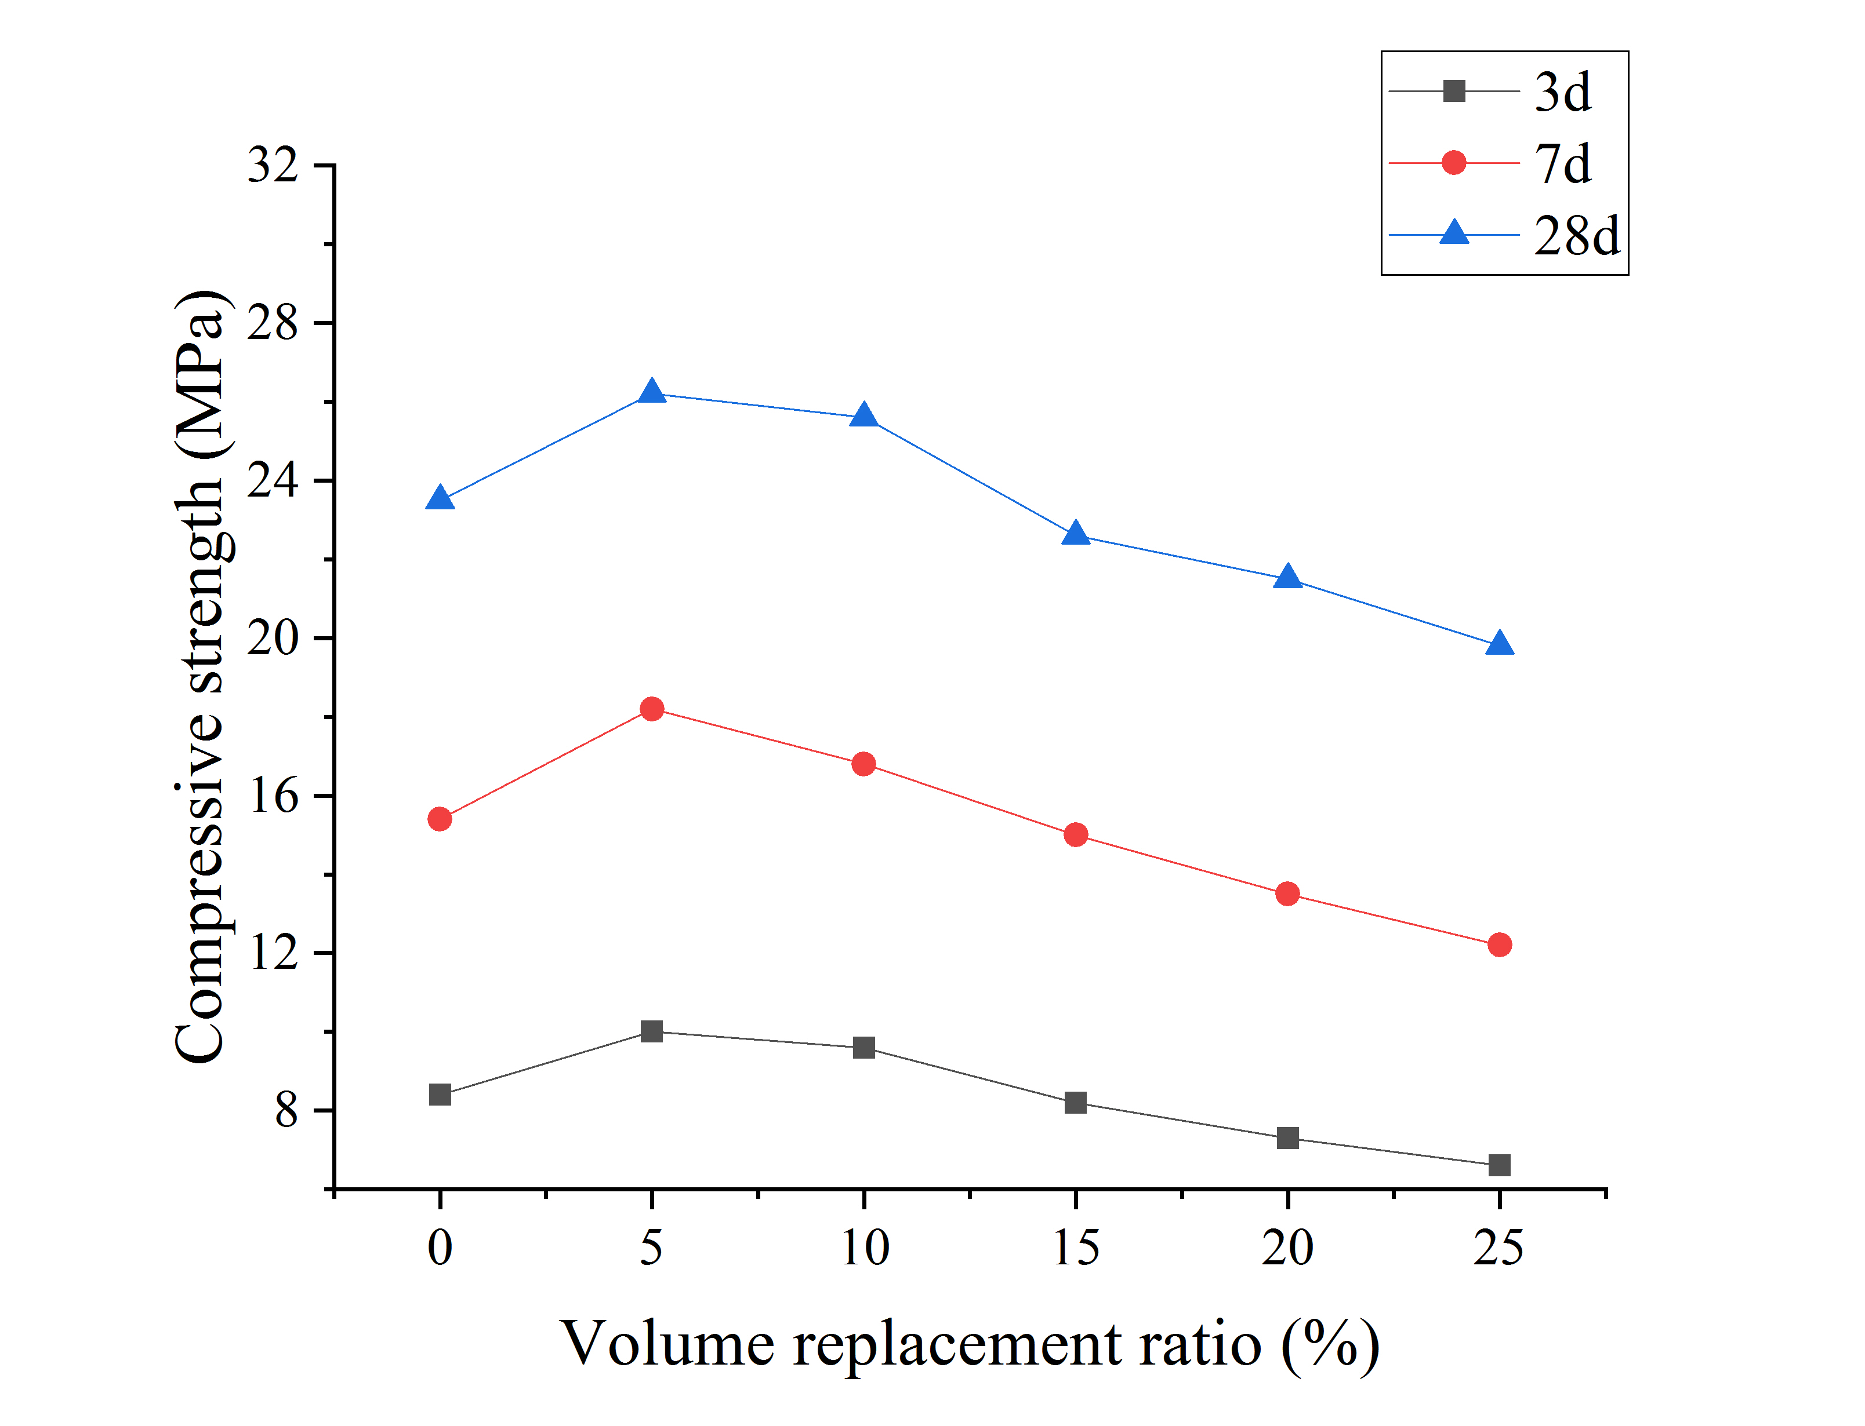 | 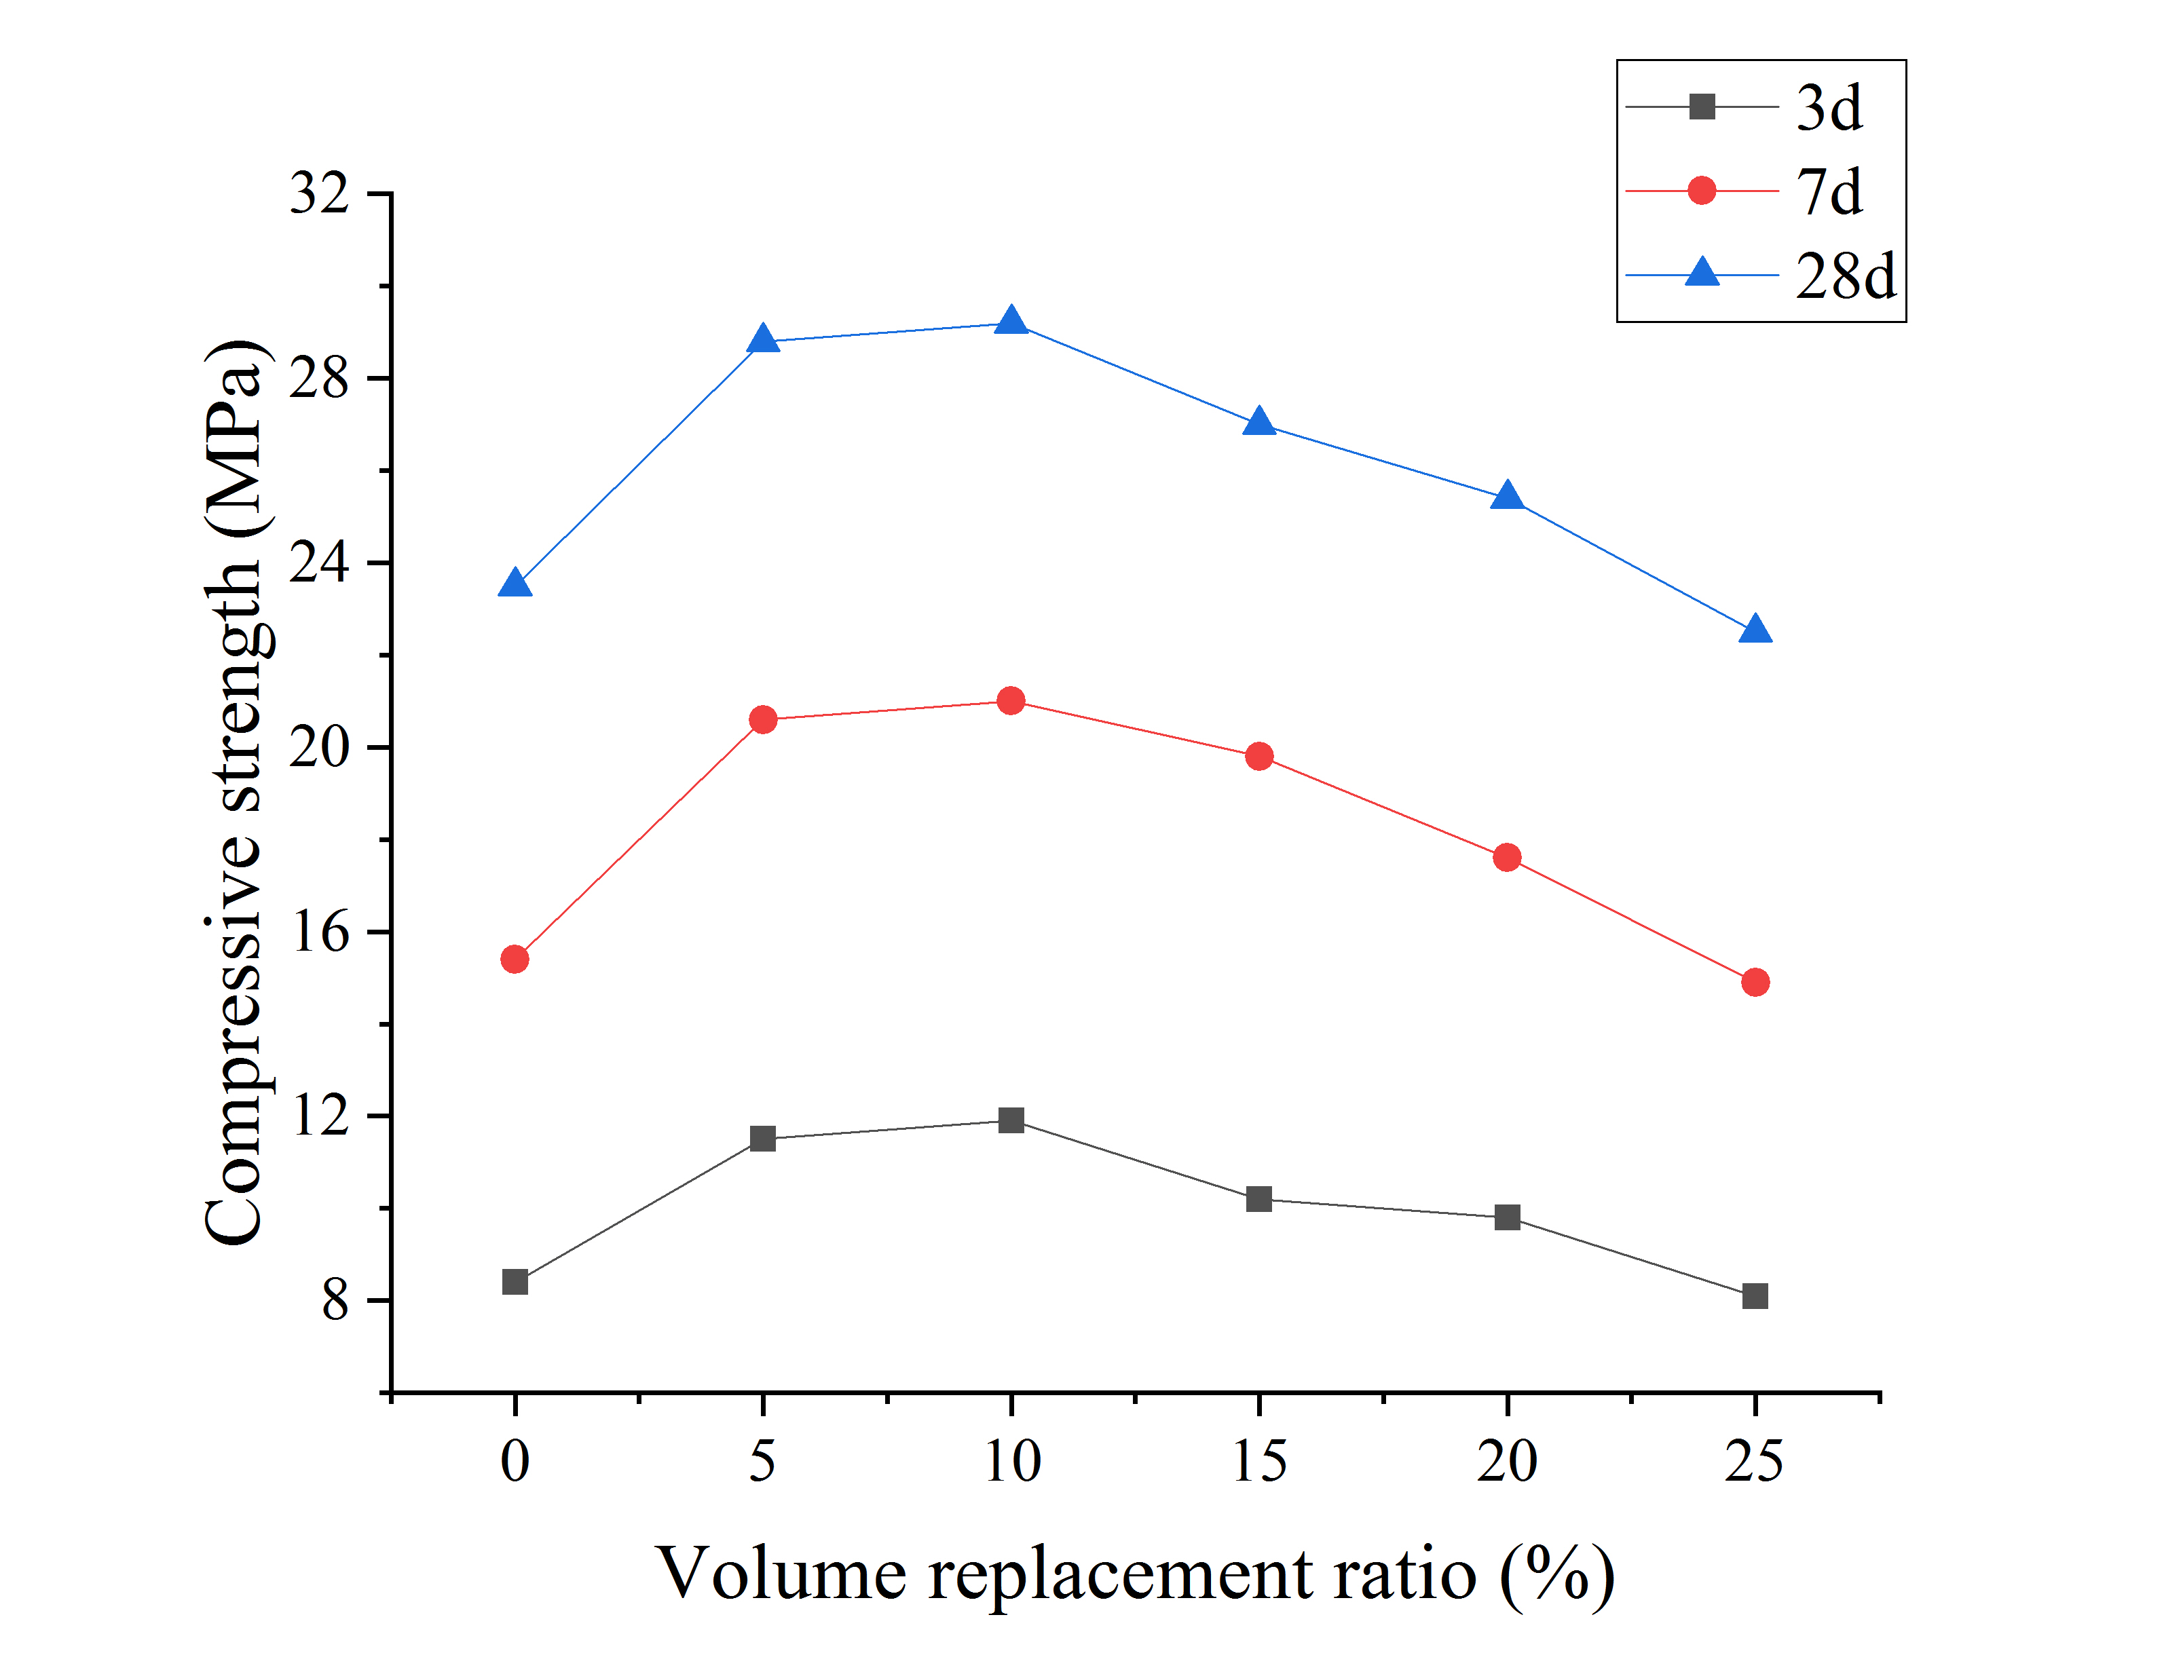
Fig. 7. Mortar compressive strength: (a) unmodified mortar, (b) modified mortar
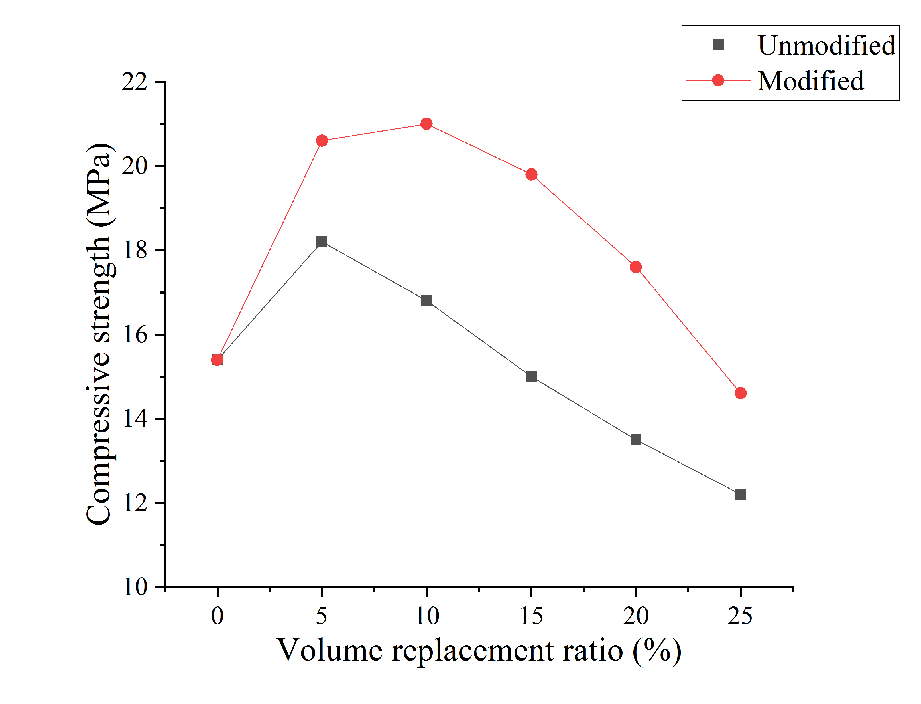 | 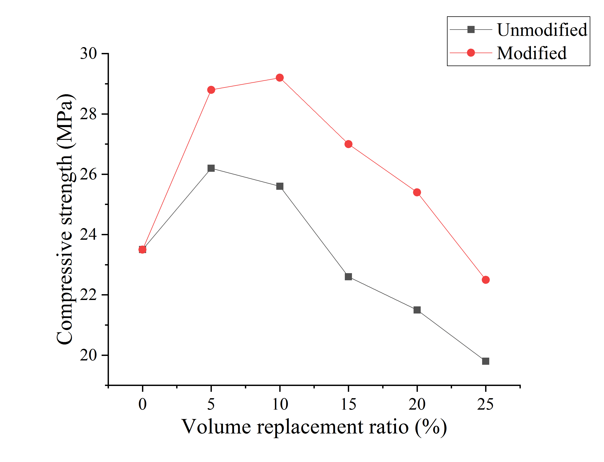
(a) | (b)
Fig. 8. Comparison of compressive strength of mortar at different ages: (a) 7d, (b) 28d

SCA, containing the inorganic and organic functional groups, which cover the surface of the recycled PVC particles after hydrolysis, can strengthen the chemical bonding between the recycled PVC particles and other inorganic materials in the cementitious material and improve the interfacial strength of the PVC particles and the cementitious material. The reaction mechanism of the silane coupling agent modification is shown in Fig. 9. Huang ^{[52]} and Dong ^{[41]} found that the strength of rubber concrete was improved when it was modified with SCA. The increase in strength was attributed to the fact that the hydroxyl group in the hydrolysed SCA would bond effectively with the cement and the X group would bond effectively with the rubber thus improving the bond between the cement and the inorganic material. PVC as an organic polymer has similar properties to rubber and is thus better able to bond with the hydrolysed SCA. Therefore, the compressive properties of the recycled PVC concrete and mortar after modification by SCA are significantly improved.

Fig. 9. Reaction mechanism of the silane coupling agent modification

  - Flexural strength
It is seen from Fig. 10 that the flexural strength of recycled PVC concrete increases and then decreases with the increase of recycled PVC particles, and the change of flexural strength of concrete with the increase of recycled PVC particles at three different ages is consistent. The flexural strength of the concrete was improved when the amount of unmodified recycled PVC particles was below 10%. The PVC concrete reached the maximum flexural strength at 5% volume replacement ratio of unmodified recycled PVC particles, an improvement of approximately 8% compared to the ordinary concrete. At 25% volume replacement ratio of modified recycled PVC particles, the flexural strength of the recycled PVC mortar is still 97% of that of the ordinary concrete, demonstrating that the incorporation of modified recycled PVC particles has a small detrimental influence on the flexural strength of the concrete. The flexural strength of the modified concrete was comparable with that of the ordinary concrete when the amount of modified recycled PVC particles reached 20%. The flexural strength of the modified concrete reached a maximum at 5% volume replacement ratio.
A comparison of the flexural strength of the concrete at day 7 and day 28 before and after recycled PVC modification is shown in Fig. 11. As can be seen from Fig. 11, the flexural strength of the modified recycled PVC concrete improves less when the volume replacement ratio of recycled PVC particles is 5%. When the amount of recycled PVC particles exceeded 5%, the decreasing trend of the flexural strength of the concrete slowed down significantly, indicating that the flexural strength of the concrete improved. The rate of increase in the flexural strength of concrete increases as the volume replacement ratio increases. When the volume replacement ratio is 25%, the strength increase reaches a maximum of 9%.

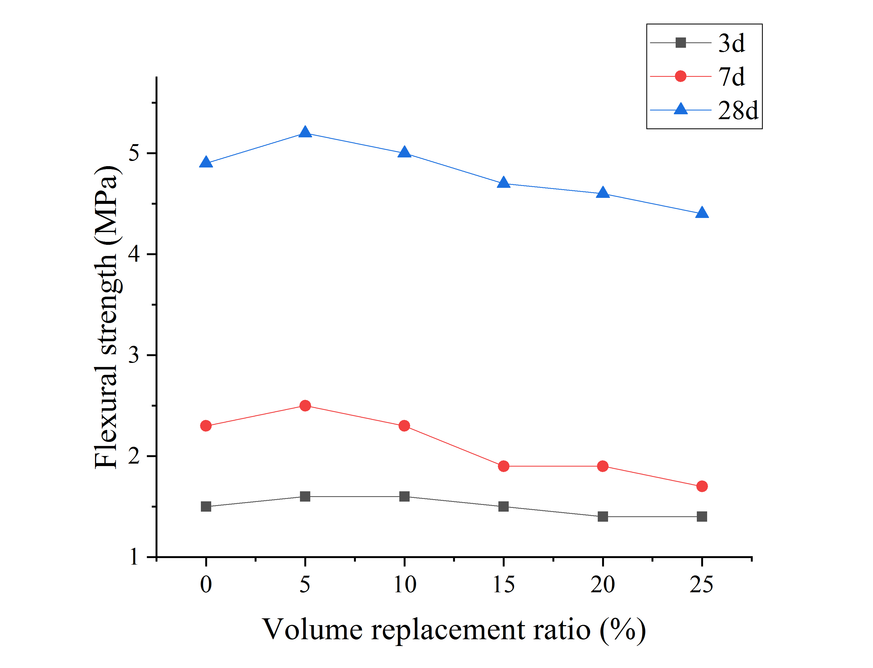 | 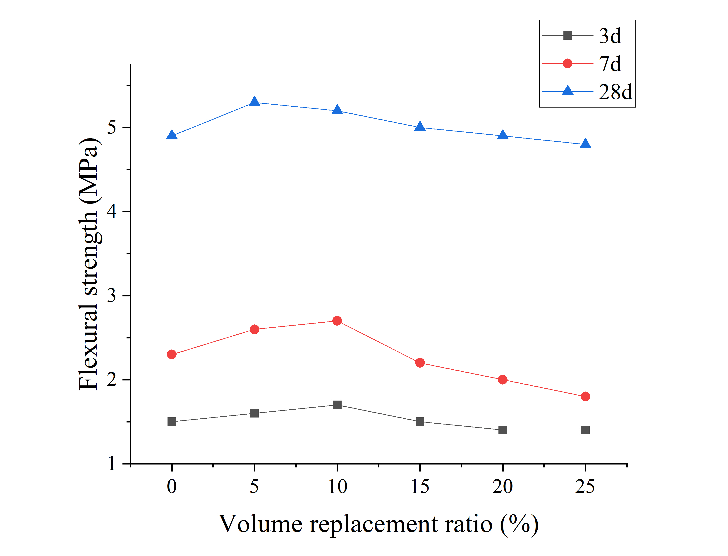
Fig. 10. Concrete flexural strength:(a) unmodified recycled PVC concrete, (b) modified recycled PVC concrete
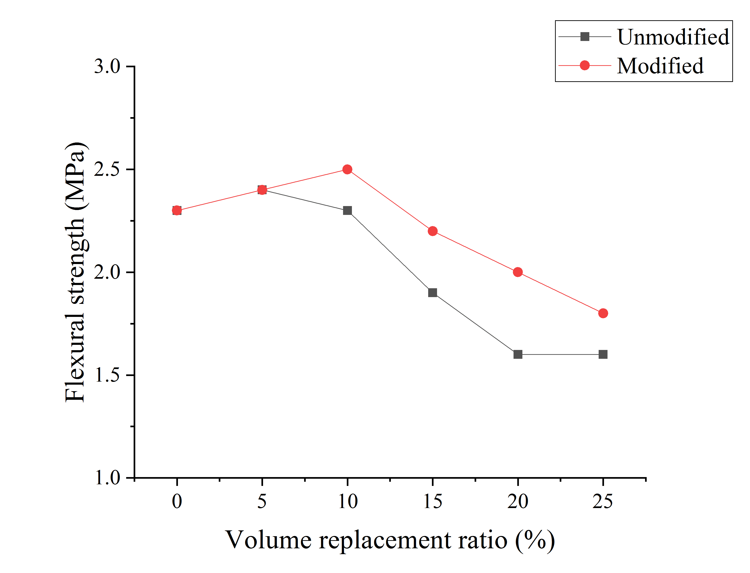 | 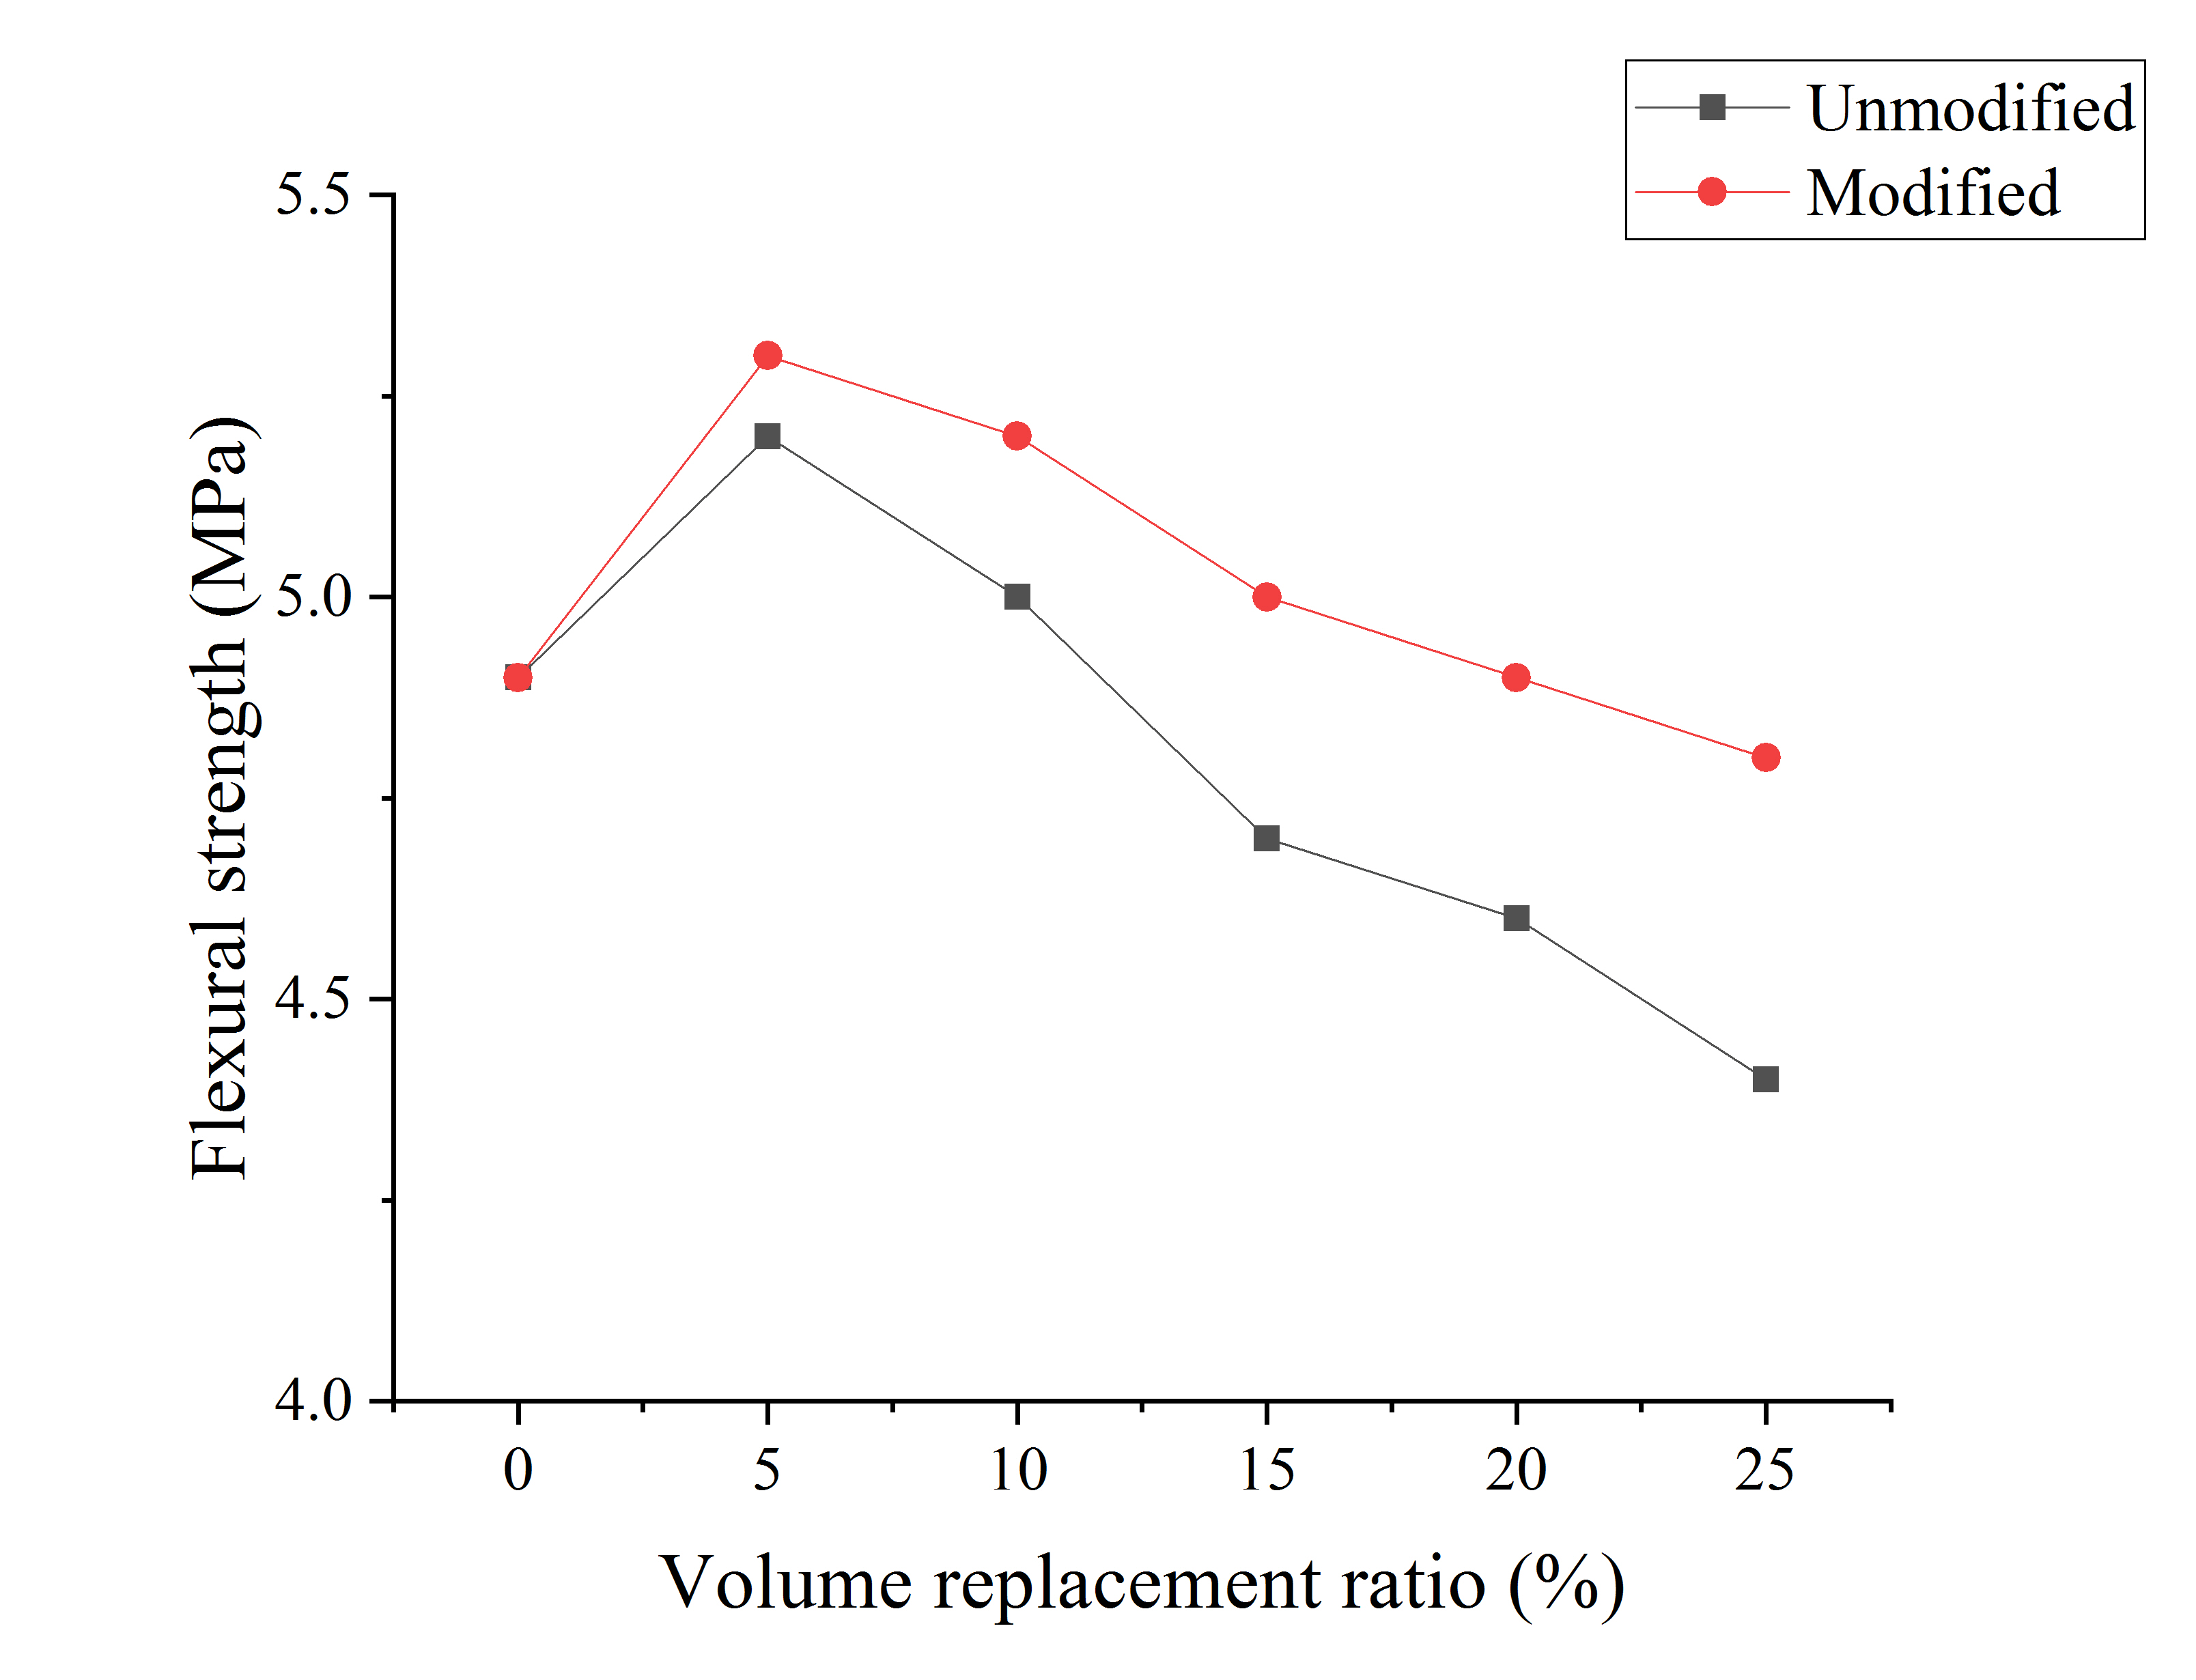
(a) | (b)
Fig. 11. Comparison of flexural strength of concrete at different ages: (a) 7d, (b) 28d

It is seen from Fig. 12 that the flexural strength of recycled PVC mortar increases and then decreases with the increase of recycled PVC particles. The trend of the flexural strength of the mortar is basically the same as that of the flexural strength of concrete. The flexural strength of the mortar was improved when the amount of unmodified recycled PVC particles was below 15%. The recycled PVC mortar reached the maximum flexural strength at 10% volume replacement ratio of PVC, an improvement of approximately 8% compared to the ordinary mortar. At 25% volume replacement ratio of recycled PVC, the flexural strength of the recycled PVC mortar is still 94% of that of the ordinary mortar, demonstrating that the incorporation of recycled PVC particles has a small detrimental influence on the flexural strength of the mortar. As can be seen from Fig.13, the flexural strength of the modified mortar was comparable with that of the ordinary mortar when the amount of recycled PVC particles reached 20%. The flexural strength of the mortar tended to increase and then decrease with the volume replacement ratio and reached a maximum at 10% volume replacement ratio.
A comparison of the flexural strength of the mortar at day 7 and day 28 before and after recycled PVC modification is shown in Fig. 13. As can be seen from Fig. 13, the improvement in flexural strength of the modified recycled PVC mortar was not noticeable when the amount of recycled PVC particles was less than 10%. When the amount of recycled PVC particles exceeded 10%, the decreasing trend of the flexural strength of the mortar slowed down significantly, indicating that the flexural strength of the mortar improved.

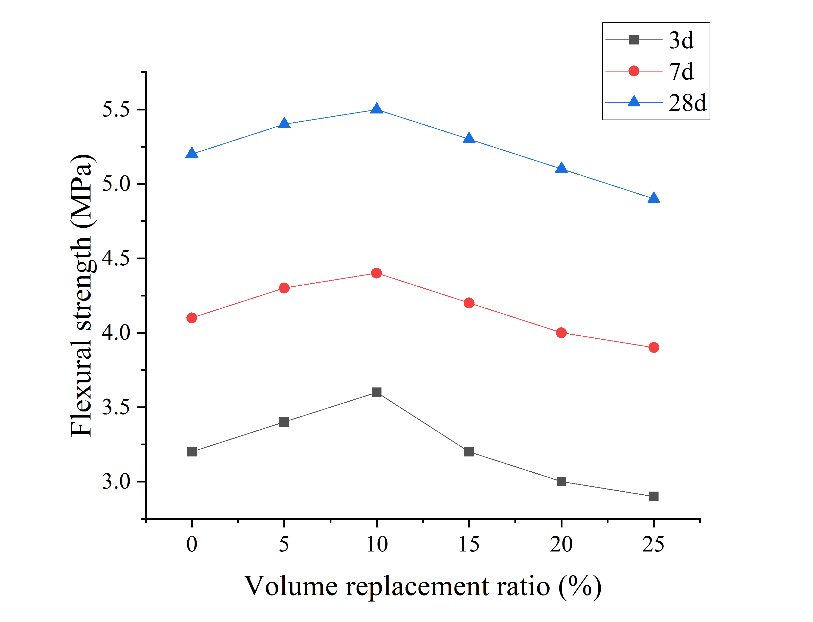 | 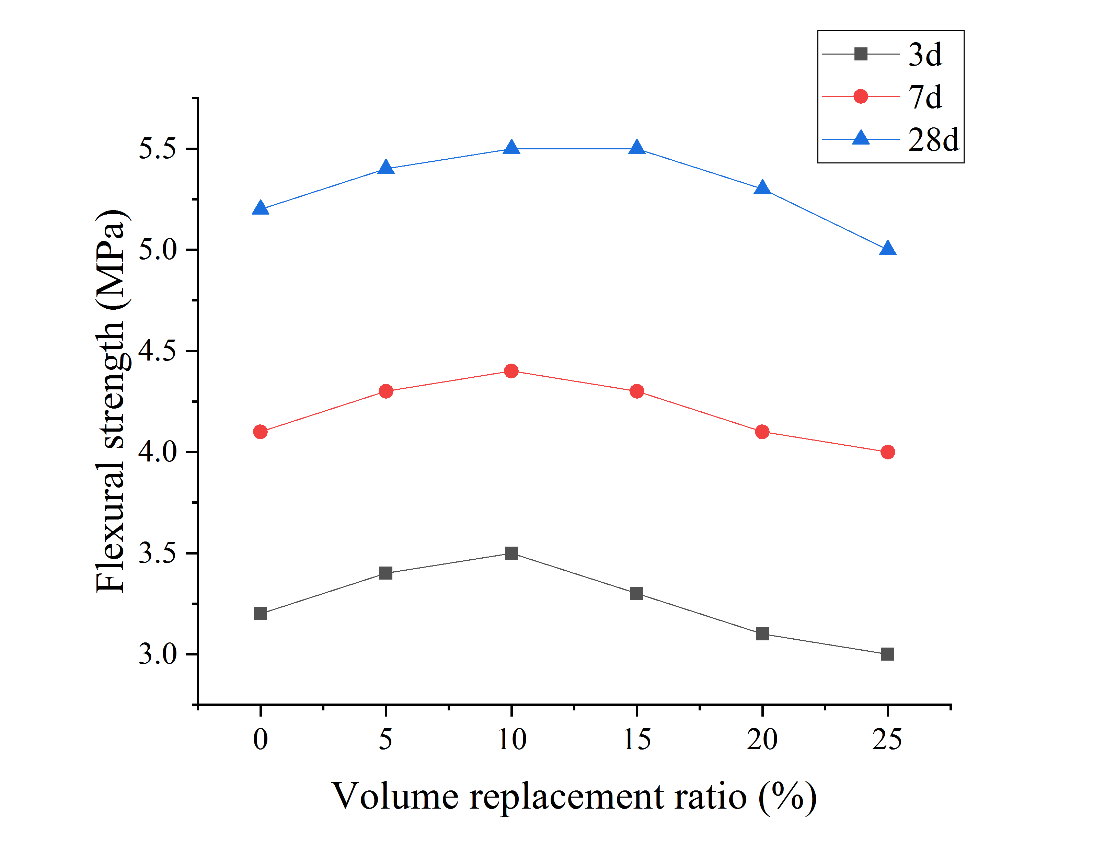
Fig. 12. Mortar flexural strength:(a) unmodified recycled PVC mortar, (b) modified recycled PVC mortar
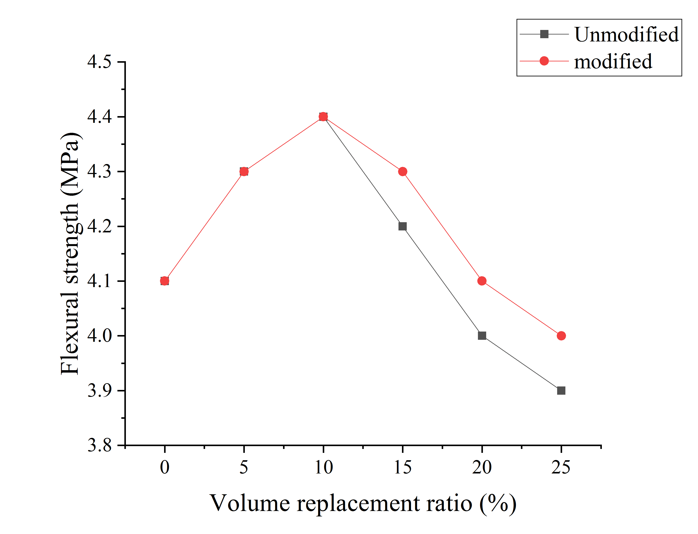 | 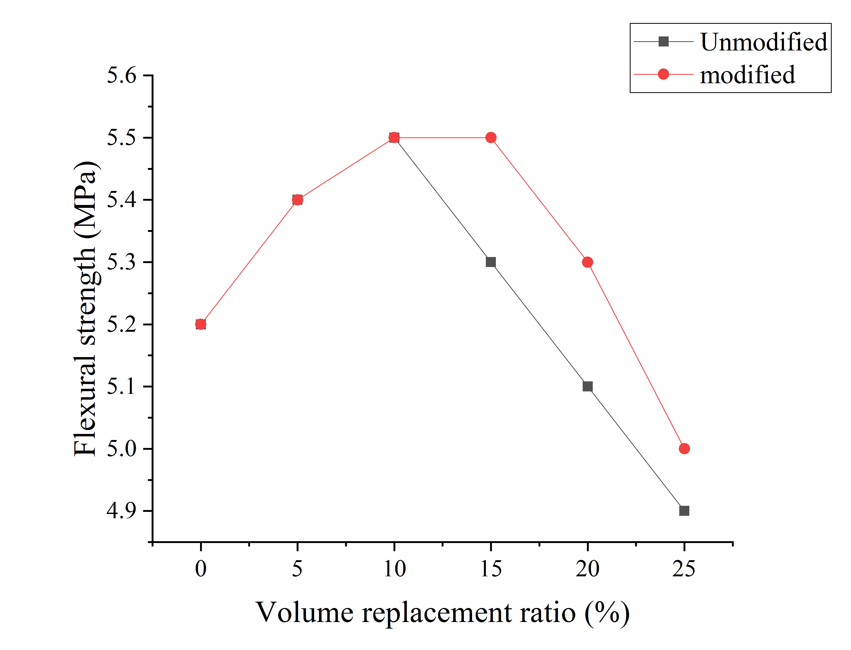
(a) | (b)
Fig. 13. Comparison of flexural strength of mortar at different ages: (a) 7d, (b) 28d

In general, the pattern of change in flexural strength of concrete and mortar is basically the same. The modification effect increases with increasing volume replacement ratio when the volume replacement ratio exceeds 15%. The reason for small change in flexural strength before and after concrete and mortar modification at low volume replacement rates is that the cross-section of the PVC concrete and mortar used for flexural testing is small, and the likelihood of the force interface containing recycled PVC particles is low.
  - Microstructure analyses
Fig. 14 and Fig. 15 illustrate the SEM microscopic morphology of recycled PVC particles before and after SCA modification. Fig. 14 shows that the surface of the PVC particles is not completely smooth as observed by SEM. The physical wrapping of the rough surface of the recycled PVC particles with the cementitious material provides some interfacial strength, which is the reason for the lack of bonding effect between the recycled PVC particles and the cementitious material but retaining most of the mechanical properties of the mortar. Fig. 15 illustrates the modified recycled PVC particles' microscopic morphology. It can be clearly observed that the hydrolysed SCA was attached a gel-like substance to the surface of the recycled PVC particles, and it is this gel-like substance that facilitates the bonding of the recycled PVC particles to the inorganic cementitious material. This explains the significant improvement in the compressive properties of the modified recycled PVC mortar from a microscopic morphological point of view.

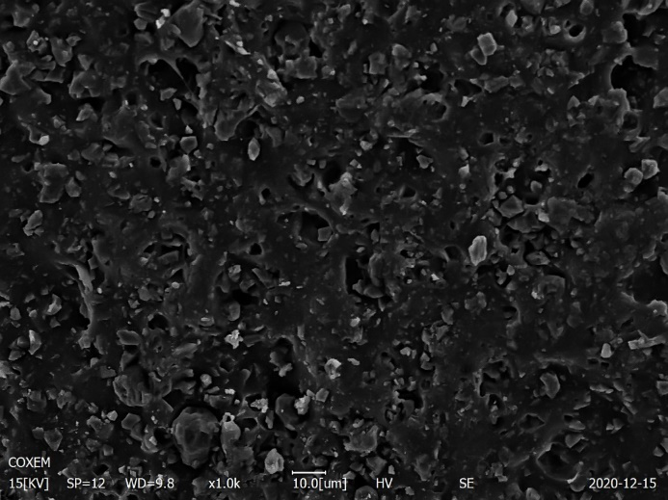
Fig. 14. Surface morphology of unmodified recycled PVC particles
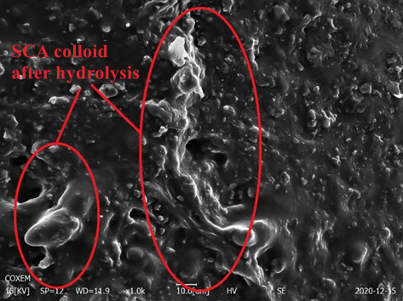
Fig. 15. surface morphology of modified recycled PVC particles

Fig. 16 and Fig. 17 show the microscopic morphology of the interface between modified and unmodified recycled PVC particles and cementitious material in recycled PVC mortar, respectively. It can be seen from Fig. 16 that there are coarse cracks at the interface between the unmodified recycled PVC particles and the cementitious material, indicating that the weak interfacial bonding between PVC particles and the cementitious material, which is the reason why the compressive performance of the recycled PVC composite mortar decreases in a straight line after the amount of unmodified recycled PVC particles exceeds 5%.According to Fig. 16 and Fig. 17, the bonding between the PVC particles and the cementitious material in the recycled PVC mortar is greatly improved after soaking PVC within the hydrolyzed SCA, and fissures between the PVC particles and the cementitious material are nearly impossible to observe. This is because the SCA has two functional groups that can both react with the inorganic cementing material and link with the organic recycled PVC particles. Therefore, the chemical bond between the recycled PVC particles and the inorganic cementing material and interface strength improved.

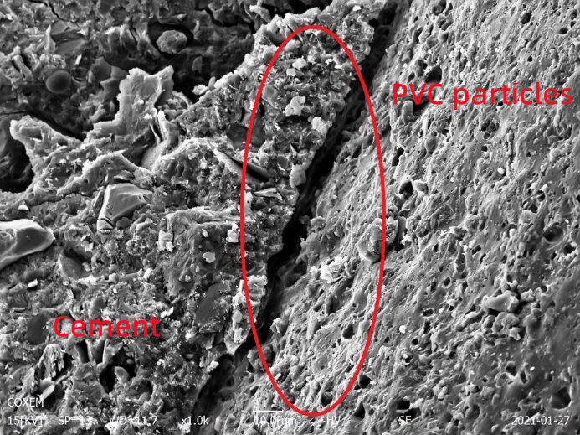
Fig. 16. Interface between unmodified recycled PVC particles and cementitious materials
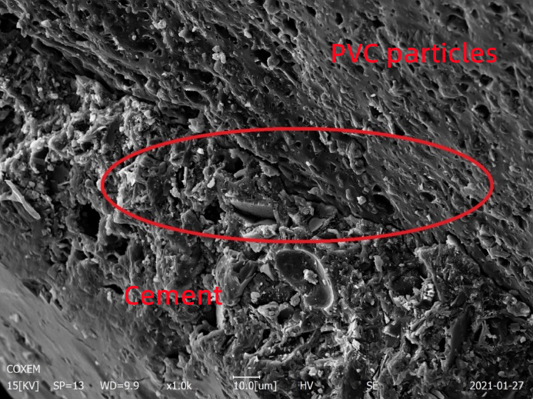
Fig. 17. Interface between modified recycled PVC particles and cementitious materials after modification

4.Conclusions
The following conclusions were drawn from a study of the mechanical properties and microstructure of concrete and mortar containing PVC particles modified with silane coupling agent (SCA) and unmodified PVC particles:
- The density of concrete and mortar decreases as the proportion of recycled PVC particles increases. This is owing to the fact that recycled PVC particles have a lower density than natural sand.
- The compressive strength of unmodified PVC concrete and mortar at Days 3, 7 and 28 increases and then decreases as the amount of unmodified PVC particles increases. The compressive strength of unmodified PVC concrete and mortar was greatest when the volume replacement ratio was 5%.
- SCA modification can effectively reduce the loss of compressive strength of PVC concrete and mortar. The compressive strength of mortar was higher than that of ordinary mortar when the amount of modified PVC particles was less than 20%, and the highest compressive strength of mortar was achieved when the amount was 10%. The compressive strength of modified PVC concrete was higher than that of ordinary concrete when the volume replacement ratio was less than 15%. The highest compressive strength of modified PVC concrete was achieved when the volume replacement ratio is 5%.
- The flexural strength of the concrete and mortar tends to increase and then decrease as the amount of PVC particles increases. The best flexural performance of the PVC mortar was obtained at 10% volume replacement ratio. The flexural strength of the concrete reaches a maximum when the volume replacement rate is 5%. The flexural strength of the modified recycled PVC concrete and mortar follows the consistent change mode with the unmodified concrete and mortar as the amount of recycled PVC particles increases.
- The microscopic morphology of the surface of the recycled PVC particles and the interface in the mortar before and after the modification was observed by scanning electron microscopy (SEM), and it was clearly observed that the hydrolysed SCA covered the surface of the recycled PVC particles. The hydrolysed SCA in the mortar can effectively bond the PVC particles to the cementitious material and improve the mechanical properties of the recycled PVC mortar.
Acknowledgements
This work was supported financially by Natural Resources Development Special Foundation of Jiangsu Province (Grant No. JSZRHYKJ202113).

References
[1] YANG H. Current Situation and Development Trade of PVC and its Stability [J]. China Plastics, 2019, 33(04): 111-119. (in Chinese)
[2] WENQI H, YINGYING S. Study on Aging and Property Degradation of Building Membrane Materials [J]. Synthetic Materials Aging and Application, 2019, 48(02): 60-65+70. (in Chinese)
[3] HUAN L, LONG Z, QIAN S, et al. Policy Analysis in Plastic Pollution Governance and Recommendations in China [J]. Environmental Science: 1-9. (in Chinese)
[4] PANDA A K, SINGH R K, MISHRA D. Thermolysis of waste plastics to liquid fuel: A suitable method for plastic waste management and manufacture of value added products—A world prospective [J]. Renewable and Sustainable Energy Reviews, 2010, 14(1): 233-248.
[5] MERSIOWSKY I. Long-term fate of PVC products and their additives in landfills [J]. Progress in polymer science, 2002, 27(10): 2227-2277.
[6] GARCIA D, BALART R, CRESPO J E, et al. Mechanical properties of recycled PVC blends with styrenic polymers [J]. Journal of Applied Polymer Science, 2010, 101(4): 2464-2471.
[7] GEYER R, JAMBECK J R, LAW K L. Production, use, and fate of all plastics ever made [J]. Science advances, 2017, 3(7): e1700782.
[8] POON C S, SHUI Z, LAM L. Effect of microstructure of ITZ on compressive strength of concrete prepared with recycled aggregates [J]. Construction and Building Materials, 2004, 18(6): 461-468.
[9] LIU F, YAN Y, LI L, et al. Performance of recycled plastic-based concrete [J]. Journal of Materials in Civil Engineering, 2015, 27(2): A4014004.
[10] TAGBA M, LI S, JIANG M, et al. Performance Evaluation of Cementitious Composites Containing Granulated Rubber Wastes, Silica Fume, and Blast Furnace Slag [J]. Crystals, 2021, 11(6): 632.
[11] WU H, LIU C, SHI S, et al. Experimental research on the physical and mechanical properties of concrete with recycled plastic aggregates [J]. Journal of Renewable Materials, 2020, 8(7): 727.
[12] ZáLESKá M, PAVLIKOVA M, POKORNý J, et al. Structural, mechanical and hygrothermal properties of lightweight concrete based on the application of waste plastics [J]. Construction and Building Materials, 2018, 180: 1-11.
[13] AKçAöZOĞLU S, ATIŞ C D, AKçAöZOĞLU K. An investigation on the use of shredded waste PET bottles as aggregate in lightweight concrete [J]. Waste management, 2010, 30(2): 285-290.
[14] HANNAWI K, KAMALI-BERNARD S, PRINCE W. Physical and mechanical properties of mortars containing PET and PC waste aggregates [J]. Waste management, 2010, 30(11): 2312-2320.
[15] REIS J, CHIANELLI-JUNIOR R, CARDOSO J, et al. Effect of recycled PET in the fracture mechanics of polymer mortar [J]. Construction and Building Materials, 2011, 25(6): 2799-2804.
[16] BENOSMAN A S, MOULI M, TAIBI H, et al. Mineralogical study of polymer-mortar composites with PET polymer by means of spectroscopic analyses [J]. 2012.
[17] FOTI D. Use of recycled waste pet bottles fibers for the reinforcement of concrete [J]. Composite Structures, 2013, 96: 396-404.
[18] WON J-P, JANG C-I, LEE S-W, et al. Long-term performance of recycled PET fibre-reinforced cement composites [J]. Construction and Building Materials, 2010, 24(5): 660-665.
[19] FRIGIONE M. Recycling of PET bottles as fine aggregate in concrete [J]. Waste management, 2010, 30(6): 1101-1106.
[20] NABAJYOTI, SAIKIA, JORGE, et al. Mechanical properties and abrasion behaviour of concrete containing shredded PET bottle waste as a partial substitution of natural aggregate [J]. Construction & Building Materials, 2014.
[21] AMBIKA D, SABITHA M, PRAVINRAJ S. Experimental Study on Mechanical Properties of Concrete Using Plastics as Fiber (PP) and Partial Replacement of Fine Aggregate (PET) [J]. IOP Conference Series Materials Science and Engineering, 2020, 955: 012046.
[22] LATROCH N, BENOSMAN A S, BOUHAMOU N-E, et al. Physico-mechanical and thermal properties of composite mortars containing lightweight aggregates of expanded polyvinyl chloride [J]. Construction and Building Materials, 2018, 175: 77-87.
[23] MERLO A, LAVAGNA L, SUAREZ-RIERA D, et al. Mechanical properties of mortar containing waste plastic (PVC) as aggregate partial replacement [J]. Case Studies in Construction Materials, 2020, 13: e00467.
[24] SENHADJI Y, SIAD H, ESCADEILLAS G, et al. Physical, mechanical and thermal properties of lightweight composite mortars containing recycled polyvinyl chloride [J]. Construction and Building Materials, 2019, 195: 198-207.
[25] BOLAT H, ERKUS P. Use of polyvinyl chloride (PVC) powder and granules as aggregate replacement in concrete mixtures [J]. Science and Engineering of Composite Materials, 2016, 23(2): 209-216.
[26] KOU S, LEE G, POON C S, et al. Properties of lightweight aggregate concrete prepared with PVC granules derived from scraped PVC pipes [J]. Waste Management, 2009, 29(2): 621-628.
[27] SENHADJI Y, ESCADEILLAS G, BENOSMAN A, et al. Effect of incorporating PVC waste as aggregate on the physical, mechanical, and chloride ion penetration behavior of concrete [J]. Journal of Adhesion Science and Technology, 2015, 29(7): 625-640.
[28] AGARWAL L K, FELIX S, AGARWAL S. Strength and Behavior of Concrete Contains Waste Plastic (High Density PVC) Aggregates As Partial Replacement of Coarse Aggregates [J]. Int J Eng Res Technol, 2019, 8: 1044-1049.
[29] MOHAMMED A A, MOHAMMED I I, MOHAMMED S A. Some properties of concrete with plastic aggregate derived from shredded PVC sheets [J]. Construction and Building Materials, 2019, 201: 232-245.
[30] NAIK T R, SINGH S S, HUBER C O, et al. Use of post-consumer waste plastics in cement-based composites [J]. Cement and concrete research, 1996, 26(10): 1489-1492.
[31] RAFFOUL S, GARCIA R, PILAKOUTAS K, et al. Optimisation of rubberised concrete with high rubber content: An experimental investigation [J]. Construction and Building Materials, 2016, 124: 391-404.
[32] YOUSSF O, HASSANLI R, MILLS J E, et al. An experimental investigation of the mechanical performance and structural application of LECA-Rubcrete [J]. Construction and Building Materials, 2018, 175: 239-253.
[33] MOHAMMADI I, KHABBAZ H, VESSALAS K. In-depth assessment of Crumb Rubber Concrete (CRC) prepared by water-soaking treatment method for rigid pavements [J]. Construction and Building Materials, 2014, 71: 456-471.
[34] Crumb rubber aggregate coatings/pre-treatments and their effects on interfacial bonding, air entrapment and fracture toughness in self-compacting rubberised concrete (SCRC) [J]. Materials and structures, 2013, 46(12): 2029-2043.
[35] MEDDAH A, BEDDAR M, BALI A. Use of shredded rubber tire aggregates for roller compacted concrete pavement [J]. Journal of Cleaner Production, 2014, 72: 187-192.
[36] ONUAGULUCHI O, PANESAR D K. Hardened properties of concrete mixtures containing pre-coated crumb rubber and silica fume [J]. Journal of Cleaner Production, 2014, 82: 125-131.
[37] CHOI Y-W, MOON D-J, CHUNG J-S, et al. Effects of waste PET bottles aggregate on the properties of concrete [J]. Cement and concrete research, 2005, 35(4): 776-781.
[38] MUñOZ-SáNCHEZ B, ARéVALO-CABALLERO M J, PACHECO-MENOR M C. Influence of acetic acid and calcium hydroxide treatments of rubber waste on the properties of rubberized mortars [J]. Materials and Structures, 2017, 50(1): 1-16.
[39] LEUNG C K, GRASLEY Z C. Effect of micrometric and nanometric viscoelastic inclusions on mechanical damping behavior of cementitious composites [J]. Construction and Building Materials, 2012, 35: 444-451.
[40] PELISSER F, ZAVARISE N, LONGO T A, et al. Concrete made with recycled tire rubber: effect of alkaline activation and silica fume addition [J]. Journal of cleaner production, 2011, 19(6-7): 757-763.
[41] DONG Q, HUANG B, SHU X. Rubber modified concrete improved by chemically active coating and silane coupling agent [J]. Construction and Building Materials, 2013, 48: 116-123.
[42] SGOBBA S, BORSA M, MOLFETTA M, et al. Mechanical performance and medium-term degradation of rubberised concrete [J]. Construction and Building Materials, 2015, 98: 820-831.
[43] KRYLOVA V, DUKŠTIENĖ N, LELIS M, et al. PES/PVC textile surface modification by thermo-chemical treatment for improving its hydrophilicity [J]. Surfaces and Interfaces, 2021, 25: 101184.
[44] ARKLES B. Tailoring surfaces with silanes [J]. Chemtech, 1977, 7: 766-778
[45] WANG L, HE Y, ZHU S. Influence of Silane Coupling Agent Concentration on Mechanical Properties of Recycled Plastic Particles Concrete [J]. Bulletin of the Chinese Ceramic Society, 2015, 34(02): 335-339. (in Chinese)
[46] WANG L, HE Y, ZHANG X. Mechanical Performance of Modified Recycled Plastic Concrete with Silane Coupling Agent [J]. Journal of Lanzhou University of Technology, 2014,40(06):136-139. (in Chinese)
[47] Housing and urban-rural development of the People's Republic of China. Specification for Mix Proportion Design of Masonry Mortar. JGJ/T 98-2010[S]. Beijing: China Construction Industry Press,2010.(in Chinese)
[48] Housing and urban-rural development of the People's Republic of China. Specification for Mix Proportion Design of Ordinary Concrete. JGJ 55-2011[S]. Beijing: China Construction Industry Press,2011.(in Chinese)
[49] Housing and urban-rural development of the People's Republic of China. Standard for test method of performance on building mortar. JGJT70-2009[S]. Beijing: China Construction Industry Press,2011.(in Chinese)
[50] Housing and urban-rural development of the People's Republic of China. Standard for test method of mechanical properties on ordinary concrete. GB/T 50081-2019[S]. Beijing: China Construction Industry Press,2019.(in Chinese)
[51] Haghighatnejad N, Mousavi S Y, Khaleghi S J, et al. Properties of recycled PVC aggregate concrete under different curing conditions[J]. Construction and Building Materials, 2016, 126: 943-950.
[52] Huang B, Shu X, Cao J. A two-staged surface treatment to improve properties of rubber modified cement composites[J]. Construction and Building Materials, 2013, 40: 270-274.

