Viability of Airborne Wind Energy in the United Kingdom
Zhihui Ye, Harry Lawner, Issa Chaer, Marcus Ross
School of The Built Environment and Architecture, London South Bank University 103 Borough Road, London SE1 0AA

yez4@lsbu.ac.uk

Abstract
To meet the worldwide requirements of carbon emission reduction, the European Council has set the UK a 15% energy target to come from renewable energy by 2020. The biggest renewable energy sources in the UK are bioenergy, wind, solar and hydro. The UK is located in prime geography, considered to be the best in Europe, for harvesting and over the last three decades, the number of wind farms has increased greatly. However, the interaction of wind speed and structural strength have limited the height of platform-based wind turbines to a maximum height of around 100 m.
Airborne Wind Energy (AWE) systems enable the extraction of more energy from the wind at elevated altitudes beyond 150 meters using a device termed a kite. A method is required to determine suitable locations for AWE system implementation. In this work, a regional feasibility study is conducted to establish an ideal suitable location to implement the AWE system. Extensive work has been carried out to assess the electricity costs and energy savings, area availability as well as regional airborne wind energy power densities at different regions within the UK. A standardised method has been developed to assess the viability of AWE in various geographical locations. It was found that Scotland was the most suitable location for the implementation of an AWE system.

Keywords
Airborne Wind Energy, Wind Turbine

Introduction

To meet the carbon emissions reduction targets that set by the European Council and UK government, the use of renewable energy has been increased greatly over the last three decades in the UK. In 2016, a total of 17.3 million tonnes of oil equivalent of primary energy use was from renewable energy sources. Of these total renewable energy usage, bioenergy accounted for 72%, followed by 19% for wind, 5.5% for solar and 2.7% for hydro (1). In 2016, 83.2 TWh electricity was generated from renewable energy sources and accounted for 24.5% of electricity generated in the UK (1). Of the 83.2 TWh electricity, 37.4 TWh was from both the onshore and offshore wind farms (1). Wind power generation increased since 1990s and by mid-June 2017, there are 7,613 wind turbines with a total installed capacity of over 15.6 gigawatts; 10,275 megawatts of onshore capacity and 5,356 megawatts of offshore capacity (2). These made the UK as the world's sixth largest producer of wind power and leading country for offshore wind energy (2).

The forthcoming of wind farms installation growth could be disrupted, due to the UK government intends to close the Renewables Obligation to new onshore wind power projects on 1 April 2016 (3).

The cost of wind energy generation has reduced greatly since 1980. In recent years, the cost reductions have also started to slow down and in the near future this could almost come to a standstill (4). The wind turbine costs have even risen between the years 2001–2009. This is a result of high demands for wind energy systems; rising cost of raw materials as well as some of the cost growth is down to refining the newer wind power systems and supply chain restrictions (5).
Despite of this, exploiting the energy from the wind has recently started to mature with technology to be now regarded as a competitive energy resource within the UK. Although it was essential for wind energy systems to improve in numerous key areas before it was regarded as a worthwhile supply of energy. The improvements comprised of investigating and creating materials such as carbon-fibre blade designs, forming and improving efficient wind energy conversion technologies, and enhancing wind energy reliability at the same time as decreasing maintenance expenses. It has become challenging to enhance the cost-efficiency of wind energy, unless there is an innovative jump in the technological method used to exploit the power in the wind.
One novel approach to make a fresh innovative jump in wind energy technology is to examine and utilise the winds at elevated altitudes (beyond 150m), where noticeably extra power is obtainable. It has already been established that ground-based wind energy is competitive in contrast to other energy resources when the cost of energy is excessive. Therefore, if AWE technology could enhance to the stage where it is competitive as well as cost-efficient at every energy cost, then the UK would significantly benefit.
AWE offers various remarkable qualities that may possibly guide the UK to a potential resolution for energy problems encountered. AWE is a way to have energy on request at isolated locations, as it lacks the dependency on an energy supply cable. AWE is accessible virtually in all places around the globe. In addition, the prospective for energy obtainability as well as the uniformity at which this energy can be extracted is extensive. It is also promising that the constant advancement in wind energy technology may drive AWE into being completely competitive with fossil fuels and hence this source of energy possibly will assist the UK government in meeting its objectives and targets.
Given that the UK government has set overarching renewable goals and the aspiration to improve renewable energy is so important for the economy, environment and the security of the country, this paper investigates the feasibility of AWE technology for satisfying the coalition requirements.

The key aim of this study is to raise awareness of AWE technologies and the prospective benefits that AWE systems can offer the UK. The objective of this investigation is to perform a feasibility study to assess a suitable region within the United Kingdom to effectively implement an AWE system.

In this study, three criteria were used to assess a suitable region. The three criteria were (1) electricity costs and energy savings; (2) available area and (3) regional airborne wind energy power densities at different regions. In this paper, firstly the electricity costs and energy savings were assessed by sourcing the data from EDF Energy website and DECC document. The data of either electricity costs or energy savings was normalised on a scale out of 10, with the largest awarded a mark of 10. Secondly the area available was assessed by analysing the regional population densities and airline traffic densities. The data of either population densities or airline traffic densities were normalised on a scale out of 10, with the lowest awarded a mark of 10. Finally the regional airborne AWE densities at different regions were obtained by overlaying the international wind power density map to a Google Earth map of the UK regions, the information obtained was normalised on a scale out of 10, with the biggest power density region awarded a mark of 10.

2.0 Wind Power Theory
The vital part in harnessing the wind’s power is to first understand the wind resource and the amount of energy it can present. The wind power varies with the density of air, the outlined surface area being considered and the wind velocity. The power obtainable from the wind can be expressed as (6):
$$P_{wind}=\frac{1}{2}ρAU^{3} (1)$$
Where $(A)$ is the cross-sectional surface area of the wind being considered, $(U)$ is the wind velocity, and $(ρ)$ is the density of the moving air. From equation (1), it can be seen that when contrasting wind power at ground-level against wind gathering at elevated altitudes, the two significant aspects are wind speed and density. Wind speed has a tendency to rise with altitude, whereas air density reduces with increased altitude.

Equation (1) demonstrates that wind velocity is particularly essential to the quantity of power generated, as power is a function of the wind speed cubed. It can be seen that eight times more power is produced if the wind velocity is doubled (2³ = 8). Therefore, the huge reliance on wind velocity is the key driving aspect for researchers since they try to enlarge the production of wind power by questing to exploit the airstreams at elevated altitudes (6).

Wind energy production is considered high altitude at elevated heights; beyond what can typically be collected by a traditional ground-built wind turbine. Generally, ground-based wind turbines have a range between 100 to 150 m in tower height, therefore airborne wind energy can be considered at heights from above 150 m to approximately 16 km.

The density of air falls from 1.225 kg/m³ at sea level to 0.413 kg/m³ at an altitude of 10 km (7). This suggests that the density at 10 km altitude is one third of the density at sea level; hence, the energy generated at a specified wind velocity at sea level would be 3 times more than the energy generated by an identical wind turbine situated at a 10 km altitude. Furthermore, it is also seems that at reduced heights the impact of density variations with altitude is moderately little, given that the density falls to 1.111 kg/m³ at an altitude of 1 km; which is equivalent to 9.1% below the sea level density. Hence, it appears that the change in air density is almost linear with height.

3.0 Availability of Airborne Wind Energy in the UK
It is common to use wind power density (kW/m²) to approximate the amount of wind energy available at a location. The wind power density includes the effect of variations in both the air density at various heights and the wind speed.

The optimal power density that wind technologies at elevated heights can harness by positioning at altitudes with the most ideal winds as shown in Figure 1 (8). The left side of Figure 1 demonstrates the optimum attitude for an airborne wind technology and similarly, on the right side is the wind power density that is available at that optimal altitude. These illustrations enable a planner to first establish the prospective output of an AWE system at a given site, and subsequently establish the ideal operating height of the technology where the greatest potential exists.

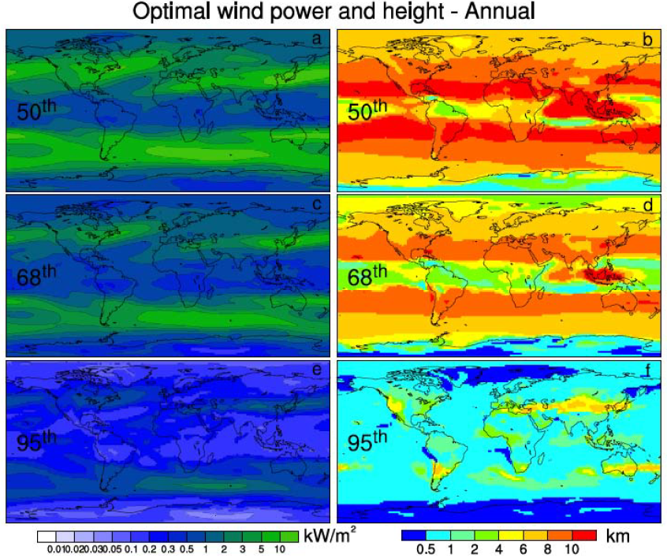
Figure 1 – Percentiles of wind power density (kW/m²) and height (km) during 1979-2006 (8)

More detailed ground level wind power densities in the UK is shown in Figure 2, and it appears that there is a further contrast of the potential of an AWE system against a traditional ground based wind turbine. The crucial aspect is that the wind power density at high attitude as shown in Figure 1 is approximately 3 – 5 kW/m², no less than 50% of the time within the entire UK.

However, in Figure 2 for the wind at ground level, i.e. 50 m above ground in hills and ridges, the mean wind power density is in the range from 0.4 to 1.8 kW/m² (9). The greater wind power densities shown in Figure 2 are available in the northern parts of the UK, i.e. Scotland. The wind power densities in Figures 1and 2 verify that AWE systems have the potential to at least produce double wind energy value than traditional wind turbines, since the wind power densities are two times the amount of what is available at ground level.
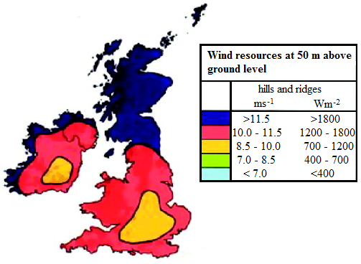
Figure 2 - Map of UK wind power densities at a height of 50 above ground level (9)

4.0 Regional Feasibility Study of an Airborne Wind Energy System
To assess the individual regions within the UK that shall deliver the most effective possibility of success, a decision matrix was created, in which eleven regions were graded on three criteria which are the electricity cost and energy savings, area availability, and obtainable high altitude wind energy within a regional vicinity.

Each individual criterion was set an equal weight, and the processes applied to establish the grades for the individual criterion are defined in the following sections. For this study, eleven regions were chosen. However, by applying the methodology developed in this study, other site locations can be evaluated. Therefore, AWE system developers could apply these stages as a standard means of discovering and evaluating appropriate site locations for their system.

4.1 Electricity Cost and Energy Savings
The UK regional potential energy and cost saving required two substantial aspects to be considered (1) the cost of electricity and (2) the regional energy requirements. The grade weighting within the cost and energy cretria was divided into 30% for the regional electricity requirements and a bigger weighted grade of 70% for the cost of electricity, as it participates more directly into the price savings per kWh of electricity created.

The cost of electricity within regional areas of the UK was the first aspect to consider, as bigger regional electricity prices could directly result in bigger cost saving for regions which implement an AWE system. Therefore, the regions that have larger electricity costs were correspondingly fixed higher marks. The estimated mean cost of electricity for individual regions was obtained from EDF Energy (10).

The electricity cost for individual regions was noted and the grade given to the cost of energy was estimated from normalising the cost figures on a scale out of 10, with the highest electricity cost region presented a mark of 10 points. The points of individual regions are shown in Table 1.
Table 1 – UK regional electricity costs and consumption marks

The regional electricity requirements were the second aspect to consider, as the quantity of energy being consumed by a region signifies the amount of energy the airborne system can be restored with renewables. This is founded on economies of scale, as bigger wind farm systems are inclined to be more cost efficient per watt-hour generated. Bigger wind farm systems are furthermore appealing as they can offer a bigger influence on the reliance of foreign oil, as well as assisting to improve the national security. Hence, the regions which exploit more yearly electricity are awarded bigger marks. The total UK annual electricity consumption for the years 2015 was obtained from the DECC Sub-national electricity and gas consumption statistics (11).

To achieve the energy savings grade, the entire yearly energy usage (GWh) for the year 2015 was noted. Next, the regional energy usage was normalised on a scale out of 10, with the largest energy usage region awarded a mark of 10 points. The points of individual regions are shown in Table 1.

4.2 Area Availability
In order for an AWE system to be successful, it is essential to ensure that there is sufficient space available to install and operate the device. This is considered to be predominantly vital in the premature phases of system development and testing, as time is required to enhance the safety and reliability of the device. Hence, a bigger safety barrier area is necessary for experimental program machines.

The aspects to consider in regards to area availability are (1) how active is the air traffic in the regional area and (2) how much ground space is available in the regional area? Solutions to these questions were evaluated by using information maps relating to regional air traffic as well as the population density. The grade for area availability was established from two aspects (1) the regional density of airline traffic and (2) the regional population density.

Preferably, developers of AWE systems would like to deploy a system direct or nearby a site location which they are supplying energy to. A beneficial way to assess the likelihood of discovering an appropriate site, with adequate space is to use the estimated population densities of regions where the system is to be implemented. Therefore, regions with high population densities will have lower possibilities of available space for the system. In addition, they are also inclined to have higher costs of leasing the land. This resulted in the lowest marks being awarded to regions with extremely high population densities.

The 2011 regional population densities of the UK was reported by the Office for National Statistics (12). The estimated population densities for the individual regions were noted and marks were awarded on a scale of 0 – 10. Table 2 demonstrates the scale which was employed.
Table 2 – Classification of population density marks

The grade weighting within the area availability group was divided into 40% for the regional airline traffic density and a higher weighted grade of 60% for the regional population density, as it is more advantageous to have energy generation systems situated closer to the consumer. The points of individual regions are shown in Table 3.
Table 3 - UK regional population density and airline traffic density marks

When an AWE system is in operation, it is essential to ensure that there is adequate air space available in the location of operation, as these devices are most effective at altitude heights which conflict with airplanes or helicopters. Thus, it is considered that regions with high airline traffic density are less expected to gain consent to be deployed.

A computer software Airline Route Mapper was used to contrast the airline traffic densities between the different regions (13). This application tool displays the airline flight paths of over 700 international airlines. A screen-print was captured of the airline flight paths over the UK, and the image was overlapped on Google Earth as shown in Figure 3 (14).

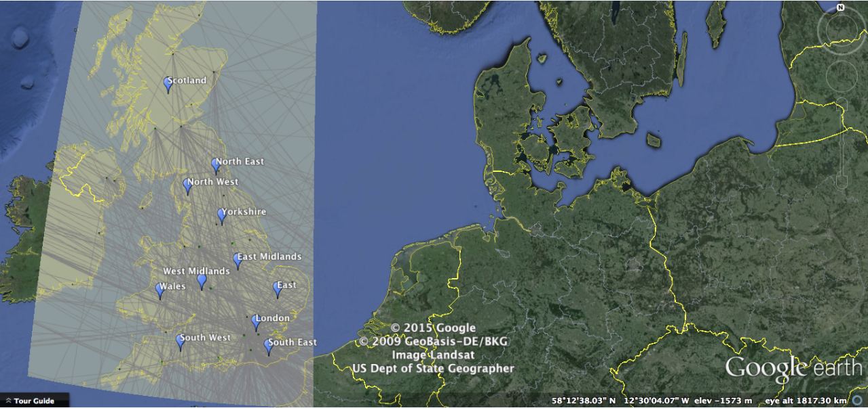
Figure 3 – Airline flight paths overlapped on Google Earth map of the UK

The pictures were then organised in sequence from high airline traffic density to less airline traffic density. This was carried out with a visual assessment and regions with big airports as well as a large amount of airline traffic were graded less.

Next, the regions were placed into one of the six classes presented in Table 3 and marked correspondingly.

4.3 Regional Airborne Wind Energy Density
The final classification in the airborne wind energy feasibility decision matrix is the obtainable high altitude wind energy within the different regions. The Global Assessment of High-Altitude Wind Power study, is used to establish the regional grades (8).

The obtainable wind power density at the individual regions was established by, overlaying the international wind power density map (Figure 1) over a Google Earth map of the UK regions being assessed. An example of the 50th percentile wind power density amplified and overlapped onto a Google Earth view of the UK is shown in Figure 4.
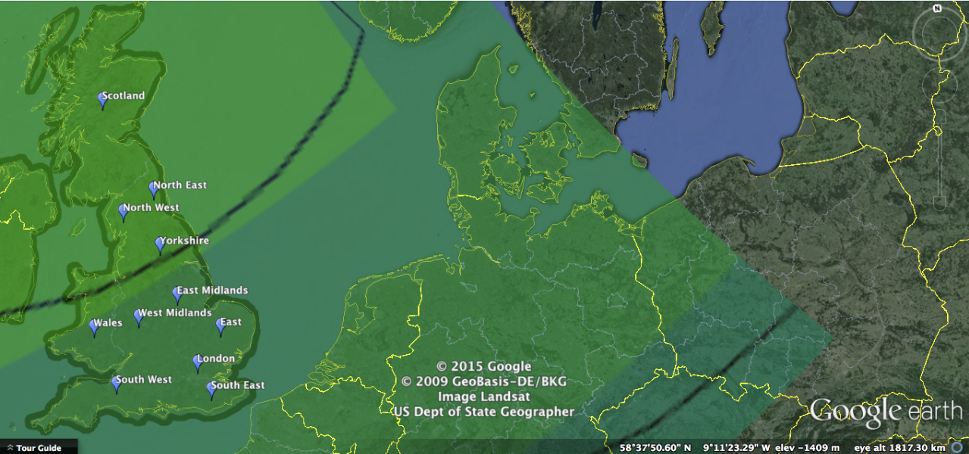
Figure 4 – 50th percentile wind power density overlapped onto the Google Earth map of the UK

A suitable assessment of the obtainable wind power densities for each region was established by contrasting the colours of the regions on the Google Earth map with the power density key, shown in Figure 5.

Figure 5 – Key for wind power densities (kW/m²) (8)

The power densities values were noted for the individual percentiles (50th, 68th, and 95th) and the marks were acquired from normalising the information on a scale out of 10 points; with the biggest power density regions awarded 10 points. Therefore, each individual region was presented three separate grades; one for each percentile. The grade weighting was the same for each of three grades in the obtainable wind power density classification. The points of individual are shown in Table 4.

Table 4 – UK regional AWE power density marks

It is observed from Figure 4, that wind power densities in the UK have a tendency to be at great in north regions, and the power densities start to reduce towards the south and the east. The biggest grades awarded in this classification are interpreted as a direct price saving in regards to an AWE system, in view of the fact that a system could deliver more power per unit in regions that have the biggest power density scores.

When developing an AWE system, it is essential to elect beneficial site locations that can deliver the greatest possibility of achievement. Hence, the aim of this assessment was to offer a standardised technique to contrast the different regions within the UK and identify the regional site location that would mostly benefit from an airborne wind energy system.

It is considered that a good grade on this assessment does not essentially ensure victory, and neither does a terrible grade suggest that an AWE system could not deliver a huge advantage to that region. The individual regions could have numerous requirements and difficulties which should have to be figured out before deploying an AWE system. This part of the study shall distinguish as well as emphasise the major aspects that have to be reflected upon in selecting the most ideal site locations.

5.0 Results Analysis and Discussion
When developing an AWE system, it is essential to elect beneficial site locations that can deliver the greatest possibility of achievement. In this study, eleven regional locations were assessed, the regional availability of AWE as shown in Table 5.
Table 5 – UK regional AWE feasibility results

5.1 Cost and Energy Savings
The top five regions in the classification of cost and energy savings are: Scotland, North West, Wales, South West, and North East. These five regions have relatively big electricity costs, and furthermore have extremely huge energy usage amounts which shrink the energy usage of many of the littler regions. In despite the fact that the cost of electricity was weighted extra compared to the energy usage aspect, it is clear that the energy usage aspect has a powerful influence on the grade for this classification.

It will be very advantageous to situate an AWE system in areas with the best cost and energy savings classification, as this will deliver a bigger effect on the price savings as well as the renewable energy usage (despite the fact that the region only uses one system) than other areas would.

5.2 Area Availability
In the classification of area availability, the five regions which established the greatest grades are: Wales, Scotland, North East, Yorkshire, and South West. These five regions are likely to have a larger chance of discovering an appropriate area on the ground to locate an AWE system. In addition these locations could also offer an extra sensibly sized area of safety in comparison to many of the regions in heavily populated locations.

These five areas are considered have more of a chance to acquire consent to utilise the airline space and to function an AWE system at the optimum altitude height for energy production. The isolation and land which is obtainable within these areas could furthermore participate in lowering the prices related to land use.

As a result of the area availability being so crucial for the operation of an AWE system, many of the regions with the worst grades in this classification may encounter a number of conflicts for the operation of AWE systems in their location. Due to this, it is substantial to be aware of the regions that established the worst grades in this classification.

The four regions with the lowest grades in this classification are: London, South East, West Midlands and East England. The following list of choices would probably have to be reflected upon by these four regions to effectively be capable of implementing and operating an AWE system:

- Implement a creditable sea type of an AWE system off the coast.
- Discover a gap in the airline traffic flight paths.
- Identify a site position (distant from big airports) which might comprise of airline traffic at larger altitude heights, and therefore a system could be operated at smaller altitude height.
- Get the CAA to produce air space for the operation of an airborne wind energy system.

Unfortunately these individual choices may offer problematic issues, in addition to larger added prices and hazards.

5.3 Regional Airborne Wind Energy Power Density
Regional AWE power density is the last classification that was assessed. The five regions with the highest grades are Scotland, North East, North West, Yorkshire and Wales. It is acknowledged that the greatest AWE power densities in the UK is in the north, and it is can be visually seen that the wind power steadily decreases for regions further south and east.

The AWE power is specifically valid for these areas, due to the fact that a big grade here suggests that it might directly transform into cost efficiencies for a system. The operation of every AWE system within these areas are more than likely to deliver considerably more power per generating system in comparison to other areas, as a result of the greatest grades being awarded in this classification. The outcome at these regions would comprise of smaller prices for the necessary upfront infrastructure, in addition to smaller charges in regards to the operation and preservation costs per kWh of electricity generated.

5.4 Best Regional Area of Airborne Wind Energy Feasibility Grades
The regions that received the highest top three total combined grades are Scotland, North West and Wales as shown in Figure 6. South West Ranked 6th overall is also included for comparison, given that it had two reasonable classification grades.

Figure 6 – The leading regional AWE feasibility grades

It is observed that these best three regions have the highest grades in either one or two out of the three classifications. Therefore, this can make either one of the three regions a suitable choice to implement an AWE system. The best three regions stand in comparison to South West which was graded satisfactory in two classifications, however the region had an extremely small grade in the regional AWE power density class.

This discrepancy participated to its comparatively smaller sixth position total score, and delivered the likelihood of severe implementation problems such as the cost efficiency of the system.

Scotland was awarded the greatest total grade as a result of the region scoring very good in each of the classifications. This region established the best grade in two out the three classifications. Scotland established the best regional AWE power density mark, which was bigger than the second place regional AWE power density mark for North West.

6.0 Conclusions
In this study, the implementation of regional AWE feasibility was assessed. A regional feasibility decision matrix was developed as a standardised method to help compare and contrast the different regions within the UK. It was found that the region of Scotland established itself as being the best suitable site location for implementation of an AWE system, as high scores were awarded for the power density, area availability as well as the electricity cost and energy savings.

This study suggested that within the Scottish region the cost of system will translate into being cheaper due to the high power densities. There is satisfactory ground and air space to operate the system as well as provide a good safety boundary for deployment and testing of the system. Lastly, the location would benefit more by having a bigger reduction in their electricity bills from the implementation of the system, as electricity costs and consumption within the area is high.

Reference

UK energy in brief 2017, Department for Business, Energy & Industrial Strategy
- https://en.wikipedia.org/wiki/Wind_power_in_the_United_Kingdom
- https://en.wikipedia.org/wiki/Renewables_Obligation_(United_Kingdom)
- NREL, January, 2012. Wind Energy Update: Wind Powering America, US: National Renewable Energy Laboratory.
- American Meteorological Society, 2009. Tapping Wind Power at High Altitudes. Bulletin of the American Meteorological Society, 90(9), pp. 1259-1261.
- Manwell, J. F., McGowan, J. G. & Rogers, A. L., 2009. Wind Energy Explained: Theory, Design and Application. 2nd ed. UK: John Wiley & Sons Ltd
- Husain, Z., February 2010. Air Breathing Engines. India: I. K. International Pvt Ltd.
- Archer, C. & Caldeira, K., 2009. Global Assessment of High-Altitude Wind Power. Energies, Volume 2, pp. 307-319.
- Risø National Laboratory, 2012. Wind Energy The Facts: Wind Atlases. [Online]
Available at: http://www.wind-energy-the-facts.org/wind-atlases.html
- EDF Energy, 2015. EDF Energy prices in your area. [Online]
Available at: http://www.edfenergy.com/residential/tariffs/prices
- DECC, December 2016. Sub-national electricity and gas consumption statistics, London: The Department of Energy and Climate Change.
- Office for National Statistics, 2011. 2011 Census - UK Population density. [Online]
Available at: ons.gov.uk/peoplepopulationandcommunity/populationandmigration
- 64 host, 2014. Airline Route Mapper. [Online]
Available at: http://arm.64hosts.com/
- Google Earth, 2017. Google Earth Maps. [Online]
Available at: https://www.google.co.uk/intl/en_uk/earth/

