Making a Racism Reporting Tool: A legal design case study
Andy Unger and Lucia Otoyo
This chapter describes a project by student volunteers to build a racism reporting tool for a local charity, The Monitoring Group (TMG). It grew out of a final year module on Law and Technology, which we have been running for Law students at London South Bank University since 2018/2019. The 20 CAT, one semester, Level 6 module runs in parallel with a Computing Sciences final year module called ICT Project Management in Practice and the students are taught and assessed together.
The modules aim to introduce students to the increasing impact of technology on the professions and professional careers, particularly in the field of legal services, and to help them develop and demonstrate new core skills that are likely to be in demand from employers. In the first few weeks, we explore and discuss LawTech, Legal Design and Project Management. Students engage in a short design project rethinking how to present social media contracts to users. They then work in multi-disciplinary teams to design a digital Access to Justice resource for a real client. Clients include members of our Legal Advice Clinic team and local lawyers, charities and organisations. Students are assessed by an individual piece of self-reflection (Coursework 1 – Careers, Skills & Personal Development Planning) and a group work report (Coursework 2 – which includes a recorded demonstration of the working prototype of their proposed resource).
It has always been our ambition to see potentially viable prototypes taken on and developed for use in the local community. The Law and Technology module is too short for this to be a realistic outcome. The volunteer project for TMG was our first attempt to realise our goal. In the long run, we hope to establish a LawTech clinic to create further opportunities for our students and support for local access to justice initiatives.

The Project
The Monitoring Group is a grassroots organisation established in Southall in the early 1980’s, by community campaigners and lawyers who wished to challenge the growth of racism in the locality. It has grown to become a national anti-racist charity that promotes civil rights. Their aims are: a) to promote good race relations; b) to advance race relations by means of education and awareness raising; and c) to relieve the needs of those who are distressed or suffering violence or harassment. They specialise in ‘family-led empowerment and justice campaigns’ which focus on casework, research and campaigns, including helping the families of, for example, Kuldip Singh Sekon, Ricky Reel, Michael Menson, Stephen Lawrence, Zahid Mubarek and Victoria Climbie.
The Law Division of London South Bank University has worked with TMG for a number of years, including hosting joint conferences. At one such conference, in October of 2018, which focused on State Racism, Collusion and Resistance, we agreed to explore developing a tool to enable victims to report incidents of racism to the TMG online. Presently, TMG receives over 1,000 calls a year to its Help Line, from people suffering racial violence, religious hatred, sexual violence and state neglect or misconduct. They do not have the resources to staff the helpline 24 hours a day, 7 days a week and are aware that many incidents go unreported and unaddressed. So, we agreed that an online reporting tool would be useful.
As an initial step, two senior Monitoring Group staff members, Suresh Grover and Dorothea Jones, volunteered to act as clients for groups of students taking the Law and Technology module. Their groups were asked to develop a racism reporting prototype for their assessed project work. Students consulted them to understand the needs of potential users and to test potential designs for the proposed reporting tool. After the students submitted their work, the projects were reviewed by TMG and it was agreed that together we had a good understanding of what was needed.

The Project Team
Then, in December 2019, we began the process of recruiting a group of student volunteers to help build a Minimum Viable Product (MVP) for The Monitoring Group to adopt, test and develop further. Students were invited to submit a one-page application letter outlining their motivation, skills and experience. Completion of the Law and Technology module was not a prerequisite. From those applications, Lucia and Andy recruited three law students and three computing students. The three law students were Gloria Feudjo-Tepie, Victoria Heidt & Jasmine Upton and they worked on content and design. The three computing students were Juan Carlos Blanco Delgado, who was the technical mentor and advisor, Nasir Cujaj, who was responsible for the frontend development, and Vittorio Rinaldo, who was responsible for the backend development.
We were also very fortunate to recruit Alex Hamilton from Radiant Law as a mentor. From the teaching team, Andy Unger, who knew the client and their problem well, acted as an internal client and Lucia Otoyo was the Scrum master/project coordinator.

How we worked
We used an ‘agile’ project management framework known as Scrum for our project. The goal of this framework is to promote flexibility and to allow the design process to continue throughout the lifetime of the product’s development, incorporating regular reviews by the team and the clients. This was necessary for our project because although we knew what we wanted to build, many questions about the best way to achieve our goals remained unanswered. The project was planned as a series of Scrum sprints (development iterations) each aiming to develop and test a selection of the product’s features. We chose to work on fortnightly sprints and met weekly, on our own mid-sprint so we could review progress and solve problems and with our clients at the end of the sprint to get their feedback. One of the key Scrum practices is the end of sprint ‘retrospective’ meeting, during which the whole team takes part in discussing what went well and what can be improved going forward into the next sprint. We also had the commitment and availability of all internal team members to work in close collaboration, which is the key requirement for this approach to work successfully.
Since not all team members were familiar with this way of working, Lucia trained us on Scrum methodology at the outset and then continuously coached on Scrum practices during the project. We started with weekly meetings at LSBU and then moved online when the coronavirus pandemic intervened. Our main tools were MS Teams for online meetings, Google Docs for sharing documents, WhatsApp for instant communication, Jira for managing the project development, Easy Retro for weekly sprint retrospective meetings and MockFlow for creating the designs. Tasks were created and assigned to team members during weekly Scrum planning meetings based on team members’ skills. Each team member updated progress on these tasks during each sprint on the JIRA board. We met at the end of each sprint and every team member demonstrated what they had developed or produced and feedback was provided which then fed into the next sprint. At the end of the meeting we held the sprint retrospective.

The Design Process
To begin with, we reviewed our understanding of the requirements of good legal design, particularly by reference to the work of Margaret Hagan and her three fundamental design principles: be user-centred, be experimental and be intentional. She outlines a five stage design process: discover; synthesize; build; test; and evolve, see Law By Design and Design Comes to Law School . To be user-centred, legal designers are encouraged to engage extensively with stakeholders at the discovery stage and to create detailed user personas for a range of specific imagined users at the synthesis stage. The consequent design brief is then explored and experimented and finally built in an iterative way, allowing for thorough testing with users and planned evolution, based upon practical operational experience and feedback. We also reviewed the design work of the Law and Technology students who had already worked on a TMG racism reporting tool for their assessed coursework. These students kindly assigned their intellectual property rights to TMG and allowed us to benefit from their work.
We were then ready for an initial meeting with Suresh Grover, TMG Director, to establish the project brief. Suresh spoke directly on behalf of potential TMG advisors and administrators and indirectly, based on his experience, on behalf of members of the public who might use the tool to report racist incidents. Suresh first helped the team to understand the typical concerns and potential vulnerability of people who seek help from TMG, including fears for their personal safety, anxiety about provoking further incidents, previous negative experiences with the police, language barriers and, sometimes, irregular immigration status. Consequently, Suresh explained, it was important to establish that TMG can be trusted and will deal with the issue promptly. He identified key messages to communicate, particulary: we understand your problem; we want to ensure you are safe; we understand it is not your fault; even if it is minor, we understand the impact; and, we will do everything we can do to help you.
Secondly, Suresh emphasised that the proposed tool is intended to supplement the TMG office hours Help Line and will be used for out of office hours emergencies, as well as more general advice and emotional and legal support. He advised that in an emergency, it is best to ask the minimum number of questions. Based on TMG practice, the key initial questions to be asked are ‘are you safe?’ and ‘have you reported the incident to the police?’. Victims in immediate danger needed to be advised to contact the police immediately. He also explained that, as is common in the advice sector, vulnerable clients may fail to continue to seek help if their initial effort fails for whatever reason. For this reason, all users need to be given an option to leave their minimum contact details and to request TMG to get back to them urgently, rather than making a full online report.
These insights led the team to identify the following essential features (known in Agile methodology as User Stories): a client can report an incident out of hours; TMG will be alerted to incoming reports so they can respond as soon as possible; a client can access initial information and advice online; TMG can allocate reports to advisors to follow up; and, the developed system has to be secure, as TMG has been the subject to cyber-attacks in the past. The following desirable additional features were also identified: TMG can search and compile reports from the same client, to be used as an incident diary to assist reporting and prosecution in cases of repeated acts of harassment and abuse and TMG can analyse report data collected to identify trends and hotspots of racist activity.
The detailed user stories we created are shown below (Table 1). Each user story captures the role of a particular type of user, what they want to achieve and why. Once we started discussing these user stories it became evident that as a team we didn’t have a common understanding of how the key function - report incident - should work, so we undertook a group exercise led by Victoria involving post-it notes and discussion to establish our first version of the process and required information needed for this feature (Figure 1).
User | Stories
Victims of Racism | I can call 999 through the app.  I can call TMG through the app.  I can complete a short contact form (out of hours).  I can submit a detailed racism report (including video/picture).  I can read the latest TMG news/posts.  I can get online resource (list of sites and their support type)  I can get online help (content provided by TMG)
TMG Staff | I can update the latest news report. (Create, Read, Update, Delete)  I can delete/approve forum posts.  I can update the online help section. (Create, Read, Update, Delete)  I can see report stats. (Number of cases, regions, timetable etc)  I can filter the reports.  After Report Submission:  Automatic Email is sent to the “victim” with Case ID.  Send a link to guide users to “self-service Page”.  TMG receives a message that a case is submitted.  TMG team reads and contacts the victim.  TMG updates case information for that victim.  After Emergency report submission:  TMG team is notified immediately.  TMG calls back the victim asap.
Table 1: Minimum viable product user stories
The next step was to start thinking of how the information will be organised within the system, in particular the page layout. The first draft was made by Nasir during one of our meetings (Figure 2), which we then revised over several iterations until we decided on the number of pages we needed and roughly what information we wanted to present on each.

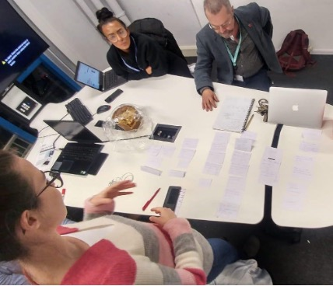
Figure 1: Clarifying the report racism feature
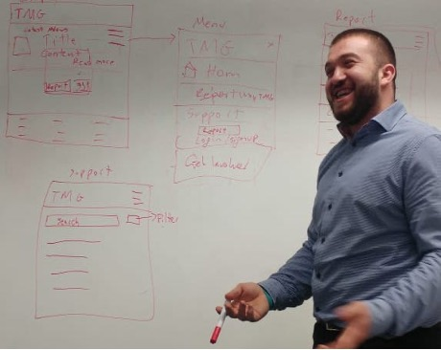
Figure 2: First version of the page layout
Having had a good enough understanding of the key features and the page layout, we started to create User Interface (UI) designs. Our first few versions were created using Google slides, but then we switched to using a professional UI planning tool MockFlow, which allowed us to use pre-built components (such as material design) that can be re-used by our development team and thus speed up the implementation. Figure 3 shows early designs of the report racism feature which underwent several feedback and review iterations. Gloria took these with her on a Black Lives Matter march to get instant feedback from fellow protestors and wrote up all their responses in a Design Report (Table 2) which we shared with TMG.
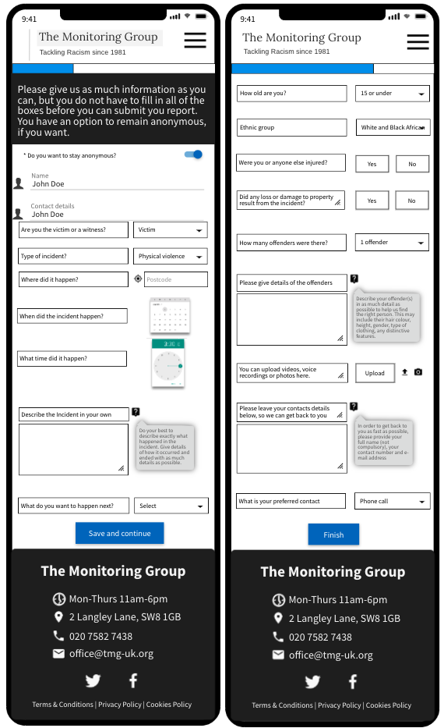
Figure 3: Early design of the ‘report racism’ feature

Protestors | Feedback
Helena, 17. | “... the best thing you could make is a website that tells you other people’s experiences and from that you can see how they dealt with it and go from there. I am tired of people who do not look like me telling me how to handle situations as they do not know how it feels like to be in my position.”
Joelle, 44. | “this website would need to ensure that if I report to them, they do something about it.
Jess, 20. | “… like now I have reported our abuse now what? What will you do with my data, I’m tired of speaking and not being heard.”
Mo, 19. | “offer useful legal information when I do report to you. That’s important”
Jay, 21. | “I would like a website that if I report I can also browse through valuable information. I do not know my rights and laws and lawyers are expensive. If you want to make a good app you will find a way to help people who have suffered abuse to know what steps to take”
JC, 12. | “There should be an option to vent to someone, but also ... a report section”
Nathan, 19. | “I think it would be nice to have a website where we can share our views on things that’s happened and also comment on others.”
Hanniyah, 19. | “have helplines attached to the website so people can know where to go if the comment section is not doing it”
Justine, 21. | “The main goal should be to show users on website that other people are going through what they went through. On twitter you can find people discussing their experiences but there lost in the other topics.”
Helena, 17. | “looks professional and nice but I don’t really get what you want me to do other than donate to the charities”
Hanniyah, 19. | “it’s very triggering I can’t lie. I think it needs to be more about helping us deal with racism than give reasons for us to be angry”
Table 2: Examples of feedback from Black Lives Matters protestors extracted from the Design Report
What we built
The application we have built, allows users to make detailed reports of racist incidents or simply request TMG to contact them. They are alerted to contact the police if they are in immediate danger. TMG can monitor and manage reports. They are alerted to urgent matters and can allocate and review reports for further action. TMG can compile individual reports into a log of incidents for anyone making a complaint or seeking a legal remedy. In the next stage of development, TMG will be able to analyse reports to identify significant patterns and trends of racist incidents over time and across the country.
The Scrum methodology we followed supported early and iterative development. As soon as we had a good enough understanding of the requirements, our technical team started the Technical review to research and select suitable technologies to implement the system. It was decided to build a progressive web application (as opposed to a native mobile app) that will allow users to access the site on any device without the need to download it, which was an important consideration for our user demographic. The application was split into two main parts from the development point of view, both of which can be seen in Figure 4 below. Firstly, there is an outward-facing frontend, built using React.js with Material UI React Framework, for members of the public to submit reports, access information and get online support. Secondly, there is an inward-facing backend, originally built using WordPress CMS and MySQL database, for TMG administrators to view and manage submitted reports. Each of these parts were responsible for different key features of the application, but all of them were linked, so close collaboration between the developers of each part was essential. WordPress was initially selected to develop the backend due to its out of the box features that allow for fast development. However, after several sprints we realised it did not have enough flexibility to allow us to implement the required features to an acceptable standard of user experience. There were too many compromises we had to make because we couldn’t design and label the frontend exactly as we wanted. Juan Carlos, our most experienced developer, undertook another technical review to find a suitable alternative. On his advice, we chose Directus v8, a Data-First Headless CMS & API Management platform, which proved to have the flexibility and all the required features to implement the backend. Once we completed the backend implementation, the founder of Directus asked us, as one of the active contributors to the new release of Directus, for permission to mention our project within one of their testimonials, which made us very proud.

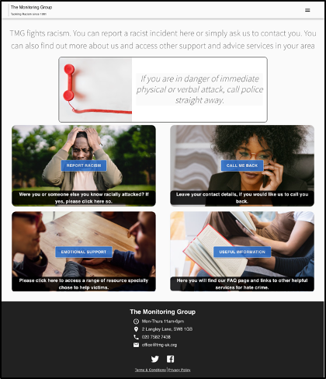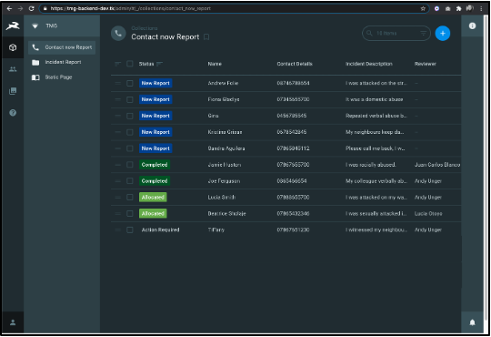
Figure 4: Frontend - desktop view of the homepage (Top) Backend - list of submitted reports (Bottom)
Nine months after the project began, the first release of the application was made available to the client for testing. The system was made available as a closed beta to the TMG team, the frontend and backend were self-hosted using a VPN as a docker-machine that belonged to the team during the project. Feedback from TMG was very positive, and because they were involved at regular intervals during development, the application only required minor editorial content changes before they approved it.
Alex Hamilton has allowed us to deploy and maintain the backend on a Radiant Law server, which provides stability and security and saves TMG costs. The application is now a standalone system.
After further consultation with TMG and Alex, we decided to undertake a further reimplementation, this time of the frontend. We decided to use form.io instead of React.js, so that it can be integrated directly within the TMG website. This decision was made to help improve the user experience and avoid visitor confusion by having two different sites, with overlapping content. At the time of writing, the second release is still under development. We are seeking direct engagement with users by asking grass roots members of TMG to submit test reports using this first release so we can gather feedback. By the time of publication, we expect that readers will be able to see and explore the tool at www.tmg-uk.org.

What we learned
We learnt the value and potential of intentional legal design and good teamwork and project management. It is important to gently resist any tendency for team members to want to get on with their own work and leave the rest to others. Everyone needs to be aware of what everyone else is doing, otherwise you may end up with difficult problems when you come to assemble the application from its parts. Our biggest problem, inevitably for a volunteer project, was time. The project lasted over 9 months, and throughout that time the students had significant work, study and family commitments, quite apart from the stress and disruption of the pandemic. At a certain point, we had to recommit to following the agile scrum methodolog because whenever someone skipped reporting on their progress we found ourselves drifting, sometimes in the sense of not making progress but often in terms of drifting apart, meaning that we all ended up working on slightly different projects. Not only was there a tendency to design/build what was easy rather than what was needed, but it became clear several times that we were all working to our own personal templates of what the tool would look like and do. In hindsight, despite our best intentions, we rushed the discovery stage of the design process. This was in part because the onset of the Coronavirus pandemic prevented a planned visit to observe a TMG advice session and in part because limited time led us to rely on Suresh’s experience rather than investigate further ourselves. In the end, we do not think this impacted negatively on our final design, but greater time spent involving the whole team in the creation of user personas might have helped to prevent the problem of us all working towards slightly different visions of both what the tool was for and how it would work. To address this, we appointed Andy as the internal client, to speak for TMG when they were not present, and Juan Carlos as a mentor/supervisor of the technical team. Scrum methodology facilitates and encourages this kind of intervention through retrospectives and the flexible allocation of roles for each Sprint. The most encouraging lesson was that none of us could have built the tool on our own, it is a product of our combined work, expertise and creativity and a testament to the power and importance of teamwork, greatly assisted by Agile methodology.

Conclusion
For us the project has been a success and encourages us to continue with our ambition to involve students in building LawTech resources for use in the local community. Initial feedback from TMG is also very positive but we will not really know if the tool is useful until it has been used and tested by TMG and users in real cases. We were very grateful to receive the support of Alex Hamilton at Radiant Law, who not only gave us valuable advice and feedback but stepped in at the end to solve some key problems in setting up the tool in a safe, sustainable and affordable way by giving us access to the time and resources of the firm. Feedback from our volunteers has been very positive. They were very impressed with the work of TMG and were glad of the opportunity to contribute to their fight against racism. They developed a deeper understanding of the importance of design, project management, communication and teamworking skills and the impact of technology on access to justice and legal services. They enjoyed the creativity and fun of teamworking and missed our weekly meetings once the coronavirus pandemic forced us to meet online. Finally, they have built something they are proud of and can include in their career portfolios.

Associate Professor in Law, London South Bank University
Senior Lecturer in Computing, London South Bank University
See The Monitoring group Website - http://www.tmg-uk.org/
For more information about the LSBU LAC, see - https://www.lsbu.ac.uk/study/study-at-lsbu/our-schools/law-and-social-sciences/subjects/law/legal-advice-clinic
For more information about the module, see Legal education meets computer science: an interdisciplinary approach to teaching law, Chapter in Gledhill, K. & Thanaraj, A. (Eds), (2020), Teaching Legal Education in the Digital Age, Routledge.
See The Monitoring Group Website - http://www.tmg-uk.org/
http://www.tmg-uk.org/state-racism-collusion-resistance/
Radiant Law specialise in applying LawTech solutions to commercial contracting, see their website for more information - https://radiantlaw.com/
See - https://www.scrumguides.org/ and https://www.atlassian.com/agile/scrum
For project management – see https://www.atlassian.com/software/jira
Formerly FunRetro, for our weekly retrospective reviews of our progress, see - https://easyretro.io/
To visualise and collaborate on our front end designs – see https://www.mockflow.com/
See Hagan, M., Law by Design - https://www.lawbydesign.co/
See Hagan, M. Design Comes to The Law School in Denvir, C. (Ed), Modernising Legal Education (2020), Cambridge University Press
The HMICFRS Report Hate Crime: What do Victims Tell Us (2018) reported that victims would like the police to be better at recognising hate crime, to be better trained in dealing with them and to be provided with clear and accessible information about support services. See https://www.justiceinspectorates.gov.uk/hmicfrs/wp-content/uploads/hate-crime-what-do-victims-tell-us.pdf (accessed 19th February 2021).
See also, Challenge it, Report it, Stop it: The Government’s Plan to Tackle Hate Crime (March 2012), para 3.2, review of reasons victims are reluctant to report hate crime. See https://assets.publishing.service.gov.uk/government/uploads/system/uploads/attachment_data/file/97849/action-plan.pdf (accessed 19th February 2021).
See for example Pleasance, P., Balmer, N. & Sandefuron, J., Paths to Justice: A Past, Present and Future Roadmap, Report prepared under a grant from the Nuffield Foundation (AJU/39100), August 2013 - https://www.nuffieldfoundation.org/sites/default/files/files/PTJ%20Roadmap%20NUFFIELD%20Published.pdf
See, for Example Agile Alliance: What are User Stories - https://www.agilealliance.org/glossary/user-stories/
As recommended by Wavelength Law and others – see https://www.wavelength.law/blog/legaldesign3
https://www.mockflow.com/
See https://reactjs.org/
See https://material-ui.com/
See https://en-gb.wordpress.org/
See https://www.mysql.com/
https://directus.io/
See https://directus.io/open-source/
https://www.form.io/
See section 3. Design Process for Lawyers in Hagan, M., Law by Design - https://www.lawbydesign.co/

