How to photograph onion skins.

Adam Brown

What is success? In the past, a successful photographic career led ultimately to a monograph or a retrospective. Let’s unbox one.

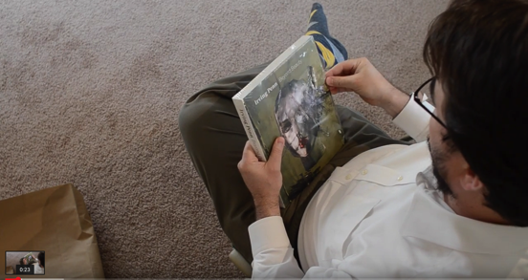
Embed Video : https://www.youtube.com/watch?v=2VzcqTSb4dg

A man sits in a comfortable chair. I look over his shoulder as he turns the pages of a book of photographs, a catalogue of the show Irving Penn: Beyond Beauty, exhibited at the Smithsonian from October 2015 to March 2016, and later the same year in Dallas. The man is dressed in formal yet comfortable clothes, clean white shirt unbuttoned at the top, shoeless in modernist socks. He peels off the shrink-wrap, and browses, slowly, turning the pages so that they are visible to me, the invisible intruder.

Unboxing - a now established YouTube phenomenon in which consumers upload videos of themselves opening new purchases (mostly toys or gadgets) - has finally filtered up to the photographic cognoscenti. The act of possession is staged for your entertainment – only in this case the object of desire is not a Marvel figurine but different kind of superhero.

Irving Penn – one of the big bulls of photography – considered the artificiality of the studio space a creative challenge. The proscenium of backdrop and lights is never taken for granted: Penn constantly breaks and rebuilds it. Even in his more formal work, the edge of the studio backdrop intrudes, working clothes are photographed as if they were high fashion (6:17), studio equipment is assembled in innovative ways to remodel the space.

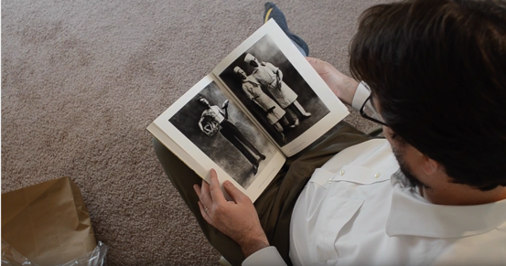
Embed Screenshot: 6:17

Crossing the threshold from ‘real world’ to ‘studio’ is a significant architectural moment – and a moment of photographic ‘weirding.’ In my experience, whenever you open a portal of this kind, something crosses the threshold to our world…

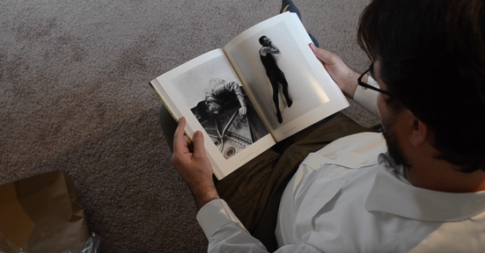
Embed Screenshot: 3:13

At 3.13 a corner formed by studio backdrop supports echoes the structure of the book, the human subject boxed in, as the man is himself cropped, his feet unboxed, in his hoovered house.

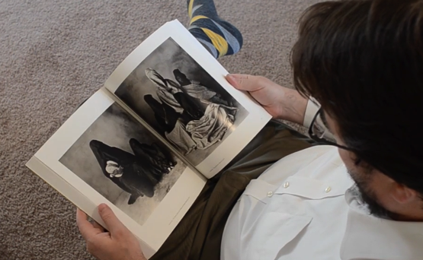
Embed Screenshot: 8:00

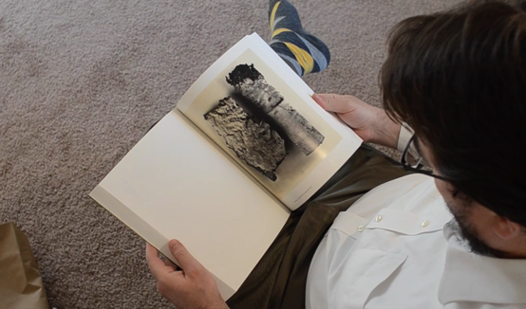
Embed Screenshot: 8:22

At 8.00 we look over his shoulder at an image of veiled figures, resisting our gaze forever – using pause and rewind we can watch this unreveal again and again. At 8.22 we are invited to spend time looking at a supersized cigarette butt in a spotless house with no attendant risk of contamination.

Penn understood that the studio was a kind of trap - a box into which people are lured with the promise that they will come out intact, but from which they emerge skinned. We don't know much about the lives of his bakers, chimney sweeps and hod-carriers, but their outward appearance is captured and delivered to our comfortable homes. Fashionably ethnographic, he innovated a ‘tent studio’ which he transported to Morocco, Nepal, Mali, Papua New Guinea in a Jeep – not so much a time machine as a context machine. Marcel Duchamp in reverse, he transported the gallery to the readymade. He boxed people. If you can’t take the people of Cuzko out of the Andes, he reasons, you can take the Andes out of the people of Cuzko. (4.57)

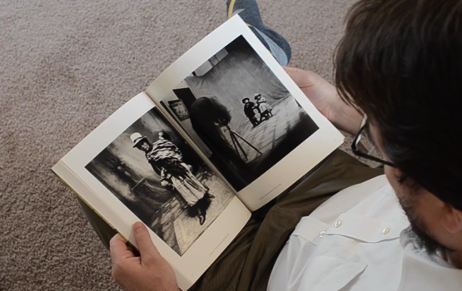
Embed Screenshot: 4:57

Watching over the man’s shoulder, I feel like a voyeur watching a voyeur ogling a voyeur. The curiosity – healthy or unhealthy – Penn had for the people he lured into his studio extends to the author of our video. Tempted into the frame by the possibilities offered by technology, he becomes the object of both my gaze and Penn’s – by some kind of spooky action, as if the photographer’s gaze lives on after death, through the magic of reproduction. He has stepped right into the trap, the vortex. And so have I. And now so have you. (6.40)

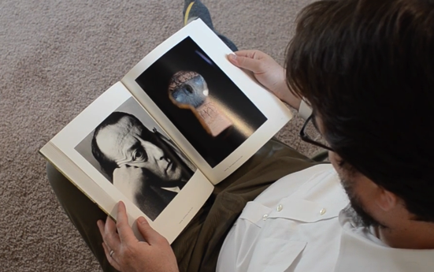
Embed Screenshot: 6:40

Here’s some background on Penn for the curious. He writes:

I would often daydream of being mysteriously deposed in my ideal studio among the disappearing aborigines of course in remote parts of the earth. In my phantasies [sic] these remarkable strangers would come to me and place themselves in front of my camera and in the clear north sky light I would make records of their physical presence, pictures that would survive us both and at least to the extent something of their already disappearing cultures would be forever preserved.

Photographic culture is as remarkable – or even stranger - than that which Penn sought to collect and preserve against the threat of their – and his - obliteration. Let’s journey further.
…

On a quiet day – the kind of day you find yourself leafing through books - I’m watching people watching things on YouTube, again. I’m looking for online tutorials about studio lighting to recommend to my students. I’ve decided that, rather than planning to demonstrate the essentials of high key and low key lighting for a coming class, I’ll recommend some videos so we can spend workshop time improvising creatively. There are some good tutorials out there. My students can watch, pause and rewind to their heart’s content. (So far, nobody has found a way to ‘upgrade’ a lecturer to include pause and rewind functionality. Yet.)

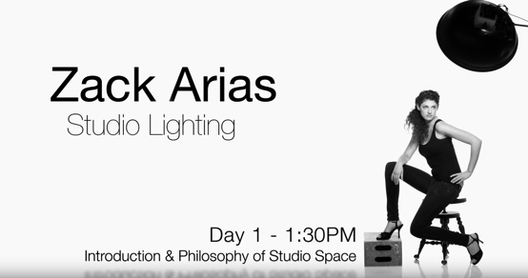

Embed Video: https://www.youtube.com/watch?v=jHD9Win0I1I

Here’s a ‘keeper’ – it’s a video about ‘the philosophy of the photographic studio.’ But no, it’s not some lost archive footage of philosopher Vilem Flusser, it’s Zack Arias, in a big networked cavern in Seattle. Produced by the online creative education channel CreativeLive, it takes place in a purpose-built photography studio within a film studio. Zack’s a good speaker, with a down-to-earth demeanour, his feet obviously on the ground. He talks about his family and backstory, about his origins, how he made himself. How he made himself a subject. He tells a story about how, beginning from working out of coffee shops – of course - and from home, he graduated to big studios and a style characterised by white seamless backdrops. (I wonder what kind of socks he wears when he takes off his shoes off to walk on the backdrop paper?) I like this space – it’s definitely a place of work. I like the brickwork, the sofas, the lighting. I could relax here, and work – as if chilling and working could somehow be the same thing. I like his style - if I was there, listening to Zack, I could learn something.

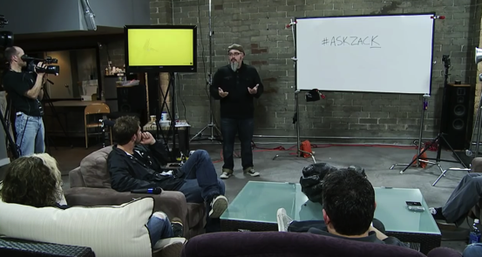
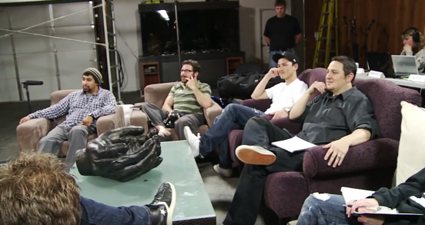
Insert Screenshots of students

Look at the people he’s gathered together – model students, they have the requisite hunger for knowledge and know how to sit quietly and pay attention. They don't resemble my classes, demographically. The gender balance is wrong, for a start. I imagine after-shoot drinks – we could probably shoot the breeze, though maybe talk would turn to uncomfortable topics - maybe gentrification and the creative industries. Curses, I find I’ve sabotaged my dream. Again. I would love to be able to teach like this, but I couldn't teach like this. Faced with the choices he had to make when he was poor, (11.50) I would have bought a Jeep, like Penn.

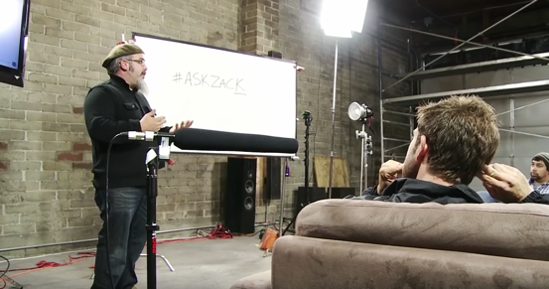
14:40
At 14.40, as Zach explores the architecture of studio set-ups, I find myself thinking about real estate deals. I’m looking at the rig – kilos of it – and how the production team have lit the workshop participants. Nice lighting - what’s the brand? Looks good on them, and good on Zack. However, unlike Irving Penn’s anxious, nomadic studio, this seems like somewhere to photograph the similar, not the different.

I carry on looking distractedly past Zack at the background, the networked studio, thinking about how this thing I’m watching is made. I’m not thinking about studio photography any more. I’m thinking about making a living from teaching studio photography, becoming a YouTube star. I’m thinking about how such a career could maybe fund a property portfolio. The CreativeLive ‘studio-within-a-studio’ is the kind of well-resourced learning environment I would love to have at my disposal. Impressively networked and effortlessly adaptable. It’s like the scene for the final TED talk of your life, when you have to account for your every action to the final boss (13:50).

Half way through the episode I feel inspired to flick to a video I’d previously watched about social reproduction. Now here’s something my students might find useful. Social reproduction theory describes how cultural and social practices replicate themselves – how they are handed on, how they are promoted, spread. What kind of mechanism makes new photographers? Photography seems hard-wired to reproduce itself. I feel that Zack’s video is half technical instruction, and half fantasy – a fantasy of autonomy, daring, entrepreneurialism – all the keywords that promise success, or at least an escape from precarity. But these are promises, not guarantees. YouTube does not deliver photography to us so much as deliver us, potential photographers or consumers, to a hungry market. The market unboxes us – this is one definition of success.

