Breast Biopsy Characterization Through Microwave Imaging Using MammoWave® Apparatus

Daniel Álvarez Sánchez-Bayuela^{(1,} ³⁾, Cristina Romero Castellano⁽¹⁾, Rubén Giovanetti González⁽¹⁾, Lina Marcela Cruz Hernández⁽¹⁾, Paul Martín Aguilar Angulo⁽¹⁾, María Pilar Sánchez-Camacho González-Carrato⁽¹⁾, Juan Ruiz Martín⁽¹⁾, Lorenzo Sani⁽²⁾, Alessandro Vispa⁽²⁾, Mario Badia⁽²⁾ and Gianluigi Tiberi^{(2,4)}
- General University Hospital, Toledo, Spain

UBT- Umbria Bioengineering Technologies, Perugia, Italy
- University of Castilla – La Mancha, Toledo, Spain (Daniel.Alvarez@uclm.es)

School of Engineering, London South Bank University, London, UK

Abstract— Nowadays, novel microwave imaging applications in breast cancer screening are being investigated as an alternative technique to traditional mammography and recent tomosynthesis. In this context, MammoWave® system shows great potential to identify breast lesions based on their dielectric properties. Dedicated phantoms have been used to test, validate, and characterize the system, but additional research is necessary for further studying in vivo dielectric behavior of tissues. For optimization and capability enhancement of lesions discrimination via microwave imaging, a set of different biopsied tissues has been collected to analyze their impact in a controlled environment. This paper highlights the potential of the microwave images obtained with MammoWave® device to correctly identify different pathological samples through the analysis of different images’ features.

- INTRODUCTION
In recent years researchers have increased their attention to new technologies such as microwave imaging, for breast cancer detection [1]. Microwave imaging methods are developed to discriminate between healthy tissues and tissues with lesions by exploiting their contrast in dielectric properties. In [2] a high contrast is shown only between malignant and fatty breast tissues, while a lower contrast (lower than 10% in dielectric properties) is found between healthy fibro glandular and malignant tissues. Moreover, it is demonstrated that the dielectric properties of benign lesions are similar to the properties of fibro glandular tissues.
Pioneering microwave technology, Umbria Bioengineering Technologies (UBT srl) designed, developed, and tested MammoWave®, a new apparatus that discriminates between healthy tissues and tissues with lesions based on an innovative reconstruction algorithm.
This paper is aimed to tackle a new research field using the microwave apparatus, proposing a novel approach through biopsied breast tissue. Specifically, the procedure aims to correctly identify different pathological samples through the analysis of different microwave images’ features, giving a better understanding and quantification of the homogeneity variations of the correspondent microwave images. An optimized methodology has been developed from the initial collection of biopsy samples to the analysis of MammoWave® images’ output parameters. Several objectives were proposed including: (i) Design a specific procedure for analyzing biopsy

samples through MammoWave® device; (ii) analyze the microwave response via reconstructed images’ parameters to determine patterns for tissue classification.
The rest of the paper is outlined as follows. A brief description of the device is provided in Section II, as well as the description of the experimental procedure. Experimentation results are described in Section III, while Section IV concludes the paper.
- MATERIALS AND METHODS
- Microwave system MammoWave®

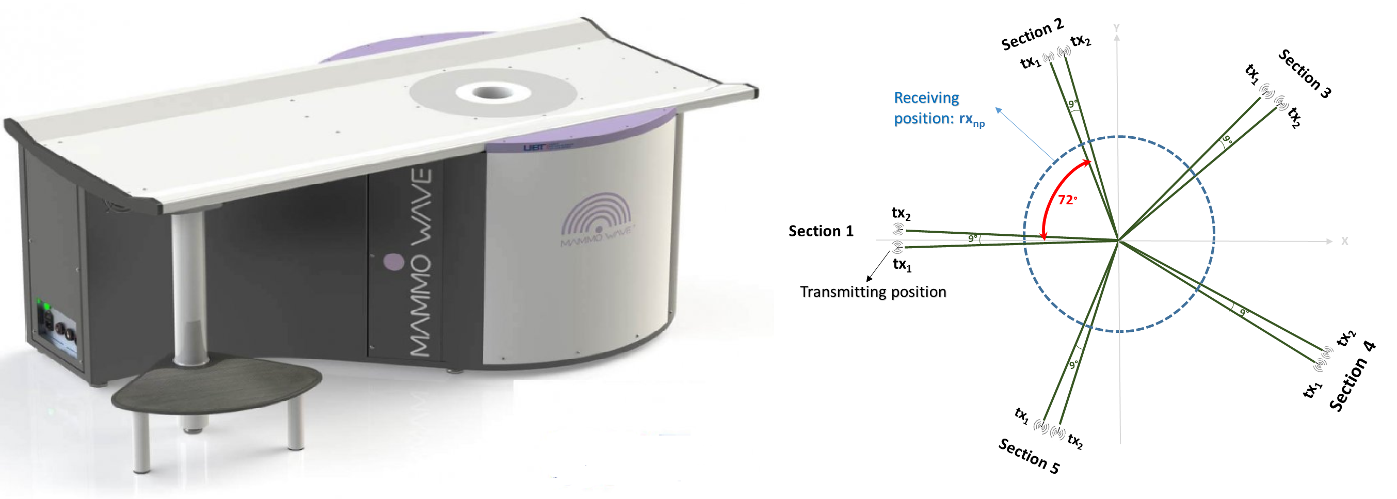
Figure 1. UBT’s MammoWave® system (left) and acquisition configuration (right).
MammoWave® system is composed of two antennas operating in air: one transmitting antenna (Tx) that emits the electromagnetic fields in the microwave band (1-9 GHz), and one receiving antenna (Rx) which detects the correspondent scattered electromagnetic fields via a Vector Network Analyzer (Cobalt C1209, Copper Mountain, Indianapolis, IN). Both antennas are surrounded by a cylindrical aluminum hub internally coated by absorption cones, which arranges as an anechoic chamber. Microwave signals are collected in the 1-9 GHz frequency band with a frequency step of 5 MHz, from different angular positions using the two movable antennas (Tx, Rx). Antenna’s configuration and acquisition details are described in [3]. Finally, the signals collected in the VNA from Rx (i.e., complex matrix S21) are sent to an external server and processed through an imaging algorithm based on Huygens Principle (HP) to generate a digital image. More details of HP and its application in image reconstruction can be found in [4].
- Experimental procedure
This paper proposes a thorough methodology, from the initial recruitment of women suitable for breast biopsy to the very last analysis of the samples using MammoWave®, and its

2022 IEEE International Symposium on Antennas and Propagation and USNC-URSI Radio Science Meeting (AP-S/USNC-URSI) | 978-1-6654-9658-2/22/$31.00 ©2022 IEEE | DOI: 10.1109/AP-S/USNC-URSI47032.2022.9886646
978-1-6654-9658-2/22/$31.00 ©2022 IEEE

874

APS 2022

correspondent pathology output. Initially, a subject recruitment strategy is proposed in agreement with regular hospital circuits. For the experimentation proposed in this paper, we recruit patients that must undergo a biopsy and one of their extracted samples is used for MammoWave® imaging, prior to pathologist exam. Specifically, after biopsy extraction, the sample is attached to a dedicated phantom adapter in a controlled environment (see Fig 2), i.e., a cylindrical phantom filled with sunflower seeds oil.

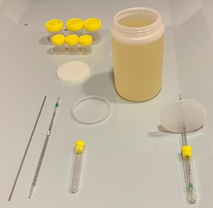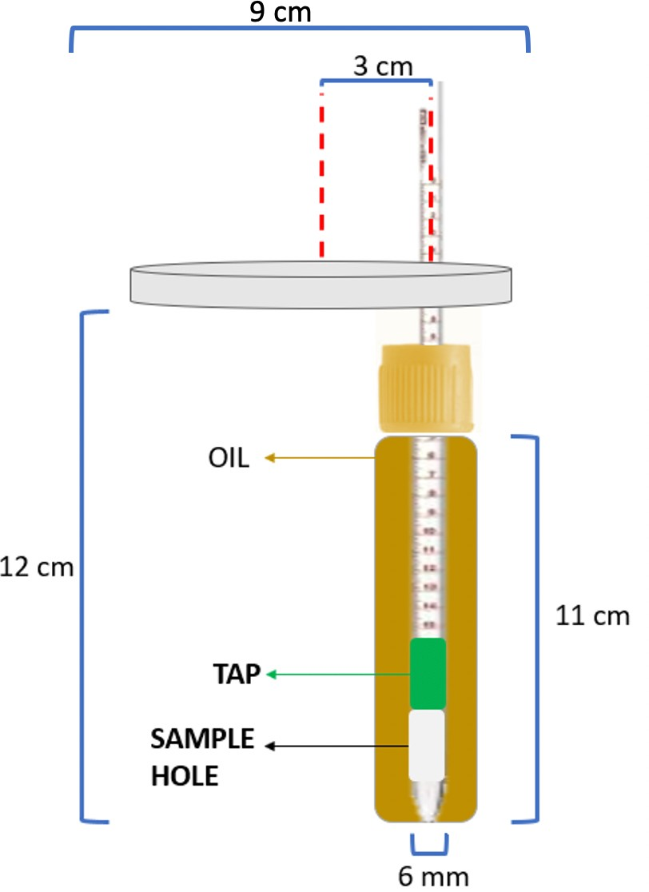
Figure 2. Experimental set-up (left), and biopsy container (right).
Some initial tests of sample immersion in sunflower seeds oil after its extraction from formalin were done to evaluate the possible impact of oil in tissue stability. No relevant distortion of tissues was found.
MammoWave® imaging was performed on the biopsy samples; for each image, microwave images’ features (including maximum to mean ratio, maximum to median ratio, skewness, variance) have been calculated. Results were correlated with pathological analyses output. As control tests, MammoWave® imaging was performed also the cylindrical phantom (filled with sunflower seeds oil) without any probe (i.e., with no biopsy sample); note that sunflower seeds oil has dielectric properties similar to adipose breast tissues [5].
A total number of six biopsy samples were analyzed (3 times per sample) through microwave imaging using the container shown in Fig. 2. Most usual radiological findings: calcifications, fibroadenoma, ductal carcinoma in situ (DCIS), invasive ductal carcinoma (IDC), were analyzed to evaluate MammoWave® potential ability to differentiate common breast conditions. Every sample was identified by an ID number to correctly distinguish among samples during the study (note that 3a and 3b are two samples from the same breast). Table I summarizes subjects’ information.

TABLE I. SUMMARY OF RADIOLOGICAL INFORMATION AND PATHOLOGY OUTPUT.

Sample Id | Age | Breast density | Radiological finding | Pathologic output
1 | 46 | C | Noduli | Fibroadenoma
2 | 83 | C | Noduli + calcifications | IDC + DCIS
3a | 75 | A | Noduli | IDC
3b | 75 | A | Adenopatia | Adenocarcinoma
4 | 46 | B | Arch. distortion | No neoplasia
5 | 27 | D | Noduli | Fibroadenoma
- RESULTS AND DISCUSSION
MammoWave images are intensity maps, representing the homogeneity of dielectric properties of the phantom (or breast) under investigation. In Table II microwave images’ parameters (already introduced in [5]) for each different
sample are provided as average numbers with corresponding standard deviations. The two fibroadenoma samples provide quite similar metrics (i.e., ~10%), not change heavily in women from 27 to 46 years old. However, deeper studies must be performed in the future to confirm such finding.
Besides, it is clearly observed that a huge differences in metrics (i.e., >50%; the skewness changes its sign) with respect to control probes appear in adenocarcinoma, since its composition varies a lot and presents high dielectric properties contrasts.

TABLE II. AVERAGED MICROWAVE IMAGES’ PARAMETERS OF COLLECTED BIOPSY SAMPLES

Sample Id | Max/Avg | Max/Med | Skewness | Variance
Control | 1.43 ± 0.08 | 1.31 ± 0.08 | -0.92 ± 0.10 | 0.07 ± 0.00
1 | 1.63 ± 0.08 | 1.57 ± 0.09 | -0.47 ± 0.16 | 0.09 ± 0.01
2 | 1.76 ± 0.16 | 1.63 ± 0.15 | -0.38 ± 0.25 | 0.10 ± 0.02
3a | 1.66 ± 0.08 | 1.59 ± 0.10 | -0.36 ± 0.23 | 0.10 ± 0.00
3b | 2.18 ± 0.01 | 2.24 ± 0.15 | 0.39 ± 0.03 | 0.14 ± 0.02
4 | 1.46 ± 0.06 | 1.36 ± 0.08 | -0.72 ± 0.18 | 0.08 ± 0.00
5 | 1.59 ± 0.10 | 1.50 ± 0.10 | -0.61 ± 0.19 | 0.08 ± 0.01

- CONCLUSIONS
A specific procedure for analyzing biopsy samples through MammoWave® device was successfully designed, in agreement to internal clinical circuits and in accordance with specialists. Image parameters from reconstructed images were analyzed and differences among tissues were observed. HP reconstruction of microwave images provided clearly remarkable differences in terms of image metrics in presence of biopsy samples with respect to control probes.

ACKNOWLEDGMENT
This project has received funding from the European Union’s Horizon 2020 research and innovation program under grants agreements No: 830265, 872752, 101017098. Clinical data used in this paper have been collected in the context of MammoWave clinical trials, executed in Hospital Virgen de la Salud, Toledo, Spain (ClinicalTrials.gov Identifier: NCT04253366).
REFERENCES
- M. A. Aldhaeebi, K. Alzoubi, T. S. Almoneef, S. M. Bamatraf, H. Attia, and O. M. Ramahi, “Review of Microwaves Techniques for Breast Cancer Detection,” Sensors, vol. 20, no. 8, p. 2390, Apr. 2020, doi: 10.3390/s20082390.
- M. Lazebnik et al., “A large-scale study of the ultrawideband microwave dielectric properties of normal, benign and malignant breast tissues obtained from cancer surgeries,” Physics in Medicine and Biology, vol. 52, no. 20, pp. 6093–6115, Oct. 2007, doi: 10.1088/0031- 9155/52/20/002.
- L. Sani et al., “Breast lesion detection through MammoWave device: Empirical detection capability assessment of microwave images’ parameters,” PLOS ONE, vol. 16, no. 4, p. e0250005, Apr. 2021, doi: 10.1371/journal.pone.0250005.
- N. Ghavami, G. Tiberi, I. Craddock, P. Probert Smith, and D. Edwards, “Non-iterative beamforming based on Huygens principle for multistatic ultrawide band radar: application to breast imaging,” IET Microwaves, Antennas & Propagation, vol. 9, no. 12, pp. 1233–1240, Sep. 2015, doi: 10.1049/iet-map.2014.0621.
- A. Vispa et al., “UWB device for breast microwave imaging: phantom and clinical validations,” Measurement, vol. 146, pp. 582–589, Nov. 2019, doi: 10.1016/j.measurement.2019.05.109.

875

