An experimental and CFD study into the dispersion of buoyant gas using passive venting in a small fuel cell enclosure

T.S. Ghatauray, J.M. Ingram, P.G. Holborn, Explosion and Fire Research Group, London South Bank University, Borough Road, London, SE1 0AA, UK

With the emergence of a ‘Hydrogen Economy’, fuel cell (FC) deployment in small enclosures will become common place. However, hydrogen’s wide flammable range (4-74%) poses a significant safety concern. Without adequate ventilation, a hydrogen gas leak from a FC could create flammable mixtures in the enclosure, and hence the potential for an explosion. Traditionally, a mechanical ventilation system would be employed in an enclosure to ensure that the hydrogen gas is removed and prevent a flammable concentration forming. However, in many applications (e.g. low power and remote installations) mechanical ventilation is undesirable, since it would drain the FC output and its operation would be vulnerable to any power failures that may occur. In such situations, it is therefore desirable to be able to employ a passive ventilation system to remove the hydrogen gas from the FC enclosure. Passive ventilation relies upon buoyancy driven flow, with the size, shape and position of ventilation openings critical for producing predictable flows and maintaining low gas concentrations.

Determining the relationship between gas leak rate, ventilation configuration and internal concentration of buoyant gas will help to inform and optimise FC enclosure safety design. An experimental and Computational Fluid Dynamics (CFD) study was therefore carried out to investigate helium gas dispersion (employed as a safe analogue for hydrogen gas) in a 0.191 m3 ventilated enclosure. The helium gas was released from a centrally positioned, vertical, 4mm diameter nozzle at low flow rates (1-5 L/min), to simulate a hydrogen leak from a fuel cell (FC) in a small enclosure. A single narrow horizontal vent was created at the top of one vertical face. The helium leak rate was varied and observations of dispersal behaviour and gas concentration made. Similarly positioned vents were introduced on the remaining vertical faces and further observations made. Ventilation flow rates were found to increase as the number of vents increased, and became more effective at keeping helium concentrations below 4% v/v, across the range of leak rates investigated. A cross-flow passive ventilation scheme using opposing lower and upper matched vents provided comparative data.

The cross-flow arrangement provided effective displacement ventilation and performed best. The more challenging, high-level vent arrangements provided mixing/exchange ventilation, which became more effective with increasing number of vents. The CFD model was found to be able to replicate the experimental flow behaviour observed, but with variance in concentration levels produced.

Keywords: hydrogen safety, helium, passive venting, buoyancy driven flow, fuel cell enclosure

Introduction

Global, social, economic and environmental pressures have led to the emergence of a ‘hydrogen economy’, using hydrogen fuel cells (that produce ‘clean’ energy with no carbon emissions and only water and heat as by-products) to reduce carbon emissions and create a distributed (grid independent) energy supply structure. Consequently, hydrogen fuel cells (FCs) are now being increasingly employed in transport, domestic power and heating and industrial scale plant applications. Such hydrogen FCs are typically deployed in enclosures, which provide weather protection, physical security, hazard mitigation and aesthetics. However, hydrogen’s wide flammable range (4-74%) poses a significant safety concern. Without adequate ventilation, a hydrogen gas leak from a FC could create flammable mixtures in the enclosure, and hence the potential for an explosion. Hydrogen gas safety is also an issue in the nuclear industry where hydrogen can be generated via radiolysis and/or corrosion in enclosures containing nuclear waste (e.g. storage liners and boxes) and must be reliably removed to prevent it accumulating and reaching a flammable concentration.

Traditionally, a mechanical ventilation system would be employed in an enclosure to ensure that the hydrogen gas is removed and prevent a flammable concentration forming. However, in many applications (e.g. low power and remote installations) mechanical ventilation is undesirable, since it would drain the FC output and its operation would be vulnerable to any power failures or reliability issues that may occur. In such situations, it is therefore desirable to be able to employ a passive (natural) ventilation system to remove the hydrogen gas from the enclosure. Passive ventilation relies upon buoyancy driven flow, with the size, shape and position of ventilation openings critical for producing predictable flows and maintaining low gas concentrations.

Passive hydrogen removal research is motivated by accident prevention and understanding hydrogen’s behaviour in hazardous scenarios (Weiner S.C. 2014). Hydrogen accidents begin with evolution/leaks in air, followed by ignition, fire or deflagration with thermal/pressure effects which threaten life and property. Confinement scenarios have more serious outcomes since significant explosion overpressures can be developed (Molkov 2012). An early study examining the release of a buoyant fluid in an enclosure was made by Baines and Turner (Baines and Turner 1973) who developed a ‘filling box’ model. Epstein (1988) and Swain (2002) investigated buoyant gas behaviour in geometric enclosures, using salt water analogue techniques focused on nuclear and fire safety. Recent work such as the HYPER project (Hyper-2015) has focused upon the role of hydrogen as an energy carrier and use in stationary hydrogen FCs and raising user confidence (Friedrich 2010). Hydrogen FC deployment will be in small enclosures (indoor and outdoor), garage sized buildings and vehicles.

Passive hydrogen management is favoured due to inherent reliability and hydrogen’s suitability as a buoyant gas (Hübert, T 2011). Schemes for removal of pollutants from buildings, air-flow management and thermal control are well established (Liddament 1996). Application of passive ventilation concepts to simple hydrogen FC enclosures should manage concentrations below the LFL (Bachellerie 2003).

Linden (1999) has extensively reviewed the conditions responsible for producing natural ventilation. Density differences and buoyancy are the driving forces in scenarios where wind forces are absent. Linden identifies two distinct regimes of ventilation: (i) mixing ventilation (e.g. via a single upper vent) which produces an (approximately) uniform concentration throughout the interior of an enclosure and (ii) displacement ventilation (e.g. via two vents one located near the top and one near the bottom) where the gas is stratified into distinct layers.

The effect of vent geometry and design on natural ventilation in small enclosure was investigated by Cariteau et al (2013) using the GAMELAN enclosure with a single high level vent and helium as the buoyant gas. They found that the vertically tallest vent quickly achieved a homogenous upper layer, producing a high density gradient.

The terms “passive ventilation” and “natural ventilation” have often tended to be used interchangeably to denote a naturally driven ventilation system (i.e. one which is passive in nature and is not driven by a mechanically forced system). However, Molkov et al. (2014) have suggested a more precise usage of the terms. For natural ventilation (applicable to the flow of air) the neutral plane is assumed to be positioned approximately half-way up the opening. However, under passive ventilation conditions, which can occur for lighter than air gases, particularly those capable of filling the entire enclosure, such as hydrogen (for a single vent scenario), the neutral plane (where the pressure inside and outside the enclosure is equal) can be positioned anywhere between the half-way point and the bottom of the ventilation opening. By removing this assumption they are able to derive a generalised expression for the gas concentration for a well-mixed, single upper vent passive ventilation scenario.

Obtaining further information about the relationship between gas leak rate and the resulting internal concentration of buoyant gas for different passive ventilation configurations will help to inform and optimise future FC enclosure safety design. An experimental and Computational Fluid Dynamics (CFD) study has therefore been carried out at LSBU to investigate helium gas (employed as a safe analogue for hydrogen gas) build-up and dispersion behaviour in a 0.191 m3 (internal volume) enclosure for different passive ventilation configurations and in particular the effect of using different numbers of upper horizontal vents. The helium gas was released from a centrally positioned, vertical, 4 mm diameter nozzle at low flow rates (1-5 L/min), to simulate a hydrogen leak from a fuel cell (FC) in a small enclosure. The helium gas flow rate and vent configuration were varied and observations of the dispersal behaviour and gas concentration achieved. A cross-flow passive ventilation scheme was achieved via opposing lower and upper matched vents.

Experimental setup

An experimental rig (Figure 1) has been developed at LSBU to investigate the effect on passive buoyant gas ventilation behaviour (using helium as an analogue for hydrogen for safety reasons) for a representative small-scale enclosure (that could represent, for example a nuclear waste skip liner or fuel cell enclosure). The rig consisted of a large Perspex outer chamber 1 m x 1m x 2 m long (to prevent draughts) which provides a containment area for a cuboid enclosure (0.6m x 0.6 m x 0.6 m outer dimensions). The enclosure was designed so that an adjustable number of ventilation openings could be introduced into the enclosure walls at different locations. A mass flow controller was connected to a helium (CP grade) 9 m3 (STP) cylinder adjacent to the rig and was used to introduce helium into the enclosure at gas flow rates of 1, 2 3, 4 and 5 normal litres per minute through a 4 mm diameter inlet orifice located at the centre of the floor of the enclosure. Four ‘MEMS’ (Micro electro mechanical machines) helium sensors (XEN-TCG3880) were incorporated into the rig, positioned in a vertical line at heights of 0.2m, 0.3m, 0.4m and 0.5m above the enclosure floor, and used to monitor and record variations in helium concentration in the enclosure over time. The horizontal location of the vertically suspended helium sensor line could also be adjusted to one of five different positions (across the central plane of the enclosure) for different experimental tests.



**Figure 1- Experimental scheme, showing the position of helium sensors and vents**

A series of experiments was carried out to investigate and compare the effect on helium gas concentrations in the enclosure of using different passive ventilation configurations. Of particular interest was the effect of different combinations of horizontal ventilation openings, positioned near to the top of the enclosure. A cross-flow passive ventilation pattern achieved via a single upper and lower opposing vents was also examined for comparison purposes.

**Table 1- Experimental scenarios, vent arrangements and vent areas**



CFD modelling of releases

CFD codes solve the partial differential equations for the conservation of mass, momentum (Navier–Stokes), energy, chemical concentrations, and turbulence quantities. Solutions provide the field distributions of pressure, velocity, temperature, the concentrations of water vapour (relative humidity), gas and contaminants, and turbulence parameters.

CFD codes hold many modelling uncertainties, requiring modelling assumptions and user interpretation, but are widely used for engineering predictions (Chen, Qingyan 2009). Advantages of CFD are the potential to provide detailed flow patterns and temperature distributions throughout the space and can deal with complex geometry. Chen (2009) used multi-zone computational fluid dynamics (CFD) models as the main tool for predicting ventilation performance.

The SolidWorks Flow Simulation CFD software has been used to create computer models of the experimental test setup and the various vent arrangements. SolidWorks Flow Simulation solves the Navier-Stokes equations to predict laminar and turbulent flows. Turbulent flows are solved using the Favre-averaged Navier Stokes equations, where time averaged effects of the flow turbulence on flow parameters are considered (Dassault Systems 2015). The *k-ε* transport equations for turbulent kinetic energy and its dissipation rate are applied in this study. SolidWorks Flow Simulation code has not been validated for the scenarios under investigation, and so this study provides important information on the codes suitability.

Five SolidWorks CAD models (Figure-2) were created and CFD simulations at the five helium flow rates run on each one. Each simulation was run to a steady state position and helium concentrations determined at the sensor points. The CFD model scenarios were as per those for the experimental study in Table 1.

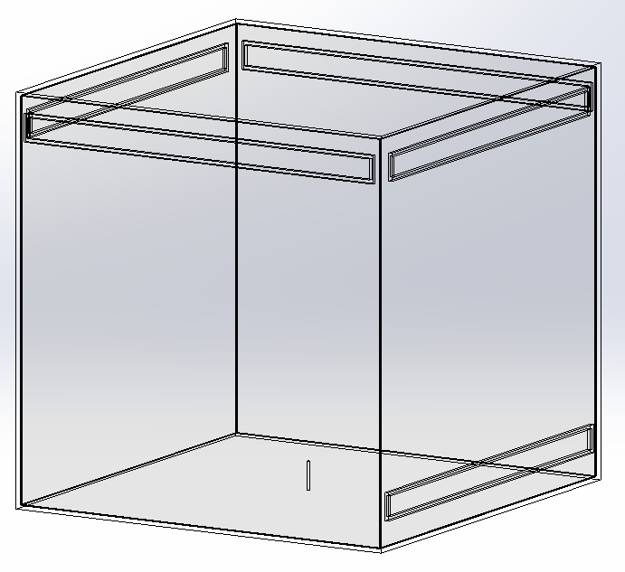

**Figure 2- SolidWorks CFD CAD model, showing the position of vents**

Results - Experimental

For each experiment the Helium gas build up was allowed to pass through the transient phase and reach a steady state position for each flow rate. Helium concentration data from the four sensors was retrieved via a USB link to a PC running LabVIEW. A time averaged section of steady state data has been used to provide helium concentration results, following the approach in Cariteau (2013).

 

 



**Figure 3 Average Helium concentrations for the four sensors on each stack position against Helium leak rate.**

Figure 3 presents the averaged helium concentrations for the four sensors on each stack position against the increasing helium leak rate. The 300mm stack position is in the direct path of the helium plume and as such the sensors are saturated by the flow and consequently produce high concentration levels. The flow is more turbulent in this area, leading to significant noise in the sensor readings and variation in output. On this basis the 300mm sensor stack position is disregarded.

It is clear from the graphs in Figure 3 that the most challenging scenario is the single top level vent where average helium concentrations across the enclosure are only below the LFL at leak rates of 1 and 2 L/minute. The single vent arrangement achieves the highest average helium concentrations. These are 9.67% at the 100mm position and 9.5% at the 400mm position, for the 5 L/minute test.

It is not until four vents are introduced to the enclosure that consistent Helium average concentrations below the LFL are achieved, the highest level being 3.98% at the 400mm position for the 5 L/min leak rate. The four vent arrangement also manages to slightly outperform the cross flow scenario at the 1 L/min leak rate. This is the only occasion on which this occurs for all scenarios.

 

 



**Figure 4 Average Helium concentrations for the four sensors on each stack position against Helium leak rate.**

Figure 4, presents the average helium concentrations, for each sensor, across four stack positions (100mm, 200mm, 400mm, 500mm). As would be expected the highest helium concentrations are found at the top of the enclosure at sensor 4. With two, three and four top vents, there is a clear gap of one percentage point between sensor three and four above the 2 L/minute leak rate. This is less so with the cross-flow and single vent scenarios. This suggests an area of stratified higher concentration near to the enclosure roof.

With one, two, three and four top vents the concentrations for sensors 1 and 2 (the lower sensors) are very close, throughout all leak rates. This suggests a homogenous, low concentration, layer, is present in the middle area of the enclosure. In the steady state position concentration stratification appears to be present.

Of particular interest is the cross flow scenario. The graph indicates that there is clear

separation between sensor 2 and 3. Also, the concentration values at sensors 1 and 2 and at 3 and 4 follow each other closely, separated by about a quarter percentage point. This effect becomes more pronounced with increasing flow rate. This suggests the presence of a higher concentration layer close to the enclosure roof and much lower concentrations at the middle level. At 5 L/minute this separation is more than 2 percentage points.

**Results - CFD**

Each SolidWorks Flow Simulation CFD project was set up to run through to steady state conditions. Once the calculation was complete, point source data, reflecting the helium sensor positions was extracted from the modelling results.







**Figure 5 Average Helium concentrations for the point source data at each stack position against Helium leak rate.**

Figure 5 presents the SolidWorks Flow simulation output in the same way as Figure 3 did for the experimental data. As can be seen in all cases, concentrations get lower with increased number of vents and the best performing scenario is cross-flow with one lower and one upper vent. This replicates the behaviour seen with the experimental studies. There are strong similarities between the graphs at 100mm, 200mm, 400mm and 500mm, a trend again seen with the experimental data. Average concentrations appear to be consistent across the sensor stacks, suggesting uniformity. The most striking observation though, is that the concentration levels are significantly lower than with the experimental data, at higher leak rates.

The SolidWorks Flow Simulation CFD calculations, using the *k-ε* transport equations, are consistently producing helium concentrations that are lower than the experimental results. Figure 6 presents the average helium concentration across all sensor positions in the enclosure and sets it against the five leak rates, for both the CFD and experimental data.

In all cases the CFD concentrations are lower than the experimental findings. The closest correlating data is found at the lower leak rates in all cases, with the values for 1 and 2 L/minute with the 4 top vent scenario being the best. As leak rates increase in all scenarios the values diverge, with the greatest difference found with the single vent scenario at the 5 L/minute leak rate. The best performing CFD models from the representation in Figure 6 are the cross-flow and four top vent scenarios. Aside from the divergence at higher leak rates there appears to be some conformity in the CFD results, but no full correlation with the experimental data. The images in Figure 7 present the steady state position for helium concentrations (0-4% v/v range) for each scenario. This qualitative data provides a strong visual insight into the CFD models results. The helium plume is evident and an increase in helium concentration is clear as the leak rate increases. There is also strong visual evidence of layering. Although the concentrations produced by the CFD are lower than the experimental findings, the CFD imagery provides a valuable insight into the behaviour of a buoyant gas in a small enclosure.

 





**Figure 6 - Average Helium concentration (across all sensor positions) against leak rate (CFD and experimental data)**

**One vent (Top right)**

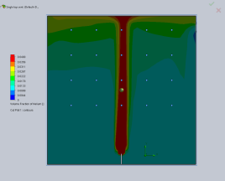 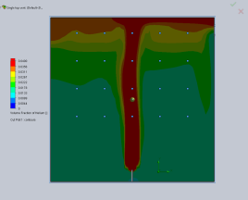 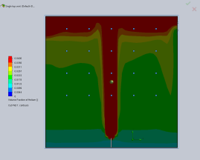 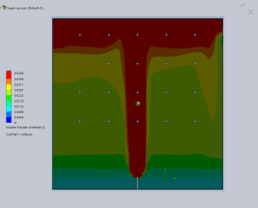 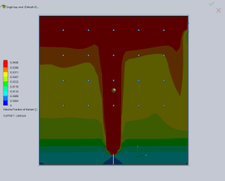

1 L/m 2 L/m 3 L/m 4 L/m 5 L/m

**Two vents (Top right and left)**

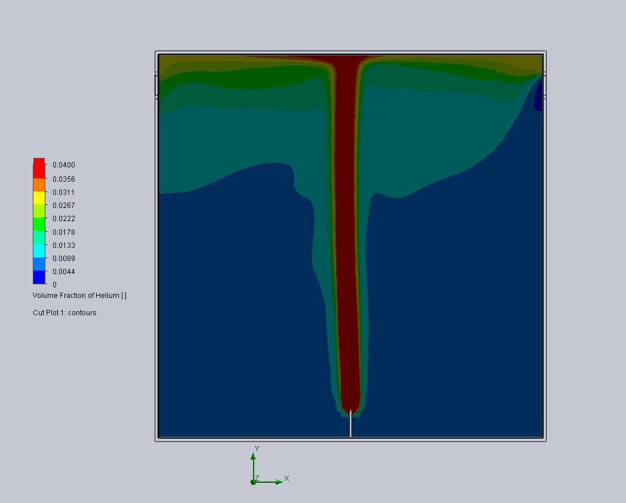 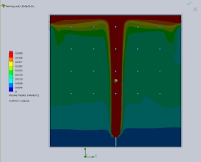 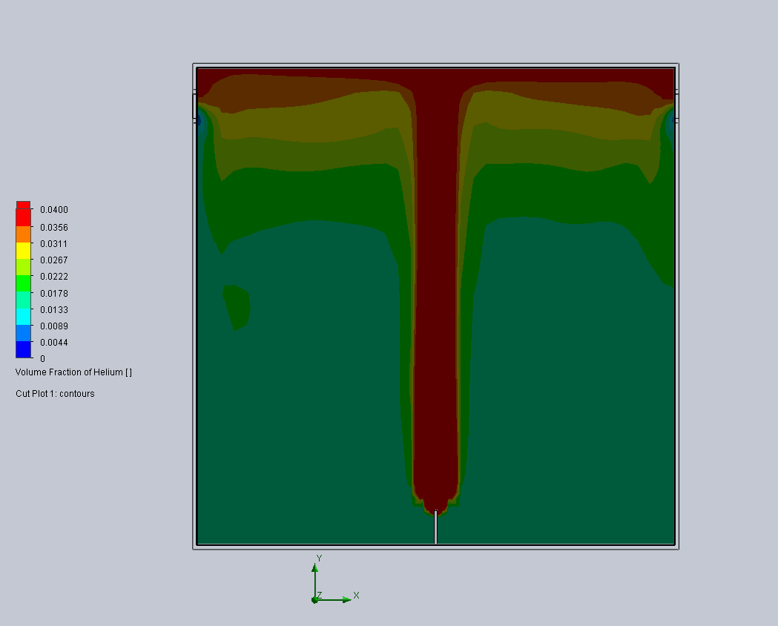 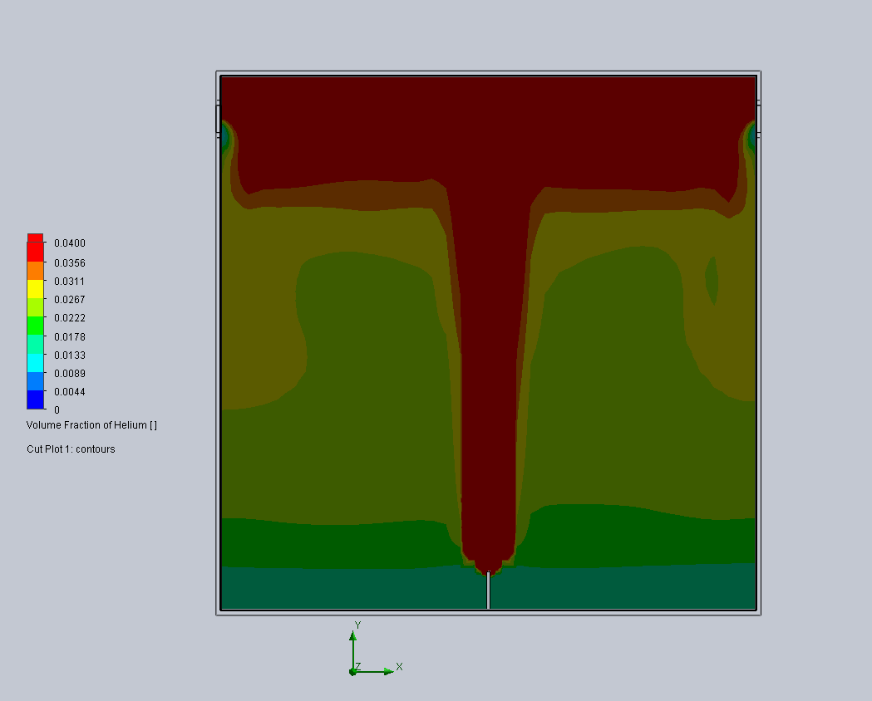 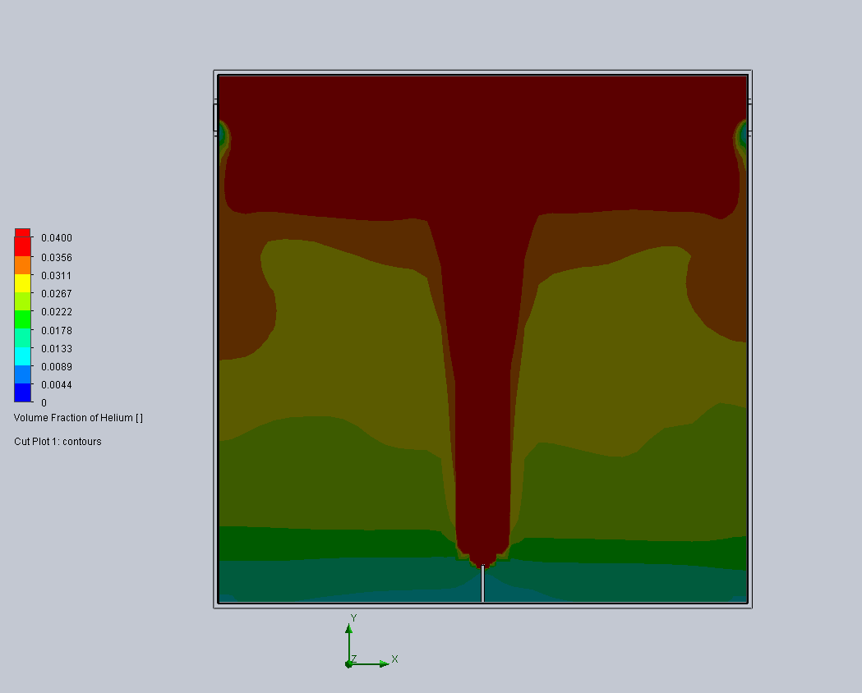

1 L/m 2 L/m 3 L/m 4 L/m 5 L/m

**Three vents**

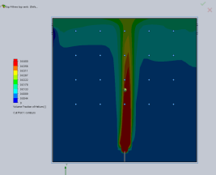 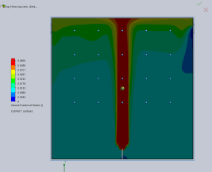 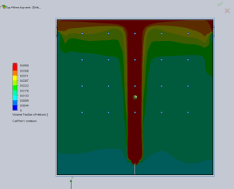 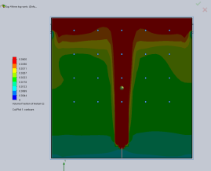 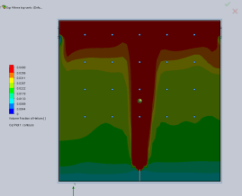

1 L/m 2 L/m 3 L/m 4 L/m 5 L/m

**Four vents**

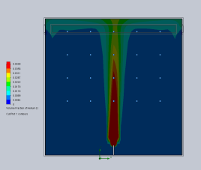 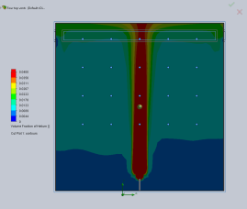 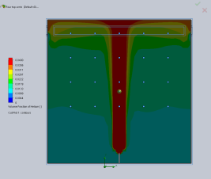 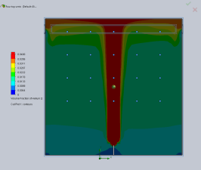 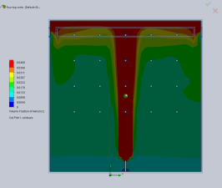

1 L/m 2 L/m 3 L/m 4 L/m 5 L/m

**Cross-flow (Lower vent left and top at right)**

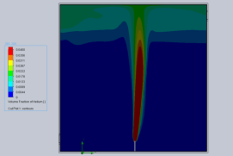 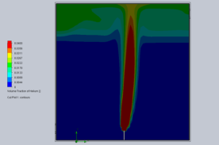 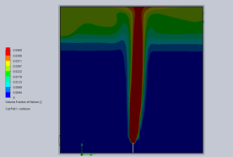 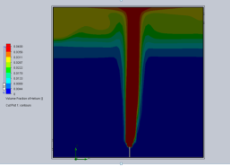 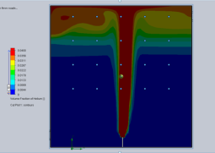

1 L/m 2 L/m 3 L/m 4 L/m 5 L/m

**Figure 7 – SolidWorks images of steady state helium concentrations (0-4% v/v range) for each scenario**

Conclusions

A series of experiments to study the dispersion of helium in a fuel cell enclosure and the effect of different vent arrangements on gas concentrations has been conducted. The focus of the experiments was dispersal behaviour at low leak rates from 1-5 L/min. Fuel cells release small amounts of gas as part of normal operation. With gas supply pipework usually fitted externally to the enclosure, catastrophic leaks into the enclosure are less likely. However, there is still the potential for small amounts of Hydrogen to build up.

Enclosure fabrication adds to the commercial costs of fuel cells and adding vents is a further cost. Understanding the minimum ventilation requirements for small enclosures will provide guidance on enclosure manufacture and help to create a safety standard. The use of computer modelling to support fuel cell enclosure design should help to speed development. The SolidWorks CAD modeller is used in this industry. Validation of the SolidWorks Flow Simulation CFD code for these scenarios would provide a logical step towards computer aided manufacturing (CAM).

It is clear from the experimental results that exchange ventilation through the high level vents increases with vent number. The single vent arrangement struggles to provide sufficient mixing in the enclosure with a dangerous gas concentration created from the 3 L/minute point with concentrations at sensor 4, 4% higher than at the bottom two sensors. A more homogenous layer appears to develop near the enclosure roof as more vents are added to the enclosure, with overall helium concentrations reducing as a result.

The traditional cross flow arrangement with a high and a low vent provide for the most effective ventilation solution of all five scenarios. The small pressure differential present, even with only a 500mm height difference, is sufficient to create a driving flow through the enclosure that can maintain low helium concentrations across the range of leak rates tested.

The validation exercise for SolidWorks Flow Simulation has demonstrated that the setup used for this study consistently underestimates helium concentrations at the higher leak rates. This is reflected across all of the vent arrangements and flow rates. That said, the simulation data at lower flow rates is close to the experimental data and this position improves as the number of vents increases. There is a close correlation at low flow rates with the cross-flow scenario also. The images in Figure 7 provide useful qualitative insight into dispersal behaviour. This new simulation information provides a focus for the parameters with which useful data can be obtained from SolidWorks Flow Simulation for this modelling study.

Cross-flow ventilation, the best performing case, will not be appropriate or possible in all commercial/domestic deployments of fuel cell enclosures. Also, with nuclear storage liners and box scenarios, mentioned in the introduction, there is no scope for a lower vent. In such cases high level vents may be the only option for a passive scheme. This study has demonstrated that a four top vent solution can be a viable alternative to a traditional cross-flow arrangement, particularly in the lower flow range.

**Future work**

* Incorporate additional gas sensors into the experimental rig,
* Use the SolidWorks I-L (turbulence-intensity and length) solver to compare performance with the k-e,
* Introduce thermal wall effects,
* Introduce obstructions into the enclosure,
* Apply much lower flow rates,
* Use alternative vent configurations,
* Use different nozzle diameters,
* Introduce chimney arrangements,
* Simulate wind effects.

Acknowledgements

The authors would like to acknowledge Sellafield Ltd for their financial support of this project and BOC for training in and the use of their SolidWorks application.

References

Bachellerie, E.; Arnould, F.; Auglaire, M.; de Boeck, B.; Braillard, O.; Eckardt, B.; Ferroni, F.; Moffett R. (2003); Generic approach for designing and implementing a passive autocatalytic recombiners PAR-system in nuclear power plant containments; Journal of Nuclear Engineering and Design; 221, pp. 151–165.

Baines, W.D., Turner, J.S. (1969), Turbulent Bouyant convection from asource in a confined region; Journal of Fluid mechanics; 37; 51-80

Brown, W.G. and Solvason, K.R (1962); Natural Convection through Rectangular Openings in Partitions; International Journal of Mass Transfer; Volume 5, pp 859-868; Pergamon Press

Cariteau, B., Tkatschenko, I. (2013); Experimental study of the effects of vent geometry on the dispersion of a buoyant gas in a small enclosure; International Journal of Hydrogen Energy; 38, 8030-8038

Chen Qingyan (2007); Design of natural ventilation with CFD; Sustainable urban housing in China, principle ventilations and case studies for low energy design; Springer

Chen, Qingyan (2009); Ventilation performance prediction for buildings: A method overview and recent applications; Building and Environment (2009), 44, 4, 848-858

Conte, M.; Ronchetti, M. (2013); Energy: Hydrogen Economy; Molecular Sciences and Chemical Engineering; Elsevier

Cook M.J; Lomas, K.J. (1979); Guidance on the use of computational fluid dynamics for modelling buoyancy driven flows; DE Montfort University; Leicester

Dassault Systems (2015); Technical Reference; SolidWorks Flow Simulation 2015

Epstein, M. (1988); Buoyancy-driven exchange flow through small openings in horizontal partitions; Journal of Heat Transfer; 110; pp. 885-893

Epstein, M. Burelbach, J. P. (1999); Transient vertical mixing by natural convection in a wide layer; International Journal of Heat and Mass Transfer; 43 (2000) 321-325

Friedrich, A. et al (2010); Hyper experiments on catastrophic hydrogen releases inside a fuel cell enclosure; International Journal of hydrogen Energy; 36 (2011) 2678-2687)

Hedley, D; Hawks worth, S.J; Rattigan, W; Brentnall, R; Allen, J (2014); Large scale passive ventilation trials of hydrogen; International Journal of Hydrogen Energy 39 (2014) 20325-20330

Hübert, T.; Boon-Brett, L.; Black, G.; Banacha, U. (2011); Hydrogen sensors – A Review; Journal of Sensors and Actuators B: Chemical; 157, pp. 329–352.

HYPER project (2015); Installation Permitting Guidance for Hydrogen and Fuel Cells Stationary Applications (HYPER) www.hyperproject.eu ; European Commission [Accessed 02/06/2015]

Jiang Y, Chen Q (2003); Buoyancy driven single-sided natural ventilation in buildings with large openings; Journal of Heat and Mass Transfer; 45: 973-988

Kenton, M. A.; Epstein, M. (1989); Combined natural convection and forced flow through small openings in a horizontal partition, with special reference to flows in multi-compartment enclosures; Journal of Heat Transfer, 111, pp. 908-987.

Liddament, M.W. (1996); A Guide to Energy Efficient Ventilation; Air Infiltration and Ventilation Centre, IEA Energy Conservation in Buildings and Community Systems Programmed; Coventry

Linden, P.F. (1999); The Fluid Mechanics of Natural Ventilation; Annual Reviews; Fluid Mechanics; 1999, 31, 201-238

Middha, P.; Hansen, R. (2009); Validation of CFD-model for hydrogen dispersion; Journal of loss prevention in the process industries; 22, pp.1034-1038

Molkov V. Fundamentals of hydrogen safety engineering. free download eBook (search hydrogen), [www.bookboon](http://www.bookboon). com; October 2012.

Molkov, V., Shentov, V, Quintiere (2014): Passive ventilation of a sustained gaseous release in an enclosure with one vent; International Journal of Hydrogen Energy; 39 (2014) 8158-8168

Papanikolau, E.A. (2010); HySafe SBEP-V20: Numerical studies of release experiments inside a naturally ventilated residential garage; International Journal of Hydrogen Energy; 35 (2010) 4747-4757

Pitt W.M. et al (2011); Helium dispersion following release in a 1/4-scale two-car residential garage; International Journal of Hydrogen Energy; 23012, 37, 6, 5286-5298

Prasad, K. Pitts, W.M. Fernandez, M. Yang, J.I.; Natural and forced ventilation of buoyant gas released in a full-scale garage: Comparison of model predictions and experimental data; International Journal of Hydrogen Energy 37 (2012) 17436-17445

Swain, M. et al (2002); Hydrogen leakage into simple geometric enclosures; The International Journal of Hydrogen Energy; 28, pp. 229-248

Weiner S.C. (2014); Advancing the hydrogen safety knowledge base; International Journal of Hydrogen Energy; 39 (2014) 20357-20361

XEN-TGC 3880 Data Sheet; http://www.xensor.nl/pdffiles/sheets/xen-tcg3880.pdf [Accessed 02/06/2015]