Practical and technical suitability perceptions of sound sources and test signals used in room acoustic testing

Gomez-Agustina, Luis
London South Bank University
103 Borough Road, London SE1 0AA, England, UK

Barnard, Jonathan
London South Bank University
103 Borough Road, London SE1 0AA, England, UK

ABSTRACT
High intensity and accurate test signals are required to be produced by sound sources for acoustic characterisation and evaluation of indoor spaces. A variety of modern room excitation test signals, sources and processing methods (systems) exist and their suitability for most purposes is well documented in the literature. Those test systems are firmly established and employed in academia and research applications due to their accuracy and reliability; despite requiring sophisticated, expensive and bulky equipment which needs electrical power. More convenient and traditional impulsive test signals and sources are widely used in the acoustic industry as an alternative to modern system mainly due to their low cost and practicality merits. However these alternatives are not as robust or as well documented. This paper reports on a preliminary attitude survey regarding perceived technical and practical suitability of different systems used in academia and industry in the UK. A social survey asked acoustic consultancies, researchers and academics questions about usage, perceived accuracy and reliability of systems used. Results conclusively showed that some traditional systems are widely used and favoured due to their practicality and convenience despite the acknowledged lack of robustness. A proposed novel all-round system addressing most of the technical and practical merits would be welcomed and adopted by the industry.

Keywords: impulsive source, sound source, test signal
I-INCE Classification of Subject Number: 71

1. INTRODUCTION

1.1 Background
The acoustic characteristics of a space can be fully determined by the impulse response of the space obtained at a receiver position when excited at a source position.
The traditional procedure to characterise the acoustics of an indoor space (or room) involves the generation of an approximation of a Dirac delta function characterised by a very short transient sound signal of a high power. This type of signal is used to excite the space under investigation to obtain its acoustic response or “acoustic signature” (impulse response) in the time domain. The sound level and dynamic range of the excitation signal is required to be high and is normally a function of the size and geometry of the space, its contents, the background noise and the measuring technique used.
In principle any kind of excitation signal may be used to determine the impulse response of a linear and time-invariant system (in this case a room) provided that the test signal is well defined and has sufficient energy at each relevant frequency.
A range of excitation systems (test signals and sources) are available for the acoustic characterisation of indoor spaces. They could be classified into traditional impulsive sound sources and modern excitation systems involving electroacoustic instrumentation and specialist signals.
The first part of this paper provides an introduction to a range of room excitation systems used in the acoustics industry, research and academia. The second part presents an explorative investigation into the beliefs and attitudes from UK users, as well as choice and suitability of systems when conducting room acoustic testing. This part also establishes the likely acceptability of a proposed optimised excitation system.

1.2 Modern excitation systems
Relatively recent developments in digital signal processing have given rise to specialist sound test signals and processing techniques to achieve the required control of the excitation signal to obtain reliable room impulse responses (RIR).
A few modern systems or techniques exist which have been scientifically proven to be robust and reliable. They have been adopted and described in relevant international standards [1,2,3] and have been widely accepted by the academic, research industry communities as reference methods [3,4,5,6]
In these modern techniques the room is excited by a known digitally processed sound signal (deterministic and non-impulsive signal) to obtain the RIR only after special processing of the recorded microphone signal through the process of deconvolution. The linearity and time invariance of the system is an important condition that these modern systems must fulfil and this can limit practical implementations where there is movement, changes of temperature or air flow speed during measurements.
These excitation signals and processing techniques are designed to achieve high reproducibility, repeatability, signal to noise ratio, dynamic range and immunity from the effects of undesired noises. They are deterministic signals of a broad frequency band whose energy content is distributed over time to increase the sound energy radiated. These systems usually require cables connecting the measuring platform to the source and sometimes to the receiver. They provide the practical convenience of being able to be reproduced effectively with stable and repeatable sound sources such as loudspeakers. Suitable loudspeakers however, need to fulfil challenging minimum requirements of spectrum balance and frequency range as well as omni-directionality characteristics [1]. Moreover loudspeakers for these purposes are intrinsically heavy and are ineffective and unreliable sources for reproducing short and high level impulsive sounds. The combination of specialist loudspeaker sources (e.g. dodecahedron loudspeaker, “dodec”), deterministic signals and signal processing can generate a sound excitation that can approximate some desired performance criteria for many applications. These performance criteria include high repeatability and reproducibility, balanced and wide frequency spectrum, high dynamic range and satisfactory directional characteristics.
Examples of the most commonly used and suitable deterministic and non-impulsive excitation signals are MLS (Maximum Length Sequence) [7] , the swept sine (sine with frequency increasing linearly or exponentially with time) [8,9]. Due to the significant improvements in signal-to-noise ratio that these signals provide, the dynamic range demand on the sound source (loudspeaker) can be relatively low.
There are however important practical disadvantages to these modern systems which overcome performance limitations and weaknesses of traditional systems. They entail computational requirements, the hardware equipment needed is costly, heavy and bulky (Figure 1). The manoeuvrability and transport of the equipment can be time consuming when undertaking large scale acoustic surveys. Such equipment can also be problematic when acoustic surveys need to be undertaken in spaces which are difficult to reach by transport, or that do not have power sources, as is often the case in new build developments at the time acoustic surveys are undertaken.

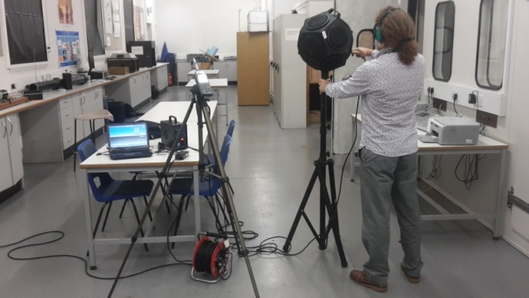

Figure 1 Example of a modern excitation system, including amplifier, dodecahedron loudspeaker, sound level meter (or microphone) and computer measurement platform.

1.3 Traditional excitation systems
Traditional sound sources can generate short transient sounds or impulsive signals to obtain the RIR. A range of these sources exist and are mentioned in relevant test standards [1,2,3]. These include starter pistols (capable of firing blanks) ( Figure 2 left), noise bursts, and electrical spark gaps which generate impulsive sounds. The guidance and performance requirements for traditional impulsive sound sources in the test standards are limited and not specific. Test standards acknowledge that other types of impulsive sources or methods could exist and may yield a correct impulse response; however, they are generally not mentioned specifically.
Some of these traditional and practical impulsive sources not mentioned specifically by the standards are nevertheless widely used by researchers and acoustic practitioners in the industry. They include balloon bursts [10,11] (Figure 2), fire cracker explosions [12], bangs from mechanical systems (e.g. clappers, see Figure 3) [13] and even hand claps [14].

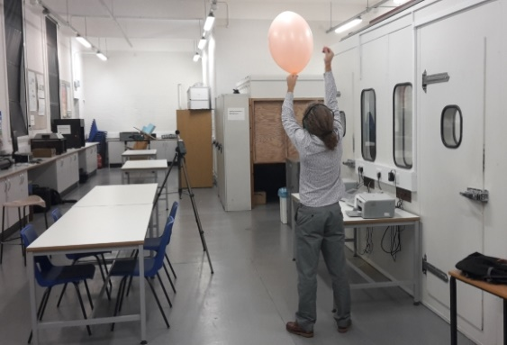
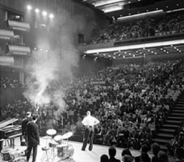

Figure 2 Traditional sources: starter pistol being used in Royal Festival Hall (London, UK )(left) and balloon burst being used at LSBU acoustics laboratory (right).

The advantages of these traditional impulsive sources are portability, simple use, light weight, low cost, small volume and quick operation. However, they have their own practical disadvantages such the need to inflate balloons, the need of powerful electrical arc to generate an electrical spark of sufficient peak sound pressure level (SPL), health, safety and security concerns in the use of blank firing pistols (starter pistol) and fire crackers. Moreover, the use of these sources requires measurement instrumentation that can withstand and process adequately the very short and high peak SPL.

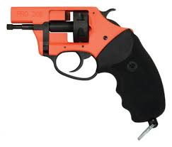
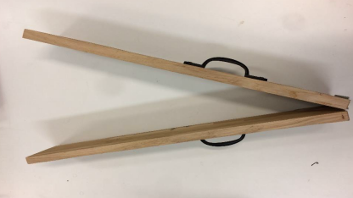

Figure 3. Examples of starter pistol (left) and clapper boards (right)

The required performance criteria for these sources is not specific or fully defined in the relevant standards [1,2,3]. There is limited research in the literature determining the suitability of traditional excitation systems and sources. Most of the studies have focused on gun blank shots [15,16] and balloon bursts [10,11] and to a much lesser extent on clapper boards [13]. The literature has shown that compared to modern excitation systems (or reference methods), traditional impulsive sound sources generally have lower repeatability and reproducibility, narrower and less balanced frequency range, and generally lower dynamic range and omni-directionality [3, 12].
Despite the overall poorer performance and caution suggested by the relevant test standards [1-3], traditional impulsive sources have been and are still widely employed by acoustic practitioners as a convenient and practical alternative to modern methods.

2. SOCIAL SURVEY
This section describes a preliminary social survey carried out on a representative sample of users to explore perceptions, choice and attitudes towards the use of acoustic excitation systems and their practical and technical suitability.

2.1 Methodology
In order to obtain data on practice-based, experiential perspectives of use and choice of excitation systems, a phenomenological approach was chosen, informed by social science methodologies. A combination of quantitative and qualitative methods was used to attempt to obtain robust inferences and reliable findings. Three data collection techniques included an extensive UK-wide online survey questionnaire and a brief documentary analysis.
2.2 Questionnaire design
The online questionnaire was designed to collect demographic and attitudinal data from the industrial, research and academic communities in the UK. The qualifying respondents (target group) for the questionnaire were experienced users of room acoustics measurement systems. These included acoustic consultants, acoustic engineers, academic, researchers and other experienced practitioners in acoustics.
Invitations to participate in the self-administered online questionnaire were sent to the authors’ professional contacts. The questionnaire was publicised online via London South Bank University (LSBU) acoustic blog and Institute of Acoustics (IOA) acoustic blogs and other diverse online professional networks and relevant social media channels such as Linked-In themed groups.
Latest data for the year 2018 on the acoustic industry shows [17] that there are over 600 companies in the UK working in acoustics. Their apportioned revenue is £4.6bn which is approximately 0.6% of the UK’s GDP. These companies employ 16,000 people working in acoustics [17]. The main professional association for the acoustics profession in UK (the Institute of Acoustics , IOA) reports [18] that a recent employment survey shows that of their 3000 members, some 900 are employed in industry, commerce and consultancies, 400 in education and research, and nearly 500 in public authorities. Based on the above information on the acoustic sector in UK, the population size for this survey questionnaire was estimated at 2000. The responses obtained (sample) were considered to be from simple random sampling approach. The questionnaire was opened on 18 August 2018 and closed on 30 November 2018.
Eligibility criteria stated in the invitation and introduction of the survey was any acoustician with experience in room acoustic measurements. The questionnaire was devised to obtain a high response rate as a design priority. Hence to make it attractive, the core and compulsory part only included six questions. Four questions were of multi choice close ended type and another two were open ended. The first multi choice close question featured one open ended answer option to allow for potential responses not included in the pre-defined list of close ended answers. After the sixth question, there was a free text comment box to provide unrestricted opportunity to the participant to comment freely.
Six optional questions requested personal and professional information of the participant to obtain demographic data. The questionnaire was trialled and verified until it was considered to be free from bias, error and ambiguity. An academic-grade online survey platform (Jisc) was selected to host the online questionnaire and store responses. The questionnaire was first piloted and iterated until a satisfactory point of suitability and validity. Data validation processes were undertaken on the raw collected responses.
2.4 Data analysis
Multi choice, close ended and scalar questions were statistically analysed. Content analysis techniques were employed to extract relevant data and information from open ended answers of the questionnaire. An answer matrix of relevant valid data was employed to analyse and infer meaning from patterns observed from the qualitative data and information extracted. This tool included coding data categories based on questions and main themes occurring from question responses.
3. RESULTS AND ANALYSIS

3.1 Questionnaire participation and sample composition
A total of 72 questionnaires were completed online of which 72 were deemed valid (100%). This sample size exceeded the minimum number of responses needed to obtain results that reflect the population with acceptable accuracy at a 90% confidence level and with margin of error of 10%.
The vast majority of respondent (89.1%) practice in the acoustic industry, while the rest (10.9%) work in acoustic research. Of those working in the industry 27.3% declared they work at consultant level and 72.7% at senior level (Figure 4). Of those at senior level, 43% are in managerial positions including, director, associate director, head of acoustics department, principal engineer/consultant or company owner.
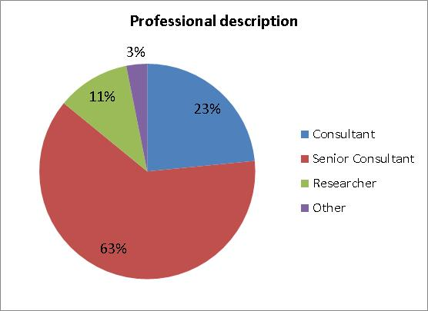

Figure 4. Sample demographic composition regarding professional description
These results clearly suggest that the sample is mostly constituted by highly experienced professionals working mostly in acoustic consultancy.

3.2 Questionnaire results
Question 1 asked to select from a list the sound sources/test signals (excitation system) types that the participant has used in the past for the measurement of acoustic characteristics of rooms or indoor spaces. A summary of the percentages of respondents who have used any of the sources listed is presented in figure 4 left graph. It was indicated in the question that sine sweep, pink noise, MLS and chirp system types assume associated hardware including signal generator, omni-directional like loudspeaker (dodec) or cabinet loudspeaker and amplifier. Under “other” the following answers were received: “Hard backed note pads in an emergency”, “Complementary Golay sequences” and “Bag bursts”.

Question 2 Asked to rank each of the ten sound sources performance or practical characteristics listed according to the importance to the respondent professional activity/usage (1= negligible importance, 5 = utmost importance). The summary of the percentages of respondents that chose ratings 5 or 4 per characteristic are presented in figure 4, right graph.
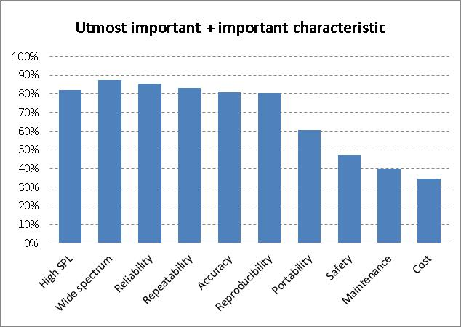
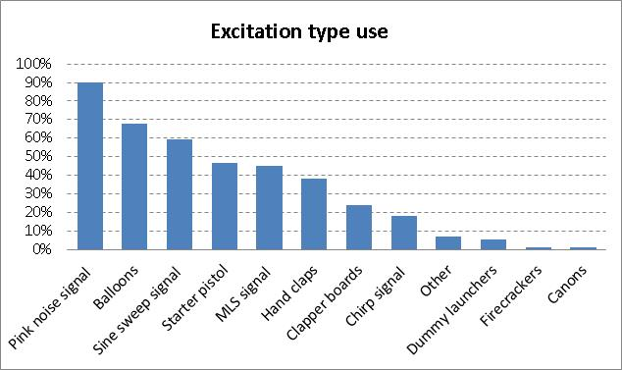
Figure 5. Q1, Use of excitation type (left). Q2, Characteristics importance (right)

In the left chart of figure 5, it can be observed that the use of Pink noise as a source signal is the most commonly used excitation system. Employing Pink noise as a sound source involves the use of a signal generator, an amplifier and a suitable loudspeaker. This system owes its high score in the survey to its use in the two most popular acoustic tests in the industry, measurement of reverberation time (RT) and sound insulation testing, which are usually measured with conventional methods for which it is not necessary to obtain the RIR. The pink noise test signal itself is not an effective excitation signal in practice for obtaining the RIR and it is not typically used for that purpose.
The popularity of the Pink noise signal system for measuring RT is due to the fact that the system is employed in the old standardised Interrupted Noise method [1], which is a simple, intuitive and well know method. The system is also widely utilised by consultancies in sound insulation testing since it also complies with the relevant test requirements. Since the introduction of the mandatory UK Building Regulations, Approved Document part E in 2003, sound insulation testing is one of the most demanded jobs to be carried out by consultancies.
If we exclude pink noise as an excitation signal for obtaining the RIR, then the most used excitation source type for the purposes of RIR is the balloon burst. However, this source is shown in the literature to have poor performance characteristics and it is not endorsed specifically in the test standards [1-3].

The starter pistol appears also to be widely used despite security restrictions typically imposed on its use and its unsatisfactory spectral balance, repeatability and uncontrolled directional characteristics. Surprisingly, results show that 38% of practitioners have used hand claps as an excitation source signal. The substantial use of such a poor excitation signal could be due to a lack of understanding or the pressing need to use a source of practical convenience. The use of alternative impulsive sources of unknown performance suitability (clapper boards, dummy launchers, firecrackers, cannons and others such as paper bags) by some practitioners reinforces the argument that users are attempting to find alternatives to proven and established systems.

In the right graph of figure 5, it can be seen that performance characteristics are highly regarded, above more practical considerations. This seems to contradict the overall results observed in the left chart where some of the most used excitation types are shown in the literature to exhibit unsatisfactory performance characteristics. This could be interpreted as showing that what is desired is not what is later implemented in practice due perhaps to economic or practical constrains.

Question 3 required respondents to list the main practical or technical advantages associated with the excitation sound sources/signal systems selected in question 1. Question 4 required respondents to list the main practical or technical disadvantages associated with the excitation sound sources/signal systems selected in question 1.

Pink Noise (including amplifier and loudspeaker) and the starter pistol were praised frequently by respondents for their capacity for producing high sound level pressures (SPL) and therefore a high signal to noise ratio (SNR). Pink noise was also highlighted by many respondents for the good control in its reproduction, wide and balanced spectrum, reliability and repeatability. However, the heavy, bulky and expensive amplifier and loudspeaker necessary to reproduce the pink signal at all frequencies of interest at suitable levels, was the main recurring disadvantage mentioned by many participants. Many respondents commented that one of the main advantages of the starter pistol is the high peak SPL it can generate, particularly useful for large or noisy spaces. The high portability, low cost and simplicity of operation of the starter pistol and balloon bursts, were the most commended advantage. This was justified by very short time to set up, light weight and the absence of power supply or cables. The main disadvantages identified for the starter pistol were the security concerns and legal impediments involved, as well as the large quantity of smoke generated. These concerns can prevent the use of this source. The observed lack of repeatability was also seen as an important performance weakness in the starter pistol and balloon bursts. Another reoccurring theme among detractors of the balloon burst was the insufficient peak SPL and lack of frequency content at low frequencies. The high SNR, high repeatability and accuracy as well as the good immunity to non-linearity of the sine sweep system were considered good distinctive advantages by some respondents particularly those in research. However this system was more criticised than praised for the perceived lack of portability of the hardware needed. This included the heavy, bulky and expensive characteristics of the loudspeaker, amplifier, measuring platform and cables needed. Other disadvantages attributed to this system were the complexity of operation and post processing as well the time consumed to set up

The advantages found for the MLS signal system were much less often commented showing that this systems is less used by practitioners. The main advantages identified were the high SNR perceived reliability and low potential for disturbance. Since this excitation system involves the same equipment as the sine sweep the same disadvantages were consistently identified.

Clapper boards were mentioned by a few participants. They found its portability and simplicity of operation its main advantage and the lack of repeatability and wide and balance spectrum its main disadvantages. Surprisingly the portability simplicity and low cost of the hand clap were mentioned by few respondents as practical advantages when this source is used in indicative surveys. More respondents commented on the lack of peak SPL, repeatability, wide and balanced frequency spectrum. The chirp did not attract much commentary. The very few comments found its repeatability and accuracy advantageous and lack of high SPL disadvantageous. Under the “other” category of source some respondents commented on the portability simplicity, low cost and quick operation of bursting paper bags and the dummy launcher. However the identified disadvantages were the lack of sufficient peak SPL for many applications and their low reliability.

Question 5 asked participants if there is a need for a novel optimised excitation sound source that meets all or most of the desired ten characteristics listed in question 2. Almost two thirds of respondent (64.9%) responded yes and 30.6% responded no.

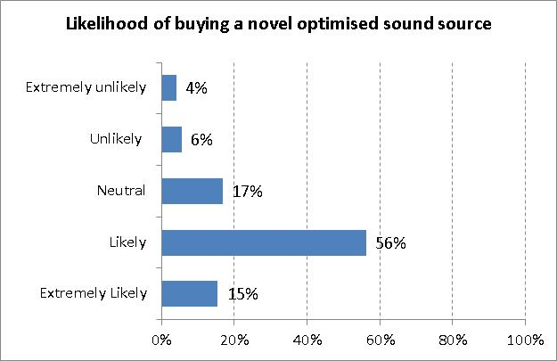
Question 6 (Figure 6) followed by asking if such an optimised excitation sound source were available and affordable to the participant or their company, how likely would it be for them company to buy it. 71% of participants responded that it would be very likely or likely.

Figure 6. Question 6. Respondents’ likelihood of buying a novel optimised sound source

Results from question 6 (Figure 6) seem to reinforce and provide increased confidence in the findings obtained in question 5.
In summary, it appears that when time, access, portability, cost and transport are important restrictions in the field and high accuracy is not required, impulsive sources are often used. However, despite their apparent convenience these traditional and practical sources are not standardised or optimised for acoustics measurements.

4. CONCLUSIONS

There are a range of sound sources and test signals that can be used to test the acoustics of a room. Modern sources and test signals have been the subject of much research and development. Their performance, reliability and robustness is well documented in the literature. Less investigative work has been undertaken into the development and performance evaluation of more traditional and practical impulsive sources.

The current guidance and performance criteria for sound sources and test signals used in room acoustics could benefit from further definition and detailed specification of traditional impulsive sources.

The lack of specific guidelines allow practitioners to employ more practical and convenient impulsive sources of lower performance or unknown suitability.
A social survey has been undertaken on a representative sample of acousticians in the UK to explore perceptions, choice and attitudes towards the use of acoustic excitation systems and their practical and technical suitability.

It has been found that the most utilised sound source to obtain a room impulse response is the Pink noise signal system, followed by balloon bursts, sine sweep and then starter pistols. It was revealed that practitioners also employ other non-standardised sources such the hand clap (6th most utilised), clapper boards, dummy launchers and even paper bags in an attempt to avoid cumbersome and expensive equipment associated with standardised excitation systems.

However, the vast majority of practitioners expressed that performance characteristics, such as reliability, accuracy, peak SPL, wide and balanced frequency spectrum, repeatability and reproducibility, were the most important merits when considering the utilisation of a sound source in room acoustic testing.

The survey also showed that highly regarded source systems for their overall performance advantages (pink noise and sine sweep) had strong practical disadvantages including low portability, time efficiency and cost of the hardware needed. The most advantageous characteristics commented in survey were the high portability of the balloon and starter pistol. The high peak SPL produced by pink noise, sine sweep and starter pistol were also frequently commented as key advantages. The practitioners felt that the balloon burst and starter pistol lacked good repeatability and that was a disadvantage.

It appears that despite the perceived and documented overall inferior performance of traditional impulsive sources, practitioners in UK use them widely mostly due to their portability and other practical advantages.

The literature and the survey have revealed that there is no one single source or excitation system that fulfils all or most of the desired practical and performance characteristics. Different sources have key strengths but also important weaknesses which can lead to compromise. It appears that the choice of source or system depends on the particular application parameters.

A large majority of the survey sample believed that there is a need for a novel optimised sound source that meets all or most of the practical and performance characteristics required in room acoustics testing.

5. ACKNOWLEDGEMENT

The authors wish to thank London South Bank University, Research Enterprise and Innovation department for their support to conduct this study.

6. REFERENCES

1. International Organization for Standardization. (2009). ISO 3382-1:2009 Acoustic-Measurement of room acoustic parameters. Part 1: Performance spaces. : Geneva , Switzerland
2. International Organization for Standardization. (2008). ISO 3382-2:2008 Acoustic-Measurement of room acoustic parameters. Part 2: Reverberation time in ordinary rooms. Geneva , Switzerland.
3 International Organization for Standardization. (2006). BS EN ISO 18233:2006 Application of new measurement methods in building and room acoustics. Geneva , Switzerland
4. G. Stan, J. J. Embrechts, D. Archambeau, “Comparison of Different Impulse Response Measurement Techniques” J. Audio Eng. Soc., 50(4) p. 249-262, (2002). 5. L. Guidorzi, L. Barbaresi, D. D’Orazio, M.Garai, “Impulse responses measured with MLS or Swept-Sine signals applied to architectural acoustics: an in depth analysis of the two methods and some case studies of measurements inside theatres”, Energy Procedia, vol 78, p 1611-1616, (2015)
6. H. Kuttruff. Room Acoustics, 6th edition, , Taylor & Francis Group, Boca Raton, USA (2016).
7. D.D. Rife, & J. Vanderkooy, “Transfer-function measurement with maximum-length sequences”, J.Audio Eng.Soc, vol. 37, no. 6, pp. 419-444, (1989)
8. A. Farina, “Simultaneous Measurement of Impulse Response and Distortion with a Swept-Sine Technique”, 108th Convention of the Audio Engineering Society, Paris, France, (2000)
9. A. Farina, "Advancements in impulse response measurements by sine sweeps", Proceedings of 122nd AES Convention, Vienna, Austria, (2007)
10. J. S. Abel, N. J. Bryan, P. P. Huang, M. Kolar, B. V. Pentcheva, “Estimating room impulse responses from recorded balloon pops”, Audio Engineering Society Convention 129, Audio Engineering Society, (2010)
11. J. Pätynen.B. Katz, T. Lokki, “Investigations on the balloon as an impulse source”, The Journal of the Acoustical Society of America, 129 (1), pp. EL33. (2011)
12. R. San Martín, M. Arana, J. Machín, and A. Arregui, “Impulse source versus dodecahedral loudspeaker for measuring parameters derived from the impulse response in room acoustics”, The Journal of the Acoustical Society of America, 134 (1), pp. 275-284. (2013)
13. D. Sumarac-Pavlovic, M. Mijic, H. Kurtovic, “A simple impulse sound source for measurements in room acoustics”, Applied Acoustics, 69 (4), pp. 378-383. (2008)
14. P. Seetharaman, S. P. Tarzia, “The hand clap as an impulse source for measuring room acoustics”, Audio Engineering Society Convention 132, Audio Engineering Society. (2012)
15. M. R. Lamothe, J. S Bradley, “Acoustical characteristics of guns as impulse sources”, Canadian Acoustics, 13 (2), pp. 16-24. (1985)
16. J. S. Bradley, “Auditorium acoustics measures from pistol shots”, The Journal of the Acoustical Society of America, 80 (1), pp. 199-205. (1986)
17. K. Horoshenkov, R. Craster, “January 2019 Newsletter”, UK Acoustic Network, (2019), Available from: <https://acoustics.ac.uk/wp-content/uploads/2019/01/UKAN-News-Letter-19012019.pdf > [Accessed 25 February 2019]
18. Institute of Acoustics, “About us, website page”, (2019), Available from : < https://www.ioa.org.uk/about-us> [Accessed 25 February 2019]
19. Ministry of Housing, Communities & Local Government, “Building Regulations. Approved Document E - Resistance to the passage of sound (2003 Edition incorporating 2004, 2010, 2013 and 2015 amendments)”, (2015), Available from <https://assets.publishing.service.gov.uk/government/uploads/system/uploads/attachment_data/file/468870/ADE_LOCKED.pdf > [Accessed 25 February 2019]

gomezagl@lsbu.ac.uk
jon.barnard1@gmail.com

