Internally Displaced Entrepreneur in Pakistan: The Case Study of Abdullah
Humera Manzoor, Kohat University of Science and Technology, Pakistan
Mehboob Ur Rashid, University of Peshawar, Pakistan
Cherry W M Cheung, London South Bank University, United Kingdom
Caleb Kwong, University of Essex, United Kingdom

Abstract
Abdullah sells solar panels and items along with a few electric items. He also knows how to repair these items and to fix electrical items at homes. The local community use his services in fixing their household electric items. Abdullah has been able to understand the needs of the local people since there is an increase demand of solar items due to electricity shortage all over Pakistan. Abdullah’s personal motivation, courage, persistence, hope and faith in God together with the prior knowledge of the business. Lack of capital and lack of knowledge of the local market has been a major constraint. Abdullah’s relatives and the local people gave him charity (Zakat) and loans to start his business. His friends prefer to purchase from his shop to help him in his business. The wholesaler has become a constraint since they now refuse to do business with him on credit. The main institutional barrier that Abdullah face is the lack of knowledge about getting financial assistance and his way around but his friends helped him in educating about the local market and how to do business.
Country Specific information and data
FATA is a semiautonomous tribal region consisting of seven tribal agencies, namely Bajaur agency, Mohmand Agency, Orakzai Agency, Kurram Agency, North Waziristan Agency and South Waziristan Agency, all located in the Khyber Pakhtunkhwa province of Pakistan but directly governed by the Federal government of the country. Orakzai Agency belongs to a Pashtun tribe known as ‘Orakzai’ that spreads over an area of 1,538 square kilometers. It is bounded by Kurram Agency in the west, Khyber Agency in the north, Kohat district in the south, and Peshawar district in the east. Orakzai Agency does not have a direct border with Afghanistan but it borders with Kurram agency that is bounded with Afghanistan (See Figure 1 and 2).
***Insert Figure 1 and 2 about here***
The Talibanization and the counterinsurgency operations in FATA has resulted into mass scale displacement of people creating one of the greatest humanitarian crisis in a country that is already inhabiting Afghan Refugees. According to the UNHCR (United Nations High Commission for Refugees) report on Global trends of 2016, Pakistan had the second largest refugee population after Turkey of around 1.4 million. The movement of IDPs (Internally Displaced Persons) further added to the burden on the resources of the third world country. As of July 2015, there were more than 1.8 million people displaced by insurgency, counter-insurgency, and other related violence in Pakistan. The UNHCR global report (2013) shows that an estimated 747,500 IDPs were living in Khyber Pakhtunkhwa (KP) province – 5% resided in three IDP camps and 95 per cent with host communities. The main host communities are mainly settled in Dera Ismail Khan, Hangu, Kohat, Peshawar, Tank, Nowshera, FR Peshawar and Kurram agency, with extended family members or in rented accommodation. The IDPs population is expected to be much higher as reported by several governmental and aid organizations since there are several unregistered IDPs and it has not been possible to get the exact number of IDPs in the region. However, the figures do show that the displacement has been massive and had affected the lives of several families.
Personal history of reason to leave the home country, and to the specific host
Abdullah is a twenty-five years old electrician displaced from Orakzai Agency – an agency located in the FATA (Federally Administered Tribal Areas) of Pakistan, due to the armed conflict between the Taliban insurgents and the military operation in his area. Abdullah was having a peaceful life in his village though he was poor and had to bear all the expenses of supporting his family all by himself. He went to school but had to leave and start working to feed his family. His father had died a long time ago. His brother got married at a young age but has been ill for several years due to mental health problems. His exact cause of illness is undiagnosed since his family could not afford to pay for his health care. His brother has three daughters and three sons. Abdullah had a responsibility to take care of his brother’s family too since he was the sole male member of the family. He always wanted to be an electrician so he started working in a friend’s shop where he taught him the skill of fixing electric products. He could not study in a proper institution to become an electrician both due to finances and because there were no such educational institutions in his area. The usual practice has been that people learn various skills from their elders who are already running their businesses. A small fertile land and raising cattle was an additional source of meagre income for Abdullah’s family. In 2007, Abdullah managed to start a business of small electric items and solar panels in his village. His business was gradually progressing and he was very contended with his life.
As Abdullah was enjoying his life, there were some developments going on in his village and the nearby areas. The Taliban had entered the tribal areas. Initially, they were welcomed by the tribal elders and the local people. No one knew about their real motives. They intermingled with the local people and manipulated people to gain support by bringing Sharīʿah law, also spelled as sharia law. People became happy with the sharia law since they felt secure. No one stole anything from anyone even if they left their valuables in the open and several historical disputes among families and tribes were resolved. People were not fighting or killing each other anymore. Mainly, the poor people were happy since their lives and rights were protected. People started to go to the masjids to pray. No body felt oppressed due to fair treatment of the rich and the poor but it did not sustain for longer. The Taliban were increasing in numbers and soon they started to dictate and impose strange laws on the local people that they did not made any sense of. People were confused, surprised/astounded and shocked on what was going on. They began to get offended and suppressed. The Pakistan military had already started military operations in the tribal areas. In 2009, they moved their attention towards Orakzai agency and had asked all the inhabitants to vacate the area. The Taliban began to harass and threaten the local people for money to purchase weapons to fight against the Pakistan’s military/armed forces with an excuse that they were not being allowed to retain Sharīʿah law in the region. The situation was getting rough and dangerous on local people like Abdullah. The Taliban were becoming cruel. They had started to torture and kill people who refused to support them either financially or physically to fight with them against the government. They had made their own prisons and many people were sent into these prisons. The positive feelings towards the Taliban had turned into hatred and the atmosphere of peace and happiness had turned into nervousness and panic. Some of the people had already left but the mass scale movement started during and after the counterinsurgency operation led by the Pakistan military/ Pakistan’s armed forces. People were still giving false hopes to each other that their homes will not be attacked. They waited till the last minute for circumstances to get better but then the time came when they had no other choice than to run for their lives.
Personal reason and circumstance to get to the specific host country
The war had begun shattering Abdullah’s hopes and dreams. In haste, he could not carry all the valuables and belongings. He could not afford to hire trucks or taxis since the drivers and transporters were taking unnecessary advantage of the situation. They had raised the fare charges to Rs. 5,000 per person instead of Rs. 500 per person, which of course Abdullah could not afford for the entire family. Taxi drivers were scared too since it was not safe for them to drive in the midst of fighting and explosions. The Taliban had their hideouts on the shortest route that is hardly an hour drive and there was heavy military operation in that area. Also, Taliban were firing on the local people who were leaving. Therefore, they had to think over the safer and longer route and had to walk for at least 6 hours on foot to reach a place near a city where taxis and public transporters were charging normal rates. The circumstances were no different for Abdullah. The path that he took to reach Kohat was too long and difficult. (Figure 3)
***Insert Figure 3 about here***
Abdullah and his family could not carry much. The cattle had to be left behind. They had no time to pack their belongings and no transport facility. People could not help each other. They had their own women and families to take care of. The richer ones with financial and other resources had already left. Everyone was nervous, scared and panicking. Abdullah recalls, “it was like a day of judgement for us. There was chaos everywhere. Nobody had time for each other. We all were running to save our lives”. Abdullah and his family carried whatever they could and walked through rough paths of hills and mountains. Abdullah felt losing his strength. His mother was already ill and too feeble to walk. The kids had fallen ill as they walked for miles. On his way, Abdullah noticed empty houses except for one house where a man was offering food and shelter to the people on the move. After walking for hours, they reached a place where taxis were charging normal rates. Abdullah complains that the government was not supportive and that they were left alone to take care of themselves.
At first, Abdullah could not decide whether to go to a camp set by the government and UN aid agencies or to rent a house somewhere at a safer place. His friends informed him about the miserable situation in camps. It was unsuitable for women and younger girls due to ‘Purdah’, which according Abdullah is taken seriously in Pakhtun culture. The camps were too small to accommodate his large family with insufficient basic facilities, such as, clean drinking water. and. Hence, most of the IDPs avoided to move to camps with exceptions who could not find shelter elsewhere. The statistics mentioned above indicates a very low percentage of people who inhabited the camps and preferred to take shelter among host communities. Thus, moving to a camp was the last resort for Abdullah. With all the scary thoughts of how things would be? Where to find shelter? How will he do? Abdullah and his family reached Kohat where other IDPs had already taken refuge. The local community included people from similar tribes were already settled and helped the IDPs by giving them accommodation on rent. Abdullah had a distant relative in this area but he could not help him much in this regard. He had a small house that he had already rented to two families. Other people took advantage of the situation and grabbed/took IDPs desperation as an opportunity to raise their house rents. Abdullah’s relatives helped him to find a house.
History of setting up business
Initially, Abdullah had to work on daily wages to pay for the house rent. Unfortunately, the food items known as “ration” that the government and united nations aid agencies tried to provide was also not being distributed fairly since people with more resources and networks bribed them. They registered their names with the aid organizations whereas most of the needy people like Abdullah were left empty handed. Others could not understand the process of getting ration card and there was no one to help them to understand the process. The ration cards distributing staff told Abdullah, “your work cannot be done because you have double addresses on Identity Cards and I saw most of the people who had the same double addresses as myself, but they got it by giving bribe”. The income from the daily wages was not enough to feed his family so he had to ask for financial help from his friends to start his own business. This was risky because he was starting from scratch and was not sure if he will succeed. He did not know much about the local market though he used to visit Kohat sometimes to buy goods for his shop in the village. He felt himself a stranger and did not know much about his whereabouts. Constant worry of not being able to repay the loan was bothering him but the circumstances pushed him to take the risk. Also, he was shifting/moving houses which made it very difficult for him to manage and concentrate on starting his own business.
As time went on, Abdullah began to settle down. He started to think about various options of starting a business. Over time, he managed to save Rs. 25,000 through his daily wages but it was not enough so he had to borrow Rs. 150,000 from a relative. He was also getting some ‘zakat’ (charity that Muslim pay every year to the needy as an obligation) from his relatives that help him and his family to survive. It took him three years to start his own business in Kohat. Abdullah came to know very late that he could borrow money from the bank but they require various documents to ensure that he could repay or he has to pledge some property that he does not have. He feels bewildered and hesitant to take a loan from a bank due to religious reasons. He says, “interest is forbidden in Islam and I prefer to borrow from someone and then repay in time rather than indulging into something which is not halal”.
Now, Abdullah has a small shop of solar electric devices in Dheri Banda at the main Dhoda Road, Kohat where he sells mainly solar panels, solar fans and cooler, and repairs them that he has rented from someone (Figures 4-7). His main suppliers are based in the Karkhano Market in Peshawar but he also looks for more options in the whole sale market and try to find the product which costs him less. His main customers are the people living in the village and his friends who often purchase from his shop. The rent of shops in the main city were very high so he started his business in the small community where he got settled. He wanted to learn more and develop his skills further of fixing electrical items but he had no further time so he started with what he had already learned. Abdullah believes that his previous experience has proved to be very beneficial for him to start business in Kohat. Also, he has interest in doing electrical work like doing fitting of electricity in houses and repairing different electrical devices like fan, iron etc. He can also install solar panels for tube wells and for homes, and is eager to learn more to enhance his expertise. He is still planning to expand his business and wants to move to the main city but he is unable to pay high rents at the moment. However, he is determined and has faith in Almighty and in himself that he would be able to shift his business to the main city and he believes that his business would expand and flourish even better in the main Kohat city. The current major constraint is the lack of adequate financial resources. Getting communal support and help has not been easy anymore. Everyone is busy in their lives and have problems to take care off. He says that hardly you will find very less people who are willing to help you. Back in village, they used to help each other. They used to share their happiness and sorrows. For instance, the entire village used to come together on funerals and cooked for the bereaved family for days. In weddings, they used to share tasks and make all the wedding arrangements for others.
***Insert Figures 4 – 7 here***
With pride, he says “Pashtun show love and unity towards each other and we always welcome our guest very warmly and we are very hospitable. We are also very “Ghairati”. When asked what “Ghairat” means? He explained that it means that “we never asked helped from anyone and we take care of our women and their purdah”. Now, he feels depressed that he is losing his identity as a “Pashtun”.
Individual enablers and constraints
The troubles and setbacks were enough to shake his courage and confidence. His friends were a good moral support for him. They couldn’t help him financially but helped him to regain his confidence. Abdullah feels lonely but he has friends who are financially weak but are there to support him through their words of encouragement. They could not help him financially but encouraged him that he had the skills and he could do it. He appreciates his friend’s kind words: “you cannot make your business successful until the one day on which you should be patient and it will take some time “they also tell me that personal business is very good and I should not go for partnership. Unfortunately, all of his friends are in similar plight and are suffering from low economic situation and cannot help him financially, that’s why they just encourage and help him by saying a few words of appreciation, which actually gives him energy and makes him going. Abdullah recalls, “In business, I just got guidance from my friends not local community here. No one told me that I will take less rent from and no one told me to come and work with me and no give me money to run business. I asked from people to give me loan but they were not even ready to give me money on loan”.
Abdullah believes that he has to take risks and one risk that he took was borrowing money from a relative but he is confident that he will return it in time. He believes that hard work always pay and that we should have a faith in ourselves and the Almighty. He has been able to build networks and is using the help of social media to advertise his products and services that he can provide. This is helping him in gaining access to new customers. In Orakzai agency, Abdullah had a range of customers. People used to come from other surrounding/ nearby small villages to buy electric and solar items or to seek his services for repair. He was well known for his skills and expertise. He thinks that good customer skills and dealing with people nicely with reasonable prices can help to make one’s business successful.
Community enablers and constraints
The cultural shock that he experienced over time was discouraging too. Abdullah discovered that Kohat was different from his village though people spoke the same language but the accent and meaning of words differed. He never thought that he is unfamiliar with this place since he used to visit Kohat sometimes before the displacement to buy electrical goods for his shop. He knew a few people around from similar tribes who used to do business in his village. As he started to live in Kohat, he realized that things are completely different from his village. He experienced a culture shock. The people had different lifestyles and the women used to go out in the markets not fully covered as compared to those in his village. He was not used to seeing women going out of their homes that frequently and without a male member of their family. Another difficulty that he faced was being alone and being more individualistic. He recalls that people in his village lived more collectively and shared their happiness, sorrows and grief with each other but this was not the case in Kohat. Everyone was busy in their lives and no one had time for each other. The way Abdullah dressed was different from the people in Kohat. His Pashto accent and walking style is different from the people around. He feels uncomfortable when people stare at him as if he is some kind of an alien. Over time, he is learning to adapt. Abdullah along with other people from similar tribes and regions have been trying to sustain their cultural practices. They still discourage their women to go out alone and without the male member of the family.
To add further misery, the security personnel’s who were supposed to look after the IDPs were harassing them by asking for money. They threatened them to make false allegations of terrorism and used to take them to police station to harass them. This was very frightening for people like Abdullah and their families since they were scared to death about being falsely labelled as terrorists. Their houses were raided and searched several times due to the fear of them being terrorists. Later, he registered with the police too so that they know that he is an IDP. He used to feel an alien from some other planet like the way he and his family were treated by the police and the local community. However, over time, things have improved and now he thinks that he is being treated well since people know that he and his family is innocent and they migrated for safety.
Institutional enablers and constraints
Abdullah strongly feels that the government should help people like him who had to migrate and who lost everything. He suggests that helping to start new businesses would create less burden on the government and would improve the economy. Fortunately, Abdullah does not have to register his business at the moment and it is legal for him to work. The size and the nature of the business does not require it to be registered. However, he will have to register and pay taxes when he expands his business and shift from retail to wholesale business.
Concluding remarks
Abdullah also wants to improve his qualification and is preparing for his intermediate exams. He cannot afford to attend the college so he will give exams as a private student. He wants his children to be educated though he doesn’t have kids at the moment. He advises that people should be patient. Calamities come since everything is uncertain and unpredictable. A person should never lose courage like he never did and started with daily wages which was very tough. He says: “you should always work hard and never lose faith and hope”. He further says that one should try to deal with the stress and cope with the situation. Also, he believes that we should help other people who are in need. Humanity is like a family and people should console each other. It helps like the way it helped him. He got the courage from the moral support from his words who could not help him much. Bad things happen but they should be deal with patience and courage.
Acknowledgement
The authors would like to acknowledge the contribution of Abdur Redman, from the Institute of Management Science, Kohat University of Science and Technology, Pakistan, for being a gatekeeper for this research.

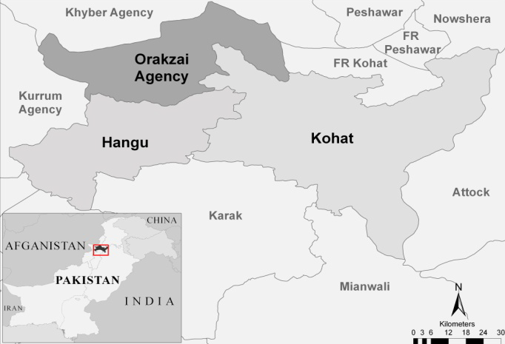
Figure 13.1: Map of Pakistan and of the region

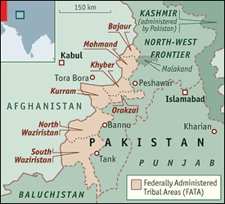
Figure 13.2: Map of the region (detailed)

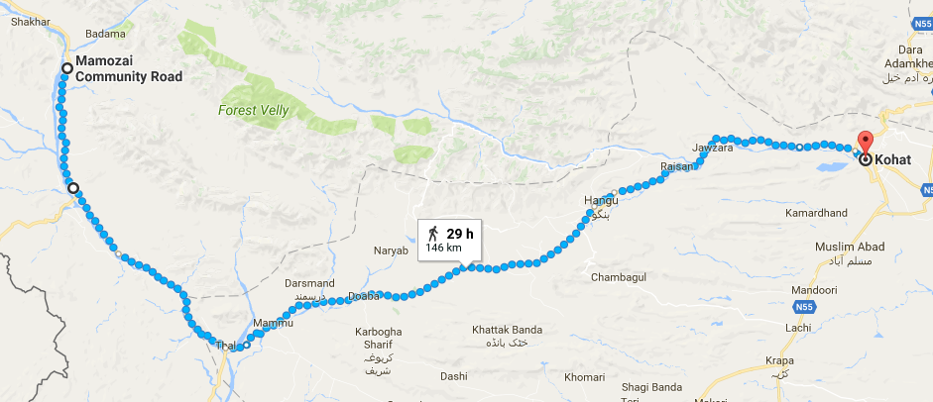
Figure 13.3: Journey of Abdullah in map
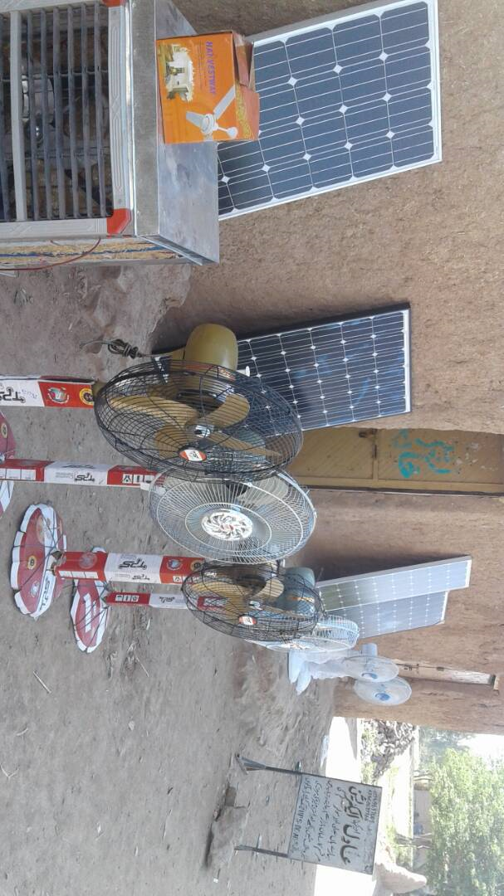
Figure 13.4: Solar Panels on sale

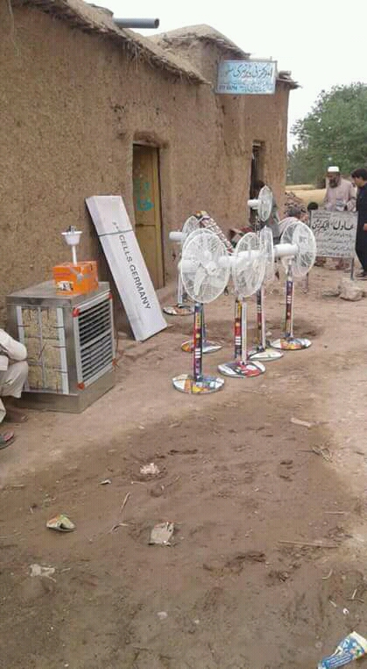
Figure 13.5: Other electrical items on sale

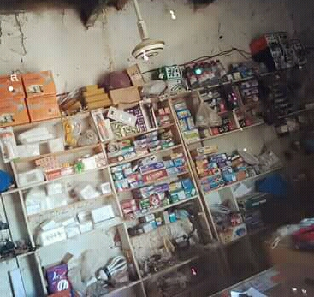
Figure 13.6: Other smaller electrical items

UNHCR. 2016. “Global Trends - forced displacement in 2016”. http://www.unhcr.org/globaltrends2016/. Accessed on 14 September 2017.
Internal Displacement Monitoring Centre. 2015.http://www.internal-displacement.org/south-and-south-east-asia/pakistan/figures-analysis. Accessed on 10 October 2017.
UNHCR. 2013. “Global Report”. http://www.unhcr.org/539809fbb.html. Accessed on 4 April 2017.
Religious law in Islam
According to Encyclopedia Britannica, Purdah, also spelled Pardah, Hindi Parda (“screen,” or “veil”), practice that was inaugurated by Muslims and later adopted by various Hindus, especially in India, and that involves the seclusion of women from public observation by means of concealing clothing (including the veil) and by the use of high-walled enclosures, screens, and curtains within the home.

