Experimental study and flow visualization of Fe₂O₃ /Kerosene in glass oscillating heat pipes

Hamid Reza Goshayeshi^{a*}, Issa Chaer ^{b}
ª Department of Mechanical Engineering, Mashhad Branch, Islamic Azad University, Mashhad, Iran
^{b} London South Bank University, 103 Borough Road, London, SE1 0AA, United Kingdom

ABSTRACT
Pulsating or otherwise known as oscillating heat pipes (OHPs) are two-phase heat transfer devices that can offer simple and reliable operation (no moving parts and vibration-free) with high effective results. This paper presents findings from an experimental flow visualization study into the various types of flow patterns within a closed-Loop OHP with Fe₂O₃/kerosene as the working fluid. The complete transitions from nucleate boiling to formation of liquid slug and vapour plug were observed in the closed-loop OHP. From the flow visualization results, it was deduce that the motions of liquid slugs and vapour plugs are complex and influenced by many factors, such as heat rate, filling ratio and tube diameter. The findings also revealed that bubble generation and bubble growth induced a large driving force which contributed to the random motion of liquid slugs and vapour plugs. The flow visualization also revealed that bubbles with diameter equal to the inner diameter of the tube, otherwise known as tube-size or TS bubbles, were generated when the velocity of liquid slug was lower or equal to 0.15 m/s and the velocity of the liquid-vapour interface increased as TS bubbles were generated.

Keywords: Oscillating heat pipes, flow visualization, liquid slug and vapour plug.
Corresponding Author e-mail: goshayshi@yahoo.com

1. Introduction
Over the last thirty years, conventional heat pipe technology has been successfully applied in a variety of applications; like space applications and electronics cooling []. However, component miniaturization and higher loads have led to an increased need for better thermal management systems and components that could transfer and dissipate high intensity heat flux. Pulsating or closed loop heat pipes as proposed by Akachi [], also known as oscillating heat pipes (OHPs), represent one theme of research that has promising prospect of providing novel solutions that are fitting to the needs of present industry demands. This range of devices offer high effective heat transfer and owing to their favourable operational characteristics (no moving parts) coupled with their relatively cheaper costs, OHPs are projected to meet present and possibly future specific requirements of the electronics cooling industry. In OHPs, heat is transferred not only by the latent heat transfer like in other types of heat pipes, but also as a result of the sweeping effect of the hot walls by the colder moving fluid and vice versa []. For example as the temperature difference between the evaporator and condenser exceed a certain threshold, gas bubbles and liquid plugs begin to oscillate spontaneously back and forth. The amplitude of oscillations is enough to enable liquid plugs to oscillate between the condenser and evaporator. Review of available literature has revealed six major thermo-mechanical design parameters as the primary parameters affecting the OHP system dynamic. These include; input heat to the device, filling ratio of the working fluid, total number of turns, internal diameter of the OHP tube, device orientation with respect to gravity and flow dynamic and behaviour.
Many researchers have also performed flow visualization for OHPs and studied the behaviours of liquid slugs and vapour plugs in an OHP. However, no research was found relating to the flow visualization of OHPs with Fe₂O₃/kerosene as the working fluid. Wook et al. [] conducted flow visualization for the closed-loop Oscillation Heat Pipe (COHP) made from brass and the base fluid was ethanol. Miyazaki and Arikawa [] carried out flow visualization for a closed-loop OHP with R142b as the working fluid and a filling ratio of 0.42. The heat pipe was oriented horizontally with a heat input of 80 W. The authors reported that only oscillations were observed. Gi et al. [], conducted flow visualization for closed-loop OHP made from Teflon tube of 2 mm inner diameter and filled with R142b. The flow behaviour was recorded using a video camera and circulation and oscillations of the working fluid was observed between the evaporator and condenser of this OHP.
Faghri [] performed a study of liquid slugs and vapour plugs motions in an OHP. He reported an oscillating motion of neighbouring vapour plugs, which gradually dampened and was attributed by the author to the zeroing of pressure difference between the vapour plugs. Shaﬁi et al. [] obtained the simple sinusoidal oscillating motions of liquid-vapour interfaces and flow visualization mainly by sensible heat due to the motions of liquid slugs and vapour plugs. Tong et al. [] obtained the simple sinusoidal oscillating motions followed by the circulating motions due to the liquid slugs break off and ﬂow toward a neighbouring tube. However, the results were almost the same with the previous ones.
Hosoda et al. [] investigated the ﬂow patterns within a meandering closed-loop heat transport device when low heat inputs were applied. They observed a regular ﬂow which was called vapour plugs propagation and the motions of liquid slugs and vapour plugs were mainly oscillating.
Tong et al. [] did ﬂow visualization of an OHP at higher heat input by using a CCD camera. They observed small bubble generation and bubbles’ growth to a vapour plug. Xu et al. [] investigated the ﬂow visualization in an OHP by using a high-speed video camera. Qu and Ma [] investigated the startup of liquid slugs and vapour plugs motions in an OHP. The results showed that the startup motion was affected by the amount of heat ﬂux input.
Li and Yan[] used a closed loop OHP (CLOHP) made from capillary glass and observed the flow patterns of different flow regimes, such as startup, transition and steady state. Effects of charging ratio and heat transfer rate were also considered in their study. They reported 50% as the best charging ratio for the case they investigated.
Using a high-speed video camera, Zhang and Faghri [], investigated the flow patterns of water and methanol within an OHP at high heat input. They reported that the flow patterns in the OHP were mainly the dispersed bubbles flow, transition flow from dispersed bubbles flow to liquid slugs–vapour plugs flow and liquid slugs-vapour plugs flow. Senjaya, and Inoue [] investigated the start-up of water liquid slugs and vapour plugs motions in an OHP. They concluded that the start-up of motion was influenced by the wall surface conditions, level of heat input and size cavities on the inner wall surface.
Jia-qiang et al. [] performed a simulation of liquid slugs and vapour plugs motions in an OHP by giving a sudden pressure disturbance in one end of the tube. They obtained an oscillating motion of the neighbouring vapour plugs but it was gradually dampened because the pressure difference between those vapour plugs went to zero. At the same time, Senjaya and Inoue [] presented the simulations of closed and open OHPs.
Ferrofluid such as Fe₂O₃ is a colloid suspension of sub-domain magnetic particles in a carrier liquid. The particles are coated with a stabilizing dispersing agent, which prevents particle agglomeration [3, ]. Many other authors have visualized the heating section of an OHP with propane, HFC-134a and Butane as a working fluids [, , and ] and they studied the effects of bubbles generation on the motions of liquid slugs and vapour plugs. However, none of the existing visualization studies related to phenomena of bubble generation and growth for Fe₂O₃/kerosene. In this research, the phase change phenomena in the heating section of an OHP with Fe₂O₃/kerosene used as the working fluid, was studied using a high-speed video camera and special care was taken to observe and detail bubble generation and pulsation dynamic.
2. Experimental setup
Ferrofluids are colloidal mixture of magnetic particles synthesized in a carrier liquid which comprise of 85% liquid such as kerosene, 10% surfactant for preventing aggregation such as oleic acid and 5% magnetic particles which in our case is Fe₂O₃. Application of ferrofluids e.g. Fe₂O₃ and Fe₃O₄ in some technology such as aerospace, electronic packing and micro-scaled heat exchangers makes them one of the most significant novel technology branches [, ].
In the absence of a magnetic field, ferrofluids have some common interactions with nanofluids such as the one caused by the Brownian motion. However, after a period of no movement, settlement starts to occur and as could be seen from Fig. 1, the settlement of ferrofluid nanoparticles in the motionless fluid differ with respect to time and reach almost complete settlement after 24 hours.
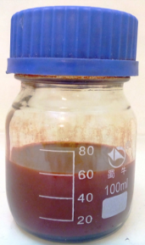
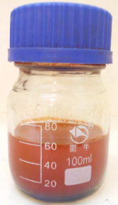
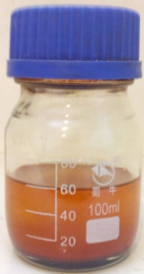
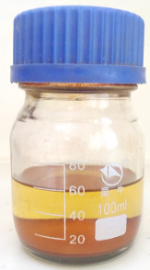
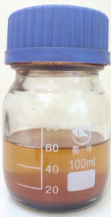
At 0 minute | After 1 hour | After 2 hours | after 5 hours | after 24 hours
Fig. 1. Settlement of ferrofluid nanoparticles in the motionless fluid.

Fig. 2, presents a picture of the experimental apparatus and a schematic of the closed-loop OHP setup. To explore the effect of different heat loads on the evaporator segment of the closed-loop OHP, an electric heater connected to a Variac and standard current and volt meters were used to simulate the different heat inputs (10 to 80 Watts) on the evaporator of the vertical OHP. The uncertainties in the current and voltage readings were found to be ± 0.015 Amps and ± 0.4 Volts, respectively. A set of K-type thermocouples linked to a data acquisition system were also used to monitor temperatures at the condenser and evaporator. The uncertainty of the temperature measurements was found to be ±1 K. All other geometrical parameters for the OHP are given in Table 1.
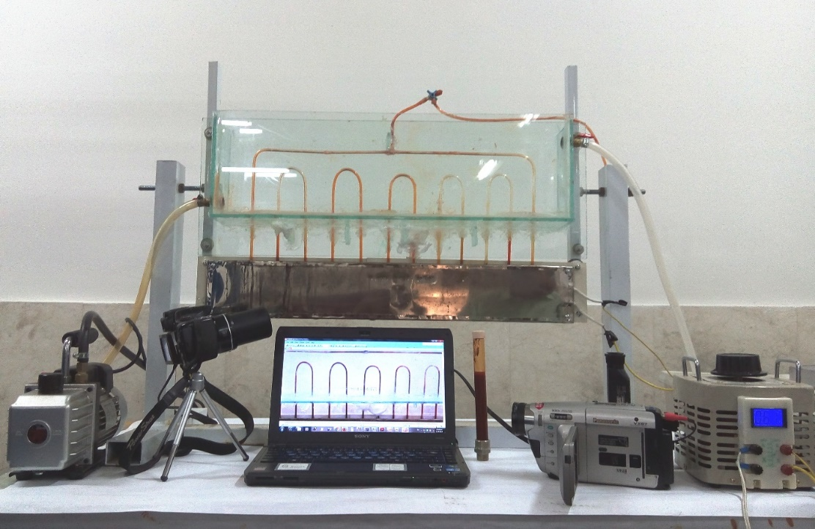
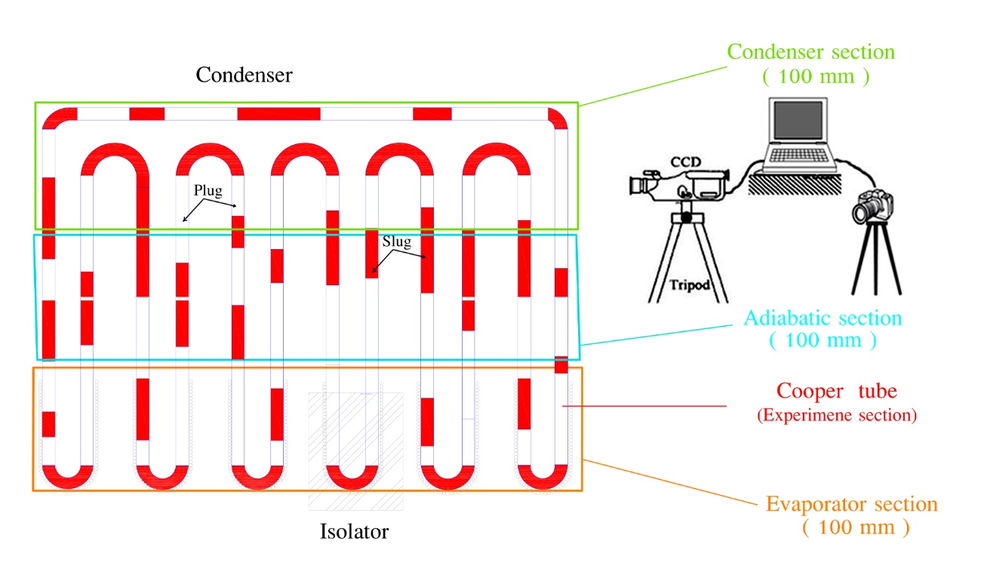
Fig. 2. Picture (top) and diagram (bottom) of the closed-loop OHP configuration.

Table 1: Heat pipe configuration
OHP material | Copper & Glass
OHP length | 380mm
Condenser length | 100mm
Adiabatic length | 100mm
Evaporator length | 100mm
Outer diameter | 3mm
Wall thickness | 1.25mm
Inner diameter | 1.75mm
Liquid filled ratio | 50%
Total length of OHP | 4.4 m

Fig. 3, shows diameter distribution of the Fe₂O₃. This information was obtained by using the Dynamic Light Scattering (DLS) technique. According to this figure, the Fe₂O₃ diameter distribution ranged between 10 and 30 nm with the highest distribution diameter being that of the 20 nm ones.
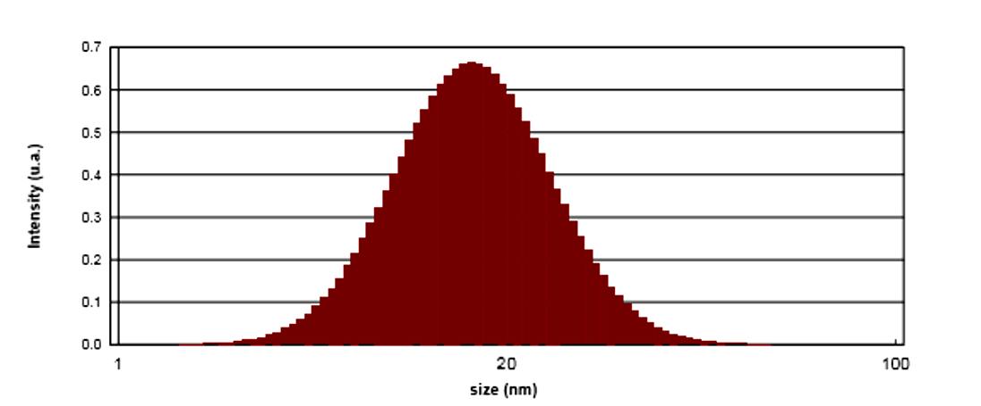
Fig. 3. Diameter distribution of Fe₂O₃ ferrofluid.

3. Experimental procedure and repeatability
As highlighted previously, the heat transfer medium used in the present study comprised Fe₂O₃ nanoparticles (5 % by volume), Oleic acid as a surfactant and kerosene as the base fluid. The nanoparticles of Fe₂O₃ were mixed in the base fluid using a standard stirrer. An ultrasonic oscillator was used to sonicate the fluid for 5 hours. The bath type sonicator had a power source of 120V/AC220-240V 50/60 Hz, 100V/AC and working frequency of 45 kHz [23].
The device was vacuumed before charging the fluid into the OHP by applying 0.1 Pa suction pressure for 15 minutes via a vacuum pump joined to a 3-way valve. Next, the vacuum pump was isolated using the 3-way valve and the fluid was charged into the OHP (see Fig. 2).
Tests were performed at different heat settings (10 to 80 Watts applied on the evaporator of the OPH). Less than ± 0.1 °C variation in temperature for 10 min was assumed to be steady state conditions. This is in line with what was done by Li and Yan [14]. Following this stage, the power was amplified to the next level and the performance of the OHP was again evaluated. This process was then repeated for all the settings from 10 to 80 Watts heat inputs.
The OHP was stopped after each set of runs for a week before tests were repeated. The tests showed no significant difference. The exceptional repeatability can be attributed to the fact that nanoparticles’ random motion under the effect of buoyancy in the base liquid could have created uniform nanofluid after the long stoppage period. This is in agreement with the findings of Lu et.al [] who stated that test results can be well repeated for a uniformly dispersed nanofluids.

4. Visualization results
A Pyrex glass (7740) was used for the flow visualization. The phase change phenomena and bubble generation in the heating section were recorded using a high-speed video camera (Panasonic VX87) with frame rate of 100 frames per second and sensitivity of $1504×1128$ pixels. The dynamic images captured by the camera were transmitted and stored on a Laptop in real time. The successive images were processed using Photoshop CC commercial software to measure the distance of the fluid movement with respect to time, and thus the velocity was obtained.
When the heating power reached 40 Watts, the internal flow was observed. At the beginning, most liquid slugs were located near the bottom of the channels in vertical mode due to gravity effect with bubbles first emerging from the side walls region. As the temperature in the evaporator section was increased, the growth rate of bubbles increased. The growth rate of the bubble resulted in an increase in buoyancy and thus subsequent bubbles accelerated to catch up with previous ones. Several initial small spherical bubbles merged into large vapour column. The intense boiling of Fe₂O₃/kerosene caused pressure imbalance, which resulted in the intermittent up and down oscillation. A large number of bubbles emerged in the middle channels, then, the local oscillation inside the channels gradually shifted to the interactive oscillation in all connecting channels. When heat was added to the evaporator section, the intermediate bubbles grew faster in the liquid plugs than those long column bubbles.
As heat was continuously added at the evaporator section, a large amount of vapour was generated in the intermediate bubble and the vapour pressure increased. Since the surface tension force inside the OHP is dominant, a chain of liquid slug and vapour plug was formed inside the OHP. The sudden increase of vapour pressure made the chain of vapour bubbles and liquid plugs move quickly. This pressure difference is the driving force for the oscillating motion of liquid plugs and vapour bubbles along the capillary and is in line with previous research [, , and ]. The input heat, which is the driving force, increased the pressure of vapour plugs in the evaporator while the heat dissapiation at the condenser decreased the pressure of vapour plugs. The flow visualisation revealed that nucleate boiling within the evaporator section took longer time to occur with low heat inputs and as a result the OHP took longer time to have sudden movement of vapour bubbles and liquid plugs. Three bubble sizes were characterized in one section at one time; small bubbles, vapour plugs, and long vapour plugs, as shown in figure 4. The small bubbles were visible as a result of the continuous nucleate pool boiling near the bottom section and before the occurrence of coalescence in the evaporator section. The vapour plugs, whose size nearly equalled the tube diameter, were predominantly produced due to bubbles’ growth and coalescence as they travel upward. Long vapour plugs, easy to collapse, were also observed towards the upper part of the visualization section.

Previous flow visualization results identified TS bubble generation and growth as important phase change parameters for sustained pulsation. Internal diameters between 0.1 to 5 mm were recommended in the literature for the production of good TS bubbles in OHPs and vapour plugs [24, , ]. Our visualization results revealed that, generation of TS bubbles is influenced by the liquid slug velocity and the rate of growth and/or coalescence of smaller bubbles. The velocity of a liquid slug just before TS bubbles generation reached 0.15 m/s. This velocity is lower than that found by other researchers for other fluids. We believe this is due to density variation. With velocities higher than 0.15 m/s, the small bubbles detached from the inner wall of the tube before reaching tube size, thus no formation of TS bubbles. We believe that the TS bubbles generation is one of the possible causes of the large amplitude and random motions of liquid slugs and vapour plugs. The velocity of liquid–vapour interface was almost constant during the small bubbles generation but it was suddenly accelerated when TS bubbles were generated. This means that the TS bubbles generation provided a greater driving force.

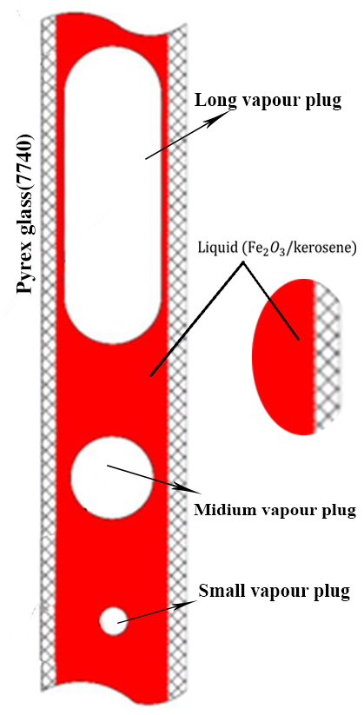
Fig. 4. Schematic of three types of bubbles for Fe₂O₃/kerosene

4.1 Flow patterns
Previous visualization studies have identified five types of ﬂow patterns as characterized in terms of bubble sizes. Those included bubbly flow, slug flow, foam flow, annular steak flow and annular flow. Our visualization results for Fe₂O₃/kerosene inside the OHP revealed similar flow patterns. Those flow patterns are shown in Fig. 5 and explained in more detail in the following points.

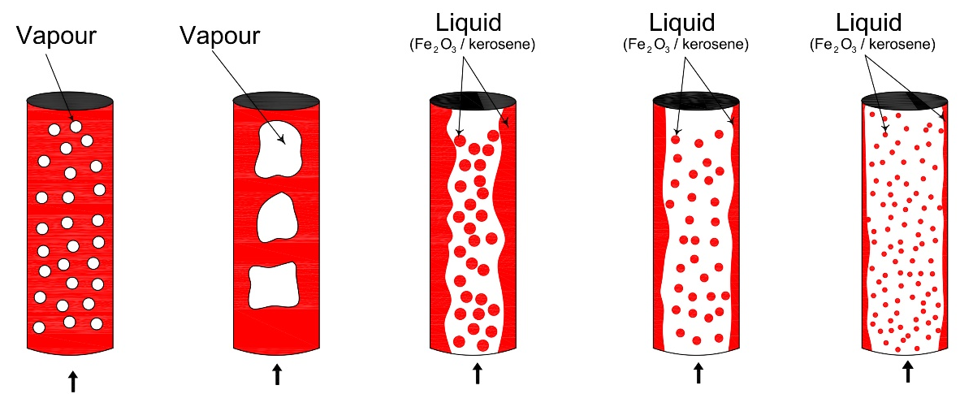

- Bubble flow (b) Slug flow (c )Foam flow (d) Annular streak flow (e) Annular flow
Fig. 5. Schematics of the flow patterns obtained in the evaporator section of the vertically-held OHP with FR=0.5.

- Bubbly flow: Vapour bubbles were of approximately the same size and they were produced as a result of the continuous nucleate pool boiling and detachment from the inner wall of the tube.
- Slug flow: Slug and plug arrangement were observed in our study and are clearly visible from Fig 5. (b) where the coexistence of liquid slugs and vapour plugs of different length are shown. Some small vapour bubbles distributed throughout the liquid were also visible.
- Foam (Churn) flow: This visible from Fig 5. (c) where highly unstable flow of an oscillatory nature was observed.
- Annular steak (wispy) flow: As the liquid flow rate increased in annular flow, the concentration of drops in the vapour core increased; ultimately, droplet coalescence in the core lead to large lumps or streaks of liquid in the vapour core. This flow pattern is characteristic of flows with high mass flux as proposed by Ghajar [].
- Annular flow: The liquid travelled mostly as an annular film on the inside walls of the vertical tube while the centre of the tubes was mainly vapour with some small liquid drops that eventually vaporised, please see Fig 5. (e). Those results are similar to findings obtained by previous researchers with other fluids [23, 33].

The liquid slug oscillation inside the OHP was also affected by the temperature difference generated between the heating and cooling sections, the larger the temperature difference, the better the oscillation and this is in line with previous findings of Khandekar et al. [], Marneli et.al. [] and Taslimifar et. Al. [].

In the evaporator, the bubbles are evolved due to the rapid evaporation at the nucleation site and once the bubbles are formed, they are swept away quickly by the high slug flow velocity through the evaporator as a result large quantity of heat is transported from the evaporator towards the condenser region. Thus, the boiling process at the evaporator region of the OHP can be considered as forced convective boiling as the liquid enters the heated region [] and [] and bubbles are continuously displacing the superheated liquid film away from the evaporator surface. Our visualization results also showed that, the velocity direction of the liquid slugs is almost the same and the slugs move clockwise, but their values changed every second, although the amplitude is small. Fig.6, shows TS bubbles position vs TS bubble generation and growth.

Fig. 6. Tube size (TS) during bubble generation and growth.

4.2 Flow pattern map
In this study a series of experiments were also performed on the OHP in vertical bottom heat mode, with variations in two parameters; the fill ratio (FR) and heat input (q). The results were mapped as presented in Table 2, where the flow patterns are indicated for the different heat inputs and different filling ratios. Bubble flow is represented by the letter B, slug flow is represented by the letter S, foam flow is represented by the letter F, annular steak flow is represented by the letters AS and annular flow by the letter A.

Table 2. Flow pattern map
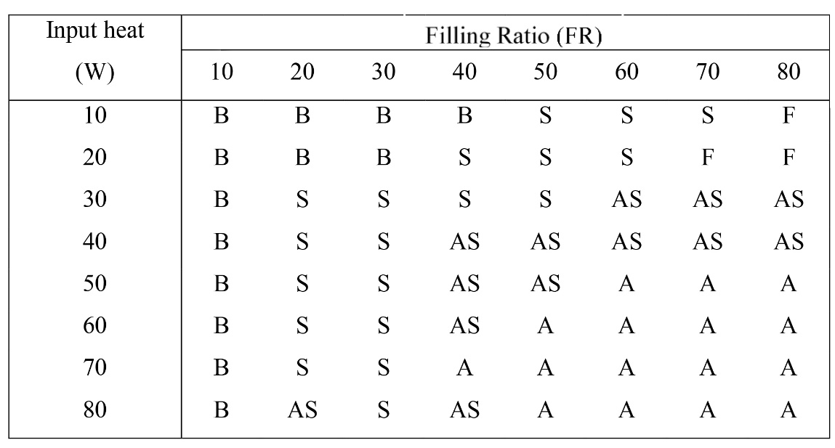

The visualization experiments of the flow patterns in the present work showed that the flow condition inside the OHP were more complex than the single bubble-liquid slug flow. Various flow patterns, such as the bubble-liquid slug flow, the semi-annular flow and the annular flow may occur in different working conditions. However, looking holistically at Table 1, gives is a link between the thermal performance of the OHP and the internal flow patterns inside the tube at different filling ratios. Bubble flows tended to dominate the low filling ratio regions. This was followed by the slug flow patterns but with higher heat input. Eventually with 80 % filling ratio it was difficult to observe bubble or Slug flows.
The flow patterns for the 50 % filling ratio seemed to have a self -adjusting characteristic with the increased heat input, moving from slug flow to annular steak flow and then to annular flow. This is in line with results reported previously by Goshayeshi et. al [].

5. Conclusions

An experimental closed-loop OHP, made from Pyrex glass and with Fe₂O₃/kerosene as the working fluid, was developed. The flow patterns within the heating section of the OHP were observed using a high-speed video camera for a range of filling ratios between 10 and 80% and heat inputs between 10 and 80 Watts, From this study the following conclusions may be drawn:
- Bubble generation and bubble growth induced a large driving force which contributed to the random motion of liquid slugs and vapour plugs.
- Circulation and oscillations of Fe₂O₃/kerosene induced heat transfer between the evaporator to the condenser of the heat pipe.
- Five flow patterns were observed in the heating section in the studied range of filling ratios and heat inputs. This included bubble flow, slug flow, foam flow, annular steak flow and annular flow.
- As heat input was increased, the bubble-liquid slug flow transformed to annular steak and then to annular flow. This was clearly visible for filling ratios around 50%.
- Annular flows were more consistent and dominant for filling ratios between 50 and 80% and heat inputs of 60 Watts and above.
- For Fe₂O₃/kerosene, TS bubbles were generated when the velocity of liquid slugs were lower or equal to 0.15 m/s and the velocity of liquid-vapour interface increased as TS bubbles were generated.
Acknowledgments
This research was supported by Mashhad Azad University with grant number of 62115. The authors would like to express their sincere appreciation for all the support provided by this university.

References

- Groll, M. and Rösler S., “Operation principles and performance of heat pipes and closed two-phase thermosyphons”, Journal of Non-Equilibrium Therm. 17, (1992) 91-151.
- H. Akachi, F. Polášek and P. Štulc, Pulsating heat pipes, Proc. 5th International Heat Pipe Symposium, Melbourne, Australia, 1996, pp. 208-217.
. H. R Goshayeshi, I Chaer, Comparison of copper and glass oscillating heat pipes of Fe₂O₃ under magnetic field, Int. J. Low Carbon Technologies. (2015).
. H.L. Wook, S.J. Hyun, H.K. Jeung, S.K. Jong, Flow visualization of oscillating capillary tube heat pipe, , Proc. 11th International Heat Pipe Conference Japan, Vol. 2, 1999, pp. 131-136.
Y. Miyazaki, M. Arikawa, Oscillatory flow in the oscillating heat pipe, Proc. 11th International Heat Pipe Conference, Japan, Vol. 2, 1999, pp. 143-148.
K. Gi, F. Sato, S. Maezawa, Flow visualization experiment on oscillating heat pipe, , Proc. 11th International Heat Pipe Conference, Japan, Vol. 2, 1999, pp. 149-153.
A. Faghri, Analysis of pulsating heat pipe with capillary wick and varying channel diameter, Int. J. Heat Mass Transfer. l48 (2005) 2635-2651.
M.B. Shaﬁi, A. Faghri, Y. Zhang, Thermal modeling of unlooped and looped pulsating heat pipes, J. Heat Transfer. 123 (2005) 1159-1172.
B. Tong, S. Lim, K. Ooi, Theoretical modeling of pulsating heat pipe, in: Proceedings of Eleventh International Heat Pipe Conference, Tokyo, 1999, pp. 159-163.
M. Hosoda, S. Nishio, R. Shirashaki, Study of meandering closed-loop heat-transport device (vapour plug propagation phenomena), JSME Int. J. B42/4 (1999) 737-744.
B.Y. Tong, T.N. Wong, K.T. Ooi, Closed-loop pulsating heat pipe, Appl. Therm. Eng. 21 ( 2001) 1845-1862.
J.L. Xu, Y.X. Li, T.N. Wong, High speed ﬂow visualization of a closed loop pulsating heat pipe, Int. J. Heat Mass Transfer. 48 (2005) 3338-3351.
W. Qu, H.B. Ma, Theoretical analysis of startup of a pulsating heat pipe, Int. J. Heat Mass Transfer. 50/11-12 (2007) 2309-2316.
J. Li, L. Yan, Experimental research on heat transfer of pulsating heat pipe, Journal of Thermal Sciences. 17 (2008) 181-185,.
Y. Zhang, A. Faghri, Advances and unsolved issues in pulsating heat pipe, , Int. J. Heat Transfer Engineering. (2008) 20-14.
R. Senjaya, T. Inoue, Bubble generation in oscillating Heat Pipe. Applied Thermal Engineering. 22 (2013).
E, Jia-qiang. Z, Rong-jia. C, Jian-mei. L, Yan-ping. H, Xiao-feng. Oscillation heat transfer dynamic model for new type oscillation looped heat pipe with double liquid slugs. Journal of Central South University. (2012) 3194-3201.
R, Senjaya. T, Inoue. Oscillating heat pipe simulation considering bubble generation Part I: Presentation of the model and effects of a bubble generation. Int. J. Heat and Mass Transfer. (2013) 816–824.
H. R. Goshayeshi, M. Goodarzi, M. Dahari, Effect of Magnetic Field on the Heat Transfer Rate of kerosene / Fe2O3 Nanofluid in a Copper Oscillating Heat Pipe, Experimental Thermal and Fluid Science. 68 (2015) 663-668
Z, Lin. S, Wang. R, Shirakashi. L Winston Zhang. Simulation of miniature oscillating heat pipe in bottom heating mode using CFD with unsteady modeling. Int. J. Heat and Mass Transfer. (2013) 642-656.
G. Xu, S. Liang, M, Vogel. Thermal characterization of pulsating heat pipes. The tenth intersociety conference on thermal and thermomechanical in electronics, IEEE, (2006) 552-556.
H Yang, A, Khandekar, M, Groll. Operational limit of closed loop pulsating heat pipes. Applied Thermal Engineering. 28(2008).
R, Senjaya. T, Inoue. Oscillating heat pipe simulation considering bubble generation Part I: Presentation of the model and effects of a bubble generation. Int. J. Heat and Mass Transfer. (2013) 816–824.
H. Jamshidi S. Arabnejad, M. Shafii,” Thermal characteristic of closed loop pulsating heat pipe with nanofluids” Journal of Enhanced Heat Transfer. 18/ 3 (2011) 221-237.
M. Mohammadi, M. Taslimifar, Experimental investigation of an Open Loop Pulsating Heat Pipe Using Ferrofluid Proceeding of the ASME 2012 3rd Micro/Nanoscale Heat & Mass Transfer International Conference Atlanta, Georgia. USA, 2012.
L. Lu, L.-C. Lv, Z.-H. Liu, Application of Cu-water and Cu-ethanol nanofluids in a small flat capillary pumped loop, Thermochimica Acta, 512 (2011) 98-104.
L.Shi, L.Jingtao, D. Xiangyuan Experimental study of flow patterns and improved configuration for Pulsating Heat Pipes Journal of Thermal Science. 16/1 (2007) 56-62.
S. Khandekar, N. Dollinger and M. Groll, Understanding operational regimes of pulsating heat pipes: an Experimental study. Applied Thermal Engineering. 23/6 (2003)707-719.
M. Mohammadi , M. Taslimifar, Experimental investigation of an Open Loop Pulsating Heat Pipe Using Ferrofluid Proceeding of the ASME 2012 3rd Micro/Nanoscale Heat & Mass Transfer International Conference Atlanta, Georgia. USA, (2012).
Y Long, H Xiao-feng. Oscillation heat transfer dynamic model new tape oscillation looped heat pipe with double liquid slugs J. Cent. South Univ. 19 (2012) 3194- 3201.
J. L. Xu, Y.X .Li and T. N Wong, High speed flow visualization of a closed loop pulsating heat pipe, Int. J. Heat and mass Transfer. 48/16 (2005) 3338-3351.
S. Khandekar, P. Charoensawan, M. Groll, P. Terdtoon, Closed loop pulsating heat pipes Part B: visualization and semi-empirical modeling, Applied Thermal Eng. 23/16 (2003) 2021–2033.
A. J Ghajar. Non-boiling heat transfer in gas-liquid flow in pipes – a tutorial, J. Braz. Soc. Mech. Sci. & Eng. 27/1 (2005).
S. Khandekar, P.K. Panigrahi, F. Lefèvre, J. Bonjour, Local hydrodynamics of flow in a pulsating heat pipe: a review, Frontiers in Heat Pipes, 1/20 (2010).
M. Mameli, V. Manno, S. Filippeschi, M. Marengo, Thermal instability of a Closed Loop Pulsating Heat Pipe: Combined effect of orientation and filling ratio, Experimental Thermal and Fluid Science. 59 (2014) 222-229.
M. Taslimifar, M. Mohammadi, H. Afshin, M.H. Saidi, M.B. Shafii, Overall thermal performance of ferrofluidic open loop pulsating heat pipes: An experimental approach, Int. J. Thermal Sciences 65 (2013) 234-241,
M.J. Pastoriza-Gallego, L. Lugo, J.L. Legido, M.M. Piñeiro, Rheological non-Newtonian behaviour of ethylene glycol-based Fe2O3 nanofluids, Nanoscale research letters. 6 (2011) 1-7.
M. Pishvar, M.S. Avval, Z. Mansoori, M. Amirkhosravi, Three dimensional heat transfer modeling of gas-solid flow in a pipe under various inclination angles, Powder Technology. 262 (2014) 223-232.
H.R. Goshayeshi, A. Khosravi, M.A. Karizaki, Experimental investigation on nanofluids effectiveness on heat transfer in oscillating heat pipe, Advanced Materials Research, Trans Tech Publ, (2014) 98-102.

